Before completing these steps, please make sure that you have signed up for Microsoft CMT according to the directions listed in the [Google doc](https://docs.google.com/document/d/1ubzdWekH2WLzft-IaSnkYflKrR7DqW-X7WsWiG30loI/edit#heading=h.wfalxc53x421).

The following steps need to be completed ONCE by the Team Leader ONLY

1. Fork the [Course Project github repo](https://github.com/CS410Assignments/CourseProject) by clicking on the “Fork” button on Github



Your fork is the main place to submit all the course project submission, i.e. proposals, progress reports, code, final software documentation, demo presentations, etc.

**Naming:** The project will be manually graded, so there are no specific names required as long as they are easily recognizable (or better yet, described in the Readme file).

**Format**: The proposal, progress report, and final documentation can be a word/pdf document.

**Grading**: The proposal, progress report, and final documentation will be peer-graded by all of you (with guidance from the instructors). We will later provide more details on the peer-grading process and reviewer functionality on CMT.

2. Log into [Microsoft CMT](https://cmt3.research.microsoft.com/Conference/Recent) and click on “All Conferences”. Search for the conference named “CS410Expo2021” and click on the conference.

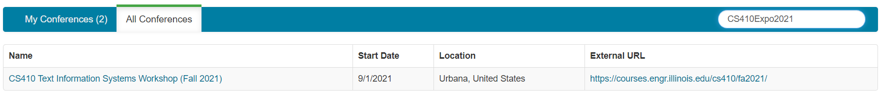

3. Click “+ Create New Submission” and select the track that you chose for your project. This should match your listed track in the [Google sheets page](https://docs.google.com/spreadsheets/d/1AwQW_q9AKCplRDQUhgXYIP9Kg0xRb_nRo0bbx1FeJ7I/edit#gid=0).

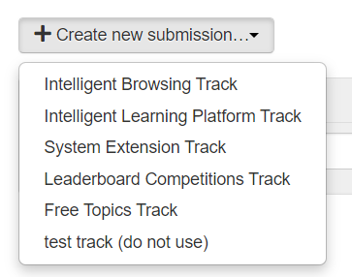

4. Enter your Project Topic in the “Title” field. In the “Abstract” field, enter the URL of your fork created in step 1.

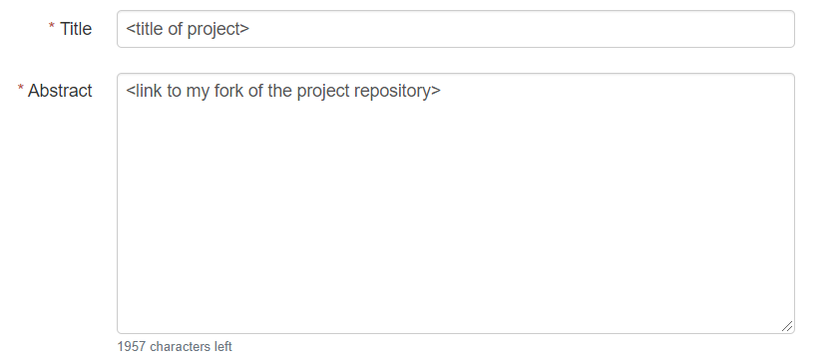

5. Add the emails of **all the team members** under authors.

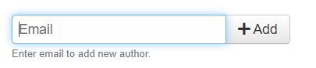

6. Select the subject area that you feel best describes your project.

7. Finally, click on “Submit”.

All these steps need to be done **ONLY ONCE** for the course project. Just keep adding the relevant files to your Github fork for all the required submissions.

Hope you enjoy the course project!!!