**1- Introduction**

1.1 Background of the study

Paragraph

1.2 Purpose of the projects

1.3 objectives of the project

1.4 Project scope and limitations

1.5 assumptions

**2 - Projects deliveries**

**3- system requirements**

3.1 functional requirements

Functional requirements are what a software system must do: its features and functions.

|  |  |  |
| --- | --- | --- |
| **FR.no** | **Functional requirements** | **Comments** |
| FR1 | Customer registration | Login system and this will be skipped if customer is already registered.  The user has 2 ways to register physically and online.  the online form must be verified by the client uploading their ID , birth certificate, or any credentials that will validate their identity, for this process We are using salt with hash php function ,  $user =$_post['user_input'];  $result = hash("sha256" , $user);  In this way we will encrypt the user's password and validate all the data with sanitization of all the inputs |
| FR2 | Forgot password | we will use an input where the user will be asked for the email and we will send an email to his email after verifying if the user exists,  input and button form to recover the password are using encryption SHA256 with hash and salt |
| FR3 | Search for available vehicle | Search car by their ID , model , color , capacity , etc, all of them are input which come from the user upload and the input names must be the same as the database |
| FR4 | View vehicle with details | Once customer found the vehicle we will create dynamic Single product page in which will be using global variable $_POST PHP to identify the id product page |
| FR5 | Product catalog | The product catalog will be organized by categories car (cars, sedan,suvs trucks) which one will have category ID |
| FR6 | Payment mode | This payment module will give the option to pay with bankwire , paypal and offline credit card |
| FR7 | Calculate cost | The calculate total cost is doing by our class Payment that has functions to validate the payment |
| FR8 | E- payment | We will include Paypal and apple wallet |
| FR9 | Reserve vehicle for renting | This reserve will be working with 2 important php fundamental PHP elements like date and objects date will be storage in the mysql database |
| FR10 | Feedback from customer | for the feedback we will use a module that will allow us to leave a review of the user and product and company, which must be moderated by the web master and this will be Integrated through javascript to Google merchant center through the API and this will allow us to show our stars in google adwords ads. |
| FR11 | Add new vehicle/ vehicle category | Each user will be allow to add new vehicle if this is beetween our categories and the system will check add the new vehicle with a new ID which is automatic generated in order |
|  | Update vehicle details | Same as add the system will check our booking system doing a query to the database with php, our schedule and calendar with date() |
|  | Change vehicle status | this will allow the customer to modify the vehicle and make it available or unavailable and all this will be verified by our dates in the database and the input ID will be used to update each vehicle |
|  | Remove vehicle/ vehicle category | The user has the option to delete the car with a button that will delete the vehicle ID within the account on the client side and this way it will not be displayed on the front end |
|  | Send availability via text message | We collect user phone number from form registration and If the user authorized us we will send a text message when the vehicle they want is available |
|  | Database management | Mysql Database will be manage by database specialist and it will use the CRUD system, that will update each user vehicle. |
|  | Payment management | The payment management will record each transaction and send the money to the client where a fee will be charged to the user by our company.  will be connect to our reckon accounting software with an API and the manager will be do it by sales employees |
|  | Admin dashboard | Admin dashboard will be very easy to use.  Will allow to manage payments , add , edit and remove products and customers , edit content , prices etc. |
|  | Car gallery | the user will upload images to the web through a form that will use a tag in the html form like this enctype="multipart/form-data" , this allows uploading files with php to the database and in this way the images will be displayed to the gallery |
|  | Booking cancelation | The cancellation of the reservation will be through a PHP form connected to our calendar and database that will again use the most important input, which is the ID input. |
|  | Customer dashboard | Will show the car they have rent and their customer history , Develop with html css , php and javascript in front and back end |
|  |  |  |
|  |  |  |
|  |  |  |
|  |  |  |
|  |  |  |
|  |  |  |
|  |  |  |
|  |  |  |
|  |  |  |
|  |  |  |

3.1 No functional requirements

Non-functional requirements specify the quality attributes of the system, hence their second name — quality attributes. Continuing our messaging platform example, a non-functional requirement can be the speed with which a system must perform editing to satisfy user expectations, “The message must be updated for all users in a chat within 0.1 seconds, given that all users are online and have LTE connection or better.”

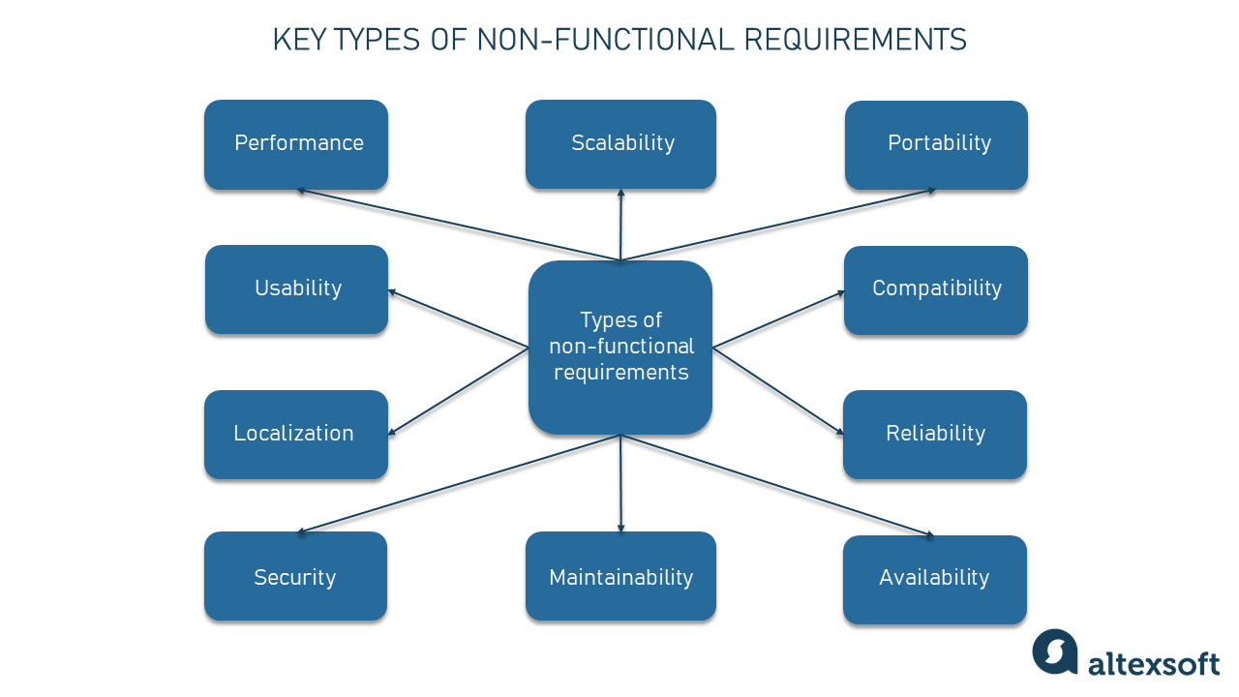

|  |  |  |
| --- | --- | --- |
| **FR.no** | **not function requirements** | **Comments** |
| FR1 | Accessibility | our system is programmed in php 7.4 and mysql and is using apache server.  It has a responsive design that allows it to be visible from any device and also has a magnifying glass function for reading. |
| FR2 | security | Our forms are all validated, sanitized and prepared for any type of attack or mysql injection.  because md5 is not secure passwords will be encrypted in SHA256 which is considered the most secure form of encryption at the moment |
| FR3 | scability | our system is designed to support 1.000.000 visit at the same time and adapt the database space if its need it.  all programmed in PHP and MySQL, which are free languages and work on all systems and allow it to grow, modify and update easily.  We are using horizontal scaling |
| FR4 | performance | Cache , cdn and Load balancer which allow reduce time of loading data.  Site is loading in 1 second |
| FR5 | Availability | the system is available according to our tests 98% without errors 24 hours a day |
| FR6 | Reliability | the system is being tested and works in 95% of cases without any errors |
| FR7 | Usability | the system is very easy to use where the user needs to create an account that will allow him to access the backoffice and be able to manage leases and payments |
| FR3 not function requirements | About us - |  |
| FR4 not function requirements | social media - newsletter |  |

4 Software and hardware architect diagram

5- use case diagram

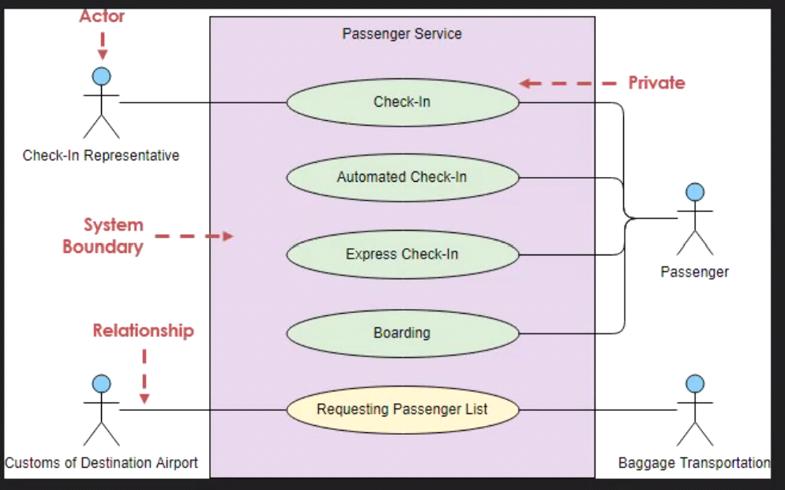

6 Contacts diagrams (draw.io)

7 data flow diagramas

8 System design

System design is the process of designing the elements of a system such as the architecture, modules and components, the different interfaces of those components and the data that goes through that system.

The element of Car Rental system will be :

**Architecture:** The architecture will be created and Develop with HTML CSS and JavaScript in the front end , php and MySQL back end , this use the system CRUD (Created , read , update and return data).

So we will be using some our DNS which is our IP or name server on internet and the proxy cache on the web server will help the web page to load faster if the user have been before, the cdn and load balancer those will allow our site to be secure and running mostly 98% of the time.

System is user request to web server and web server will give an answer if there are nothing wrong or potential maligns .

**Modules:** our modules are specific for the different types of actions such as users and manager need to do , the manger will use the administrate the system .

We have to develop a Payment and booking modules , user registration modules , car review module, validations owner credential and information modules, all this modules will includes the form inputs which will be connected to the database.

**Components:** Develop with html css , php and javascript in front and back end

Interfaces: front interface and back office interface will be develop with the components already specified .

**Data:** data will be collected in our data base and we will also collected local storage data with cokies so we will be able to run our remarketing campaigns and will allow us to know the user preferences and will help to manage our catalog .

8.1 User interface design

Login form module , customer information management module ,payment method module , user management module , database system administrator using MYSQL & PHP on this way we are able to manage our data

9 sequence diagrams

10 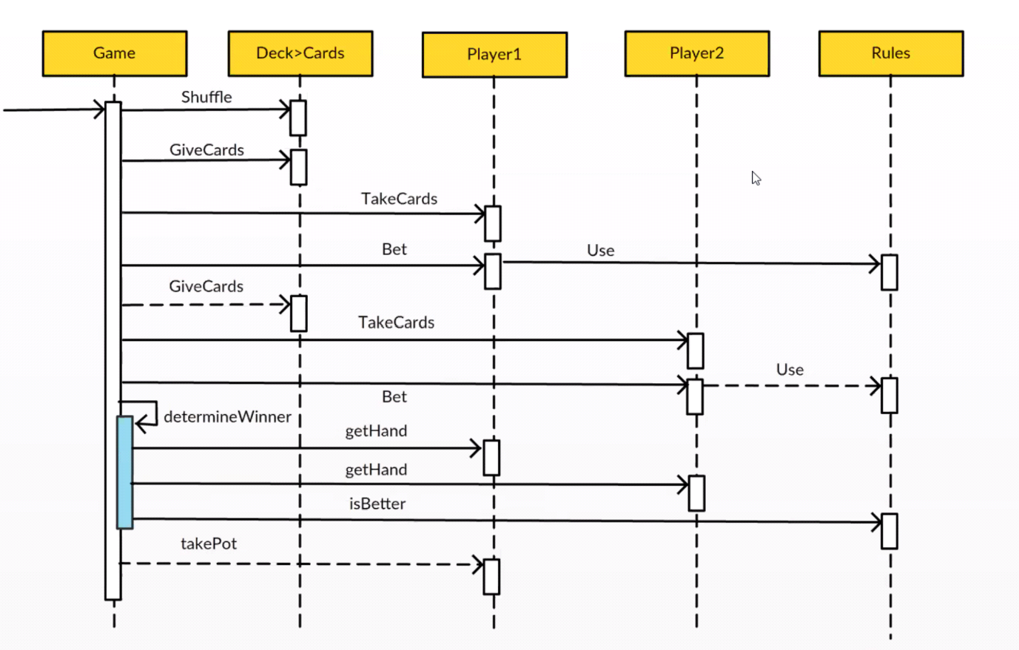

10. Entity relationship diagram 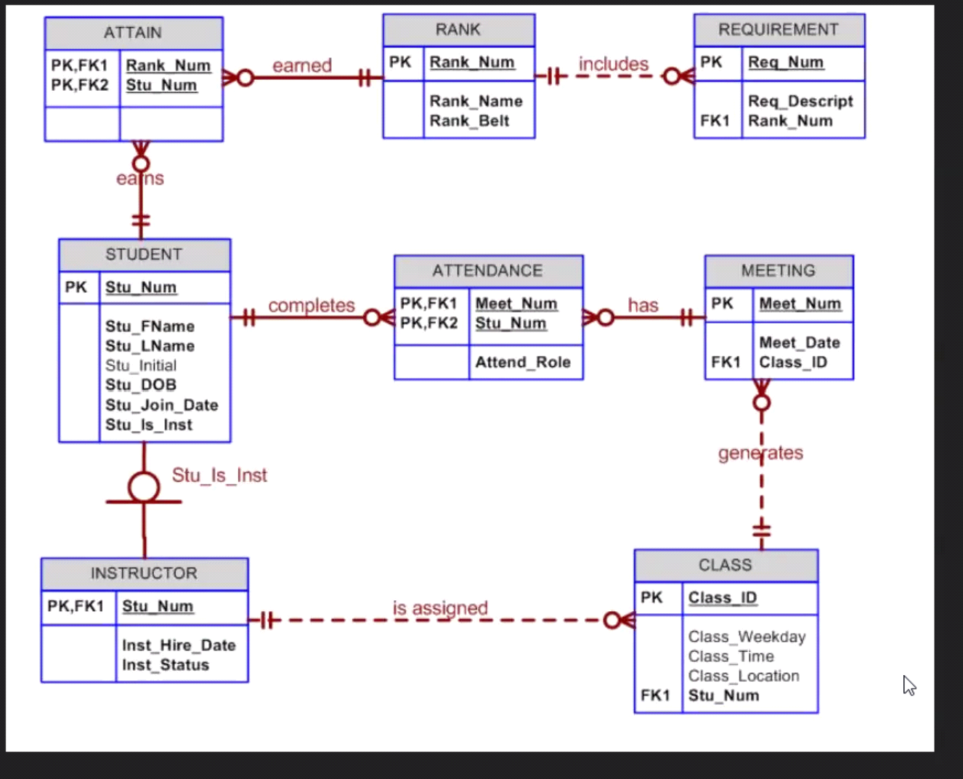

Blob for images in sql

For user interface design will be 20 different user interfaces design

Use different tools for ID - UX