COMMONWEALTH OF MASSACHUSETTS
EXECUTIVE OFFICE OF HEALTH AND HUMAN SERVICES



Data Warehouse Project

Informatica Data Quality

Data Scorecard Monitoring

Technical Specification for IICS Addendum

Version 1.7 Draft

Date: May 28, 2026

Revision History

Version# | Date | Version Details | Author
1.0 | 9/3/2020 | Initial Design | JP Leger
1.1 | 9/25/2020 | Rima Reviewed | JP Leger, Rima Kayyali
1.2 | 10/2/2020 | Released from DWDQ | JP Leger, Shruti Dadhi
1.3 | 4/1/2021 | After reports created before showing to Nicole | JP Leger, Shruti Dadhi
1.4 | 8/20/2021 | Fails sheet on DIF Excel Report | JP Leger, Shruti Dadhi
1.5 | 1/5/2022 | SFTP DIF extension and SCO processing | JP Leger, Shruti Dadhi
1.6 | 2/26/2024 | Scorecard_Documentation_1_6.docx after IICS migration | JP Leger, Shruti Dadhi
1.7 | 5/28/2026 | Scorecard_Documentation_1_7.docx Adding how to run instructions | JP Leger, Shruti Dadhi

Contents
Revision History 2
How to run the ACO, OC and SCO scorecards 4
Summary for Running 4
ACO Detail 4
Informatica Step 4
SQL pre or post processing 6
DIF Step 9
OC and SCO Detail 11
SQL pre-step 11
Informatica Step 12
DIF Step 13
The IICS Migration 15

How to run the ACO, OC and SCO scorecards

Summary for Running
Where I run on a bit below, here is a quick summary of how these are run.

All are run in two stages, Informatica to populate the tables and Data Integration Framework (DIF) as BI component to create the spreadsheets, and for ACO, deliver them.
ACO is run monthly. Informatica step sets the Run Date (As of Date against WH From Date) for the last day of the previous month. DIF step runs from command line on Data Mastering server. I run ACO DIF in multiple steps just to be sure before it sends out a lot of emails. DIF creates 15 spreadsheets, packages them into 6 MCO zip files and one overall zip file, moves them to the SFTP server, and sends email to the MOC’s and DI team.

SCO and OC are run quarterly, with a lot of reruns, based on a schedule described below.
Each run/rerun requires an SCO and OC run in Informatica and in DIF. Informatica requires setting parameters according to schedule for both OC and SCO. DIF is run from command line on the Data Mastering server. Resulting spreadsheets are consolidated by hand from emails sent from the server and manually zipped and mailed to Bobby Roche and Augustus Matekole. There can be up to 20 spreadsheets in the delivered zip file. It can take several days to run all of the jobs.

ACO Detail
As discussed below, where the DQ team has not been permitted a Linux server to make REST calls to IICS, and the parameters are more than can be done with the IICS scheduler, the jobs are run manually, and the parameters are set manually. In the future, if it is desired to automate the jobs, like they were in on-prem, I have included the on-prem scripts in my Git ACO and OC & SCO repositories.
ACO is run monthly on the 2nd or 3rd day of the month, to ensure all the previous month’s processing is complete. The process consists of running Informatica to generate the data and the DIF to deliver the scorecards and emails.

Informatica Step
The ACO Informatica is easy. Log onto the CDGC Prod IICS Data Integration. Find z_jleger/ACO Scorecard/TF_INF_B_ACO.

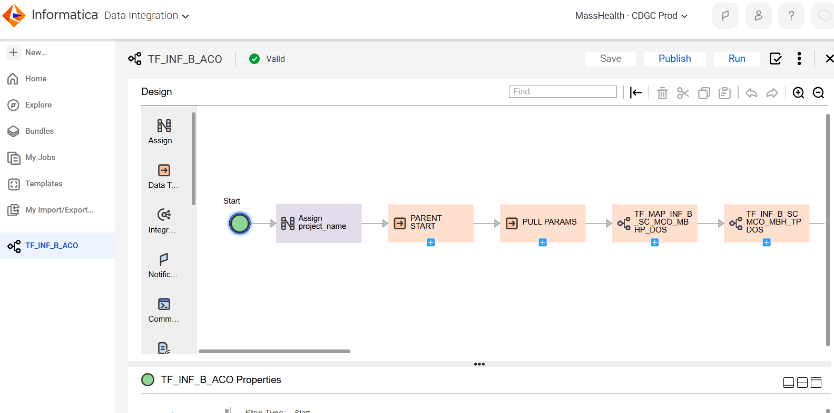
Click in the purple Assign project_name.
Select Assignments.
Replace the run date with the last day of the previous month. (After changing the date click on some white space outside the data to make sure it takes in the screen)

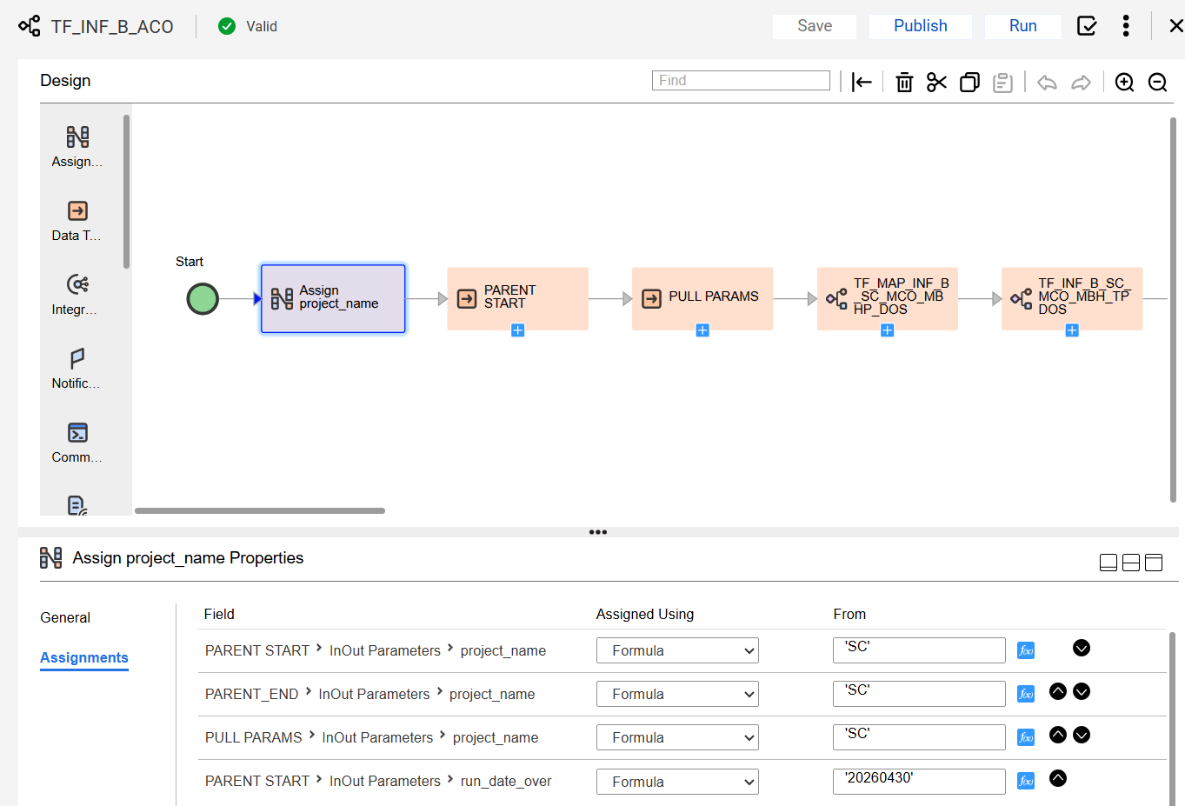

Click Publish.
And click Run.
Switch to My Jobs and watch the sub tasks. It should run without trouble.

SQL pre or post processing
As a follow up, or before running the job, log into Snowflake as DWDQ_RW_ROLE, MHTEAM.DWDQ. Check on the SQL_ERROR table and remove old run tables.
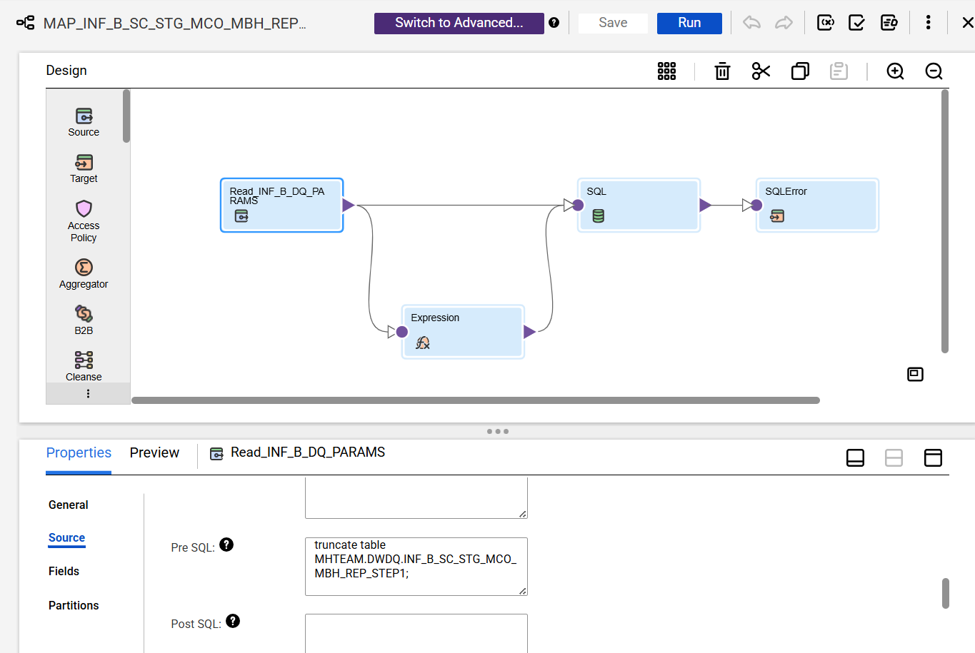

This is a SQL runner Mapping with an expression to convert the passed in date. The Truncate is in the pre SQL of the start block Read INF_B_DQ_PARAMS.

The SQL runner Mappings (just wrappers to run SQL (frequently with a TRUNCATE in the Pre SQL , in the start block – because Snowflake can’t run multiple steps in a SQL block (unlike Oracle?))) write SQL errors out to the table MHTEAM.DWDQ.INF_B_SQL_ERROR;
Informatica won’t see these errors, so it is good to look in this table to see if any SQL errors occurred.
And truncate it frequently to have less to look through – should be a lot of blank lines.

select * from MHTEAM.DWDQ.INF_B_SQL_ERROR;
truncate table MHTEAM.DWDQ.INF_B_SQL_ERROR;
( if you keep this IICS process and don’t move the SQL to some other platform: SNOWSQL, SAS: it would be nice to write the job name to the SQL_ERROR table (your prerogative))

[ Word of warning: Please stay away from the step2 snapshot and step3 tables until you have to change the ACO plans. These tables contain historical aggregate snapshots to support the sliding windows in the Completeness spreadsheet, that, due to the moving nature of the DW, really CAN NOT be reproduced. The logic behind these tables is involved.
MHTEAM.DWDQ.INF_B_SC_STG_MCO_MBH_REP_STEP2_SNAPSHOTS
MHTEAM.DWDQ.INF_B_SC_STG_MCO_MBH_REP_STEP3 ]

The jobs create a fixed set of tables from the front SQL scripts suffixed with MONYYY_MONYYYY.
It is good to get rid of the older ones occasionally, or each time. Use this SQL and change the dates:

drop table MHTEAM.DWDQ.INF_B_SC_MCO_MBHP_DOS_FEB2025_MAY2025;
drop table MHTEAM.DWDQ.INF_B_SC_MCO_MBHP_DOS_MAR2025_JUN2025;
drop table MHTEAM.DWDQ.INF_B_SC_MCO_MBHP_DOS_APR2025_JUL2025;
drop table MHTEAM.DWDQ.INF_B_SC_MCO_MBHP_DOS_MAY2025_AUG2025;

drop table MHTEAM.DWDQ.INF_B_SC_MCO_MBH_FRPDOS_FEB2025_MAY2025;
drop table MHTEAM.DWDQ.INF_B_SC_MCO_MBH_FRPDOS_MAR2025_JUN2025;
drop table MHTEAM.DWDQ.INF_B_SC_MCO_MBH_FRPDOS_APR2025_JUL2025;
drop table MHTEAM.DWDQ.INF_B_SC_MCO_MBH_FRPDOS_MAY2025_AUG2025;

drop table MHTEAM.DWDQ.INF_B_SC_MCO_MBH_PTPDOS_FEB2025_MAY2025;
drop table MHTEAM.DWDQ.INF_B_SC_MCO_MBH_PTPDOS_MAR2025_JUN2025;
drop table MHTEAM.DWDQ.INF_B_SC_MCO_MBH_PTPDOS_APR2025_JUL2025;
drop table MHTEAM.DWDQ.INF_B_SC_MCO_MBH_PTPDOS_MAY2025_AUG2025;

drop table MHTEAM.DWDQ.INF_B_SC_MCO_MBH_TPDOS_FEB2025_MAY2025;
drop table MHTEAM.DWDQ.INF_B_SC_MCO_MBH_TPDOS_MAR2025_JUN2025;
drop table MHTEAM.DWDQ.INF_B_SC_MCO_MBH_TPDOS_APR2025_JUL2025;
drop table MHTEAM.DWDQ.INF_B_SC_MCO_MBH_TPDOS_MAY2025_AUG2025;

drop table MHTEAM.DWDQ.INF_B_SC_MCO_MBH_REP_TRANSPOSE_FEB2025_MAY2025;
drop table MHTEAM.DWDQ.INF_B_SC_MCO_MBH_REP_TRANSPOSE_MAR2025_JUN2025;
drop table MHTEAM.DWDQ.INF_B_SC_MCO_MBH_REP_TRANSPOSE_APR2025_JUL2025;
drop table MHTEAM.DWDQ.INF_B_SC_MCO_MBH_REP_TRANSPOSE_MAY2025_AUG2025;

drop table MHTEAM.DWDQ.INF_B_SC_MCO_MBH_REP_STEP1_FEB2025_MAY2025;
drop table MHTEAM.DWDQ.INF_B_SC_MCO_MBH_REP_STEP1_MAR2025_JUN2025;
drop table MHTEAM.DWDQ.INF_B_SC_MCO_MBH_REP_STEP1_APR2025_JUL2025;
drop table MHTEAM.DWDQ.INF_B_SC_MCO_MBH_REP_STEP1_MAY2025_AUG2025;

drop table MHTEAM.DWDQ.INF_B_SC_MCO_MBH_REP_STEP2_FEB2025_MAY2025;
drop table MHTEAM.DWDQ.INF_B_SC_MCO_MBH_REP_STEP2_MAR2025_JUN2025;
drop table MHTEAM.DWDQ.INF_B_SC_MCO_MBH_REP_STEP2_APR2025_JUL2025;
drop table MHTEAM.DWDQ.INF_B_SC_MCO_MBH_REP_STEP2_MAY2025_AUG2025;

DIF Step
The BI back-end step, the DIF run.
Where ACO scorecards are sent to all the MCO plans, along with emails announcing their availability, I tend to run the DIF processes twice, once in Test, to make sure all is well and the second time for real.
And I have a check-off list, which I copy each month.

-----------------------------
But first, log onto the Prod Data Mastering server.
Open a File Explore window and navigate to D:\DataIntegration\EncounterScorecards The excel will write to \Excel and the logs to \Logs.

Open a PowerShell window
cd D:\DataIntegration\EncounterScorecards\Executables
use the command:
./runProdSnowGenerateEncounterDataScorecardMain.bat
If you are going to run both the Test and Prod runs (and even if you are just running Prod, I am leaving it set to Test, so it has to be switched.) Ask Calvin for assistance.

open the DIF Command Editor and load

Project: Encounter Scorecards
Deploy Stage: Prod-Snow
Job Server: DQ
Username: yours
Password: yours

Lines 10 and 11 toggle Test and Prod. Change to Prod by removing the X on line 10 “XGenerate encounter …” and putting a X on line 11 in front of Generate encounter …”

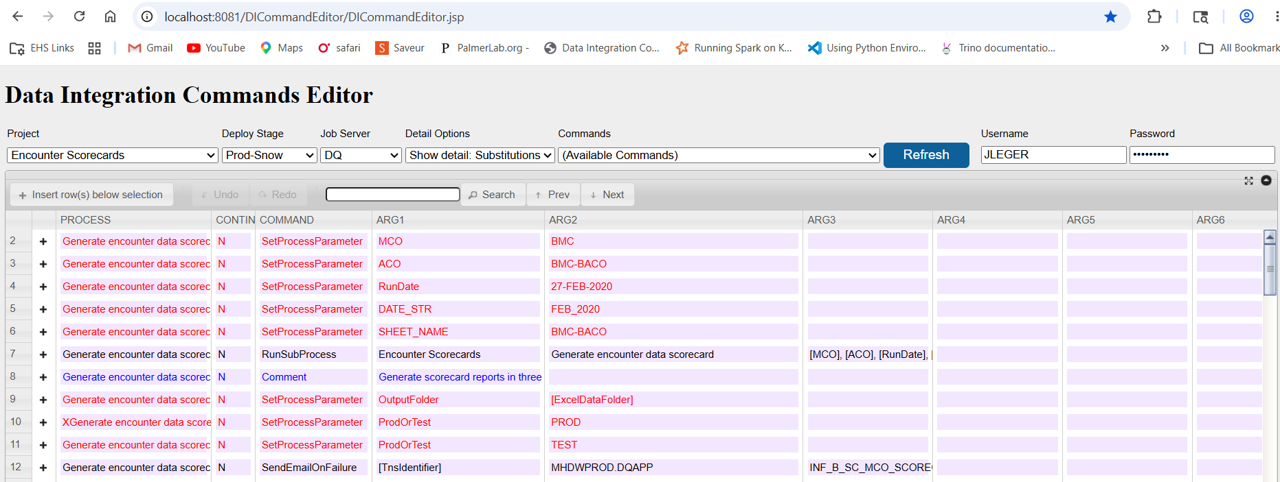
And reverse it back when done as mentioned in the Check off list.
-----------------------------
Check-off list (I use – to flag step was done):
Run ACO Dashboards
Email list file (if you need to edit the recipients – ask Calvin)
C:\Users\JLeger\fromDesktop\Downloads\Encounter_37_fields\ DQAPP_data_to_SF-3.sql – in ACO_Scorecard Git and Handoff folder.

--ACO scorecards
Remove older tables
--Clear INF_B_SQL_ERRORS
--Set run dates in Informatica
--Check INF_B_SQL_ERRORS
--Run Reports in Prod Test to check email ( set Test on and Prod off in DIF editor)
--Run the Test reports using CMD
D:\DataIntegration\EncounterScorecards\Executables>runDevGenerateEncounterDataScorecardMain.bat
--Check the log and rename to
rename EncounterScorecards_EncounterData.log EncounterScorecards_EncounterData_test_YYYYMMDD-1.log
--Delete the test zip files
--Switch Test to Prod in DIF Commands Editor – Job Server DQ
Run reports using CMD
D:\DataIntegration\EncounterScorecards\Executables>runDevGenerateEncounterDataScorecardMain.bat
--Check the log and rename to
rename EncounterScorecards_EncounterData.log EncounterScorecards_EncounterData_Prod_YYYYMMDD-1.log
--Switch Prod back to Test in DEV Commands Editor – Job Server DQ
--Check zip file in Prod SFTP
--Remove zip file in Test SFTP

-----------------------------

OC and SCO Detail

Running OC and SCO is similar to ACO. The OC and SCO scorecards are run for Bobby Roche to produce a quarterly finance report. Bobby merges the Scorecard data with financial data for an elaborate scorecard. The OC and SCO scorecards are also sent to Augustus Matekole.
The ACO runs monthly with (not visible) a 5 month look back and 3 month data range based on DOS. In other words, ACO skips the most recent 5 months and reports on 3 months DOS (the score card actually shows sliding windows, but that magic is done in the step 2 snapshot and step 3 processing.) It is not rerun even though it has extra processing to allow snapshots.

SCO reports and OC reports are the same, just run against different plans. They run separately at the same time, quarterly, two months after the close of the quarter, with 2 month look backs and 3- or 12-month data ranges. In other words, Bobby request reruns each quarter after the first quarter with annual runs in March (Run Date 2/28 or 29) and June (Run Date 5/31).
So, the schedule is:

Early March (Run Date 2/28 or 29)
3 month data, look back 2, 5, 8, 11 (previous year 4th quarter, 3rd quarter, 2nd quarter, 1st quarter)
12 month data look back 2 (previous year)
For each of these runs the DIF is run separately.

Early June (Run Date 5/31)
3 month data, look back 2 (this year, 1st quarter)
12 month data look back 5 (previous year)

Early September (Run Date 8/31)
3 month data, look back 2, 5 (this year, 2nd quarter, 1st quarter)

Early December (Run Date 11/30)
3 month data, look back 2, 5, 8 (this year, 3rd quarter, 2nd quarter, 1st quarter)

SQL pre-step

For SCO and OC, where the tables are rerunning the previous quarters, I clear all of the history and truncate some of the tables (though should not be necessary.)
Change dates and make multiple copies as necessary:

select * from MHTEAM.DWDQ.INF_B_SQL_ERROR;

truncate table MHTEAM.DWDQ.INF_B_SQL_ERROR;
drop table MHTEAM.DWDQ.INF_B_SC_SCO_DOS_OCT2025_DEC2025;
drop table MHTEAM.DWDQ.INF_B_SC_SCO_TOT_REX_OCT2025_DEC2025;
drop table MHTEAM.DWDQ.INF_B_SC_SCO_FIELD_REX_OCT2025_DEC2025;
drop table MHTEAM.DWDQ.INF_B_SC_SCO_PERCENTS_OCT2025_DEC2025;
drop table MHTEAM.DWDQ.INF_B_SC_SCO_TRANSPOSE1_OCT2025_DEC2025;
drop table MHTEAM.DWDQ.INF_B_SC_SCO_TRANSPOSE2_OCT2025_DEC2025;
drop table MHTEAM.DWDQ.INF_B_SC_SCO_TRANSPOSE21_OCT2025_DEC2025;
drop table MHTEAM.DWDQ.INF_B_SC_SCO_TRANSPOSE22_OCT2025_DEC2025;
drop table MHTEAM.DWDQ.INF_B_SC_SCO_REP_STEP1_OCT2025_DEC2025;
drop table MHTEAM.DWDQ.INF_B_SC_SCO_REP_STEP2_OCT2025_DEC2025;

truncate table MHTEAM.DWDQ.INF_B_SC_STG_SCO_PROVIDER;
truncate table MHTEAM.DWDQ.INF_B_SC_STG_SCO_PROVIDER_MISSING_IDS;
truncate table MHTEAM.DWDQ.INF_B_SC_STG_SCO_PROVIDER_STATS;
truncate table MHTEAM.DWDQ.INF_B_SC_STG_SCO_FAILS;
truncate table MHTEAM.DWDQ.INF_B_SC_STG_SCO_REP_STEP2;

truncate table MHTEAM.DWDQ.INF_B_SQL_ERROR;
drop table MHTEAM.DWDQ.INF_B_SC_SCO_DOS_JAN2025_DEC2025;
drop table MHTEAM.DWDQ.INF_B_SC_SCO_TOT_REX_JAN2025_DEC2025;
drop table MHTEAM.DWDQ.INF_B_SC_SCO_FIELD_REX_JAN2025_DEC2025;
drop table MHTEAM.DWDQ.INF_B_SC_SCO_PERCENTS_JAN2025_DEC2025;
drop table MHTEAM.DWDQ.INF_B_SC_SCO_TRANSPOSE1_JAN2025_DEC2025;
drop table MHTEAM.DWDQ.INF_B_SC_SCO_TRANSPOSE2_JAN2025_DEC2025;
drop table MHTEAM.DWDQ.INF_B_SC_SCO_TRANSPOSE21_JAN2025_DEC2025;
drop table MHTEAM.DWDQ.INF_B_SC_SCO_TRANSPOSE22_JAN2025_DEC2025;
drop table MHTEAM.DWDQ.INF_B_SC_SCO_REP_STEP1_JAN2025_DEC2025;
drop table MHTEAM.DWDQ.INF_B_SC_SCO_REP_STEP2_JAN2025_DEC2025;

truncate table MHTEAM.DWDQ.INF_B_SC_STG_SCO_PROVIDER;
truncate table MHTEAM.DWDQ.INF_B_SC_STG_SCO_PROVIDER_MISSING_IDS;
truncate table MHTEAM.DWDQ.INF_B_SC_STG_SCO_PROVIDER_STATS;
truncate table MHTEAM.DWDQ.INF_B_SC_STG_SCO_FAILS;
truncate table MHTEAM.DWDQ.INF_B_SC_STG_SCO_REP_STEP2;

Informatica Step
For each SCO and OC run, log onto the CDGC Prod IICS Data Integration. Find z_jleger/OC Scorecard/TF_INF_B_OC_WO_MAPPLETS and z_jleger/OC Scorecard/TF_INF_B_SCO_WO_MAPPLETS.
(_WO MAPPLETS – I turned off the mapplet processing and just use the SQL results pushed into the tables the Mapplets populated. The Mapplets and SQL produce the same data. ACO still runs both.)
And there are no scarry aggregate historical snapshots in OC and SCO.

For both the SCO and OC individually, using parameters from the schedule outline above:
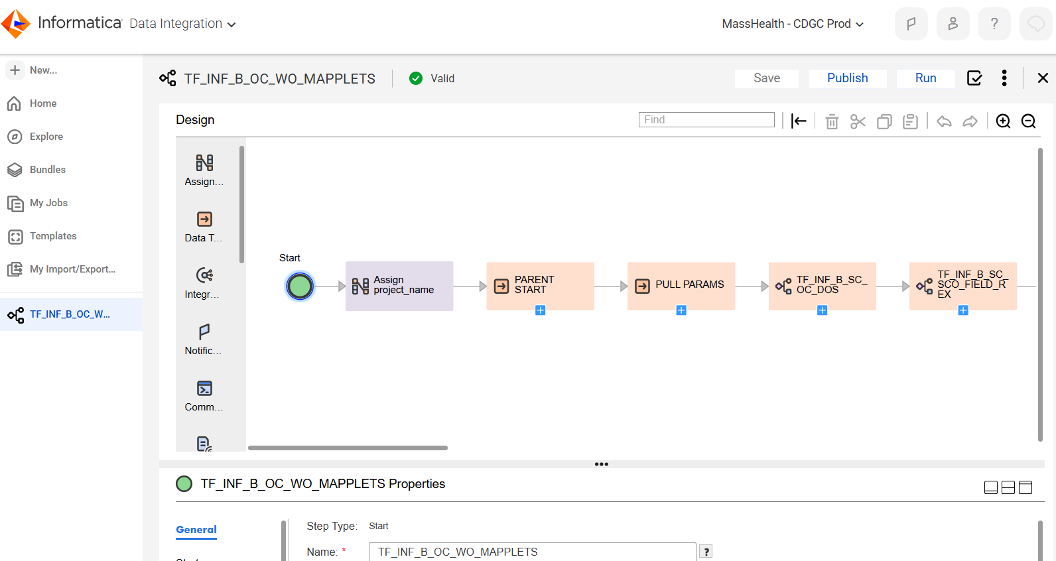
Click in the purple Assign project_name.
Select Assignments.
Replace the run date with the last day of the previous month. Replace the max_offset_mnths_over with 2,5,8, or 11. Replace the run_mnths_over with 3 or 12.
(Again, after changing data in the boxes, click on some white space outside the data to make sure it takes in the screen)

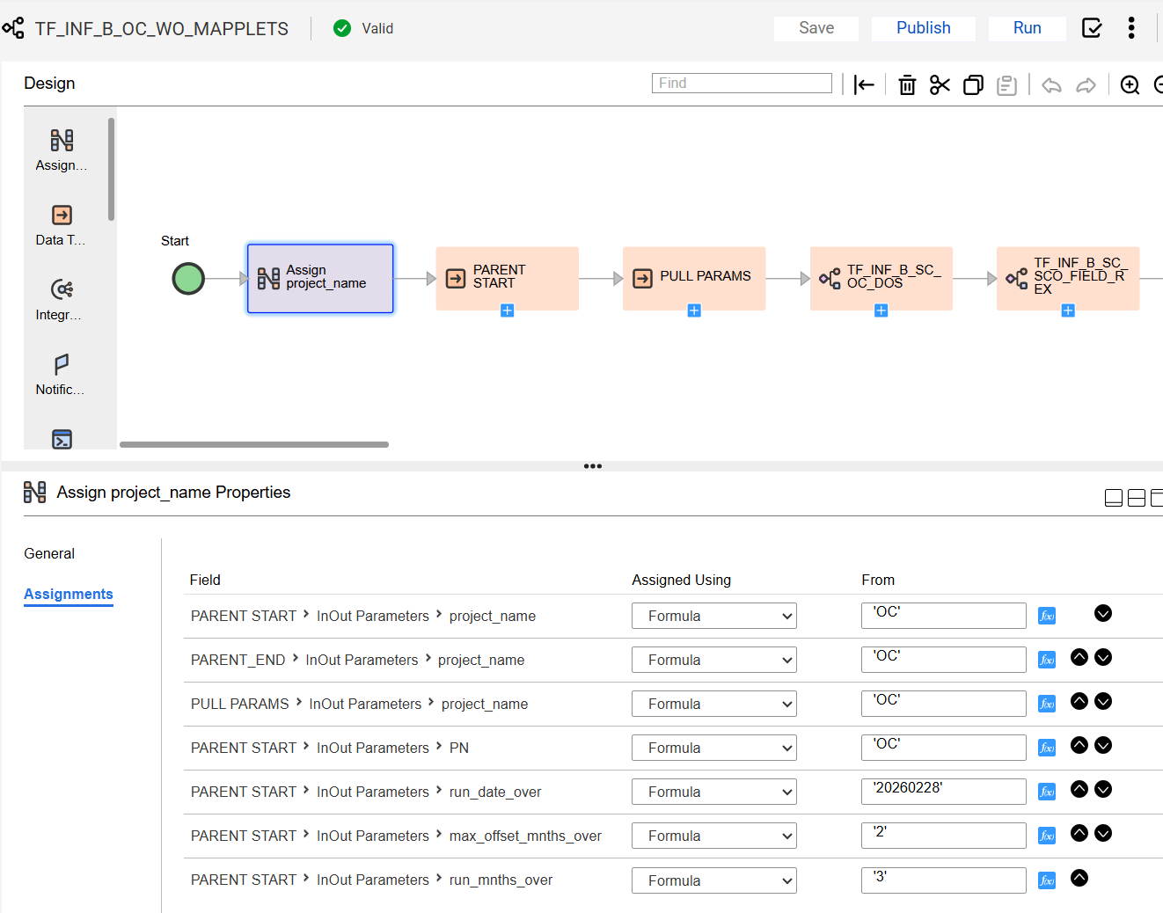

Click Publish.
And click Run.
Switch to My Jobs and watch the sub tasks. It should run without trouble. Check INF_B_SQL_ERROR for SQL errors.

DIF Step
SCO and OC are not sent directly so DIF processing is a lot easier, there is just a lot of it.
There is no switching back and forth between Test and Prod.

After each OC and SCO combination Informatica are run:
-----------------------------
Log onto the Prod Data Mastering server.
Open a File Explore window and navigate to D:\DataIntegration\EncounterScorecards The excel will write to \Excel and the logs to \Logs.

Open a PowerShell window
cd D:\DataIntegration\EncounterScorecards\Executables
use the commands:
./runProdSnowGenerateOCSpreadsheetMain.bat
./runProdSnowGenerateSCOSpreadsheetMain.bat
-----------------------------

--Run the reports using CMD
./runProdSnowGenerateOCSpreadsheetMain.bat
./runProdSnowGenerateSCOSpreadsheetMain.bat

--Check the logs and rename to
rename EncounterScorecards_OC_Q1_20220901.log
EncounterScorecards_OC_Q1 to 4 or CYXX_YYYYMMDD-1.log

rename EncounterScorecards_SCO_Q1_20220901.log
EncounterScorecards_SCO_Q1 to 4 or CYXX_YYYYMMDD-1.log

Don’t Delete the zip files

-----------------------------
The spreadsheets will be mailed to you (you will have to add your name to the mail list.) They are not directly sent to Bobby or Augustus. Save them in a folder in home\ExcelDataFolder (create this) and when all of the spreadsheets have been run zip the folder and send it to Bobby and Augustus.

The IICS Migration 2024

The IICS upgrade was a migration of the Informatica extraction back end for the ACO, SCO and OC scorecards and Data Anomaly from on-prem Informatica IDQ to IICS CDI. Migration was necessitated by the retirement of the out of support on-prem Informatica Powercenter and IDQ.

The migration was done by re-writing the IDQ visual code into IICS CDI visual code, but for the most part it was a cut and paste of the logic in IDQ to CDI. Please refer to the previous versions of this documentation on migrating Nicole’s SAS SQL to Informatica including running both a copy of the original SQL and a migrated copy to Mapplets logic via the IDQ Analyst Rule Specification interface. In IDQ the logic was specified as Rule Specifications. As a final step in the Rule Specification construction the Rule Specification was saved in Mapplet form, using Mapplet logic. Where IICS CDQ does not have the close tie between Rule Specifications and Mapplets (in CDQ, Rule Specifications are run directly in Mappings but not migrated to Mapplets), the IDQ Mapplet logic was migrated to IICS CDI Mapplets, skipping the Rule Specification step. Otherwise, the Mapping processing is nearly identical between IDQ and IICS.
What did change is the run framework. In IDQ the jobs are controlled by Linux scripts (borrowed from PDM processing.) The Linux scripts set the params table values, in some cases write parameter files, and call the Apps in IDQ. In IDQ Mapplets are in Mappings, Mappings are called by workflows, workflows are published to the IDQ server as Apps and the Apps are called from Linux using the INFCMD Informatica CLI command. The Linux scripts are run by cron. In IICS CDI, Mapplets run in Mappings, Mappings are wrapped in Mapping Tasks, and Tasks are called by Taskflows. We are not using Linux currently to do the calling; the Linux steps are performed from an outer Taskflow which sets the parameters and the param table. At this time, the outer Taskflows are being triggered manually but will be called by the IICS scheduler or will be called from a Linux environment TBD.
As discussed in more detail in the previous documentation, there are two controlling tables for processing the Scorecard tasks, INF_B_DQ_PARAMS and INF_B_DQ_LOAD_BATCH. Params holds sets of key value pairs parameters for controlling the run dates and the time frame parameters. Load batch is an audit table of how the jobs ran. In IDQ Load Batch was also used for delaying steps in Linux to wait for IDQ processing to be completed.
The Scorecards and DA run in the CDGC Informatica orgs, primarily against the DQ_SVC_ACCT Snowflake schemas and the DQ schemas in Oracle.
The outer Taskflows for the scorecards and DA are z_leger/Data Anomaly Scorecard/TF_INF_B_DA,
ACO Scorecard/TF_INF_B_ACO, SCO Scorecard/TF_INF_B_SCO and OC Scorecard/TF_INF_B_OC. Processing in the four Taskflows is quite similar, with an attempt at object reuse through the Taskflows in the order listed. Unfortunately, Informatica parameter processing is more difficult than desired and there is more duplication of code than was hoped for.
Looking into the ACO scorecard Taskflow:

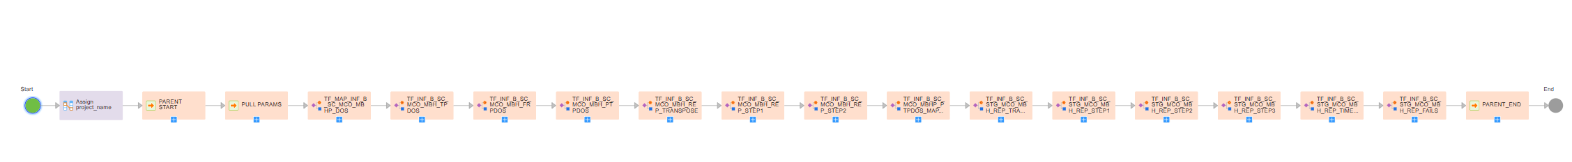

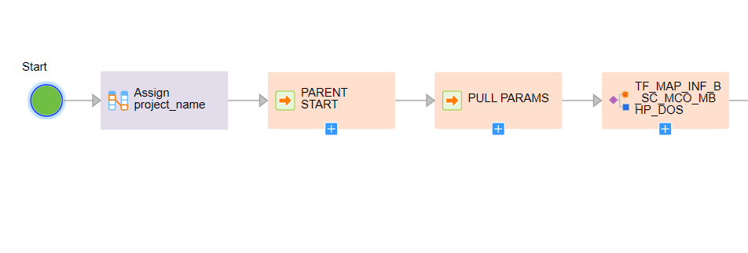
The processing starts with setting parameters (which may be passed in the future from CLI or REST)
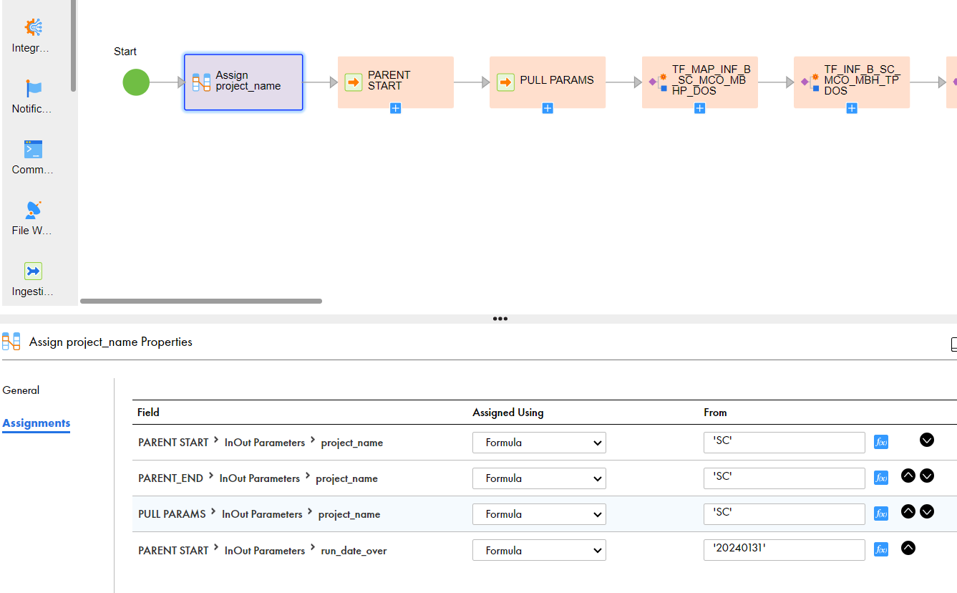
The Run Date can be set manually or if left as 19000101 will be automatically set to the date the TF is run (it is really necessary to set it since the jobs a run several days after the end of month and the date has to be the endo of the previous month.)
In SCO and OC, the durations are also set in the assignment step, where these Taskflows are frequently rerun. Again, these params may be set in outside calls in the future.

The M_ACO_PARENT_BATCH_START replicates batch start processing from the Linux scripts into a mapping and writes the Parent record – a tracker for the entire job and to which the child records refer:
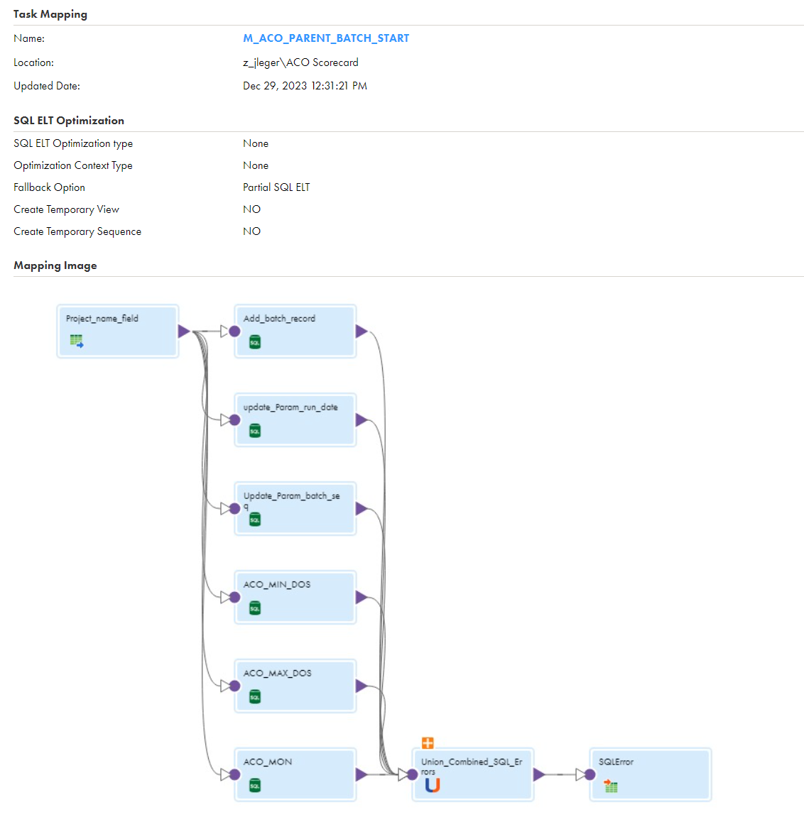
The logic:
CASE WHEN '~RUN_DATE_OVER~' != '19000101' THEN TO_DATE('~RUN_DATE_OVER~','YYYYMMDD') ELSE CURRENT_DATE END,
In Add_batch_record sets the run date to the passed in date or the current date. Again, a holdover from Linux.

The SQLError table is a catch all table from running SQL transformations and is very useful for catching SQL errors. It is a holdover from IDQ.

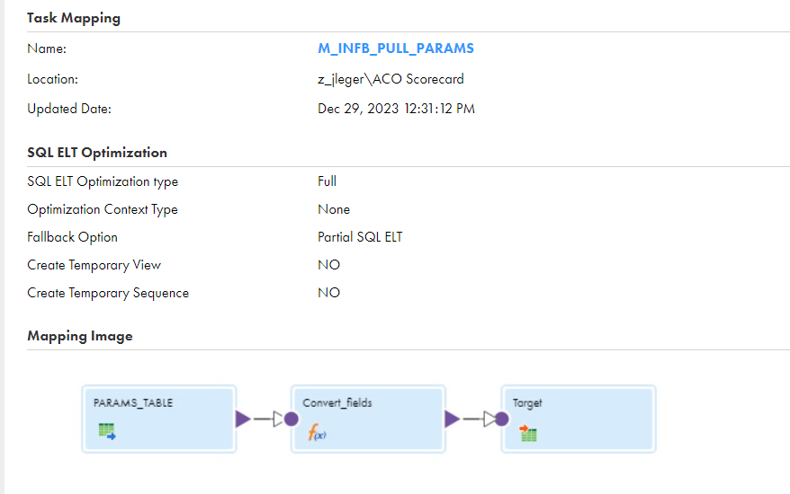
The M_INFB_PULL_PARAMS mapping also replicates Linux processing and uses the Convert fields expression to pass parameters back up into the TF_INF_B_ACO Taskflow.

The first real work is done in TF_MAP_INF_B_SC_MCO_MBHP_DOS, which pulls a snapshot of records from the NW_B_ENCOUNTER_HISTORY table and support tables into a staging table.
Most of the mapping tasks are wrapped with their own start and end Load batch tracking records, so they have a M_INF_B_DQ_LOAD_BATCH_START_Task and END_Task to with the records. Where this means three tasks to run the single task, the tasks are thus wrapped in their own Taskflow. This is done throughout.

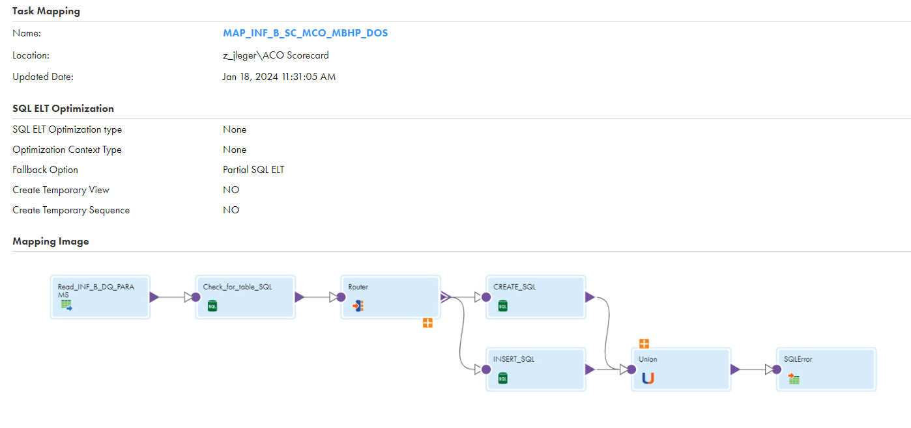
The DOS – Date of Service based pulls are run as CTAS or Inserts to create a DOS table with a suffix of the date in the format MHTEAM.DWDQ.INF_B_SC_MCO_MBHP_DOS_MAY2023_AUG2023. This is holdover from Nicole’s processing and is also done for FRPDOS, TPDOS, PTPDOS and following steps through STEP2. This may seem redundant with the following Mapplet based processing, it is, but it is very useful for validating the mapplets, and would somewhat easily allow for falling back to Nicole’s SA based processing, if needed, for the first part of the processing – pre the Master step (which I have done for SCO and OC in 2026.)
The SQL CTAS or Insert allowed for multiple run dates for the same DOS so as to keep multiple reruns, which has proven to be not useful – usually keep just one run date per DOS. Keep in mind, for the ACO processing, the final spreadsheet windows across seven Run Dates and four DOS. See the discussion in the older versions of the documentation. And yes, we are just using Informatica as a SQL runner (as Jeff Robertson said Fidelity would do to just run Oracle SPs.)
Moving along through TF_INF_B_ACO, the processing is pretty much the same until TF_INF_B_SC_MCO_MBHP_PTPDOS_MAPPLET which runs the mapplets.
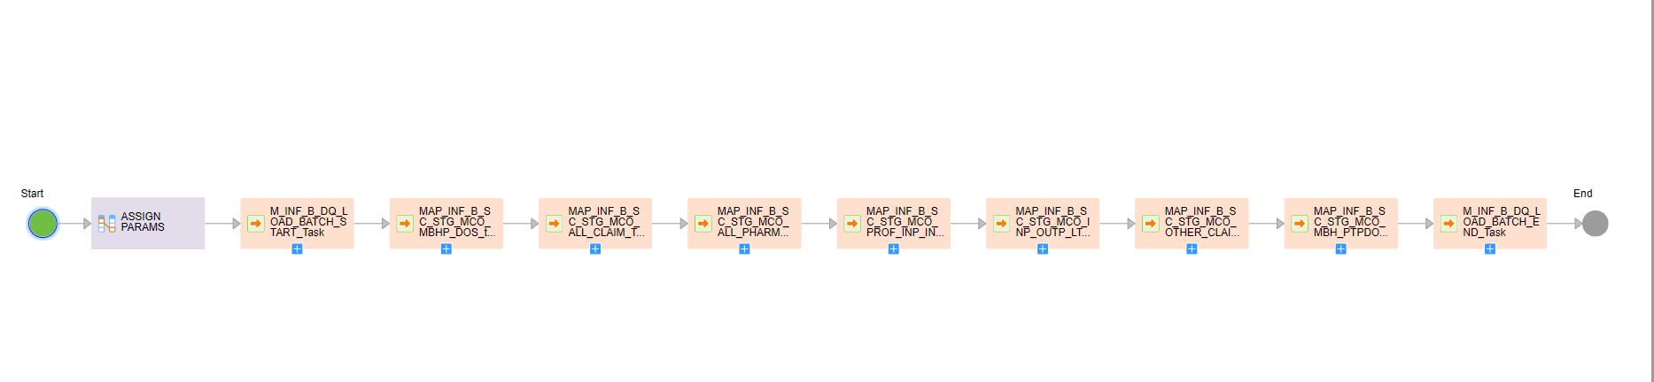
The Taskflow starts with an assignment transformation and has start and end batch steps. MAP_INF_B_SC_STG_MCO_MBHP_DOS_task is another SQL mapping that makes a STG copy of the base table.

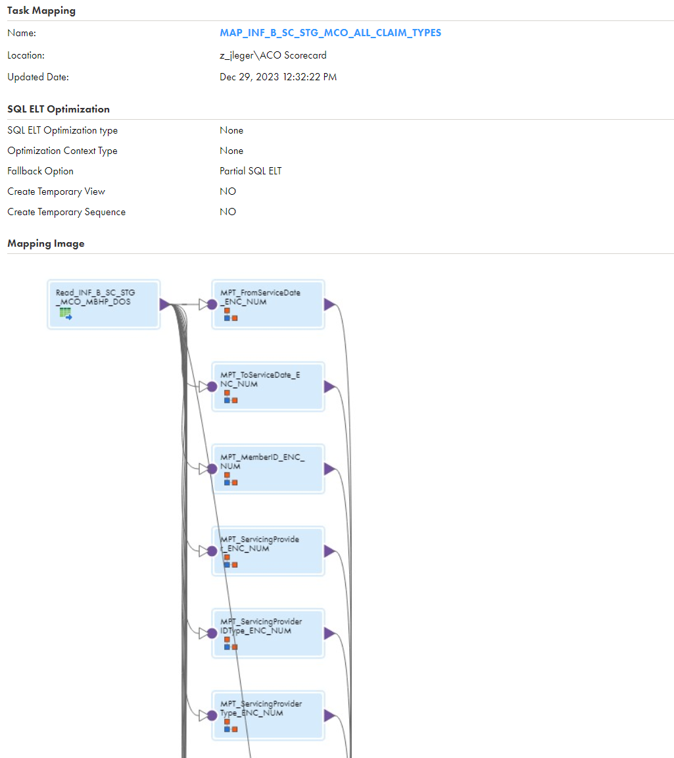

MAP_INF_B_SC_STG_MCO_ALL_CLAIM_TYPES along with the following mappings cut the mapplets into groups of not more than 20 mapplets (see more detail in the older documentation) This mapping runs maplets of the group all claim type – in other words the sum of the records are divided by the total record count. The other mappings group maplets with subsets of the overall records – INPAT AND OUTPAT and the likes. Each record in the STG base table is written into additional STG tables that track 1 or 0 for each of the measures in the mapping.
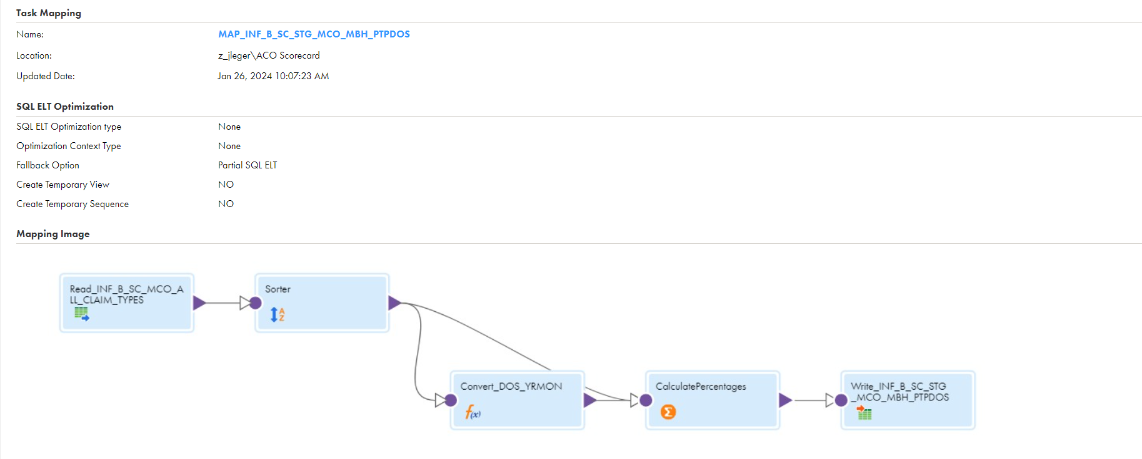
MAP_INF_B_SC_STG_MCO_MBH_PTPDOS joins the STG base table with additional tables, sorts the results

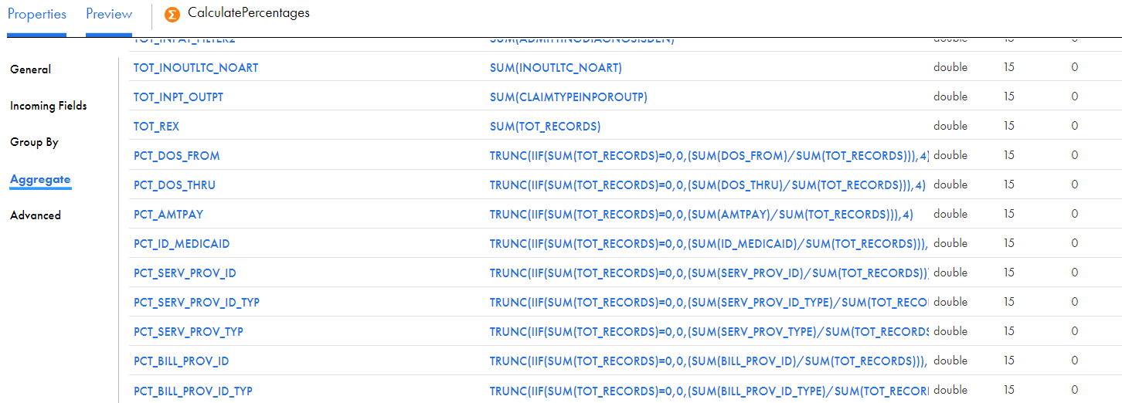

and a large aggregate transformation sums the 1 and 0’s into numerators and denominators and divides them to generate the percentages. See the older documentation.

After the mapplets Taskflow, TF_INF_B_ACO runs more SQL Taskflows matching the ones done for Nicole’s SQL based processing and adds a STEP2_Snapshot and STEP3 to stage for the Date Integration Framework spreadsheet generator. (see the older documentation for these two Steps, they are quite complicated to do that multiple windowing.)
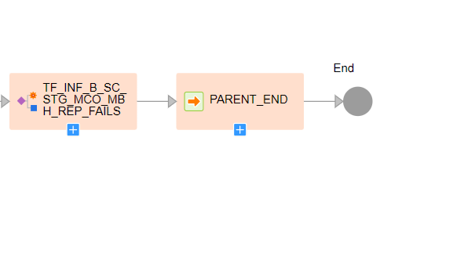
TF_INF_B_ACO runs Fails processing to pull out examples of failure records and finally closes out the parent batch record.
As of this writing, the DIF still runs against Oracle so there are extra workflows like TF_MAP_ACO_SF_TO_ORC to migrate the necessary results back to Oracle before running the DIF.
(Not used any more. Used to have to write back to Oracle for the DIF.)
To run these workflows, I usually clear out the STG tables in Snowflake, except for the lookup tables, change the run dates in the assignments, save and publish the TF_INF_B_ACO , SCO , OC. Run them (see how to run instructions above. Please be very careful with the STEP2_SNAPSHOT and STEP3 in ACO, those contain 7 runs of data and are quite hard (impossible) to reproduce (see the older documentation.) And don’t clear the look-up tables. When doing multiple reruns of SCO and OC, usually drop the older Nicole _MonYEAR_MonYEAR tables (see how to run SCO and OC above).

Good luck

