COMMONWEALTH OF MASSACHUSETTS
EXECUTIVE OFFICE OF HEALTH AND HUMAN SERVICES



Data Warehouse Project

Informatica Data Quality

Data Scorecard Monitoring

Technical Specification for IICS Adendum

Version 1.6[Status]

Date: [Publish Date]

1. Naming Standards and Programming Discussions 4
1.1. Object Naming Convention 4
1.2. Programing Discussions 4
2. Scorecard Review 5
3. Nicole’s SAS and SQL 5
4. Work to be done in this project 6

The IICS upgrade is a migration of the Informatica extraction back end for the ACO, SCO and OC scorecards and Data Anomaly extraction from on-prem Informatica IDQ to IICS CDI. The migration was necessitated by the retirement of the out of support on-prem Informatica Powercenter and IDQ.

The migration was done by re-writing the IDQ visual code into IICS CDI visual code, but for the most part it was a cut and paste of the logic in IDQ to CDI. Please refer to the previous documentation of migrating Nicole’s SAS SQL to Informatica including running both a copy of the original SQL and a migrated copy to Mapplets logic via the IDQ Analyst Rule Specification interface. In IDQ the logic was specified as Rule Specifications and as a final step in the Rule Specification construction was save as a Rule in Mapplet form, using Mapplet logic. Where IICS CDQ does not have the close tie between Rule Specifications and Mapplets (Rule Specifications are run directly in Mappings but not migrated to Mapplets), the IDQ Mapplet logic was migrated to IICS CDI Mapplets, skipping the Rule Specification step. Otherwise the Mapping processing is nearly identical between IDQ and IICS.

What did change is the run framework. In IDQ the jobs are controlled by Linux scripts (borrowed from PDM processing.) The Linux scripts set the params table values, in some cases write parameter files, and call the Apps in IDQ. In IDQ Mapplets are in Mappings, Mappings are called by workflows, workflows are published to the IDQ server as Apps and the Apps are called from Linux using the INFCMD Informatica CLI command. The Linux scripts are run by cron. In IICS CDI, Mapplets run in Mappings, Mappings are wrapped in Tasks, and Tasks are called by Taskflows. We are not using Linux currently to do the calling; the Linux steps are performed from an outer Taskflow which sets the parameters and the param table. At this time, the outer Taskflows are being triggered manually but will be called by the IICS scheduler or will be called from a Linux environment TBD.
As discussed in more detail in the previous documentation, there are two controlling tables for processing the Scorecard tasks, INF_B_DQ_PARAMS and INF_B_DQ_LOAD_BATCH. Params holds sets of key value pairs parameters for controlling the run dates and the time frame parameters. Load batch is a audit table of how the jobs ran. In IDQ Load Batch was also used for delaying steps in Linux to wait for IDQ processing to complete.
The Scorecards and DA run in the CDGC Informatica orgs, primarily against the DQ_SVC_ACCT Snowflake schemas and the DQ schemas in Oracle.
The outer Taskflows for the scorecards and DA are z_leger/Data Anomaly Scorecard/TF_INF_B_DA,
ACO Scorecard/TF_INF_B_ACO, SCO Scorecard/TF_INF_B_SCO and OC Scorecard/TF_INF_B_OC. Processing in the four Taskflows is quite similar with an attempt at object reuse through the Taskflows in the order listed. Unfortunately, Informatica parameter processing is more difficult than desired and there is more duplication of code than hoped for.
Looking into the ACO scorecard Taskflow:

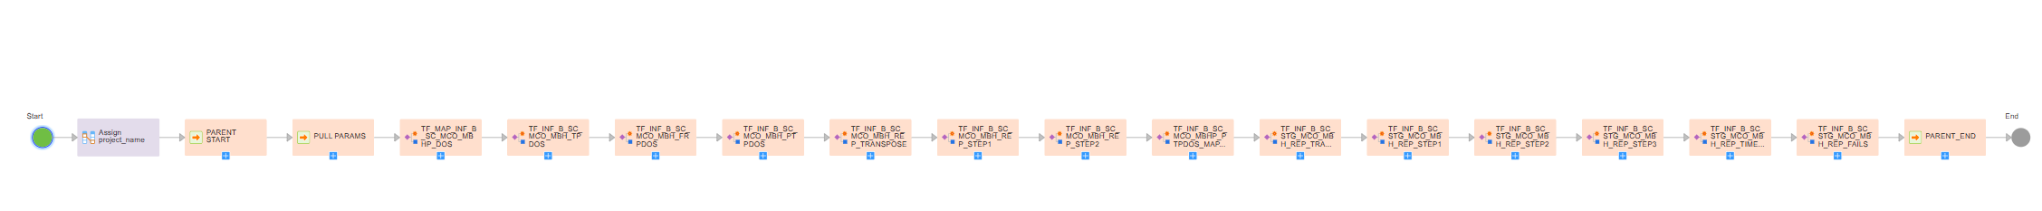

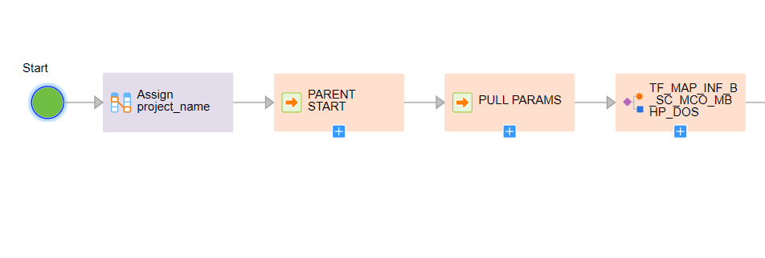
The processing starts with setting parameters (which may be passed in the future from CLI or REST)
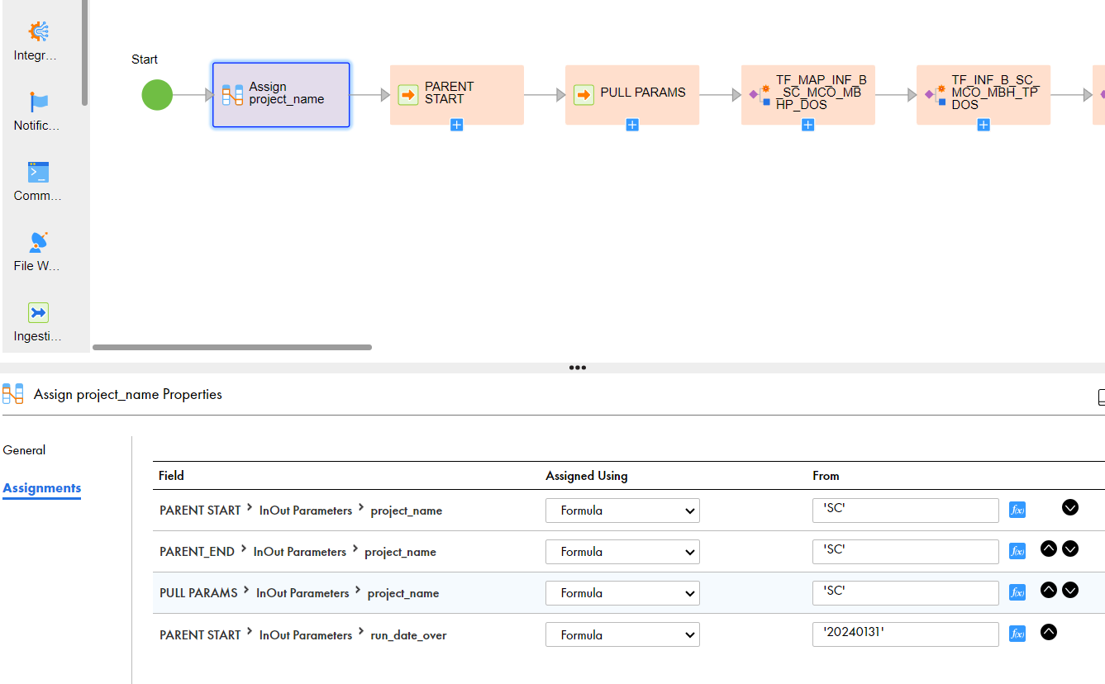
The Run Date can be set manually or if left as 19000101 will be automatically set to the date the TF is run.
In SCO and OC, the durations are also set in the assignment step, where these Taskflows are frequently rerun. Again, these params may be set in outside calls in the future.

The M_ACO_PARENT_BATCH_START replicates batch start processing from the Linux scripts into a mapping and writes the Parent record – a tracker for the entire job and to which the child records refer:
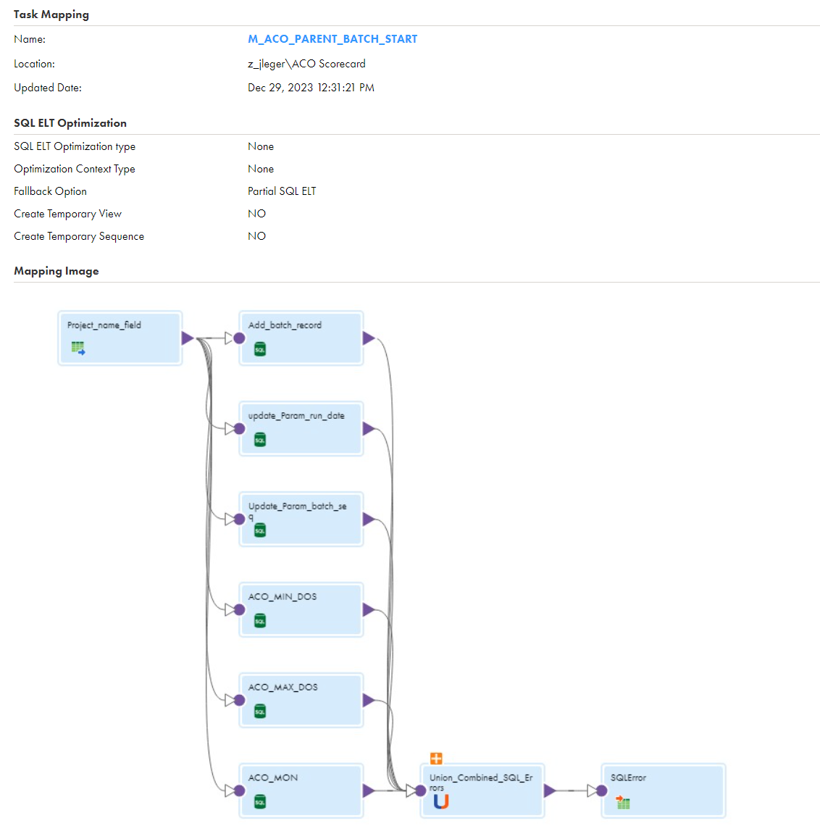
The logic:
CASE WHEN '~RUN_DATE_OVER~' != '19000101' THEN TO_DATE('~RUN_DATE_OVER~','YYYYMMDD') ELSE CURRENT_DATE END,
In Add_batch_record sets the run date to the passed in date or the current date. Again a hold over from Linux.

The SQLError table is a catch all table from running SQL transformations and is very useful for catching SQL errors. It is a holdover from IDQ.

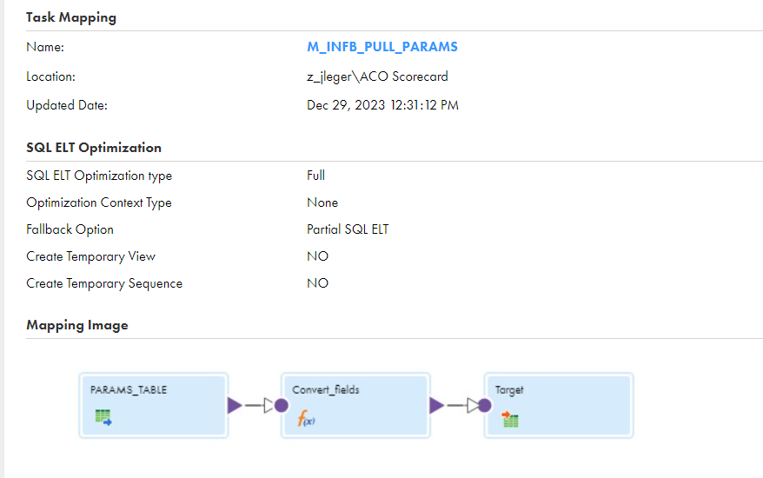
The M_INFB_PULL_PARAMS mapping also replicates Linux processing and uses the Convert fields expression to pass parameters back up into the TF_INF_B_ACO Taskflow.

The first real work is done in TF_MAP_INF_B_SC_MCO_MBHP_DOS, which pulls a snapshot of records from the NW_B_ENCOUNTER_HISTORY table and support tables into a staging table.
Most of the mapping tasks are wrapped with their own start and end Load batch tracking records, so the have a M_INF_B_DQ_LOAD_BATCH_START_Task and END_Task to with the records. Where this means three tasks to run the single task, the tasks are thus wrapped in their own Taskflow. This is down throughout.

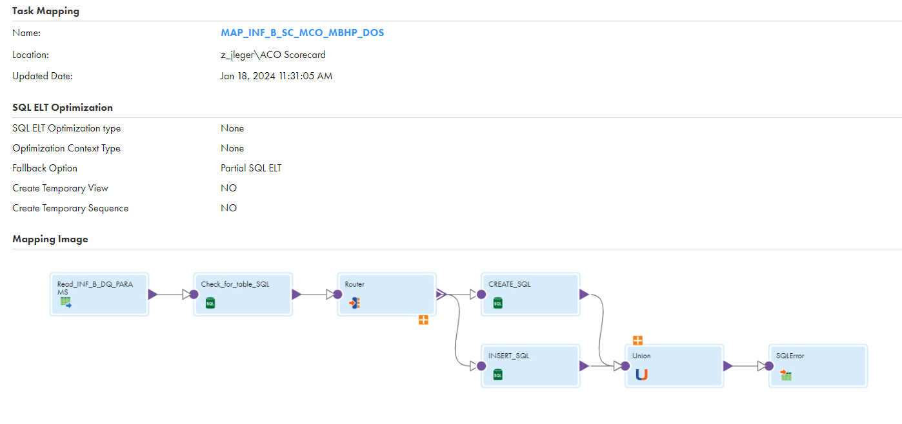
The DOS – Date of Service based pulls are run as CTAS or Inserts to create a DOS table with a suffix of the date in the format MHTEAM.DWDQ.INF_B_SC_MCO_MBHP_DOS_MAY2023_AUG2023. This is holdover from Nicole’s processing and is also done for FRPDOS, TPDOS, PTPDOS and following steps through STEP2. This may seem redundant with the following Mapplet based processing, it is, but it is very useful for validating the mapplets, and would somewhat easily allow for falling back to Nicole’s SA based processing, if needed, for the first part of the processing – pre the Master step.
The SQL CTAS or Insert allowed for multiple run dates for the same DOS so as to keep multiple reruns, which has proven to be not so useful – usually keep just one run date per DOS. Keep in mind, for the ACO processing, the final spreadsheet windows across seven run_dates and four DOS. See the discussion in the older versions of the documentation. And yes, we are just using Informatica as a SQL runner (as Jeff Robertson said Fidelity would do to just run Oracle SPs.)
Moving along through TF_INF_B_ACO, the processing is pretty much the same until TF_INF_B_SC_MCO_MBHP_PTPDOS_MAPPLET which runs the mapplets.
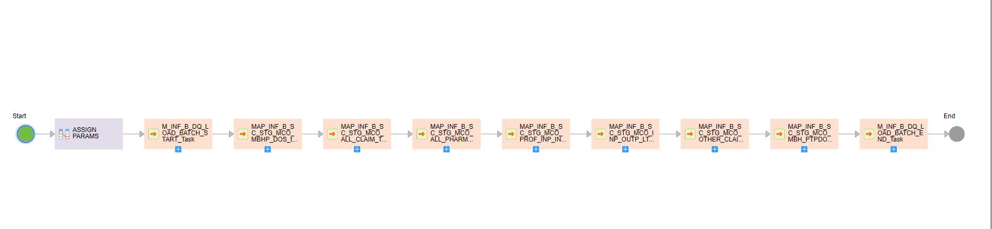
The Taskflow starts with an assignment transformation and has start and end batch steps. MAP_INF_B_SC_STG_MCO_MBHP_DOS_task is another SQL mapping that makes a STG copy of the base table.

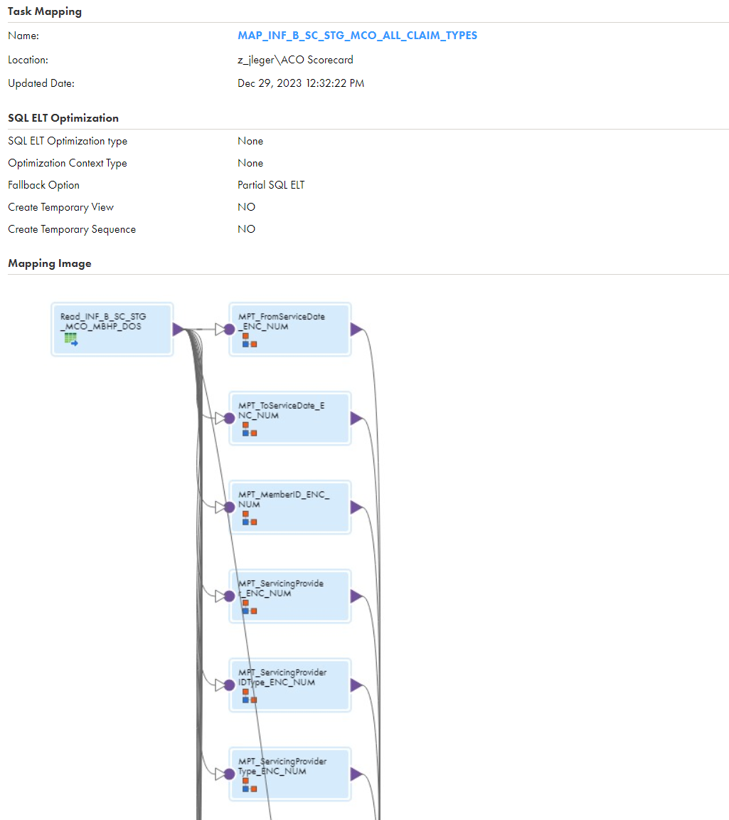

MAP_INF_B_SC_STG_MCO_ALL_CLAIM_TYPES along with the following mappings cut the mapplets into groups of not more than 20 mapplets (see more detail in the older documentation) This mapping runs mappings of the group all claim type – in other words the sum of the records are divided by the total record count. The other mappings group mapplets with subsets of the overall records – INPAT AND OUTPAT and the likes. Each record in the STG base table is written into additional STG tables that track 1 or 0 for each of the measures in the mapping.
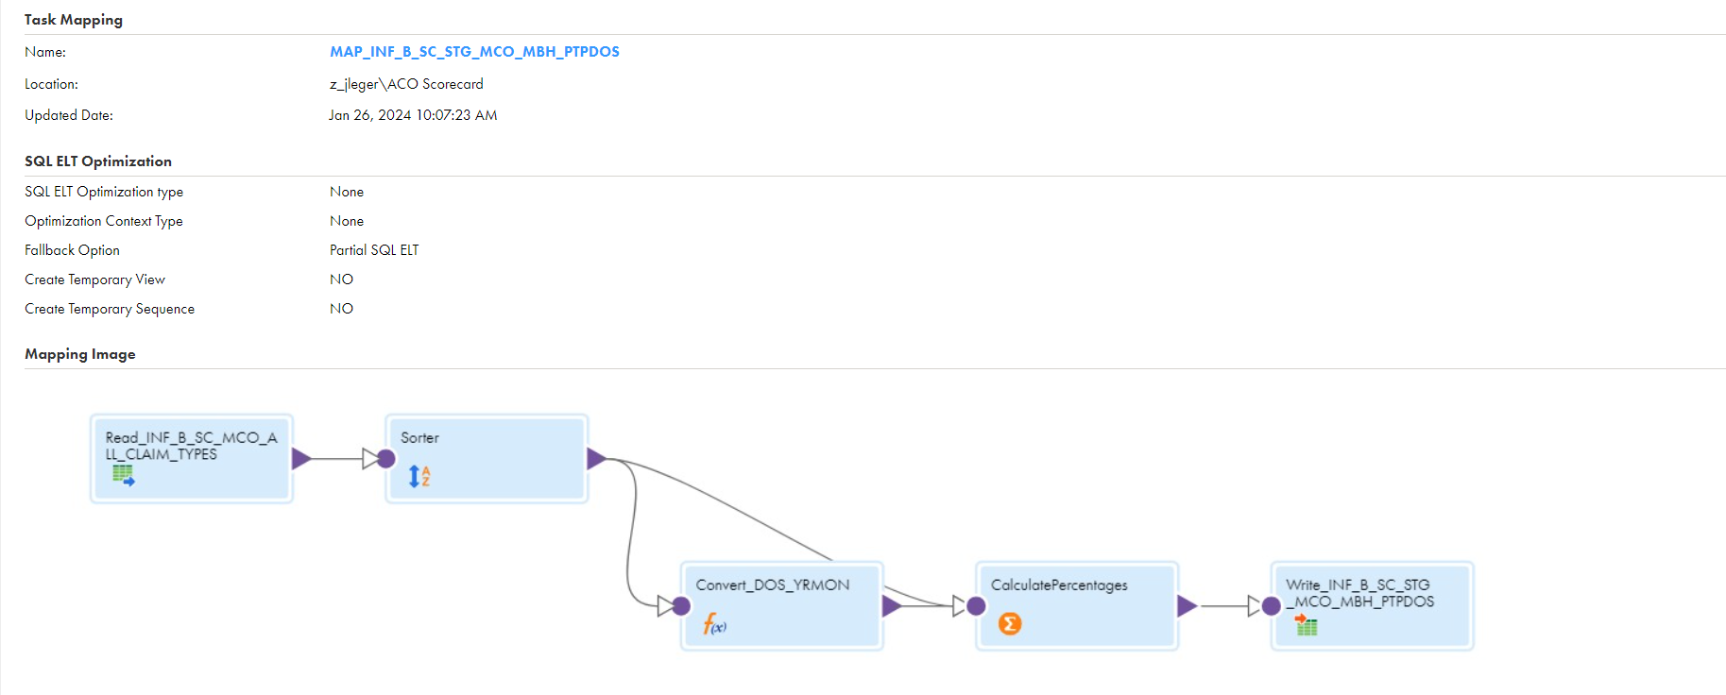
MAP_INF_B_SC_STG_MCO_MBH_PTPDOS joins the STG base table with additional tables, sorts the results

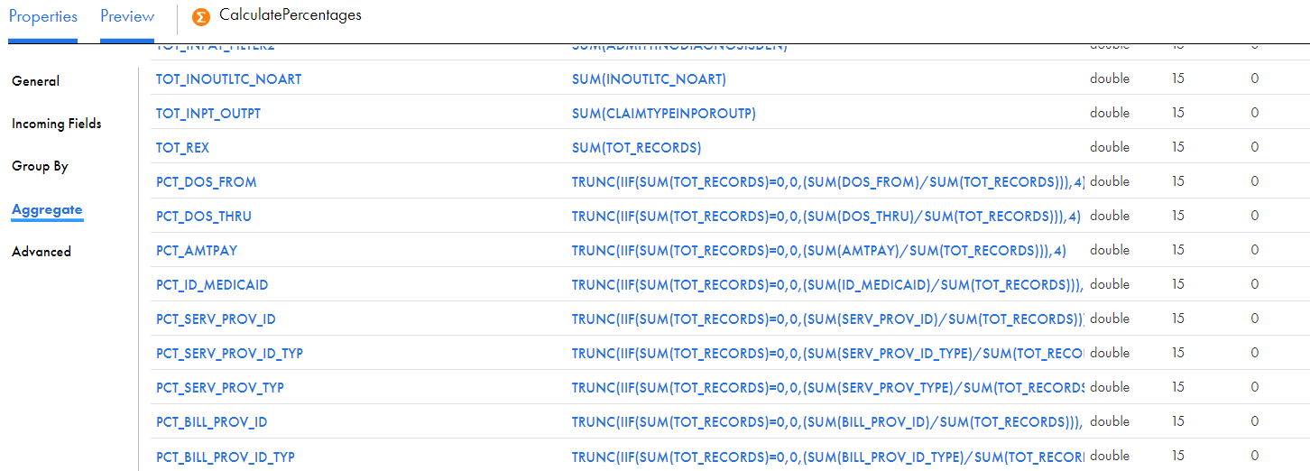

and a large aggregate transformation sums the 1 and 0’s into numerators and denominators and divides them to generate the percentages. See the older documentation.

After the mapplets Taskflow, TF_INF_B_ACO runs more SQL Taskflows Matching the ones done for Nicole’s SQL based processing and adds a STEP2_Snoapshot and STEP3 to stage for the Date Integration Framework spreadsheet generator. (see the older documentation for these two Steps, they are quite complicated to do that multiple windowing.)
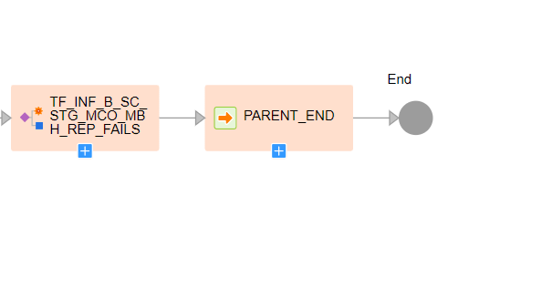
TF_INF_B_ACO runs Fails processing to pull out examples of failure records and finally closes out the parent batch record.
As of this writing, the DIF still runs against Oracle so there are extra workflows like TF_MAP_ACO_SF_TO_ORC to migrate the necessary results back to Oracle before running the DIF.

To run these workflows, I usually clear out the STG tables in Oracle, except for the lookup tables, change the run dates in the assignments, save and publish the TF_INF_B_ACO , SCO , OC. Run them and push the results over to Oracle with the SF_TO_ORC. Please be very careful with the STEP2_SNAPSHOT and STEP3 in ACO, those contain 7 runs of data and are quite hard to reproduce (see the older documentation.) And don’t clear the lookup tables. When do multiple reruns of SCO and OC, usually drop the older Nicole _MonYEAR_MonYEAR tables.
Good luck

