COMMONWEALTH OF MASSACHUSETTS
EXECUTIVE OFFICE OF HEALTH AND HUMAN SERVICES



Data Warehouse Project

Informatica Data Quality

Data Scorecard Monitoring

DRAFT Technical Specification

Version 1.5

Date: January 5, 2022

Contents
Revision History 3
1. Naming Standards and Programming Discussions 4
1.1. Object Naming Convention 4
1.2. Programing Discussions 4
2. Scorecard Review 5
3. Nicole’s SAS and SQL 5
4. Work to be done in this project 6
5. Running SQL in IDQ 6
6. Scorecard DQ Tables 8
7. Workflow Discussion 9
7.1. The Workflow Overview 9
7.2. IDQ SQL Workflow 10
7.3. Scheduling using Linux Command Line and the DW Informatica Framework 15
8. Using Mappings with Mapplets to replace SQL 19
9. Cognos Reports replacing Excel Report - Planned 33
10. Cognos Reports actual and Infrastructure for reports 39
11. Data Integration Framework Excel Report 59
12. SFTP DIF Extension 78
13. SCO Report 78
14. Summary 78

Revision History

Version# | Date | Version Details | Author
1.0 | 9/3/2020 | Initial Design | JP Leger
1.1 | 9/25/2020 | Rima Reviewed | JP Leger, Rima Kayyali
1.2 | 10/2/2020 | Released from DWDQ | JP Leger, Shruti Dadhi
1.3 | 4/1/2021 | After reports created before showing to Nicole | JP Leger, Shruti Dadhi
1.4 | 8/20/2021 | Fails sheet on DIF Excel Report | JP Leger, Shruti Dadhi
1.5 | 1/5/2022 | SFTP DIF extension and SCO processing | JP Leger, Shruti Dadhi

Naming Standards and Programming Discussions

Object Naming Convention

    - Table Name Convention
INF_B_SC_MCO_MPH_<Group>_<StartMonth>_<EndMonth>. For example, extract table name is: INF_B_SC_MCO_MBHP_DOS_APR2018_JUL2018
    - Field Naming Convention
      - The field names in the extract are based on the Encounter field names.
      - Numerator tables have field names based on Encounter field names with 2 at the end, such as ID_MEDICAID2. Numerator tables hold summed data and the 2 indicates the output of summing.
      - Denominator tables have field names starting with TOT_, such as TOT_INPAT. Denominator tables hold summed data.
      - Percentage tables have field names starting with PCT_, such as PCT_ID_MEDICAID. Percentage tables hold the results of the numerator fields divided by the denominator fields.

    - Informatica job Naming Convention
Job names are based on the tables being produced
      - Mappings - MAP_INF_B_SC_MCO_MBHP_DOS
      - Workflows - WKF_INF_B_SC_MCO_MBHP_DOS
      - Applications - APP_ INF_B_SC_MCO_MBHP_DOS

    - Parameter names
      - DA_MIN_DOS - Anomaly Start Date of Service
      - DA_MAX_DOS - Anomaly End Date of Service
      - DA_RUN_DATE - Anomaly currently running, or last run report run date
      - DA_BATCH_SEQ – Anomaly currently running, or last run DQ_BATCH_SEQ
      - SC_MON – Scorecard concatenated start and end date as MONYYYY_MONYYYY
      - SC_MIN_DOS – Scorecard Start Date of Service in YYYYMMDD – also used as MONS
      - SC_MAX_DOS - Scorecard End Date of Service
      - SC_RUN_DATE - Scorecard currently running, or last run report run date – also used as ASOFDT
      - SC_BATCH_SEQ – Scorecard currently running, or last run DQ_BATCH_SEQ

Programing Discussions

    - Mapplet processing vs SQL processing

Due to the visual aspect of programming mappings, they become unwieldy when there are more than 15 to 20 transformations in a single mapping. To keep the mapping manageable, we are processing the measures in groups and writing the logic for each field into staging tables at the un-aggregated 1 or 0 levels. The second pass sums the fields and generate the percentages on one pass. This is somewhat like processing data frames by adding columns with logic results and then aggregating.
    - SQL to compare final table for Cognos
Where we will not be maintaining the final Completeness report by hand, we need to scan across the four snapshots and generate a new report each time. We will be doing as much of the scanning and layout work as possible before handing over to Cognos, to keep the Cognos report writing manageable. As is, the Cognos report could require a dozen SQLs, or more, even with the pre-calculations.

Scorecard Review
This project is to move Nicole Tibbetts SAS and SQL Encounter Scorecard system to IDQ and Cognos. Nicole uses a SAS framework to run three sets of SQL that culminate in a spreadsheet reports of submission Completeness (percentage of submissions for many categories and indicators when the completeness is out of compliance, based on fixed thresholds.)
In this project will replace the SAS framework with an Informatica Data Quality (IDQ) framework called by a DW Informatica SQL*Plus control framework to schedule the Informatica jobs.
We are looking to replace several of Nicole’s core SQL script with IDQ Mapping and Mapplets.
We will also be adding a SQL that scans over the four snapshots in the report and produces a consolidated table layed out for Cognos to consume. In Cognos we will write a multi-page report to create a multi-tab spreadsheet, which replace the existing Completeness report.

Nicole’s SAS and SQL
There are three SAS scripts and a master SQL script.
- The first, “STEP 1 GENERATE CLAIMS.sas” runs the main Encounter extract, along with the a couple minor SQL scrips.
- The second, “STEP 2 GENERATE MEASURES.sas” loops over the master SQL script, “SAS_MASTER_COMPOSITE.sas”, parsing out the individual SQLs and running them.
- The third script, “STEP 3 GENERATE REPORT BMC.sas” runs a combination of Oracle SQL and SAS SQL to create a monthly snapshot spreadsheets, offering statistics over a four month Date of Service Window, “ MCO_XXX_SCORECARD_MONYYYY_MONYYYY”, which serves as input to the by hand maintained final product, “MCO-ACPP Encounter SCORECAR_month_yyyy.xlsx”.

Work to be done in this project
- Setup Nicole’s SQL to run in IDQ mappings and call it from a DW Informatica SQL*Plus framework. This will require porting several of the SAS SQLs in the third script to Oracle SQL.
- Write a SQL script that concatenates the “MCO_XXX_SCORECARD_MONYYYY_MONYYYY” tables into a table configured to feed into a Cognos report which will automatically generate the final Completeness report.
- Create a Cognos report to generate the Completeness report.
- Re-write three Oracle SQLs from the “STEP 2 GENERATE MEASURES.sas” and “SAS_MASTER_COMPOSITE.sas” as IDQ Mappings and Maplets.
- Leave the SQL from the Step 1, Encounter pull and the Step 3, Generate report, as SQL.

Running SQL in IDQ
Running SQL in Informatica is very straightforward; it is mostly a question of how to pass in parameters which, as of our current understanding, is either done two ways.
- The first is by passing an XML parameter file to the Informatica job scheduler via the command line and replacing variable in a Read Transformation at the start of an Informatica mapping. ( we ended up not using this method because it was too inflexible, and we reused the existing Linux Informatica architecture – this may need to be revisited for Cloud Data Quality)
- The other method is to have the Informatica mapping read a Linux flat parameter file or run SQL against a parameter table, and pass the read in parameters to a following SQL transformation which creates a table directly. (we propose to do this for Nicole’s SQL, at least to start. One interesting aspect of this that the flat file read will call the create multiple time if there are multiple dates in the flat file.
In IDQ this looks like:
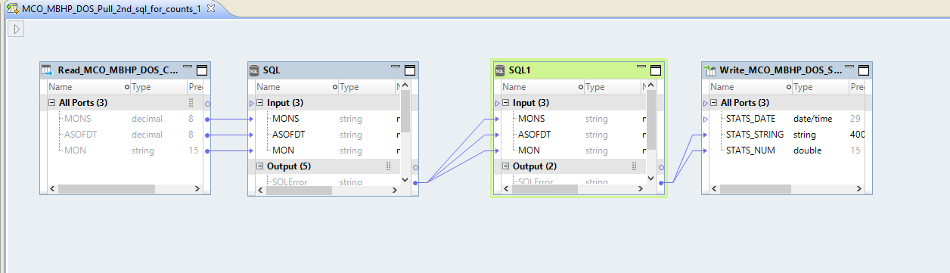
Mapping MAP_INF_B_SC_MCO_MBHP_DOS

- Explanation of Mapping-
    - The read at the beginning reads run parameters from a flat file on the Informatica server. It reads the same control parameters as used in Nicole’s SAS and SQL
MONS – is the start DOS
ASOFDT – as the As of Date – the run date
MON – is a string representation of the start DOS
These are fed into the two SQL calls and used to do string substitution in the SQL.
    - There are two SQLs because we want to capture insert statistics which requires running an Insert separate from the Create table.
The first SQL runs a CTAS
CREATE TABLE MCO_MBHP_DOS_~MON~
AS
SELECT
…
AND ROWNUM < 1
To create the table with no rows.

The second SQL Inserts data into the table
INSERT INTO MCO_MBHP_DOS_~MON~
SELECT
ENC.CDE_ENC_MCO,
ENC.CDE_ENC_ACO,
…
    - The second SQL passes the number of rows to the last write step which adds rows to the statistics table,
MCO_MBHP_DOS_STATS.
The stats table provides a run date, a SQL error message if there was an error, and the number of records inserted:
STATS_DATE STATS_STRING STATS_NUM
9/8/2020 4:05:25 PM 1660193
9/8/2020 4:05:25 PM 483127
9/8/2020 4:05:25 PM 43979
9/8/2020 4:05:25 PM 49043

The mapping is wrapped into a workflow WKF_INF_B_SC_MCO_MBHP_DOS which is deployed as an Application APP_INF_B_SC_MCO_MBHP_DOS which is called from the Linux framework, described in section 6.

Scorecard DQ Tables
We will be storing the tables in the DQ schema, instead of the nw1 schema where they are currently stored. The extract table will be renamed from MCO_MBHP_DOS_APR2018_JUL2018 to INF_B_SC_MCO_MBHP_DOS_APR2018_JUL2018.
The tables below are listed in the order they are run both in Nicole’s SAS and in Informatica.
- “STEP 1: Generates the claims population extract (based on Nicole’s SAS program GENERATE CLAIMS.sas”). This step generates the table INF_B_SC_MCO_MBHP_DOS_APR2018_JUL2018
- “STEP 2: Create a SAS/SQL scripts to define the numerators and denominators for all Scorecard measures (based on Nicole’s SAS programs GENERATE MEASURES.sas” and which iterates over “SAS_MASTER_COMPOSITE.sas”.
Tables are created in the order below:

    - INF_B_SC_MCO_MBH_TOTREX_APR2018_JUL2018

    - INF_B_SC_MCO_MBH_TDOS_APR2018_JUL2018

    - INF_B_SC_MCO_MBH_FLDREX_APR2018_JUL2018

    - INF_B_SC_MCO_MBH_FRDOS_APR2018_JUL2018

    - INF_B_SC_MCO_MBH_PCNT_APR2018_JUL2018

    - INF_B_SC_MCO_MBH_PCTDOS_APR2018_JUL2018

    - INF_B_SC_MCO_MBH_TPDOS_APR2018_JUL2018

    - INF_B_SC_MCO_MBH_FRPDOS_APR2018_JUL2018

    - INF_B_SC_MCO_MBH_PTPDOS_APR2018_JUL2018

- “STEP 3: Generate the final calculations based on the above steps and output data to be used for final report. (based on Nicole’s SAS program GENERATE REPORT BMC.sas”)

    - INF_B_SC_MCO_MBH_REP_TRANSPOSE_JUN2018_SEP2018

    - INF_B_SC_MCO_MBH_REP_STEP1_APR2018_JUL2018

    - INF_B_SC_MCO_MBH_REP_STEP2_APR2018_JUL2018

- Step 4: A New step created by DQ to create a SQL for the scan across the snapshots. And the new SQL for the scan across the snapshots will be:
Data in this table is based on a new SQL to scan across the snapshots
    - INF_B_SC_MCO_MBH_REP_STEP3_APR2018_JUL2018.

Workflow Discussion

The Workflow Overview
Scorecard SQL and mapplet workflows run SQL and mapplets to generate tables of measure counts which are analyzed in the Cognos reporting tool.
Workflows consist of:

    - The IDQ mapping is used to run SQLs and mapplets. It has a source and target.
    - The source holds SQL which accepts parameters for the Date of Service Start and End dates.
    - The target writes output to a DW DQ table, along with a timestamp for the run.
    - The target table will holds individual runs. The Completeness reports compare multiple runs and will select the runs using the table names.
    - The IDQ mapping is wrapped with an IDQ workflow.
    - The IDQ workflow is deployed to the Informatica server as an IDQ application.
    - The application is run by a call from the DW bash shell script based framework, on the Informatica server or by being called by the Informatica Scheduler.
    - The shell script is scheduled by cron on the Informatica server.
    - Cognos uses Data Modules to access the DW and DQ tables.
    - Cognos reads the DQ table and uses the output to populate a Cognos Completeness Report.
    - The Cognos Report is scheduled using the Cognos scheduler. It is distributed via email.

Fig. 1 SCORECARD and Linux and Informatica workflow

    - In Figure 1 above, the left side of the Visio shows the flow through the DW bash based Informatica workflow and the right shows the Informatica processing.
    - The DW bash process sets variables, writes a batch tracking record and loops calling the Informatica SQL processing steps.
    - The DW bash part is discussed in Section 4.3. The Informatica flows are discussed next
    - The workflows for Anomaly and Scorecard are very similar.
    - The Scorecard workflow will include mappings for both SQL and mapplet processing.

IDQ SQL Workflow
    - We will review running SQL here. Mapplets and Mappings are discussed in the next section.
    - We will use the extract “INF_B_SC_MCO_MBHP_DOS” table as an example to discuss the steps.
    - The IDQ SLQ mapping is:
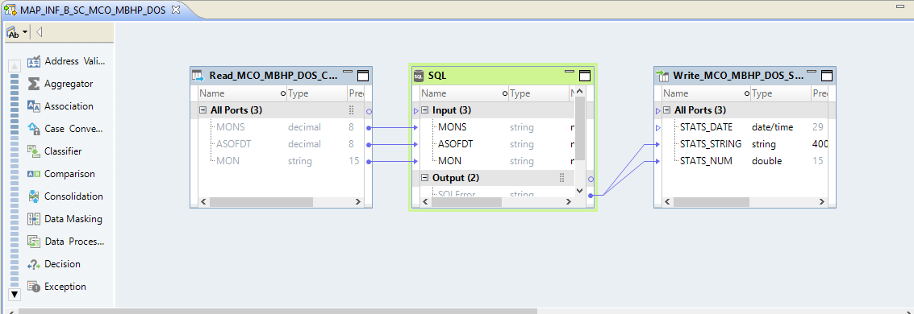

Fig. 2 MAP_INF_B_SC_MCO_MBHP_DOS
    - The first step reads the Linux control file MCO_MBHP_DOS_CONTROL_FILE which contains three parameters: MONS, ASOFDT and MON
    - The SQL transformation contains the SQL, which has parameters overwritten ~MON~,~ASOFDT~, and ~MONS~
CREATE TABLE INF_B_SC_MCO_MBHP_DOS_~MON~
AS
SELECT
ENC.CDE_ENC_MCO,
ENC.CDE_ENC_ACO,
CASE WHEN ENC.CDE_ENC_ACO in('#','+','-') THEN 'NA' ELSE ENC.CDE_ENC_ACO END AS ACO,
MEM.ID_MEDICAID,
ENCATT.CDE_ENC_REC_IND,
ENCATT.DSC_ENC_REC_IND,
ENC.DOS_FROM_DT AS DOS_FROM,
ENC.DOS_TO_DT AS DOS_THRU,
ENC.REMIT_FROM_DT AS PAID_DT,
ENC.ADMIT_DT,
ENC.DISCHARGE_DT,
ENC.DATE_SCRIPT_WRITTEN,
ENC.QTY_REFILL,
ENC.QTY_UNITS_BILLED,
ENC.RX_NUMBER,
ENC.AMT_NDC_PROFEE,
ENC.ENCSRGGRP_SEQ,
DIAGGRP.CDE_DIAG_ADMIT,
DIAGGRP.DSC_DIAG_ADMIT,
CSA.CDE_PATIENT_STATUS,
CSA.DSC_PATIENT_STATUS,
DIAGGRP.CDE_DIAG_1 AS PRIMARY_DIAG,
DIAGGRP.DSC_DIAG_1 AS PRIMARY_DIAG_DESC,
DIAGGRP.CDE_ICD_VERSION,
DIAGGRP.DIAGRP_SEQ,
CSA.CDE_ADMIT_TYPE,
CSA.DSC_ADMIT_TYPE,
CSA.CDE_ADMIT_SOURCE,
NCF.CDE_ENC_PROC AS PROC_CODE_ENC,
NCF.DSC_ENC_PROC AS PROC_CODE_ENC_DESC,
PROC.CDE_PROC AS PROC_CODE,
PROC.DSC_PROC AS PROC_CODE_DESC,
MFR.CDE_PROC_MOD AS PROC_MODIFIER1,
MFR.DSC_PROC_MOD AS PROC_MODIFIER1_DESC,
MFR.CDE_PROC_MOD_2 AS PROC_MODIFIER2,
MFR.DSC_PROC_MOD_2 AS PROC_MODIFIER2_DESC,
MFR.CDE_PROC_MOD_3 AS PROC_MODIFIER3,
MFR.DSC_PROC_MOD_3 AS PROC_MODIFIER3_DESC,
MFR.CDE_PROC_MOD_4 AS PROC_MODIFIER4,
MFR.DSC_PROC_MOD_4 AS PROC_MODIFIER4_DESC,
NCF.CDE_ENC_PROC_TYPE,
NCF.DSC_ENC_PROC_TYPE,
CSA.CDE_REVENUE,
CSA.DSC_REVENUE,
CSA.CDE_PLACE_OF_SERVICE,
CSA.DSC_PLACE_OF_SERVICE,
SUBSTR(CSA.CDE_PLACE_OF_SERVICE,2,2) AS PLACE_OF_SERVICE,
SUBSTR(CSA.CDE_PLACE_OF_SERVICE,1,1) AS PLACE_OF_SERVICE_TYPE,
CSA.CDE_PLACE_OF_SERVICE_ENC,
CSA.CDE_TYPE_OF_BILL,
CSA.CDE_TYPE_OF_BILL_ENC,
CSA.CDE_BILL_FREQ,
SVC_PROV.ID_PROVIDER AS SERV_PROV_ID,
SVC_PROV.ENC_PROV_ID AS ENC_SERV_PROV_ID,
SVC_PROV.DSC_ENC_PROV_ID_TYPE AS SERV_PROV_ID_TYPE,
SVC_PROV.ID_NPI AS SERV_NPI,
SVC_PROV.CDE_ENC_PROV_TYPE AS ENC_SERV_PROV_TYPE,
SVC_PROV.CDE_ENC_PROV_ID_LOC AS SERV_PROV_ID_LOC_CODE,
NCF.CDE_ENC_PROV_SPEC AS SERV_PROV_SPECIALTY,
PROV.ID_PROVIDER AS BILL_PROV_ID,
PROV.ENC_PROV_ID AS ENC_BILL_PROV_ID,
PROV.DSC_ENC_PROV_ID_TYPE AS BILL_PROV_ID_TYPE,
PROV.CDE_ENC_PROV_ID_LOC AS BILL_PROV_ID_LOC_CODE,
PROV.ID_NPI AS BILL_NPI,
PRS_PROV.ID_PROVIDER AS PRES_PROV_ID,
PRS_PROV.ENC_PROV_ID AS ENC_PRES_PROV_ID,
PRS_PROV.DSC_ENC_PROV_ID_TYPE AS PRES_PROV_ID_TYPE,
PRS_PROV.CDE_ENC_PROV_ID_LOC AS PRS_PROV_ID_LOC_CODE,
DRG.CDE_DRUG_CLASS,
DRG.CDE_NDC,
ENC.CDE_CLM_TYPE AS CLAIM_TYPE,
ENC.ENC_CLAIM_NO,
ENC.ENC_CLAIM_SUFFIX,
ENC.AMT_PAID,
ENC.AMT_BILLED,
ENC.AMT_ALLOWED,
ENC.CDE_CLM_DISPOSITION,
ENC.AMT_TPL,
ENC.AMT_COPAY,
ENC.AMT_COINSURANCE,
ENC.NUM_LOGICAL_CLAIM,
ENCATT.CDE_ENC_DISP_AS_WRTN,
ENCATT.DSC_ENC_DISP_AS_WRTN,
ENCATT.CDE_ENC_CLAIM_CAT,
ENCATT.DSC_ENC_CLAIM_CAT,
ENCATT.CDE_ENC_SVC_CAT,
ENCATT.DSC_ENC_SVC_CAT,
ENCATT.IND_ENC_COMPOUND
FROM NW_ENCOUNTER_HIST ENC
LEFT OUTER JOIN NW.NW_ENC_ATTRIBUTE ENCATT ON ENC.ATTRENC_SEQ = ENCATT.ATTRENC_SEQ
LEFT OUTER JOIN NW_MEMBER MEM ON ENC.MEM_SEQ = MEM.MEM_SEQ
LEFT OUTER JOIN NW_DIAGNOSIS_GROUP DIAGGRP ON ENC.DIAGRP_SEQ = DIAGGRP.DIAGRP_SEQ
LEFT OUTER JOIN NW_CLAIM_SERVICE_ATTRIBUTE CSA ON ENC.ATTRSRV_SEQ = CSA.ATTRSRV_SEQ
LEFT OUTER JOIN NW_PROCEDURE PROC ON ENC.PROC_SEQ = PROC.PROC_SEQ
LEFT OUTER JOIN NW_PROCEDURE_MFR_GROUP MFR ON ENC.PROCMFRGRP_SEQ= MFR.PROCMFRGRP_SEQ
LEFT OUTER JOIN NW_DRUG DRG ON ENC.DRUG_SEQ = DRG.DRUG_SEQ
LEFT OUTER JOIN NW_ENC_PROVIDER PROV ON ENC.BILL_ENCPRV_SEQ = PROV.ENCPRV_SEQ
LEFT OUTER JOIN NW_ENC_PROVIDER SVC_PROV ON ENC.SRV_ENCPRV_SEQ = SVC_PROV.ENCPRV_SEQ
LEFT OUTER JOIN NW_ENC_PROVIDER REF_PROV ON ENC.REF_ENCPRV_SEQ = REF_PROV.ENCPRV_SEQ
LEFT OUTER JOIN NW_ENC_PROVIDER PRS_PROV ON ENC.PRS_ENCPRV_SEQ = PRS_PROV.ENCPRV_SEQ
LEFT OUTER JOIN NW_ENC_NONCONF_ATTRIBUTE NCF ON NCF.ATTRENC_NC_SEQ = ENC.ATTRENC_NC_SEQ
WHERE ENC.DOS_FROM_DT BETWEEN TO_DATE('~MONS~','YYYYMMDD')
AND ((TO_DATE('~MONS~', 'YYYYMMDD') + INTERVAL '4' MONTH ) -1)
AND ENC.REMIT_THRU_DT = TO_DATE('99991231','YYYYMMDD')
AND TO_DATE('~ASOFDT~','YYYYMMDD') BETWEEN ENC.WH_FROM_DT AND ENC.WH_THRU_DT
AND ENC.CDE_CLM_DISPOSITION <> 'V'
AND ENC.IND_OFFSET = 'N'
AND ENC.CDE_ENC_MCO IN('BMC','CHA','FLN','NHP','HNE','MBH')

The target writes to the extract table table
CREATE TABLE INF_B_SC_MCO_MBHP_DOS_MAR2018_JUN2018
(
CDE_ENC_MCO VARCHAR2(3 BYTE) NOT NULL,
CDE_ENC_ACO VARCHAR2(10 BYTE) NOT NULL,
ACO VARCHAR2(10 BYTE),
ID_MEDICAID VARCHAR2(12 BYTE),
CDE_ENC_REC_IND VARCHAR2(1 BYTE),
DSC_ENC_REC_IND VARCHAR2(120 BYTE),
DOS_FROM DATE,
DOS_THRU DATE,
PAID_DT DATE,
ADMIT_DT DATE,
DISCHARGE_DT DATE,
DATE_SCRIPT_WRITTEN DATE,
QTY_REFILL NUMBER(10,2),
QTY_UNITS_BILLED NUMBER(12,2),
RX_NUMBER VARCHAR2(15 BYTE) NOT NULL,
AMT_NDC_PROFEE NUMBER(9,2),
ENCSRGGRP_SEQ NUMBER(10) NOT NULL,
CDE_DIAG_ADMIT VARCHAR2(7 BYTE),
DSC_DIAG_ADMIT VARCHAR2(70 BYTE),
CDE_PATIENT_STATUS VARCHAR2(20 BYTE),
DSC_PATIENT_STATUS VARCHAR2(126 BYTE),
PRIMARY_DIAG VARCHAR2(7 BYTE),
PRIMARY_DIAG_DESC VARCHAR2(70 BYTE),
CDE_ICD_VERSION NUMBER(2),
DIAGRP_SEQ NUMBER(10),
CDE_ADMIT_TYPE VARCHAR2(1 BYTE),
DSC_ADMIT_TYPE VARCHAR2(18 BYTE),
CDE_ADMIT_SOURCE VARCHAR2(20 BYTE),
PROC_CODE_ENC VARCHAR2(6 BYTE),
PROC_CODE_ENC_DESC VARCHAR2(120 BYTE),
PROC_CODE VARCHAR2(6 BYTE),
PROC_CODE_DESC VARCHAR2(49 BYTE),
PROC_MODIFIER1 VARCHAR2(2 BYTE),
PROC_MODIFIER1_DESC VARCHAR2(45 BYTE),
PROC_MODIFIER2 VARCHAR2(2 BYTE),
PROC_MODIFIER2_DESC VARCHAR2(45 BYTE),
PROC_MODIFIER3 VARCHAR2(2 BYTE),
PROC_MODIFIER3_DESC VARCHAR2(45 BYTE),
PROC_MODIFIER4 VARCHAR2(2 BYTE),
PROC_MODIFIER4_DESC VARCHAR2(45 BYTE),
CDE_ENC_PROC_TYPE VARCHAR2(1 BYTE),
DSC_ENC_PROC_TYPE VARCHAR2(120 BYTE),
CDE_REVENUE NUMBER(4),
DSC_REVENUE VARCHAR2(87 BYTE),
CDE_PLACE_OF_SERVICE VARCHAR2(20 BYTE),
DSC_PLACE_OF_SERVICE VARCHAR2(301 BYTE),
PLACE_OF_SERVICE VARCHAR2(2 BYTE),
PLACE_OF_SERVICE_TYPE VARCHAR2(1 BYTE),
CDE_PLACE_OF_SERVICE_ENC VARCHAR2(20 BYTE),
CDE_TYPE_OF_BILL VARCHAR2(7 BYTE),
CDE_TYPE_OF_BILL_ENC VARCHAR2(7 BYTE),
CDE_BILL_FREQ VARCHAR2(1 BYTE),
SERV_PROV_ID VARCHAR2(10 BYTE),
ENC_SERV_PROV_ID VARCHAR2(15 BYTE),
SERV_PROV_ID_TYPE VARCHAR2(120 BYTE),
SERV_NPI VARCHAR2(10 BYTE),
ENC_SERV_PROV_TYPE VARCHAR2(3 BYTE),
SERV_PROV_ID_LOC_CODE VARCHAR2(20 BYTE),
SERV_PROV_SPECIALTY VARCHAR2(3 BYTE),
BILL_PROV_ID VARCHAR2(10 BYTE),
ENC_BILL_PROV_ID VARCHAR2(15 BYTE),
BILL_PROV_ID_TYPE VARCHAR2(120 BYTE),
BILL_PROV_ID_LOC_CODE VARCHAR2(20 BYTE),
BILL_NPI VARCHAR2(10 BYTE),
PRES_PROV_ID VARCHAR2(10 BYTE),
ENC_PRES_PROV_ID VARCHAR2(15 BYTE),
PRES_PROV_ID_TYPE VARCHAR2(120 BYTE),
PRS_PROV_ID_LOC_CODE VARCHAR2(20 BYTE),
CDE_DRUG_CLASS VARCHAR2(1 BYTE),
CDE_NDC VARCHAR2(11 BYTE),
CLAIM_TYPE VARCHAR2(1 BYTE) NOT NULL,
ENC_CLAIM_NO VARCHAR2(20 BYTE) NOT NULL,
ENC_CLAIM_SUFFIX VARCHAR2(4 BYTE) NOT NULL,
AMT_PAID NUMBER(9,2),
AMT_BILLED NUMBER(9,2),
AMT_ALLOWED NUMBER(9,2),
CDE_CLM_DISPOSITION VARCHAR2(1 BYTE) NOT NULL,
AMT_TPL NUMBER(10,2),
AMT_COPAY NUMBER(9,2),
AMT_COINSURANCE NUMBER(9,2),
NUM_LOGICAL_CLAIM VARCHAR2(29 BYTE) NOT NULL,
CDE_ENC_DISP_AS_WRTN VARCHAR2(1 BYTE),
DSC_ENC_DISP_AS_WRTN VARCHAR2(120 BYTE),
CDE_ENC_CLAIM_CAT VARCHAR2(1 BYTE),
DSC_ENC_CLAIM_CAT VARCHAR2(120 BYTE),
CDE_ENC_SVC_CAT VARCHAR2(5 BYTE),
DSC_ENC_SVC_CAT VARCHAR2(120 BYTE),
IND_ENC_COMPOUND VARCHAR2(1 BYTE)
)
Fig. 3 DQ Scorecard Extract Table
The mapping is wrapped in a workflow:
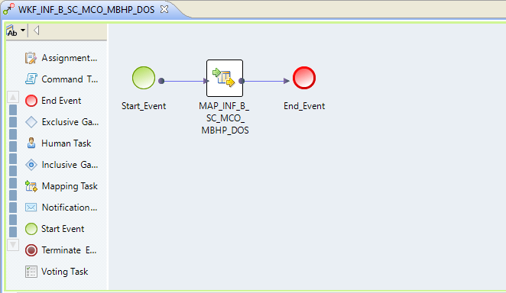
Fig. 4 WKF_INF_B_SC_MCO_MBHP_DOS
Which is deployed as application APP_INF_B_ SC_MCO_MBHP_DOS
Application APP_INF_B_ SC_MCO_MBHP_DOS is run on the informatica server by the DW bash based Informatica framework described in section 4.3

Scheduling using Linux Command Line and the DW Informatica Framework
    - Simple Example of Running an IDQ Application
From Linux, an IDQ Application is invoked using the Informatica infacmd.sh command, and is wrapped in a bash shell scrip which can be called by the cron scheduler. This is how was testing the POC Applications. It looks like this:
/informatica/prod/102/PowerCenter/server/infa_shared/BWParam/DQ/run_MCO_MBHP_DOS
Which reads an xml file to pass the parameters
-rw-r--r-- 1 infm infm 531 Jul 30 10:55 Run_Start_and_End_Dates.xml
(Figure 6 shows how to create a parameter file)

#! /usr/bin/bash
echo "starting"
echo "running Application_ANOMALY_MONTHLY_METRICS_BY_MCO_BY_CLAIM_TYPE"
$INFA_HOME/isp/bin/infacmd.sh wfs startWorkflow -dn domain_prod -sn INFA_DIS_PROD -un jleger -pd xxxxxx -a Application_ APP_INF_B_ SC_MCO_MBHP_DOS -wf APP_INF_B_ SC_MCO_MBHP_DOS -pf Run_Start_and_End_Dates.xml
#
sleep 5
echo "done"
Fig. 7 run_MCO_MBHP_DOS shell script

    - The DW Informatica Framework for Running Informatica Jobs
      - Overview
I was considering expanding on the example in Fig 7, by writing a set of batch scripts to track the IDQ job execution, but upon review, found that a much better framework had already been written, based on DW functions.
The scripts are used to run PDM, EIM and NW (lbbatch) workflows. It should be fairly easy to copy and modify one of the existing script sets.
This has the advantages of:
- not reinventing the wheel,
- using something that already runs
- providing a consistent support interface – it is the same as the others
- The functions include: reading from nw_params, writing to the job logging tables, running SQL in various nodes and wrappers for sending emails.

      - Framework
PDM, EIM and NW (lbbatch) have user accounts on the informatica servers. We will request that EOTTS sets up a DQ user account.
The parts of the framework:
        - The ~/.bash_profile and .pdm_profile contain environment variables
        - The pdms/applications.sh script contains connection information
        - The pdms/scheduling/functions.sh contains standard NW functions for logging and running SQL
        - The dqs/scheduling/scripts/ runDQ_SCORECARD.sh calls DQ_SCORECARD.sh
        - DQ_SCORECARD.sh stops any running DQ scripts, runs steps numbered under 10 for setup, steps 11 and over for ETL, steps 41 and above for cleanup and step 51 to close the batch.
        - DQ_SCORECARD.sh sends emails about job success
        - For now we are using cron to schedule the DQ jobs, like PDM. EIM is called by the EOTTS Master Scheduler and NW is run from the DW Production DB, but these are probably overkill for DQ.

      - Setup
We copied the contents of the PDM users’ directories into the DQ user’s home, renamed the PDM scripts to DQ scripts and edit the DQ_SCORECARD.sh to make Informatica Developer calls using the CLI infacmd.sh vs PowerCenter’s pmcmd

      - Passing Parameters
The Linux scripts pass parameters into the workflows and mappings in two ways, SQL and XML. These are set in the first 10 steps of the scripts, and both the SQL and XML have the same data. Parameters are used in the mappings either as named parameters using $parameter name or as string inserts using ~passed_parameter~. The $ version works in fixed SQL scripts as seen in with '$DA_BATCH_SEQ' in many of the SQLs above (batch seq is explained below). The ~ version is needed for dynamic SQL calls as used in the Scorecard SQL runs. With the SQL version the parameters are read out of INF_B_DQ_PARAMS a standard DW name value parameter table.

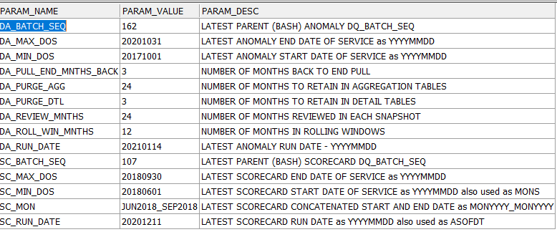
Fig. 5 Params table

The XML version writes to an XML file in the scripts directory and passes parameters to named workflows and applications. This is very similar to how PowerCenter passes parameters to PDM and EIM except for PowerCenter, the file format is not XML and the drop point in in the $INFA_HOME structure.

The DA XML looks like:

<?xml version="1.0" encoding="UTF-8" standalone="no"?> <root xmlns="http://www.informatica.com/Parameterization/1.0" xmlns:xsi="http://www.w3.org/2001/XMLSchema" version="2.0"> <project name="b_DW_Monitoring_Project"> <folder name="DI_Anomaly_Scorecards_v1_9"> <workflow name="WKF_INF_B_DA_MNTH_MCO_ACO_BASE"> <parameter name="DA_BATCH_SEQ">162</parameter> <parameter name="DA_RUN_DATE">20210114</parameter> <parameter name="DA_MIN_DOS">20171001</parameter> <parameter name="DA_MAX_DOS">20201031</parameter> <parameter name="program_name">WKF_INF_B_DA_MNTH_MCO_ACO_BASE</parameter> <parameter name="step_num">11</parameter> <parameter name="table_name">INF_B_DA_MNTH_MCO_ACO_BASE</parameter> <parameter name="project_name">DA</parameter> </workflow>
Fig. 6 head of DA_PARAMETERS.xml

      - Batch Number
The runs are marked with a Run Date and a DQ_BATCH_SEQ batch number. The Batch Numbers are generated using an Oracle sequence INF_DQ_BATCH_SEQ specified in 2.6.1. Batch records are written to the INF_B_DQ_LOAD_BATCH table, which tracks the batch jobs and the steps. The Linux scripts DQ_ANOMALY_v1_9.sh and DQ_SCORECARD.sh write a parent batch record with the initial status of ‘Running’ and no BATCH_END_DT_TM.
Each Informatica step writes child batch records from the workflow ( see Fig. 7 WKF_INF_B_DA_MNTH_MCO_CLMTYP above) BATCH_START and BATCH_END mappings. The child steps are tied to the parent by the PARENT_BATCH_SEQ.
Step 51 in the Linux scripts closes out the parent batch by updating BATCH_END_DT_TM and setting the status to ‘Complete’.
This is best seen using:
select * from INF_B_DQ_LOAD_BATCH
order by DQ_BATCH_SEQ desc
Which looks like:
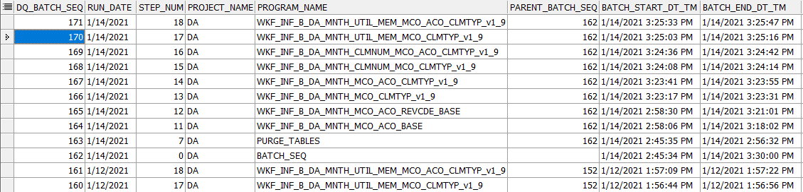
Fig. 7 LOAD_BATCH

If the status (not sown above) is still ‘Running’ long after the job should have completed, something went wrong. Start with the logs in /home/dq/dqs/scheduling/logs and check the Informatica jobs in the Informatica Admin Console Logs>Service>Data Integration Service.

Using Mappings with Mapplets to replace SQL

- To more fully utilize IDQ we will be rewriting a number of Nicole’s SQLs listed in section 5
- To start with we will be recoding
    - MAP_INF_B_SC_MCO_MBH_TPDOS
    - MAP_INF_B_SC_MCO_MBH_FRPDOS
    - MAP_ INF_B_SC_MCO_MBH_PTPDOS

- These are the ACO versions that are displayed in the Completeness report described in section8.
    - INF_B_SC_MCO_MBH_TPDOS generates the ACO level denominator measures
    - INF_B_SC_MCO_MBH_FRPDOS generates the ACO level numerator measures
    - INF_B_SC_MCO_MBH_PTPDOS generates the percentages as numerator / denominator
- This process is described in great detail in the Scorecard BRD.
- The implementation will consist of writing Rule Specifications to describe parameters that are then wrapped into mapplets as building blocks.
- The building blocks are then assembled into further mapplets representing each of the 37 measure’s numerators and denominators.
- The numerators and denominators are then grouped into mappings so that they can populate staging tables.
- The groupings will be done by Scorecard measures (as described in section 4 of the BRD.)
- Grouping the numerators and denominators by measure, e.g. All Claim Types, makes the enclosing mapping more manageable – 15 numerators and denominators in the All Claim Types mapping.
- The mapping populates a staging table INF_B_SC_MCO_ALL_CLAIM_TYPES which is at the level of ENC_CLAIM_NO and ENC_CLAIM_SUFFIX with 1’s or 0’s indicating pass or fail.
- When all of the mappings are done, probably four or five, will determine when developing, then the staging stables are merged with SQL and fed in the aggregation and percentage mapping, MAP_INF_B_SC_MCO_MBH_PTPDOS_MPT which writes the mapplet version of INF_B_SC_MCO_MBH_TPDOS_MPT. This should produce the same results as found in INF_B_SC_MCO_MBH_TPDOS. Comparing the two table will be one of the QA steps.
- Note that the mapplet version of the processing is done with a more horizontal slicing of the measures and uses intermediate tables at the claim line level which are then summed and turned into percentages in one pass.
- This compares with the SQL method which create sperate summed numerator and denominator tables and then calculates the percentages of the sums in a final pass.
- The reason for running the mapplet processing in bands is due to, working with mappings of more than 15 to 20 mapplets becomes difficult, prone to making errors and harder to maintain.
- We will review the components for 4.1 All Claim Types 4.1.1 From Service Date
- The rule specification defines the logic for the mapplets. We are using rule specifications in two ways, for the real logic in the Claim Population Parameters and as combining logics in the Scorecard Measures.
- The pieces look like: From the BRD 4.1.1 is defined as
    - From Service Date (MPT_FromServiceDate_ENC)
      - All Claims population: MPT_ClaimType_ALL
      - Valid Date value parameter: MPT_DateIsNotNull_ALL, DOS_FROM

- From Service Date will be defined in one or two mapplets MPT_FromServiceDate_ENC and MPT_FromServiceDate_ENC_den. If needed.
- These mapplets define the combining logic for the Measure.
- If additional Claim Population Parameters are needed to feed into the measure, the combining logic mapplet and the supporting parameter mapplets are wrapped into a wrap mapplet named after the combining logic mapplet with _wrap appended. So here MPT_FromServiceDate_ENC is combined with a MPT_DateIsNotNull_ALL mapplet and wrapped in MPT_FromServiceDate_ENC_wrap.
- The two parameter mapplets are :
    - MPT_ClaimType_ALL is defined as “All Claims population then 1 else 0”
    - MPT_DateIsNotNull_ALL is defined as “Date is null then 1 else 0” and testing DOS_FROM
- Mapplets start as Rule Specifications:
    - The parameter MPT_ClaimType_ALL has the specification
    - Specifications are defined in the IDQ Analyst tool.

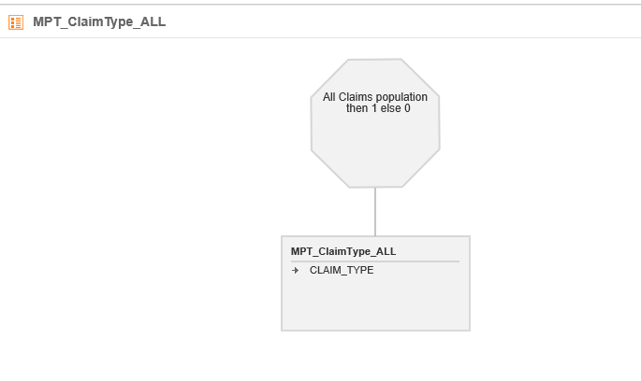
Fig. 8 MPT_ClaimType_ALL Rule Specification
- Rule specifications are defined with a stop sign head which defines general rule specification name and description.
- Below the head is a hierarchy of rule specifications which combine up through the hierarchy to define complex business logic.
- The rule specification logic is defined in non-programmer friendly logic statements. (the logic capability is quite powerful, but verbose) Here we are looking at a simple rule specification with one layer of hierarchy.
- The rule specification has input ports defined in (we are in Edit mode)
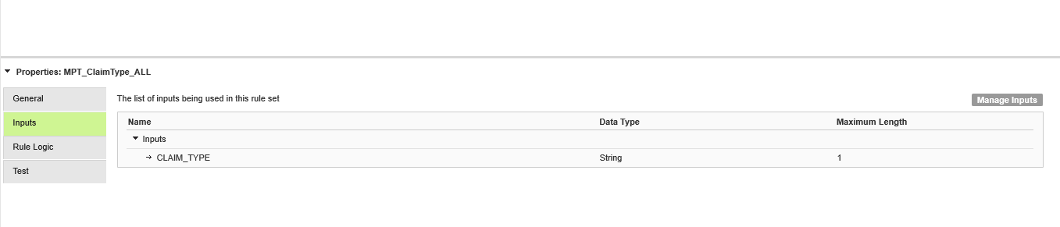
Clicking on manage Inputs provides an interface to edit the ports:
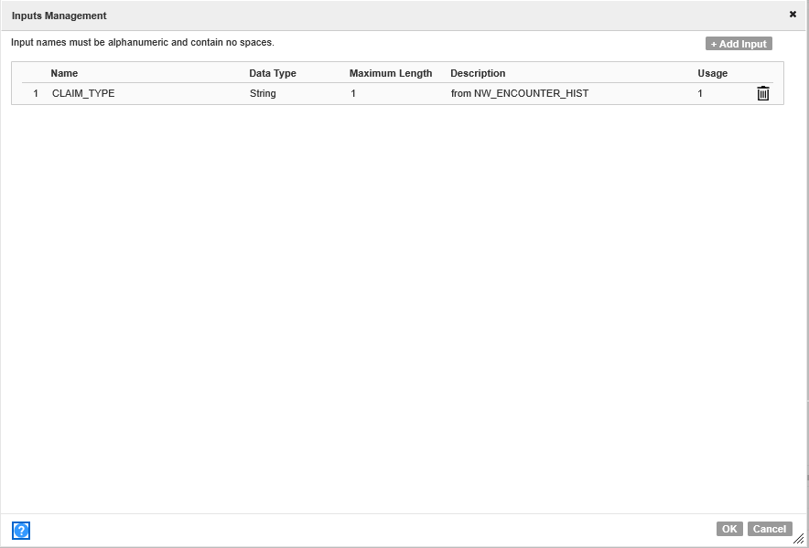
- This rule specification will be passed in claim types, which it will evaluate.
- Looking at the rule logic:
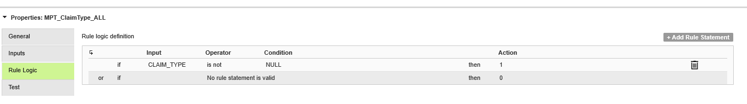
    - We are returning 1 or 0 logic, where 1 is if the claim_type is not null (a bit contrived since claim_type is never null, thus all records)
    - Looking at a better example, MPT_ClaimType_PROF shows, as expected, the logic checking to professional, medical, claims with claim_type = ‘M’
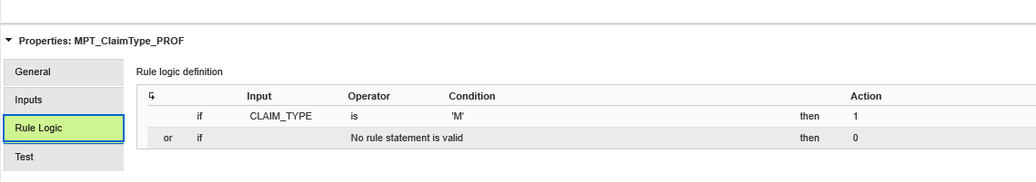
A nice feature, the rule specification interface provides built in testing.
For professional claim_type we check for M or not M:
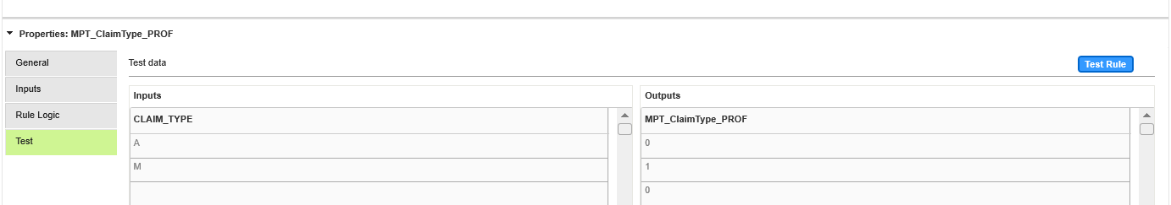

- After the rule specification is completed and tested, it is validated and then can be turned into a rule mapplet. This is done in edit mode by these two icons

- Saving the rule specification as a mapplet provides portability and allows the rule logic to be edit using the Informatica expression language. Saving it as the special form or rule mapplet, allows the mapplet to be used in other rule specifications (more portable.) Rule mapplets can only be created in the Analyst tool, not the Developer tool.
- Switching to the Developer tool, the rule specification is visible under rule specifications:
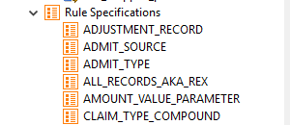
    - Rule specification can not be edited in the Developer tool, but can be copied (which is very useful.)
    - The Mapplets are visible under mapplets:
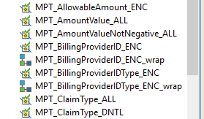
- Note the rule mapplets have the and the mapplets defined in developer have .
- Opening the rule mapplet for MPT_ClaimType_PROF, we see:
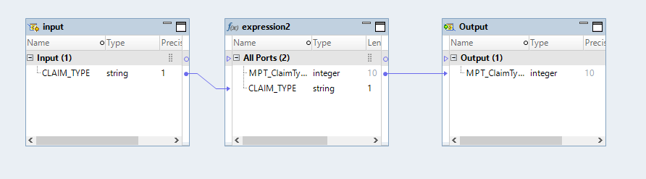

Where the mapplet is a reusable set of transformations, it starts with an input transformation, ends with am output transformation and has an expression transformation in the middle which holds the rule specification logic.
- Opening the expression transformation, and looking at the port definitions:
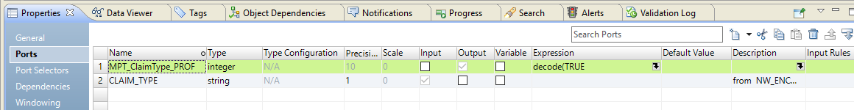
We see the expression logic under Expression for the MPT_ClaimType_Prof output port.
Clicking on the expression down arrow, we see:
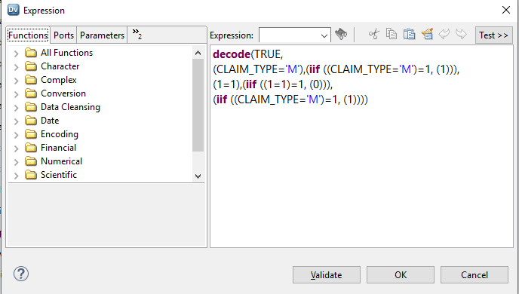
Fig. 9
- The rule specification logic has been converted to Informatica expression language, which can be edited.
- The logic is a bit complicated for a simple CLAIM_TYPE = ‘M’ gives 1 if M else 0, but I guess all this extra baggage is used somewhere. I have had success getting rid of the extra baggage and still having the expression work, but for now we will only do that when we need to add to the expression.
- The second type of mapplet is the Measure mapplet that merges the logic from the parameter maplets.
- For BRD 4.1.1 the measure mapplets are called MPT_FromServiceDate_ENC.
- The final mapplets are further named MPT_FromServiceDate_ENC_NUM and MPT_FromServiceDate_ENC_DEN which are final wrapped mapplets.
    - Not all measures will need denominator maplets, the simple parameter mapplet may not need to be wrapped.
    - This is the case for the 4.1 All mapplets, where the MPT_ClaimType_ALL is the denominator all the 4.1 measures and does not need wrapping.
    - All of the numerators will have mapplets and will be wrapped.
    - For MPT_FromServiceDate_ENC_NUM, it starts with a rule specification:
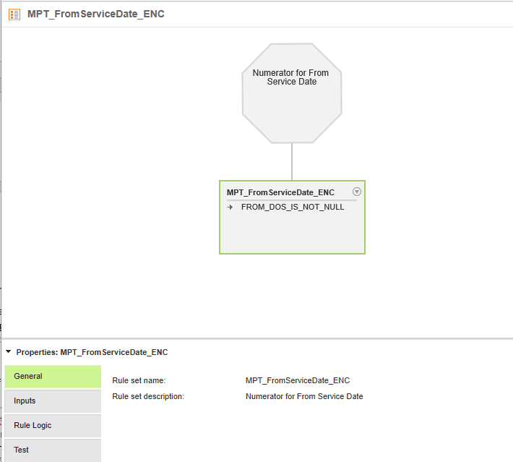
Fig. 10
    - Which look like the parameter rule specifications.
- The difference with the measure rule specifications is that the inputs are 1’s or 0’s passed in from parameter mapplets
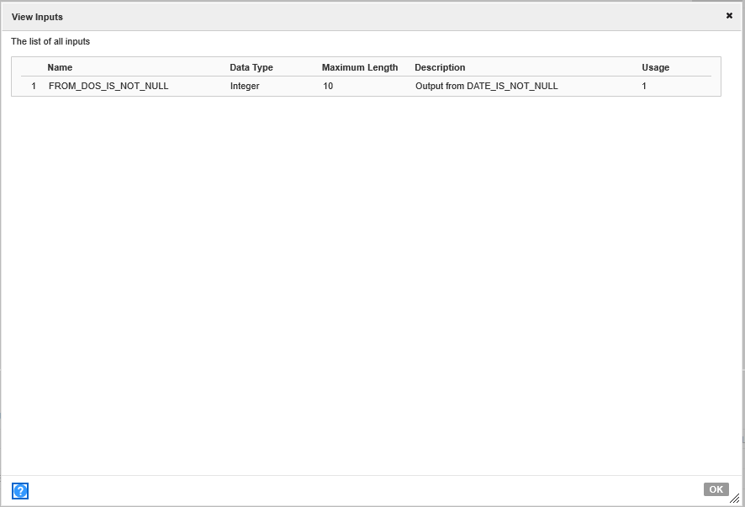
Fig. 11
- And the rule logic is simple and’ing and or’ing the passed in 1’s and 0’s.
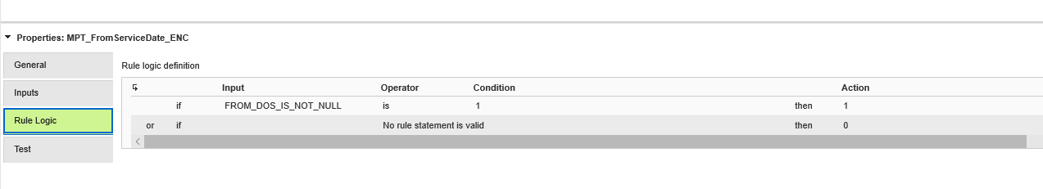
Fig. 12
- The logic for this one is pretty much a pass thru, but the more advanced measures, especially for proc codes, can get quite involved (as is the SQL version.)
- The measure rule specifications are turned into mapplets, as described above for parameter mapplets.
- The mapplet generated MPT_FromServiceDate_ENC has a expects to be fed the results from MPT_DateIsNotNull_ALL for DOS_FROM, but it does not contain the MPT_DateIsNotNull_ALL in it automatically.
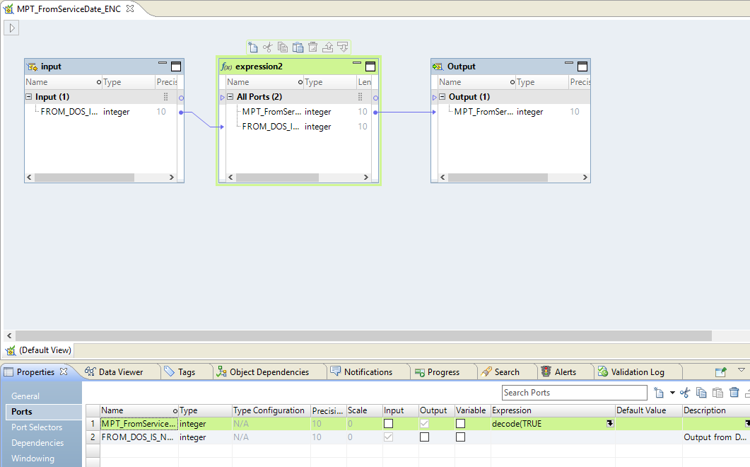
Fig. 13
- This mapplet needs to have the MPT_DateIsNotNull_ALL added to it. To do that we create a wrapping mapplet, MPT_FromServiceDate_ENC_NUM, which includes both these mapplets.
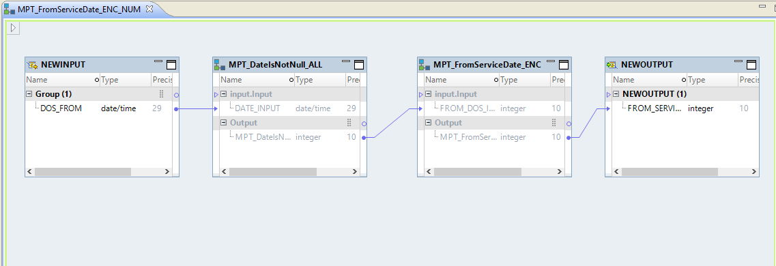
Fig. 14
- The final mapplet takes in DOS_FROM and returns a 1 or 0 if the DOS_FROM is populated.
- As described above the mapplets are grouped into mappings which reads the extracted encounter table and populates the staging table with sets of ones and zeros.
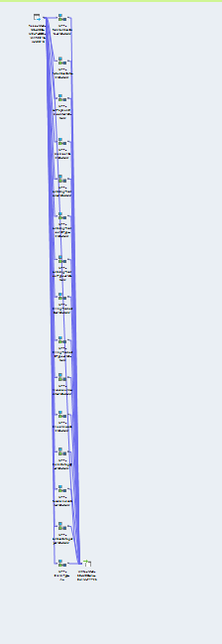
Fig. 15
- As explained above, these mappings become rather unwieldly when they grow to more than 15 or 20 mapplets, so we will run them as four to five groups.
- Looking at the head and tail of this mapping we see:
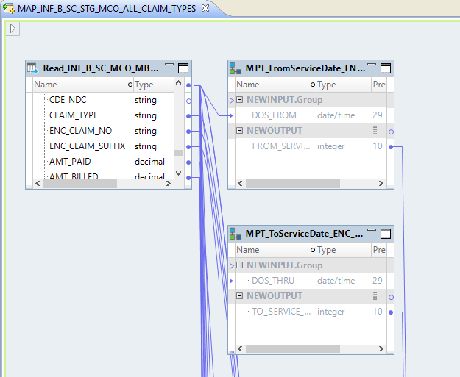

Fig. 16
- The MPT_FromServiceDate_ENC_NUM is being passed in the DOS_FROM and is sending the DOS_FROM
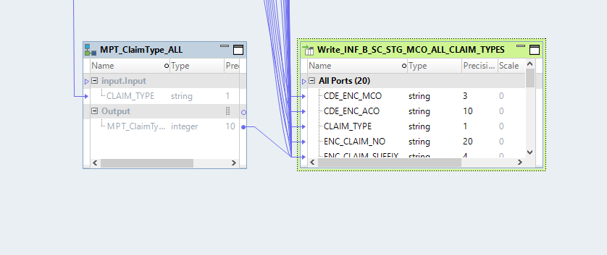
Fig. 17
To the staging table.
The staging table looks like:
CREATE TABLE INF_B_SC_STG_MCO_ALL_CLAIM_TYPES
(
CDE_ENC_MCO VARCHAR2(3 BYTE) NOT NULL,
CDE_ENC_ACO VARCHAR2(10 BYTE) NOT NULL,
CLAIM_TYPE VARCHAR2(1 BYTE) NOT NULL,
ENC_CLAIM_NO VARCHAR2(20 BYTE) NOT NULL,
ENC_CLAIM_SUFFIX VARCHAR2(4 BYTE) NOT NULL,
DOS_FROM NUMBER,
DOS_THRU NUMBER,
AMTPAY NUMBER,
ID_MEDICAID NUMBER,
SERV_PROV_ID NUMBER,
SERV_PROV_ID_TYPE NUMBER,
SERV_PROV_TYPE NUMBER,
BILL_PROV_ID NUMBER,
BILL_PROV_ID_TYPE NUMBER,
AMTALLOW NUMBER,
AMTBILL NUMBER,
CLAIMCAT NUMBER,
RECIND NUMBER,
SVCCAT NUMBER,
TOT_RECORDS NUMBER
)

It is at the claim line level of detail.
- Each of the groupings will have a similar staging table and will be merged by SQL and fed to the summation and aggregation mapping MAP_INF_B_SC_MCO_MBH_PTPDOS_MPT
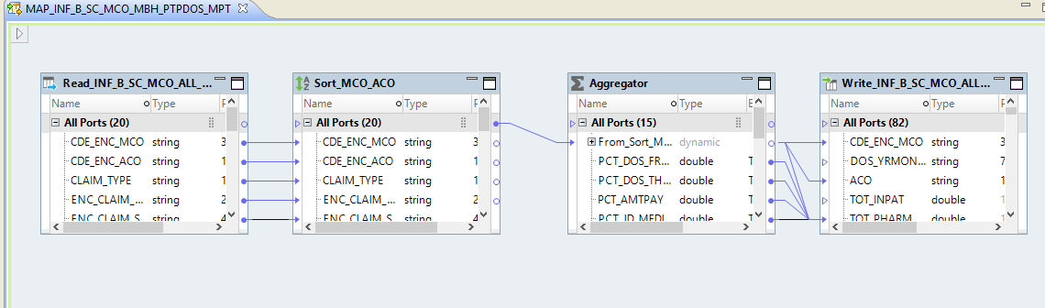
Fig. 18
Which populates a MPT version of the percentages table INF_B_SC_MCO_MBH_PTPDOS_MPT.
- The SQL feeding it will look like an expanded version of:
SELECT
"INF_B_SC_MCO_ALL_CLAIM_TYPES"."CDE_ENC_MCO",
"INF_B_SC_MCO_ALL_CLAIM_TYPES"."CDE_ENC_ACO",
"INF_B_SC_MCO_ALL_CLAIM_TYPES"."CLAIM_TYPE",
"INF_B_SC_MCO_ALL_CLAIM_TYPES"."ENC_CLAIM_NO",
"INF_B_SC_MCO_ALL_CLAIM_TYPES"."ENC_CLAIM_SUFFIX",
"INF_B_SC_MCO_ALL_CLAIM_TYPES"."DOS_FROM",
"INF_B_SC_MCO_ALL_CLAIM_TYPES"."DOS_THRU",
"INF_B_SC_MCO_ALL_CLAIM_TYPES"."AMTPAY",
"INF_B_SC_MCO_ALL_CLAIM_TYPES"."ID_MEDICAID",
"INF_B_SC_MCO_ALL_CLAIM_TYPES"."SERV_PROV_ID",
"INF_B_SC_MCO_ALL_CLAIM_TYPES"."SERV_PROV_ID_TYPE",
"INF_B_SC_MCO_ALL_CLAIM_TYPES"."SERV_PROV_TYPE",
"INF_B_SC_MCO_ALL_CLAIM_TYPES"."BILL_PROV_ID",
"INF_B_SC_MCO_ALL_CLAIM_TYPES_2"."BILL_PROV_ID_TYPE",
"INF_B_SC_MCO_ALL_CLAIM_TYPES_2"."AMTALLOW",
"INF_B_SC_MCO_ALL_CLAIM_TYPES_2"."AMTBILL",
"INF_B_SC_MCO_ALL_CLAIM_TYPES_2"."CLAIMCAT",
"INF_B_SC_MCO_ALL_CLAIM_TYPES_2"."RECIND",
"INF_B_SC_MCO_ALL_CLAIM_TYPES_2"."SVCCAT",
"INF_B_SC_MCO_ALL_CLAIM_TYPES_2"."TOT_RECORDS"
FROM "INF_B_SC_MCO_ALL_CLAIM_TYPES"
JOIN "INF_B_SC_MCO_ALL_CLAIM_TYPES_2"
ON "INF_B_SC_MCO_ALL_CLAIM_TYPES"."CDE_ENC_MCO" =
"INF_B_SC_MCO_ALL_CLAIM_TYPES_2"."CDE_ENC_MCO"
AND "INF_B_SC_MCO_ALL_CLAIM_TYPES"."ENC_CLAIM_NO" =
"INF_B_SC_MCO_ALL_CLAIM_TYPES_2"."ENC_CLAIM_NO"
AND "INF_B_SC_MCO_ALL_CLAIM_TYPES"."ENC_CLAIM_SUFFIX" =
"INF_B_SC_MCO_ALL_CLAIM_TYPES_2"."ENC_CLAIM_SUFFIX"
Fig. 19
    - Which combines the staging tables. This is a POC, since it is not written yet.
    - The sum/percentages are done in the Aggregator:
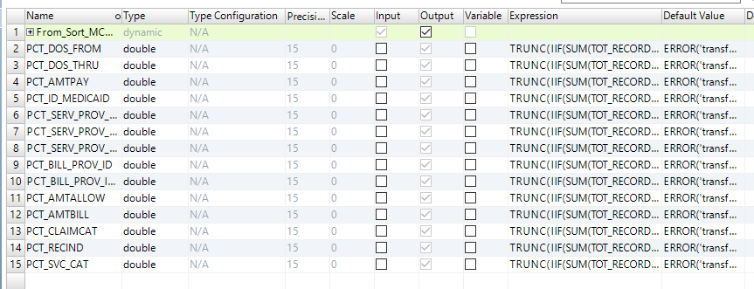
Fig. 20
    - With the aggregation and percentage done in the expressions:
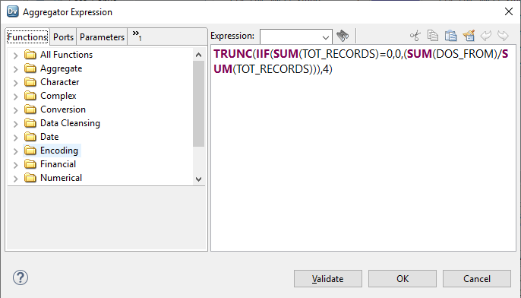
Fig. 21
    - There will be a final step which renames the INF_B_SC_MCO_MBH_PTPDOS_MPT to the INF_B_SC_MCO_MBH_PTPDOS_MPT_JUN2018_SEP2018.

Cognos Reports replacing Excel Report - Planned

Nicole’s Completeness deliverable consists of a spreadsheet with 6 tabs.
- The Cover tab provides links and dates for the reports
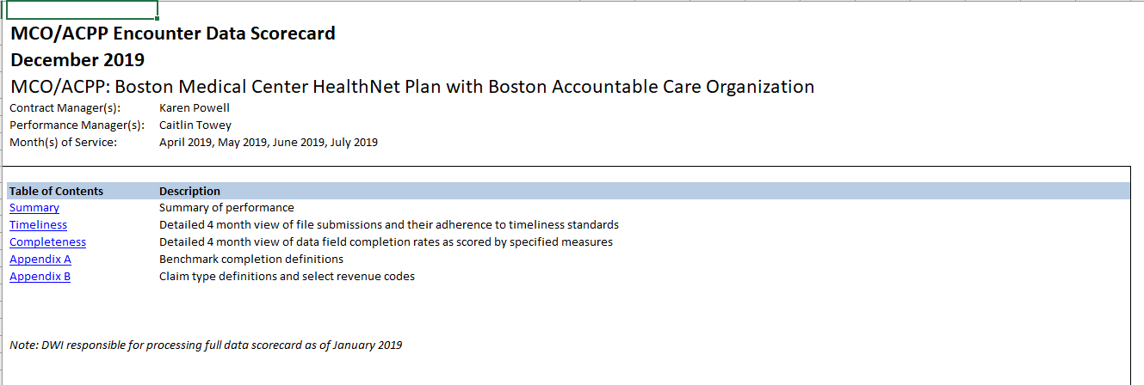
- The Summary provides overall statistics for the number of files loaded and Completeness benchmarks missed.
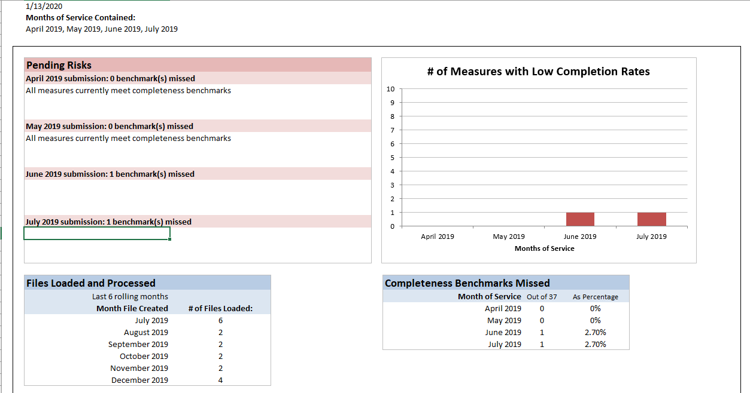

- The Timeliness tab provides statistics from the Encounter Statistics table, covering when file were received, if they were received on time and if there was a manual override.
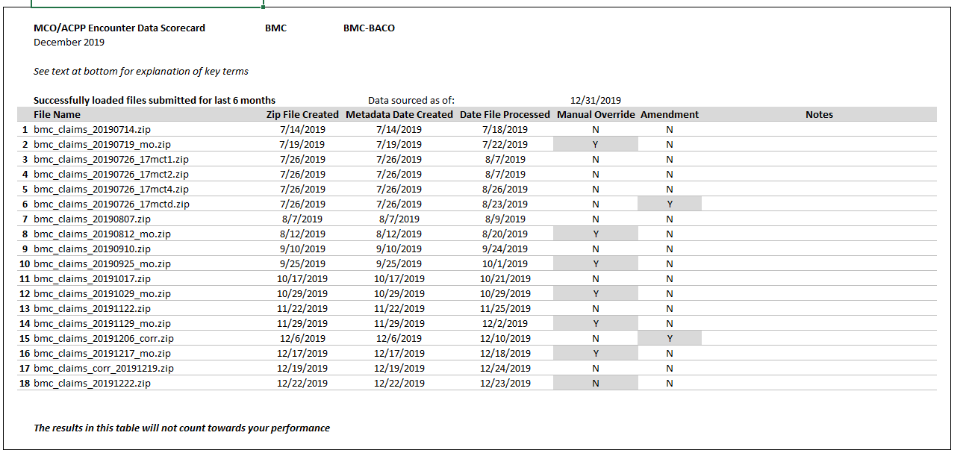

- The Completeness tab is the main report. It shows a comparison of statistics for each of the 37 measures across four submissions.
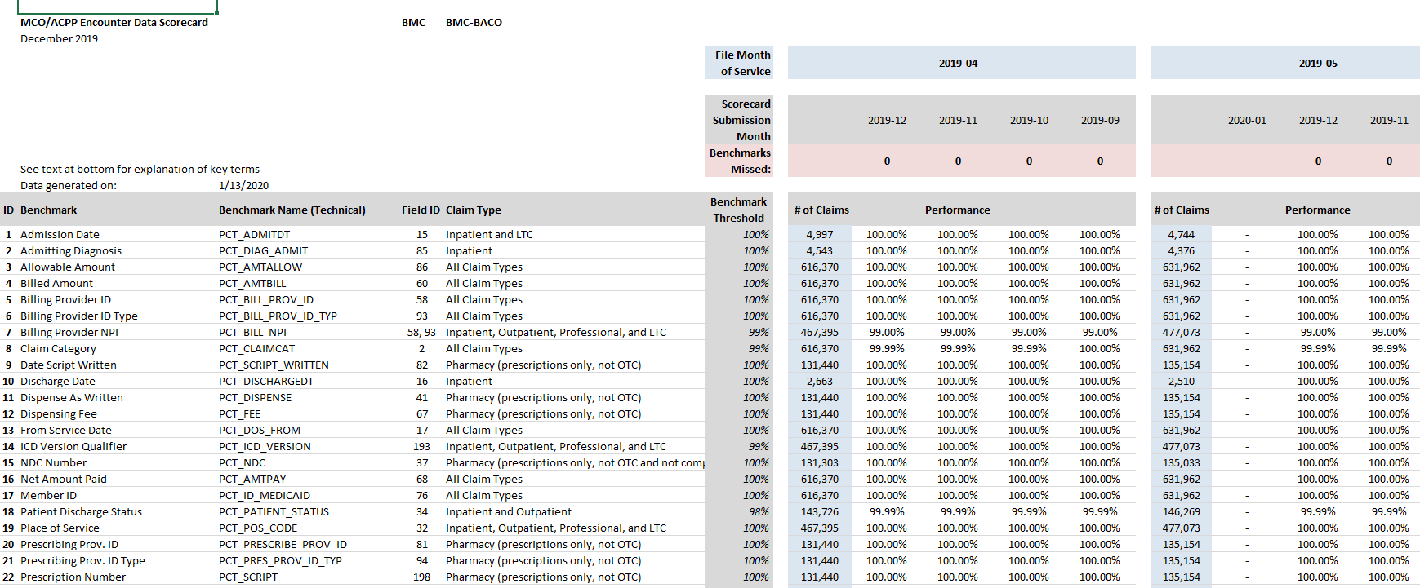

- Tabs 5 and 6 are Static Appendix tabs. Tab 5, Appendix A provides a list of definitions for the measures.
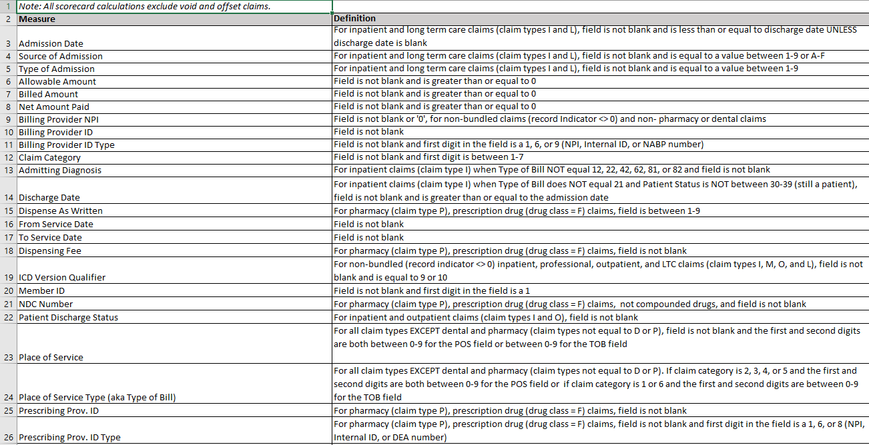

- Tab 6, Appendix 6 provides a list of Claim Types and an abbreviated list of Revenue Codes.
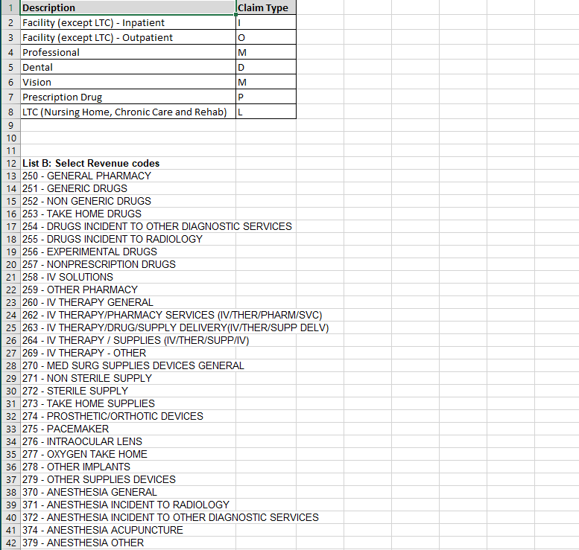

- The Cognos version.

    - For the revised report, we will be generating the tabs as pages on a Cognos Report Studio report. The report will consist of 6 pages, one for each tab and will use a combination of static and dynamic content.
    - Appendix A and B will probably be static (text type directly into the Cognos report page.)
    - The Cover will have a simple SQL query, for the dates.
    - The Completeness tab is the most difficult and requires a full set of pre SQLs creating staging tables, up to a final table which pretty much lays out the data for the report in a relational table.
    - The Summary will have several simple SQL Queries written against the tables crated for the Completeness tab.
    - The Timeliness tab will have one or more SQLs written against the Encounter Statistics table.
    - So far, we have been concentrating on the completeness tab. Kishore assisted in a preliminary POC report, which was sourced by a hand generated table (manual insert statements into a columnar, row table with cells corresponding to individual data points on the report.)
    - The report shown to the DI/DQ team looked like:
The Cover, with no links:
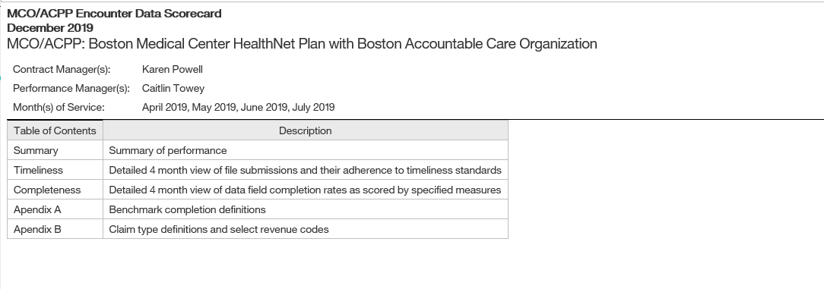
    - This was to demonstrate that a mixed content report could be generated that looked similar to the existing Cover report.
    - A piece of the Completeness report (here we were constrained for time, so it is only a piece, and layout had been demonstrated in the Cover report)
    - Here is a sample of the data created by had for the report. This needs to be replicated in the last SQL.
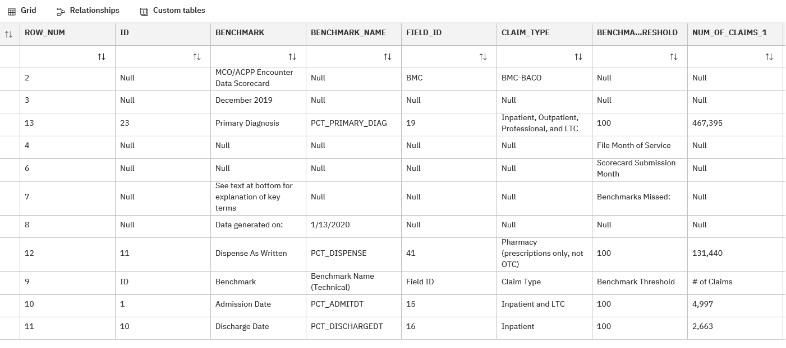
    - Borrowing from Nicole’s spreadsheet, the report showed this (more or less)
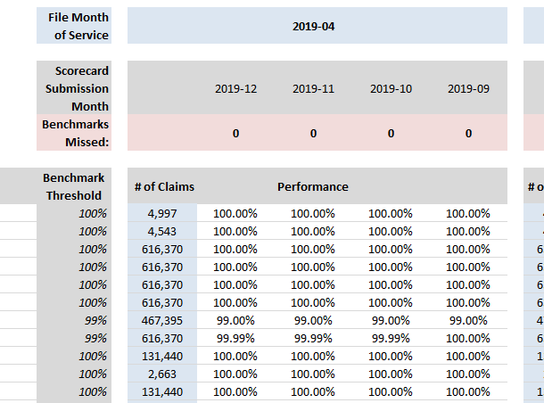

Cognos Reports actual and Infrastructure for reports

Leaving the introduction section 9 intact, this section is after the reports were completed, before showing to Nicole. We created a Cognos version of the Completeness spreadsheet that looks ok as HTML and PDF but not great as a spreadsheet. For the spreadsheet version we are utilizing the Data Integration Framework (DIF) and a template of Nicole’s worksheet to generate an exact replica. The DIF version will be discussed in section 11. Both versions utilize the same IDQ/SQL Infrastructure as outlined below.
- Nicole’s worksheet really consists of two reports, Completeness (the focus to this point of this document) and Timeliness (tracking the Encounter zip files), with various visualizations of the results derived from the two displayed across the pages of the worksheet.

- Continuing with the Completeness report, Nicole’s third SAS script, “STEP 3 GENERATE REPORT_aco.sas” picks up after PTPDOS table has been created (what we duplicated with Mappings and Mapplets above) and runs the results through four steps to produce a one-month spreadsheet output which Nicole then uses to manually update the Completeness report, by sliding all of the monthly windows over by a month.

- The four steps are: transpose, step 1, step 2 and generate the spreadsheet. With IDQ, we duplicated transpose, step 1 and step 2. We then added a step 2 snapshot, which holds all of the step 2 months versioned by run date (and adds dummy entries looking forward) and we created a step 3 table, which looks across the monthly windows in step 2 snapshot data, to generate a consolidated monthly data picture for the BI tools to generate the Completeness report. Step 3 is also versioned and thus holds a history of all of the consolidated completeness reports going back in time. Step 3 is then visualized by applying a set of views to each consolidated completeness data which presents the data to the Cognos data module and DIF SQLs (and perhaps Tableau, if desired for time based analytic processing.) We discus each of the steps below.

- Transpose uses a SAS pivot to pivot the data, we duplicated to with an Oracle unpivot.

Nicole’s SAS transpose
proc sort data=nw1.mco_mbh_ptpdos_&TF. out=mco_mbh_ptpdos_&TF.;
by cde_enc_mco dos_yrmonth aco;
run;

proc transpose data=mco_mbh_ptpdos_&TF. /*(where=(cde_enc_mco='BMC'))*/
out=mco_mbh_ptpdos_&TF._t (drop=TOT_INPAT TOT_PHARM TOT_OUTPT TOT_OUTPTQ2 TOT_DENT TOT_DENTQ2 TOT_MED
TOT_MEDQ2 TOT_NON_PHRM_DENTQ2 TOT_PHARM_SCRIPT TOT_INPT_LTC TOT_INPT_OUTPT_LTC
TOT_INP_OP_LTC_M_EXCQ2 TOT_NON_PHRM_DENT TOT_INPAT_FILTER1 TOT_INPAT_FILTER2
TOT_MOD_DME TOT_MOD_LABXRAY TOT_MOD_SURGERYM TOT_INOUTLTC_NOART TOT_INPT_OUTPT
TOT_PHARMSCRIPT_NOTCOMP TOT_NONPHARM TOT_RECORDS _label_ rename=(_name_=measure col1=actual));
var pct_id_medicaid -- pct_numlogclm;
by cde_enc_mco dos_yrmonth aco;
run;

IDQ Oracle transpose

truncate table INF_B_SC_STG_MCO_MBH_REP_TRANSPOSE;

insert into INF_B_SC_STG_MCO_MBH_REP_TRANSPOSE
select * from (
select
CDE_ENC_MCO,
DOS_YRMONTH,
ACO,
PCT_ID_MEDICAID,
PCT_DOS_FROM ,
PCT_DOS_THRU ,
PCT_SERV_PROV_ID,
PCT_SERV_PROV_ID_TYP,
PCT_SERV_PROV_TYP,
PCT_SERV_PROV_SPEC,
PCT_BILL_PROV_ID,
PCT_BILL_PROV_ID_TYP,
PCT_PRESCRIBE_PROV_ID,
PCT_PRES_PROV_ID_TYP,
PCT_PRIMARY_DIAG,
PCT_ICD_VERSION,
PCT_PROC_CODE ,
PCT_PROC_CODE_O_D,
PCT_PROC_CODE_M,
PCT_PROC_MOD_DME,
PCT_PROC_MOD_LABXRAY,
PCT_PROC_MOD_SURGERYM,
PCT_QTY_UNIT_BILL,
PCT_BILL_NPI ,
PCT_SERV_NPI ,
PCT_SCRIPT_WRITTEN,
PCT_REFILL ,
PCT_DISPENSE ,
PCT_SCRIPT ,
PCT_FEE ,
PCT_NDC ,
PCT_CLAIMCAT ,
PCT_SVC_CAT ,
PCT_RECIND ,
PCT_AMTBILL ,
PCT_AMTPAY ,
PCT_AMTALLOW ,
PCT_ADMITDT ,
PCT_DISCHARGEDT,
PCT_DIAG_ADMIT ,
PCT_PATIENT_STATUS,
PCT_ADMIT_TYPE ,
PCT_ADMIT_SOURCE,
PCT_REV_CODE ,
PCT_POS_CODE ,
PCT_POS_TYPE ,
PCT_PAID_DT ,
PCT_SERV_ID_LOC,
PCT_BILL_ID_LOC,
PCT_PRS_ID_LOC ,
PCT_ACO ,
PCT_TPL ,
PCT_COPAY ,
PCT_COINS ,
PCT_CLMDISP ,
PCT_CLMNUM ,
PCT_CLMSUF ,
PCT_NUMLOGCLM
from INF_B_SC_STG_MCO_MBH_PTPDOS
) s
unpivot (
(actuals) for meas in (
PCT_ID_MEDICAID,
PCT_DOS_FROM ,
PCT_DOS_THRU ,
PCT_SERV_PROV_ID,
PCT_SERV_PROV_ID_TYP,
PCT_SERV_PROV_TYP,
PCT_SERV_PROV_SPEC,
PCT_BILL_PROV_ID,
PCT_BILL_PROV_ID_TYP,
PCT_PRESCRIBE_PROV_ID,
PCT_PRES_PROV_ID_TYP,
PCT_PRIMARY_DIAG,
PCT_ICD_VERSION,
PCT_PROC_CODE ,
PCT_PROC_CODE_O_D,
PCT_PROC_CODE_M,
PCT_PROC_MOD_DME,
PCT_PROC_MOD_LABXRAY,
PCT_PROC_MOD_SURGERYM,
PCT_QTY_UNIT_BILL,
PCT_BILL_NPI ,
PCT_SERV_NPI ,
PCT_SCRIPT_WRITTEN,
PCT_REFILL ,
PCT_DISPENSE ,
PCT_SCRIPT ,
PCT_FEE ,
PCT_NDC ,
PCT_CLAIMCAT ,
PCT_SVC_CAT ,
PCT_RECIND ,
PCT_AMTBILL ,
PCT_AMTPAY ,
PCT_AMTALLOW ,
PCT_ADMITDT ,
PCT_DISCHARGEDT,
PCT_DIAG_ADMIT ,
PCT_PATIENT_STATUS,
PCT_ADMIT_TYPE ,
PCT_ADMIT_SOURCE,
PCT_REV_CODE ,
PCT_POS_CODE ,
PCT_POS_TYPE ,
PCT_PAID_DT ,
PCT_SERV_ID_LOC,
PCT_BILL_ID_LOC,
PCT_PRS_ID_LOC ,
PCT_ACO ,
PCT_TPL ,
PCT_COPAY ,
PCT_COINS ,
PCT_CLMDISP ,
PCT_CLMNUM ,
PCT_CLMSUF ,
PCT_NUMLOGCLM
))
order by
CDE_ENC_MCO,
DOS_YRMONTH,
ACO;

- STEP 1 adds claim type information and formats the completeness calcs (“actuals”)
Nicole’s SAS
proc sql;
create table report_step1 as
select
'2021-03' as query_month, /*UPDATE*/
dos_yrmonth as month_service,
measure,
case when measure ='PCT_ID_MEDICAID' or measure ='PCT_DOS_FROM' or measure ='PCT_DOS_THRU' or
measure ='PCT_SERV_PROV_ID' or measure ='PCT_SERV_PROV_ID_TYP' or measure ='PCT_SERV_PROV_TYP' or
measure ='PCT_SERV_PROV_SPEC' or measure ='PCT_BILL_PROV_ID' or measure ='PCT_BILL_PROV_ID_TYP' or
measure='PCT_SVC_CAT' or measure='PCT_CLAIMCAT' or
measure='PCT_RECIND' or measure='PCT_AMTBILL' or measure='PCT_AMTALLOW' or measure='PCT_AMTPAY' or
measure='PCT_PAID_DT' or measure='PCT_SERV_ID_LOC' or measure='PCT_BILL_ID_LOC' or measure='PCT_TPL' or
measure='PCT_COPAY' or measure='PCT_COINS' or measure='PCT_CLMDISP' or measure='PCT_CLMNUM' or
measure='PCT_CLMSUF' or measure='PCT_NUMLOGCLM' or measure='PCT_ACO'
then 'All Claim Types'

when measure='PCT_QTY_UNIT_BILL' then 'Non Pharmacy'

when measure='PCT_PRESCRIBE_PROV_ID' or measure='PCT_PRES_PROV_ID_TYP' or measure='PCT_SCRIPT_WRITTEN' or
measure='PCT_REFILL' or measure='PCT_DISPENSE' or measure='PCT_SCRIPT' or measure='PCT_FEE' or
measure='PCT_PRS_ID_LOC'
then 'Pharmacy (prescriptions only, not OTC)'

when measure='PCT_NDC' then 'Pharmacy (prescriptions only, not OTC and not compounded)'

when measure='PCT_PRIMARY_DIAG' or measure='PCT_ICD_VERSION' or measure='PCT_POS_CODE' or
measure='PCT_POS_TYPE' or measure='PCT_SERV_NPI' or measure='PCT_BILL_NPI'
then 'Inpatient, Outpatient, Professional, and LTC'

when measure='PCT_PROC_CODE_O_D' then 'Outpatient'

when measure='PCT_PROC_CODE_M' or measure='PCT_PROC_MOD_LABXRAY' or measure='PCT_PROC_MOD_SURGERYM'
then 'Professional'

when measure='PCT_PROC_MOD_DME' then 'Professional (modifier=RR,NU,UE)'

when measure='PCT_ADMITDT' or measure='PCT_ADMIT_TYPE' or measure='PCT_ADMIT_SOURCE' then 'Inpatient and LTC'

when measure='PCT_DISCHARGEDT' or measure='PCT_DIAG_ADMIT' then 'Inpatient'

when measure='PCT_PATIENT_STATUS' then 'Inpatient and Outpatient'

when measure='PCT_REV_CODE' then 'Inpatient, Outpatient, and LTC'
end as claimtype,

cde_enc_mco as plan,
aco,
ROUND((actual)*100,.01) as actual /*converting rate to a percent and rounding 2 decimal places*/
from mco_mbh_ptpdos_&TF._t;
run;

The IDQ Oracle replacement
truncate table INF_B_SC_STG_MCO_MBH_REP_STEP1;

insert into INF_B_SC_STG_MCO_MBH_REP_STEP1
select
'~QUERY_MONTH~' as query_month,
dos_yrmonth as month_service,
meas,
case when meas ='PCT_ID_MEDICAID' or meas ='PCT_DOS_FROM' or meas ='PCT_DOS_THRU' or
meas ='PCT_SERV_PROV_ID' or meas ='PCT_SERV_PROV_ID_TYP' or meas ='PCT_SERV_PROV_TYP' or
meas ='PCT_SERV_PROV_SPEC' or meas ='PCT_BILL_PROV_ID' or meas ='PCT_BILL_PROV_ID_TYP' or
meas='PCT_SVC_CAT' or meas='PCT_CLAIMCAT' or
meas='PCT_RECIND' or meas='PCT_AMTBILL' or meas='PCT_AMTALLOW' or meas='PCT_AMTPAY' or
meas='PCT_PAID_DT' or meas='PCT_SERV_ID_LOC' or meas='PCT_BILL_ID_LOC' or meas='PCT_TPL' or
meas='PCT_COPAY' or meas='PCT_COINS' or meas='PCT_CLMDISP' or meas='PCT_CLMNUM' or
meas='PCT_CLMSUF' or meas='PCT_NUMLOGCLM' or meas='PCT_ACO'
then 'All Claim Types'

when meas='PCT_QTY_UNIT_BILL' then 'Non Pharmacy'

when meas='PCT_PRESCRIBE_PROV_ID' or meas='PCT_PRES_PROV_ID_TYP' or meas='PCT_SCRIPT_WRITTEN' or
meas='PCT_REFILL' or meas='PCT_DISPENSE' or meas='PCT_SCRIPT' or meas='PCT_FEE' or
meas='PCT_PRS_ID_LOC'
then 'Pharmacy (prescriptions only, not OTC)'

when meas='PCT_NDC' then 'Pharmacy (prescriptions only, not OTC and not compounded)'

when meas='PCT_PRIMARY_DIAG' or meas='PCT_ICD_VERSION' or meas='PCT_POS_CODE' or
meas='PCT_POS_TYPE' or meas='PCT_SERV_NPI' or meas='PCT_BILL_NPI'
then 'Inpatient, Outpatient, Professional, and LTC'

when meas='PCT_PROC_CODE_O_D' then 'Outpatient'

when meas='PCT_PROC_CODE_M' or meas='PCT_PROC_MOD_LABXRAY' or meas='PCT_PROC_MOD_SURGERYM'
then 'Professional'

when meas='PCT_PROC_MOD_DME' then 'Professional (modifier=RR,NU,UE)'

when meas='PCT_ADMITDT' or meas='PCT_ADMIT_TYPE' or meas='PCT_ADMIT_SOURCE' then 'Inpatient and LTC'

when meas='PCT_DISCHARGEDT' or meas='PCT_DIAG_ADMIT' then 'Inpatient'

when meas='PCT_PATIENT_STATUS' then 'Inpatient and Outpatient'

when meas='PCT_REV_CODE' then 'Inpatient, Outpatient, and LTC'
end as claimtype,
cde_enc_mco as plan,
aco,
ROUND((actuals)*100,2) as actuals /*converting rate to a percent and rounding 2 decimal places*/
from INF_B_SC_STG_MCO_MBH_REP_TRANSPOSE;

- STEP 2 categorizes the measure into reporting groups
SAS query
proc sql;
create table report_step2 as
select query_month, month_service, measure, claimtype, plan, aco, claim_count, actual
from
(
select rpt1.*,
case when measure ='PCT_ID_MEDICAID' or measure ='PCT_DOS_FROM' or measure ='PCT_DOS_THRU' or
measure ='PCT_SERV_PROV_ID' or measure ='PCT_SERV_PROV_ID_TYP' or measure ='PCT_SERV_PROV_TYP' or
measure ='PCT_SERV_PROV_SPEC' or measure ='PCT_BILL_PROV_ID' or measure ='PCT_BILL_PROV_ID_TYP' or
measure='PCT_SVC_CAT' or measure='PCT_CLAIMCAT' or
measure='PCT_RECIND' or measure='PCT_AMTBILL' or measure='PCT_AMTALLOW' or measure='PCT_AMTPAY' or
measure='PCT_PAID_DT' or measure='PCT_SERV_ID_LOC' or measure='PCT_BILL_ID_LOC' or measure='PCT_TPL' or
measure='PCT_COPAY' or measure='PCT_COINS' or measure='PCT_CLMDISP' or measure='PCT_CLMNUM' or
measure='PCT_CLMSUF' or measure='PCT_NUMLOGCLM' or measure='PCT_ACO'
then TOT_RECORDS
when measure='PCT_PRESCRIBE_PROV_ID' or measure='PCT_PRES_PROV_ID_TYP' or measure='PCT_SCRIPT_WRITTEN' or
measure='PCT_REFILL' or measure='PCT_DISPENSE' or measure='PCT_SCRIPT' or measure='PCT_FEE' or
measure='PCT_PRS_ID_LOC' then TOT_PHARM_SCRIPT
when measure='PCT_NDC' then TOT_PHARMSCRIPT_NOTCOMP
when measure='PCT_QTY_UNIT_BILL' then TOT_NONPHARM
when measure='PCT_PRIMARY_DIAG' or measure='PCT_SERV_NPI' or measure='PCT_BILL_NPI' then TOT_NON_PHRM_DENTQ2
when measure='PCT_ADMITDT' or measure='PCT_ADMIT_TYPE' or measure='PCT_ADMIT_SOURCE' then TOT_INPT_LTC
when measure='PCT_PRIMARY_DIAG' then TOT_NON_PHRM_DENTQ2
when measure='PCT_ICD_VERSION' then TOT_INP_OP_LTC_M_EXCQ2
when measure='PCT_PROC_CODE_M' then TOT_MEDQ2
when measure='PCT_PROC_CODE_O_D' then TOT_OUTPTQ2
when measure='PCT_PROC_MOD_DME' then TOT_MOD_DME
when measure='PCT_PROC_MOD_LABXRAY' then TOT_MOD_LABXRAY
when measure='PCT_PROC_MOD_SURGERYM' then TOT_MOD_SURGERYM
when measure='PCT_POS_CODE' or measure='PCT_POS_TYPE' then TOT_NON_PHRM_DENT
when measure='PCT_REV_CODE' then TOT_INOUTLTC_NOART
when measure='PCT_PATIENT_STATUS' then TOT_INPT_OUTPT
when measure='PCT_DIAG_ADMIT' then TOT_INPAT_FILTER2
when measure='PCT_DISCHARGEDT' then TOT_INPAT_FILTER1
end as claim_count
from report_step1 rpt1
inner join (select cde_enc_mco, dos_yrmonth, aco, TOT_INPAT, TOT_PHARM, TOT_OUTPT, TOT_OUTPTQ2, TOT_DENT, TOT_DENTQ2,
TOT_MED, TOT_MEDQ2, TOT_NON_PHRM_DENTQ2, TOT_PHARM_SCRIPT, TOT_INPT_LTC,
TOT_INPT_OUTPT_LTC, TOT_INP_OP_LTC_M_EXCQ2, TOT_NON_PHRM_DENT,
TOT_INPAT_FILTER1, TOT_INPAT_FILTER2, TOT_MOD_DME, TOT_MOD_LABXRAY,
TOT_MOD_SURGERYM, TOT_INOUTLTC_NOART, TOT_INPT_OUTPT, TOT_PHARMSCRIPT_NOTCOMP,TOT_NONPHARM,
TOT_RECORDS
from mco_mbh_ptpdos_&TF.
/*where cde_enc_mco='BMC'*/)rpt2
on rpt1.plan=rpt2.cde_enc_mco and rpt1.month_service=rpt2.dos_yrmonth and rpt1.aco=rpt2.aco);
run;

proc sort data=report_step2 out=mco_mbh_report_&tf.;
by query_month plan month_service aco measure;
run;

IDQ Oracle replacement
truncate table INF_B_SC_STG_MCO_MBH_REP_STEP2;

insert into INF_B_SC_STG_MCO_MBH_REP_STEP2
select query_month, month_service, meas, claimtype, plan, aco, claim_count, actuals
from
(
select rpt1.*,
case when meas ='PCT_ID_MEDICAID' or meas ='PCT_DOS_FROM' or meas ='PCT_DOS_THRU' or
meas ='PCT_SERV_PROV_ID' or meas ='PCT_SERV_PROV_ID_TYP' or meas ='PCT_SERV_PROV_TYP' or
meas ='PCT_SERV_PROV_SPEC' or meas ='PCT_BILL_PROV_ID' or meas ='PCT_BILL_PROV_ID_TYP' or
meas='PCT_SVC_CAT' or meas='PCT_CLAIMCAT' or
meas='PCT_RECIND' or meas='PCT_AMTBILL' or meas='PCT_AMTALLOW' or meas='PCT_AMTPAY' or
meas='PCT_PAID_DT' or meas='PCT_SERV_ID_LOC' or meas='PCT_BILL_ID_LOC' or meas='PCT_TPL' or
meas='PCT_COPAY' or meas='PCT_COINS' or meas='PCT_CLMDISP' or meas='PCT_CLMNUM' or
meas='PCT_CLMSUF' or meas='PCT_NUMLOGCLM' or meas='PCT_ACO'
then TOT_RECORDS
when meas='PCT_PRESCRIBE_PROV_ID' or meas='PCT_PRES_PROV_ID_TYP' or meas='PCT_SCRIPT_WRITTEN' or
meas='PCT_REFILL' or meas='PCT_DISPENSE' or meas='PCT_SCRIPT' or meas='PCT_FEE' or
meas='PCT_PRS_ID_LOC' then TOT_PHARM_SCRIPT
when meas='PCT_NDC' then TOT_PHARMSCRIPT_NOTCOMP
when meas='PCT_QTY_UNIT_BILL' then TOT_NONPHARM
when meas='PCT_PRIMARY_DIAG' or meas='PCT_SERV_NPI' or meas='PCT_BILL_NPI' then TOT_NON_PHRM_DENTQ2
when meas='PCT_ADMITDT' or meas='PCT_ADMIT_TYPE' or meas='PCT_ADMIT_SOURCE' then TOT_INPT_LTC
when meas='PCT_PRIMARY_DIAG' then TOT_NON_PHRM_DENTQ2
when meas='PCT_ICD_VERSION' then TOT_INP_OP_LTC_M_EXCQ2
when meas='PCT_PROC_CODE_M' then TOT_MEDQ2
when meas='PCT_PROC_CODE_O_D' then TOT_OUTPTQ2
when meas='PCT_PROC_MOD_DME' then TOT_MOD_DME
when meas='PCT_PROC_MOD_LABXRAY' then TOT_MOD_LABXRAY
when meas='PCT_PROC_MOD_SURGERYM' then TOT_MOD_SURGERYM
when meas='PCT_POS_CODE' or meas='PCT_POS_TYPE' then TOT_NON_PHRM_DENT
when meas='PCT_REV_CODE' then TOT_INOUTLTC_NOART
when meas='PCT_PATIENT_STATUS' then TOT_INPT_OUTPT
when meas='PCT_DIAG_ADMIT' then TOT_INPAT_FILTER2
when meas='PCT_DISCHARGEDT' then TOT_INPAT_FILTER1
end as claim_count
from INF_B_SC_STG_MCO_MBH_REP_STEP1 rpt1
inner join (select cde_enc_mco, dos_yrmonth, aco, TOT_INPAT, TOT_PHARM, TOT_OUTPT, TOT_OUTPTQ2, TOT_DENT, TOT_DENTQ2,
TOT_MED, TOT_MEDQ2, TOT_NON_PHRM_DENTQ2, TOT_PHARM_SCRIPT, TOT_INPT_LTC,
TOT_INPT_OUTPT_LTC, TOT_INP_OP_LTC_M_EXCQ2, TOT_NON_PHRM_DENT,
TOT_INPAT_FILTER1, TOT_INPAT_FILTER2, TOT_MOD_DME, TOT_MOD_LABXRAY,
TOT_MOD_SURGERYM, TOT_INOUTLTC_NOART, TOT_INPT_OUTPT, TOT_PHARMSCRIPT_NOTCOMP,TOT_NONPHARM,
TOT_RECORDS
from INF_B_SC_STG_MCO_MBH_PTPDOS
)rpt2
on rpt1.plan=rpt2.cde_enc_mco and rpt1.month_service=rpt2.dos_yrmonth and rpt1.aco=rpt2.aco)

- The SAS final output to Nicole’s working spreadsheet and table

proc print data=mco_mbh_report_&tf.;
var query_month month_service measure claimtype plan aco claim_count actual;
run;

proc export data=mco_mbh_report_&tf.
(KEEP =query_month month_service measure claimtype plan aco claim_count actual where=(measure <> 'PCT_PROC_CODE'))
outfile="Z:\APPLICATION ANALYSIS\MCO and MBHP Evaluation Scorecard\&TF.\REPORTS\MCO_MBH_SCORECARD_&TF..XLS"
replace;
sheet="&SYSDATE";
run;

proc sql;
create table nw1.mco_mbh_report_&tf. as
select query_month, month_service, measure, claimtype, plan, aco, claim_count, actual
from mco_mbh_report_&tf.;
run;

- IDQ STEP 2 Snapshot. In step3 we will need seven query months to display across the four DOS month windows. The first window shows current month and three before it. Each successive window shows a future month added with “-“ of the blank data, with the final month only showing one real months data. We chose to automate this processing by adding dummy future months to the STEP 2 SNAPSHOT table. When each new monthly snapshot is run, the corresponding dummy month is removed, the new data is added and a new future dummy month is added.

Note, you will see some odd logic to coerce dashes to underscores in STEP 2 SNAPSHOT, STEP 3 and the views, this is because the pivots in step 3 did weird things with dashes, so we converted them to underscores before Step3 and back to dashes in the views.

--Delete the dummy month
delete from INF_B_SC_STG_MCO_MBH_REP_STEP2_SNAPSHOTS
where QUERY_MONTH = '~QUERY_MONTH~';

--Add the real data
insert into INF_B_SC_STG_MCO_MBH_REP_STEP2_SNAPSHOTS
(
QUERY_MONTH,
MON,
MONTH_SERVICE,
MEAS,
CLAIMTYPE,
PLAN,
ACO,
CLAIM_COUNT,
ACTUALS
)
SELECT
'~QUERY_MONTH~' AS QUERY_MONTH,
'~MONYY~' AS MON,
MONTH_SERVICE,
MEAS,
CLAIMTYPE,
PLAN,
ACO,
CLAIM_COUNT,
ACTUALS
FROM INF_B_SC_STG_MCO_MBH_REP_STEP2;

-- Insert the new dummy month
insert into INF_B_SC_STG_MCO_MBH_REP_STEP2_SNAPSHOTS
(
QUERY_MONTH,
MON,
MONTH_SERVICE,
MEAS,
CLAIMTYPE,
PLAN,
ACO,
CLAIM_COUNT,
ACTUALS
)
select distinct
'~QUERY_MON_PLUS_3~' AS QUERY_MONTH,
'~DUMMY_MON~' AS MON,
'~DUMMY_DOS_1~' AS MONTH_SERVICE,
MEAS,
CLAIMTYPE,
PLAN,
ACO,
NULL AS CLAIM_COUNT,
NULL AS ACTUALS
from INF_B_SC_STG_MCO_MBH_REP_STEP2;

insert into INF_B_SC_STG_MCO_MBH_REP_STEP2_SNAPSHOTS
(
QUERY_MONTH,
MON,
MONTH_SERVICE,
MEAS,
CLAIMTYPE,
PLAN,
ACO,
CLAIM_COUNT,
ACTUALS
)
select distinct
'~QUERY_MON_PLUS_3~' AS QUERY_MONTH,
'~DUMMY_MON~' AS MON,
'~DUMMY_DOS_2~' AS MONTH_SERVICE,
MEAS,
CLAIMTYPE,
PLAN,
ACO,
NULL AS CLAIM_COUNT,
NULL AS ACTUALS
from INF_B_SC_STG_MCO_MBH_REP_STEP2;

insert into INF_B_SC_STG_MCO_MBH_REP_STEP2_SNAPSHOTS
(
QUERY_MONTH,
MON,
MONTH_SERVICE,
MEAS,
CLAIMTYPE,
PLAN,
ACO,
CLAIM_COUNT,
ACTUALS
)
select distinct
'~QUERY_MON_PLUS_3~' AS QUERY_MONTH,
'~DUMMY_MON~' AS MON,
'~DUMMY_DOS_3~' AS MONTH_SERVICE,
MEAS,
CLAIMTYPE,
PLAN,
ACO,
NULL AS CLAIM_COUNT,
NULL AS ACTUALS
from INF_B_SC_STG_MCO_MBH_REP_STEP2;

insert into INF_B_SC_STG_MCO_MBH_REP_STEP2_SNAPSHOTS
(
QUERY_MONTH,
MON,
MONTH_SERVICE,
MEAS,
CLAIMTYPE,
PLAN,
ACO,
CLAIM_COUNT,
ACTUALS
)
select distinct
'~QUERY_MON_PLUS_3~' AS QUERY_MONTH,
'~DUMMY_MON~' AS MON,
'~DUMMY_DOS_4~' AS MONTH_SERVICE,
MEAS,
CLAIMTYPE,
PLAN,
ACO,
NULL AS CLAIM_COUNT,
NULL AS ACTUALS
from INF_B_SC_STG_MCO_MBH_REP_STEP2;

-- Just to make sure they are all underscores for STEP3 - will reverse in final views
update INF_B_SC_STG_MCO_MBH_REP_STEP2_SNAPSHOTS
set
query_month = substr(query_month,1,4) || '_' || substr(query_month,6,2),
month_service = substr(month_service,1,4) || '_' || substr(month_service,6,2);

- The Completeness spreadsheet has a static list of measures and Benchmark Thresholds that are resident in the spreadsheet. To facilitate generating the reports dynamically, a table was created to hold these values INF_B_SC_STG_MCO_MBH_SCORECARD_LOOKUP.

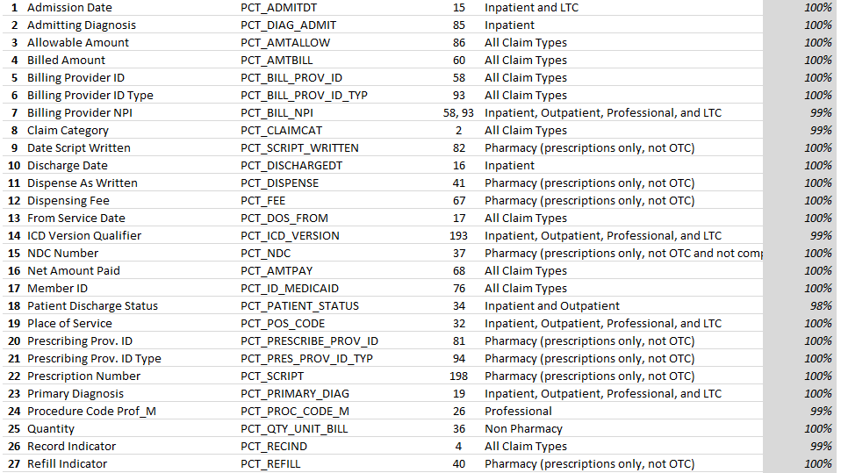

CREATE TABLE INF_B_SC_STG_MCO_MBH_SCORECARD_LOOKUP
(
ID NUMBER(4),
BENCHMARK VARCHAR2(50 BYTE),
BENCHMARK_NAME VARCHAR2(50 BYTE),
FIELD_ID VARCHAR2(50 BYTE),
CLAIM_TYPE VARCHAR2(100 BYTE),
BENCHMARK_THRESHOLD NUMBER(3,2)
)

- STEP 3 reads across the STEP 2 SNAPSHOT twice, once for the Claims and once for the Actuals, pivots the data for each and joins them with the Scorecard Lookup table to generate a layout to fill in the completeness grid. Then, to put everything in one place, the headers, run date and batch seq are denormalized added to the end of each row.

INSERT INTO INF_B_SC_STG_MCO_MBH_REP_STEP3
SELECT

PLAN

T.PLAN,
T.ACO,

LOOKUP FIELDS

L.ID,
L.BENCHMARK,
L.BENCHMARK_NAME,
L.FIELD_ID,
L.CLAIM_TYPE,
L.BENCHMARK_THRESHOLD,

PERFORMANCE GRID

T.A_MONTH_SERVICE,
C.A_CLM,
T.A_ACT_4,
T.A_ACT_3,
T.A_ACT_2,
T.A_ACT_1,
T.B_MONTH_SERVICE,
C.B_CLM,
T.B_ACT_5,
T.B_ACT_4,
T.B_ACT_3,
T.B_ACT_2,
T.C_MONTH_SERVICE,
C.C_CLM,
T.C_ACT_6,
T.C_ACT_5,
T.C_ACT_4,
T.C_ACT_3,
T.D_MONTH_SERVICE,
C.D_CLM,
T.D_ACT_7,
T.D_ACT_6,
T.D_ACT_5,
T.D_ACT_4,

DENORMALIZED FIELDS

'~RUN_DATE_STR~' AS RUN_DATE_STR,
'~LAST_SUB_STR~' AS LAST_SUB_STR,
TO_DATE('~RUN_DATE~','YYYYMMDD') AS RUN_DATE,
TO_NUMBER('~DQ_BATCH_SEQ~','99999999') AS DQ_BATCH_SEQ,
'~REP_DOS1~' AS A_CLM_HDR,
'~REP_MON4~' AS A_ACT_4_HDR,
'~REP_MON3~' AS A_ACT_3_HDR,
'~REP_MON2~' AS A_ACT_2_HDR,
'~REP_MON1~' AS A_ACT_1_HDR,
'~REP_DOS2~' AS B_CLM_HDR,
'~REP_MON5~' AS B_ACT_5_HDR,
'~REP_MON4~' AS B_ACT_4_HDR,
'~REP_MON3~' AS B_ACT_3_HDR,
'~REP_MON2~' AS B_ACT_2_HDR,
'~REP_DOS3~' AS C_CLM_HDR,
'~REP_MON6~' AS C_ACT_6_HDR,
'~REP_MON5~' AS C_ACT_5_HDR,
'~REP_MON4~' AS C_ACT_4_HDR,
'~REP_MON3~' AS C_ACT_3_HDR,
'~REP_DOS4~' AS D_CLM_HDR,
'~REP_MON7~' AS D_ACT_7_HDR,
'~REP_MON6~' AS D_ACT_6_HDR,
'~REP_MON5~' AS D_ACT_5_HDR,
'~REP_MON4~' AS D_ACT_4_HDR
FROM (

ACTUALS

WITH COMP AS (
SELECT PLAN, ACO, MEAS, MONTH_SERVICE,
"'ACT_~REP_MON7~'" AS ACT_~REP_MON7~,
"'ACT_~REP_MON6~'" AS ACT_~REP_MON6~,
"'ACT_~REP_MON5~'" AS ACT_~REP_MON5~,
"'ACT_~REP_MON4~'" AS ACT_~REP_MON4~,
"'ACT_~REP_MON3~'" AS ACT_~REP_MON3~,
"'ACT_~REP_MON2~'" AS ACT_~REP_MON2~,
"'ACT_~REP_MON1~'" AS ACT_~REP_MON1~
FROM
(
SELECT
PLAN,
ACO,
MEAS,
MONTH_SERVICE,
'ACT_' || QUERY_MONTH AS QUERY_MONTH,
ACTUALS
FROM INF_B_SC_STG_MCO_MBH_REP_STEP2_SNAPSHOTS
WHERE MONTH_SERVICE IN ('~REP_DOS1~','~REP_DOS2~','~REP_DOS3~','~REP_DOS4~')
ORDER BY PLAN, ACO, MONTH_SERVICE, MEAS, QUERY_MONTH
)
PIVOT (
MAX(ACTUALS)
FOR QUERY_MONTH IN ('ACT_~REP_MON7~', 'ACT_~REP_MON6~', 'ACT_~REP_MON5~', 'ACT_~REP_MON4~', 'ACT_~REP_MON3~', 'ACT_~REP_MON2~', 'ACT_~REP_MON1~' )
)
ORDER BY PLAN, ACO, MONTH_SERVICE, MEAS
),
FILL AS (
SELECT DISTINCT PLAN, ACO, MEAS
FROM INF_B_SC_STG_MCO_MBH_REP_STEP2_SNAPSHOTS )
SELECT F.PLAN, F.ACO, F.MEAS,
A.MONTH_SERVICE AS A_MONTH_SERVICE,
A.ACT_~REP_MON4~ AS A_ACT_4, A.ACT_~REP_MON3~ AS A_ACT_3, A.ACT_~REP_MON2~ AS A_ACT_2, A.ACT_~REP_MON1~ AS A_ACT_1,
B.MONTH_SERVICE AS B_MONTH_SERVICE,
B.ACT_~REP_MON5~ AS B_ACT_5, B.ACT_~REP_MON4~ AS B_ACT_4, B.ACT_~REP_MON3~ AS B_ACT_3, B.ACT_~REP_MON2~ AS B_ACT_2,
C.MONTH_SERVICE AS C_MONTH_SERVICE,
C.ACT_~REP_MON6~ AS C_ACT_6, C.ACT_~REP_MON5~ AS C_ACT_5, C.ACT_~REP_MON4~ AS C_ACT_4, C.ACT_~REP_MON3~ AS C_ACT_3,
D.MONTH_SERVICE AS D_MONTH_SERVICE,
D.ACT_~REP_MON7~ AS D_ACT_7, D.ACT_~REP_MON6~ AS D_ACT_6, D.ACT_~REP_MON5~ AS D_ACT_5, D.ACT_~REP_MON4~ AS D_ACT_4
FROM FILL F
LEFT JOIN COMP A ON A.MONTH_SERVICE = '~REP_DOS1~' AND A.PLAN = F.PLAN AND A.ACO = F.ACO AND A.MEAS = F.MEAS
LEFT JOIN COMP B ON B.MONTH_SERVICE = '~REP_DOS2~' AND B.PLAN = F.PLAN AND B.ACO = F.ACO AND B.MEAS = F.MEAS
LEFT JOIN COMP C ON C.MONTH_SERVICE = '~REP_DOS3~' AND C.PLAN = F.PLAN AND C.ACO = F.ACO AND C.MEAS = F.MEAS
LEFT JOIN COMP D ON D.MONTH_SERVICE = '~REP_DOS4~' AND D.PLAN = F.PLAN AND D.ACO = F.ACO AND D.MEAS = F.MEAS
ORDER BY F.PLAN, F.ACO, F.MEAS
) T,

CLAIMS

(
WITH COMP AS (
SELECT PLAN, ACO, MEAS, MONTH_SERVICE,
"'CLM_~REP_MON7~'" AS CLM_~REP_MON7~,
"'CLM_~REP_MON6~'" AS CLM_~REP_MON6~,
"'CLM_~REP_MON5~'" AS CLM_~REP_MON5~,
"'CLM_~REP_MON4~'" AS CLM_~REP_MON4~,
"'CLM_~REP_MON3~'" AS CLM_~REP_MON3~,
"'CLM_~REP_MON2~'" AS CLM_~REP_MON2~,
"'CLM_~REP_MON1~'" AS CLM_~REP_MON1~
FROM
(
SELECT
PLAN,
ACO,
MEAS,
MONTH_SERVICE,
'CLM_' || QUERY_MONTH AS QUERY_MONTH,
CLAIM_COUNT
FROM INF_B_SC_STG_MCO_MBH_REP_STEP2_SNAPSHOTS
WHERE MONTH_SERVICE IN ('~REP_DOS1~','~REP_DOS2~','~REP_DOS3~','~REP_DOS4~')
ORDER BY PLAN, ACO, MONTH_SERVICE, MEAS, QUERY_MONTH
)
PIVOT (
MAX(CLAIM_COUNT)
FOR QUERY_MONTH IN ('CLM_~REP_MON7~', 'CLM_~REP_MON6~', 'CLM_~REP_MON5~', 'CLM_~REP_MON4~', 'CLM_~REP_MON3~', 'CLM_~REP_MON2~', 'CLM_~REP_MON1~' )
)
ORDER BY PLAN, ACO, MONTH_SERVICE, MEAS
),
FILL AS (
SELECT DISTINCT PLAN, ACO, MEAS
FROM INF_B_SC_STG_MCO_MBH_REP_STEP2_SNAPSHOTS )
SELECT F.PLAN, F.ACO, F.MEAS,
A.MONTH_SERVICE AS A_MONTH_SERVICE,
A.CLM_~REP_MON1~ AS A_CLM,
B.MONTH_SERVICE AS B_MONTH_SERVICE,
B.CLM_~REP_MON2~ AS B_CLM,
C.MONTH_SERVICE AS C_MONTH_SERVICE,
C.CLM_~REP_MON3~ AS C_CLM,
D.MONTH_SERVICE AS D_MONTH_SERVICE,
D.CLM_~REP_MON4~ AS D_CLM
FROM FILL F
LEFT JOIN COMP A ON A.MONTH_SERVICE = '~REP_DOS1~' AND A.PLAN = F.PLAN AND A.ACO = F.ACO AND A.MEAS = F.MEAS
LEFT JOIN COMP B ON B.MONTH_SERVICE = '~REP_DOS2~' AND B.PLAN = F.PLAN AND B.ACO = F.ACO AND B.MEAS = F.MEAS
LEFT JOIN COMP C ON C.MONTH_SERVICE = '~REP_DOS3~' AND C.PLAN = F.PLAN AND C.ACO = F.ACO AND C.MEAS = F.MEAS
LEFT JOIN COMP D ON D.MONTH_SERVICE = '~REP_DOS4~' AND D.PLAN = F.PLAN AND D.ACO = F.ACO AND D.MEAS = F.MEAS
ORDER BY F.PLAN, F.ACO, F.MEAS
) C,

LOOKUP TABLE

INF_B_SC_STG_MCO_MBH_SCORECARD_LOOKUP L
WHERE 1=1
AND T.MEAS = L.BENCHMARK_NAME
AND T.ACO = C.ACO AND T.MEAS = C.MEAS
AND T.A_MONTH_SERVICE = C.A_MONTH_SERVICE
ORDER BY T.PLAN, T.ACO, L.ID, T.A_MONTH_SERVICE;

- The Views - BI tools generally have limited SQL capabilities, so it can be easiest to do most of the prep work for the BI in views and treat the views as tables in the BI.
At this point there are 16 views
INF_SC_STEP3_0 through INF_SC_STEP_7 are for the Cognos reports.
The INF_SC_STEP3_3 views with added names suffixes are for DIF. The names match up with DATA range names in the spreadsheet template.
The views cut up parts of the STEP 3 table. Both Cognos and DIF have ranges that are continuous rows and lots of individual values. In Cognos the individual values are populated with Singleton containers. In the DIF, the individual values are loaded into a DATA DOWNLOADS sheet (last sheet) and the individual values are pulled in by spreadsheet formulas.

A couple examples are INF_SC_STEP3_1 and INF_SC_STEP3_4
INF_SC_STEP3_1 is the full block for the completeness. Note that we are formatting the Nulls to ‘-‘ in the view.
CREATE OR REPLACE FORCE VIEW INF_SC_STEP3_1
(RUN_DATE, ACO, ID, BENCHMARK, BENCHMARK_NAME,
FIELD_ID, CLAIM_TYPE, BENCHMARK_THRESHOLD, A_CLM, A_ACT_4_S,
A_ACT_3_S, A_ACT_2_S, A_ACT_1_S, B_CLM, B_ACT_5_S,
B_ACT_4_S, B_ACT_3_S, B_ACT_2_S, C_CLM, C_ACT_6_S,
C_ACT_5_S, C_ACT_4_S, C_ACT_3_S, D_CLM, D_ACT_7_S,
D_ACT_6_S, D_ACT_5_S, D_ACT_4_S, D_ACT_7, D_ACT_6,
D_ACT_5, D_ACT_4)
BEQUEATH DEFINER
AS

SELECT RUN_DATE,
ACO,
ID,
BENCHMARK,
BENCHMARK_NAME,
FIELD_ID,
CLAIM_TYPE,
TO_CHAR (BENCHMARK_THRESHOLD * 100, '999.99') AS BENCHMARK_THRESHOLD,
A_CLM,
CASE
WHEN A_ACT_4 IS NULL THEN '-'
ELSE TO_CHAR (A_ACT_4, '999.99')
END
AS A_ACT_4_S,
CASE
WHEN A_ACT_3 IS NULL THEN '-'
ELSE TO_CHAR (A_ACT_3, '999.99')
END
AS A_ACT_3_S,
CASE
WHEN A_ACT_2 IS NULL THEN '-'
ELSE TO_CHAR (A_ACT_2, '999.99')
END
AS A_ACT_2_S,
CASE
WHEN A_ACT_1 IS NULL THEN '-'
ELSE TO_CHAR (A_ACT_1, '999.99')
END
AS A_ACT_1_S,
B_CLM,
CASE
WHEN B_ACT_5 IS NULL THEN '-'
ELSE TO_CHAR (B_ACT_5, '999.99')
END
AS B_ACT_5_S,
CASE
WHEN B_ACT_4 IS NULL THEN '-'
ELSE TO_CHAR (B_ACT_4, '999.99')
END
AS B_ACT_4_S,
CASE
WHEN B_ACT_3 IS NULL THEN '-'
ELSE TO_CHAR (B_ACT_3, '999.99')
END
AS B_ACT_3_S,
CASE
WHEN B_ACT_2 IS NULL THEN '-'
ELSE TO_CHAR (B_ACT_2, '999.99')
END
AS B_ACT_2_S,
C_CLM,
CASE
WHEN C_ACT_6 IS NULL THEN '-'
ELSE TO_CHAR (C_ACT_6, '999.99')
END
AS C_ACT_6_S,
CASE
WHEN C_ACT_5 IS NULL THEN '-'
ELSE TO_CHAR (C_ACT_5, '999.99')
END
AS C_ACT_5_S,
CASE
WHEN C_ACT_4 IS NULL THEN '-'
ELSE TO_CHAR (C_ACT_4, '999.99')
END
AS C_ACT_4_S,
CASE
WHEN C_ACT_3 IS NULL THEN '-'
ELSE TO_CHAR (C_ACT_3, '999.99')
END
AS C_ACT_3_S,
D_CLM,
CASE
WHEN D_ACT_7 IS NULL THEN '-'
ELSE TO_CHAR (D_ACT_7, '999.99')
END
AS D_ACT_7_S,
CASE
WHEN D_ACT_6 IS NULL THEN '-'
ELSE TO_CHAR (D_ACT_6, '999.99')
END
AS D_ACT_6_S,
CASE
WHEN D_ACT_5 IS NULL THEN '-'
ELSE TO_CHAR (D_ACT_5, '999.99')
END
AS D_ACT_5_S,
CASE
WHEN D_ACT_4 IS NULL THEN '-'
ELSE TO_CHAR (D_ACT_4, '999.99')
END
AS D_ACT_4_S,
D_ACT_7,
D_ACT_6,
D_ACT_5,
D_ACT_4
FROM INF_B_SC_STG_MCO_MBH_REP_STEP3
ORDER BY RUN_DATE, ACO, ID;

INF_SC_STEP3_4 is one of the single value views, it returns a single copy of the run_date and formatted run_date as two values. All of the single values look like this with DISTINCT to only return one line of values – after they have been filtered for RUN_DATE and ACO (see below.)
This view will return all of the RUN_DATES in Step 3 (as seen below in the Data Module.)
CREATE OR REPLACE FORCE VIEW INF_SC_STEP3_4
(RUN_DATE, RUN_DATE_STR)
BEQUEATH DEFINER
AS

SELECT DISTINCT RUN_DATE, RUN_DATE_STR
FROM INF_B_SC_STG_MCO_MBH_REP_STEP3;

- Cognos Data Module
For the Scorecard we have not added additional calculations to the Data Module (we do in the Data Anomaly,) so the Cognos data module SC_20210308 (at this time) is a mirror of the views.
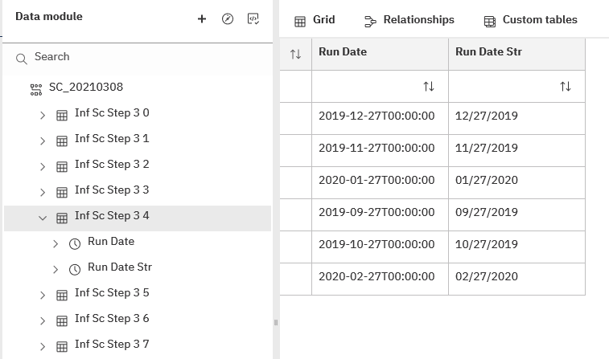

- SC Cognos Report
The Cognos report is just for Completeness. It consists of two parts, a top half of individual fields and the bottom half a table of the benchmarks filled by the INF_SC_STEP_1 view. The top half fields are singletons with reference to individual elements in the INF_SC_STEP_2 through INF_SC_STEP_7 views.
A prompt page prompts for the RUN_DATE (report version) and the ACO. Views which return different data for different versions and ACOs (vs header fields) are filtered by the prompts.

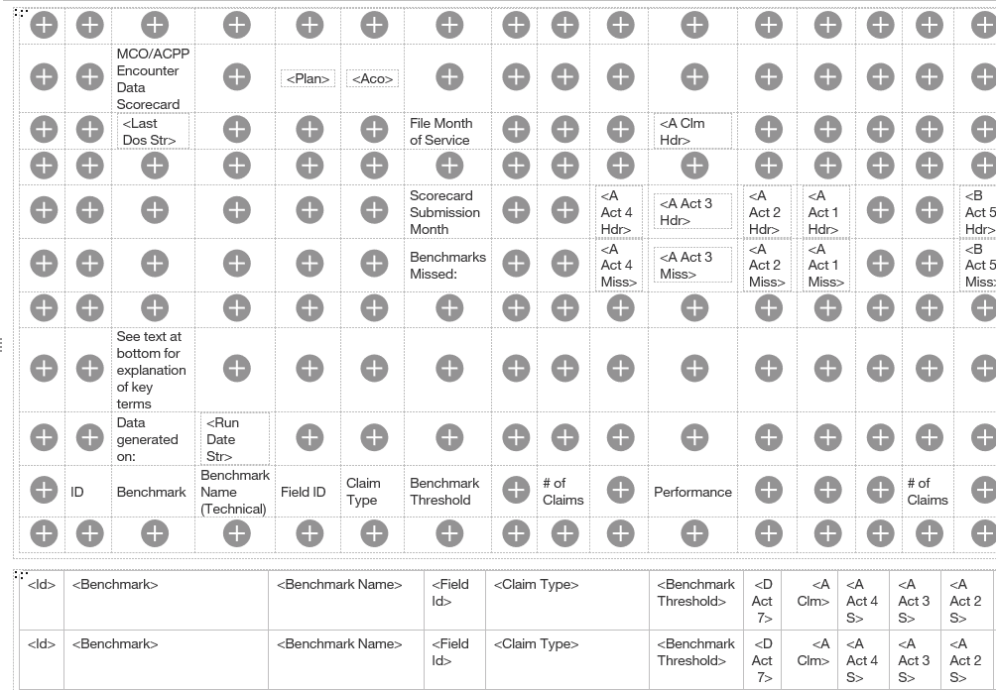
The prompt page:
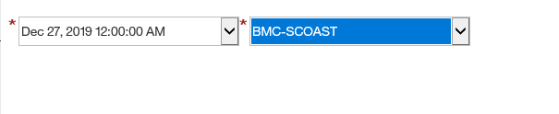
And a PDF version of the report:
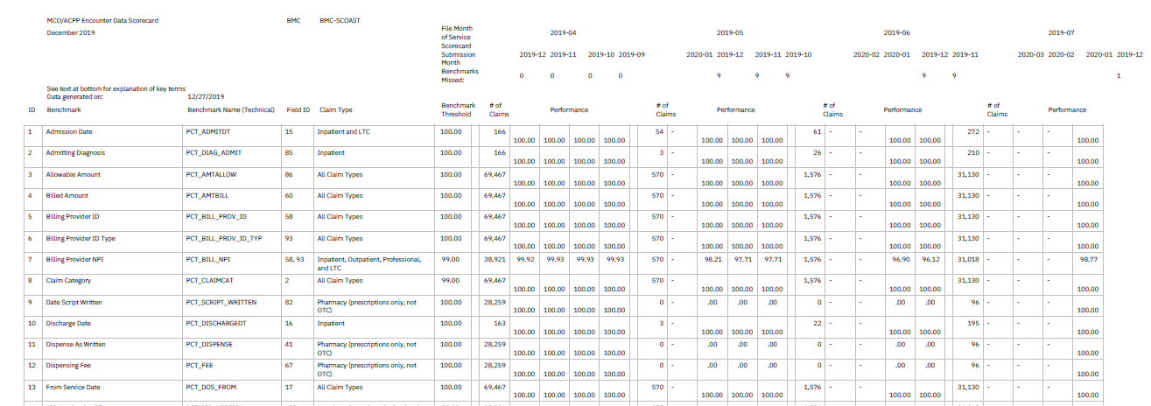

Data Integration Framework Excel Report

This section is really a continuation of section 10. Please review section 10 before reading this section.
- The Data Integration Framework (DIF) spreadsheet generator (populator)
Peter Weinstein and Calvin Luong have developed the java based Data Integration Framework, a flexible data integration and SQL analysis tool, to do advanced data quality analysis. Imbedded in the framework is a C#, Microsoft library based spreadsheet population tool, which is driven by the DIF and fills template Excel spreadsheets with data extracted from SQL sources. The tool also manages naming and versioning the resulting spreadsheets and distributing them via email (not tested yet.) In development is an end user’s interface to accept parameters (like the Cognos prompting) and automatically generate the spreadsheets.
- Views – as discussed in the previous section, a set of views were developed to cut up the STEP 3 table for the various parts of the spreadsheet.
A couple of the Cognos views are also used in the DIF along with a set of views written for the DIF version (mostly for the Timeliness report)
INF_SC_STEP3_1_BENCHMARK_DATA
INF_SC_STEP3_2
INF_SC_STEP3_7
INF_SC_STEP3_8_CLM_ACT_HDRS
INF_SC_STEP3_9_DATE_STRINGS
INF_SC_STEP3_10_TIMELINESS
INF_SC_STEP3_11_2
INF_SC_STEP3_12_TIMELINESS_COUNTS
INF_SC_STEP3_13_ACO_NAMES
INF_SC_STEP3_14_BENCHMARK_COUNT
INF_SC_STEP3_15_TIMELINESS_STRINGS

- The Template.
  - We took one of Nicole’s finished ACO spreadsheets, renamed it as “MCO-ACCP Encounter Data Scorecard_ACO_YYYY_MM_DD.xlsx”.
  - We added a DATA_DOWNLOADS tab at the end.
  - For the two lists, the Benchmark list on the Completeness tab and Successfully loaded files list on the Timeliness tab, we removed the data and created formatted named ranges, larger than the originals, 100 for Benchmarks and 50 for files. We made them bigger to allow for more values in the future. These ranges are
BENCHMARK_DATA for =Completeness!$B$10:$AF$46

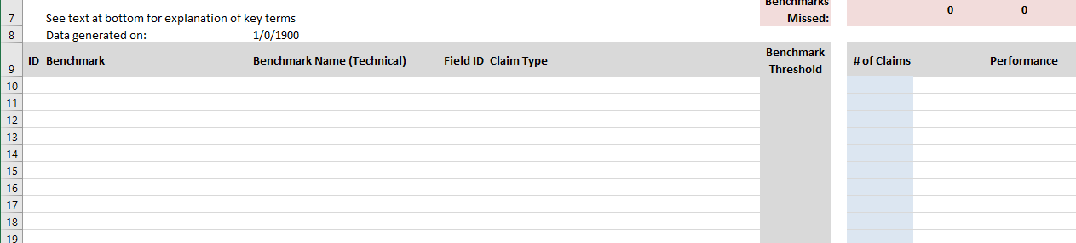

TIMELINESS for =Timeliness!$C$10:$I$12

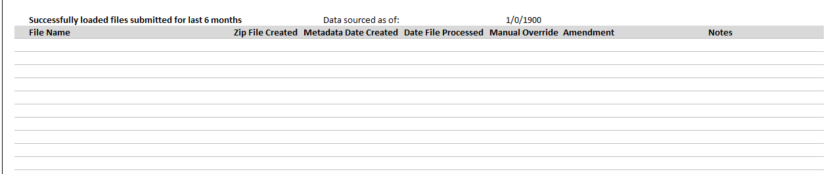

  - On the DATA_DOWNLOADS tab we added 8 named ranges for single lines of data. These ranges are:
DATA1_CLM_ACT_HDRS for =DATA_DOWNLOADS!$A$1:$X$1
DATA2_PLAN_ACO for =DATA_DOWNLOADS!$A$2:$B$2
DATA3_MISS_DATA for =DATA_DOWNLOADS!$A$3:$P$3
DATA4_DATE_STRINGS for =DATA_DOWNLOADS!$A$4:$E$4
DATA5_TIMELINESS_COUNTS for =DATA_DOWNLOADS!$A$5:$N$5
DATA6_ACO_NAMES for =DATA_DOWNLOADS!$A$6:$D$6
DATA7_BENCHMARK_COUNTS for =DATA_DOWNLOADS!$A$7:$B$7
DATA8_TIMELINESS_STRINGS for =DATA_DOWNLOADS!$A$8:$J$8

Comparing the range names with the view names, they are similarly named. View 11_2 is a working view and is not used directly on the spreadsheet.

  - All of the cells on the spreadsheets that have dynamic data (except the two tables) are pointed to cells in the named ranges on the DATA_DOWNLOADS sheet.
  - For example, on the cover sheet

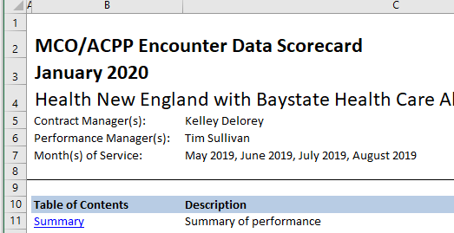

January 2020 is =DATA_DOWNLOADS!B1
Health New … is =DATA_DOWNLOADS!B6
Kelley Delorey is =DATA_DOWNLOADS!C6
Tim Sullivan is =DATA_DOWNLOADS!D6
May 2019, June … is =DATA_DOWNLOADS!E4

- The DIF uses an ordered set of commands to move data from the SQL to the spreadsheet and to generate the spreadsheet.

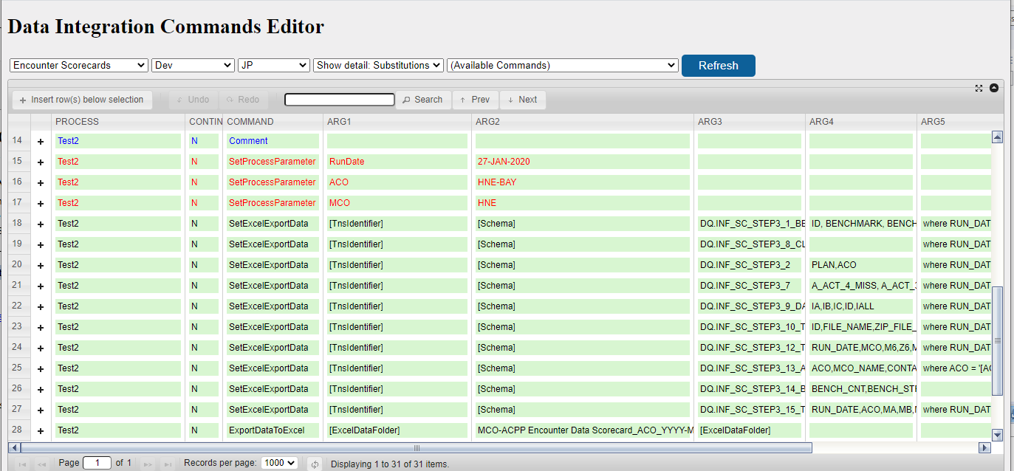

  - Test2 is the name of the overall process. It uses Comment, SetProcessParameter, SetExcelExportData and ExportDataToExcel commands.
  - The SetProcessParameter defines variables. Here we are setting the RunDate, ACO and MCO parameters.

Expanding the + in row 15 shows

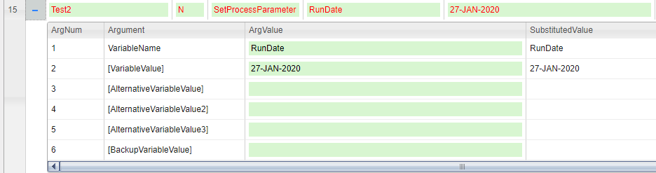

  - The SetExcelExportData defines the mapping from the database to the named range.

Expanding the + in row 20 shows pulling the ACO and Plan from the View INF_SC_STEP_2.

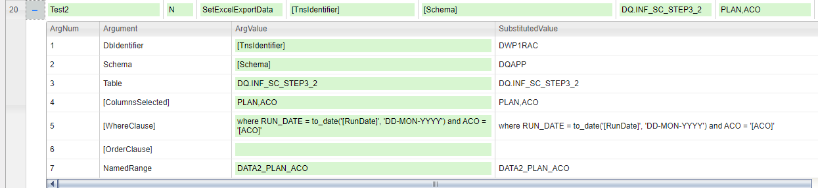

The parts of the SQL are defined separately. When this runs it will generate the SQL:

SELECT PLAN, ACO FROM DQ.INF_SC_STEP3_2 where RUN_DATE = to_date('[RunDate]', 'DD-MON-YYYY') and ACO = '[ACO]'

The two variables [RunDate] and [ACO] will be replaced with the variables defined above, giving

SELECT PLAN, ACO FROM DQ.INF_SC_STEP3_2 where RUN_DATE = to_date('27-JAN-2020', 'DD-MON-YYYY') and ACO = 'HNE-BAY'

And the resulting two values are deposited into DATA2_PLAN_ACO
=DATA_DOWNLOADS!$A$2:$B$2
Cells A2 and B2 on DATA_DOWNLOADS.

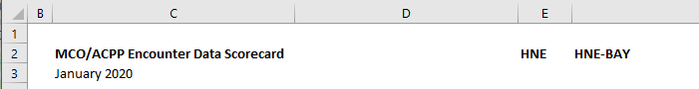

These will be used, among other places, in cells E2 and F2 of the Completeness sheet with their references =DATA_DOWNLOADS!A2 and =DATA_DOWNLOADS!B2 respectively.

  - The ExportDataToExcel generates the spreadsheet.

Expanding the + in row 28 shows definitions for the location of the template, the name of the template and the location to write the generated spreadsheet.

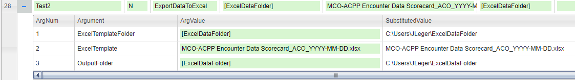

  - The process is run, for Development in Eclipse, for Prod using the end user interface.

  - A log is generated

2021-04-02 15:42:03.630 INFO ExecutionContext loaded from DataIntegration.ini on job server JP
2021-04-02 15:42:05.532 INFO Data integration process begins: Encounter Scorecards, Test2, database: DWP1RAC schema: dqapp, stage: Dev jobServer: JP
2021-04-02 15:42:05.537 INFO Running data integration process: Encounter Scorecards - Test2 (in DWP1RAC.DQAPP)

2021-04-02 15:42:06.149 INFO Command: Comment
2021-04-02 15:42:06.149 INFO Command succeeded

2021-04-02 15:42:06.149 INFO Command: SetProcessParameter
2021-04-02 15:42:06.149 INFO VariableName: RunDate
2021-04-02 15:42:06.149 INFO [VariableValue]: 27-JAN-2020
2021-04-02 15:42:06.150 INFO Command succeeded

2021-04-02 15:42:06.150 INFO Command: SetProcessParameter
2021-04-02 15:42:06.150 INFO VariableName: ACO
2021-04-02 15:42:06.150 INFO [VariableValue]: HNE-BAY
2021-04-02 15:42:06.150 INFO Command succeeded

2021-04-02 15:42:06.150 INFO Command: SetProcessParameter
2021-04-02 15:42:06.150 INFO VariableName: MCO
2021-04-02 15:42:06.150 INFO [VariableValue]: HNE
2021-04-02 15:42:06.150 INFO Command succeeded

2021-04-02 15:42:06.150 INFO Command: SetExcelExportData
2021-04-02 15:42:06.150 INFO DbIdentifier: DWP1RAC
2021-04-02 15:42:06.150 INFO Schema: DQAPP
2021-04-02 15:42:06.150 INFO Table: DQ.INF_SC_STEP3_1_BENCHMARK_DATA
2021-04-02 15:42:06.150 INFO [ColumnsSelected]: ID, BENCHMARK, BENCHMARK_NAME,FIELD_ID,CLAIM_TYPE,DUM1,BENCHMARK_THRESHOLD,DUM2,A_CLM, A_ACT_4_S,A_ACT_3_S, A_ACT_2_S, A_ACT_1_S,DUM3,B_CLM, B_ACT_5_S,B_ACT_4_S, B_ACT_3_S,B_ACT_2_S,DUM4,C_CLM, C_ACT_6_S,C_ACT_5_S, C_ACT_4_S, C_ACT_3_S,DUM5,D_CLM, D_ACT_7_S,D_ACT_6_S, D_ACT_5_S, D_ACT_4_S
2021-04-02 15:42:06.150 INFO [WhereClause]: where RUN_DATE = to_date('27-JAN-2020', 'DD-MON-YYYY') and ACO = 'HNE-BAY'
2021-04-02 15:42:06.150 INFO [OrderClause]: order by ID
2021-04-02 15:42:06.150 INFO NamedRange: BENCHMARK_DATA
2021-04-02 15:42:06.452 WARNING Failure bulk writing to DQAPP.TEMP_TABLE_1: ORA-00904: "D_ACT_4_S": invalid identifier

2021-04-02 15:42:06.453 INFO Will force write of DQAPP.TEMP_TABLE_1 dropping and re-creating table as needed
2021-04-02 15:42:06.571 INFO Bulk insert of 37 records to table DQAPP.TEMP_TABLE_1
2021-04-02 15:42:06.571 INFO Command succeeded

2021-04-02 15:42:06.571 INFO Command: SetExcelExportData
2021-04-02 15:42:06.572 INFO DbIdentifier: DWP1RAC
2021-04-02 15:42:06.572 INFO Schema: DQAPP
2021-04-02 15:42:06.572 INFO Table: DQ.INF_SC_STEP3_8_CLM_ACT_HDRS
2021-04-02 15:42:06.572 INFO [WhereClause]: where RUN_DATE = to_date('27-JAN-2020', 'DD-MON-YYYY')
2021-04-02 15:42:06.572 INFO NamedRange: DATA1_CLM_ACT_HDRS
2021-04-02 15:42:06.743 WARNING Failure bulk writing to DQAPP.TEMP_TABLE_2: ORA-00904: "D_ACT_4_HDR": invalid identifier

2021-04-02 15:42:06.743 INFO Will force write of DQAPP.TEMP_TABLE_2 dropping and re-creating table as needed
2021-04-02 15:42:06.861 INFO Bulk insert of 1 records to table DQAPP.TEMP_TABLE_2
2021-04-02 15:42:06.861 INFO Command succeeded

2021-04-02 15:42:06.861 INFO Command: SetExcelExportData
2021-04-02 15:42:06.861 INFO DbIdentifier: DWP1RAC
2021-04-02 15:42:06.861 INFO Schema: DQAPP
2021-04-02 15:42:06.861 INFO Table: DQ.INF_SC_STEP3_2
2021-04-02 15:42:06.862 INFO [ColumnsSelected]: PLAN,ACO
2021-04-02 15:42:06.862 INFO [WhereClause]: where RUN_DATE = to_date('27-JAN-2020', 'DD-MON-YYYY') and ACO = 'HNE-BAY'
2021-04-02 15:42:06.862 INFO NamedRange: DATA2_PLAN_ACO
2021-04-02 15:42:07.002 WARNING Failure bulk writing to DQAPP.TEMP_TABLE_3: ORA-00904: "ACO": invalid identifier

2021-04-02 15:42:07.002 INFO Will force write of DQAPP.TEMP_TABLE_3 dropping and re-creating table as needed
2021-04-02 15:42:07.090 INFO Bulk insert of 1 records to table DQAPP.TEMP_TABLE_3
2021-04-02 15:42:07.091 INFO Command succeeded

2021-04-02 15:42:07.091 INFO Command: SetExcelExportData
2021-04-02 15:42:07.091 INFO DbIdentifier: DWP1RAC
2021-04-02 15:42:07.091 INFO Schema: DQAPP
2021-04-02 15:42:07.091 INFO Table: DQ.INF_SC_STEP3_7
2021-04-02 15:42:07.091 INFO [ColumnsSelected]: A_ACT_4_MISS, A_ACT_3_MISS, A_ACT_2_MISS,A_ACT_1_MISS, B_ACT_5_MISS, B_ACT_4_MISS, B_ACT_3_MISS, B_ACT_2_MISS,C_ACT_6_MISS, C_ACT_5_MISS, C_ACT_4_MISS, C_ACT_3_MISS, D_ACT_7_MISS,D_ACT_6_MISS, D_ACT_5_MISS, D_ACT_4_MISS
2021-04-02 15:42:07.091 INFO [WhereClause]: where RUN_DATE = to_date('27-JAN-2020', 'DD-MON-YYYY') and ACO = 'HNE-BAY'
2021-04-02 15:42:07.092 INFO NamedRange: DATA3_MISS_DATA
2021-04-02 15:42:07.208 WARNING Failure bulk writing to DQAPP.TEMP_TABLE_4: ORA-00904: "D_ACT_4_MISS": invalid identifier

2021-04-02 15:42:07.208 INFO Will force write of DQAPP.TEMP_TABLE_4 dropping and re-creating table as needed
2021-04-02 15:42:07.308 INFO Bulk insert of 1 records to table DQAPP.TEMP_TABLE_4
2021-04-02 15:42:07.308 INFO Command succeeded

2021-04-02 15:42:07.308 INFO Command: SetExcelExportData
2021-04-02 15:42:07.308 INFO DbIdentifier: DWP1RAC
2021-04-02 15:42:07.308 INFO Schema: DQAPP
2021-04-02 15:42:07.308 INFO Table: DQ.INF_SC_STEP3_9_DATE_STRINGS
2021-04-02 15:42:07.308 INFO [ColumnsSelected]: IA,IB,IC,ID,IALL
2021-04-02 15:42:07.308 INFO [WhereClause]: where RUN_DATE = to_date('27-JAN-2020', 'DD-MON-YYYY')
2021-04-02 15:42:07.308 INFO NamedRange: DATA4_DATE_STRINGS
2021-04-02 15:42:07.450 WARNING Failure bulk writing to DQAPP.TEMP_TABLE_5: ORA-00904: "IALL": invalid identifier

2021-04-02 15:42:07.450 INFO Will force write of DQAPP.TEMP_TABLE_5 dropping and re-creating table as needed
2021-04-02 15:42:07.539 INFO Bulk insert of 1 records to table DQAPP.TEMP_TABLE_5
2021-04-02 15:42:07.539 INFO Command succeeded

2021-04-02 15:42:07.539 INFO Command: SetExcelExportData
2021-04-02 15:42:07.539 INFO DbIdentifier: DWP1RAC
2021-04-02 15:42:07.539 INFO Schema: DQAPP
2021-04-02 15:42:07.539 INFO Table: DQ.INF_SC_STEP3_10_TIMELINESS
2021-04-02 15:42:07.539 INFO [ColumnsSelected]: ID,FILE_NAME,ZIP_FILE_CREATED,METADATA_DATE_CREATED,DATE_FILE_PROCESSED,MANUAL_OVERRIDE,AMENDMENT
2021-04-02 15:42:07.540 INFO [WhereClause]: where RUN_DATE = to_date('27-JAN-2020', 'DD-MON-YYYY') and MCO = 'HNE'
2021-04-02 15:42:07.540 INFO [OrderClause]: order by ID
2021-04-02 15:42:07.540 INFO NamedRange: TIMELINESS
2021-04-02 15:42:07.710 WARNING Failure bulk writing to DQAPP.TEMP_TABLE_6: ORA-00904: "AMENDMENT": invalid identifier

2021-04-02 15:42:07.710 INFO Will force write of DQAPP.TEMP_TABLE_6 dropping and re-creating table as needed
2021-04-02 15:42:07.802 INFO Bulk insert of 3 records to table DQAPP.TEMP_TABLE_6
2021-04-02 15:42:07.802 INFO Command succeeded

2021-04-02 15:42:07.802 INFO Command: SetExcelExportData
2021-04-02 15:42:07.802 INFO DbIdentifier: DWP1RAC
2021-04-02 15:42:07.802 INFO Schema: DQAPP
2021-04-02 15:42:07.802 INFO Table: DQ.INF_SC_STEP3_12_TIMELINESS_COUNTS
2021-04-02 15:42:07.802 INFO [ColumnsSelected]: RUN_DATE,MCO,M6,Z6,M5,Z5,M4,Z4,M3,Z3,M2,Z2,M1,Z1
2021-04-02 15:42:07.802 INFO [WhereClause]: where RUN_DATE = to_date('27-JAN-2020', 'DD-MON-YYYY') and MCO = 'HNE'
2021-04-02 15:42:07.802 INFO NamedRange: DATA5_TIMELINESS_COUNTS
2021-04-02 15:42:07.965 INFO Bulk insert of 1 records to table DQAPP.TEMP_TABLE_7
2021-04-02 15:42:07.965 INFO Command succeeded

2021-04-02 15:42:07.965 INFO Command: SetExcelExportData
2021-04-02 15:42:07.965 INFO DbIdentifier: DWP1RAC
2021-04-02 15:42:07.965 INFO Schema: DQAPP
2021-04-02 15:42:07.965 INFO Table: DQ.INF_SC_STEP3_13_ACO_NAMES
2021-04-02 15:42:07.965 INFO [ColumnsSelected]: ACO,MCO_NAME,CONTACT_MGR,PERFORMANCE_MGR
2021-04-02 15:42:07.965 INFO [WhereClause]: where ACO = 'HNE-BAY'
2021-04-02 15:42:07.965 INFO NamedRange: DATA6_ACO_NAMES
2021-04-02 15:42:08.130 INFO Bulk insert of 1 records to table DQAPP.TEMP_TABLE_8
2021-04-02 15:42:08.130 INFO Command succeeded

2021-04-02 15:42:08.130 INFO Command: SetExcelExportData
2021-04-02 15:42:08.130 INFO DbIdentifier: DWP1RAC
2021-04-02 15:42:08.130 INFO Schema: DQAPP
2021-04-02 15:42:08.130 INFO Table: DQ.INF_SC_STEP3_14_BENCHMARK_COUNT
2021-04-02 15:42:08.130 INFO [ColumnsSelected]: BENCH_CNT,BENCH_STR
2021-04-02 15:42:08.130 INFO NamedRange: DATA7_BENCHMARK_COUNT
2021-04-02 15:42:08.243 INFO Bulk insert of 1 records to table DQAPP.TEMP_TABLE_9
2021-04-02 15:42:08.243 INFO Command succeeded

2021-04-02 15:42:08.243 INFO Command: SetExcelExportData
2021-04-02 15:42:08.243 INFO DbIdentifier: DWP1RAC
2021-04-02 15:42:08.243 INFO Schema: DQAPP
2021-04-02 15:42:08.243 INFO Table: DQ.INF_SC_STEP3_15_TIMELINESS_STRINGS
2021-04-02 15:42:08.244 INFO [ColumnsSelected]: RUN_DATE,ACO,MA,MB,MC,MD,SA,SB,SC,SD
2021-04-02 15:42:08.244 INFO [WhereClause]: where RUN_DATE = to_date('27-JAN-2020', 'DD-MON-YYYY') and ACO = 'HNE-BAY'
2021-04-02 15:42:08.244 INFO NamedRange: DATA8_TIMELINESS_STRINGS
2021-04-02 15:42:08.397 INFO Bulk insert of 1 records to table DQAPP.TEMP_TABLE_10
2021-04-02 15:42:08.398 INFO Command succeeded

2021-04-02 15:42:08.398 INFO Command: ExportDataToExcel
2021-04-02 15:42:08.398 INFO ExcelTemplateFolder: C:\Users\JLeger\ExcelDataFolder
2021-04-02 15:42:08.398 INFO ExcelTemplate: MCO-ACPP Encounter Data Scorecard_ACO_YYYY-MM-DD.xlsx
2021-04-02 15:42:08.398 INFO OutputFolder: C:\Users\JLeger\ExcelDataFolder
4/2/2021 3:42:11 PM INFO: Opened Excel workbook at C:\Users\JLeger\ExcelDataFolder\MCO-ACPP Encounter Data Scorecard_ACO_YYYY-MM-DD.xlsx
4/2/2021 3:42:13 PM DEBUG: Opened connection to ehsdw-xpr-scan1.ehs.state.ma.us.DWP1RAC
4/2/2021 3:42:13 PM DEBUG: Opened connection to ehsdw-xpr-scan1.ehs.state.ma.us.DWP1RAC
4/2/2021 3:42:13 PM DEBUG: Opened connection to ehsdw-xpr-scan1.ehs.state.ma.us.DWP1RAC
4/2/2021 3:42:13 PM DEBUG: Opened connection to ehsdw-xpr-scan1.ehs.state.ma.us.DWP1RAC
4/2/2021 3:42:13 PM DEBUG: Opened connection to ehsdw-xpr-scan1.ehs.state.ma.us.DWP1RAC
4/2/2021 3:42:13 PM DEBUG: Opened connection to ehsdw-xpr-scan1.ehs.state.ma.us.DWP1RAC
4/2/2021 3:42:13 PM DEBUG: Opened connection to ehsdw-xpr-scan1.ehs.state.ma.us.DWP1RAC
4/2/2021 3:42:13 PM DEBUG: Opened connection to ehsdw-xpr-scan1.ehs.state.ma.us.DWP1RAC
4/2/2021 3:42:14 PM DEBUG: Opened connection to ehsdw-xpr-scan1.ehs.state.ma.us.DWP1RAC
4/2/2021 3:42:14 PM DEBUG: Opened connection to ehsdw-xpr-scan1.ehs.state.ma.us.DWP1RAC
4/2/2021 3:42:14 PM INFO: Saved Excel workbook at C:\Users\JLeger\ExcelDataFolder\MCO-ACPP Encounter Data Scorecard_ACO_2021-04-02.xlsx
2021-04-02 15:42:14.717 INFO Command succeeded

2021-04-02 15:42:14.717 INFO Data integration process complete with status: success

  - And the new spreadsheet is ready to use:

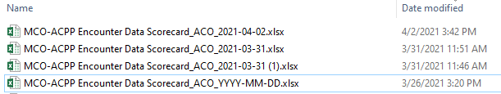

Note that if the spreadsheet is generated more than once on the day, the previous versions are automatically renamed to (1) and up.

- The TIMELINESS report is a second report delivered as part of this worksheet.
It is just a simple listing of the zip files sent by the MCE during the past 6 months. For the IDQ version of the report, we reused Nicole’s SQL and for consistency, and to facilitate generating previous report on the fly, consolidate the monthly snapshots in a versioned the table.

CREATE TABLE INF_B_SC_STG_MCO_MBH_TIMELINESS
(
RUN_DATE DATE,
DQ_BATCH_SEQ NUMBER,
MCO VARCHAR2(3 BYTE) NOT NULL,
ID NUMBER,
FILE_NAME VARCHAR2(50 BYTE) NOT NULL,
ZIP_FILE_CREATED DATE NOT NULL,
METADATA_DATE_CREATED DATE NOT NULL,
DATE_FILE_PROCESSED DATE,
MANUAL_OVERRIDE VARCHAR2(1 BYTE) NOT NULL,
AMENDMENT VARCHAR2(1 BYTE) NOT NULL
)
It is loaded with:

INSERT INTO INF_B_SC_STG_MCO_MBH_TIMELINESS
select
TO_DATE('~RUN_DATE~','YYYYMMDD') AS RUN_DATE,
TO_NUMBER('~DQ_BATCH_SEQ~','99999999') AS DQ_BATCH_SEQ,
cde_enc_mco AS MCO,
RANK() OVER (PARTITION BY cde_enc_mco ORDER BY metadata_date_created,zip_file_name,date_file_processed) ID,
zip_file_name as FILE_NAME,
zip_file_created,
metadata_date_created,
date_file_processed,
ind_manual_override AS manual_override,
ind_amendment AS Amendment
from (
select distinct
stat.cde_enc_mco,
zip_file_name,
metadata_date_created,
metadata_date_created as zip_file_created,
to_date(max(to_char(process_end_tm,'mm/dd/yyyy')) over (partition by zip_file_name), 'MM/DD/YYYY') as DATE_FILE_PROCESSED, -- as processdt2,
ind_manual_override,
ind_amendment,
CASE
WHEN md_batch_seq_scrub IS NULL THEN 'File Failed'
WHEN md_batch_seq_nw IS NULL THEN 'File processed but not loaded'
ELSE 'Successfully Loaded'
END
load_status,
cde_load_status
from nw_enc_statistics stat
inner join ods_encounter enc
on enc.md_batch_seq=stat.md_batch_seq_ods and stat.cde_enc_mco=enc.cde_enc_mco
where 1=1
and metadata_date_created between
TO_CHAR(ADD_MONTHS(TRUNC(TO_DATE('~RUN_DATE~','YYYYMMDD'),'MONTH'), -5)) AND
TO_CHAR(LAST_DAY(TRUNC(TO_DATE('~RUN_DATE~','YYYYMMDD'),'MONTH'))) --rolling history of 6months
order by stat.cde_enc_mco, metadata_date_created
) t;

And the view is pretty much a straight write to the named range:

CREATE OR REPLACE FORCE VIEW INF_SC_STEP3_10_TIMELINESS
(RUN_DATE, DQ_BATCH_SEQ, MCO, ID, FILE_NAME,
ZIP_FILE_CREATED, METADATA_DATE_CREATED, DATE_FILE_PROCESSED, MANUAL_OVERRIDE, AMENDMENT)
BEQUEATH DEFINER
AS

SELECT "RUN_DATE",
"DQ_BATCH_SEQ",
"MCO",
"ID",
"FILE_NAME",
"ZIP_FILE_CREATED",
"METADATA_DATE_CREATED",
"DATE_FILE_PROCESSED",
"MANUAL_OVERRIDE",
"AMENDMENT"
FROM INF_B_SC_STG_MCO_MBH_TIMELINESS
ORDER BY run_date, mco, id;

TIMELINESS for =Timeliness!$C$10:$I$12

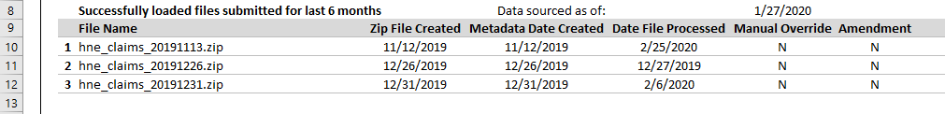

The other Timeliness views and fields just provide counts of the zip files.
- The Failure Claims Listing sheet was added to provide sample failing encounter records.
It replaces individual sample spreadsheets Nicole was sending with one sheet that lists up to 25 failed encounter records per missed benchmark. The records are stacked by ID and display up to 5 failed data points per record. The data points are specific to the Measure’s validation logic and are listed horizontally as “Validation Category 1”, “Validation Value 1” through 5. The Validation Category is the field name. For example for failed ID 24, Benchmark Procedure Code Prof_M the validation categories are: CLAIM_TYPE, CDE_ENC_REC_IND, PROC_CODE, CDE_ENC_PROC_TYPE, and PROC_CODE_ENC. Null “+”,”-“,”#” values are indicated with the string “Missing or Invalid”.

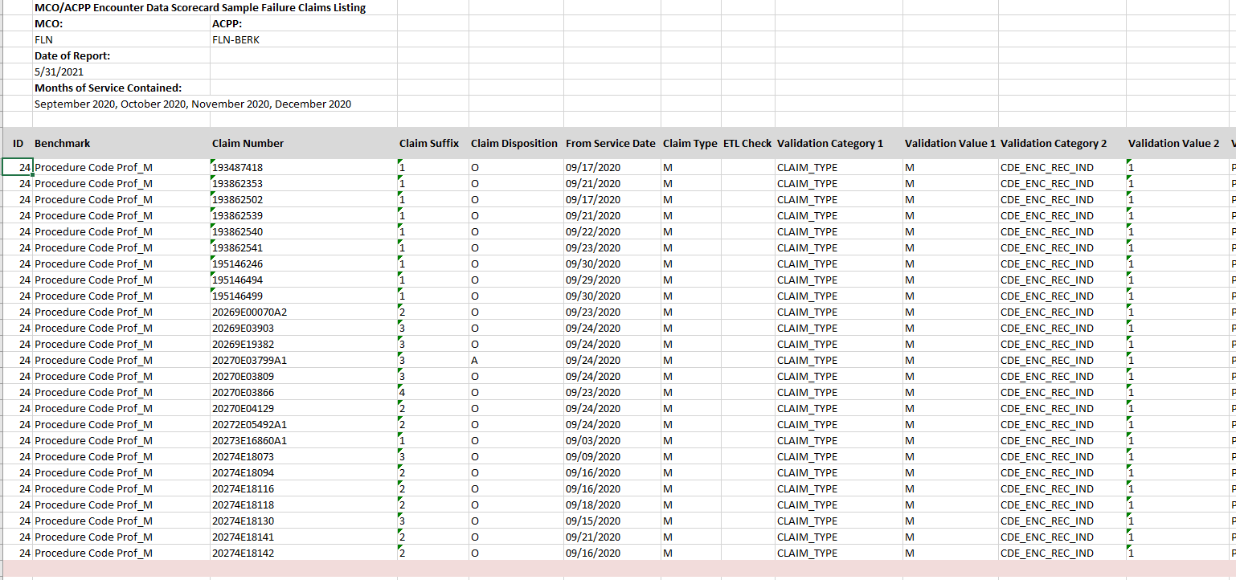

Processing for the Fails follows the flow as the Completeness and Timeliness, a versioned table INF_B_SC_STG_MCO_MBH_REP_FAILS was added, IDQ processing was added to populate the fails table, a view INF_SC_STEP3_17_ACO_FAILS was added to feed a new Data Integration Framework step to load the sheet.
CREATE TABLE INF_B_SC_STG_MCO_MBH_REP_FAILS
(
RUN_DATE DATE,
DQ_BATCH_SEQ NUMBER,
ID NUMBER(4),
BENCHMARK VARCHAR2(50 BYTE),
FIELD_ID VARCHAR2(50 BYTE),
BENCHMARK_THRESHOLD NUMBER(3,2),
CDE_ENC_MCO VARCHAR2(3 BYTE),
CDE_ENC_ACO VARCHAR2(10 BYTE),
ENC_CLAIM_NO VARCHAR2(20 BYTE),
ENC_CLAIM_SUFFIX VARCHAR2(4 BYTE),
CDE_CLM_DISPOSITION VARCHAR2(1 BYTE),
DOS_FROM DATE,
CLAIM_TYPE VARCHAR2(1 BYTE),
ETL_CHECK VARCHAR2(100 BYTE),
DESC1 VARCHAR2(18 BYTE),
VALUE1 VARCHAR2(120 BYTE),
DESC2 VARCHAR2(20 BYTE),
VALUE2 VARCHAR2(20 BYTE),
DESC3 VARCHAR2(20 BYTE),
VALUE3 VARCHAR2(126 BYTE),
DESC4 VARCHAR2(24 BYTE),
VALUE4 VARCHAR2(20 BYTE),
DESC5 VARCHAR2(13 BYTE),
VALUE5 VARCHAR2(6 BYTE)
)

SQL is run to populate the table. The SQL is a rewrite of SAS and SQL written by Nicole with the SQL for each Benchmark stacked using UNION on top of each ordered by ID. The SQL is run in two parts due to the SQL being too large > 32K to fit in a single step.

-- PART 1

INSERT INTO INF_B_SC_STG_MCO_MBH_REP_FAILS
-- MCO_FAIL1
SELECT * FROM (
WITH MCO_FAIL1 AS (
SELECT DISTINCT
1 AS ID,
CDE_ENC_MCO,CDE_ENC_ACO,ENC_CLAIM_NO,ENC_CLAIM_SUFFIX,CDE_CLM_DISPOSITION,DOS_FROM,CLAIM_TYPE,
'CLAIM_TYPE' AS DESC1, CLAIM_TYPE AS VALUE1, 'ADMIT_DT' AS DESC2, TO_CHAR(ADMIT_DT,'YYYYMMDD') AS VALUE2, NULL AS DESC3, NULL AS VALUE3,
NULL AS DESC4, NULL AS VALUE4, NULL AS DESC5, NULL AS VALUE5
FROM INF_B_SC_STG_MCO_MBHP_DOS
WHERE TO_CHAR(DOS_FROM,'YYYYMM') = SUBSTR('~MONS~',1,6)
AND CLAIM_TYPE IN('I','L') and ( (ADMIT_DT IS NULL)
OR ( ADMIT_DT IS NOT NULL AND DISCHARGE_DT IS NOT NULL AND ADMIT_DT > DISCHARGE_DT) )
ORDER BY CDE_ENC_MCO,CDE_ENC_ACO,ENC_CLAIM_NO,ENC_CLAIM_SUFFIX
)
SELECT
TO_DATE('~RUN_DATE~','YYYYMMDD') AS RUN_DATE,
TO_NUMBER('~DQ_BATCH_SEQ~','99999999') AS DQ_BATCH_SEQ,
L.ID,
L.BENCHMARK,
L.FIELD_ID,
L.BENCHMARK_THRESHOLD,
F.CDE_ENC_MCO,
F.CDE_ENC_ACO,
F.ENC_CLAIM_NO,
F.ENC_CLAIM_SUFFIX,
F.CDE_CLM_DISPOSITION,
F.DOS_FROM,
F.CLAIM_TYPE,
NULL AS ETL_CHECK,
F.DESC1,
F.VALUE1,
F.DESC2,
F.VALUE2,
F.DESC3,
F.VALUE3,
F.DESC4,
F.VALUE4,
F.DESC5,
F.VALUE5
FROM
INF_B_SC_STG_MCO_MBH_SCORECARD_LOOKUP L
JOIN MCO_FAIL1 F ON L.ID = F.ID
ORDER BY L.ID, CDE_ENC_MCO, CDE_ENC_ACO, ENC_CLAIM_NO, ENC_CLAIM_SUFFIX
)
UNION
-- MCO_FAIL2
SELECT * FROM (
WITH MCO_FAIL2 AS (
SELECT DISTINCT
2 AS ID,
CDE_ENC_MCO,CDE_ENC_ACO,ENC_CLAIM_NO,ENC_CLAIM_SUFFIX,CDE_CLM_DISPOSITION,DOS_FROM,CLAIM_TYPE,
'CLAIM_TYPE' AS DESC1, CLAIM_TYPE AS VALUE1, 'CDE_TYPE_OF_BILL_ENC' AS DESC2, CDE_TYPE_OF_BILL_ENC AS VALUE2, 'CDE_DIAG_ADMIT' AS DESC3, CDE_DIAG_ADMIT AS VALUE3,
NULL AS DESC4, NULL AS VALUE4, NULL AS DESC5, NULL AS VALUE5
FROM INF_B_SC_STG_MCO_MBHP_DOS
WHERE TO_CHAR(DOS_FROM,'YYYYMM') = SUBSTR('~MONS~',1,6)
AND CLAIM_TYPE='I' AND SUBSTR(CDE_TYPE_OF_BILL_ENC,1,2) NOT IN('12','22','42','62','81','82')
AND CDE_DIAG_ADMIT IN ('+','-', ' ')
ORDER BY CDE_ENC_MCO,CDE_ENC_ACO,ENC_CLAIM_NO,ENC_CLAIM_SUFFIX
)
SELECT
TO_DATE('~RUN_DATE~','YYYYMMDD') AS RUN_DATE,
TO_NUMBER('~DQ_BATCH_SEQ~','99999999') AS DQ_BATCH_SEQ,
L.ID,
L.BENCHMARK,
L.FIELD_ID,
L.BENCHMARK_THRESHOLD,
F.CDE_ENC_MCO,
F.CDE_ENC_ACO,
F.ENC_CLAIM_NO,
F.ENC_CLAIM_SUFFIX,
F.CDE_CLM_DISPOSITION,
F.DOS_FROM,
F.CLAIM_TYPE,
NULL AS ETL_CHECK,
F.DESC1,
F.VALUE1,
F.DESC2,
F.VALUE2,
F.DESC3,
F.VALUE3,
F.DESC4,
F.VALUE4,
F.DESC5,
F.VALUE5
FROM
INF_B_SC_STG_MCO_MBH_SCORECARD_LOOKUP L
JOIN MCO_FAIL2 F ON L.ID = F.ID
ORDER BY L.ID, CDE_ENC_MCO, CDE_ENC_ACO, ENC_CLAIM_NO, ENC_CLAIM_SUFFIX
)
UNION

Each of the With clauses contains different fields for the validation fields and values
'CLAIM_TYPE' AS DESC1, CLAIM_TYPE AS VALUE1, 'CDE_TYPE_OF_BILL_ENC' AS DESC2, CDE_TYPE_OF_BILL_ENC AS VALUE2, 'CDE_DIAG_ADMIT' AS DESC3, CDE_DIAG_ADMIT AS VALUE3,
NULL AS DESC4, NULL AS VALUE4, NULL AS DESC5, NULL AS VALUE5

The RUN_DATE, MCO, ACO and ID set the versioning.

The Fails table contains all data for all fails. The view does the processing to limit the records displayed to only those that show as fails in the Completeness report, restricts to 25 rows each, and adds (for the moment) blank lines between the IDs.

CREATE OR REPLACE FORCE VIEW INF_SC_STEP3_17_ACO_FAILS
(RUN_DATE, DQ_BATCH_SEQ, ID, BENCHMARK, CDE_ENC_MCO,
CDE_ENC_ACO, ENC_CLAIM_NO, ENC_CLAIM_SUFFIX, CDE_CLM_DISPOSITION, DOS_FROM,
CLAIM_TYPE, ETL_CHECK, DESC1, VALUE1, DESC2,
VALUE2, DESC3, VALUE3, DESC4, VALUE4,
DESC5, VALUE5, IND)
BEQUEATH DEFINER
AS

SELECT RUN_DATE,
DQ_BATCH_SEQ,
-- To add blank lines that sort correctly the IDs are mult by 10 and blanks are mult 10 + 5
-- and then return IDs to normal with:
CASE
WHEN (MOD (ID, 2) = 0) THEN TO_CHAR ( (ID / 10), '999')
ELSE ''
END
AS ID,
BENCHMARK,
CDE_ENC_MCO,
CDE_ENC_ACO,
ENC_CLAIM_NO,
ENC_CLAIM_SUFFIX,
CDE_CLM_DISPOSITION,
CASE
WHEN (MOD (ID, 2) = 0) THEN TO_CHAR (DOS_FROM, 'MM/DD/YYYY')
ELSE ''
END
AS DOS_FROM,
CLAIM_TYPE,
ETL_CHECK,
DESC1,
VALUE1,
DESC2,
VALUE2,
DESC3,
VALUE3,
DESC4,
VALUE4,
DESC5,
VALUE5,
-- Putting a dot in the last field to indicate a blank line, this way no Fails won't be all pink
CASE WHEN (MOD (ID, 2) = 0) THEN '' ELSE '.' END AS IND
FROM (-- Row selection
(SELECT f."RUN_DATE",
f."DQ_BATCH_SEQ",
f."ID",
f."BENCHMARK",
f."CDE_ENC_MCO",
f."CDE_ENC_ACO",
f."ENC_CLAIM_NO",
f."ENC_CLAIM_SUFFIX",
f."CDE_CLM_DISPOSITION",
f."DOS_FROM",
f."CLAIM_TYPE",
f."ETL_CHECK",
f."DESC1",
f."VALUE1",
f."DESC2",
f."VALUE2",
f."DESC3",
f."VALUE3",
f."DESC4",
f."VALUE4",
f."DESC5",
f."VALUE5"
FROM ( SELECT RUN_DATE,
DQ_BATCH_SEQ,
-- increase by 10
ID * 10 AS ID,
BENCHMARK,
CDE_ENC_MCO,
CDE_ENC_ACO,
ENC_CLAIM_NO,
ENC_CLAIM_SUFFIX,
CDE_CLM_DISPOSITION,
DOS_FROM,
CLAIM_TYPE,
ETL_CHECK,
DESC1,
VALUE1,
DESC2,
VALUE2,
DESC3,
VALUE3,
DESC4,
VALUE4,
DESC5,
VALUE5
FROM (SELECT RUN_DATE,
DQ_BATCH_SEQ,
ID,
BENCHMARK,
FIELD_ID,
BENCHMARK_THRESHOLD,
CDE_ENC_MCO,
CDE_ENC_ACO,
ENC_CLAIM_NO,
ENC_CLAIM_SUFFIX,
CDE_CLM_DISPOSITION,
DOS_FROM,
CLAIM_TYPE,
ETL_CHECK,
DESC1,
CASE
WHEN ( DESC1 IS NOT NULL
AND ( VALUE1 IS NULL
OR VALUE1 IN ('+',
'-',
'#',
'',
' ',
'Unknown')))
THEN
'Missing or Invalid'
ELSE
VALUE1
END
AS VALUE1,
DESC2,
CASE
WHEN ( DESC2 IS NOT NULL
AND ( VALUE2 IS NULL
OR VALUE2 IN ('+',
'-',
'#',
'',
' ',
'Unknown')))
THEN
'Missing or Invalid'
ELSE
VALUE2
END
AS VALUE2,
DESC3,
CASE
WHEN ( DESC3 IS NOT NULL
AND ( VALUE3 IS NULL
OR VALUE3 IN ('+',
'-',
'#',
'',
' ',
'Unknown')))
THEN
'Missing or Invalid'
ELSE
VALUE3
END
AS VALUE3,
DESC4,
CASE
WHEN ( DESC4 IS NOT NULL
AND ( VALUE4 IS NULL
OR VALUE4 IN ('+',
'-',
'#',
'',
' ',
'Unknown')))
THEN
'Missing or Invalid'
ELSE
VALUE4
END
AS VALUE4,
DESC5,
CASE
WHEN ( DESC5 IS NOT NULL
AND ( VALUE5 IS NULL
OR VALUE5 IN ('+',
'-',
'#',
'',
' ',
'Unknown')))
THEN
'Missing or Invalid'
ELSE
VALUE5
END
AS VALUE5,
RANK ()
OVER (PARTITION BY RUN_DATE,
CDE_ENC_MCO,
CDE_ENC_ACO,
ID
ORDER BY
RUN_DATE,
CDE_ENC_MCO,
CDE_ENC_ACO,
ID,
ENC_CLAIM_NO,
ENC_CLAIM_SUFFIX)
AS rnk
FROM INF_B_SC_STG_MCO_MBH_REP_FAILS)
WHERE rnk <= 25
ORDER BY ID, ENC_CLAIM_NO, ENC_CLAIM_SUFFIX) f,
(SELECT RUN_DATE,
ACO,
ID,
CASE
WHEN (A_ACT_4 IS NULL OR A_ACT_4 = 0)
THEN
0
ELSE
CASE
WHEN A_ACT_4 + p.ADJ <
BENCHMARK_THRESHOLD * 100
THEN
1
ELSE
0
END
END
AS MISS
FROM INF_B_SC_STG_MCO_MBH_REP_STEP3,
(SELECT TO_NUMBER (PARAM_VALUE, '9.9999') AS ADJ
FROM INF_B_DQ_PARAMS
WHERE PARAM_NAME = 'SC_ACTUALS_ROUND') p
WHERE ACO != '+') m
WHERE 1 = 1
AND m.run_date = f.run_date
AND m.aco = f.cde_enc_aco
AND m.id * 10 = f.id
AND m.miss = 1)
UNION
-- Blank line selection
(-- Create a list of filler rows with 5 at then end of the ID
SELECT *
FROM (SELECT RUN_DATE,
DQ_BATCH_SEQ,
(ID * 10) + 5 AS ID,
NULL AS BENCHMARK,
PLAN AS CDE_ENC_MCO,
ACO AS CDE_ENC_ACO,
NULL AS ENC_CLAIM_NO,
NULL AS ENC_CLAIM_SUFFIX,
NULL AS CDE_CLM_DISPOSITION,
NULL AS DOS_FROM,
NULL AS CLAIM_TYPE,
NULL AS ETL_CHECK,
NULL AS DESC1,
NULL AS VALUE1,
NULL AS DESC2,
NULL AS VALUE2,
NULL AS DESC3,
NULL AS VALUE3,
NULL AS DESC4,
NULL AS VALUE4,
NULL AS DESC5,
NULL AS VALUE5
FROM (SELECT RUN_DATE,
DQ_BATCH_SEQ,
PLAN,
ACO,
ID,
CASE
WHEN (A_ACT_4 IS NULL OR A_ACT_4 = 0)
THEN
0
ELSE
CASE
WHEN A_ACT_4 + p.ADJ <
BENCHMARK_THRESHOLD * 100
THEN
1
ELSE
0
END
END
AS MISS
FROM INF_B_SC_STG_MCO_MBH_REP_STEP3,
(SELECT TO_NUMBER (PARAM_VALUE, '9.9999')
AS ADJ
FROM INF_B_DQ_PARAMS
WHERE PARAM_NAME = 'SC_ACTUALS_ROUND') p
WHERE ACO != '+') n
WHERE n.miss = 1) b
)
-- Sort before setting IDs back to /10 and blank
ORDER BY RUN_DATE,
CDE_ENC_MCO,
CDE_ENC_ACO,
ID)

The section above the UNION pulls the records the section below adds blank lines for seperators.
The
WHEN A_ACT_4 + p.ADJ < BENCHMARK_THRESHOLD * 100
With
END
AS MISS
...
AND m.miss = 1)

Filters the records to only those that fail the benchmark test + the .5 offset (a param in param table)

The
OVER (PARTITION BY RUN_DATE,
CDE_ENC_MCO,
CDE_ENC_ACO,
ID
ORDER BY
RUN_DATE,
CDE_ENC_MCO,
CDE_ENC_ACO,
ID,
ENC_CLAIM_NO,
ENC_CLAIM_SUFFIX)
AS rnk
FROM INF_B_SC_STG_MCO_MBH_REP_FAILS)
WHERE rnk <= 25

Limits each ID to 25 rows
And the
WHEN (MOD (ID, 2) = 0) THEN TO_CHAR ( (ID / 10), '999')
with
ID * 10 AS ID,
and
(ID * 10) + 5 AS ID,
and
ORDER BY RUN_DATE,
CDE_ENC_MCO,
CDE_ENC_ACO,
ID)

Inserts the blank lines as 15 between 10 and 20 depending on ID, sorts the blank lines in and removes and resets the IDs for display.
The entry in the DIF is:
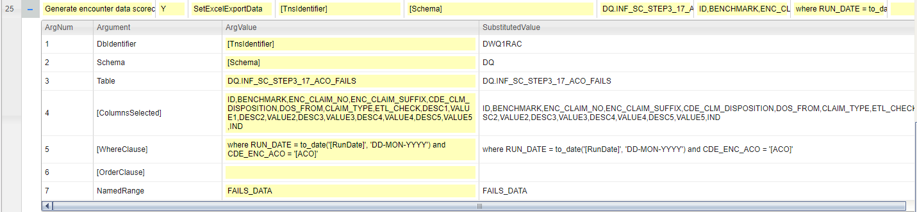
This rule populates the FAILS
The IND at the end of the list adds a dot in the T column of FAILS_DATA named range defined as
='Failure Claims Listing'!$B$11:$T$36
And the conditional formatting rule Formula: = $T11=’.’ Recognizes the dot and turns the blank line pink.

SFTP DIF Extension
With the successful automation of Nicole’s monthly reports, the next step was to use the Data Integration Framework to automatically deliver the reports and notify the plans. This removes Nicole from the loop and automatically distributes the reports.
12.1 Steps in the process
Main processing is
Generate encounter data scorecard main
Which calls
Generate encounter data scorecard
Create the 15 spreadsheets, 5 external zip files and one internal zip file
Generate encounter data scorecard external send
Moves the external zip files to the SFTP server and sends emails to the plans
Generate encounter data scorecard internal send
Creates the summary report and sends the summary report and internal zip file to the DI teams in an email

12.2 Code review from the Command Editor
I have pulled the text of the commands out of the Commands Editor to make the reading easier.

The main calls the 3 subroutines. Each is called with SQL looping. For two of the steps this provides a way to iterate over the ACO’s and plans, and for the final step it servers as a hack to run SQL to load variables.
------------------------------
The main routine: Generate encounter data scorecard main

Generate encounter data scorecard main N Comment Generate scorecard reports in three steps
Generate encounter data scorecard main N SetProcessParameter OutputFolder [ExcelDataFolder]
Set to Test or Prod to send to the Test or Prod SFTP folders and use Test or Prod email lists
XGenerate encounter data scorecard main N SetProcessParameter ProdOrTest PROD
Generate encounter data scorecard main N SetProcessParameter ProdOrTest TEST

Generate encounter data scorecard main N SendEmailOnFailure [TnsIdentifier] [Schema] INF_B_SC_MCO_SCORECARD_EMAIL_ALERTS
Generate encounter data scorecard main N Comment Step 1 loop over the ACOs generating reports
Generate encounter data scorecard main N ForEachRecordOfTable [TnsIdentifier] DQ INF_SC_STEP3_16_ACO_RUNDATE PLAN,ACO,RUN_DATE,DATE_STR,SHEET_NAME MCO,ACO,RunDate,DATE_STR,SHEET_NAME
Generate encounter data scorecard main N RunSubProcess Encounter Scorecards Generate encounter data scorecard [MCO],[ACO],[RunDate],[DATE_STR],[SHEET_NAME],[ProdOrTest]
Generate encounter data scorecard main N NextRecordOfTable INF_SC_STEP3_16_ACO_RUNDATE

Generate encounter data scorecard main N Comment Step 2 loop over MCO to move zips to SFTP and send emails
Generate encounter data scorecard main N ForEachRecordOfTable [TnsIdentifier] DQ INF_SC_STEP3_19_PLAN_EMAIL_BODY RUN_DATE,DATE_STR,PLAN,EMAIL_BODY,EMAIL_RECIPIENT_TABLE,SFTP_FOLDER where DEPLOY_STAGE='[ProdOrTest]' RunDate,DATE_STR,MCO,EmailBody,EmailRecipentTable,SFTPFolder
Generate encounter data scorecard main N RunSubProcess Encounter Scorecards Generate encounter data scorecard external send [RunDate],[DATE_STR],[MCO],"[EmailBody]",[EmailRecipentTable],[SFTPFolder],[ProdOrTest]
Generate encounter data scorecard main N NextRecordOfTable INF_SC_STEP3_19_PLAN_EMAIL_BODY

Generate encounter data scorecard main N Comment Step 3 run the summary report and send to internal list
STEP3_20 only has one record. This sets variables.
Generate encounter data scorecard main N ForEachRecordOfTable [TnsIdentifier] DQ INF_SC_STEP3_20_INTERNAL_EMAIL_BODY RUN_DATE,DATE_STR,EMAIL_BODY RunDate,DATE_STR,EmailBody
Generate encounter data scorecard main N RunSubProcess Encounter Scorecards Generate encounter data scorecard internal send [RunDate],[DATE_STR],"[EmailBody]",[ProdOrTest]
Generate encounter data scorecard main N NextRecordOfTable INF_SC_STEP3_20_INTERNAL_EMAIL_BODY
------------------------------
First subroutine: Generate encounter data scorecard
Generate encounter data scorecard N Comment Create the spreadsheets and zips
Generate encounter data scorecard N SubProcess PLAN,ACO,RUN_DATE,DATE_STR,SHEET_NAME,ProdOrTest
Use views to build the report content and load into named ranges in the spreadsheet.
Generate encounter data scorecard N SetExcelExportData [TnsIdentifier] [Schema] DQ.INF_SC_STEP3_1_BENCHMARK_DATA ID, BENCHMARK, BENCHMARK_NAME,FIELD_ID,CLAIM_TYPE,DUM1,BENCHMARK_THRESHOLD,DUM2,A_CLM, A_ACT_4_S,A_ACT_3_S, A_ACT_2_S, A_ACT_1_S,DUM3,B_CLM, B_ACT_5_S,B_ACT_4_S, B_ACT_3_S,B_ACT_2_S,DUM4,C_CLM, C_ACT_6_S,C_ACT_5_S, C_ACT_4_S, C_ACT_3_S,DUM5,D_CLM, D_ACT_7_S,D_ACT_6_S, D_ACT_5_S, D_ACT_4_S where RUN_DATE = to_date('[RunDate]', 'DD-MON-YYYY') and ACO = '[ACO]' order by ID BENCHMARK_DATA
Generate encounter data scorecard N SetExcelExportData [TnsIdentifier] [Schema] DQ.INF_SC_STEP3_8_CLM_ACT_HDRS where RUN_DATE = to_date('[RunDate]', 'DD-MON-YYYY') DATA1_CLM_ACT_HDRS
Generate encounter data scorecard N SetExcelExportData [TnsIdentifier] [Schema] DQ.INF_SC_STEP3_2 PLAN,ACO where RUN_DATE = to_date('[RunDate]', 'DD-MON-YYYY') and ACO = '[ACO]' DATA2_PLAN_ACO
Generate encounter data scorecard N SetExcelExportData [TnsIdentifier] [Schema] DQ.INF_SC_STEP3_7 A_ACT_4_MISS, A_ACT_3_MISS, A_ACT_2_MISS,A_ACT_1_MISS, B_ACT_5_MISS, B_ACT_4_MISS, B_ACT_3_MISS, B_ACT_2_MISS,C_ACT_6_MISS, C_ACT_5_MISS, C_ACT_4_MISS, C_ACT_3_MISS, D_ACT_7_MISS,D_ACT_6_MISS, D_ACT_5_MISS, D_ACT_4_MISS where RUN_DATE = to_date('[RunDate]', 'DD-MON-YYYY') and ACO = '[ACO]' DATA3_MISS_DATA
Generate encounter data scorecard N SetExcelExportData [TnsIdentifier] [Schema] DQ.INF_SC_STEP3_9_DATE_STRINGS IA,IB,IC,ID,IALL where RUN_DATE = to_date('[RunDate]', 'DD-MON-YYYY') DATA4_DATE_STRINGS
Generate encounter data scorecard Y SetExcelExportData [TnsIdentifier] [Schema] DQ.INF_SC_STEP3_10_TIMELINESS ID,FILE_NAME,ZIP_FILE_CREATED,METADATA_DATE_CREATED,DATE_FILE_PROCESSED,MANUAL_OVERRIDE,AMENDMENT where RUN_DATE = to_date('[RunDate]', 'DD-MON-YYYY') and MCO = '[MCO]' order by ID TIMELINESS
Generate encounter data scorecard Y SetExcelExportData [TnsIdentifier] [Schema] DQ.INF_SC_STEP3_12_TIMELINESS_COUNTS RUN_DATE,MCO,M6,Z6,M5,Z5,M4,Z4,M3,Z3,M2,Z2,M1,Z1 where RUN_DATE = to_date('[RunDate]', 'DD-MON-YYYY') and MCO = '[MCO]' DATA5_TIMELINESS_COUNTS
Generate encounter data scorecard N SetExcelExportData-ZeroRowsOk [TnsIdentifier] [Schema] DQ.INF_SC_STEP3_13_ACO_NAMES ACO,MCO_NAME,CONTACT_MGR,PERFORMANCE_MGR where ACO = '[ACO]' DATA6_ACO_NAMES
Generate encounter data scorecard N SetExcelExportData [TnsIdentifier] [Schema] DQ.INF_SC_STEP3_14_BENCHMARK_COUNT BENCH_CNT,BENCH_STR DATA7_BENCHMARK_COUNT
Generate encounter data scorecard Y SetExcelExportData [TnsIdentifier] [Schema] DQ.INF_SC_STEP3_15_TIMELINESS_STRINGS RUN_DATE,ACO,MA,MB,MC,MD,SA,SB,SC,SD where RUN_DATE = to_date('[RunDate]', 'DD-MON-YYYY') and ACO = '[ACO]' DATA8_TIMELINESS_STRINGS
Generate encounter data scorecard Y SetExcelExportData [TnsIdentifier] [Schema] DQ.INF_SC_STEP3_17_ACO_FAILS ID,BENCHMARK,ENC_CLAIM_NO,ENC_CLAIM_SUFFIX,CDE_CLM_DISPOSITION,DOS_FROM,CLAIM_TYPE,ETL_CHECK,DESC1,VALUE1,DESC2,VALUE2,DESC3,VALUE3,DESC4,VALUE4,DESC5,VALUE5 where RUN_DATE = to_date('[RunDate]', 'DD-MON-YYYY') and CDE_ENC_ACO = '[ACO]' FAILS_DATA
Generate encounter data scorecard N ExportDataToExcel [OutputFolder] MCO-ACPP Encounter Data Scorecard_ACO_YYYY-MM-DD.xlsx [OutputFolder]
Rename the spreadsheet to format MCO-ACPP Encounter Data Scorecard_NHP-MVACO_JANUARY_2022.xlsx
Generate encounter data scorecard N SetVariablesWithSql [TnsIdentifier] [SqlFolder][Slash]get_date.sql ProducedDate
Generate encounter data scorecard N RunSubProcess Data Integration Operations Rename file with overwrite [OutputFolder], MCO-ACPP Encounter Data Scorecard_ACO_[ProducedDate].xlsx, MCO-ACPP Encounter Data Scorecard_[SHEET_NAME]_[DATE_STR].xlsx
Generate encounter data scorecard N Comment Add the spreadsheet to the MCO zip
Generate encounter data scorecard N RunShellCommand C:\tools\7-Zip\7z.exe a [OutputFolder][Slash]MCO-ACPP_Encounter_Data_Scorecard_[MCO]_[DATE_STR].zip [OutputFolder][Slash]MCO-ACPP Encounter Data Scorecard_[SHEET_NAME]_[DATE_STR].xlsx
Generate encounter data scorecard N Comment Add the spreadsheet to the Summary zip
Generate encounter data scorecard N RunShellCommand C:\tools\7-Zip\7z.exe a [OutputFolder][Slash][DATE_STR]_ACO.zip [OutputFolder][Slash]MCO-ACPP Encounter Data Scorecard_[SHEET_NAME]_[DATE_STR].xlsx
Generate encounter data scorecard N Comment Delete the un-zipped spreadsheet
Generate encounter data scorecard N RunSubProcess Data Integration Operations Delete file [OutputFolder], MCO-ACPP Encounter Data Scorecard_[SHEET_NAME]_[DATE_STR].xlsx
------------------------------
Second subroutine: Generate encounter data scorecard external send
The Email body is formed in the main call in view INF_SC_STEP3_19_PLAN_EMAIL_BODY

Generate encounter data scorecard external send N Comment Move the zips to SFTP and generate the plan email
Send email to plan members
Generate encounter data scorecard external send N SubProcess RunDate,DATE_STR,MCO,EmailBody,EmailRecipentTable,SFTPFolder,ProdOrTest
Generate encounter data scorecard external send N Comment Move the zip to SFTP - move to local dir for now
This was for testing and will be turned off
Generate encounter data scorecard external send N RunSubProcess Data Integration Operations Copy new files from local path [OutputFolder],MCO-ACPP_Encounter_Data_Scorecard_[MCO]_[DATE_STR].zip,[ExcelDataFolder][Slash]copytest
Send the zip file to the SFTP server
Generate encounter data scorecard external send N SFTPCopyFile Y [OutputFolder][Slash]MCO-ACPP_Encounter_Data_Scorecard_[MCO]_[DATE_STR].zip [SFTPFolder]/MCO-ACPP_Encounter_Data_Scorecard_[MCO]_[DATE_STR].zip
Generate encounter data scorecard external send N Comment Create Plan Summary report
For the data Integration Operations team
Generate encounter data scorecard external send N SetVariable EmailSubject Encounter Scorecards Posted for [DATE_STR]
Generate encounter data scorecard external send N RunSubProcess Data Integration Operations Send email [Schema],[EmailRecipentTable],RECIPIENT,[EmailSubject],"[EmailBody]"
------------------------------
Third subroutine: Generate encounter data scorecard internal send
Create an exception report called the Summary Report and send the report an the zip of all of the spreadsheets to the Data Integrity team.
The Email body is formed in the main call in view INF_SC_STEP3_20_INTERNAL_EMAIL_BODY

Generate encounter data scorecard internal send N Comment Run and send the Summary Report
Generate encounter data scorecard internal send N Comment Run the Summary Report
Generate encounter data scorecard internal send N SubProcess RunDate,DATE_STR,EmailBody,ProdOrTest
Generate encounter data scorecard internal send N SetExcelExportData [TnsIdentifier] [Schema] DQ.INF_SC_STEP3_8_CLM_ACT_HDRS LAST_SUB_STR where RUN_DATE = to_date('[RunDate]', 'DD-MON-YYYY') RUN_DATE_STRING
Generate encounter data scorecard internal send N SetExcelExportData [TnsIdentifier] [Schema] DQ.INF_SC_STEP3_18_SUMMARY RUN_DATE, PLAN, ACO, MISSED_BENCHMARKS, ACTUALS_WITH_ZERO where RUN_DATE = to_date('[RunDate]', 'DD-MON-YYYY') order by RUN_DATE, PLAN, ACO SUMMARY_DATA
Generate encounter data scorecard internal send Y ExportDataToExcel [OutputFolder] MCO-ACPP Encounter Data Scorecard_Summary_YYYY-MM-DD.xlsx [OutputFolder]
Generate encounter data scorecard internal send N SetVariablesWithSql [TnsIdentifier] [SqlFolder][Slash]get_date.sql ProducedDate
Generate encounter data scorecard internal send N RunSubProcess Data Integration Operations Rename file with overwrite [OutputFolder], MCO-ACPP Encounter Data Scorecard_Summary_[ProducedDate].xlsx, MCO-ACPP Encounter Data Scorecard_Summary_[DATE_STR].xlsx
Generate encounter data scorecard internal send N Comment Compiling the email
Generate encounter data scorecard internal send N SetVariable EmailSubject [DATE_STR] ACO Summary Report
Generate encounter data scorecard internal send N SetEmailAttachment [OutputFolder] MCO-ACPP Encounter Data Scorecard_Summary_[DATE_STR].xlsx
Generate encounter data scorecard internal send N SetEmailAttachment [OutputFolder] [DATE_STR]_ACO.zip Y
Generate encounter data scorecard internal send N RunSubProcess Data Integration Operations Send email [Schema],INF_B_SC_MCO_SCORECARD_[ProdOrTest]_INTERNAL_RECP,RECIPIENT,[EmailSubject],"[EmailBody]"

SCO Report and One Care

The SCO and One Care spreadsheets are done by a group outside the DW:
Abigail.V.Alegi, Jimmy.Kaduboski taking over for Amar Parikh.
As Nicole explained it:
It’s a similar process to the MCO Encounter evaluation, however, I do not format/distribute the final evaluation. I generate the raw completeness evaluation and send to Amar Parikh. He formats on his end and generates the dashboard and distributes.

DQ was considering taking over the full generation of the spreadsheet but upon examination it became clear that the report summarizes many feeds, including financial reports which the DQ team does not have available. Thus the effort is simply to reproduce Nicole’s spreadsheet and fails reports using IDQ and DIF.
Nicole’s processing consists of:
Step 1 Generate Claims.SAS
Step 2 Generate Measures.SAS
Step 3 Generate Report.SAS
SAS_MASTER_COMPOSITE.TXT
SCO_Sample_Fail_list_<SCO>.SAS
This is very similar to the ACO processing but added 44 additional measures.

13.1 Informatica steps
SCO processing is an extension to the ACO processing with the mappings named SCO
Where there are 44 additional fields there were a similar number of Rule specifications and mapplets required. The mapplet names are detailed in the BRD.

Mappings reused from ACO
MAP_INF_B_SC_STG_SCO_DOS – with additional fields for SCO
MAP_INF_B_SC_STG_SCO_ALL_CLAIM_TYPES
MAP_INF_B_SC_STG_SCO_ALL_PHARMACY
MAP_INF_B_SC_STG_SCO_INP_OUTP_LTC_NONRX
MAP_INF_B_SC_STG_SCO_OTHER_CLAIM
MAP_INF_B_SC_STG_SCO_PROF_INP_INPLTC
MAP_INF_B_SC_STG_SCO_PTPDOS – with additional tables in the initial SQL and additional PCT calculations

Mappings added for SCO
To process the additional All Claims
MAP_INF_B_SC_STG_SCO_ALL_CLAIM_TYPES_II
MAP_INF_B_SC_STG_SCO_ALL_CLAIM_TYPES_III
To process the additional professional and the outpatient measures
MAP_INF_B_SC_STG_SCO_PROF_AND_OUT

Steps from Step 3 Generate Report.SAS
Transpose the Numerators (required an Oracle pivot and unpivot to duplicate the SAS transpose)
MAP_INF_B_SC_STG_SCO_TRANSPOSE1
MAP_INF_B_SC_STG_SCO_TRANSPOSE2
Transpose the Denominators (required an Oracle pivot and unpivot to duplicate the SAS transpose)
MAP_INF_B_SC_STG_SCO_TRANSPOSE21
MAP_INF_B_SC_STG_SCO_TRANSPOSE22
Add the Measures descriptions
MAP_INF_B_SC_STG_SCO_STEP1
Pivot it into the final form by SCO plan
MAP_INF_B_SC_STG_SCO_STEP2

13.2 DIF steps
The final table is the exact output for the spreadsheet. In the SAS Nicole just writes the table out to a spreadsheet. For DIF we created a spreadsheet template with a singles sheet named SCO (vs the run date name Nicole uses) and a single named range.
The spreadsheet name has the quarter on it. This has not been automated yet. Here we see the variables being set manually.

Generate SCO spreadsheet N SetProcessParameter RunDate 20-DEC-2021
Generate SCO spreadsheet N SetProcessParameter DATE_STR Q2_12212021
Generate SCO spreadsheet N SetProcessParameter OutputFolder [ExcelDataFolder]
Generate SCO spreadsheet N SetExcelExportData [TnsIdentifier] [Schema] DQ.INF_SC_SCO_REPORT MEASURE,CLAIMTYPE,BENCHMARK,BHP,BHP_DENOM,CCA,CCA_DENOM,NAV,NAV_DENOM,SWH,SWH_DENOM,TFT,TFT_DENOM,UHC,UHC_DENOM where RUN_DATE = to_date('[RunDate]', 'DD-MON-YYYY') order by MEASURE SCO_DATA
Generate SCO spreadsheet Y ExportDataToExcel [OutputFolder] SCO_REPORT_CARD_YYYY-MM-DD.xlsx [OutputFolder]
Generate SCO spreadsheet N SetVariablesWithSql [TnsIdentifier] [SqlFolder][Slash]get_date.sql ProducedDate
Generate SCO spreadsheet N RunSubProcess Data Integration Operations Rename file with overwrite [OutputFolder], SCO_REPORT_CARD_[ProducedDate].xlsx, SCO_REPORT_CARD_[DATE_STR].xlsx

This produces a spreadsheet named SCO_REPORT_CARD_Q2_12212021.xlsx

13.3 SCO Fails reports
Steps have been added to create a Fails report. Where this spreadsheet shows five plans at once, the ACO fails report, being a pivoted list of 25 fails for each benchmark miss, had to be modified to further stack by SCO.
The view INF_SC_SCO_FAILS uses the ACO logic for fails, without the percent adjustment and an Oracle unpivot to stack by SCO by benchmark.

The fails sheet is on tab Failure Claims Listing and shows the same fields for ACO, this time with nine validation categories to cover the expanded logic for procedure code processing. The fields are SCO, Measure, Claim Number, Claim Suffix Claim Disposition, From Service Date, Claim Type and Validation Category and Validation Values 1 through 9.
13.4 SCO Email distribution
A simple email distribution step was added to the SCO DIF processing to send the spreadsheet to the interest parties. It is based on the ACO internal distribution, using the INF_B_SC_SCO_SCORECARD_TEST_RECP and INF_B_SC_SCO_SCORECARD_PROD_RECP mail lists.
The DIF email process is:
The view INF_SCO_QUARTER was modified to include the email body passed as email_body.
The Generate SCO spreadsheet main passes the email_body to Generate SCO spreadsheet which sends the email using
Generate SCO spreadsheet N Comment Compiling the email
Generate SCO spreadsheet N SetVariable EmailSubject
Generate SCO spreadsheet N SetEmailAttachment [OutputFolder]
Generate SCO spreadsheet N RunSubProcess Data Integration Operations send email

Summary
In this technical document we have discussed:
- Naming Standards and programming considerations
- A review of the Scorecard process
- A review of the work to be done in the project
- A discussion of running SQL in IDQ
- A list of the Scorecard tables
- An overview of scheduling using Linux Command Line and the DW Informatica Job Runner
- An explanation of the programming process for using Mapping and Mapplets
- An initial plan for the possible Cognos Report to generate the Completeness spreadsheet
- A discussion of the after Cognos report best used for HTML and Excel
- An automatically generated DIF version of Nicole’s worksheet exactly reproducing the Nicole’s original ACO worksheet with a Fails sheet showing examples of failed Encounter records.
- Extending the DIF report generation to automatically zip the spreadsheets, move the five plan zip files to SFTP folders, send notification reports to the plans and send an internal email to the members of the DI team.
- Automating the SCO report spreadsheet generation.

