SENDPro Raw Dashboard Technical Specification - Version 1.1

Revision History
Version | Date | Revision Description | Author
1.0 | 5/1/2025 | Base version created | JP Leger
1.1 | 12/31/2025 | Added Text Summary viz and BRD link in Version | JP Leger

The SENDPro Raw dashboard provides counts on 42 data fields available in the initial XML to Relational ETL RAW tables. These tables usually include the word RAW in their name. There are four dashboards: 837I inpatient, long term care and outpatient, 837M, (called P in the dashboard) professional, 837D, dental and 837 NCPDP, pharmacy. All four dashboards provide the same visualizations (viz), filtered for the applicable data.
As of the update, December 31, 2025, the SENDPro RAW data is only in QA, with the dashboards residing in the Tableau Dev instance at Explore / Data Quality and Integrity / UAT / SENDPRO_RAW.

The 4 dashboards are:
DQ_SENDPRO_RAW_837I
DQ_SENDPRO_RAW_837P
DQ_SENDPRO_RAW_837D
DQ_SENDPRO_RAW_837_NCPDP

Dashboard Layout and Navigation
SENDPRO_RAW consists of the four dashboards accessed through the tabs on the top. Each dashboard provides four main viz’s, the Summary and Text Summary at the top and two dependent viz’s, Benchmarks and Detail. The dependent viz’s are toggled by the Benchmarks or Detail view parameter at the bottom of the filter’s pop-up. The Summary and Text Summary are toggled by the Bar or Text view parameter in the filter pop-up.

Summary
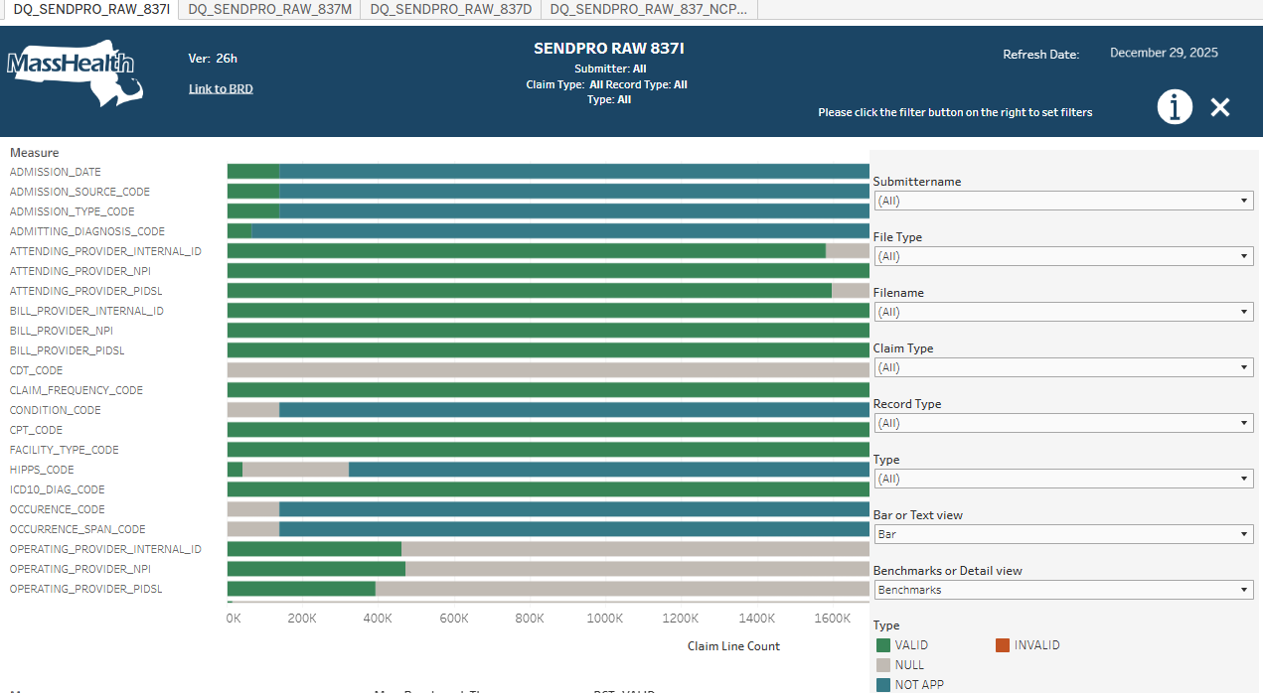

Text Summary
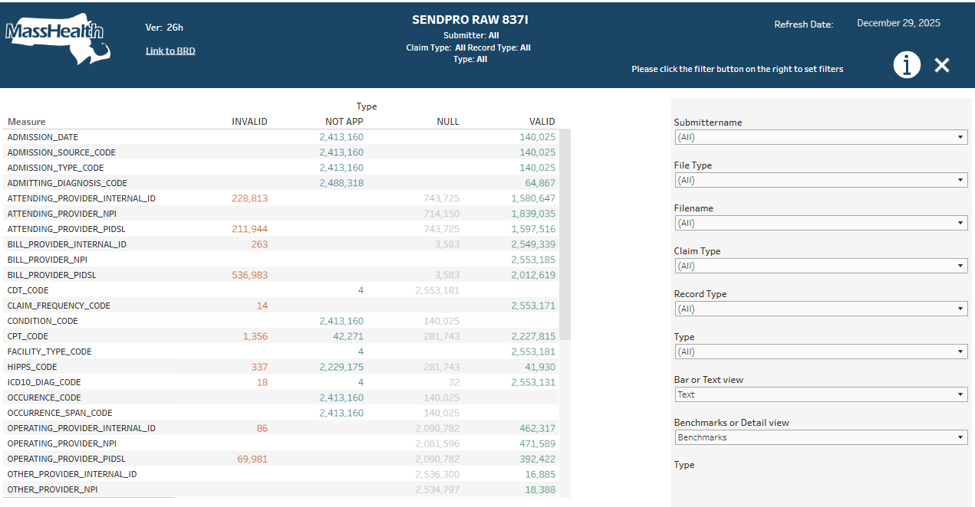
Benchmarks
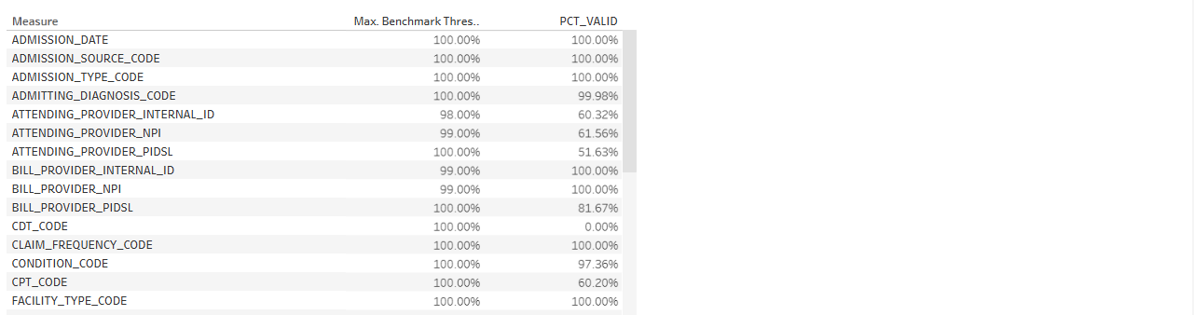
Detail
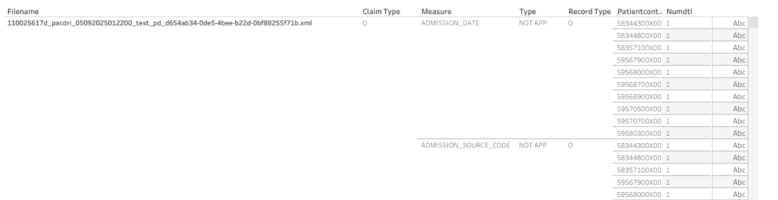

The SENDPRO_POC dashboards are based on the MH Tableau standard provided by Timothy Lalowski and the slalom consulting group. The Tableau templates are found at:
MH_Tableau_Templates_FINAL: Welcome - Tableau Server

We are using the “D – One Menu Bar Top” template with the filters and parameters all located in the filter hide/show pop up accessed by the filter  button in the top menu bar.
The dashboard titles include information about the selected filters
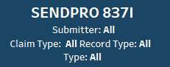
as suggested by John Boney and provide by Yi-Ling Lin.
The dashboard version is indicated on the menu bar left, as of this update 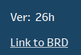.
Also with the version is a link to the shared BRD. (Also suggested by John Boney) The information button  (will) provide a pop-up description of the dashboard. The Refresh Date shows the latest Run Date of the Informatica processing and Tableau data sources refresh. 

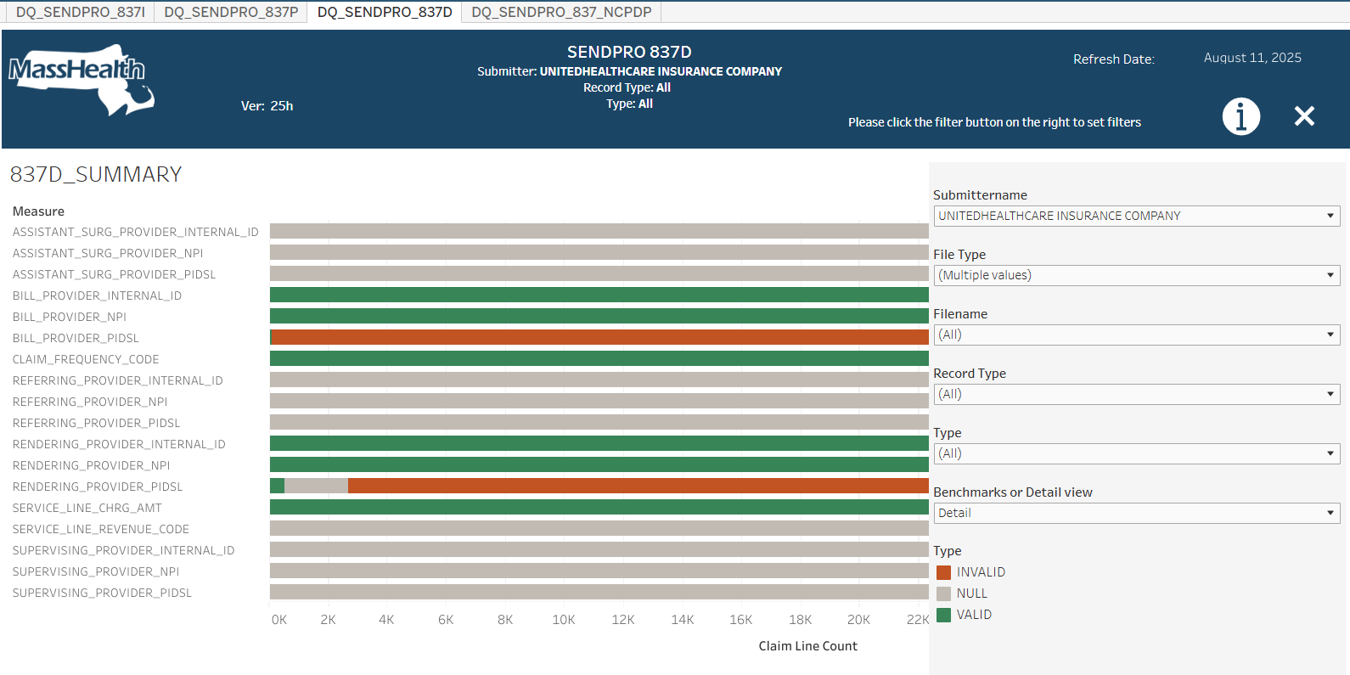

The Summary viz provides a high-level view of the quality of the data in the XML files submitted by Deloitte. Each measure (field) has a horizontal bar that visually and numerically, using the tool tips, displays the percentage of data in the file(s) that are Valid (green), Invalid (red), Null (grey) or Not Applicable (blue). Valid and Invalid are determined by algorithms defined in the BRD. Not Applicable is for measures that are displayed but not having data for the measure and the Claim Type (usually Outpatient on the 837I for Inpatient and LTC fields.) Not applicable would also be displayed on the P, D and NCDPD dashboards, but most have been hidden.
The top filters on the menu control selection of the files included. Submitter Name limits files to one or multiple submitters. File Type further filters files to those containing data for Paid, Partially Accepted, Denied and Fully Denied (based on filtering for characters in the file name _pd_ for Paid.) Filename explicitly picks files out of what is left after the previous filters.
The lower three filters remove aspects of the data. Claim Type limits to one or more Claim Types (only shown on 837I) the Record Type filters to show: original, adjustments and voids. The Type filters to show Valid, Invalid, Null and Not Applicable.
The Text Summary viz presents the same data as the bar Summary viz, just the bars are replaced with the record counts for each Type.

The “Benchmarks or Detail view” parameter toggles the dependent viz’s to show or hide.

Benchmarks Viz
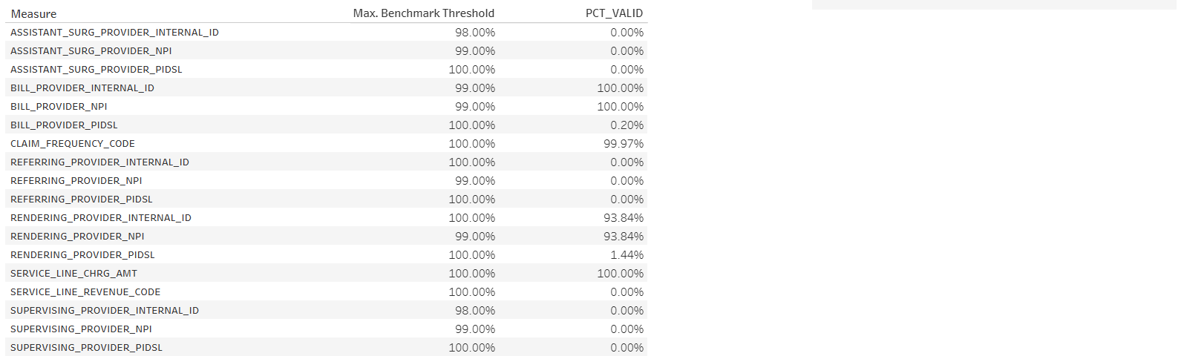
The Benchmarks viz repeats the PCT_REC_TYPE from the Summary tool tip as PCT_VALID and compares it to a Benchmark Threshold for the measure. The Benchmark thresholds are defined in the BRD. Here, Billing Provider Internal Id’s Benchmark Threshold is 98% and the data shows 100%.

Detail Viz
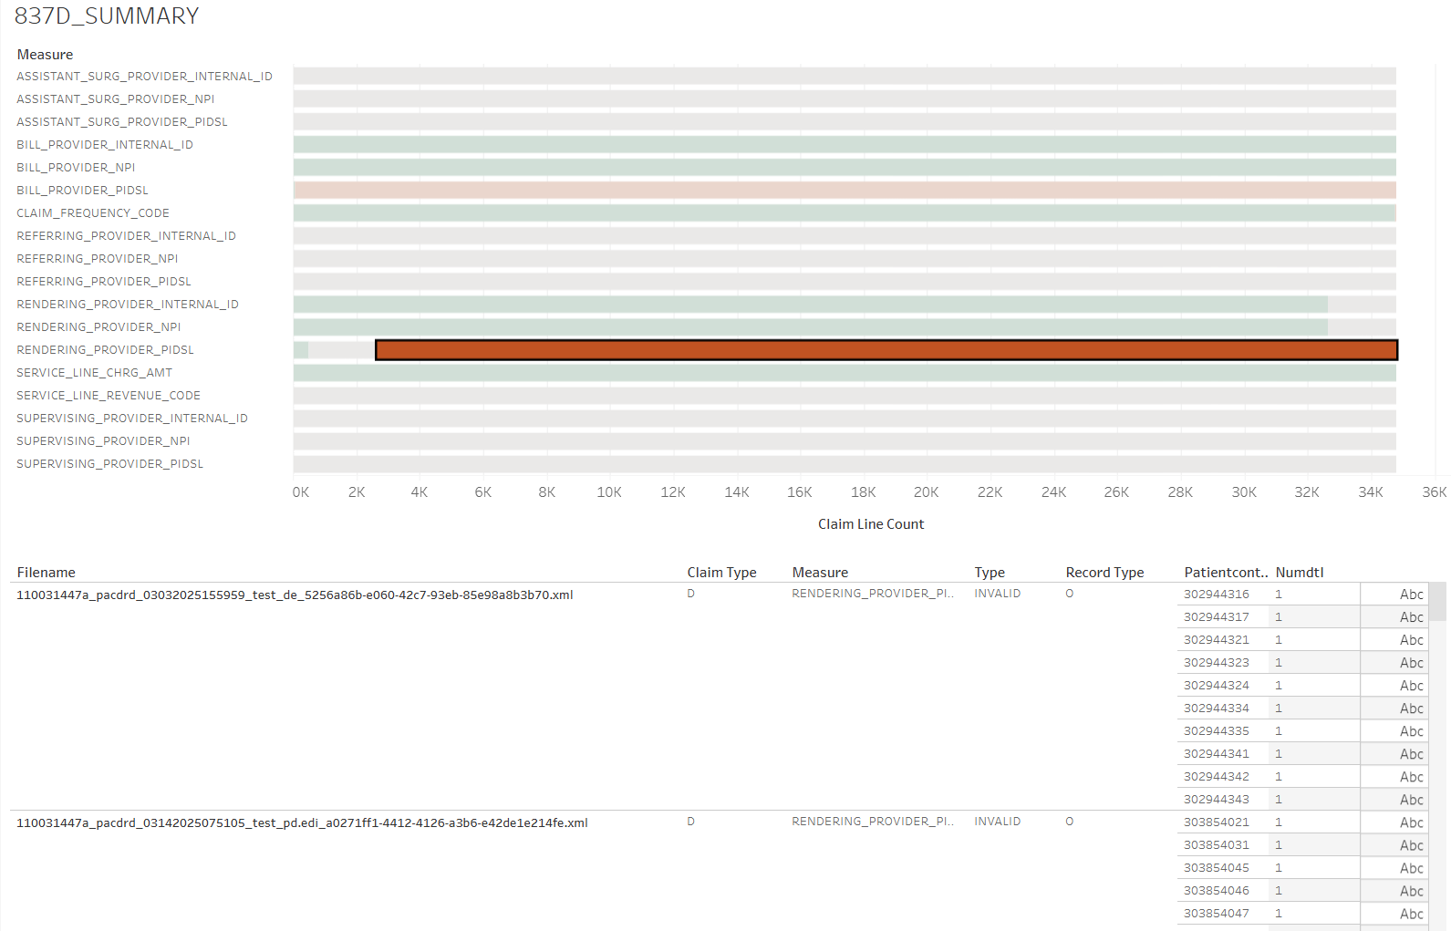

The Detail viz attempts to provide sample claims, for the measure in question, to facilitate further analysis via SQL or other BI tools, if available. Here we are looking at sample Dental claims with invalid Rendering Provider PIDSLs. The sample data is limited to 5 or 10 claims per: Filename, Claim Type, Type and Record Type combination, and only the first Numdtl (claim lines) are utilized.

Internals

The dashboards use data from 9 Snowflake views:

INF_SENDPRO_CLAIMS_DQ_7_837_QA_UNPIV
INF_SENDPRO_CLAIMS_DQ_7_837D_QA_UNPIV
INF_SENDPRO_CLAIMS_DQ_7_837M_QA_UNPIV
INF_SENDPRO_NCPDP_DQ_QA_UNPIV

INF_SENDPRO_CLAIMS_DQ_7_837I_QA_UNPIV_DETAIL
INF_SENDPRO_CLAIMS_DQ_7_837D_QA_UNPIV_DETAIL
INF_SENDPRO_CLAIMS_DQ_7_837M_QA_UNPIV_DETAIL
INF_SENDPRO_NCPDP_DQ_QA_UNPIV_DETAIL

INF_SENDPRO_RAW_RUN_DATE

The sets of views follow similar processing, so we will look at the dental views because they are shorter.
The SQL views and tables are available in Snowflake, the table refresh SQL is in Informatica Dev and both are in my GitHub repository jplegeratma.

The base table is:
create or replace TABLE MHTEAM.DWDQ.INF_B_SENDPRO_CLAIMS_DQ_7D_QA (
RUN_DATE DATE,
TRANSSETCONTROLNUM VARCHAR(255),
SUBMITTERID VARCHAR(255),
PATIENTCONTROLNUM VARCHAR(255),
CLAIM_TYPE VARCHAR(1),
NUMDTL NUMBER(4,0),
FILENAME VARCHAR(1000),
RECORD_TYPE VARCHAR(1),
CLAIMFREQUENCYCODE1 NUMBER(1,0),
CLAIMFREQUENCYCODE1X VARCHAR(7),
SVCLINECHARGEAMT1 NUMBER(1,0),
SVCLINECHARGEAMT1X VARCHAR(7),
SVCLINEADJREVENUECODE1 NUMBER(1,0),
SVCLINEADJREVENUECODE1X VARCHAR(7),
BILLINGPROVNPI1 NUMBER(1,0),
BILLINGPROVNPI1X VARCHAR(7),
BILL_PROVIDERINTERNALID1 NUMBER(1,0),
BILL_PROVIDERINTERNALID1X VARCHAR(7),
BILL_PROVIDERPIDSL1 NUMBER(1,0),
BILL_PROVIDERPIDSL1X VARCHAR(7),
REF_REFERRINGPROVNPI1 NUMBER(1,0),
REF_REFERRINGPROVNPI1X VARCHAR(7),
REF_PROVIDERINTERNALID1 NUMBER(1,0),
REF_PROVIDERINTERNALID1X VARCHAR(7),
REF_PROVIDERPIDSL1 NUMBER(1,0),
REF_PROVIDERPIDSL1X VARCHAR(7),
REN_RENDERINGPROVNPI1 NUMBER(1,0),
REN_RENDERINGPROVNPI1X VARCHAR(7),
REN_PROVIDERINTERNALID1 NUMBER(1,0),
REN_PROVIDERINTERNALID1X VARCHAR(7),
REN_PROVIDERPIDSL1 NUMBER(1,0),
REN_PROVIDERPIDSL1X VARCHAR(7),
ASST_ASSISTANTSURGEONPROVNPI1 NUMBER(1,0),
ASST_ASSISTANTSURGEONPROVNPI1X VARCHAR(7),
ASST_PROVIDERINTERNALID1 NUMBER(1,0),
ASST_PROVIDERINTERNALID1X VARCHAR(7),
ASST_PROVIDERPIDSL1 NUMBER(1,0),
ASST_PROVIDERPIDSL1X VARCHAR(7),
SUP_SUPERVISINGPROVNPI1 NUMBER(1,0),
SUP_SUPERVISINGPROVNPI1X VARCHAR(7),
SUP_PROVIDERINTERNALID1 NUMBER(1,0),
SUP_PROVIDERINTERNALID1X VARCHAR(7),
SUP_PROVIDERPIDSL1 NUMBER(1,0),
SUP_PROVIDERPIDSL1X VARCHAR(7),
TOT_REX NUMBER(1,0)
);
It holds one row per claim line and includes the fields needed to support the filters, the patient control number (member id) the detail line number, the run_date, tot_rex ( in this case 1 used for calculations) and a 1 and 1X field for each measure (here CLAIMFREQUENCYCODE1 and 1X). The 1 field is a numeric: 1 (valid) or 0 (invalid, null) used for summing. The 1x contains ‘VALID’, ‘INVALID’, ‘NULL’ or ‘NOT APP’)
RUN_DATE DATE,
TRANSSETCONTROLNUM VARCHAR(255),
SUBMITTERID VARCHAR(255),
PATIENTCONTROLNUM VARCHAR(255),
CLAIM_TYPE VARCHAR(1),
NUMDTL NUMBER(4,0),
FILENAME VARCHAR(1000),
RECORD_TYPE VARCHAR(1),
CLAIMFREQUENCYCODE1 NUMBER(1,0),
CLAIMFREQUENCYCODE1X VARCHAR(7),
…
TOT_REX NUMBER(1,0)
The table is populated by a SQL transformation (just a SQL runner) in the Informatica CDGC Dev Org:
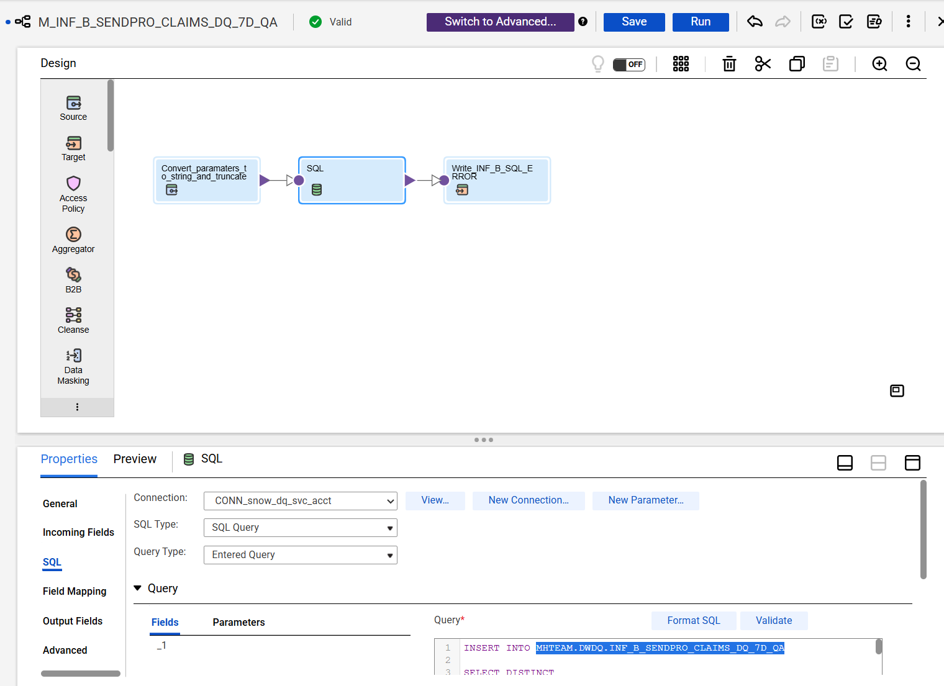

Run by schedule SENDPro Dashboard Weekly Monday at 3 AM on TF_INF_B_SENDPRO_Dashboard
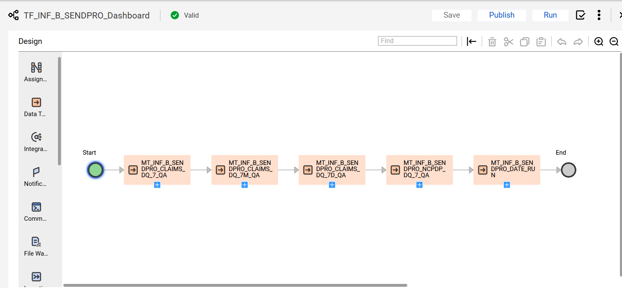
The Insert SQL in the mapping loads incrementally, only looking at the files not already processed. This is used to reduce the processing times. The Run_Date acts as the batch date.

INSERT INTO MHTEAM.DWDQ.INF_B_SENDPRO_CLAIMS_DQ_7D_QA
SELECT DISTINCT
RUN_DATE,
TransSetControlNum,
SubmitterID,
PatientControlNum,
claim_type,
NumDtl,
FileName,
Record_Type,

{ REMOVED EXTRA LINES showing Service Line Revenue Code as example}
-- Service Line Adjustment Revenue Code
/*
12.7.20. Service Line Adjustment Revenue Code (MPT_SENDPRO_AdjRevenueCode_837I)
4.1.1.1. 837I Claims population: MPT_SENDPRO_ClaimType_837I_LTC, MPT_SENDPRO_ClaiimType_837I_INP, MPT_SENDPRO_ClaiimType_837I_OUTP, MPT_SENDPRO_ClaiimType_837P, MPT_SENDPRO_ClaiimType_837D

4.1.1.2. MPT_SENDPRO_ServiceLineRevenueCode_Valid:
STG_SPRO_837I_CLAIM_SVCLN_LINEADJ_INFO.SvcLineAdjRevenueCode,
STG_SPRO_837P_CLAIM_SVCLN_LINEADJ_INFO.SvcLineAdjRevenueCode,
STG_SPRO_837D_CLAIM_SVCLN_LINEADJ_INFO.SvcLineAdjRevenueCode,
4.1.1.3. MPT_SENDPRO_StringIsNull_ALL:
STG_SPRO_837I_CLAIM_SVCLN_LINEADJ_INFO.SvcLineAdjRevenueCode,
STG_SPRO_837P_CLAIM_SVCLN_LINEADJ_INFO.SvcLineAdjRevenueCode,
STG_SPRO_837D_CLAIM_SVCLN_LINEADJ_INFO.SvcLineAdjRevenueCode,
*/

-- DI
CASE WHEN Claim_Type IN ('L','I','O','M','D')

AND SvcLineAdjRevenueCode IS NOT NULL
AND SvcLineAdjRevenueCode IN (SELECT CDE_CHAR FROM MHDWQA.NW.NW_SUP_CODE_REF WHERE CDE_GROUP = 'CDE_REVENUE' AND CDE_CHAR NOT IN ('#','**','+','-','$',' '))
THEN 1 ELSE 0 END SvcLineAdjRevenueCode1,

-- Ex
CASE WHEN Claim_Type NOT IN ('L','I','O','M','D') THEN 'NOT APP'
WHEN SvcLineAdjRevenueCode IS NULL THEN 'NULL'
WHEN SvcLineAdjRevenueCode NOT IN (SELECT CDE_CHAR FROM MHDWQA.NW.NW_SUP_CODE_REF WHERE CDE_GROUP = 'CDE_REVENUE' AND CDE_CHAR NOT IN ('#','**','+','-','$',' ')) THEN 'INVALID'
ELSE 'VALID' END SvcLineAdjRevenueCode1X,
{ REMOVED EXTRA LINES}
-- ALL RECORDS
1 AS TOT_REX

FROM (
select * from (

select DISTINCT
CURRENT_DATE() AS RUN_DATE,
h."TransSetControlNum" as TransSetControlNum,
-- h."ImplementationConventionRef" as ImplementationConventionRef,
h."SubmitterID" as SubmitterID,
h."PatientControlNum" as PatientControlNum,
to_number(d."NumDtl",4,0) as NumDtl,
h."FileName" as FileName,

'D' as Claim_Type,

h."ClaimFrequencyCode" as ClaimFrequencyCode,

CASE
WHEN h."ClaimFrequencyCode" IN ('1','2','3','4','5') THEN 'O'
WHEN h."ClaimFrequencyCode" IN ('7') THEN 'A'
WHEN h."ClaimFrequencyCode" IN ('8') THEN 'V'
ELSE 'X'
END AS Record_Type,

to_number(d."SvcLineChargeAmt", 12,2) as SvcLineChargeAmt,
-- a."AdjReasonCode01" as AdjReasonCode01,

h."BillingProvNPI" as BillingProvNPI,
h."ContractTypeCode" as ContractTypeCode,

CASE WHEN LEFT(a."SvcLineAdjRevenueCode",1) != '0' then a."SvcLineAdjRevenueCode" ELSE SUBSTR(a."SvcLineAdjRevenueCode",2,3) END as SvcLineAdjRevenueCode,

-- Billing Provider
trim(h."ProviderInternalId") as ProviderInternalId,
upper(trim(h."ProviderPidsl")) as ProviderPidsl,

trim(bp."ProviderInternalId") as ProviderInternalId_bp,
upper(trim(bp."ProviderPidsl")) as ProviderPidsl_bp,

trim(ref."ReferringProvNPI") as ref_ReferringProvNPI,
trim(ref."ProviderInternalId") as ref_ProviderInternalId,
upper(trim(ref."ProviderPidsl")) as ref_ProviderPidsl,
trim(ref."ProviderLocationCode") as ref_ProviderLocationCode,

trim(ren."RenderingProvNPI") as ren_RenderingProvNPI,
trim(ren."ProviderInternalId") as ren_ProviderInternalId,
upper(trim(ren."ProviderPidsl")) as ren_ProviderPidsl,
trim(ren."ProviderLocationCode") as ren_ProviderLocationCode,

trim(sup."SupervisingProvNPI") as sup_SupervisingProvNPI,
trim(sup."ProviderInternalId") as sup_ProviderInternalId,
upper(trim(sup."ProviderPidsl")) as sup_ProviderPidsl,
trim(sup."ProviderLocationCode") as sup_ProviderLocationCode,

trim(asst."AssistantSurgeonProvNPI") as asst_AssistantSurgeonProvNPI,
trim(asst."ProviderInternalId") as asst_ProviderInternalId,
upper(trim(asst."ProviderPidsl")) as asst_ProviderPidsl,
trim(asst."ProviderLocationCode") as asst_ProviderLocationCode

from MHDWQA.SENDPRO.RAW_SPRO_837D_CLAIM as h

left join MHDWQA.SENDPRO.RAW_SPRO_837D_CLAIM_SERVICE_DTL as d
on h."TransSetControlNum" = d."TransSetControlNum"
and h."SubmitterID" = d."SubmitterID"
and h."PatientControlNum" = d."PatientControlNum"

left join MHDWQA.SENDPRO.RAW_SPRO_837D_CLAIM_SVCLN_ADJUDICATION_DTL as a
on h."TransSetControlNum" = a."TransSetControlNum"
-- and h."SubmitterID" = a."SubmitterID"
and h."PatientControlNum" = a."PatientControlNum"
and d."NumDtl" = a."NumDtl"

left join MHDWQA.SENDPRO.RAW_SPRO_837D_BILLING_PROVIDER_DTL bp
on bp."TransSetControlNum" = h."TransSetControlNum" and
bp."SendProTransId" = h."SendProTransId" and
bp.RAW_SPRO_BPROV_SEQ = h.RAW_SPRO_BPROV_SEQ

left join MHDWQA.SENDPRO.RAW_SPRO_837D_REFERRING_PROVIDER_DTL ref
on h."FileName" = ref."FileName" and
-- h.RAW_SPRO_CLAIM_SEQ = ref.RAW_SPRO_CLAIM_SEQ and
h."PatientControlNum"= ref."PatientControlNum" and
h."NumDtl" = ref."NumDtl"

left join MHDWQA.SENDPRO.RAW_SPRO_837D_RENDERING_PROVIDER_DTL ren
on h."FileName" = ren."FileName" and
-- h.RAW_SPRO_CLAIM_SEQ = ren.RAW_SPRO_CLAIM_SEQ and
h."PatientControlNum"= ren."PatientControlNum" and
h."NumDtl" = ren."NumDtl"

left join MHDWQA.SENDPRO.RAW_SPRO_837D_ASSISTANT_SURGEON_DTL asst
on h."FileName" = asst."FileName" and
-- h.RAW_SPRO_CLAIM_SEQ = asst.RAW_SPRO_CLAIM_SEQ and
h."PatientControlNum"= asst."PatientControlNum" and
h."NumDtl" = asst."NumDtl"

left join MHDWQA.SENDPRO.RAW_SPRO_837D_SUPERVISING_PROVIDER_DTL sup
on h."FileName" = sup."FileName" and
-- h.RAW_SPRO_CLAIM_SEQ = sup.RAW_SPRO_CLAIM_SEQ and
h."PatientControlNum"= sup."PatientControlNum" and
h."NumDtl" = sup."NumDtl"

where FileName NOT IN ( SELECT DISTINCT FileName from MHTEAM.DWDQ.INF_B_SENDPRO_CLAIMS_DQ_7D_QA )

order by
TransSetControlNum,
-- ImplementationConventionRef,
h."SubmitterID",
FileName,
h."PatientControlNum",
to_number(d."NumDtl",4,0)
));

The base table is processed through a view (originally for Tableau, now may not be needed)
create or replace view MHTEAM.DWDQ.INF_SENDPRO_CLAIMS_DQ_BI_7D_QA(
RUN_DATE,
TRANSSETCONTROLNUM,
SUBMITTERID,
FILENAME,
PATIENTCONTROLNUM,
NUMDTL,
CLAIM_TYPE,
RECORD_TYPE,
CLAIMFREQUENCYCODE1,
SVCLINECHARGEAMT1,
SVCLINEADJREVENUECODE1,
BILLINGPROVNPI1,
BILL_PROVIDERINTERNALID1,
BILL_PROVIDERPIDSL1,
REF_REFERRINGPROVNPI1,
REF_PROVIDERINTERNALID1,
REF_PROVIDERPIDSL1,
REN_RENDERINGPROVNPI1,
REN_PROVIDERINTERNALID1,
REN_PROVIDERPIDSL1,
SUP_SUPERVISINGPROVNPI1,
SUP_PROVIDERINTERNALID1,
SUP_PROVIDERPIDSL1,
ASST_ASSISTANTSURGEONPROVNPI1,
ASST_PROVIDERINTERNALID1,
ASST_PROVIDERPIDSL1,
TOT_REX
) as
SELECT
RUN_DATE,
TRANSSETCONTROLNUM,
SUBMITTERID,
FILENAME,
PATIENTCONTROLNUM,

NUMDTL,
CLAIM_TYPE,
RECORD_TYPE,
CLAIMFREQUENCYCODE1,
SVCLINECHARGEAMT1,
SVCLINEADJREVENUECODE1,

BILLINGPROVNPI1,
BILL_PROVIDERINTERNALID1,
BILL_PROVIDERPIDSL1,

REF_REFERRINGPROVNPI1,
REF_PROVIDERINTERNALID1,
REF_PROVIDERPIDSL1,

REN_RENDERINGPROVNPI1,
REN_PROVIDERINTERNALID1,
REN_PROVIDERPIDSL1,

SUP_SUPERVISINGPROVNPI1,
SUP_PROVIDERINTERNALID1,
SUP_PROVIDERPIDSL1,

ASST_ASSISTANTSURGEONPROVNPI1,
ASST_PROVIDERINTERNALID1,
ASST_PROVIDERPIDSL1,

TOT_REX
FROM MHTEAM.DWDQ.INF_B_SENDPRO_CLAIMS_DQ_7D_QA;
And processed by the Summary view:

create or replace view MHTEAM.DWDQ.INF_SENDPRO_CLAIMS_DQ_7D_QA_UNPIV(
RUN_DATE,
FILENAME,
CLAIM_TYPE,
RECORD_TYPE,
MEASURE,
TYPE,
REC_CNT,
SUBMITTERNAME,
BENCHMARK_THRESHOLD
) as

SELECT DISTINCT RUN_DATE, FILENAME, CLAIM_TYPE, RECORD_TYPE, MEASURE, TYPE, REC_CNT,
DS."SubmitterLastOrgName" AS SUBMITTERNAME,
L.BENCHMARK_THRESHOLD
FROM
(
SELECT RUN_DATE, FILENAME, CLAIM_TYPE, RECORD_TYPE, MEASURE, TYPE, COUNT(TYPE) AS REC_CNT
FROM (
SELECT RUN_DATE, FILENAME, CLAIM_TYPE, RECORD_TYPE, MEASURE, TYPE
FROM (
SELECT
RUN_DATE,
FILENAME,
CLAIM_TYPE,
RECORD_TYPE,
CLAIMFREQUENCYCODE1X AS Claim_Frequency_Code,
SVCLINECHARGEAMT1X AS Service_Line_Chrg_Amt,
SVCLINEADJREVENUECODE1X AS Service_Line_Revenue_Code,

BILLINGPROVNPI1X AS Bill_Provider_NPI,
BILL_PROVIDERINTERNALID1X Bill_Provider_Internal_ID,
BILL_PROVIDERPIDSL1X Bill_Provider_PIDSL,

REF_REFERRINGPROVNPI1X Referring_Provider_NPI,
REF_PROVIDERINTERNALID1X Referring_Provider_Internal_ID,
REF_PROVIDERPIDSL1X Referring_Provider_PIDSL,

REN_RENDERINGPROVNPI1X Rendering_Provider_NPI,
REN_PROVIDERINTERNALID1X Rendering_Provider_Internal_ID,
REN_PROVIDERPIDSL1X Rendering_Provider_PIDSL,

SUP_SUPERVISINGPROVNPI1X Supervising_Provider_NPI,
SUP_PROVIDERINTERNALID1X Supervising_Provider_Internal_ID,
SUP_PROVIDERPIDSL1X Supervising_Provider_PIDSL,

ASST_ASSISTANTSURGEONPROVNPI1X Assistant_Surg_Provider_NPI,
ASST_PROVIDERINTERNALID1X Assistant_Surg_Provider_Internal_ID,
ASST_PROVIDERPIDSL1X Assistant_Surg_Provider_PIDSL

FROM MHTEAM.DWDQ.INF_SENDPRO_CLAIMS_DQ_QA_7D_QA
)
UNPIVOT (
TYPE
FOR MEASURE IN (
Claim_Frequency_Code,
Service_Line_Chrg_Amt,
Service_Line_Revenue_Code,

Bill_Provider_NPI,
Bill_Provider_Internal_ID,
Bill_Provider_PIDSL,

Referring_Provider_NPI,
Referring_Provider_Internal_ID,
Referring_Provider_PIDSL,

Rendering_Provider_NPI,
Rendering_Provider_Internal_ID,
Rendering_Provider_PIDSL,

Supervising_Provider_NPI,
Supervising_Provider_Internal_ID,
Supervising_Provider_PIDSL,

Assistant_Surg_Provider_NPI,
Assistant_Surg_Provider_Internal_ID,
Assistant_Surg_Provider_PIDSL
)
) AS INF_B_SENDPRO_CLAIMS_DQ_7D_UNPIV
ORDER BY RUN_DATE, FILENAME, CLAIM_TYPE, RECORD_TYPE, MEASURE, TYPE
)
GROUP BY RUN_DATE, FILENAME, CLAIM_TYPE, RECORD_TYPE, MEASURE, TYPE
) A
LEFT JOIN MHDWQA.SENDPRO.RAW_SPRO_837D_FILE_STATISTICS DS
ON A.FILENAME = DS."FileName" AND A.CLAIM_TYPE = 'D'
JOIN INF_B_SENDPRO_LOOKUP L ON A.MEASURE = L.BENCHMARK
ORDER BY FILENAME, CLAIM_TYPE, MEASURE, TYPE;

The unpiv aggregates each measure into a separate row in the view, by run_date, filename, claim_type, type and measure. The Benchmark table INF_B_SENDPRO_LOOKUP is joined in to add the Benchmark threshold at the end .

The view gives data that looks like:
select *
from MHTEAM.DWDQ.INF_SENDPRO_CLAIMS_DQ_7D_QA_UNPIV
order by RUN_DATE, FILENAME, MEASURE, claim_type, record_type, type
limit 10;

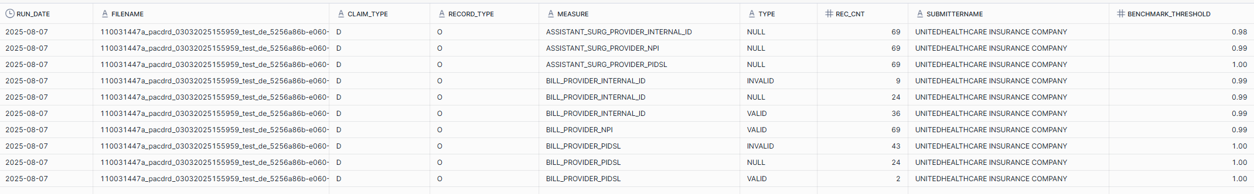

Detail Unpiv
The detail unpiv is similar but stays at the claim line level, using the unpiv to pivot the Type. It also limits the number of rows to 10 and uses Numdtl = 1.

create or replace view MHTEAM.DWDQ.INF_SENDPRO_CLAIMS_DQ_7_837D_UNPIV_DETAIL(
RUN_DATE,
FILENAME,
CLAIM_TYPE,
RECORD_TYPE,
MEASURE,
TYPE,
PATIENTCONTROLNUM,
NUMDTL,
RNK
) as
-- limit rank to 10 lines
SELECT *
FROM (
-- rank
SELECT *,
RANK ()
OVER (PARTITION BY RUN_DATE,
FILENAME,
CLAIM_TYPE,
RECORD_TYPE,
MEASURE
ORDER BY
RUN_DATE,
FILENAME,
CLAIM_TYPE,
RECORD_TYPE,
MEASURE,
TYPE,
PATIENTCONTROLNUM,
NUMDTL) AS rnk

FROM (

-- only first claim line

SELECT *
FROM (

-- core unpiv

SELECT RUN_DATE, FILENAME, CLAIM_TYPE, RECORD_TYPE, MEASURE, TYPE, PatientControlNum, NumDtl
FROM (
SELECT
RUN_DATE,
FILENAME,
CLAIM_TYPE,
RECORD_TYPE,
CLAIMFREQUENCYCODE1X AS Claim_Frequency_Code,
SVCLINECHARGEAMT1X AS Service_Line_Chrg_Amt,
SVCLINEADJREVENUECODE1X AS Service_Line_Revenue_Code,

BILLINGPROVNPI1X AS Bill_Provider_NPI,
BILL_PROVIDERINTERNALID1X Bill_Provider_Internal_ID,
BILL_PROVIDERPIDSL1X Bill_Provider_PIDSL,

REF_REFERRINGPROVNPI1X Referring_Provider_NPI,
REF_PROVIDERINTERNALID1X Referring_Provider_Internal_ID,
REF_PROVIDERPIDSL1X Referring_Provider_PIDSL,

REN_RENDERINGPROVNPI1X Rendering_Provider_NPI,
REN_PROVIDERINTERNALID1X Rendering_Provider_Internal_ID,
REN_PROVIDERPIDSL1X Rendering_Provider_PIDSL,

SUP_SUPERVISINGPROVNPI1X Supervising_Provider_NPI,
SUP_PROVIDERINTERNALID1X Supervising_Provider_Internal_ID,
SUP_PROVIDERPIDSL1X Supervising_Provider_PIDSL,

ASST_ASSISTANTSURGEONPROVNPI1X Assistant_Surg_Provider_NPI,
ASST_PROVIDERINTERNALID1X Assistant_Surg_Provider_Internal_ID,
ASST_PROVIDERPIDSL1X Assistant_Surg_Provider_PIDSL,

PatientControlNum,
NumDtl
FROM MHTEAM.DWDQ.INF_SENDPRO_CLAIMS_DQ_QA_7D_QA
)
UNPIVOT (
TYPE
FOR MEASURE IN (
Claim_Frequency_Code,
Service_Line_Chrg_Amt,
Service_Line_Revenue_Code,

Bill_Provider_NPI,
Bill_Provider_Internal_ID,
Bill_Provider_PIDSL,

Referring_Provider_NPI,
Referring_Provider_Internal_ID,
Referring_Provider_PIDSL,

Rendering_Provider_NPI,
Rendering_Provider_Internal_ID,
Rendering_Provider_PIDSL,

Supervising_Provider_NPI,
Supervising_Provider_Internal_ID,
Supervising_Provider_PIDSL,

Assistant_Surg_Provider_NPI,
Assistant_Surg_Provider_Internal_ID,
Assistant_Surg_Provider_PIDSL

)
) AS UNPIV7D
ORDER BY RUN_DATE, FILENAME, CLAIM_TYPE, RECORD_TYPE, MEASURE, TYPE

)
-- only first claim line
WHERE NUMDTL = 1
)
-- add rank
)
-- limit rank to 10 line
WHERE rnk <= 10
ORDER BY
RUN_DATE,
FILENAME,
CLAIM_TYPE,
RECORD_TYPE,
MEASURE,
TYPE,
PATIENTCONTROLNUM,
RNK
;

The rank processing is borrowed from the ACO scorecard Failure Claims Processing.

The Detail view data looks like:

select *
from MHTEAM.DWDQ.INF_SENDPRO_CLAIMS_DQ_7_837D_UNPIV_DETAIL
order by RUN_DATE, FILENAME, MEASURE, claim_type, record_type, type, rnk
limit 5;

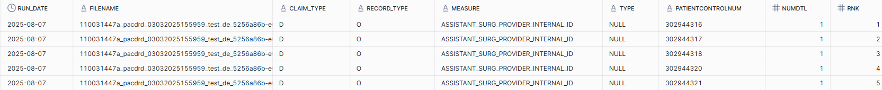

Tableau processing
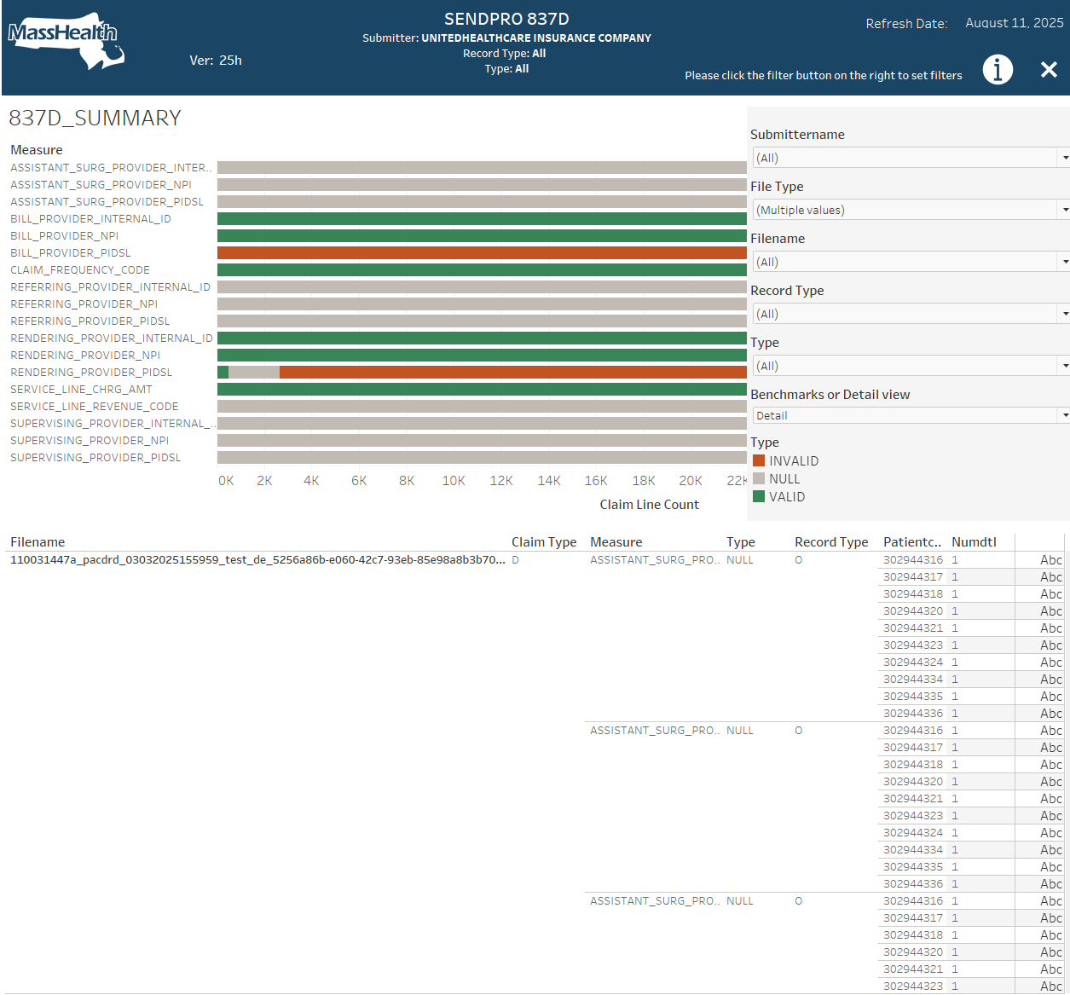
Continuing with 837D, the dashboard encompasses 6 viz worksheets:
837D_Summary
837D_Benchmarks
837D_Detail
837D_Title
Run_Date
Version
837D_Summary

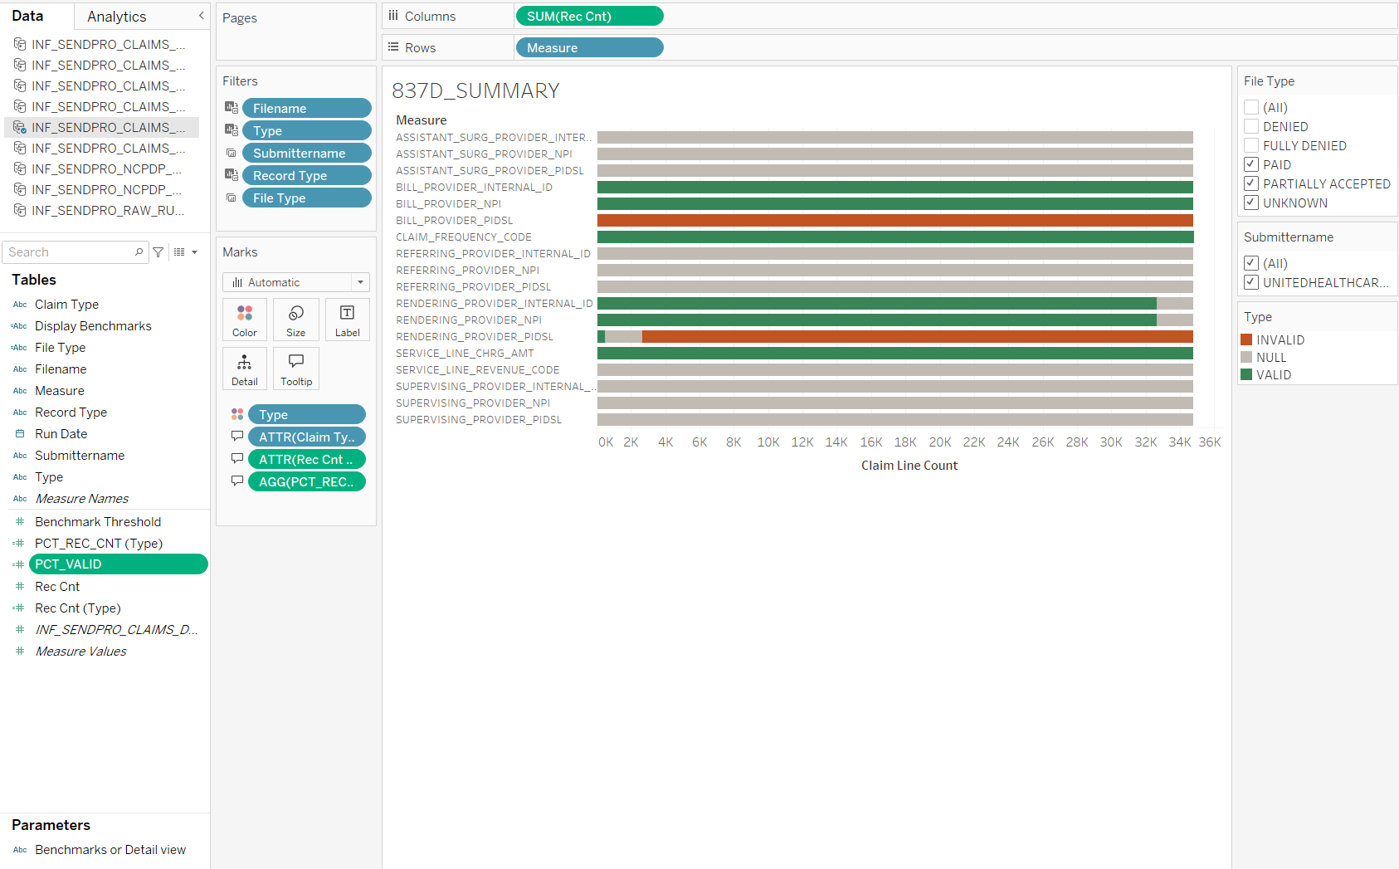

Because of the additional filters for Type, Record_Type and File_Type, the percentage calculations have to be done in Tableau. The SQL views created the Rec_Cnt aggregation.
The percent record_count and percent valid are within an individual bar and are divided by the Type requiring LOD calculations to remove the Type. The calculations are:
Rec Cnt (Type)
{ EXCLUDE [Type]: SUM([Rec Cnt]) }

PCT_REC_CNT (Type)
SUM([Rec Cnt])/SUM([Rec Cnt (Type)])

PCT_VALID
SUM( IF [Type] = 'VALID' OR [Type] = 'NOT APP' THEN [Rec Cnt] ELSE 0 END ) / SUM([Rec Cnt])

837D_Benchmarks

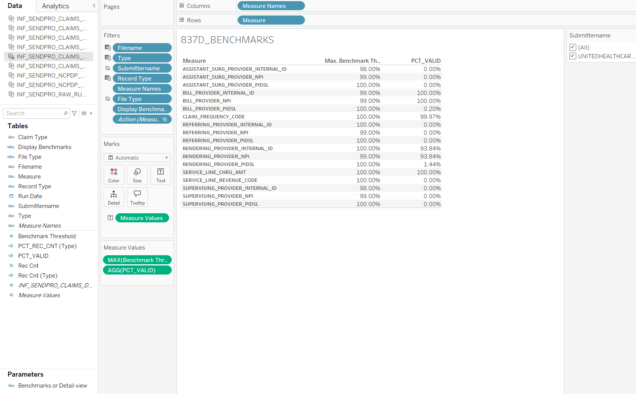

The Benchmarks displays the PCT_VALID, developed for the Summary viz, compared to the Benchmark Threshold.

837D_Detail

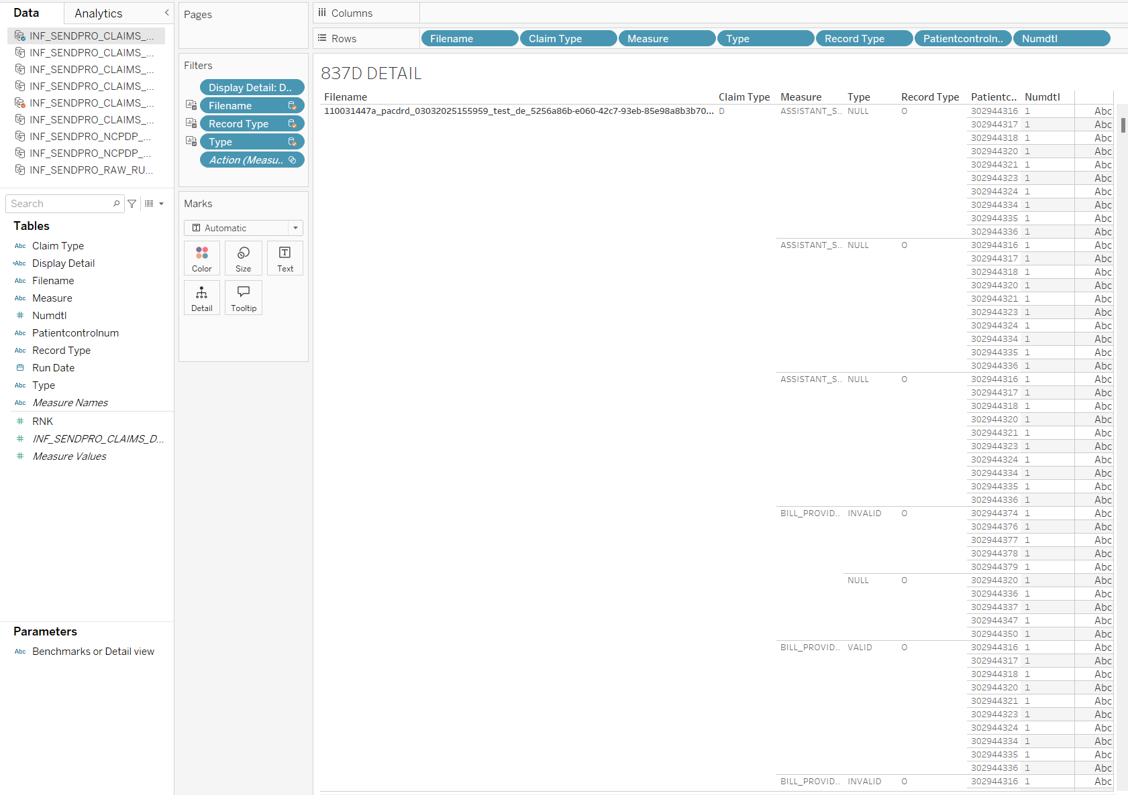
The Detail viz does not require any special processing. It is a simple text table of the detail lines in the view, filtered by the filters in the dashboard and the selected row in the Summary viz

An interesting part is the toggle for showing Benchmarks or Detail. This is done with a parameter “Benchmarks or Detail View”, which is used in all of the dashboards.

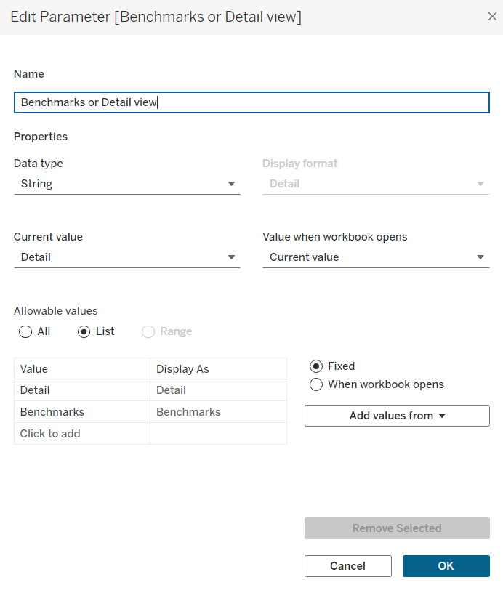
It lists a set of choices, here Detail and Benchmarks.
On each of the viz’s calculated fields are added which recognize the parameter choice.
Display Detail
[Benchmarks or Detail view]

Display Benchmarks
[Benchmarks or Detail view]

The appropriate calculated field is added as a filter to the sheet. For detail, use Display Detail. Edit the filter and add the value for the viz to be visible.
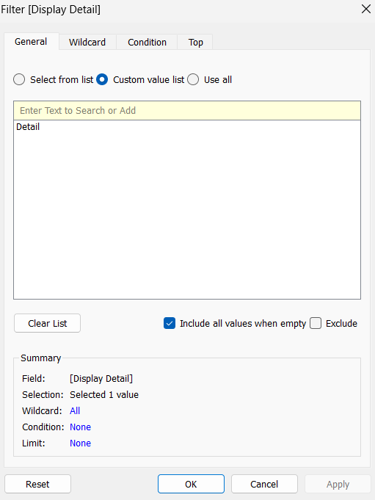
Use “Custom value list” – not the provided “Select from list”
Put a single value: Detail
in the yellow “Enter Text to Search or Add” press the + to have it display below.

On the dashboard, add the parameter to the filters container. The viz’s will now show and hide base on the parameter.
If two or more vizs are to occupy the same space, like the benchmark and detail,
put the first one on the sheet. Remove its title – the title will not hide.
Use the parameter to hide the viz. Put the next viz in the same place and remove its title.
The viz’s should now show and hide based on the one or more parameters. The Submissions dashboard has 16 vizs in sets of 2, with 3 parameters, = 8 combinations x 2.

837D_Title

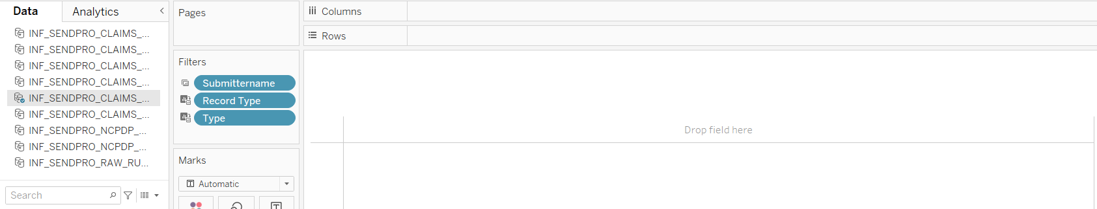

Title is a copy of the Summary with everything removed but the title.
The default title is replaced with color White, Tableau Medium 12 for the top line. Tableau Medium 8 for the following lines. The filter fields are bold:
SENDPRO 837D
Submitter: <Submittername>
Record Type: <Record Type>
Type: <Type>

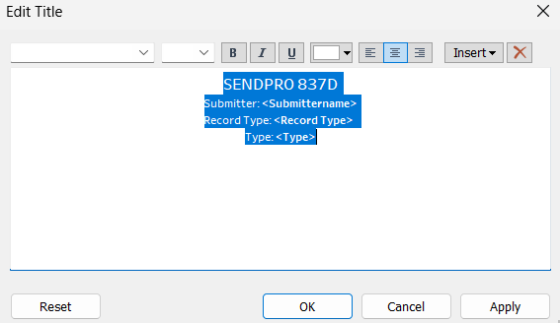

Place the title in the middle of the dashboard menu bar as a floating Sheet.
I recommend using Position and Size values to set its location.
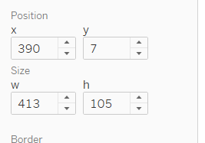

Refresh Date

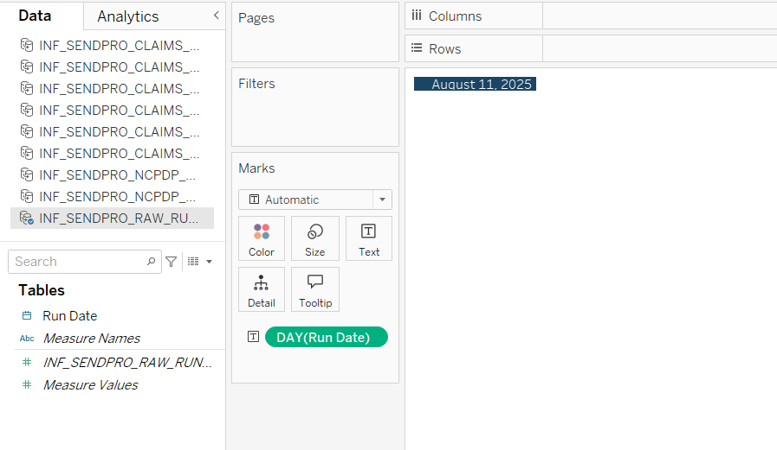A simple sheet based on the Run_Date field in the Run Date table.
In the dashboard, I placed it at position:
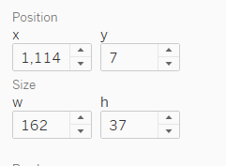

Version

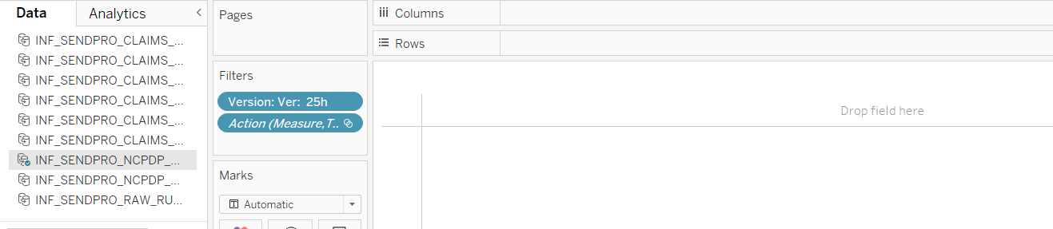

Again, a sheet with just a title. The version is a string in the Version calculated field.
Version
"Ver: 25h"

Add the Version calculated field as a filter and reference it in the title.
When the version changes, I manually update the calculated field. For some reason I have to remove the Version from the filters and replace it to get it to update?

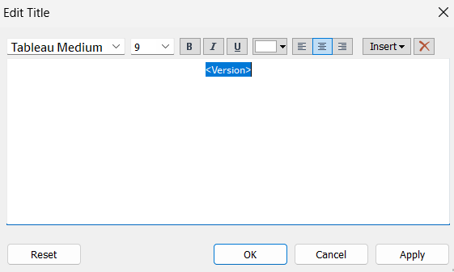

In the dashboard, I placed it at position:
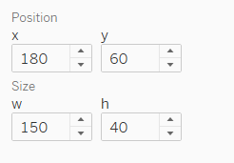

That’s All Folks!

