SENDPro Target Dashboard Technical Specification - Version 1.1

Revision History
Version | Date | Revision Description | Author
1.0 | 12/31/2025 | Base version created | JP Leger
1.1 | 4/8/2026 | Added section at end for steps to add new measures | JP Leger

The SENDPro Target dashboard provides counts on 49 data fields provided in the target tables prefixed with SPRO_B_ENC, like SPRO_B_ENC_CLAIM_INST_LEG_HIST. These are post staging and scrubbing processing of the RAW tables and are meant for final consumption. They are still in separate table groupings based on the four legs: INST, PROF, DNLT and PHRM. Presidio is working on a data structure that will combine (or provide a view) of the four legs to a single encounter structure similar to the legacy encounter tables.
Like for RAW, there are four dashboards: SENDPRO TARGET 837I with inpatient, long term care and outpatient, SENDPRO TARGET 837M, professional, SENDPRO TARGET 837D, dental and SENDPRO TARGET 837 NCPDP, pharmacy and compounds. All four dashboards provide the same visualizations (viz), filtered for the applicable data.
As of this update, December 31, 2025, the SENDPro TARGET data is only in Dev and QA, with the dashboards residing in the Tableau Dev instance at Explore / Data Quality and Integrity / UAT / SENDPRO_TARGET.

The 4 dashboards are:
DQ_TARGET_837I
DQ_TARGET_837P
DQ_TARGET_837D
DQ_TARGET_837_NCPDP
Dashboard Layout and Navigation
SENDPRO_TARGET consists of the four dashboards accessed through the tabs on the top. Each dashboard provides four main viz’s, the Summary and Text Summary at the top and two dependent viz’s, Benchmarks and Detail. The dependent viz’s are toggled by the Benchmarks or Detail view parameter at the bottom of the filter’s pop-up. The Summary and Text Summary are toggled by the Bar or Text view parameter in the filter pop-up.

Summary
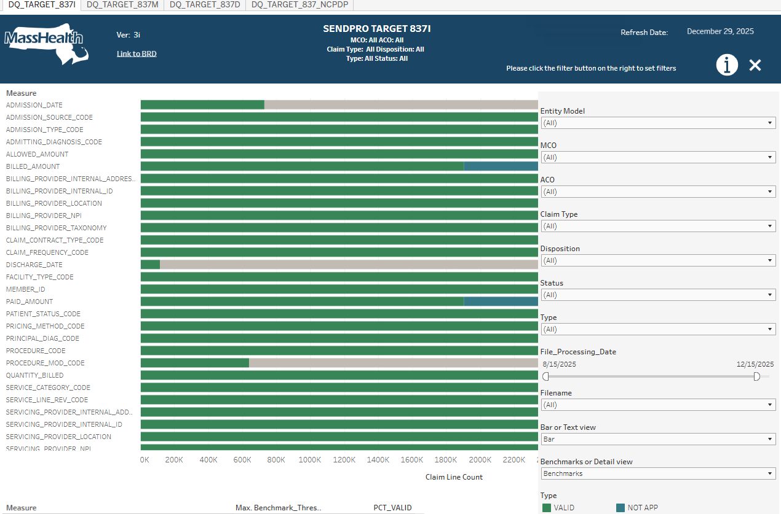

Text Summary
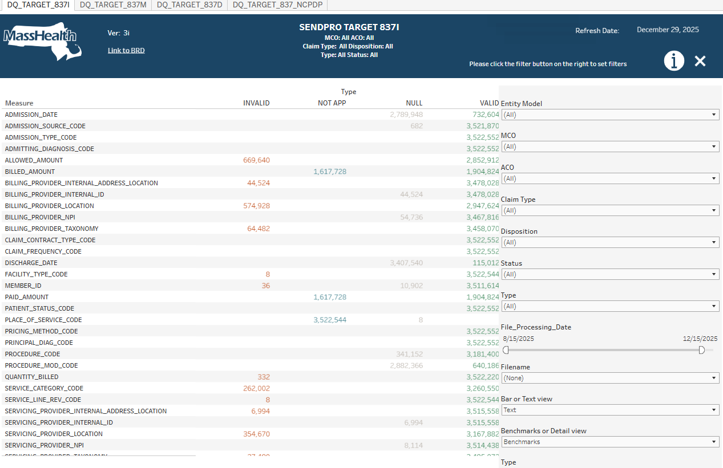

Benchmarks
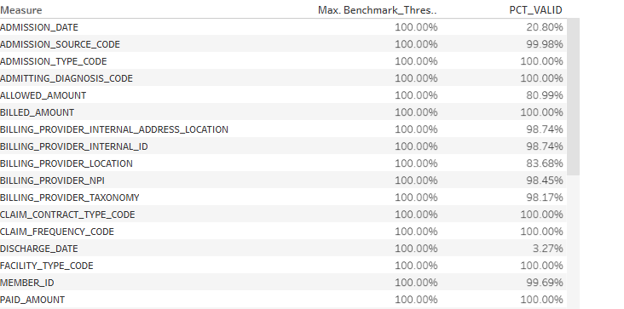

Detail
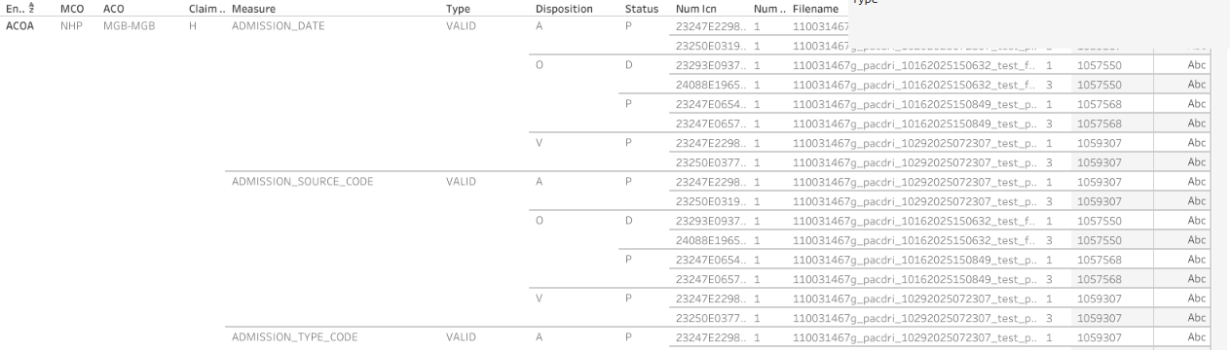

Like RAW, The SENDPRO_TARGET dashboards are based on the MH Tableau standard provided by Timothy Lalowski and the slalom consulting group. The Tableau templates are found at:
MH_Tableau_Templates_FINAL: Welcome - Tableau Server

We are using the “D – One Menu Bar Top” template with the filters and parameters all located in the filter hide/show pop up accessed by the filter  button in the top menu bar.
The dashboard titles include information about the selected filters
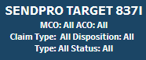
as suggested by John Boney and provide by Yi-Ling Lin.
The dashboard version is indicated on the menu bar left, as of this update 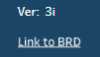.
Also with the version is a link to the shared BRD. (Also suggested by John Boney) The information button  (will) provide a pop-up description of the dashboard. The Refresh Date shows the latest Run Date of the Informatica processing and Tableau data sources refresh. 



The Summary viz provides a high-level view of the quality of the data in the XML files submitted by Deloitte after staging and scrubbing. The counts are at the Encounter detail line level. Each measure (field) has a horizontal bar that visually and numerically (using the tool tips) displays the percentage of data in the file(s) that are Valid (green), Invalid (red), Null (grey) or Not Applicable (blue). Valid and Invalid are determined by algorithms defined in the BRD. Not Applicable is for measures that are displayed but not having data for the measure and the Claim Type (usually Outpatient on the 837I for Inpatient and LTC fields.) Not applicable would also be displayed on the P, D and NCDPD dashboards, but most have been hidden.
The top filters on the menu control selection of the MCO/ACOs included. MCO limits record counts to one or multiple submitters.
The next three filters remove aspects of the data. Claim Type limits to one or more Claim Types, the Disposition filters to show: original, adjustments and voids. The Status filters to those containing data for Paid, Partially Accepted (R), and Denied. Type filters to show Valid, Invalid, Null and Not Applicable bars.
The next two filters add back RAW like processing to limit to specific XML files. For now this is done with a join back to the RAW tables for the file name but should be possible with just MD_BATCH_SEQ join to the Stats table. The File_Processing_Date allows for limiting records from files processed during a time period. Like in RAW, Filename explicitly picks files out of what is left after the previous filters.
Using the MCO filter with the File_Processing_Date and the Filename filters, it is possible to evaluate the quality of a plan’s records, post ETL, for specific XML submissions.

The Text Summary viz presents the same data as the bar Summary viz, just the bars are replaced with the record counts for each Type.


The “Benchmarks or Detail view” parameter toggles the dependent viz’s to show or hide.
Benchmarks Viz


The Benchmarks viz repeats the PCT_REC_TYPE from the Summary tool tip as PCT_VALID and compares it to a Benchmark Threshold for the measure. The Benchmark thresholds are defined in the BRD. Here, Billing Provider Internal Id’s Benchmark Threshold is 100% and the data shows 98.74%.

Detail Viz
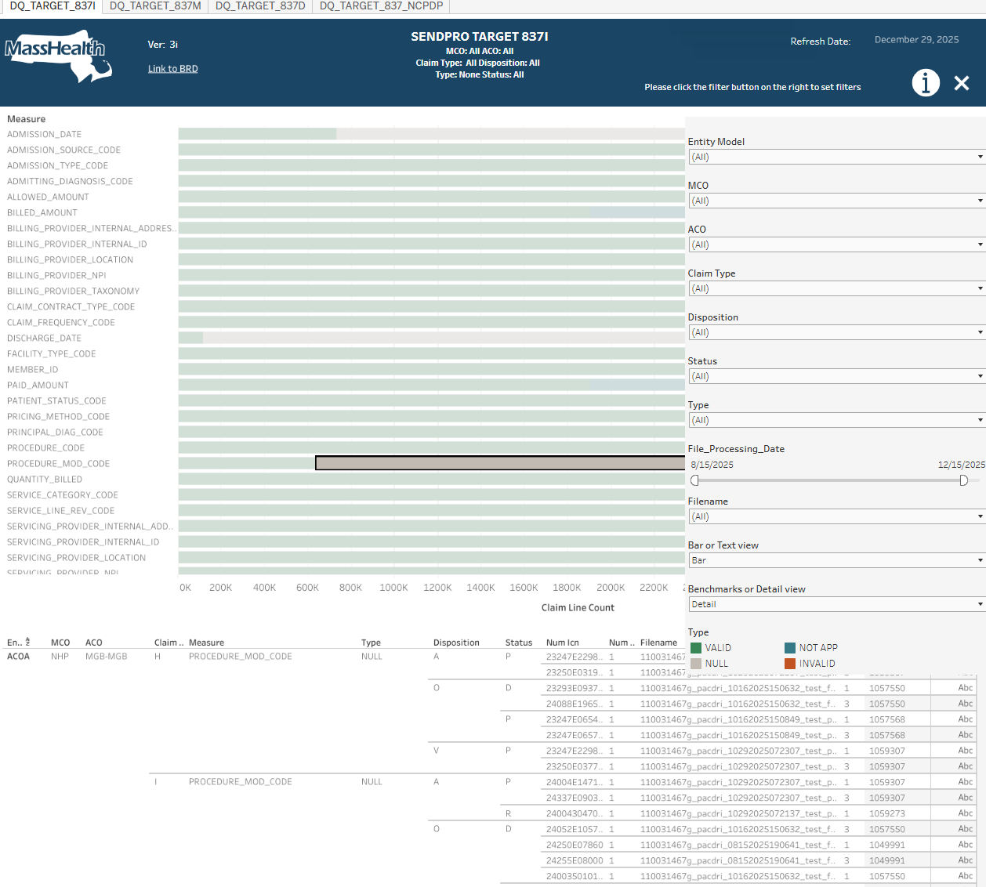

The Detail viz attempts to provide sample claims, for the measure in question, to facilitate further analysis via SQL or other BI tools, if available. Here we are looking at sample Institutional claims with NULL Procedure Modifier Codes. The sample data is limited to 5 or 10 claims per: Filename, Claim Type, Type, Disposition and Status combination, and only the first Numdtl (claim lines) are utilized.

Internals

The dashboards use data from 9 Snowflake views:

INF_SENDPRO_TARGET_837I_UNPIV
INF_SENDPRO_TARGET_837M_UNPIV
INF_SENDPRO_TARGET_837D_UNPIV
INF_SENDPRO_TARGET_837_NCPDP_UNPIV

INF_SENDPRO_TARGET_837I_UNPIV_DETAIL
INF_SENDPRO_TARGET_837M_UNPIV_DETAIL
INF_SENDPRO_TARGET_837D_UNPIV_DETAIL
INF_SENDPRO_TARGET_837_NCPDP_UNPIV_DETAIL

INF_SENDPRO_TARGET_RUN_DATE

The sets of views follow similar processing, so we will look at the dental views because they are shorter.
The SQL views and tables are available in Snowflake, the table refresh SQL is in Informatica Dev and both are in my GitHub repository jplegeratma.

The base table is:
create or replace TABLE MHTEAM.DWDQ.INF_B_SENDPRO_TARGET_837D (
RUN_DATE DATE,
NUM_ICN VARCHAR(25),
NUM_DTL NUMBER(4,0),
CDE_ENTITY_MODEL VARCHAR(30),
CDE_ENC_MCO VARCHAR(3),
CDE_ENC_ACO VARCHAR(10),
ID_SUBMITTER VARCHAR(13),
DOS_FROM_DT DATE,
CLAIM_TYPE VARCHAR(1),
CDE_CLM_STATUS VARCHAR(1),
CDE_CLM_DISPOSITION VARCHAR(1),
IND_OFFSET VARCHAR(1),
WH_FROM_DT DATE,
MD_BATCH_SEQ NUMBER(38,0),
CLAIMFREQUENCYTYPECODE1X VARCHAR(7),
CLAIMCONTRACTTYPECODE1X VARCHAR(7),
CLAIMALLOWABLEAMOUNT1X VARCHAR(7),
CLAIMPAIDAMOUNT1X VARCHAR(7),
CLAIMBILLEDAMOUNT1X VARCHAR(7),
BILLINGPROVIDERINTERNALID1X VARCHAR(7),
BILLINGPROVIDERNPI1X VARCHAR(7),
BILLINGPROVIDERTAXONOMY1X VARCHAR(7),
BILLINGINTERNALPROVIDERADDRESSLOCATION1X VARCHAR(7),
BILLINGPROVIDERLOCATION1X VARCHAR(7),
SERVICINGPROVIDERINTERNALID1X VARCHAR(7),
SERVICINGPROVIDERNPI1X VARCHAR(7),
SERVICINGPROVIDERTYPE1X VARCHAR(7),
SERVICINGPROVIDERLOCATION1X VARCHAR(7),
SERVICINGPROVIDERTAXONOMY1X VARCHAR(7),
SERVICINGINTERNALPROVIDERADDRESSLOCATION1X VARCHAR(7),
FROMSERVICEDATE1X VARCHAR(7),
TOSERVICEDATE1X VARCHAR(7),
ADMISSIONDATE1X VARCHAR(7),
MEMBERID1X VARCHAR(7),
QUANTITYBILLED1X VARCHAR(7),
ADMITTINGDIAGNOSISCODE1X VARCHAR(7),
PRIMARYDIAGNOSISCODE1X VARCHAR(7),
DISCHARGEDATE1X VARCHAR(7),
TYPEOFADMISSION1X VARCHAR(7),
SOURCEOFADMISSION1X VARCHAR(7),
PATIENTSTATUSCODE1X VARCHAR(7),
FACILITYTYPECODE1X VARCHAR(7),
PROCEDURECODE1X VARCHAR(7),
PROCEDUREMODCODE1X VARCHAR(7),
PLACEOFSERVICECODE1X VARCHAR(7),
TOOTHNUMBER1X VARCHAR(7),
SERVICECATEGORY1X VARCHAR(7),
ORALCATEGORYDESC1X VARCHAR(7),
TOOTHSURFACECODE1X VARCHAR(7),
TOT_REX NUMBER(1,0)
);

It holds one row per claim line and includes the fields needed to support the filters, the NUM_ICN claim id, the NUM_DTL detail line number, the run_date, tot_rex ( in this case 1 used for calculations) and a 1X field for each measure. The 1x contains ‘VALID’, ‘INVALID’, ‘NULL’ or ‘NOT APP’)
The table is populated by a SQL transformation (just a SQL runner) in the Informatica CDGC Dev Org:
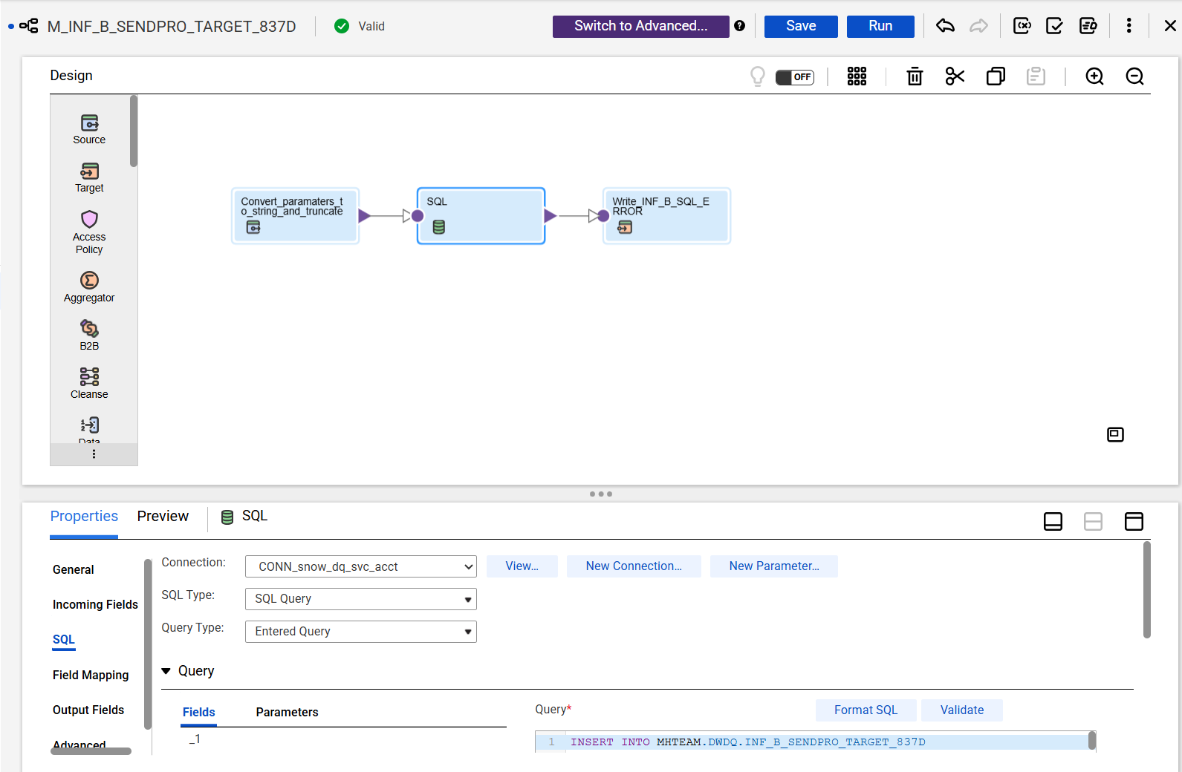

Run by schedule SENDPro Dashboard Weekly Monday at 3 AM on TF_INF_B_SENDPRO_TARGET_Dashboard
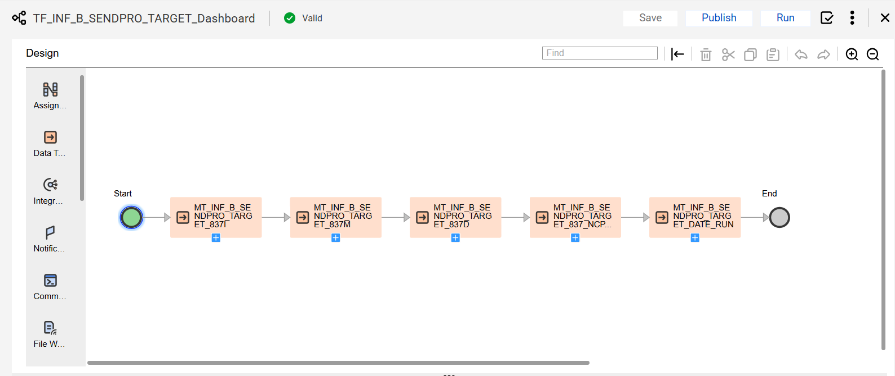

To keep the SENDPRO dashboards from running into each other, they are run sequentially with TF_SENDPro Master Dashboard (I will probably add TMSIS to this when it is ready):

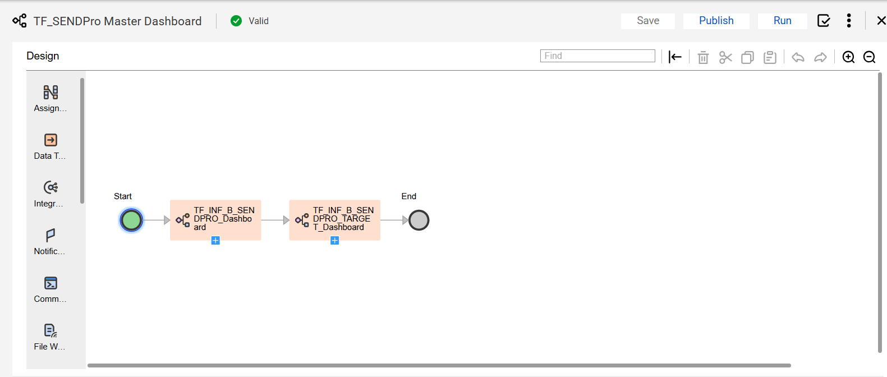

The Insert SQL in the mapping loads incrementally, only looking at the files not already processed. This is used to reduce the processing times. The Run_Date acts as the batch date.
INSERT INTO MHTEAM.DWDQ.INF_B_SENDPRO_TARGET_837D
SELECT DISTINCT
RUN_DATE,
NUM_ICN,
NUM_DTL,
CDE_ENTITY_MODEL,
CDE_ENC_MCO,
CDE_ENC_ACO,
ID_SUBMITTER,
DOS_FROM_DT,
CDE_CLM_TYPE AS CLAIM_TYPE,
-- CDE_BILL_TYPE,
CDE_CLM_STATUS,
-- CDE_FACILITY_TYPE,
CDE_CLM_DISPOSITION,
IND_OFFSET,
WH_FROM_DT,
MD_BATCH_SEQ,

/*
12.1.1 Claim Frequency Type Code (MPT_SENDPRO_ClaimFrequencyTypeCode_837)
• ALL Claims population: MPT_SENDPRO_ClaimType_837I_LTC, MPT_SENDPRO_ClaiimType_837I_INP, MPT_SENDPRO_ClaiimType_837I_OUTP, MPT_SENDPRO_ClaiimType_837P, MPT_SENDPRO_ClaiimType_837D
• Valid Frequency Code: MPT_SENDPRO_Claim_Freq_Type_Code_Valid, SPRO_B_ENC_CLAIM_PROF_LEG_HIST. CDE_BILL_FREQ, SPRO_B_ENC_CLAIM_DNTL_LEG_HIST.CDE_BILL_FREQ, SPRO_B_ENC_CLAIM_INST_LEG_HIST.CDE_BILL_FREQ, SPRO_B_ENC_CLAIM_INST_LEG_HIST.CDE_BILL_FREQ
• MPT_SENDPRO_NumberIsNull_ALL

MPT_SENDPRO_Claim_Freq_Type_Code_Valid Should contain one of these values "1”,”2”,”3”,”4”,”5”,”7”,”8”. If valid then 1 else 0

MPT_SENDPRO_NumberIsNull_ALL Number is not null then 1 else 0
*/

CASE WHEN CDE_BILL_FREQ IS NULL OR CDE_BILL_FREQ IN ('#','+','-') THEN 'NULL'
WHEN CDE_BILL_FREQ NOT IN ('1','2','3','4','5','7','8') THEN 'INVALID'
ELSE 'VALID'
END AS ClaimFrequencyTypeCode1X,

/*
{ REMOVED EXTRA LINES showing Claim Frequency Type Code as example}
1 as TOT_REX

FROM (
select DISTINCT
CURRENT_DATE() AS RUN_DATE,
dntl.NUM_ICN,
dntl.CDE_ENTITY_MODEL,
dntl.CDE_ENC_MCO,
dntl.CDE_ENC_ACO,
dntl.ID_SUBMITTER,
DATE(dntl.DOS_FROM_DT) AS DOS_FROM_DT,
dntl.CDE_CLM_TYPE,
dntl.CDE_CLM_STATUS,
dntl.CDE_CLM_DISPOSITION,
dntl.IND_OFFSET,
DATE(dntl.WH_FROM_DT) AS WH_FROM_DT,
dntl.MD_BATCH_SEQ,

dntl.CDE_BILL_FREQ,
dntl.CDE_CONTRACT_TYPE,
NULL AS AMT_ALLOWED,
dntl.AMT_PAID,
dntl.AMT_BILLED,
DATE(dntl.DOS_TO_DT) AS DOS_TO_DT,
NULL AS ADMIT_DT,
dntl.MEM_SEQ AS FACT_MEM_SEQ,
dntl.QTY_UNITS_BILLED,
NULL AS DISCHARGE_DT,
NULL AS CDE_ADMIT_TYPE,
NULL AS CDE_ADMIT_SOURCE,
NULL AS CDE_PATIENT_STATUS,
NULL AS CDE_TYPE_OF_BILL,
dntl.DIAGRP_SEQ,

dntl.BILLING_ENC_PRV_SEQ,
dntl.SERVICING_ENC_PRV_SEQ,
dntl.CDE_PLACE_OF_SERVICE,

prov_billing.ENC_PROV_ID AS billing_ProviderInternalId,
prov_billing.ID_NPI AS billing_ProviderNPI,
--prov_billing.CDE_PROVIDER_TYPE AS billing_ProviderType,

prov_servicing.ENC_PROV_ID AS servicing_ProviderInternalId,
prov_servicing.ID_NPI AS servicing_ProviderNPI,
--prov_servicing.CDE_PROVIDER_TYPE AS servicing_ProviderType

dtl.NUM_DTL,
dtl.PROC_SEQ,
dtl.PROCMFRGRP_SEQ,

-- dtl.CDE_CONTRACT_TYPE AS DTL_CDE_CONTRACT_TYPE,
NULL AS DTL_AMT_ALLOWED,
dtl.AMT_PAID AS DTL_AMT_PAID,
dtl.AMT_BILLED AS DTL_AMT_BILLED,
dtl.BILLING_ENC_PRV_SEQ AS DTL_BILLING_ENC_PRV_SEQ,
dtl.SERVICING_ENC_PRV_SEQ AS DTL_SERVICING_ENC_PRV_SEQ,
DATE(dtl.DOS_FROM_DT) AS DTL_DOS_FROM_DT,
DATE(dtl.DOS_TO_DT) AS DTL_DOS_TO_DT,
dtl.MEM_SEQ AS DTL_FACT_MEM_SEQ,
dtl.QTY_UNITS_BILLED AS DTL_QTY_UNITS_BILLED,
NULL AS DTL_DISCHARGE_DT,
dtl.CLM_DTL_SEQ AS DTL_CLM_DTL_SEQ,
dtl.CDE_ENC_SVC_CAT AS DTL_CDE_ENC_SVC_CAT,

dtl_prov_billing.ENC_PROV_ID AS dtl_billing_ProviderInternalId,
dtl_prov_billing.ID_NPI AS dtl_billing_ProviderNPI,

dtl_prov_servicing.ENC_PROV_ID AS dtl_servicing_ProviderInternalId,
dtl_prov_servicing.ID_NPI AS dtl_servicing_ProviderNPI,
dtl.CDE_ORAL_CAVITY_DESIG_01 AS dtl_CDE_ORAL_CAVITY_DESIG_01

FROM MHDWQA.SENDPRO.SPRO_B_ENC_CLAIM_DNTL_LEG_HIST dntl
LEFT JOIN MHDWQA.SENDPRO.SPRO_B_ENC_DNTL_INFO_DTL_HIST dtl
ON dntl.NUM_ICN = dtl.NUM_ICN
LEFT JOIN MHDWQA.SENDPRO.SPRO_B_ENC_PROVIDER_HIST prov_billing
ON dntl.BILLING_ENC_PRV_SEQ = prov_billing.ENC_PRV_SEQ
LEFT JOIN MHDWQA.SENDPRO.SPRO_B_ENC_PROVIDER_HIST prov_servicing
ON dntl.SERVICING_ENC_PRV_SEQ = prov_servicing.ENC_PRV_SEQ
LEFT JOIN MHDWQA.SENDPRO.SPRO_B_ENC_PROVIDER_HIST dtl_prov_billing
ON DTL_BILLING_ENC_PRV_SEQ = dtl_prov_billing.ENC_PRV_SEQ
LEFT JOIN MHDWQA.SENDPRO.SPRO_B_ENC_PROVIDER_HIST dtl_prov_servicing
ON DTL_SERVICING_ENC_PRV_SEQ = dtl_prov_servicing.ENC_PRV_SEQ

WHERE dntl.IND_OFFSET = 'N'
AND dntl.MD_BATCH_SEQ NOT IN ( SELECT DISTINCT tar.MD_BATCH_SEQ from MHTEAM.DWDQ.INF_B_SENDPRO_TARGET_837D tar)

) A;

And processed by the Summary view:

create or replace view MHTEAM.DWDQ.INF_SENDPRO_TARGET_837D_UNPIV(
RUN_DATE,
CDE_ENTITY_MODEL,
CDE_ENC_MCO,
CDE_ENC_ACO,
CLAIM_TYPE,
CDE_CLM_DISPOSITION,
CDE_CLM_STATUS,
MD_BATCH_SEQ,
MEASURE,
TYPE,
REC_CNT,
FILE_NAME,
PROCESS_START_TM,
BENCHMARK_THRESHOLD
) as

SELECT DISTINCT RUN_DATE, A.CDE_ENTITY_MODEL, A.CDE_ENC_MCO, A.CDE_ENC_ACO, CLAIM_TYPE, CDE_CLM_DISPOSITION, CDE_CLM_STATUS, A.MD_BATCH_SEQ,MEASURE, TYPE, REC_CNT,
s.FILE_NAME, s.PROCESS_START_TM, L.BENCHMARK_THRESHOLD
FROM (

SELECT DISTINCT RUN_DATE, CDE_ENTITY_MODEL, CDE_ENC_MCO, CDE_ENC_ACO, CLAIM_TYPE, CDE_CLM_DISPOSITION, CDE_CLM_STATUS, MD_BATCH_SEQ, FILE_NAME, MEASURE, TYPE, REC_CNT
FROM (
SELECT RUN_DATE, CDE_ENTITY_MODEL, CDE_ENC_MCO, CDE_ENC_ACO, CLAIM_TYPE, CDE_CLM_DISPOSITION, CDE_CLM_STATUS, MD_BATCH_SEQ, FILE_NAME, MEASURE, TYPE, COUNT(TYPE) AS REC_CNT
FROM (
SELECT RUN_DATE, CDE_ENTITY_MODEL, CDE_ENC_MCO, CDE_ENC_ACO, CLAIM_TYPE, CDE_CLM_DISPOSITION, CDE_CLM_STATUS, MD_BATCH_SEQ, FILE_NAME, MEASURE, TYPE
FROM (
SELECT
RUN_DATE,
CDE_ENTITY_MODEL,
CDE_ENC_MCO,
CDE_ENC_ACO,
CLAIM_TYPE,
CDE_CLM_DISPOSITION,
CDE_CLM_STATUS,
MD_BATCH_SEQ,
h."FileName" AS FILE_NAME,
ClaimFrequencyTypeCode1X AS Claim_Frequency_Code,
ClaimContractTypeCode1X AS Claim_Contract_Type_Code,
ClaimAllowableAmount1X AS Allowed_Amount,
ClaimPaidAmount1X AS Paid_Amount,
ClaimBilledAmount1X AS Billed_Amount,
BillingProviderInternalId1X AS Billing_Provider_Internal_ID,
BillingProviderNPI1X AS Billing_Provider_NPI,
BillingProviderTaxonomy1X AS Billing_Provider_Taxonomy,
BillingInternalProviderAddressLocation1X AS Billing_Provider_Internal_Address_Location,
BillingProviderLocation1X AS Billing_Provider_Location,
ServicingProviderInternalId1X AS Servicing_Provider_Internal_ID,
ServicingProviderNPI1X AS Servicing_Provider_NPI,
ServicingProviderType1X AS Servicing_Provider_Type,
ServicingProviderLocation1X AS Servicing_Provider_Location,
ServicingProviderTaxonomy1X AS Servicing_Provider_Taxonomy,
ServicingInternalProviderAddressLocation1X AS Servicing_Provider_Internal_Address_Location,
FromServiceDate1X AS Statement_Date,
ToServiceDate1X AS To_Service_Date,
AdmissionDate1X AS Admission_Date,
MemberID1X AS Member_ID,
QuantityBilled1X AS Quantity_Billed,
AdmittingDiagnosisCode1X AS Admitting_Diagnosis_Code,
PrimaryDiagnosisCode1X AS Principal_Diag_Code,
DischargeDate1X AS Discharge_Date,
TypeOfAdmission1X AS Admission_Type_Code,
SourceOfAdmission1X AS Admission_Source_Code,
PatientStatusCode1X AS Patient_Status_Code,
FacilityTypeCode1X AS Facility_Type_Code,
ProcedureCode1X AS Procedure_Code,
ProcedureModCode1X AS Procedure_Mod_Code,
PlaceOfServiceCode1X AS Place_Of_Service_Code,
ToothNumber1X AS Tooth_Number,
ServiceCategory1X AS Service_Category_Code,
OralCategoryDesc1X AS Oral_Category_Desc,
ToothSurfaceCode1X AS Tooth_Surface_Code
FROM MHTEAM.DWDQ.INF_B_SENDPRO_TARGET_837D tar
JOIN MHDWQA.SENDPRO.RAW_SPRO_837D_CLAIM h
ON tar.num_icn = h."PatientControlNum"
AND tar.ID_SUBMITTER = h."SubmitterID"
)
UNPIVOT (
TYPE
FOR MEASURE IN (
Claim_Frequency_Code,
Claim_Contract_Type_Code,
Allowed_Amount,
Paid_Amount,
Billed_Amount,
Billing_Provider_Internal_ID,
Billing_Provider_NPI,
Billing_Provider_Taxonomy,
Billing_Provider_Internal_Address_Location,
Billing_Provider_Location,
Servicing_Provider_Internal_ID,
Servicing_Provider_NPI,
Servicing_Provider_Type,
Servicing_Provider_Location,
Servicing_Provider_Taxonomy,
Servicing_Provider_Internal_Address_Location,
Statement_Date,
To_Service_Date,
Admission_Date,
Member_ID,
Quantity_Billed,
Admitting_Diagnosis_Code,
Principal_Diag_Code,
Discharge_Date,
Admission_Type_Code,
Admission_Source_Code,
Patient_Status_Code,
Facility_Type_Code,
Procedure_Code,
Procedure_Mod_Code,
Place_Of_Service_Code,
Tooth_Number,
Service_Category_Code,
Oral_Category_Desc,
Tooth_Surface_Code
)
) AS INF_SENDPRO_TARGET_837D_UNPIV
)
GROUP BY RUN_DATE, CDE_ENTITY_MODEL, CDE_ENC_MCO, CDE_ENC_ACO, CLAIM_TYPE, CDE_CLM_DISPOSITION, CDE_CLM_STATUS, MD_BATCH_SEQ, FILE_NAME, MEASURE, TYPE
)
ORDER BY RUN_DATE, CDE_ENTITY_MODEL, CDE_ENC_MCO, CDE_ENC_ACO, CLAIM_TYPE, CDE_CLM_DISPOSITION, CDE_CLM_STATUS, MD_BATCH_SEQ, FILE_NAME, MEASURE, TYPE

) AS A
LEFT JOIN MHDWQA.SENDPRO.SPRO_B_ENC_STATISTIC S ON A.MD_BATCH_SEQ = s.MD_BATCH_SEQ_SPRO AND A.FILE_NAME = S.FILE_NAME
LEFT JOIN MHTEAM.DWDQ.INF_B_SENDPRO_LOOKUP L ON A.MEASURE = L.BENCHMARK;

The unpiv aggregates each measure into a separate row in the view, by run_date, MCO, ACO claim_type, disposition, status, type, measure and filename. Note the join to the RAW table in the middle to retrieve the filename. The Benchmark table INF_B_SENDPRO_LOOKUP is joined in to add the Benchmark threshold at the end, and the SPRO_B_ENC_STATISTIC stats table is added for the PROCESS_START processing date.

The view gives data that looks like:
select *
from MHTEAM.DWDQ.INF_SENDPRO_TARGET_837D_UNPIV
order by RUN_DATE, FILE_NAME, MEASURE, claim_type, type
limit 10;

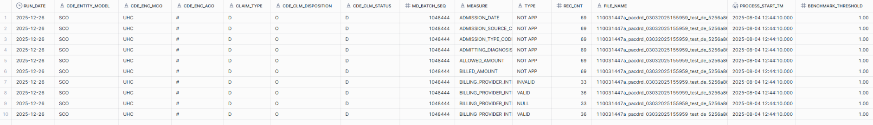

Detail Unpiv
The detail unpiv is similar but stays at the claim line level, using the unpiv to pivot the Type. It also limits the number of rows to 10 and uses Numdtl = 1.

create or replace view MHTEAM.DWDQ.INF_SENDPRO_TARGET_837D_UNPIV_DETAIL(
RUN_DATE,
CDE_ENTITY_MODEL,
CDE_ENC_MCO,
CDE_ENC_ACO,
CLAIM_TYPE,
CDE_CLM_DISPOSITION,
CDE_CLM_STATUS,
MD_BATCH_SEQ,
MEASURE,
TYPE,
NUM_ICN,
NUM_DTL,
RNK,
FILE_NAME,
PROCESS_START_TM
) as

SELECT DISTINCT
a.RUN_DATE,
a.CDE_ENTITY_MODEL,
a.CDE_ENC_MCO,
a.CDE_ENC_ACO,
a.CLAIM_TYPE,
a.CDE_CLM_DISPOSITION,
a.CDE_CLM_STATUS,
a.MD_BATCH_SEQ,
a.MEASURE,
a.TYPE,
a.NUM_ICN,
a.NUM_DTL,
a.RNK,
s.FILE_NAME,
s.PROCESS_START_TM
FROM (

-- limit rank to 10 lines
SELECT DISTINCT
RUN_DATE,
CDE_ENTITY_MODEL,
CDE_ENC_MCO,
CDE_ENC_ACO,
CLAIM_TYPE,
CDE_CLM_DISPOSITION,
CDE_CLM_STATUS,
MD_BATCH_SEQ,
MEASURE,
TYPE,
NUM_ICN,
NUM_DTL,
RNK

FROM (
-- rank
SELECT
RUN_DATE,
CDE_ENTITY_MODEL,
CDE_ENC_MCO,
CDE_ENC_ACO,
CLAIM_TYPE,
CDE_CLM_DISPOSITION,
CDE_CLM_STATUS,
MD_BATCH_SEQ,
MEASURE,
TYPE,
NUM_ICN,
NUM_DTL,
RANK ()
OVER (PARTITION BY RUN_DATE,
CDE_ENTITY_MODEL,
CDE_ENC_MCO,
CDE_ENC_ACO,
CLAIM_TYPE,
CDE_CLM_DISPOSITION,
CDE_CLM_STATUS,
MD_BATCH_SEQ,
MEASURE
ORDER BY
RUN_DATE,
CDE_ENTITY_MODEL,
CDE_ENC_MCO,
CDE_ENC_ACO,
CLAIM_TYPE,
CDE_CLM_DISPOSITION,
CDE_CLM_STATUS,
MD_BATCH_SEQ,
MEASURE,
TYPE,
NUM_ICN,
NUM_DTL) AS rnk

FROM (

-- only first claim line

SELECT

RUN_DATE,
CDE_ENTITY_MODEL,
CDE_ENC_MCO,
CDE_ENC_ACO,
CLAIM_TYPE,
CDE_CLM_DISPOSITION,
CDE_CLM_STATUS,
MD_BATCH_SEQ,
MEASURE,
TYPE,
NUM_ICN,
NUM_DTL
FROM (

-- core unpiv

SELECT
RUN_DATE,
CDE_ENTITY_MODEL,
CDE_ENC_MCO,
CDE_ENC_ACO,
CLAIM_TYPE,
CDE_CLM_DISPOSITION,
CDE_CLM_STATUS,
MD_BATCH_SEQ,
MEASURE,
TYPE,
NUM_ICN,
NUM_DTL

FROM (
SELECT
RUN_DATE,
CDE_ENTITY_MODEL,
CDE_ENC_MCO,
CDE_ENC_ACO,
CLAIM_TYPE,
CDE_CLM_DISPOSITION,
CDE_CLM_STATUS,
MD_BATCH_SEQ,
ClaimFrequencyTypeCode1X AS Claim_Frequency_Code,
ClaimContractTypeCode1X AS Claim_Contract_Type_Code,
ClaimAllowableAmount1X AS Allowed_Amount,
ClaimPaidAmount1X AS Paid_Amount,
ClaimBilledAmount1X AS Billed_Amount,
BillingProviderInternalId1X AS Billing_Provider_Internal_ID,
BillingProviderNPI1X AS Billing_Provider_NPI,
BillingProviderTaxonomy1X AS Billing_Provider_Taxonomy,
BillingInternalProviderAddressLocation1X AS Billing_Provider_Internal_Address_Location,
BillingProviderLocation1X AS Billing_Provider_Location,
ServicingProviderInternalId1X AS Servicing_Provider_Internal_ID,
ServicingProviderNPI1X AS Servicing_Provider_NPI,
ServicingProviderType1X AS Servicing_Provider_Type,
ServicingProviderLocation1X AS Servicing_Provider_Location,
ServicingProviderTaxonomy1X AS Servicing_Provider_Taxonomy,
ServicingInternalProviderAddressLocation1X AS Servicing_Provider_Internal_Address_Location,
FromServiceDate1X AS Statement_Date,
ToServiceDate1X AS To_Service_Date,
AdmissionDate1X AS Admission_Date,
MemberID1X AS Member_ID,
QuantityBilled1X AS Quantity_Billed,
AdmittingDiagnosisCode1X AS Admitting_Diagnosis_Code,
PrimaryDiagnosisCode1X AS Principal_Diag_Code,
DischargeDate1X AS Discharge_Date,
TypeOfAdmission1X AS Admission_Type_Code,
SourceOfAdmission1X AS Admission_Source_Code,
PatientStatusCode1X AS Patient_Status_Code,
FacilityTypeCode1X AS Facility_Type_Code,
ProcedureCode1X AS Procedure_Code,
ProcedureModCode1X AS Procedure_Mod_Code,
PlaceOfServiceCode1X AS Place_Of_Service_Code,
ToothNumber1X AS Tooth_Number,
ServiceCategory1X AS Service_Category_Code,
OralCategoryDesc1X AS Oral_Category_Desc,
ToothSurfaceCode1X AS Tooth_Surface_Code,
NUM_ICN,
NUM_DTL
FROM MHTEAM.DWDQ.INF_B_SENDPRO_TARGET_837D
)
UNPIVOT (
TYPE
FOR MEASURE IN (
Claim_Frequency_Code,
Claim_Contract_Type_Code,
Allowed_Amount,
Paid_Amount,
Billed_Amount,
Billing_Provider_Internal_ID,
Billing_Provider_NPI,
Billing_Provider_Taxonomy,
Billing_Provider_Internal_Address_Location,
Billing_Provider_Location,
Servicing_Provider_Internal_ID,
Servicing_Provider_NPI,
Servicing_Provider_Type,
Servicing_Provider_Location,
Servicing_Provider_Taxonomy,
Servicing_Provider_Internal_Address_Location,
Statement_Date,
To_Service_Date,
Admission_Date,
Member_ID,
Quantity_Billed,
Admitting_Diagnosis_Code,
Principal_Diag_Code,
Discharge_Date,
Admission_Type_Code,
Admission_Source_Code,
Patient_Status_Code,
Facility_Type_Code,
Procedure_Code,
Procedure_Mod_Code,
Place_Of_Service_Code,
Tooth_Number,
Service_Category_Code,
Oral_Category_Desc,
Tooth_Surface_Code
)
) AS UNPIV7D
ORDER BY RUN_DATE, CDE_ENTITY_MODEL, CDE_ENC_MCO, CDE_ENC_ACO, CLAIM_TYPE, CDE_CLM_DISPOSITION, CDE_CLM_STATUS, MEASURE, TYPE

-- only first claim line
)
WHERE NUM_DTL = 1
)
-- add rank
)
-- limit rank to 10 line
WHERE rnk <= 10

ORDER BY
RUN_DATE,
CDE_ENTITY_MODEL,
CDE_ENC_MCO,
CDE_ENC_ACO,
CLAIM_TYPE,
CDE_CLM_DISPOSITION,
CDE_CLM_STATUS,
MEASURE,
TYPE,
NUM_ICN,
RNK
) AS A
LEFT JOIN MHDWQA.SENDPRO.SPRO_B_ENC_STATISTIC S ON A.MD_BATCH_SEQ = s.MD_BATCH_SEQ_SPRO;

The rank processing is borrowed from the ACO scorecard Failure Claims Processing to limit the number of claims offered and not make the extract too big.

The Detail view data looks like:

select *
from MHTEAM.DWDQ.INF_SENDPRO_TARGET_837D_UNPIV_DETAIL
order by RUN_DATE, FILE_NAME, MEASURE, claim_type, type
limit 10;
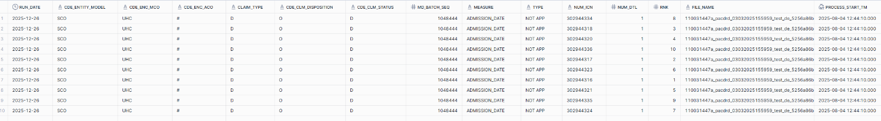

Tableau processing
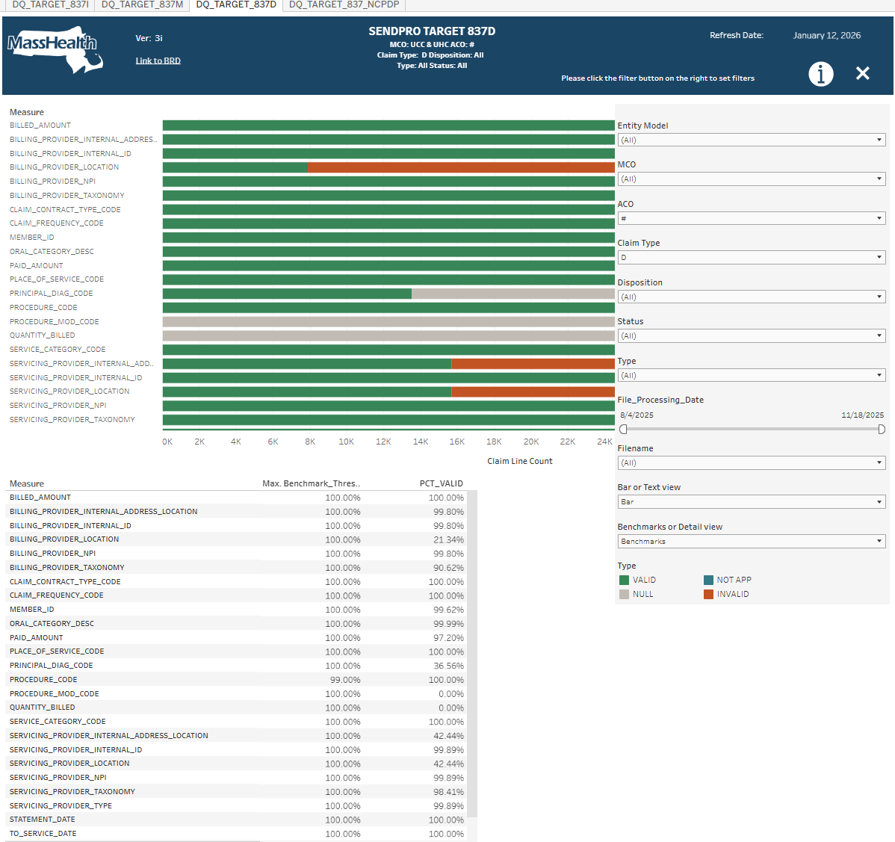

Continuing with 837D, the dashboard encompasses 7 viz worksheets:
837D_TARGET_SUMMARY
837D_TARGET_SUMMARY_TEXT
837D_TARGET_BENCHMARKS
837D_TARGET_DETAIL
837D_TARGET_Title
Run_Date
Version
837D_TARGET_SUMMARY

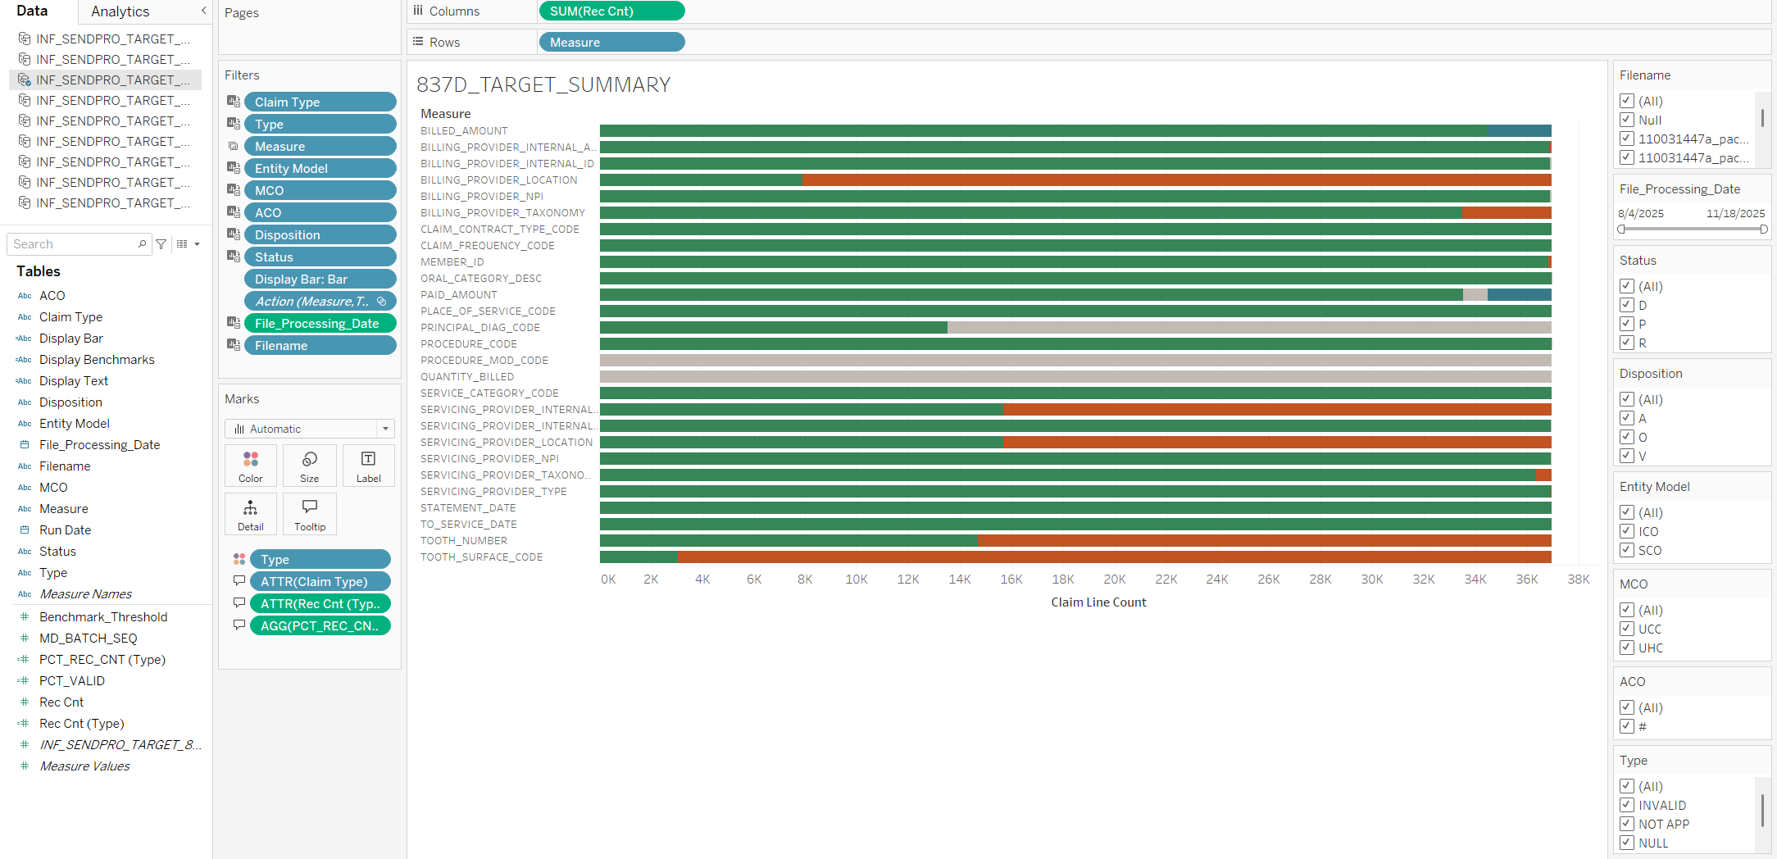

Because of the additional filters for Type, Claim_Type, Disposition and Status, the percentage calculations have to be done in Tableau. The SQL views created the Rec_Cnt aggregation.
The percent record_count and percent valid are within an individual bar and are divided by the Type requiring LOD calculations to remove the Type. The calculations are:
Rec Cnt (Type)
{ EXCLUDE [Type]: SUM([Rec Cnt]) }

PCT_REC_CNT (Type)
SUM([Rec Cnt])/SUM([Rec Cnt (Type)])

PCT_VALID
SUM( IF [Type] = 'VALID' OR [Type] = 'NOT APP' THEN [Rec Cnt] ELSE 0 END ) / SUM([Rec Cnt])

837D_TARGET_SUMMARY_TEXT

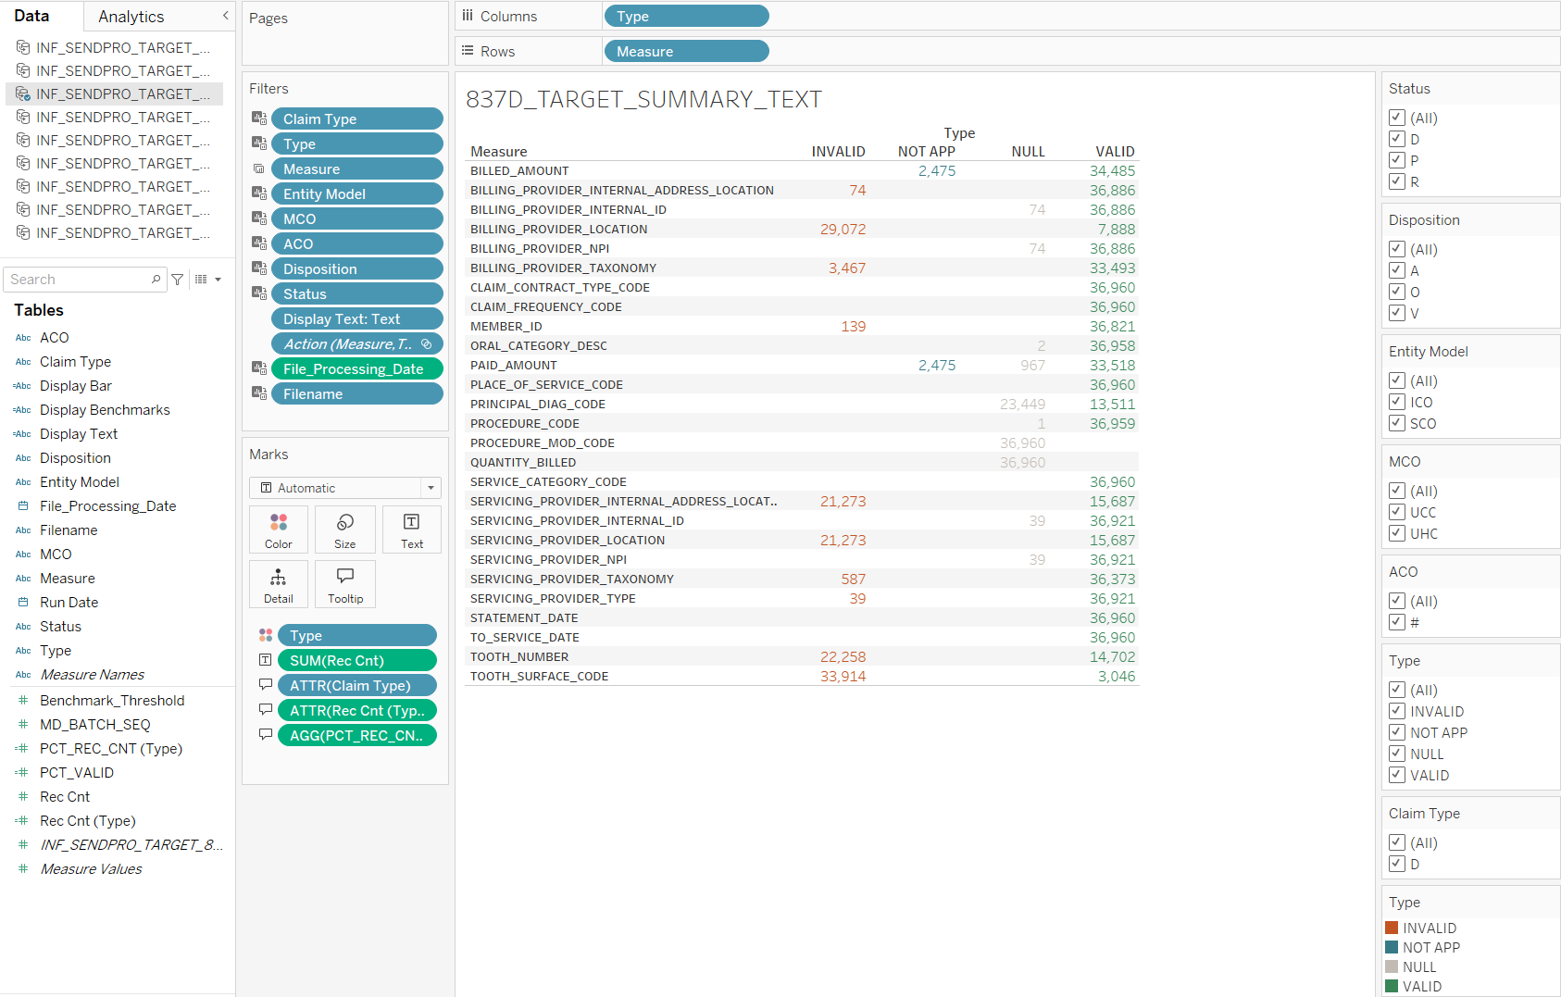

This is the same as the Bar Summary, but the numbers are displayed explicitly making it easier to recognize small numbers. The two Summaries are toggled with the Bar or Text view parameter.

837D_TARGET_BENCHMARKS
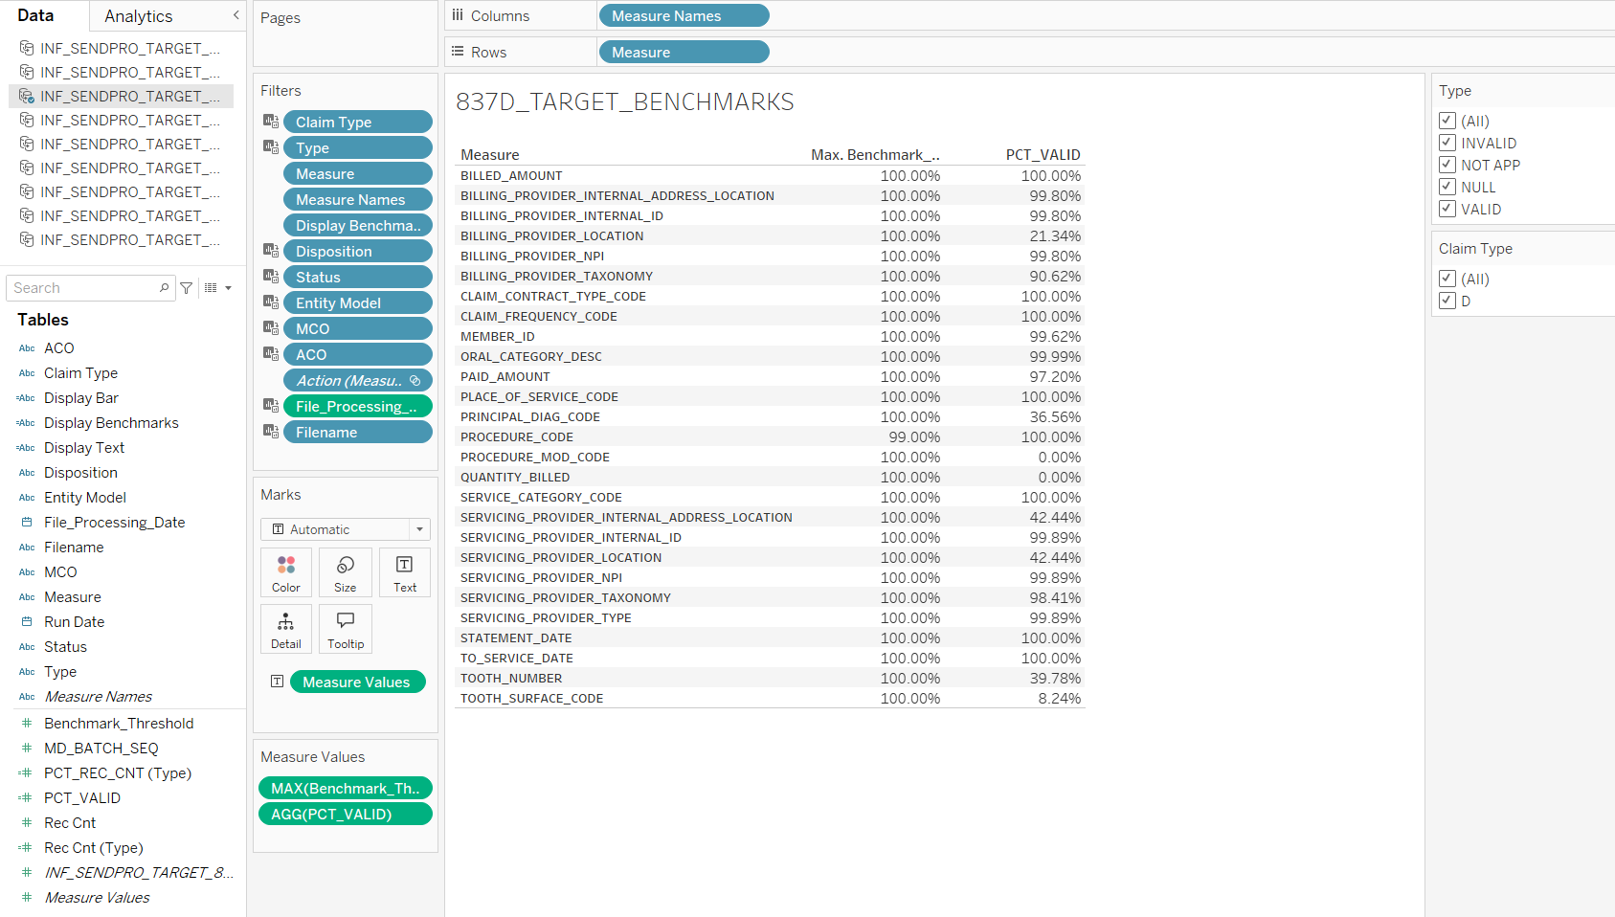

The Benchmarks displays the PCT_VALID, developed for the Summary viz, compared to the Benchmark Threshold.

837D_TARGET_DETAIL
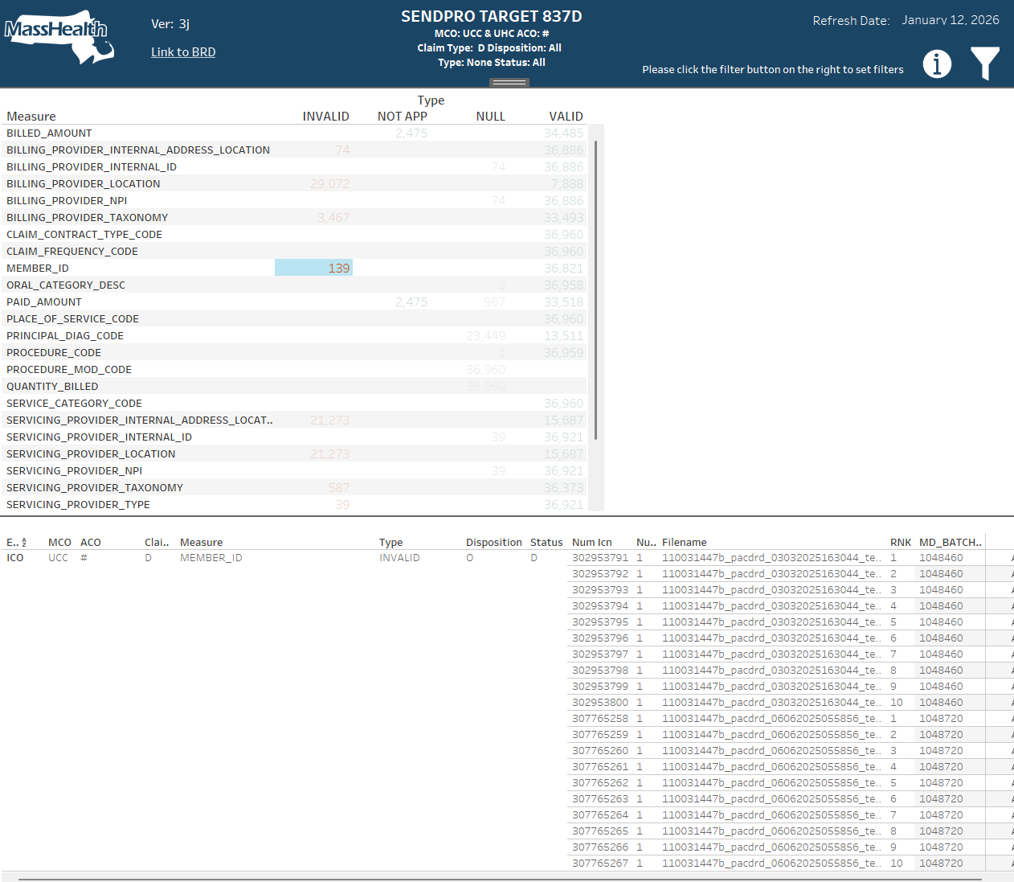

The Detail viz (the bottom pane) does not require any special processing. It is a simple text table of the detail lines in the view, filtered by the filters for the Summary dashboards and the selected row in the Summary viz. Here the 139 Invalid Member IDs is selected and sample invalid records are suggested for further research.

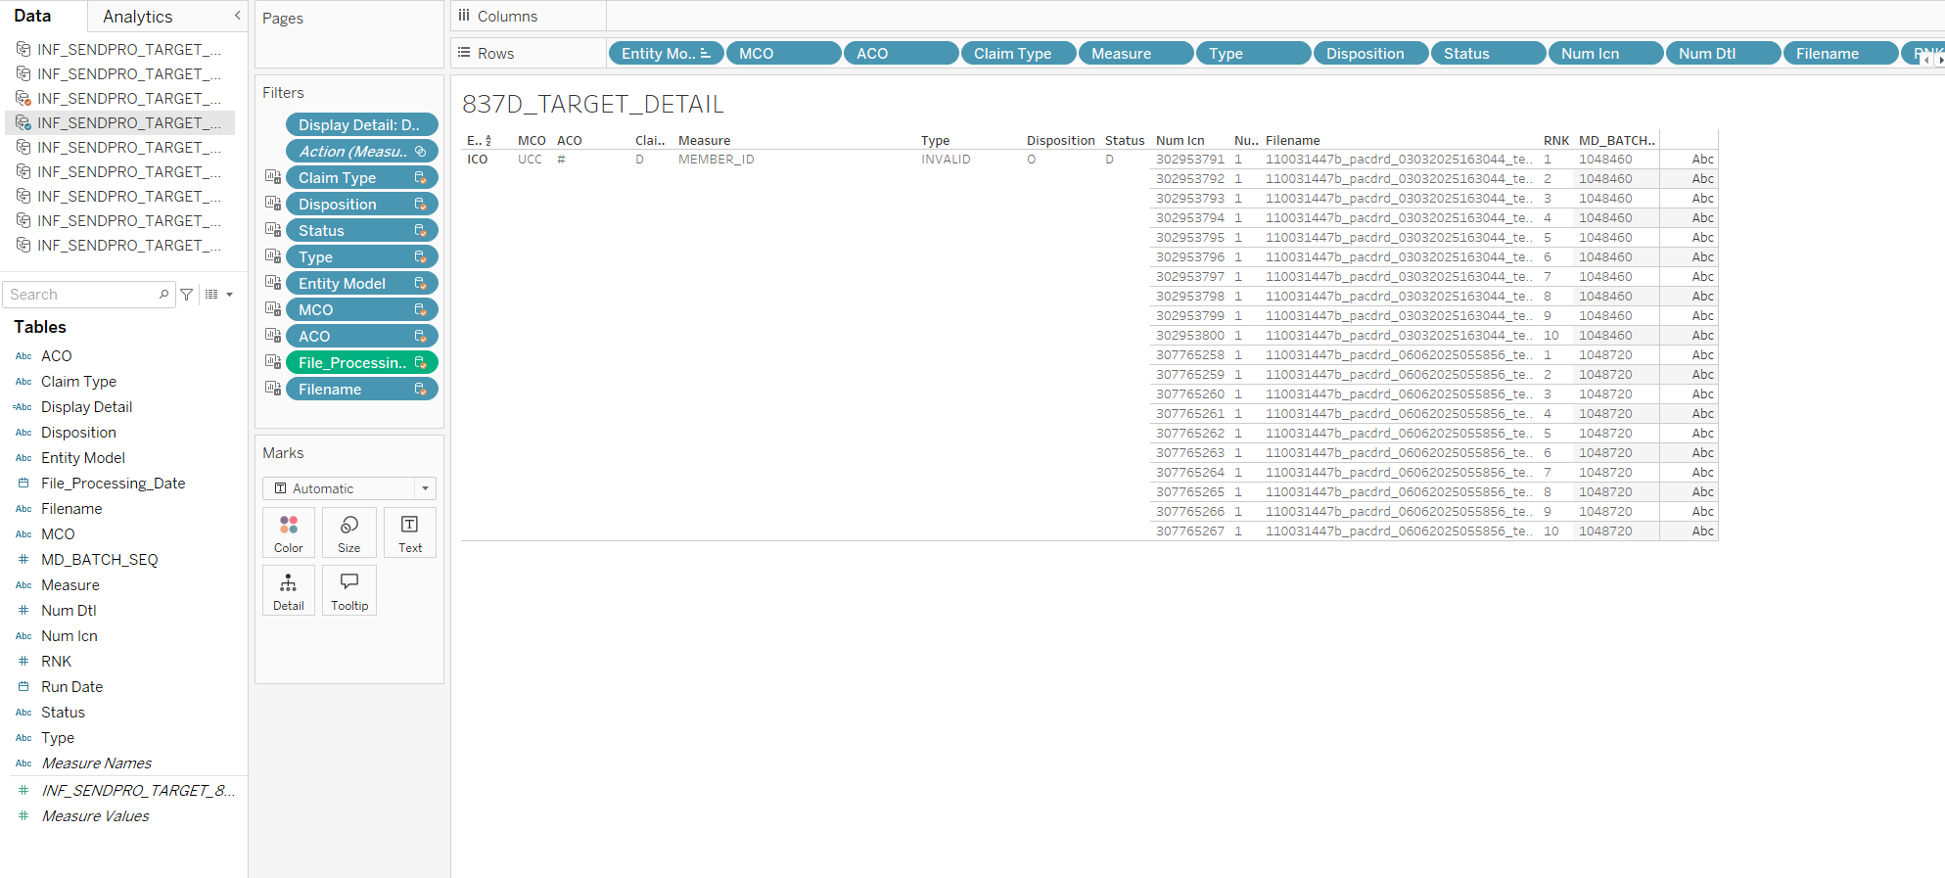
The detail worksheet with the filter for invalid Member IDs. Just a simple list of fields across each row. The filtering is done through actions by the Summary vizualitaions.

This next section is a repeat of a discussion in the RAW Tech Spec.
An interesting part is the toggle for showing Benchmarks or Detail (same for Bar or Text). This is done with a parameter “Benchmarks or Detail View”, which is used in all of the dashboards.

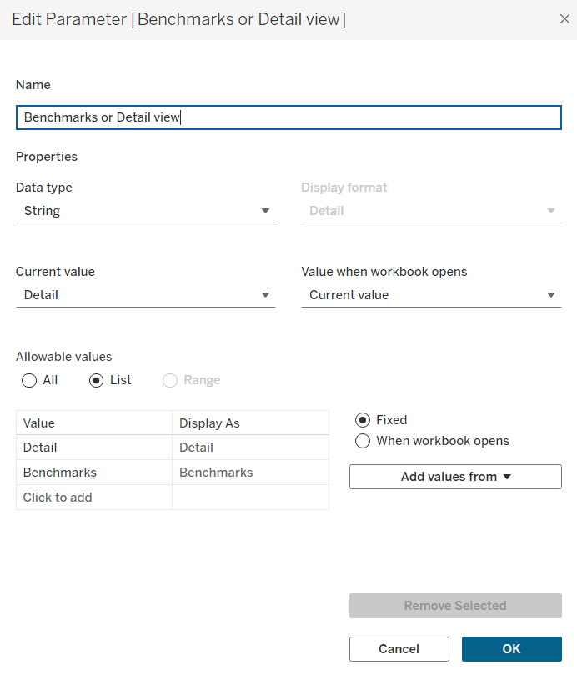
It lists a set of choices, here Detail and Benchmarks.
On each of the viz’s calculated fields are added which recognize the parameter choice.
Display Detail
[Benchmarks or Detail view]

Display Benchmarks
[Benchmarks or Detail view]

The appropriate calculated field is added as a filter to the sheet. For detail, use Display Detail. Edit the filter and add the value for the viz to be visible.
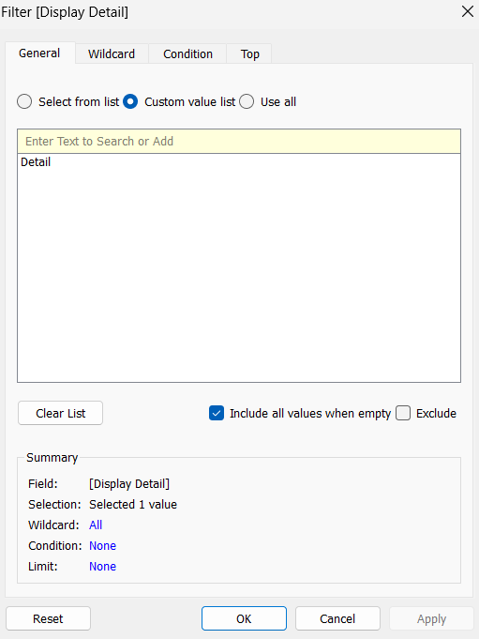
Use “Custom value list” – not the provided “Select from list”
Put a single value: Detail
in the yellow “Enter Text to Search or Add” press the + to have it display below.

On the dashboard, add the parameter to the filters container. The viz’s will now show and hide base on the parameter.
If two or more vizs are to occupy the same space, like the benchmark and detail,
put the first one on the sheet. Remove its title – the title will not hide.
Use the parameter to hide the viz. Put the next viz in the same place and remove its title.
The viz’s should now show and hide based on the one or more parameters. The Submissions dashboard has 16 vizs in sets of 2, with 3 parameters, = 8 combinations x 2.

837D_TARGET_Title

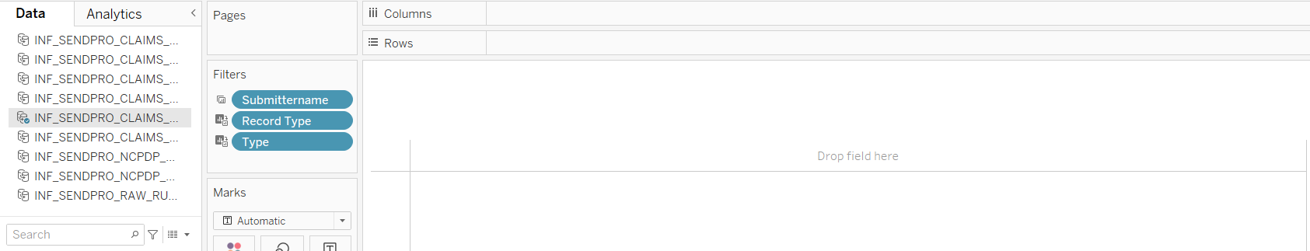

Title is a copy of the Summary viz with everything removed but the title.
The default title is replaced with color White, Tableau Medium 12 for the top line. Tableau Medium 8 for the following lines. The filter fields are bold:

SENDPRO TARGET 837D
MCO: <MCO> ACO: <ACO>
Claim Type: <Claim Type> Disposition: <Disposition>
Type: <Type> Status: <Status>

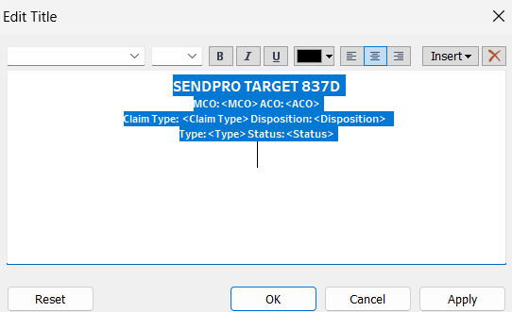

Place the title in the middle of the dashboard menu bar as a floating Sheet.
I recommend using Position and Size values to set its location.
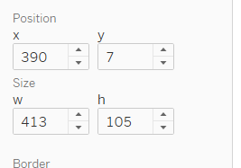

Refresh Date

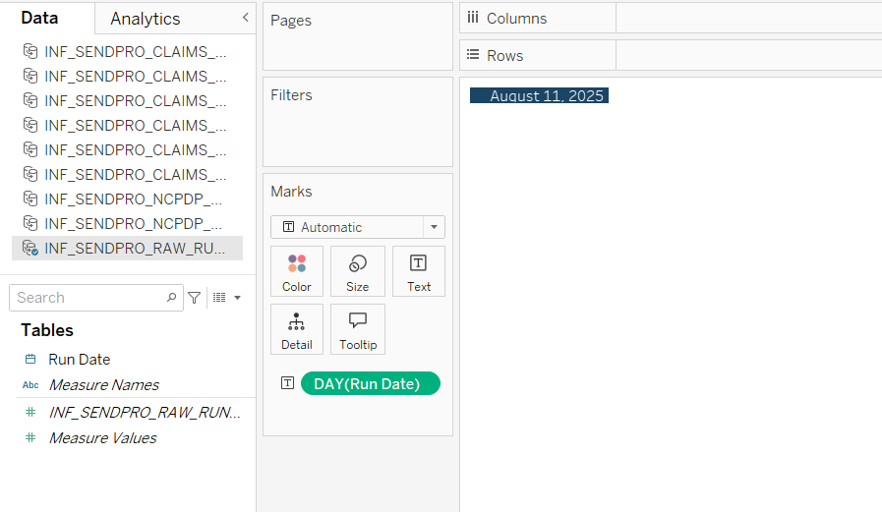A simple sheet based on the Run_Date field in the INF_SENDPRO_TARGET_RUN_DATE
table.
In the dashboard, I placed it at position:
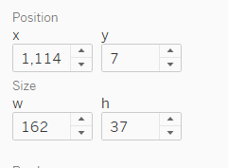

Version

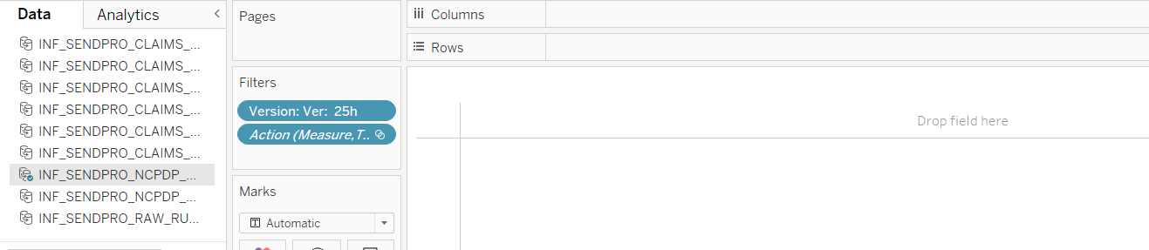

Again, a sheet with just a title. The version is a string in the Version calculated field.
Version
"Ver: 3j"

Add the Version calculated field as a filter and reference it in the title.
When the version changes, I manually update the calculated field. For some reason I have to remove the Version from the filters and replace it to get it to update?

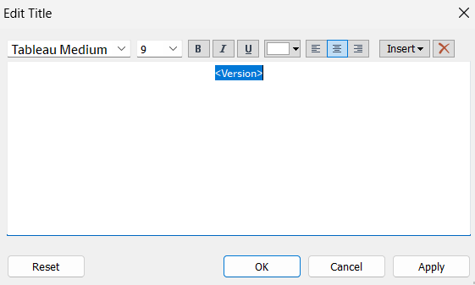

In the dashboard, I placed it at position:
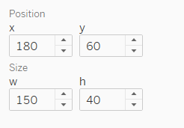
The version page also hold the BRD link implemented using Dashboard actions. It requires one per dashboard.
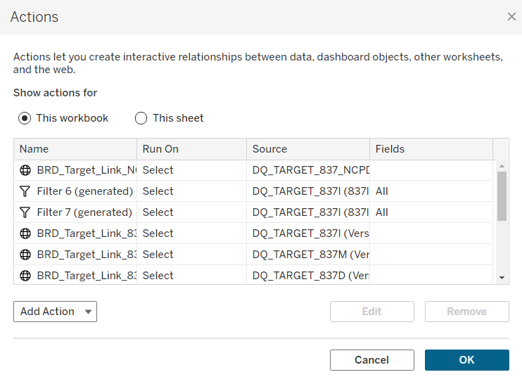
Editing the NCPDP BRD link, the top one above, show:
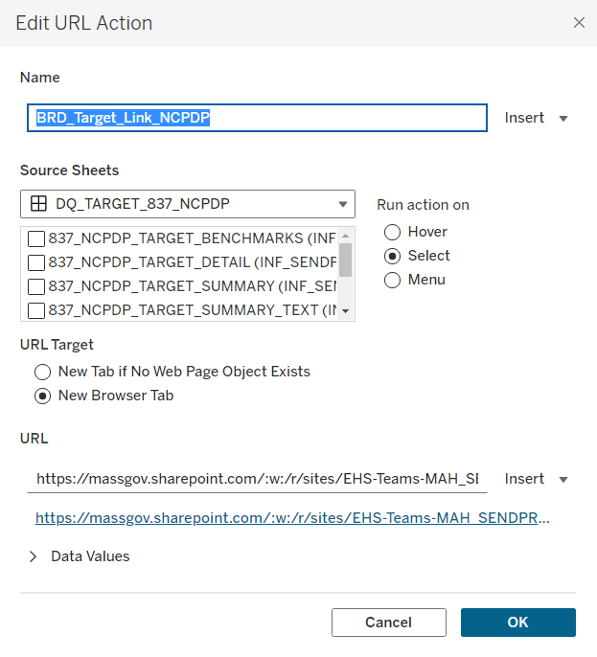
A bit of work when the link changes because it has to be replaced four times.

Steps to Add New Measures

For Tableau, measures are for the most part data defined. The changes are in the SQL and selecting to show the new measure in Tableau.
For this discussion I will use the request from Victoria, via Priya on March 13, 2026:

Can you also add Provider Internal Address Location/CDE_ENC_PROV_ID_LOC to the NCPDP Prescriber Provider measures list? ID_PROVIDER_LOCATION is present but no CDE_ENC_PROV_ID_LOC

Steps:
- Add prescribing_CDE_ENC_PROV_ID_LOC to the extract at the bottom of INF_B_SENDPRO_FINAL_837P.sql

We already have the prescribing provider join:
LEFT JOIN MHDWQA.SENDPRO.SPRO_B_ENC_PROVIDER_HIST prov_prescribing
ON phrm.PRESCRIBING_ENC_PRV_SEQ = prov_prescribing.ENC_PRV_SEQ

All that is needed is adding the CDE_ENC_PROV_ID_LOC to the fields:
prov_prescribing.IND_ENC_PROV_ATYPICAL AS prescribing_IND_ENC_PROV_ATYPICAL,
prov_prescribing.CDE_ENC_PROV_ID_LOC AS prescribing_CDE_ENC_PROV_ID_LOC,
prov_prescribing.ID_PROVIDER_LOCATION AS prescribing_ID_PROVIDER_LOCATION,

- Priya has provided the logic in the BRD for PrescribingInternalProviderAddressLocALL:
12.1.X Prescribing Internal Provider Address Location (MPT_SENDPRO_PrescribingInternalProviderAddressLocALL)
• ALL Claims population: MPT_SENDPRO_ClaimType_NCPDP
• MPT_SENDPRO_ ValidEncInternalProvider: SPRO_B_ENC_CLAIM_PHRM_LEG_HIST.ENC_PRV_SEQ

68 MPT_SENDPRO_ValidEncInternalProvider 1. Join ENC_PRV_SEQ from Fact with sendpro. spro_b_enc_provider_hist on enc_prv_seq
2. NPI: If ID_NPI IS NOT NULL Then 1 else 0
3. Internal Provider Address Location: IF CDE_ENC_PROV_ID_LOC IS NOT NULL THEN 1 ELSE 0
4. Internal Provider ID: IF ENC_PROV_ID IS NOT NULL THEN 1 ELSE 0

- Add the validation logic to INF_B_SENDPRO_FINAL_837P.sql

3/13/26 NEW

12.1.X Prescribing Internal Provider Address Location (MPT_SENDPRO_PrescribingInternalProviderAddressLocALL)
• ALL Claims population: MPT_SENDPRO_ClaimType_NCPDP
• MPT_SENDPRO_ ValidEncInternalProvider: SPRO_B_ENC_CLAIM_PHRM_LEG_HIST.ENC_PRV_SEQ

*/
CASE
WHEN
(
(prescribing_CDE_ENC_PROV_ID_LOC IS NULL OR prescribing_CDE_ENC_PROV_ID_LOC IN ('#','+','-'))
)
THEN 'NULL'
ELSE 'VALID'
END AS PrescribingInternalProviderAddressLocation1X,

Note: originally this included an in-line call to spro_b_enc_provider_hist but this was removed because it was redundant since the source in the extract is spro_b_enc_provider_hist ? And it was quite expensive where Snowflake does not like corelated sub queries.

- Add this field to the views to prepare it for Tableau

  - Add the field to the NCPDP unpivot aggregation INF_SENDPRO_FINAL_837P_UNPIV.sql. This is for the NCPDP bar, text and benchmarks worksheets.

In the upper part:
PrescribingInternalProviderAddressLocation1X AS Prescriber_Provider_Internal_Address_Location,

And after the UNPIVOT:
Prescriber_Provider_Internal_Address_Location,

Drop and recreate the view INF_SENDPRO_TARGET_837_NCPDP_UNPIV

  - Make the same changes to the detail unpivot for NCPDP in INF_SENDPRO_FINAL_UNPIV_DETAIL. This is for the detail worksheet.

In the upper part:
PrescribingInternalProviderAddressLocation1X AS Prescriber_Provider_Internal_Address_Location,

And after the UNPIVOT:
Prescriber_Provider_Internal_Address_Location,

Drop and recreate the view INF_SENDPRO_TARGET_837_NCPDP_UNPIV_DETAIL

  - Add a benchmark record for the measure by adding a row to INF_B_SENDPRO_LOOKUP via the SENDPRO_LOOKUP.sql. This table is used by both RAW and FINAL. Ask Priya for the benchmark threshold. Be sure to get the name right as UPPER( of the field in the views).

insert into INF_B_SENDPRO_LOOKUP ( BENCHMARK, BENCHMARK_THRESHOLD ) VALUES ('PRESCRIBER_PROVIDER_INTERNAL_ADDRESS_LOCATION', 1.0);

- In Tableau SENDPRO_TARGET, Measure is a data field. Adding it is easy:
  - Refresh all of the extracts using the menu option Data/Refresh All Extracts…
  - For each of the worksheets: bar, text, benchmarks and detail, go into the worksheet and, if Measure is a filter, edit the filter and enable the new measure. The filter is used to not show measures which are always 100% NOT APP.

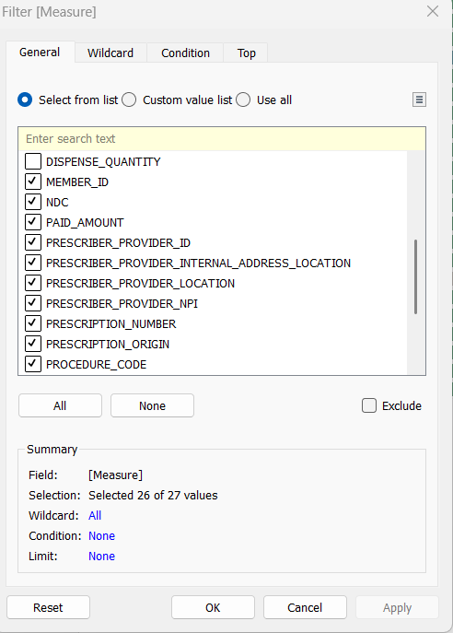
The measure should appear automatically.

End of Document, thanks for reading!

