COMMONWEALTH OF MASSACHUSETTS
EXECUTIVE OFFICE OF HEALTH AND HUMAN SERVICES



Data Warehouse Project

Data Warehouse

DWHS-41310 Encounter Data Quality Scorecard

Submission Performance

Version 1.4

Date: August 28, 2025

Contents
Contents 2
Revision History 3
1. Background 3
2. Objective 3
3. Dashboards Schedule 3
4. Data source 3
5. Parameter 4
6. Dashboards 4
5.1. Encounter Submission KPI 4
5.1.1. Summary View: 5
5.1.2 Monthly Submission Tracker 5
5.1.3 Historical resubmissions 7
5.2 Submissions Heatmap 7
5.3 Submission Lag Triangle 8
5.4 Monthly Submissions Source 9
5.5 Submission Files 11
6. Development and process – 12
7. Technical Specification 12
8. Data Security and Access 13
9. Accuracy Metrics 13
10. User access 13
11. Data Governance 13
6 Stakeholders 13
7 Team Roles and Responsibilities 13
8 Timeline 14
9 Communication Log 14

Revision History
Version | Date | Revision Description | Modified By
1.0 | 12/03/2024 | Initial document created | Shruti Dadhi
1.1 | 01/28/2025 | Added comments from JP | Shruti Dadhi
1.2 | 02/12/2025 | Added Dashboards links to the BRD | Shruti Dadhi, JP Leger
1.3 | 08/21/2025 | Added descriptions of each dashboard | Shruti Dadhi, JP Leger
1.4 | 08/28/2025 | Added section Data Governance per MHA input | Shruti Dadhi, JP Leger

Background

The MassHealth Analytics (MHA) team has requested an Encounter Submission Monitoring report to monitor the monthly submissions of encounter data and to create an easy to use “scorecard” to monitor encounter data over time that focused on monthly submission for a month complete and to get the real time information about Encounter data submission statuses to see if plan has submitted a volume of data covering the past 3 months that looks consistent with past submission volume and to see if significant amount of data submitted in a month that looks like historical corrections or submissions to get the accurate benchmark.

Objective

The goal of this BRD is to capture the business requirements to build an interactive dashboard for and publish the dashboard in Tableau for internal users. These Dashboard will allow the users to look at the datapoints, trends over time into areas of interest for more detailed analysis.

Dashboards Schedule
Dashboards will be published in Tableau and run every morning using Tableau scheduler.
Note: Per BI team the dashboards are scheduled to run weekly for now and refreshing on Monday.

Data source
The data source will use the below views for the dashboard
- NW_ENCOUNTER_HIST
- ODS_ENCOUNTER
- NW_ENC_STATISTICS

Parameter
- Claim Counts
- Averages
- Ti
- meframe: we are looking at 2-3 years back (2022)
- Look up for ACO names

- Lookup table provided by MHA to filter by ACO/MCO/SCO/Oncecare/MBHP

Dashboards

Encounter Submission KPI

Encounter Submissions KPIs is intended to be used as a high-level management tool, providing an at a glance identification of submission status and historical resubmissions. The dashboard provides two independent worksheets. The Monthly Submissions Tracker [left] gauges if a plan has submitted data in a month for recent time periods (the most recent 3 months based on DOS). This is to see if the volume of recent encounters in a month is similar to the volume in past months to help determine “are submissions in.” The historical resubmissions [right] look at monthly submissions and quantify the volume of encounters with dates of service dating back 8 months or more. Spikes in the volume of these claims suggest large resubmissions that could change past reporting in material ways and may warrant closer investigation. The other tabs in the dashboard can be used to further investigate variances observed in the KPIs.
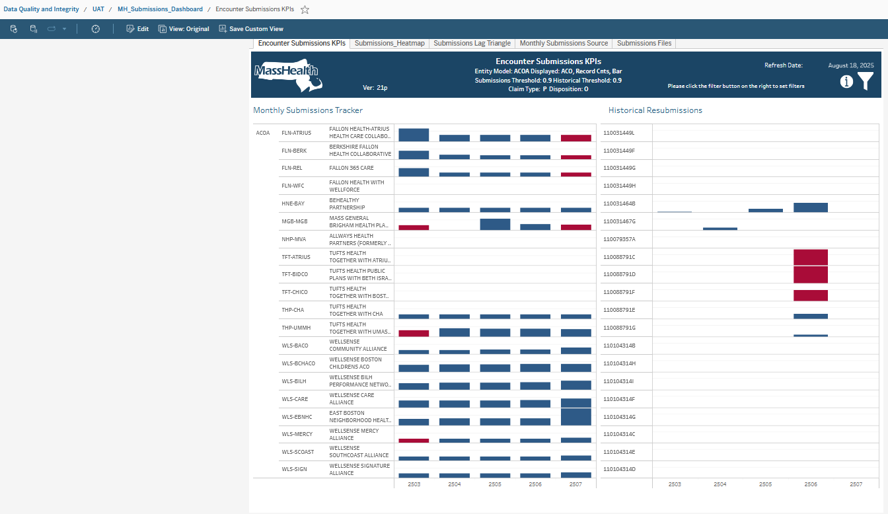

Summary View:
This view would be a simple view of the most recent 5 months and if the timeliness threshold had been met and if any months saw potential historical resubmissions This could be a grid format (see below). Plans would be grouped by type so that all plans of a given type (ie ACO/MCO) would be grouped together as a large amount of work is done by functional area. This would be main landing page but data would be sourced from views in 5.2 and 5.3

 |  | Monthly Submission Threshold |  |  |  |  | Potential Historical Adjustment
Plan Type | Plan Name | 10/1/24 | 11/1/24 | 12/1/24 | 1/1/25 | 02/01/2025 (current Month) | 10/1/24 | 11/1/24 | 12/1/24 | 1/1/25 | 02/01/2025 (current Month)

Although cells would be visual representation (checkmark or red/yellow/green), tool tips would be available to get actual # volumes

Monthly Submission Tracker
Note: Historical are the left side of the Encounter Submission KPI
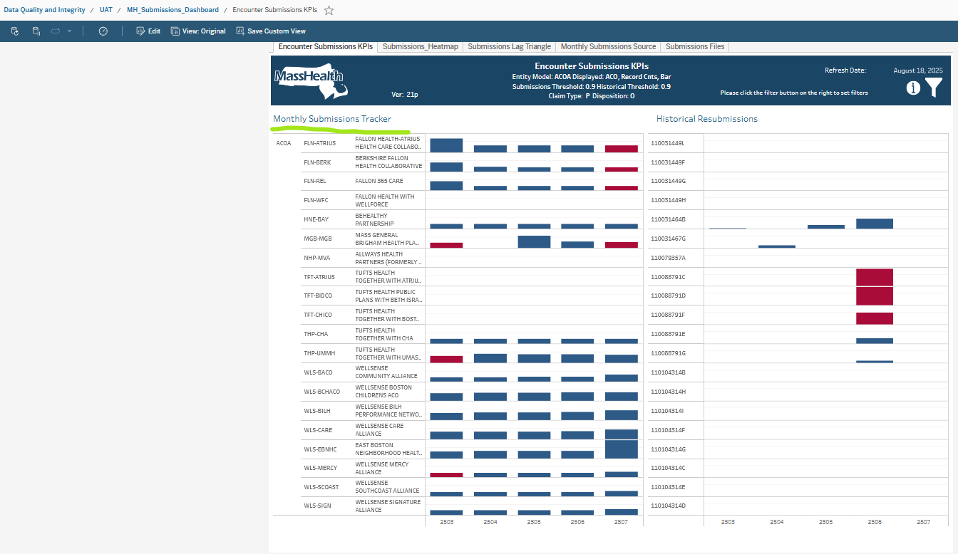

This view would show MCEs (MCO [Model A’s counted as payer], SCO, ICO, MBHP) and how they submitted data each month. Each month’s submissions in paid amounts and claims for the past 3 months would be compared to a 12-month rolling average and used to calculate a completion threshold in order to deem that the MCO has submitted sufficient volume of recent claims data to classify their monthly submission as “complete”. This would be seen as rolling monthly information that could be filtered as needed by requestor.

Ex table that would drive this:
- Plan Type (MCO/ACO, SCO, ICO, MBHP)
- Plan Name
- Plan PIDSL
- Month of Submission
- # of Claim lines submitted with DOS for the last 3 months this month
- Paid Amounts submitted with DOS of the last 3 months this month
- Rolling average [12 months] of # of Claim lines submitted with DOS of the last 3 months
- Rolling average [12 months] of Paid Amounts submitted with DOS of the last 3 months
- Threshold met [claims and paid at least 90% of rolling average]

This would allow filtering along plan types, months, names, and pidsls

Historical resubmissions
Note: Historical are the right side of the Encounter Submission KPI
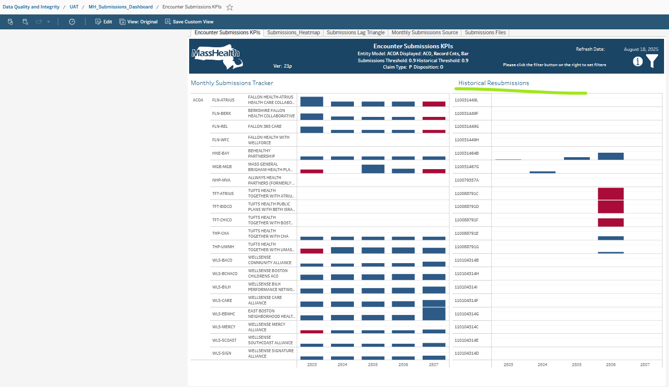

This view would show if MCEs (MCO [Model A’s counted as payer], SCO, ICO, MBHP) submitted large amount of corrections data for DOS more than 8 months in the past. This would help flag if there are large amounts of adjustments, voids, or new claims that could materially change the output of various reporting, analytic, and actuarial work.

- Ex table that would drive this:
- Plan Type (MCO/ACO, SCO, ICO, MBHP)
- Plan Name
- Plan PIDSL
- Month of Submission
- # of claims with dates of service more than 8 months from the submission date.
- Threshold met – DI can you advise on threshold

This would allow filtering along plan types, months, names, and pidsls

Submissions Heatmap

Submissions Heatmap is another DOS Mon to WH Mon comparison. This viz was the first attempt to display John’s request for a way to tell, for a given plan, which months have sufficient DOS submitted data to safely generate reports for. This viz started as a heatmap but the heatmap was not accurate enough for tooltip analysis, so the blocks were replaced with Gantt charts. The blocks are color coded Green, Red, Yellow to indicate there is sufficient data in the month based on the percentage generated by record counts for the month compared to the two-year average of record counts for the plan. In addition, the individual Gantt charts (blocks) are sized by the percentage. Slider filters are provided for the user to choose the thresholds percentages for Yellow and Red. Note that the percentages are based on a 12-month rolling average. Please provide an extra 12-month period of data for best percentages.

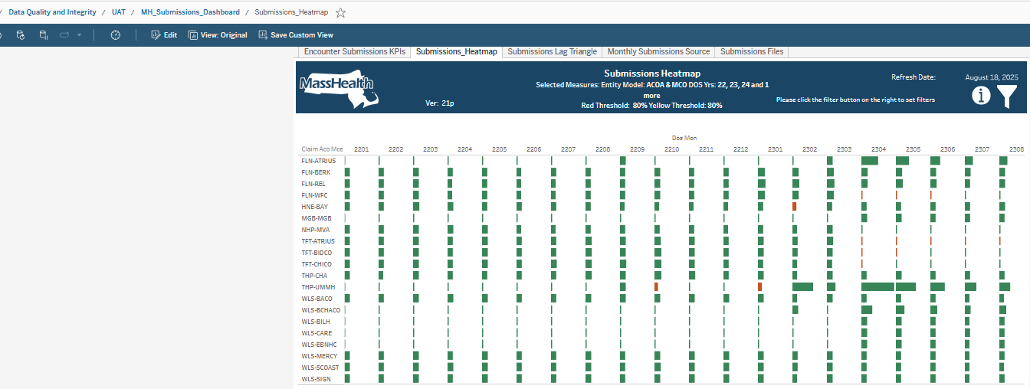

This view will demonstrate any month when claims volume is low compared to the ‘norm’. This will help inform if there are potential data gaps (not submitted to MassHealth) that should be considered and investigated
- (total record counts divided by 2-year average for the MCE) by month by MCE with red, yellow and green
- Claims count with filters by MCE by Month showing 2 years of data. MCEs will be grouped by Plan Type (ACO/MCO, SCO, ICO, MBHP)
- What months have enough data to compare with the average amount of data for the past 2 years
- By default, less than 70% is yellow but the end user can use the slider to change the percentages and less than 50% is Red

Submission Lag Triangle

Submissions Lag Triangle displays claim line counts at the month level using a crosstab of Warehouse (WH) Month (Mon) on the vertical axis vs Date of Service (DOS) Month on the horizontal axis.

Dashboard of crosstab of total record count by wh month by date of service month - Lag triangle
This view will help analysts and others at MassHealth understand encounter data completion over time and help demonstrate plan submission patterns (i.e. give a sense of ‘claims lag’

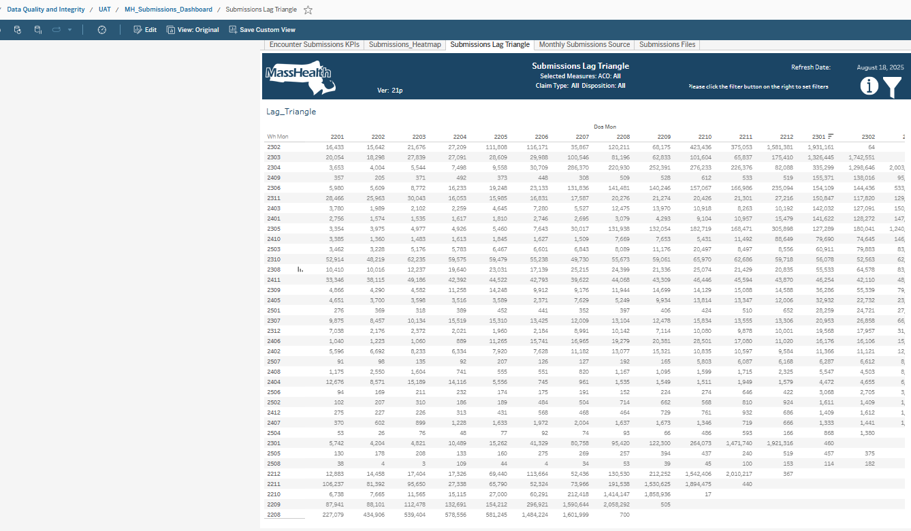

Monthly Submissions Source

Monthly Submissions Source provides two views of WH record counts versus DOS record counts using stacked bar charts (stacked by record type) by month. The left chart filters the right chart. With the top set of charts, the left chart is the DOS month filtering in the right chat which submission (WH) months the DOS records were submitted. The bottoms pair of charts are reversed. The left chart selects the submission month, and the right chart shows which DOS months the claims applied in.
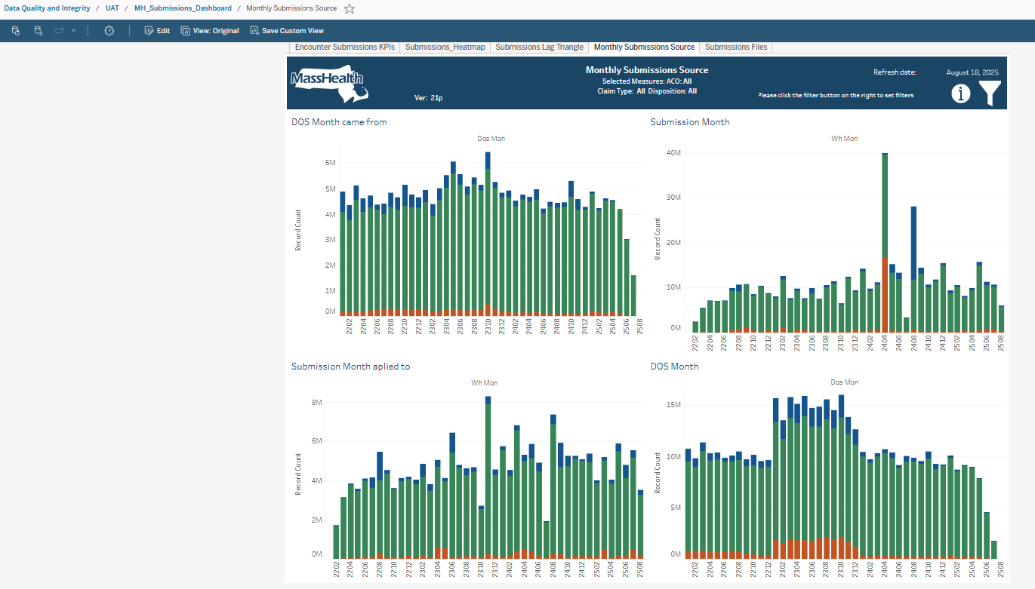

Date of service month driving the wh month
This view will help analysts and others at MassHealth to understand the relationship between what data came in in a month and when it will be seen across the encounter data. This si a companion view of 5.5.2 and will aid in ad-hoc drill downs based on better understanding on months that are seeing large resubmissions (5.3)

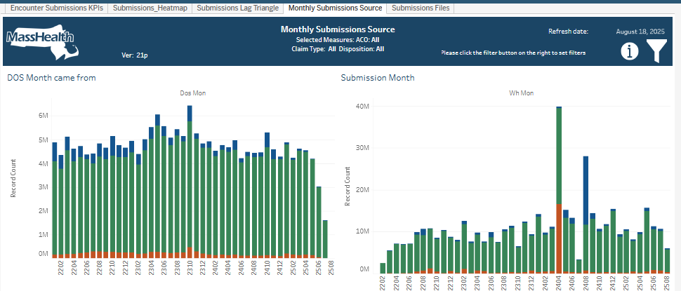

wh month driving the date of service month
This view will help analysts and others at MassHealth understand the relationship between what data came in in a month and when it will be seen across the encounter data. This is a companion view of 5.5.1 and will aid in ad-hoc drill downs based on better understanding on months that are seeing large resubmissions (5.3)

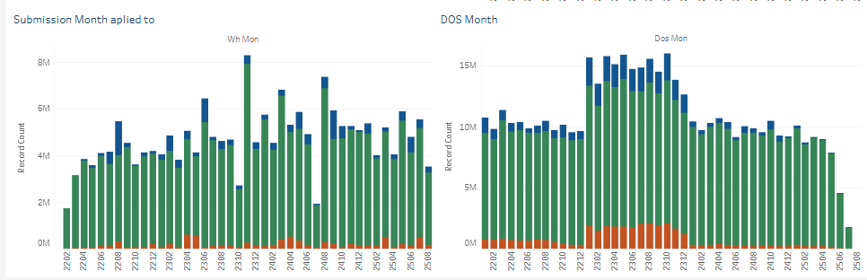

Submission Files
Submissions Files displays at the file level of detail (the lowest level. ) Files are submitted by MCOs and can contain data for multiple plans offered by the MCO – ACOA, ACOB, SCO, OC, MBH. The dashboard consists of two worksheets. The top worksheet, Submitted Files, shows files submitted by the MCO sorted in descending order with submission metadata and DW processing detail. The bottom worksheet is triggered by selecting a file in the top worksheet and shows details of where the encounters are placed by Date of Service (DOS) Month, plan (side by side bars) and Record Type (Operational Data Store (ODS) disposition (Original, Replacement (adjustment), Adjustment, and Void) (stacked within the bars).

This will help MH understand the scope of any past submissions in terms of what was submitted. This will allow for Adhoc drill downs and investigations based on the outputs of the first 3 views (sections 5.1, 5.2, and 5.3)
- Top Down -Timeliness per file
- Bottom-Up-another workbook with histogram with date of service month and record type.

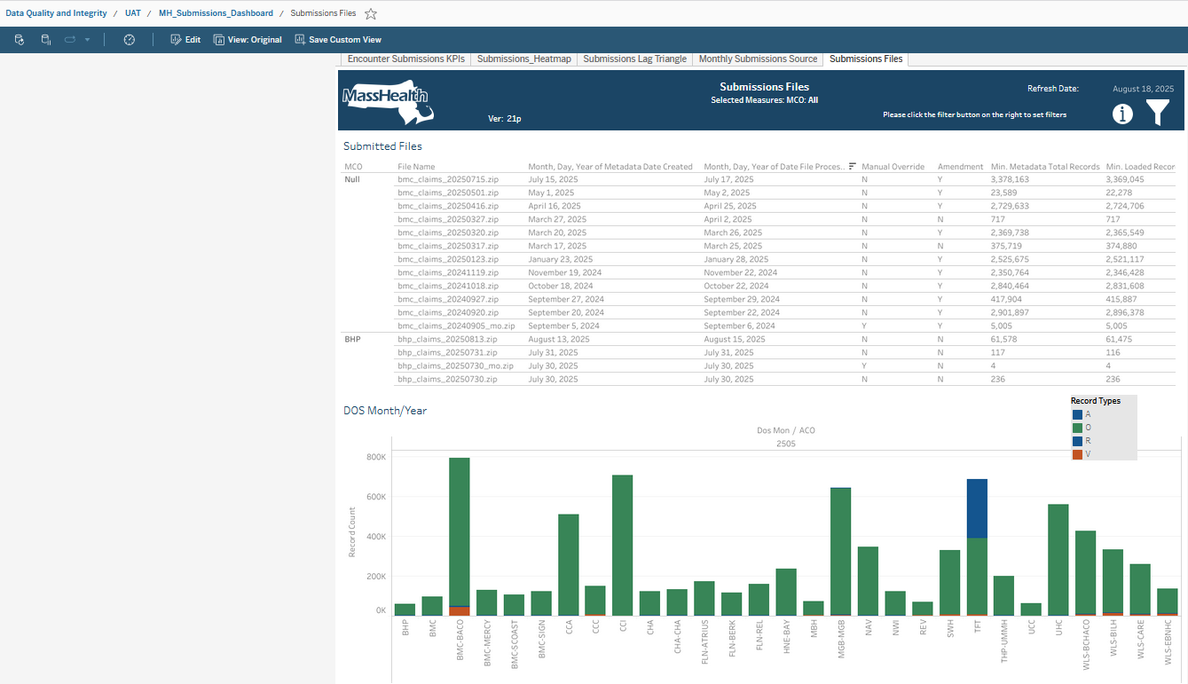

Development and process –
should be iterative and scoped for incremental delivery rather than trying to do all before release. Business preference in terms of order of delivery.

The 5 dashboards are:
- Encounter Submissions KPIs
- Submissions Heatmap
- Submissions lag Triangle
- Monthly Submissions Source
- Submissions Files

Technical Specification

Data Security and Access
This is an aggregate dashboard intended to be used throughout EHS.
Tableau dashboard access visibility needs to approved by MHA or DI with access granted by EDME BI.

Accuracy Metrics
We may plan to add additional accuracy metrics over time based on business feedback.

User access
User access will be facilitated by BI team.
- DQ Team
- MHA Team
- DI Team

Data Governance

Stakeholders
Name | Role/Team | Approver
John Boney | Director MassHealth Analytics
Alexander Belanger | Program manager, Data Integrity

Team Roles and Responsibilities
Name | Title | Role/Team
Rima Kayyali | DW Projects Lead | DQ Team Lead/DW
JP Leger | Developer/ DQ Data warehouse | DQ Developer/DW
Shruti Dadhi | Business Analyst/ DQ Data warehouse | DQ BA/DW

Timeline

Milestone | Start Date | End Date
Requirements Gathering | 12/18/2024 | 1/31/2025
Requirements Review – Internal | 1/28/2025 | 2/7/2025
Requirements Review – Business | 2/7/2025 | 3/12/2025
Requirements Signoff | 2/13/2025 | 2/17/2025
Development | 2/10/2025 | 8/15/2025
QA | 2/24/2025 | 8/15/2025
UAT Signoff | 2/24/2025 | 7/3/2025
PROD deployment | 8/1/2025 | 8/4/2025

Communication Log

Documents | Description
Intake Request-41310
Encounter Daily File Status Report 2024-12-03T13_00_06.865Z
MH Submission Dashboard refresh

