Submissions Dashboard technical Specification - Version 1.3

Revision History
Version | Date | Revision Description | Author
1.0 | 5/1/2025 | Base version created | JP Leger
1.1 | 5/8/2025 | Added Claim Type and Disposition to KPI Dashboard | JP Leger
1.2 | 5/29/2025 | Changed RUN DATE in Submission Files to current date and 12 months | JP Leger
1.3 | 6/3/2025 | Fixed filters in Submission Source and KPI. Moved KPI running avg and percent calcs to Tableau and added after calcs logic to filter number of WH MON displayed.

As of 4/30/25 the Submissions Dashboard consists of 5 dashboards showing different aggregations and levels of detail. The latest version is MH_Submissions_Dashboard-14 located at Tableau Prod Explore / Data Quality and Integrity / UAT.

The 5 dashboards are:
Submissions Files
Submissions lag Triangle
Monthly Submissions Source
Submissions Heatmap
Encounter Submissions KPIs

Submissions Files
displays at the file level of detail (the lowest level ) Files are submitted by MCOs and can contain data for multiple plans offered by the MCO – ACOA, ACOB, SCO,OC, MBH. The dashboard consists of two worksheets. The top worksheet, Submitted Files, shows files submitted by the MCO sorted in descending order with submission metadata and DW processing detail. The bottom worksheet is triggered by selecting a file in the top worksheet and shows details of where the encounters placed by Date of Service (DOS) Month, plan (side by side bars) and Record Type ( Operational Data Store (ODS) disposition (Original, Replacement (adjustment), Adjustment, and Void ) (stacked within the bars).

The dashboard provides one filter, the MOC, which is selected from the filter drop down menu.

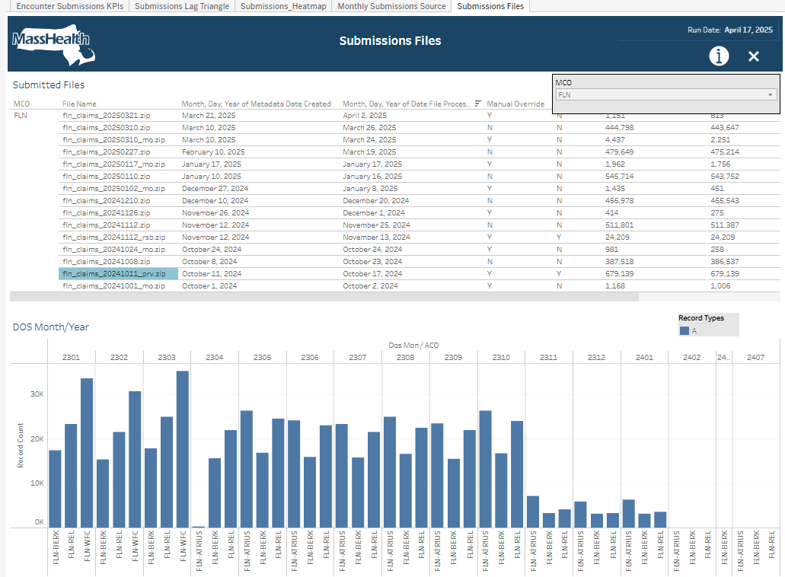

Submissions Files uses the Prod Snowflake table MHTEAM.DWDQ.INF_B_SUB_DASH_FILE_DOS_COUNTS.

create or replace TABLE MHTEAM.DWDQ.INF_B_SUB_DASH_FILE_DOS_COUNTS (
RUN_DATE DATE,
MCO VARCHAR(10),
ACO VARCHAR(10),
CDE_ENTITY_MODEL VARCHAR(10),
ENTITY_PIDSL VARCHAR(20),
ENTITY_NAME VARCHAR(100),
ID VARCHAR(10),
FILE_NAME VARCHAR(100),
METADATA_DATE_CREATED DATE,
DATE_FILE_PROCESSED DATE,
MANUAL_OVERRIDE VARCHAR(1),
AMENDMENT VARCHAR(1),
METADATA_TOTAL_RECORDS NUMBER(10,0),
LOADED_RECORD_COUNT NUMBER(10,0),
ERROR_RECORD_COUNT NUMBER(10,0),
METADATA_TOTAL_PAYMENTS NUMBER(15,2),
DOS_MON VARCHAR(4),
RECORD_TYPE VARCHAR(1),
RECORD_COUNT NUMBER(10,0)
);

Which is populated by Informatica IICS in Prod Informatica CDGC Org
z_jleger/Submissions Dashboard/M_INF_B_SUB_DASH_FILE_DOS_COUNTS

Using the DWDQ_WH, DWDQ_RW_ROLE and the SQL (will be cleaned up for final version):
TRUNCATE TABLE MHTEAM.DWDQ.INF_B_SUB_DASH_FILE_DOS_COUNTS;

INSERT INTO MHTEAM.DWDQ.INF_B_SUB_DASH_FILE_DOS_COUNTS
SELECT
RUN_DATE,
MCO,
ACO,
CDE_ENTITY_MODEL,
ENTITY_PIDSL,
ENTITY_NAME,
ID,
FILE_NAME,
metadata_date_created,
date_file_processed,
manual_override,
Amendment,
metadata_total_records,
loaded_record_count,
error_record_count,
metadata_total_payments,
DOS_MON,
record_type,
COUNT(DOS_MON) REC_COUNT
FROM (
SELECT
RUN_DATE,
cde_enc_mco AS MCO,
CLAIM_ACO_MCE AS ACO,
CDE_ENTITY_MODEL,
ENTITY_PIDSL,
ENTITY_NAME,
RANK() OVER (PARTITION BY cde_enc_mco ORDER BY metadata_date_created,zip_file_name,date_file_processed) ID,
zip_file_name as FILE_NAME,
--zip_file_created,
metadata_date_created,
date_file_processed,
ind_manual_override AS manual_override,
ind_amendment AS Amendment,
metadata_total_records,
loaded_record_count,
error_record_count,
metadata_total_payments,
DOS_MON,
record_type
FROM (
SELECT --distinct
CURRENT_DATE() AS RUN_DATE,
--TO_DATE('20250225','YYYYMMDD') AS RUN_DATE,
CASE
WHEN stat.cde_enc_mco = 'TFT' THEN 'CHA'
ELSE stat.cde_enc_mco
END AS cde_enc_mco,
CASE WHEN enc.CDE_ENC_ACO in('#','+','-') THEN enc.CDE_ENC_MCO ELSE enc.CDE_ENC_ACO END AS CLAIM_ACO_MCE,
CDE_ENTITY_MODEL, cw.ENTITY_PIDSL, ENTITY_NAME,
--stat.cde_enc_mco,
zip_file_name,
metadata_date_created,
metadata_total_records,
loaded_record_count,
error_record_count,
metadata_total_payments,
metadata_date_created as zip_file_created,
to_date(max(to_char(process_end_tm,'mm/dd/yyyy')) over (partition by zip_file_name), 'MM/DD/YYYY') as DATE_FILE_PROCESSED, -- as processdt2,
ind_manual_override,
ind_amendment,
CASE
WHEN md_batch_seq_scrub IS NULL THEN 'File Failed'
WHEN md_batch_seq_nw IS NULL THEN 'File processed but not loaded'
ELSE 'Successfully Loaded'
END
load_status,
cde_load_status,
SUBSTR(From_Service_Date,3,4) AS DOS_MON,
record_type
from mhdwprod.nw.nw_enc_statistics stat
inner join mhdwprod.nw.ods_encounter enc
on enc.md_batch_seq=stat.md_batch_seq_ods and stat.cde_enc_mco=enc.cde_enc_mco
left join mhteam.dwdq.INF_B_MCE_PIDSL_CROSSWALK cw on cw.mco = enc.cde_enc_mco and cw.aco = enc.cde_enc_aco
where 1=1
and metadata_date_created between
TO_CHAR(ADD_MONTHS(TRUNC(RUN_DATE,'MONTH'), -11)) AND
TO_CHAR(LAST_DAY(TRUNC(RUN_DATE,'MONTH'))) --rolling history of 12months
) t
) u
GROUP BY
RUN_DATE,
MCO,
ACO,
CDE_ENTITY_MODEL,
ENTITY_PIDSL,
ENTITY_NAME,
ID,
FILE_NAME,
metadata_date_created,
date_file_processed,
manual_override,
Amendment,
metadata_total_records,
loaded_record_count,
error_record_count,
metadata_total_payments,
DOS_MON,
record_type
ORDER BY RUN_DATE, mco, metadata_date_created, DOS_MON, RECORD_TYPE;

Submissions Lag Triangle
Displays claim line counts at the month level using a crosstab of Warehouse (WH) Month (Mon) on the vertical axis vs Date of Service (DOS) Month on the horizontal axis.

Filters offered are:
- Entity Model (Plan Type)
- ACOs (plan within the type)
- Claim Types: Dental (D), Inpatient (I), Outpatient (O), Long term care (L), Professional (M), and Pharmacy (P)
- Disposition: Original (O), Adjustment (A) and Void (V)
- Displayed Submission Months – WH Months
- Displayed DOS Months

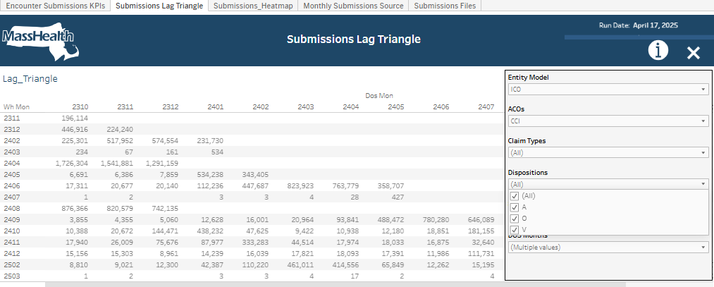

Submissions Lag Triangle uses the table MHTEAM.DWDQ.INF_B_SUB_DASH_FILE_DOS_COUNTS.

create or replace TABLE MHTEAM.DWDQ.INF_B_SUB_DASH_WH_DOS_ACO_COUNTS (
RUN_DATE DATE,
WH_MON VARCHAR(4),
DOS_MON VARCHAR(4),
CLAIM_MCE VARCHAR(10),
CLAIM_ACO_MCE VARCHAR(10),
CDE_ENTITY_MODEL VARCHAR(10),
ENTITY_PIDSL VARCHAR(20),
ENTITY_NAME VARCHAR(100),
CDE_CLM_TYPE VARCHAR(1),
CDE_CLM_DISPOSITION VARCHAR(2),
RECORD_COUNT NUMBER(38,0)
);

Which is populated by Informaitca IICS in Prod Informatica CDGC Org
z_jleger/Submissions Dashboard/ M_INF_B_SUB_DASH_WH_DOS_ACO_COUNTS

Using the DWDQ_WH, DWDQ_RW_ROLE and the SQL (will be cleaned up for final version):
TRUNCATE TABLE MHTEAM.DWDQ.INF_B_SUB_DASH_WH_DOS_ACO_COUNTS

INSERT INTO MHTEAM.DWDQ.INF_B_SUB_DASH_WH_DOS_ACO_COUNTS

SELECT RUN_DATE, WH_MON, DOS_MON, CLAIM_MCE, CLAIM_ACO_MCE, CDE_ENTITY_MODEL, ENTITY_PIDSL, ENTITY_NAME, CDE_CLM_TYPE, CDE_CLM_DISPOSITION, count(CDE_CLM_DISPOSITION)
FROM (
SELECT
--TO_DATE('20250225','YYYYMMDD') AS RUN_DATE,
CURRENT_DATE() AS RUN_DATE,
E.CDE_ENC_MCO AS CLAIM_MCE,
CASE WHEN E.CDE_ENC_ACO in('#','+','-') THEN E.CDE_ENC_MCO ELSE E.CDE_ENC_ACO END AS CLAIM_ACO_MCE,
cw.CDE_ENTITY_MODEL,
cw.ENTITY_PIDSL,
cw.ENTITY_NAME,
CDE_CLM_TYPE,
CDE_CLM_DISPOSITION,
TO_CHAR(DOS_FROM_DT,'YYMM') AS DOS_MON,
TO_CHAR(WH_FROM_DT,'YYMM') AS WH_MON
FROM mhdwprod.nw.nw_encounter_hist e
left join mhteam.dwdq.INF_B_MCE_PIDSL_CROSSWALK cw on cw.mco = e.cde_enc_mco and cw.aco = e.cde_enc_aco
WHERE e.dos_from_dt >= '01-JAN-2022'
AND e.IND_OFFSET = 'N'
)
GROUP BY RUN_DATE, WH_MON, DOS_MON, CLAIM_MCE, CLAIM_ACO_MCE, CDE_ENTITY_MODEL, ENTITY_PIDSL, ENTITY_NAME, CDE_CLM_TYPE, CDE_CLM_DISPOSITION
ORDER BY RUN_DATE, WH_MON, DOS_MON, CLAIM_MCE, CLAIM_ACO_MCE, CDE_ENTITY_MODEL, ENTITY_PIDSL, ENTITY_NAME, CDE_CLM_TYPE, CDE_CLM_DISPOSITION;

Monthly Submissions Source
Provides two views of WH record counts versus DOS record counts using stacked bar charts (stacked by record type) by month. The left chart filters the right chart. With the top set of charts, the left chart is the DOS month filtering in the right chat which submission (WH) months the DOS records were submitted. The bottoms pair of charts are reversed. The left chart selects the submission month, and the right chart shows which DOS months the claims applied to.

Filters offered are:
- Entity Model (Plan Type)
- ACOs (plan within the type)
- Claim Types: Dental (D), Inpatient (I), Outpatient (O), Long term care (L), Professional (M), and Pharmacy (P)
- Disposition: Original (O), Adjustment (A) and Void (V)

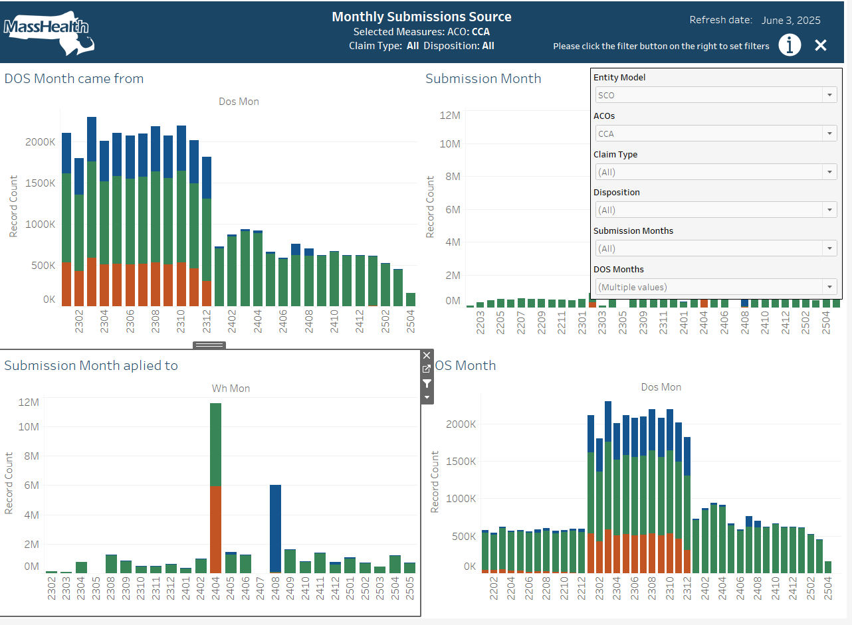

Monthly Submission Source also uses the
MHTEAM.DWDQ.INF_B_SUB_DASH_FILE_DOS_COUNTS.

create or replace TABLE MHTEAM.DWDQ.INF_B_SUB_DASH_WH_DOS_ACO_COUNTS (
RUN_DATE DATE,
WH_MON VARCHAR(4),
DOS_MON VARCHAR(4),
CLAIM_MCE VARCHAR(10),
CLAIM_ACO_MCE VARCHAR(10),
CDE_ENTITY_MODEL VARCHAR(10),
ENTITY_PIDSL VARCHAR(20),
ENTITY_NAME VARCHAR(100),
CDE_CLM_TYPE VARCHAR(1),
CDE_CLM_DISPOSITION VARCHAR(2),
RECORD_COUNT NUMBER(38,0)
);
See the above Submissions Lag Triangle for Informatica and SQL specifications.

Submissions Heatmap
Another DOS Mon to WH Mon comparison. This viz was the first attempt to display John’s request for a way to tell, for a given plan, which months have sufficient DOS submitted data to safely generate reports for. This viz started as a heatmap but the heatmap was not accurate enough for tooltip analysis, so the blocks were replaced with Gantt charts. The blocks are color coded Green, Red, Yellow to indicate there is sufficient data in the month based on the percentage generated by record counts for the month compared to the two year average of record counts for the plan. In addition, the individual Gantt charts (blocks) are sized by the percentage. Slider filters are provided for the user to choose the thresholds percentages for Yellow and Red.

Filters offered are:
- Red Percentage
- Yellow Percentage
- Entity Model (Plan Type)
- ACOs (plan within the type)
- Displayed DOS Months – using a calendar year filter

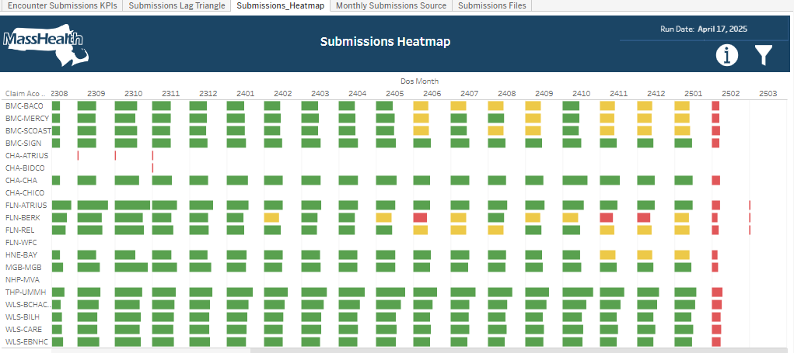

Monthly Submission Source also uses the
MHTEAM.DWDQ.INF_B_SUB_DASH_FILE_DOS_COUNTS.

create or replace TABLE MHTEAM.DWDQ.INF_B_SUB_DASH_WH_DOS_ACO_COUNTS (
RUN_DATE DATE,
WH_MON VARCHAR(4),
DOS_MON VARCHAR(4),
CLAIM_MCE VARCHAR(10),
CLAIM_ACO_MCE VARCHAR(10),
CDE_ENTITY_MODEL VARCHAR(10),
ENTITY_PIDSL VARCHAR(20),
ENTITY_NAME VARCHAR(100),
CDE_CLM_TYPE VARCHAR(1),
CDE_CLM_DISPOSITION VARCHAR(2),
RECORD_COUNT NUMBER(38,0)
);
See the above Submissions Lag Triangle for Informatica and SQL specifications.

Encounter Submissions KPIs
Unlike the previous visualizations, John intended the KPI dashboard to be used as a high-level management tool, providing an at a glance identification of trouble spots. The dashboard provides two independent worksheets. Like the Heatmap, the left worksheet shows problem months for plans, but now based on three-month DOS counts (for record counts or sums for amount paid) windows, compared to a true rolling average of three-month aggregations. The right worksheet attempts to visualize months with high submissions of older claims. It compares the DOS counts (for record counts or sums for amount paid) for the months starting 8 months back and older from the submission month, compared to the rolling average used for the Submission worksheet. The two worksheets use vertically stacked bar charts and are aligned by plan. The bars are colored Green or Red depending on percentage comparisons to thresholds set in the filters.

Filters offered are:
- Entity Model (Plan Type)
- Submissions Threshold
- Historical Threshold
- Displayed Submission Months – default 5 to keep as summary – this was changed to Display Start Submission Month and Display End Submission Month
- Record Count or Paid – a switch that switches the worksheets to display record counts or amount paid
- Disposition O,A,V
- Claim Type

Logic moved to Tableau
With adding the Disposition and Claim Type the level of detail became more granular and meant that the rolling averages and percent calculations could no longer be done at the base level in the SQL. The rolling averages and percents can’t be re-aggregated within Tableau, so they had to be moved to Tableau calcs. The rolling averages and percents were kept in the SQL (called base) for validation.
Calcs:
DOS Recs 3Mon (12-month Window)
WINDOW_AVG(SUM([Dos Recs 3Mon]),-11,0)
DOS Recs 3Mon (12-month Window) PCT
SUM([Dos Recs 3Mon])/[DOS Recs 3Mon (12-month Window)]
Dos Paid 3Mon (12-month Window)
WINDOW_AVG(SUM([Dos Paid 3Mon]),-11,0)

Dos Paid 3Mon (12-month Window) PCT
SUM([Dos Paid 3Mon])/[Dos Paid 3Mon (12-month Window)]

For testing, setting to a single Disposition and Claim Type gives the same results between the base and the Tableau calcs. I used a spreadsheet to pull 12 month 3Mon aggregations and manually calculate the averages for comparison.

There was also the difficulty that the rolling average calcs are done at the visualization level and the filters to only display the five months was blocking the rolling averages ability to see 12 months back. Working with Github Co-pilot, added parameters for Display Start and End and a Table Calc, Show in Range, that works after the rolling average calcs.
To get the Show in Rage to be a Table Calc required a couple layers:

WH_MON In Range
[Wh Mon] >= [Start Submission Month] AND [Wh Mon] <= [End Submission Month]
Show In Range (Table Calc)
WINDOW_MAX(IF ATTR([WH_MON In Range]) THEN 1 ELSE 0 END)

The Record Counts or Paid switches between two sets of Sheets, one for Records and one for Paid.
Also, set the colors to blue and red vs green and red. Where colors are based on a sliding scale, the DW default colors were not available.
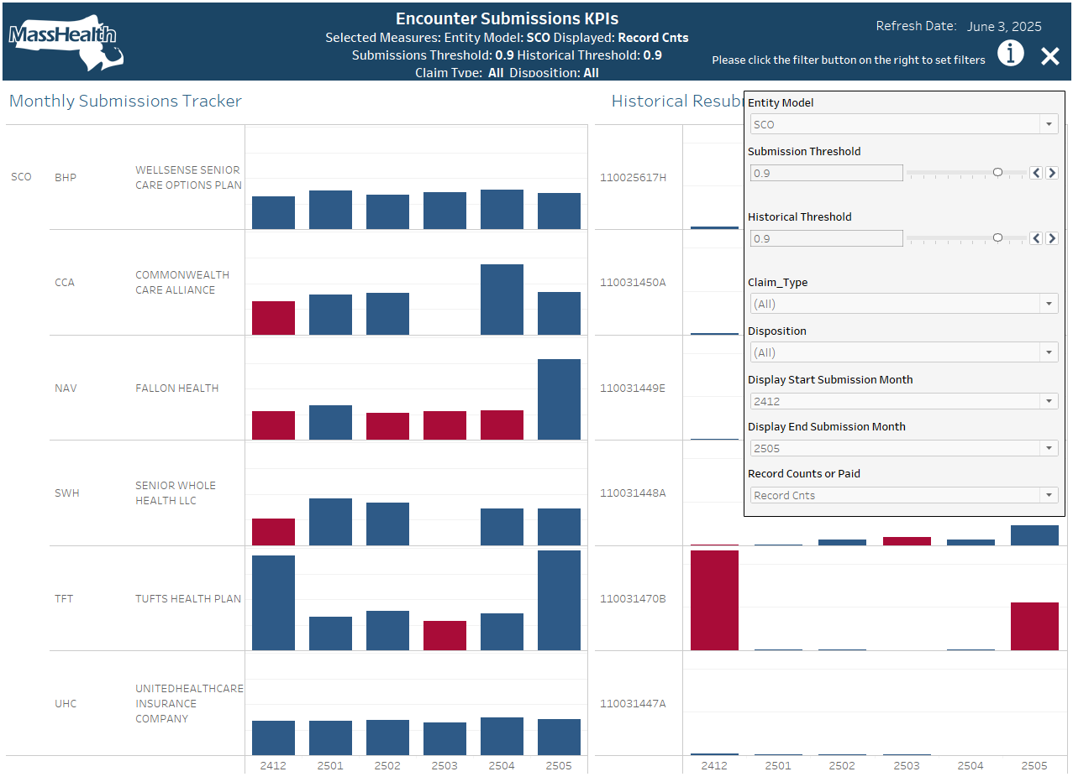

Encounter Submissions KPIs uses two tables and a view that ties them together
View:
MHTEAM.DWDQ.INF_B_SUB_DASH_KPI_COUNTS
Submissions:
MHTEAM.DWDQ.INF_B_SUB_DASH_KPI_COUNTS_5_2
History:
MHTEAM.DWDQ.INF_B_SUB_DASH_KPI_COUNTS_5_3

CREATE VIEW INF_B_SUB_DASH_KPI_COUNTS
AS
SELECT
nvl(tw.RUN_DATE,th.RUN_DATE) RUN_DATE,
nvl(tw.CDE_ENTITY_MODEL,th.CDE_ENTITY_MODEL) CDE_ENTITY_MODEL,
nvl(tw.ENTITY_PIDSL,th.ENTITY_PIDSL) ENTITY_PIDSL,
nvl(tw.ENTITY_NAME,th.ENTITY_NAME) ENTITY_NAME,
nvl(tw.CLAIM_MCE,th.CLAIM_MCE) CLAIM_MCE,
nvl(tw.CLAIM_ACO_MCE,th.CLAIM_ACO_MCE) CLAIM_ACO_MCE,
nvl(tw.WH_MON,th.WH_MON) WH_MON,
nvl(tw.CDE_CLM_TYPE,th.CDE_CLM_TYPE) CDE_CLM_TYPE,
nvl(tw.CDE_CLM_DISPOSITION,th.CDE_CLM_DISPOSITION) CDE_CLM_DISPOSITION,
nvl(tw.DOS_RECS_3MON,0) DOS_RECS_3MON,
nvl(tw.DOS_RECS_3MON_12_MNTH_RLNG_AV,0.01) DOS_RECS_3MON_12_MNTH_RLNG_AV,
nvl(tw.DOS_RECS_3MON_PCT,0) DOS_RECS_3MON_PCT,
nvl(tw.DOS_PAID_3MON,0) DOS_PAID_3MON,
nvl(tw.DOS_PAID_3MON_12_MNTH_RLNG_AV,0.01) DOS_PAID_3MON_12_MNTH_RLNG_AV,
nvl(tw.DOS_PAID_3MON_PCT,0) DOS_PAID_3MON_PCT,
nvl(th.EIGHT_MON_RECS,0) EIGHT_MON_RECS,
nvl(th.EIGHT_MON_PAID,0) EIGHT_MON_PAID
FROM INF_B_SUB_DASH_KPI_COUNTS_5_2 tw
FULL JOIN INF_B_SUB_DASH_KPI_COUNTS_5_3 th
ON tw.RUN_DATE = th.RUN_DATE
AND tw.ENTITY_PIDSL = th.ENTITY_PIDSL
AND tw.WH_MON = th.WH_MON
AND tw.CDE_CLM_TYPE = th.CDE_CLM_TYPE
AND tw.CDE_CLM_DISPOSITION = th.CDE_CLM_DISPOSITION
WHERE tw.CDE_ENTITY_MODEL IS NOT NULL OR th.CDE_ENTITY_MODEL IS NOT NULL -- LAHEY
ORDER BY tw.ENTITY_PIDSL, tw.WH_MON DESC;

create or replace TABLE MHTEAM.DWDQ.INF_B_SUB_DASH_KPI_COUNTS_5_2 (
RUN_DATE DATE,
CDE_ENTITY_MODEL VARCHAR(5),
ENTITY_PIDSL VARCHAR(20),
ENTITY_NAME VARCHAR(100),
CLAIM_MCE VARCHAR(3),
CLAIM_ACO_MCE VARCHAR(10),
WH_MON VARCHAR(16777216),
CDE_CLM_TYPE VARCHAR(1),
CDE_CLM_DISPOSITION VARCHAR(1),
DOS_RECS_3MON NUMBER(30,0),
DOS_RECS_3MON_12_MNTH_RLNG_AV NUMBER(38,3),
DOS_RECS_3MON_PCT NUMBER(38,6),
DOS_PAID_3MON NUMBER(33,2),
DOS_PAID_3MON_12_MNTH_RLNG_AV NUMBER(38,5),
DOS_PAID_3MON_PCT NUMBER(38,8)
);

create or replace TABLE MHTEAM.DWDQ.INF_B_SUB_DASH_KPI_COUNTS_5_3 (
RUN_DATE DATE,
CDE_ENTITY_MODEL VARCHAR(5),
ENTITY_PIDSL VARCHAR(20),
ENTITY_NAME VARCHAR(100),
CLAIM_MCE VARCHAR(3),
CLAIM_ACO_MCE VARCHAR(10),
WH_MON VARCHAR(16777216),
CDE_CLM_TYPE VARCHAR(1),
CDE_CLM_DISPOSITION VARCHAR(1),
EIGHT_MON_RECS NUMBER(30,0),
EIGHT_MON_PAID NUMBER(33,2)
);

Which is populated by Informaitca IICS in Prod Informatica CDGC Org
z_jleger/Submissions Dashboard/M_INF_B_SUB_DASH_KPI_COUNTS_5_2
z_jleger/Submissions Dashboard/M_INF_B_SUB_DASH_KPI_COUNTS_5_3

Using the DWDQ_WH, DWDQ_RW_ROLE and the SQL (will be cleaned up for final version):

TRUNCATE TABLE MHTEAM.DWDQ.INF_B_SUB_DASH_KPI_COUNTS_5_2;

INSERT INTO MHTEAM.DWDQ.INF_B_SUB_DASH_KPI_COUNTS_5_2

SELECT
RUN_DATE,
CDE_ENTITY_MODEL,
ENTITY_PIDSL,
ENTITY_NAME,
CLAIM_MCE,
CLAIM_ACO_MCE,
WH_MON,
CDE_CLM_TYPE,
CDE_CLM_DISPOSITION,
DOS_RECS_3MON,
DOS_RECS_3MON_12_MNTH_RLNG_AV,
CASE
WHEN DOS_RECS_3MON_12_MNTH_RLNG_AV = 0 THEN 0
ELSE DOS_RECS_3MON / DOS_RECS_3MON_12_MNTH_RLNG_AV
END AS DOS_RECS_3MON_PCT,
DOS_PAID_3MON,
DOS_PAID_3MON_12_MNTH_RLNG_AV,
CASE
WHEN DOS_PAID_3MON_12_MNTH_RLNG_AV = 0 THEN 0
ELSE DOS_PAID_3MON / DOS_PAID_3MON_12_MNTH_RLNG_AV
END AS DOS_PAID_3MON_PCT
FROM (

-- rolling WH MON average 12 months over 3 MON DOS
SELECT
RUN_DATE,
CDE_ENTITY_MODEL,
ENTITY_PIDSL,
ENTITY_NAME,
CLAIM_MCE,
CLAIM_ACO_MCE,
WH_MON,
CDE_CLM_TYPE,
CDE_CLM_DISPOSITION,
DOS_RECS_3MON,

AVG(DOS_RECS_3MON)
OVER (
PARTITION BY CLAIM_MCE, CLAIM_ACO_MCE, CDE_CLM_TYPE, CDE_CLM_DISPOSITION
ORDER BY WH_MON
ROWS BETWEEN 11 PRECEDING AND CURRENT ROW) AS DOS_RECS_3MON_12_MNTH_RLNG_AV,

DOS_PAID_3MON,
AVG(DOS_PAID_3MON)
OVER (
PARTITION BY CLAIM_MCE, CLAIM_ACO_MCE, CDE_CLM_TYPE, CDE_CLM_DISPOSITION
ORDER BY WH_MON
ROWS BETWEEN 11 PRECEDING AND CURRENT ROW) AS DOS_PAID_3MON_12_MNTH_RLNG_AV
FROM (

-- now at WH MON - push 3 month sum onto prev months
SELECT
RUN_DATE,
CDE_ENTITY_MODEL,
ENTITY_PIDSL,
ENTITY_NAME,
CLAIM_MCE,
CLAIM_ACO_MCE,
WH_MON,
CDE_CLM_TYPE,
CDE_CLM_DISPOSITION,
MAX(TOTAL_RECS_3MON) AS DOS_RECS_3MON,
MAX(TOTAL_PAID_3MON) AS DOS_PAID_3MON

FROM (

-- Sum for WH_MON over last 4 DOS (4 because none in WH_MON = DOS_MON except maybe at end of month?)
SELECT
RUN_DATE,
CDE_ENTITY_MODEL,
ENTITY_PIDSL,
ENTITY_NAME,
CLAIM_MCE,
CLAIM_ACO_MCE,
WH_MON,
DOS_MON,
CDE_CLM_TYPE,
CDE_CLM_DISPOSITION,
TOTAL_RECS,

SUM(TOTAL_RECS)
OVER (
PARTITION BY CLAIM_MCE, CLAIM_ACO_MCE, CDE_CLM_TYPE, CDE_CLM_DISPOSITION, WH_MON
ORDER BY DOS_MON
ROWS BETWEEN 3 PRECEDING AND CURRENT ROW) AS TOTAL_RECS_3MON,

TOTAL_PAID,

SUM(TOTAL_PAID)
OVER (
PARTITION BY CLAIM_MCE, CLAIM_ACO_MCE, CDE_CLM_TYPE, CDE_CLM_DISPOSITION, WH_MON
ORDER BY DOS_MON
ROWS BETWEEN 3 PRECEDING AND CURRENT ROW) AS TOTAL_PAID_3MON

FROM (
-- counts and sum for DOS
SELECT
RUN_DATE,
CDE_ENTITY_MODEL,
ENTITY_PIDSL,
ENTITY_NAME,
CLAIM_MCE,
CLAIM_ACO_MCE,
WH_MON,
DOS_MON,
CDE_CLM_TYPE,
CDE_CLM_DISPOSITION,
COUNT(ENC_CLAIM_NO||ENC_CLAIM_SUFFIX) AS TOTAL_RECS,
SUM(AMT_PAID) AS TOTAL_PAID,
FROM (
-- core
SELECT
CURRENT_DATE() AS RUN_DATE,
cw.CDE_ENTITY_MODEL,
cw.ENTITY_PIDSL,
cw.ENTITY_NAME,
E.CDE_ENC_MCO AS CLAIM_MCE,
CASE WHEN E.CDE_ENC_ACO in('#','+','-')
THEN E.CDE_ENC_MCO ELSE E.CDE_ENC_ACO END AS CLAIM_ACO_MCE,
ENC_CLAIM_NO,
ENC_CLAIM_SUFFIX,
TO_CHAR(DOS_FROM_DT,'YYMM') AS DOS_MON,
TO_CHAR(WH_FROM_DT,'YYMM') AS WH_MON,
AMT_PAID,
CDE_CLM_TYPE,
CDE_CLM_DISPOSITION
FROM mhdwprod.nw.nw_encounter_hist e
left join mhteam.dwdq.INF_B_MCE_PIDSL_CROSSWALK cw on cw.mco = e.cde_enc_mco and cw.aco = e.cde_enc_aco
WHERE e.dos_from_dt >= '01-JAN-2022'
AND e.IND_OFFSET = 'N'
--and E.CDE_ENC_ACO = 'BMC-BACO'
)
GROUP BY RUN_DATE,
CDE_ENTITY_MODEL,
ENTITY_PIDSL,
ENTITY_NAME,
CLAIM_MCE,
CLAIM_ACO_MCE,
WH_MON,
DOS_MON,
CDE_CLM_TYPE,
CDE_CLM_DISPOSITION

ORDER BY RUN_DATE, CDE_ENTITY_MODEL, ENTITY_PIDSL, ENTITY_NAME, CLAIM_MCE, CLAIM_ACO_MCE, WH_MON, DOS_MON

)
GROUP BY RUN_DATE,
CDE_ENTITY_MODEL,
ENTITY_PIDSL,
ENTITY_NAME,
CLAIM_MCE,
CLAIM_ACO_MCE,
WH_MON,
DOS_MON,
CDE_CLM_TYPE,
CDE_CLM_DISPOSITION,
TOTAL_RECS,
TOTAL_PAID
HAVING DOS_MON >= TO_CHAR(DATEADD(month, -4, TO_DATE(WH_MON,'YYMM')),'YYMM')

)

GROUP BY RUN_DATE,
CDE_ENTITY_MODEL,
ENTITY_PIDSL,
ENTITY_NAME,
CLAIM_MCE,
CLAIM_ACO_MCE,
WH_MON,
CDE_CLM_TYPE,
CDE_CLM_DISPOSITION

-- Sum for WH_MON over last 4 DOS (4 because none in WH_MON = DOS_MON except maybe at end of month?)
)
GROUP BY RUN_DATE,
CDE_ENTITY_MODEL,
ENTITY_PIDSL,
ENTITY_NAME,
CLAIM_MCE,
CLAIM_ACO_MCE,
WH_MON,
CDE_CLM_TYPE,
CDE_CLM_DISPOSITION,
DOS_RECS_3MON,
DOS_PAID_3MON

-- percent
)
ORDER BY RUN_DATE, CDE_ENTITY_MODEL, ENTITY_PIDSL, ENTITY_NAME, CLAIM_MCE, CLAIM_ACO_MCE, WH_MON DESC
;

Informatica
The SQLs are run in four mappings and mapping tasks with a Taskflow to run the mapping tasks. The Taskflow will be scheduled to run before the Tableau refresh. In the future, depending on who owns this, the SQLs could just as easily be run in SAS.

They live in Informatica CDGC Prod Org, in z_jleger / Submission Dashboard.

Mappings:
M_INF_B_SUB_DASH_FILE_DOS_COUNTS
M_INF_B_SUB_DASH_KPI_COUNTS_5_2
M_INF_B_SUB_DASH_KPI_COUNTS_5_3
M_INF_B_SUB_DASH_WH_DOS_ACO_COUNTS

Mapping Tasks:
MT_INF_B_SUB_DASH_FILE_DOS_COUNTS
MT_INF_B_SUB_DASH_KPI_COUNTS_5_2
MT_INF_B_SUB_DASH_KPI_COUNTS_5_3
MT_INF_B_SUB_DASH_WH_DOS_ACO_COUNTS

Taskflow:
TF_INF_B_Submissions_Dashboard

The mappings are all just SQL runners, Where the Informatica Snowflake SQL Transformation can only run one SQL (unlike the Oracle SQL transformation), the truncate is in the Source block in the Advanced section, Pre SQL The SQL transformation runs the SQL and the target is just for capturing SQL Errors (there has to be a target so might as well write the SQL errors, if any, to a table)
Truncate:
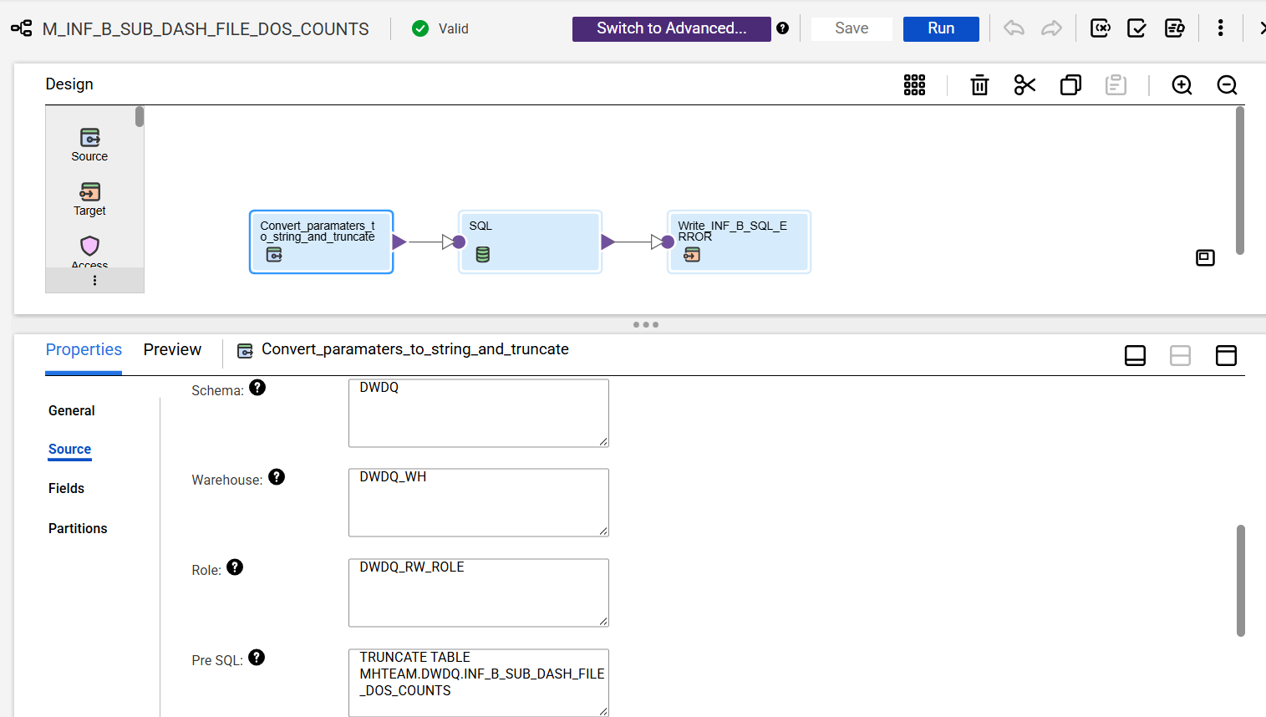

SQL:
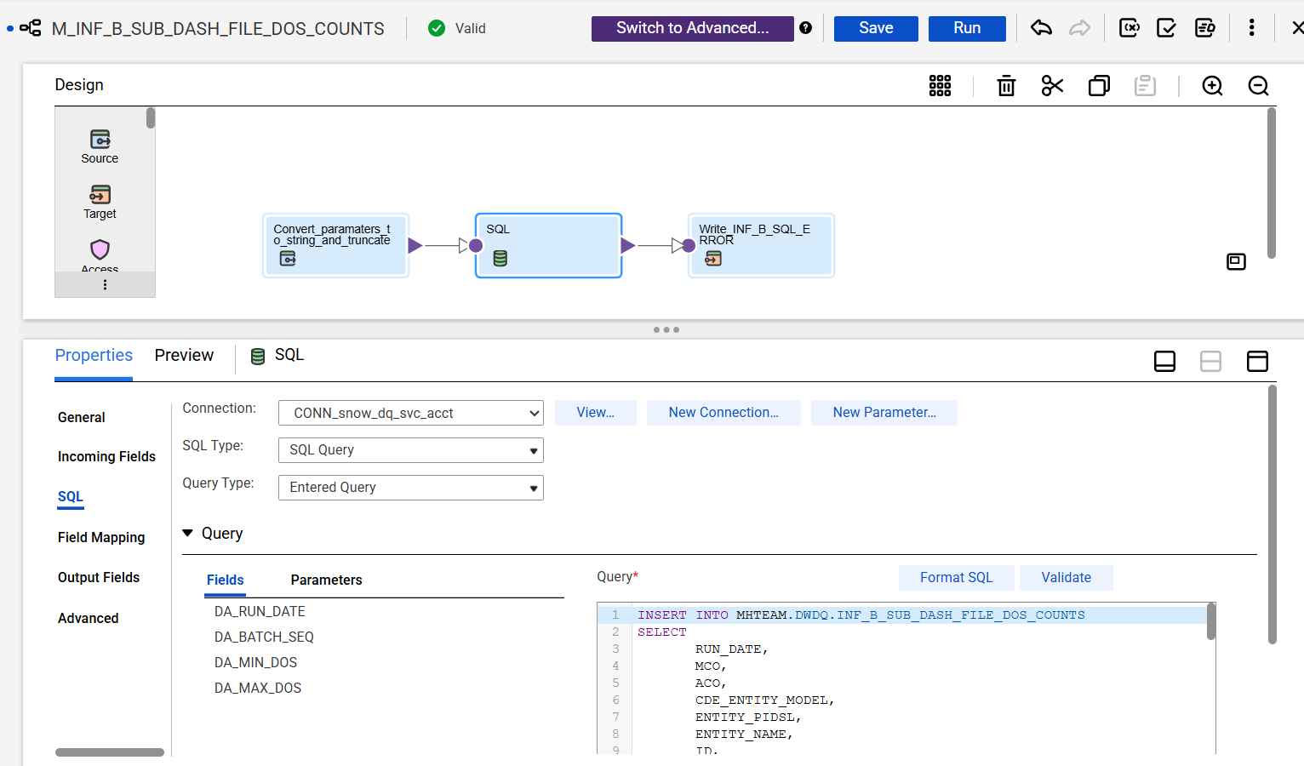

Taskflow:
