**Critical care blood glucose policy**

|  |  |
| --- | --- |
| Lead Author: | Rhodri Harris Consultant in ICM & Anaesthesia |
| Additional author(s) | Jennifer Beynon, Consultant in Diabetes & Endocrinology (MFT)  Emma Boxall, Critical Care Pharmacist. (SRFT)  Tony Thomas, Consultant ICM (SRFT)  Louise Wong, Diabetes Specialist Nurse, (SRFT)  Angela Paisley, Consultant Diabetes & Endocrinology (SRFT) |
| Division/ Department:: | Critical Care |
| Applies to: (Please delete) |  |
| Approving Committee |  |
| Date approved: | 06/11/2018 |
| Expiry date: | 12/12/2022 |

**Contents**

|  |
| --- |
| **Contents** |

|  |  |  |
| --- | --- | --- |
| **Section** | | **Page** |
| Document summary sheet | |  |
| 1 | Overview |  |
| 2 | Scope & Associated Documents |  |
| 3 | Background |  |
| 4 | What is new in this version? |  |
| 5 | Guideline |  |
|  | 5.1 Key Principles |  |
|  | 5.2 Management of increased blood glucose (basic protocol for blood glucose management) |  |
|  | 5.3 Basal and long acting insulins |  |
|  | 5.4 Use of Metformin in critical care |  |
|  | 5.5 Glucose like peptide (GLP) 1 Analogues |  |
|  | 5.6 Dipeptidyl peptidase-4 (DPP-4) inhibitors |  |
|  | 5.7 Sodium-glucose co-transporter 2 (SGLT2) inhibitors |  |
|  | 5.8 Sulphonylureas |  |
|  | 5.9 Meglitinides |  |
|  | 5.10 Thiazolidinediones |  |
|  | 5.11 Alpha glucosidase inhibitors |  |
|  | 5.12 Hypoglycaemia |  |
|  | 5.13 Rationale & Supporting Evidence |  |
| 6 | Roles and responsibilities |  |
| 7 | Monitoring document effectiveness |  |
| 8 | Abbreviations and definitions |  |
| 9 | References |  |
| 10 | Appendices |  |
| 11 | Document Control Information |  |
| 12 | Equality Impact Assessment (EqIA) screening tool |  |
|  |  |  |

|  |  |
| --- | --- |
| **1.** | **Overview (What is this guideline about?)** |

Blood glucose control is an important component of critical care. The evidence about how closely glucose should be controlled has changed over the last few years with a widening of what is considered good glycaemic control and recognition of the importance of swings in blood glucose.

There has also been an increase in the use of different classes of oral hypoglycaemic drugs, some of which should be continued in critical care and some of which should be stopped.

Other changes have included recognising that the quality of glycaemic control before critical care will influence how glucose is managed both during critical illness and then as the patient recovers. For this reason the measurement of HbA1C should be a routine test on admission to critical care.

How patients move from an insulin infusion in critical care to ward based care is also important and requires a period of transition where basal insulin is gradually reintroduced and appropriate oral drugs are started.

All of these components of patient care have changed a lot since the previous blood glucose protocol for critical care was introduced, and this is why we have produced this new protocol. The next challenge is to introduce this new protocol, make sure it is used and audit the quality of glycaemic control following the use of the new protocol.

Associated document

The protocol is used in conjunction with the ‘Hospital Inpatient Management of Diabetes Protocol’ reference TWCG41(12) (Trust protocols via Intranet)

If you have any concerns about the content of this document please contact the author or advise the Document Control Administrator.

|  |  |
| --- | --- |
| **2.** | **Scope (Where will this document be used?)** |

This protocol is only for use in the critical care unit in Salford Royal Hospital (Although similar versions of the protocol are being introduced into all critical care units in Greater Manchester). It does not include details of the management of ketoacidosis or hyperosmolar coma that are dealt with in separate Trust protocols. (‘Hospital Inpatient Management of Diabetes Protocol’ reference TWCG41(12) (Trust protocols via Intranet))

|  |  |
| --- | --- |
| **3.** | **Background (Why is this document important?)** |

Control of blood glucose in critical care is an important determinate of critical care complication free survival.

|  |  |
| --- | --- |
| **4.** | **What is new in this version?** |

The previous version of the ICU blood glucose policy was more than 10 years old. This version is a major update, particularly in the wider range of blood glucose that is now aimed for, the use of HbA1C to define glycaemic control prior to critical care, the use of oral hypoglycaemic drugs and basal insulin prescriptions.

|  |  |
| --- | --- |
| **5.** | **Guideline** |

|  |  |
| --- | --- |
| **5.1** | **Key Principles** |

* Hyperglycaemia in critically ill patients is very common and may be associated with a pre-existing diagnosis of Diabetes Mellitus (Type 1 or 2) or may represent a stress response to critical illness.
* Avoidance of hyperglycaemia is desirable and the treatment threshold above which insulin should be commence is 10mmol/l with a target range of 6.0-10mmol/l. Treatment with exogenous insulin infusions is often required to treat hyperglycaemia. Insulin infusions are associated with hypoglycaemia and are a common cause of reported drug errors.
* The avoidance of hypoglycaemia is of paramount importance as this has been associated with worse outcomes in critically ill patients.
* Minimising glucose variability and increasing time in target range are important secondary targets.
* It is likely that patients should have an individualised glucose target according to their history of diabetes, chronic glucose control and the nature of their presenting critical illness. However, until future randomised controlled trials are available, the best evidence supports using a “conventional” rather than intensive treatment strategy with a focus on avoiding hypoglycaemia and glycaemic variability.
* All patients should have their HBA1c checked on admission to Intensive Care.
* Certain patient groups such as post-organ transplant and Cystic Fibrosis related-diabetes will require specialist input and the Trust Diabetes Team should be involved at the earliest opportunity. The key principles of these guidelines may be used in the early stage of their critical illness but should not replace specialist protocols.
* There is an increasing prevalence of type 2 diabetes in the population and with it recent advances in novel antidiabetic agents that may have specific risks and benefits for the critically ill patient. This document aims to provide guidance on the use of these agents in the critical care unit.
* Critical care patients have unpredictable absorption of subcutaneous insulin and this may pose a risk of both under and overdosing of insulin.

|  |  |
| --- | --- |
| **5.2** | Management of increased blood glucose (basic protocol for blood glucose management) |

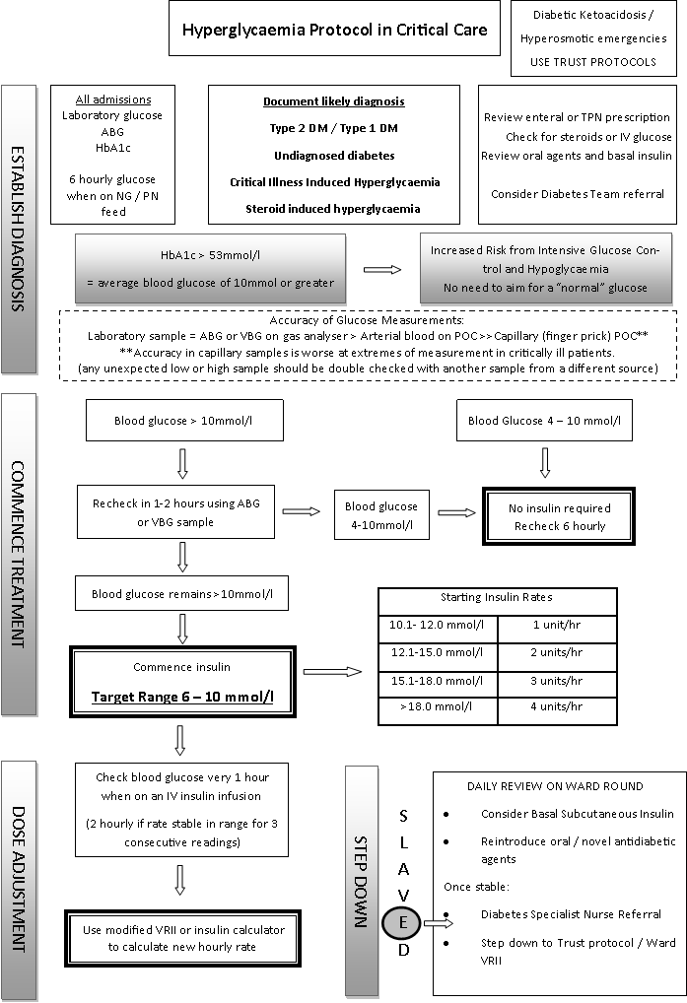

**Hyperglycaemia**

**Monitoring of blood glucose levels**

* All patients will have an admission blood glucose checked either via an ABG / VBG sample or a laboratory glucose (grey top tube)
* Patients commencing enteral or parenteral feed need their BG monitoring every 4-6 hours (see FEED section of Trust Policy).
* A raised blood glucose > 10 mmol/l should be repeated within 2 hours and if persistently elevated the doctor / ACCP covering the unit should be informed.
* An unexpectedly high or low sample taken from an arterial line or central line port may represent dilution from the flush line or contamination with glucose and should be checked with capillary POC sample. The contents of the flush solution must be checked to confirm that it contains no glucose.[1] Similarly, POC capillary glucose is the least accurate method and an unexpectedly abnormal sample should be check against an arterial or venous ABG.
* If Variable Rate Insulin Infusion is commenced, then blood glucose should be checked 1 hourly ideally via ABG / VBG but POC Capillary Sampling is acceptable if patient’s glucose control has been stable to over the preceding 24 hours and no arterial or central line access is available for monitoring. There may be considerable difference between POC analysis and gas analyser results (up to 2mmol/l) so once one method is used it is preferable to continue with this. Unexpected or grossly abnormal results must be checked with another device.
* If a Variable Vate Insulin Infusion is being stopped and is no longer required blood glucose should be monitored hourly for at least 2 hours post stopping, this is particularly relevant when stopping for procedures or scan.

**Admission HBA1c**

* All patients admitted to critical care will have their HbA1c as part of their admission blood test panel.
* The result may be used to inform decisions regarding starting of basal insulin, oral antidiabetic agents and for longterm diabetes management by the Diabetes Team
  + HBA1c > 60 mmol/mmol – refer immediately to Diabetes Specialist Nurse
  + HbA1c 40-60mmol/mmol – Discuss on ward round and consider referral. Discuss if the patient a known diabetic or if they have any other risk factor/triggers as listed below.
  + HbA1c <40mmol/mmol – normal, no need for DSN referral
* Other triggers for immediate referral to Diabetes Specialist Nurse
  + Steroid treatment causing hyperglycaemia – refer when patient expected to be discharged from critical care
  + Insulin rate of 12 units/hr for more than 6 hours

**Target blood glucose range**

* A Variable Rate Insulin Infusion (VRII) should be commenced if a patient’s blood glucose is confirmed to be > 10mmol/l on 2 separate readings taken 1-2 hours apart
* Target range for glucose control is 7.8-10mmol/l
* Pending further evidence to support individualised treatment thresholds and target ranges according to preadmission glycaemic control, all patients will be initiated on the above protocol. Admission diabetic status and HBA1c should be documented to facilitate post management post critical care and to aid decision making in individual cases where large doses of exogenous insulin are required.

**Commencing a Dynamic Variable Rate Insulin Infusion**

* A VRII should be commenced according to the initial glucose reading using the table in the Hyperglycaemia protocol shown in the table above.
* Insulin infusion should be via a Dynamic Sliding Scale using the inuslin calculator via the trust intranet site. If a Dynamic Sliding Scale Calculator is unavailable use a paper based Variable Rate Insulin Infusion modified for use in Critical Care (Stock code G12020606 WZA N462).
* Prefilled Insulin Actrapid 50 units in Sodium Chloride 0.9% 50ml should be used via a dedicated peripheral cannula or central lumen that has been confirmed to be patent and can be easily aspirated and flushed.
* Insulin preparations should be replaced every 24 hours to minimise the loss of potency

|  |  |
| --- | --- |
| **5.3** | Basal and long acting insulins |

* Patients with Type 1 Diabetes should continue their normal basal insulin.
* Patients with an insulin pump should in general have their pump removed on admission and switched to a VRII. The exception to this would be a patient who is able to adequately manage their own insulin pump appropriately. If disconnected a basal insulin will need to be prescribed in its absence, the Diabetes Team should be consulted as soon as possible.
* Patients with Type 2 Diabetes should have their basal insulin prescribed at 50% of their normal dose initially, once they have been established on enteral or TPN feed. If there is any doubt about patient’s normal dose or compliance, then commence Insulatard at 10 units twice daily.
* Non-diabetic patients (or those not previously diagnosed) who have been on a VRII for more than 24 hours and who have been established on enteral or TPN feed can be considered for basal subcutaneous insulin after discussion on the ward round. Dose should be 80% of their total intravenous requirements split in 2 doses of Insulatard or Humilin I up to a **maximum** of 40 units daily (if requirements exceed this seek Diabetes Specialist Nurse input).
* Increases of basal insulin doses should be gradual (ideally every 48-72 hours) and not by more than 50% of the current dose. This may be modified after review by the Diabetes Specialist Nurse.
* Basal insulins should be administered to the abdomen, legs, buttocks or upper arms away from sites of scarring, lipohypertrophy (hard lumps) and sites of infection. If there is widespread oedema the injection should be to the upper arms.
* Basal insulin should not be started for patients in critical care who are felt to have hyperglycaemia secondary to critical illness, in whom HBA1c < 53mmol/l and are non-diabetic. Hyperglycaemia is likely to be transient and resolve when critical illness resolves. In steroid induced hyperglycaemia basal insulins should be considered with caution as hyperglycaemia may resolve after stopping therapy. Basal insulin may be commenced after consultation with the Diabetes team and consideration of the likelihood for need for medium to long-term treatment.
* Insulin requirements may fall rapidly on resolution of critical illness and should prompt review of basal insulin dose if blood glucose is persistently below the target range (7.8-10.0mmol/l)

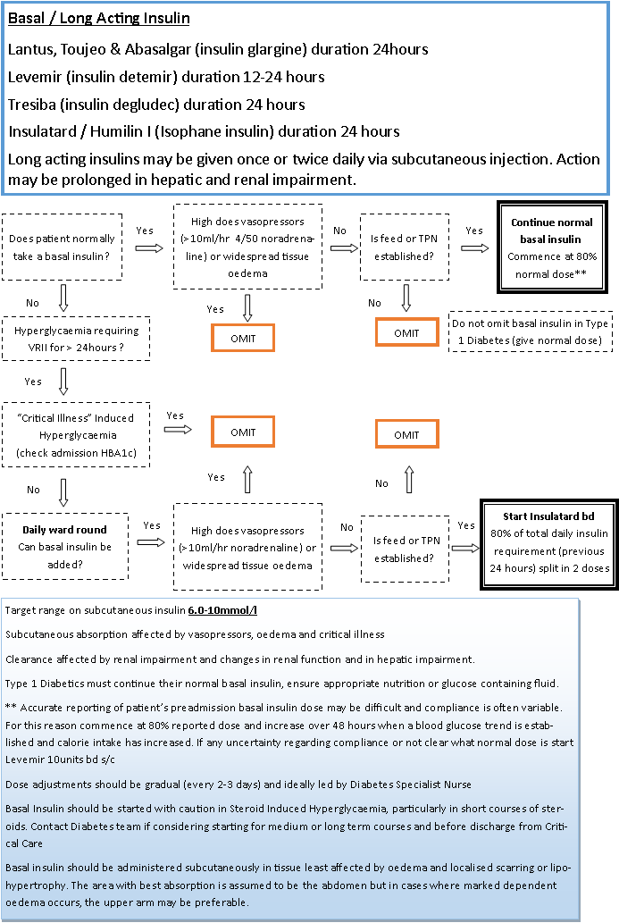

|  |  |
| --- | --- |
| **5.4** | **Use of Metformin in critical care** |

***Metformin***

* Metformin may be associated with lactic acidosis in critically ill patients with shock, hepatic impairment or acute and chronic renal failure.
* Metformin should be suspended in patients with:
  + - No enteral route / surgical contraindication
    - Shock requiring > 10ml/hr of 4mg/50ml noradrenaline or equivalent
    - Acute or chronic liver failure
    - Acute kidney injury (AKI) Stage 2 or 3 (increase serum creatinine >200%, urine output < 0.5ml/kg/hr for >12hrs or on renal replacement therapy).
* Metformin may be associated with improved survival in patients presenting to critical care who have Type 2 diabetes and are already taking metformin or have sepsis. It may reduce the need for intravenous insulin and therefore minimise glycaemic variability, so continuation is to be considered in the absence of risk factors above.
* Metformin dose adjusted according to EGFR in chronic renal failure or stable AKI / on CVVHF
* In patients admitted with a high HbA1c (>48mmol/l) who are requiring high doses of intravenous insulin (6ml/hr) to control hyperglycaemia, consider starting metformin once full feed is established if none of the above contraindications exist.

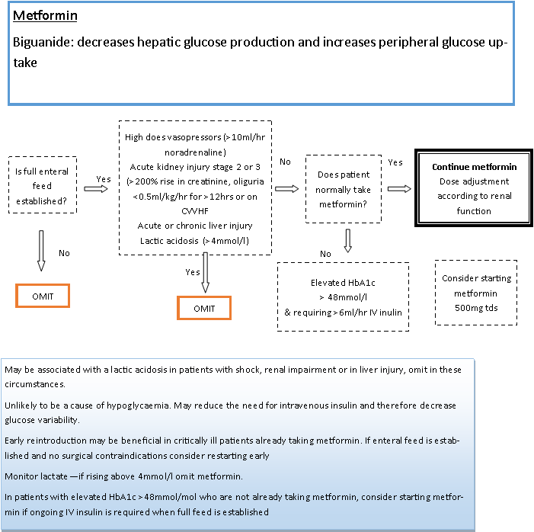

|  |  |
| --- | --- |
| **5.5** | **Glucose like peptide (GLP) 1 Analogues** |

* Exenatide and liraglutide are subcutaneously administered medications and absorption may be unpredictable in critically ill patients. They should be discontinued in patients admitted to critical care with evidence of shock requiring vasopressors (greater than 10ml/hr 4mg/50ml noradrenaline)
* The GLP1 Analogues (exenatide and liraglutide) act by increasing incretin levels which reduce gastric emptying. A common side effect is nausea and vomiting. If there are concerns regarding high gastric aspirates, paralytic ileus or vomiting then these agents should be suspended.
* Exenatide has been demonstrated to be an effective agent in controlling blood glucose in critically ill patients but it’s use at high doses was limited by gastrointestinal side effects. In the absence of high gastric aspirates or nausea these agents can be safely continued in patients who are already using them.

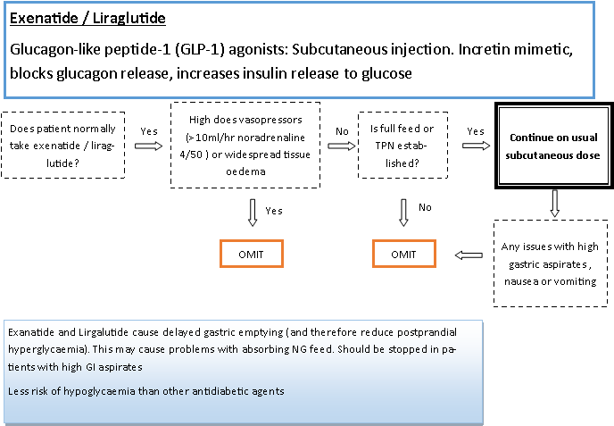

|  |  |
| --- | --- |
| **5.6** | Dipeptidyl peptidase-4 (DPP-4) inhibitors |

* Sitagliptin and Linagliptin are oral agents that stimulate incretin release and supress glucagon. They have a similar mechanism of action to the GLP-1 analogues and could therefore be reintroduced to patients who already prescribed these medications once the enteral route has been established. They should be discontinued in high gastric aspirates, nausea or vomiting.

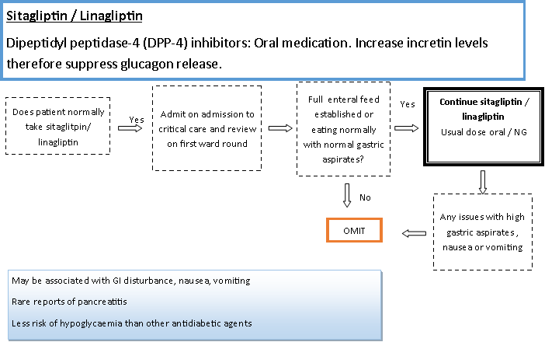

|  |  |
| --- | --- |
| **5.7** | Sodium-glucose co-transporter 2 (SGLT2) inhibitors |

* SGLT-2 inhibitors reduce the renal reabsorption of glucose and are associated with an osmotic diuresis which may cause profound hypovolaemia.
* They are associated with a euglycaemic ketoacidosis that may exist for several days after discontinuation of treatment. This a particular risk to critically ill patients. Unexplained acidosis in a patient admitted who has been taking a SGLT-2 inhibitor should prompt investigation for ketoacidosis even in the context of normal glucose levels. Treatment of this condition is supportive with fluid resuscitation and continuation of an insulin and glucose infusion, ketones should be monitored for 48-72 hours after treatment has been suspended.
* **Canagliflozin, Dapagliflozin or Empagliflozin should be held on admission to and not restarted until discharge from critical care. They should be omitted for 72 hours in patients undergoing elective surgery.**

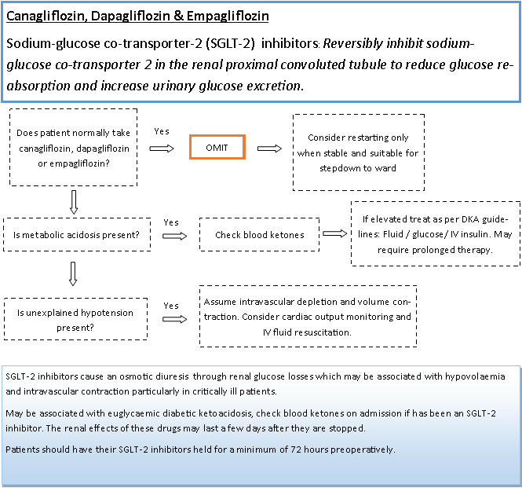

|  |  |
| --- | --- |
| **5.8** | Sulphonylureas |

* The sulphonylureas (gliclazide and glimepiride) cause insulin release by direct binding to receptors on beta cells. They are associated with hypoglycaemia. Critically ill patients with unpredictable absorption and renal clearance may be at higher risk.
* **Gliclazide and glimepiride should be suspended on admission to critical care and blood glucose should be monitored closely (every 4-6 hours) for up to 48 hours if the patient has any evidence of renal impairment**.
* If blood glucose is found to be below 6 mmol/l in a patient who has been taking sulphonylureas prior to admission to critical care, consider starting a background glucose infusion until full feed is established to minimise the risk of a hypoglycaemia.
* Sulphonylureas should not be restarted until the patient is well enough to discharge to ward level care, is eating or has enteral route established and has been reviewed by the Diabetes Specialist nurse. They may be considered in certain patients with Type 2 Diabetes e.g. prolonged ventilatory wean with single organ support.

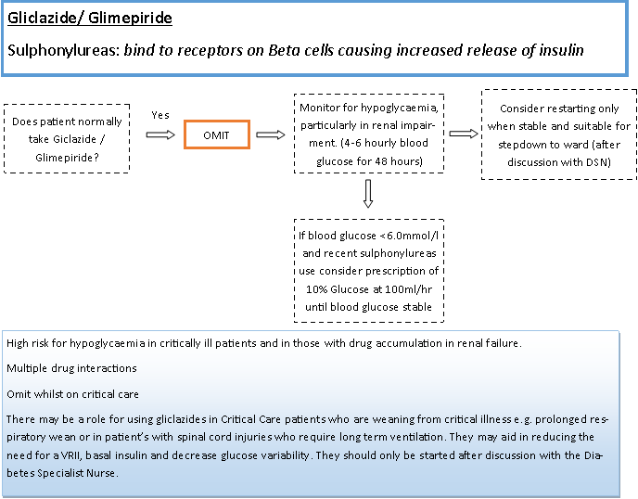

|  |  |
| --- | --- |
| **5.9** | Meglitinides |

* Repaglinide, Nateglinide and Metiglinide act in a similar manner to the sulphonylureas (bind to beta cells causing insulin release). They are less potent and have a shorter duration of action than sulphonylureas but still may pose a risk of hypoglycaemia.
* Repaglinide, Nateglinide and Metiglinide should be suspended on admission to critical care and blood glucose should be monitored closely (every 4-6 hours) for up to 48 hours if the patient has any evidence of renal impairment.
* **Meglitinides should not be restarted until the patient is well enough to discharge to ward level care, is eating or has enteral route established and has been reviewed by the Diabetes Specialist nurse. They may be considered in certain patients with Type 2 Diabetes e.g. prolonged ventilatory wean with single organ support.**

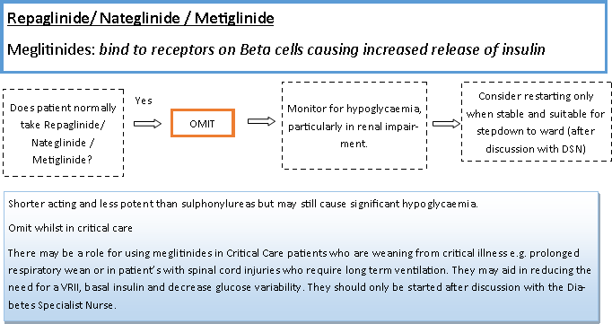

|  |  |
| --- | --- |
| **5.10** | Thiazolidinediones |

* Pioglitazone and rosiglitazone act via nuclear receptors to increase free fatty acid uptake into adipocytes which results in an increase in glucose metabolism.
* Their action at nuclear receptors results in a markedly prolonged duration of action even after the drug is discontinued.
* They are associated with an increased risk of hypoglycaemia and in chronic use associated with peripheral oedema, fluid retention and exacerbation of congestive cardiac failure.

* Pioglitazone and rosiglitazone should be suspended on admission to critical care and blood glucose should be monitored closely (every 4-6 hours) for up to 48 hours if the patient has any evidence of renal impairment.
* **Thiazolidinediones should not be restarted until the patient is well enough to discharge to ward level care, is eating or has enteral route established and has been reviewed by the Diabetes Specialist nurse.**

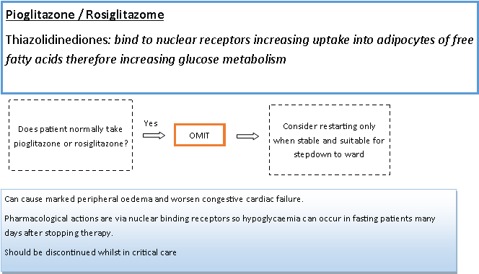

|  |  |
| --- | --- |
| **5.11** | Alpha glucosidase inhibitors |

* Acarbose inhibits the intestinal brush border enzymes and reduces glucose absorption. They are associated with gastrointestinal upset and should not be used in patients in critical care.

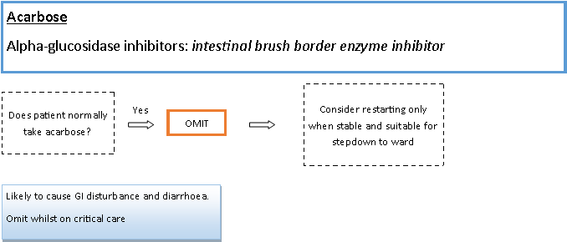

|  |  |
| --- | --- |
| **5.12** | Hypoglycaemia |

* Avoidance of hypoglycaemia is a key priority in patients being treated for hyperglycaemia on critical care. Hypoglycaemia is associated with a significantly elevated risk of mortality in critically ill patients and the effect may be related to the severity of the hypoglycaemia.
* Hypoglycaemia may be absolute or relative. Patients with pre-existing diabetes with poor control may exhibit cardiovascular, hormonal and neurological changes at low-normal levels. Aggressively targeting a blood glucose in the “normal” range may be harmful in these patients.
* Minimising hypoglycaemia in critical care will consist of three aims: Avoidance, Treatment & Learning from Hypoglycaemia.

**Avoidance of Hypoglycaemia**

* Monitoring of blood glucose should be 1 hour when on an insulin infusion. If blood glucose has been stable and between 6 – 12 mmol/l for the last 3 hours, then extend to 2 hourly checks.
* Monitoring frequency should increase to every 30 minutes if blood glucose has dropped below 6.0mmol/l and on an insulin infusion until glucose has been demonstrably stable above 4.0 mmol/l for 2 hours (insulin infusion will have been discontinued according to protocol at this stage).
* Blood glucose should be monitored every 4 hours when on a long acting subcutaneous insulin regardless of mode of nutrition
* Minimising interruptions to glucose supply. Any patient receiving enteral feed which is interrupted either deliberately (e.g. for procedures) or unintentionally due to tube displacement should be managed according to the following protocol:
  + Anticipated stop for transfer or procedure: stop insulin 1 hour before and monitor blood glucose every hour as per protocol
  + Unanticipated stop (e.g. NG tube displacement or urgent scan): stop Variable Rate Insulin Infusion immediately, increase frequency of monitoring to every 30 minutes for 2 hours.
  + Feed stopped for > 2hours: stop Variable Rate Insulin Infusion and consider prescription of 10% glucose infusion at 100mls/hr

**Treatment of Hypoglycaemia**

* Management of an episode of hypoglycaemia in the critical care should be according to a treatment protocol that is weighted differently to ward areas. This reflects the patient population being less likely to be conscious and able to report hypoglycaemia symptoms and the likelihood of central venous access making the use of 50% glucose safe and more practical. Management should consist of a step wise protocol (see algorithm).
  + Treatment should be initiated if blood glucose < 4.0mmol/l – Four is the Floor
  + Central line access: give 50ml 50% glucose immediately
  + No central line but peripheral access: give 250ml 10% glucose immediately
  + No central or peripheral access: give either

1.Crush & dissolve 5 dextrose tablets with 20mls sterile water, syringe through the feed tube and flush again with sterile water

2. give 2 tubes of GlucoGel administered via the gums

* To ensure immediate access to these treatments any patient starting on an insulin infusion in critical care shall have the 3 glucose preparations prescribed on the PRN side of the chart. On EPR this will be included in the Insulin infusion Order Set.

**Learning from Hypoglycaemia**

* It should be recognised that hypoglycaemia is a common and sometimes unavoidable side effect of glucose management in the Critical Care Unit. The causes of hypoglycaemia are multifactorial. Steps should be taken to minimise further episodes where possible.
* Any episode of hypoglycaemia in critical care (<4.0mmol/l) should be reported via the Hospital Reporting System.
* Blood glucose values recorded in the ABG analysers and POC machines can be accessed and used to review the management of both hyperglycaemia and hypoglycaemia. A structured review of hypoglycaemia episodes should be undertaken every 3 months and report issued to aid education and aid with protocol redevelopment.

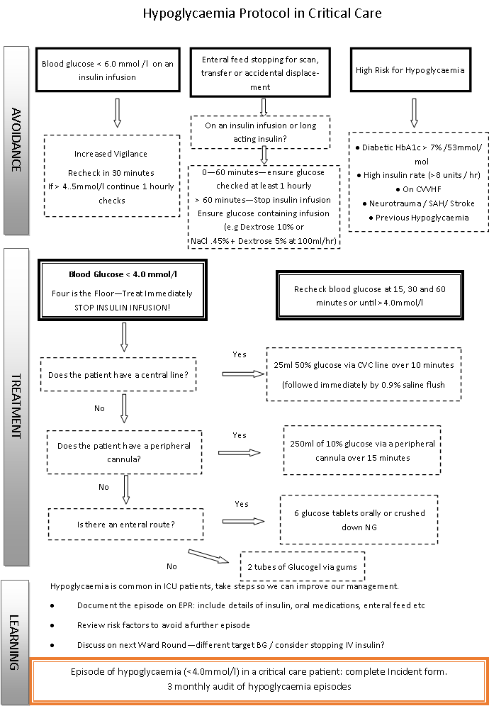

|  |  |
| --- | --- |
| **5.13** | **Rationale & Supporting Evidence** |

**Monitoring of blood glucose levels**

Monitoring of blood glucose in ICU can be done via several available devices. Sample time must be minimised with readily available results, particularly during close monitoring when the patient is on an insulin infusion. Laboratory blood glucose remains the reference standard but has the disadvantages of requiring a relatively large volume of sampled blood and incorporates unacceptable delays in obtaining results for use in calculating insulin infusion dosage changes. Arterial blood analysers are of an acceptable equivalent accuracy to the laboratory standard. Point of Care (POC) analysers have an acceptable level of accuracy in the stable patient but their accuracy is diminished in critically ill patients and at the extremes of measurement. [2] There have been reports of inadvertent insulin administration resulting from sampling from flush lines contaminated with glucose containing fluids in critical care units. [3] Recent consensus guidelines recommend the use of arterial blood gas analysers as reliable but potentially costly method of intermittent glucose monitoring.[4]

**Target blood glucose range**

There have been a number of studies and consensus guidelines with various target ranges for glucose control in Critical Care. Following the Leuwen studies in the early 2000’s our unit has utilised a tight glycaemic control policy (4.0 – 6.7 mmol/l) with the use of a computer algorithm. The publication of the NICE-SUGAR trial in 2009 and subsequent other studies have shown either no benefit or harm associated with from tight glucose control. Concensus guidelines[5] from the Critical Care Society in 2012 advocate commencing treatment for hyperglycaemia above 8.3mmol/l but absolutely above 10.0mmol/l. The “Conventional” arm of the NICE-SUGAR trial utilised a treatment threshold above 10.0mmol/l with a target range of 7.8-10mmol/l. This is line with UK NHS Perioperative Guidelines[6] (specify 4-10mmol/l but state 6-10mmol/l also acceptable) and the Joint British Societies Guideliens for Inpatient Diabetes Care, 2014[7] (6-10mmol/l).

*Individualised Target Ranges*

Whilst it is not clear what the ideal target range for glucose is in criticaly ill patients it is apparent that an individualised strategy may be beneficial. An international cohort study by Krinsley et al[8] demonstated that the presence of diabetes modified the normal risks associated with hyperglycaemia, hypoglycaemia and glucose variability and suggested that a higher target range for glucose may be beneficial in those with diabetes. [9] A higher treatment threshold (>14mmol/l) and target range (10-14mmol/l) in those with preexisting diabetes has been shown to be safe in an exploratory analysis and cohort study, may reduce glucose variability, hypoglycaemia and insulin requirments. The LUCID Trial, currently recruiting in Australasia will provide further evidence on this question. Pending the results of this study our guidelines will recommend targetting a range reflecting the Conventional Arm of the NICE-SUGAR trial.

*Neurological Injury*

There remains conflicting evidence regarding ideal target strategy in patients with neurological injury. Hyperglycaemia is associated with a worse prognosis in a variety of patients with neurological injury. Treatment with intensive insulin therapy is however associated with an increased risk of hypoglycaemia.[10] Microdialysis catheter placement in areas of injured brain in traumatic brain injury has demonstrated low levels of diasylate glucose suggesting energy crisis in patients treated with insulin to control hyperglycaemia.[11] Hyperglycaemia as a stress response may be particularly important in brain injured patients as brain metabolism is glucose dependent. The optimal glucose target is yet to be defined but the avoidance of hypoglycaemia is of paramount importance.

**Insulin infusion – variable rate versus dynamic sliding scale via computer algorithm**

Current trust protocol for inpatient insulin infusion is via Variable Rate Insulin Infusion (VRII). This has the disadvantage of having a self defined target blood glucose range of 4.0-7.0mmol/l, a level lower than desired. VRII’s do not take into account the trend in glucose over time and are therefore at more riskof rapid changes and increasd glucose variability. A Dynamic Sliding Scale reduces this potential hazard and although this is a more intensive in terms of nursing workload our unit has an established practice and safety record in using such an algorithm. The algorithm used in the control arm of the NICE- SUGAR trial ich targets the desired range of 7.8-10.0mmol/l is readily available online and can be converted into an simple to use tool via an Excel workbook or online tool.

**Basal Insulin, Oral and Novel Antidiabetic Agents**

The increasing prevalence of Type 2 Diabetes and the explosion of medications licenced to treat this condition mean that an increasing number of our critically ill patients will present whilst taking these medications. Intravenous insulin infusions have an inherent risk of hypoglycaemia which may be mitigated by the continuation or addition of alternative antidiabetic agents. These agents may have specific risks and benefits in the critically ill patient.

Basal / Long acting Insulin

Continuation or addition of a long acting insulin may reduce intravenous requirements and glucose variability on a variable rate infusion. There are few studies examining subcutaneous insulin absorption in critically ill patients. Insulin has been shown to have poor absorption in non-critically ill patients with tissue oedema. Absorption of subcutaneous low molecular weight heparin is impaired in patients on vasopressors, suggesting a risk of similar problems with insulin.[12] Injection site may affect absorption with injection into areas of lipohypertrophy, oedema and inflammation likely to affect absorption. Where oedema is widespread and dependent the upper arm may be preferable to the abdomen.

*Metformin*

Metformin is contraindicated in patients with severe hepatic, renal and cardiovascular failure. This is due to the perceived risk of lactic acidosis associated with biguanide medications. A Cochrane review of the incidence of lactic acidosis in 2009 however found no evidence of metformin induced lactic acidosis and found the incidence of lactic acidosis to be lower in the Type 2 diabetic population taking metformin than in those not taking metformin.[13] Recent cohort studies have found that metformin use at admission to critical care was associated with an improved 30-day mortality, particularly seen in those patients that continued metformin in the early phase of their admission[14] and in the second study[15] was found to be associated with a lower mortality in sepsis patients, with no evidence of harm overall.

Given the low-quality evidence and until high quality studies on the subject are available it would be sensible to advise that metformin is suspended on admission to ICU if any of the above contraindications are present. Given the potential benefits of increased insulin sensitivity, decreased glucose variability associated with higher insulin infusion rates and the perceived benefits of immunomodulation and cardiac protective effects it would be reasonable to restart or even start this in those patients who are on established enteral feed and in whom renal failure has been excluded.

*Glucose-like-peptide (GLP) 1 Analogues*

A few small, low grade quality trials have demonstrated use of the incretin mimetics liraglutide[16] and exenatide[17] in critically ill patients with hyperglycaemia to be effective and with a lower rate of hypoglycaemia than insulin infusions. The main side effects of these therapies were noted to be nausea and vomiting. An intrinsic effect of these agents is to delay gastric emptying which may exacerbate poor gastric absorption in the critically ill. As administration is via the sub -cutaneous route, absorption is likely to be affected in patients on high dose vasopressors and with widespread oedema. Whilst there is growing evidence that these agents may be safe and effective in reducing critical illness induced hyperglycaemia whilst reducing hypoglycaemia and glucose variability, there is a lack of high-quality studies to support routine use in the critically ill patient.[18] However, it is reasonable to continue administration in those without clear contraindications.

*Dipeptidyl peptidase-4 (DPP-4) inhibitors.*

Sitagliptin and Linagliptin are oral agents that stimulate incretin release and supress glucagon. They have a similar mechanism of action to the GLP-1 analogues and could therefore be reintroduced to patients who already prescribed these medications once the enteral route has been established. They should be discontinued in high gastric aspirates, nausea or vomiting.

*Sodium-glucose co-transporter 2 (SGLT2) inhibitors*

SGLT-2 inhibitors reduce the renal reabsorption of glucose and may be associated with reduced cardiovascular complications in patients with Type 2 diabetes[19] and improved HBA1c in patients with Type 1 diabetes[20]. They are likely to become more common in patients presenting to critical care. Due to their class mechanism of action they may exacerbate hypovolaemia in the acutely unwell patient due to an osmotic diuretic effect and have been associated with severe hypovolaemia. A report by the European Medicines Agency concluded that SGLT-2 inhibitors caused an increased risk of potentially fatal euglycaemic ketoacidosis. SGLT-2 inhibitors should therefore be withheld in[21] patients undergoing major surgery or in those with acute illness. They should not be restarted in critical care but may be considered when a patient is stable, on full enteral feed and considered well enough to step down to ward care.

**Hypoglycaemia**

Hypoglycaemia is a common side effect of insulin therapy in the ICU. Various studies have demonstrated an association between episodes of hypoglycaemia and worse outcomes in critically ill patients, a post -hoc analysis of the NICE- SUGAR trial demonstrated a doubling of the risk of mortality in patients with one episode of severe hypoglycaemia (<2.3mmol/l) with an apparent dose-response relationship in harm.[22] Risk factors for hypoglycaemia in the ICU include Intensive insulin therapy (versus liberal), history of diabetes, mechanical ventilation, continuous veno-venous haemofiltration and ICU length of stay.[23]

|  |  |
| --- | --- |
| **6.** | **Roles & responsibilities** |

Where teams, groups or individuals have specific roles and/ or responsibilities specifically relating to this guideline, they should be listed in this section. There is no need to list the generic responsibilities of executives and senior clinical managers.

**6.1 Role 1**

Critical Care Governance Committee to monitor and manage the introduction of the protocol for the Critical Care Management committee

**6.2 Role 2**

POC monitoring staff in biochemistry to extract information about blood glucose measures in critical care

**6.3 Role 3** Critical care practice educator team to teach medical and nursing staff about use of the protocol

|  |  |
| --- | --- |
| **7.** | **Monitoring document effectiveness** |

Guidelines support staff in their work. Typically they summarise best practice. Evidence of compliance with a guideline is not always required, particularly if the practice is embedded in usual care. Some guidelines do need monitoring – such as the introduction of new systems, a change the way something is done or where achievement of a standard is required.

If your guideline will be monitored please use this section to describe how this will be done. You may wish to use the layout below or adapt it to your own requirements.

**Key standards:** The control of blood glucose between 6 and 10 mmol/l in critical care. The routine measurement of HbA1c, the identification and review of episodes of hypoglycaemia in critical care, the rational use of other antidiabetic drugs in critical care

**Methods:** The routine review of blood gas estimates in critical care obtained from the bedside glucometers and arterial blood gas machines, the records of HbA1C measurement and the formal review or reported episodes of hypoglycaemia

**Team responsible for monitoring:** Biochemistry and critical care staff

**Frequency of monitoring:** Monthly until the protocol is established

**Process for reviewing results and ensuring improvements in performance:** The results will be reviewed at the 6 weekly critical care clinical governance meeting

|  |  |
| --- | --- |
| **8.** | **Abbreviations and definitions** |

**List all abbreviations or acronyms**

ABG/VBG- arterial blood gas/Venous blood gas

AKI- Acute Kidney Injury

DDP-4 Dipeptidyl peptidase-4

GLP-Glucose like peptide

HbA1C: Glycosylated haemoglobin .

POC: Point of care

SGLT2:Sodium-glucose co-transporter 2

VRII: Variable Rate Insulin Infusion

|  |  |
| --- | --- |
| **9.** | **References** |

Gupta, K. J. and T. M. Cook "Accidental hypoglycaemia caused by an arterial flush drug error: a case report and contributory causes analysis." Anaesthesia **68**(11): 1179-1187.

Inoue, Shigeaki, Moritoki Egi, Joji Kotani, and Kiyoshi Morita. “Accuracy of Blood-Glucose Measurements Using Glucose Meters and Arterial Blood Gas Analyzers in Critically Ill Adult Patients: Systematic Review.” *Critical Care* 17, no. 2 (2013): R48. <https://doi.org/10.1186/cc12567>.

“Fatal Neuroglycopaenia after Accidental Use of a Glucose 5% Solution in a Peripheral Arterial Cannula Flush System - Sinha - 2007 - Anaesthesia - Wiley Online Library.” Accessed October 3, 2018. <https://onlinelibrary.wiley.com/doi/full/10.1111/j.1365-2044.2007.04989.x>.

Finfer, Simon, Jan Wernerman, Jean-Charles Preiser, Tony Cass, Thomas Desaive, Roman Hovorka, Jeffrey I Joseph, et al. “Clinical Review: Consensus Recommendations on Measurement of Blood Glucose and Reporting Glycemic Control in Critically Ill Adults.” *Critical Care* 17, no. 3 (2013): 229. <https://doi.org/10.1186/cc12537>.

Jacobi, Judith, Nicholas Bircher, James Krinsley, Michael Agus, Susan S. Braithwaite, Clifford Deutschman, Amado X. Freire, et al. “Guidelines for the Use of an Insulin Infusion for the Management of Hyperglycemia in Critically Ill Patients:” *Critical Care Medicine* 40, no. 12 (December 2012): 3251–76. <https://doi.org/10.1097/CCM.0b013e3182653269>.

Dhatariya, K., N. Levy, A. Kilvert, B. Watson, D. Cousins, D. Flanagan, L. Hilton, et al. “NHS Diabetes Guideline for the Perioperative Management of the Adult Patient with Diabetes*.” *Diabetic Medicine* 29, no. 4 (April 1, 2012): 420–33. <https://doi.org/10.1111/j.1464-5491.2012.03582.x>.

“Use of Variable Rate Intravenous Insulin Infusion in Medical Inpatients_0.Pdf.” Accessed August 22, 2018. <https://www.diabetes.org.uk/resources-s3/2017-09/Use%20of%20variable%20rate%20intravenous%20insulin%20infusion%20in%20medical%20inpatients_0.pdf>.

Krinsley, James S., Moritoki Egi, Alex Kiss, Amin N. Devendra, Philipp Schuetz, Paula M. Maurer, Marcus J. Schultz, et al. “Diabetic Status and the Relation of the Three Domains of Glycemic Control Tomortality in Critically Ill Patients: An International Multicenter Cohort Study.” *Critical Care* 17, no. 2 (March 1, 2013): R37. <https://doi.org/10.1186/cc12547>.

Krinsley, James S., Moritoki Egi, Alex Kiss, Amin N. Devendra, Philipp Schuetz, Paula M. Maurer, Marcus J. Schultz, et al. “Diabetic Status and the Relation of the Three Domains of Glycemic Control Tomortality in Critically Ill Patients: An International Multicenter Cohort Study.” *Critical Care* 17, no. 2 (March 1, 2013): R37. <https://doi.org/10.1186/cc12547>.

Rostami, Elham. “Glucose and the Injured Brain-Monitored in the Neurointensive Care Unit.” *Frontiers in Neurology* 5 (June 6, 2014). <https://doi.org/10.3389/fneur.2014.00091>.

Vespa, Paul, Robert Boonyaputthikul, David L. McArthur, Chad Miller, Maria Etchepare, Marvin Bergsneider, Thomas Glenn, Neil Martin, and David Hovda. “Intensive Insulin Therapy Reduces Microdialysis Glucose Values without Altering Glucose Utilization or Improving the Lactate/Pyruvate Ratio after Traumatic Brain Injury*:” *Critical Care Medicine* 34, no. 3 (March 2006): 850–56. <https://doi.org/10.1097/01.CCM.0000201875.12245.6F>.

Rommers, Mirjam K., Netty Van Der Lely, Toine CG Egberts, and Patricia MLA van den Bemt. “Anti-Xa Activity after Subcutaneous Administration of Dalteparin in ICU Patients with and without Subcutaneous Oedema: A Pilot Study.” *Critical Care* 10, no. 3 (June 21, 2006): R93. <https://doi.org/10.1186/cc4952>.

Salpeter, Shelley R., Elizabeth Greyber, Gary A. Pasternak, and Edwin E. Salpeter (posthumous). “Risk of Fatal and Nonfatal Lactic Acidosis with Metformin Use in Type 2 Diabetes Mellitus.” *Cochrane Database of Systematic Reviews*, no. 1 (2010). <https://doi.org/10.1002/14651858.CD002967.pub3>.

Christiansen, Christian Fynbo, Martin Berg Johansen, Steffen Christensen, James M. O’Brien, Else Tønnesen, and Henrik Toft Sørensen. “Preadmission Metformin Use and Mortality among Intensive Care Patients with Diabetes: A Cohort Study.” *Critical Care* 17, no. 5 (September 9, 2013): R192. <https://doi.org/10.1186/cc12886>.

Jochmans, Sebastien, Jean-Emmanuel Alphonsine, Jonathan Chelly, Ly Van Phach Vong, Oumar Sy, Nathalie Rolin, Olivier Ellrodt, Mehran Monchi, and Christophe Vinsonneau. “Does Metformin Exposure before ICU Stay Have Any Impact on Patients’ Outcome? A Retrospective Cohort Study of Diabetic Patients.” *Annals of Intensive Care* 7 (December 2, 2017). <https://doi.org/10.1186/s13613-017-0336-8>.

Verma, Vishesh, Narendra Kotwal, Vimal Upreti, Monish Nakra, Yashpal Singh, K. Anand Shankar, Amit Nachankar, and K.V.S. Hari Kumar. “Liraglutide as an Alternative to Insulin for Glycemic Control in Intensive Care Unit: A Randomized, Open-Label, Clinical Study.” *Indian Journal of Critical Care Medicine : Peer-Reviewed, Official Publication of Indian Society of Critical Care Medicine* 21, no. 9 (September 2017): 568–72. <https://doi.org/10.4103/ijccm.IJCCM_105_17>.

Abuannadi, Mohammad, Mikhail Kosiborod, Lisa Riggs, John A. House, Mitchell S. Hamburg, Kevin F. Kennedy, and Steven P. Marso. “Management of Hyperglycemia with the Administration of Intravenous Exenatide to Patients in the Cardiac Intensive Care Unit.” *Endocrine Practice: Official Journal of the American College of Endocrinology and the American Association of Clinical Endocrinologists* 19, no. 1 (February 2013): 81–90. <https://doi.org/10.4158/EP12196.OR>.

Plummer, Mark P, Marianne J Chapman, Michael Horowitz, and Adam M Deane. “Incretins and the Intensivist: What Are They and What Does an Intensivist Need to Know about Them?” *Critical Care* 18, no. 1 (2014). <https://doi.org/10.1186/cc13737>.

Zinman, Bernard, Christoph Wanner, John M. Lachin, David Fitchett, Erich Bluhmki, Stefan Hantel, Michaela Mattheus, et al. “Empagliflozin, Cardiovascular Outcomes, and Mortality in Type 2 Diabetes.” *New England Journal of Medicine* 373, no. 22 (November 26, 2015): 2117–28. <https://doi.org/10.1056/NEJMoa1504720>.

Garg, Satish K., Robert R. Henry, Phillip Banks, John B. Buse, Melanie J. Davies, Gregory R. Fulcher, Paolo Pozzilli, et al. “Effects of Sotagliflozin Added to Insulin in Patients with Type 1 Diabetes.” *New England Journal of Medicine* 377, no. 24 (December 14, 2017): 2337–48. <https://doi.org/10.1056/NEJMoa1708337>.

Excellence, NICE-The National Institute for Health and Care. “BNF: British National Formulary - NICE.” CorporatePage. Accessed September 17, 2018. <https://bnf.nice.org.uk/drug/canagliflozin.html>.

“Hypoglycemia and Risk of Death in Critically Ill Patients | NEJM.” Accessed August 15, 2018. <https://www.nejm.org/doi/full/10.1056/NEJMoa1204942>.

Arabi, Yaseen M., Hani M. Tamim, and Asgar H. Rishu. “Hypoglycemia with Intensive Insulin Therapy in Critically Ill Patients: Predisposing Factors and Association with Mortality*:” *Critical Care Medicine* 37, no. 9 (September 2009): 2536–44. <https://doi.org/10.1097/CCM.0b013e3181a381ad>.

|  |  |
| --- | --- |
| **10.** | **Rationale & Supporting Evidence** |

The rational and supporting evidence for this protocol are covered in section 5.13 of the protocol.ll

|  |  |
| --- | --- |
| **11.** | **Document Control Information** |

**All sections must be completed by the author prior to submission for approval**

|  |  |  |  |
| --- | --- | --- | --- |
| **Lead Author:** | A.N. Thomas Consultant in critical care | | |
| **Lead author contact details:** | Contact telephone number and email address  Dr A.N. Thomas 2064718, tony.thomas@srft.nhs.uk | | |
| **Consultation**  List the persons or groups who have contributed to this guideline. (please state which Care Organisation) | **Name of person or group** | **Role / Department / Committee (Care Org)** | **Date** |
| Rhodri Harris | Contributed 90% +- only not lead author as does not currently work in the Trust | 10/12/2018 |
| Emma Boxall | Critical Care Pharmacist SRFT | 10/12/2018 |
|  |  |  |
|  |  |  |
|  |  |  |
|  |  |  |
| **Endorsement**  List the persons or groups who have seen given their support to this guideline. (please state which Care Organisation) | **Name of person or group** | **Role / Department / Committee (Care Org)** | **Date** |
| Critical Care Management committee | Critical care management | 10/12/2018 |
|  |  |  |
|  |  |  |
|  |  |  |
|  |  |  |
|  |  |  |
| **Keywords / phrases:** | Glucose control, Insulin, Critical Care, Hypoglycaemic Drugs, Intensive Care, Diabetic Management, Hyperglycaemia, Hypoglycaemia | | |
| **Communication**  **plan:** | .  There are multiple components to this plan that are too complex to add to this protocol | | |
| **Document review arrangements:** | This document will be reviewed by the author, or a nominated person, at least once every three years or earlier should a change in legislation, best practice or other change in circumstance dictate. | | |

**This section will be completed following committee approval**

|  |  |  |
| --- | --- | --- |
| **Guideline Approval:** | Name of Approving Committee: Critical Care Management Committee | |
| Chairperson: J.Goodall | |
| Approval date: 05/11/2018 | |
| Formal Committee decision Yes | Chairperson’s approval Yes |

|  |  |
| --- | --- |
| **12.** | **Equality Impact Assessment (EqIA) screening tool** |

Legislation requires that our documents consider the potential to affect groups differently, and eliminate or minimise this where possible. This process helps to reduce health inequalities by identifying where steps can be taken to ensure the same access, experience and outcomes are achieved across all groups of people. This may require you to do things differently for some groups to reduce any potential differences.

|  |  |
| --- | --- |
| **1a) Have you undertaken any consultation/ involvement with service users, staff or other groups in relation to this document?** If yes, specify what. | *Yes*  *Discussed at ICU management meeting* |
| **1b) Have any amendments been made as a result?** If yes, specify what. | *No* |
| **2) Does this guideline have the potential to affect any of the groups below differently?**  *Place an X in the appropriate box*: *Yes, No or Unsure*  This may be linked to access, how the process/procedure is experienced, and/or intended outcomes. Prompts for consideration are provided, but are not an exhaustive list. | |

|  |  |  |  |
| --- | --- | --- | --- |
| **Protected Group** | **Yes** | **No** | **Unsure** |
| **Age** *(e.g. are specific age groups excluded? Would the same process affect age groups in different ways?)* |  | **X** |  |
| **Sex** *(e.g. is gender neutral language used in the way the guideline or information leaflet is written?)* |  | **X** |  |
| **Race** *(e.g. any specific needs identified for certain groups such as dress, diet, individual care needs? Are interpretation and translation services required and do staff know how to book these?)* |  | **X** |  |
| **Religion & Belief** *(e.g. Jehovah Witness stance on blood transfusions; dietary needs that may conflict with medication offered.)* |  | **X** |  |
| **Sexual orientation** *(e.g. is inclusive language used? Are there different access/prevalence rates?)* |  | **X** |  |
| **Pregnancy & Maternity** *(e.g. are procedures suitable for pregnant and/or breastfeeding women?)* |  | **X** |  |
| **Marital status/civil partnership** *(e.g. would there be any difference because the individual is/is not married/in a civil partnership?)* |  | **X** |  |
| **Gender Reassignment** *(e.g. are there particular tests related to gender? Is confidentiality of the patient or staff member maintained?)* |  | **X** |  |
| **Human Rights** *(e.g. does it uphold the principles of Fairness, Respect, Equality, Dignity and Autonomy?)* |  | **X** |  |
| **Carers** *(e.g. is sufficient notice built in so can take time off work to attend appointment?)* |  | **X** |  |
| **Socio/economic** *(e.g. would there be any requirement or expectation that may not be able to be met by those on low or limited income, such as costs incurred?)* |  | **X** |  |
| **Disability** *(e.g. are information/questionnaires/consent forms available in different formats upon request? Are waiting areas suitable?) Includes hearing and/or visual impairments, physical disability, neurodevelopmental impairments e.g. autism, mental health conditions, and long term conditions e.g. cancer.* |  | **X** |  |

|  |  |  |  |
| --- | --- | --- | --- |
| **Are there any adjustments that need to be made to ensure that people with disabilities have the same access to and outcomes from the service or employment activities as those without disabilities?** *(e.g. allow extra time for appointments, allow advocates to be present in the room, having access to visual aids, removing requirement to wait in unsuitable environments, etc.)* |  | **X** |  |
| **3) Where you have identified that there are potential differences, what steps have you taken to mitigate these? NA**  *(what action has been taken or will be taken, who is responsible for taking a future action, and when it will be completed by – may include adjustment to wording of guideline or leaflet to mitigate*  **4) Where you have identified adjustments would need to be made for those with disabilities, what action has been taken? NA**  *(what action has been taken or will be taken, who is responsible for taking a future action, and when it will be completed by – may include adjustment to wording of guideline or leaflet)* | | | |
| **Will this guideline require a full impact assessment? No**  (*a full impact assessment will be required if you are unsure of the potential to affect a group differently, or if you believe there is a potential for it to affect a group differently and do not know how to mitigate against this - Please contact the Inclusion and Equality team for advice on* [equality@pat.nhs.uk](mailto:equality@pat.nhs.uk))  Author: Type/sign: Dr A.N. Thomas Date: 10/12/2018  Sign off from Equality Champion: Date: | | | |

1. Gupta, K. J. and T. M. Cook "Accidental hypoglycaemia caused by an arterial flush drug error: a case report and contributory causes analysis." Anaesthesia **68**(11): 1179-1187.
2. Inoue, Shigeaki, Moritoki Egi, Joji Kotani, and Kiyoshi Morita. “Accuracy of Blood-Glucose Measurements Using Glucose Meters and Arterial Blood Gas Analyzers in Critically Ill Adult Patients: Systematic Review.” *Critical Care* 17, no. 2 (2013): R48. <https://doi.org/10.1186/cc12567>.
3. “Fatal Neuroglycopaenia after Accidental Use of a Glucose 5% Solution in a Peripheral Arterial Cannula Flush System - Sinha - 2007 - Anaesthesia - Wiley Online Library.” Accessed October 3, 2018. <https://onlinelibrary.wiley.com/doi/full/10.1111/j.1365-2044.2007.04989.x>.
4. Finfer, Simon, Jan Wernerman, Jean-Charles Preiser, Tony Cass, Thomas Desaive, Roman Hovorka, Jeffrey I Joseph, et al. “Clinical Review: Consensus Recommendations on Measurement of Blood Glucose and Reporting Glycemic Control in Critically Ill Adults.” *Critical Care* 17, no. 3 (2013): 229. <https://doi.org/10.1186/cc12537>.
5. Jacobi, Judith, Nicholas Bircher, James Krinsley, Michael Agus, Susan S. Braithwaite, Clifford Deutschman, Amado X. Freire, et al. “Guidelines for the Use of an Insulin Infusion for the Management of Hyperglycemia in Critically Ill Patients:” *Critical Care Medicine* 40, no. 12 (December 2012): 3251–76. <https://doi.org/10.1097/CCM.0b013e3182653269>.
6. Dhatariya, K., N. Levy, A. Kilvert, B. Watson, D. Cousins, D. Flanagan, L. Hilton, et al. “NHS Diabetes Guideline for the Perioperative Management of the Adult Patient with Diabetes*.” *Diabetic Medicine* 29, no. 4 (April 1, 2012): 420–33. <https://doi.org/10.1111/j.1464-5491.2012.03582.x>.
7. “Use of Variable Rate Intravenous Insulin Infusion in Medical Inpatients_0.Pdf.” Accessed August 22, 2018. <https://www.diabetes.org.uk/resources-s3/2017-09/Use%20of%20variable%20rate%20intravenous%20insulin%20infusion%20in%20medical%20inpatients_0.pdf>.
8. Krinsley, James S., Moritoki Egi, Alex Kiss, Amin N. Devendra, Philipp Schuetz, Paula M. Maurer, Marcus J. Schultz, et al. “Diabetic Status and the Relation of the Three Domains of Glycemic Control Tomortality in Critically Ill Patients: An International Multicenter Cohort Study.” *Critical Care* 17, no. 2 (March 1, 2013): R37. <https://doi.org/10.1186/cc12547>.
9. Krinsley, James S., Moritoki Egi, Alex Kiss, Amin N. Devendra, Philipp Schuetz, Paula M. Maurer, Marcus J. Schultz, et al. “Diabetic Status and the Relation of the Three Domains of Glycemic Control Tomortality in Critically Ill Patients: An International Multicenter Cohort Study.” *Critical Care* 17, no. 2 (March 1, 2013): R37. <https://doi.org/10.1186/cc12547>.
10. Rostami, Elham. “Glucose and the Injured Brain-Monitored in the Neurointensive Care Unit.” *Frontiers in Neurology* 5 (June 6, 2014). <https://doi.org/10.3389/fneur.2014.00091>.
11. Vespa, Paul, Robert Boonyaputthikul, David L. McArthur, Chad Miller, Maria Etchepare, Marvin Bergsneider, Thomas Glenn, Neil Martin, and David Hovda. “Intensive Insulin Therapy Reduces Microdialysis Glucose Values without Altering Glucose Utilization or Improving the Lactate/Pyruvate Ratio after Traumatic Brain Injury*:” *Critical Care Medicine* 34, no. 3 (March 2006): 850–56. <https://doi.org/10.1097/01.CCM.0000201875.12245.6F>.
12. Rommers, Mirjam K., Netty Van Der Lely, Toine CG Egberts, and Patricia MLA van den Bemt. “Anti-Xa Activity after Subcutaneous Administration of Dalteparin in ICU Patients with and without Subcutaneous Oedema: A Pilot Study.” *Critical Care* 10, no. 3 (June 21, 2006): R93. <https://doi.org/10.1186/cc4952>.
13. Salpeter, Shelley R., Elizabeth Greyber, Gary A. Pasternak, and Edwin E. Salpeter (posthumous). “Risk of Fatal and Nonfatal Lactic Acidosis with Metformin Use in Type 2 Diabetes Mellitus.” *Cochrane Database of Systematic Reviews*, no. 1 (2010). <https://doi.org/10.1002/14651858.CD002967.pub3>.
14. Christiansen, Christian Fynbo, Martin Berg Johansen, Steffen Christensen, James M. O’Brien, Else Tønnesen, and Henrik Toft Sørensen. “Preadmission Metformin Use and Mortality among Intensive Care Patients with Diabetes: A Cohort Study.” *Critical Care* 17, no. 5 (September 9, 2013): R192. <https://doi.org/10.1186/cc12886>.
15. Jochmans, Sebastien, Jean-Emmanuel Alphonsine, Jonathan Chelly, Ly Van Phach Vong, Oumar Sy, Nathalie Rolin, Olivier Ellrodt, Mehran Monchi, and Christophe Vinsonneau. “Does Metformin Exposure before ICU Stay Have Any Impact on Patients’ Outcome? A Retrospective Cohort Study of Diabetic Patients.” *Annals of Intensive Care* 7 (December 2, 2017). <https://doi.org/10.1186/s13613-017-0336-8>.
16. Verma, Vishesh, Narendra Kotwal, Vimal Upreti, Monish Nakra, Yashpal Singh, K. Anand Shankar, Amit Nachankar, and K.V.S. Hari Kumar. “Liraglutide as an Alternative to Insulin for Glycemic Control in Intensive Care Unit: A Randomized, Open-Label, Clinical Study.” *Indian Journal of Critical Care Medicine : Peer-Reviewed, Official Publication of Indian Society of Critical Care Medicine* 21, no. 9 (September 2017): 568–72. <https://doi.org/10.4103/ijccm.IJCCM_105_17>.
17. Abuannadi, Mohammad, Mikhail Kosiborod, Lisa Riggs, John A. House, Mitchell S. Hamburg, Kevin F. Kennedy, and Steven P. Marso. “Management of Hyperglycemia with the Administration of Intravenous Exenatide to Patients in the Cardiac Intensive Care Unit.” *Endocrine Practice: Official Journal of the American College of Endocrinology and the American Association of Clinical Endocrinologists* 19, no. 1 (February 2013): 81–90. <https://doi.org/10.4158/EP12196.OR>.
18. Plummer, Mark P, Marianne J Chapman, Michael Horowitz, and Adam M Deane. “Incretins and the Intensivist: What Are They and What Does an Intensivist Need to Know about Them?” *Critical Care* 18, no. 1 (2014). <https://doi.org/10.1186/cc13737>.
19. Zinman, Bernard, Christoph Wanner, John M. Lachin, David Fitchett, Erich Bluhmki, Stefan Hantel, Michaela Mattheus, et al. “Empagliflozin, Cardiovascular Outcomes, and Mortality in Type 2 Diabetes.” *New England Journal of Medicine* 373, no. 22 (November 26, 2015): 2117–28. <https://doi.org/10.1056/NEJMoa1504720>.
20. Garg, Satish K., Robert R. Henry, Phillip Banks, John B. Buse, Melanie J. Davies, Gregory R. Fulcher, Paolo Pozzilli, et al. “Effects of Sotagliflozin Added to Insulin in Patients with Type 1 Diabetes.” *New England Journal of Medicine* 377, no. 24 (December 14, 2017): 2337–48. <https://doi.org/10.1056/NEJMoa1708337>.
21. Excellence, NICE-The National Institute for Health and Care. “BNF: British National Formulary - NICE.” CorporatePage. Accessed September 17, 2018. <https://bnf.nice.org.uk/drug/canagliflozin.html>.
22. “Hypoglycemia and Risk of Death in Critically Ill Patients | NEJM.” Accessed August 15, 2018. <https://www.nejm.org/doi/full/10.1056/NEJMoa1204942>.
23. Arabi, Yaseen M., Hani M. Tamim, and Asgar H. Rishu. “Hypoglycemia with Intensive Insulin Therapy in Critically Ill Patients: Predisposing Factors and Association with Mortality*:” *Critical Care Medicine* 37, no. 9 (September 2009): 2536–44. <https://doi.org/10.1097/CCM.0b013e3181a381ad>.