**Meaningful Use-Menu Sets**

Menu Set #1

* **Implement drug formulary checks.**
* Requires use/purchase of RxHub
* Formulary check needs to be turned on thru Chart>file>options>Scriptwriter
* 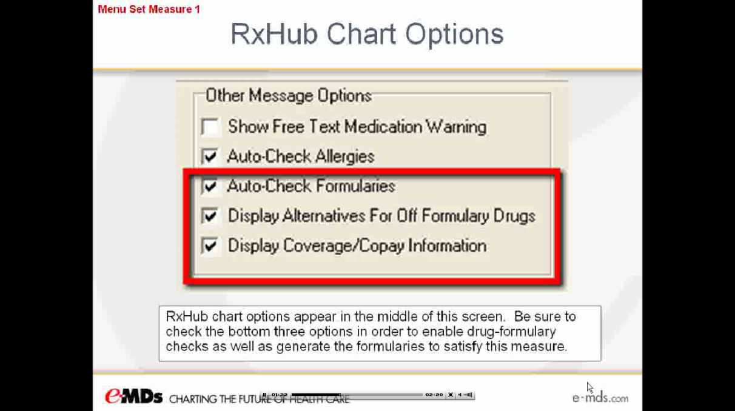
* To check for formulary status you must first check for formulary eligibility:
* 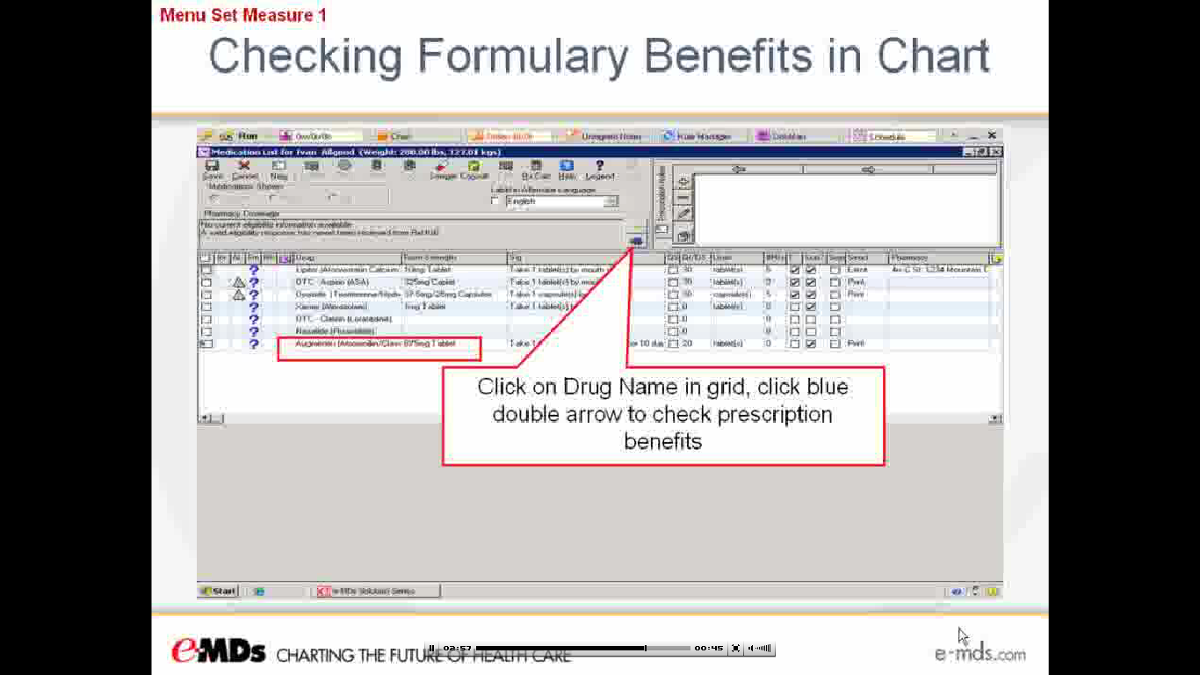
* No issues meeting this criterion for the Meaningful Use (MU) incentive. eMDs already provides this capability.

Menu Set #2

* **Incorporate clinical lab-test results into EHR as structured data.**
* 40% of all clinical lab test results ordered by eligible professionals must be incorporated into the EHR as structured data as Flowsheets.
* Results via lab interface will be marked with a blue triangle. Double-clicking this triangle will open results from within the patient chart allowing for quick access for review & sign-offs
* 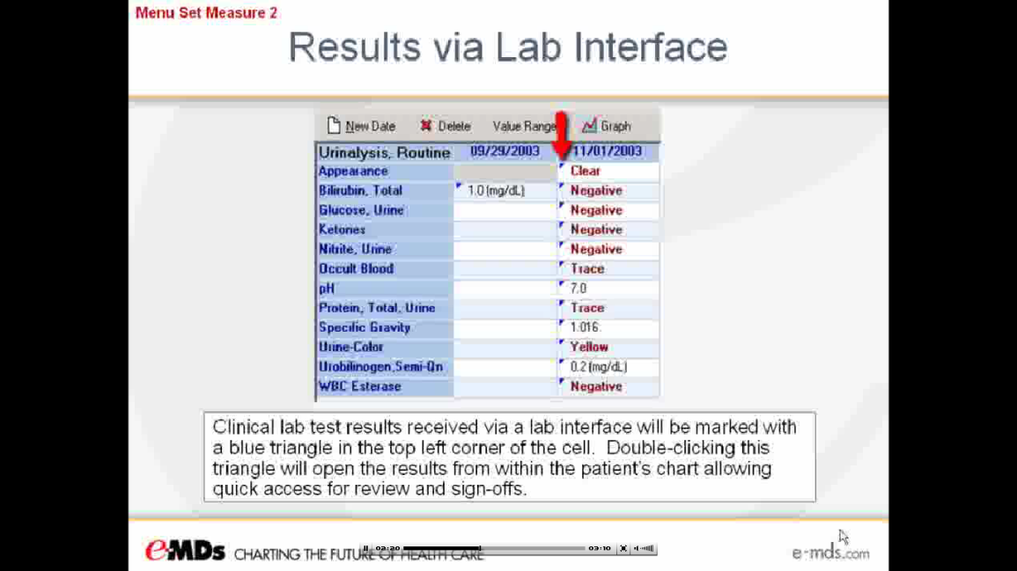
* 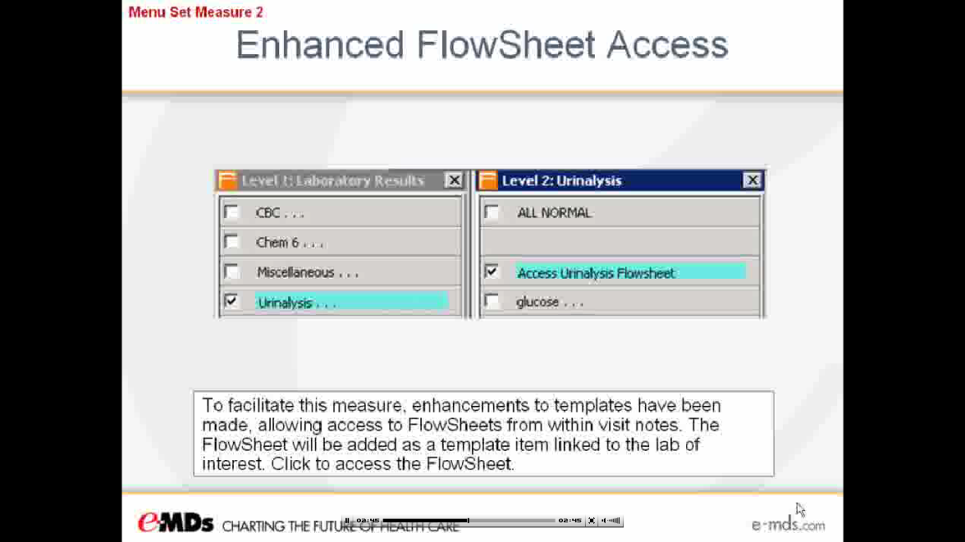
* Enhancements to templates have been made, allowing access to Flowsheets from withing visit notes. Data can be added to the Flowsheets thru template access within the office note. Or data already added to the Flowsheet (ie. Via lab interface) can be added to the office note via the template.
* To pull information from Flowsheets into the visit note>click “Acess Flowsheet” within the lab template>click the cell to be pulled. Selected cells to be pulled will be donated with a green check mark. Then click “Select” to bring these lab results into the OV note.
* No issues meeting this criterion for the Meaningful Use (MU) incentive. eMDs already provides this capability.

Menu Set #3

* **Generate patient lists by specific conditions to use for quality improvement, reduction of disparities, research or outreach.**
* This list will be generated thru the Registry Processor.
* 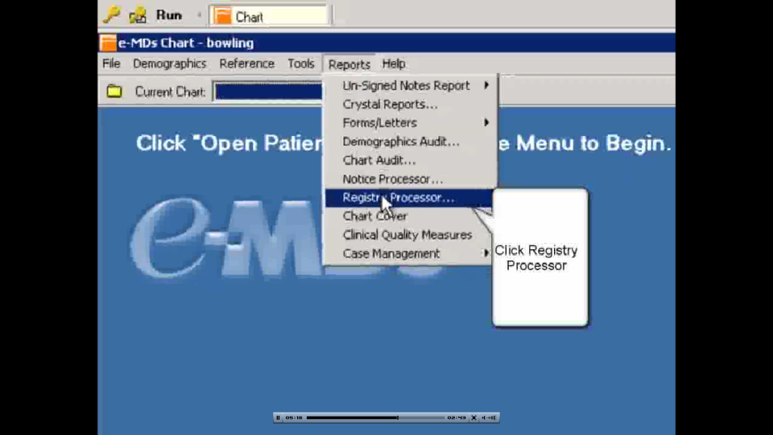
* No issues meeting this criterion for the Meaningful Use (MU) incentive. eMDs already provides this capability.

Menu Set #4

* **Send patient reminders per patient preference for preventive/follow-up care.**
* 20% of unique patients 65 years or older and 5 years or younger were sent a reminder during the reporting period.
* The patient’s contact method preference must be set.
* This will be the responsibility of the Front Desk staff.
* 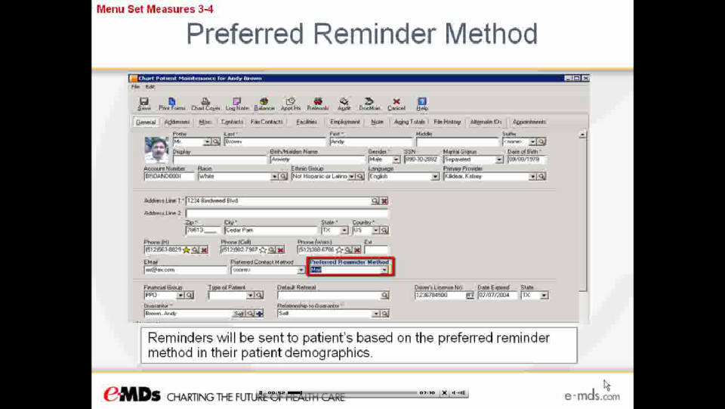

Menu Set #5

* **Provide patients with timely electronic access to their health information (including lab results, problem list, medication lists and allergies) within 4 business days of the information being available to the eligible provider (EP).**
* Greater than 10% of all patients seen with reporting period have available updated information.
* The eligible professional is not responsible for ensuring that 10% of patients request access or have the means to access, only that the updated information is available.
* This measure can be met by utilizing the Patient Portal.
* 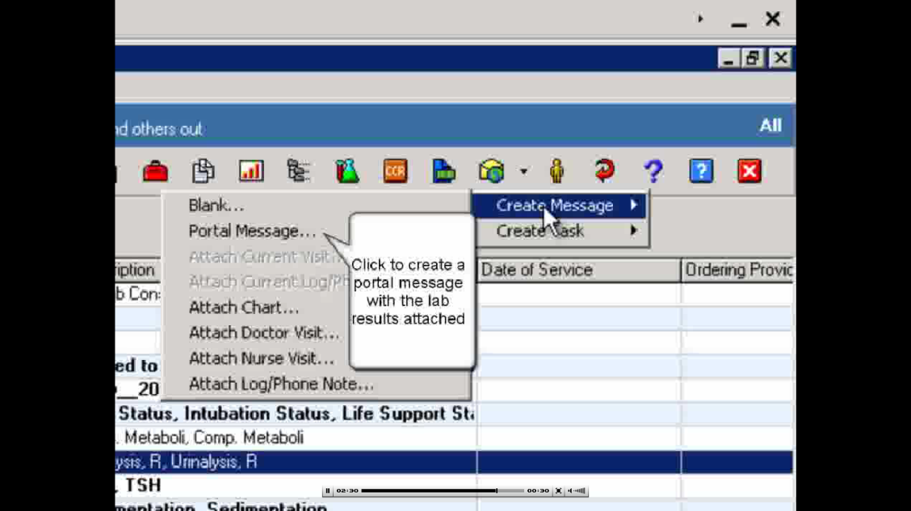

Menu Set #6

* **Use certified EHR technology to identify patient-specific education resources and provide those resources to the patient if appropriate.**
* Provide patient-specific (disease or medication) patient education to at least 10% of all patients seen during reporting period.
* 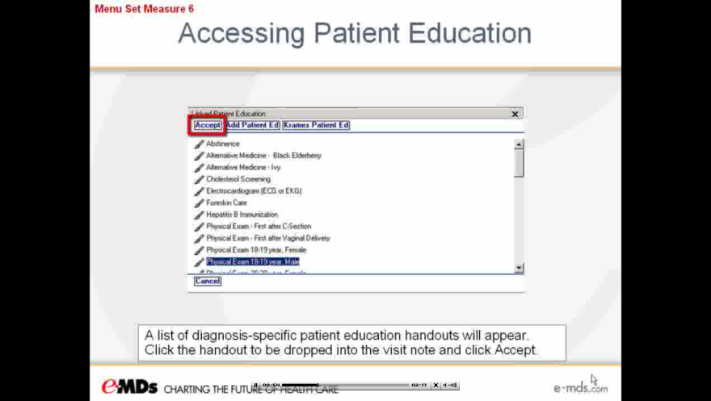
* Krames patient education can be printed directly from the Krames Patient Education Module by selecting print. Documentation of the patient education will be added to the office note and you will receive credit towards Meaningful Use-Menu Set #6.
* To receive credit for eMDs’ patient education, it must be printed from the Solution Series at the note conclusion.
* 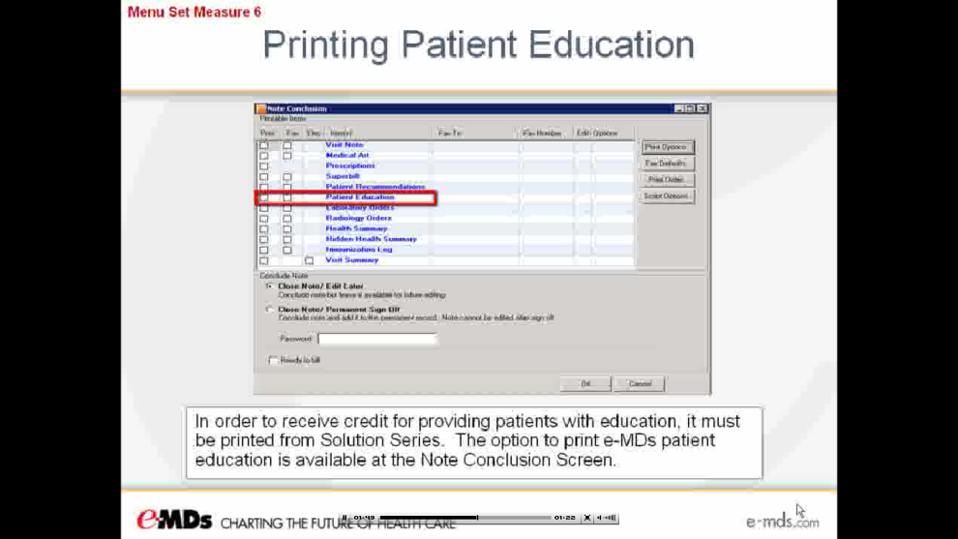

Menu Set #7

* **The eligible provider (EP) who receives a patient from another setting of care or provider of care or believes an encounter is relevant should perform medication reconciliation.**
* Medication reconciliation for more than 50% of transitions of care.
* Custom TCARE CPT code has been created & added as an extended attribute to template item in all Chief Complaint Templates.
* Examples of this situation would be ER/Hospital follow up; Nursing Home follow up or referral from another provider.
* 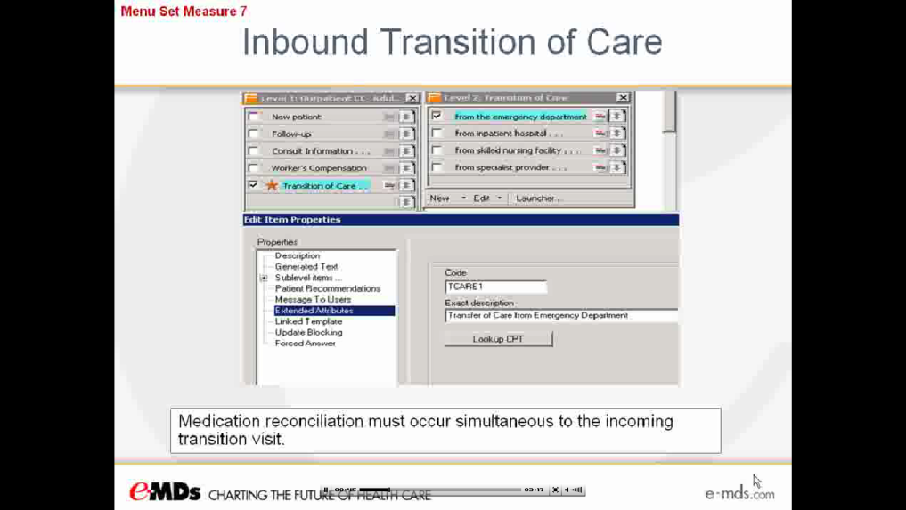
* Medication reconciliation must occur simultaneously to the incoming transition visit.
* Eligible Provider receives MU credit by clicking on the MED REC button and performing the medication reconciliation.
* 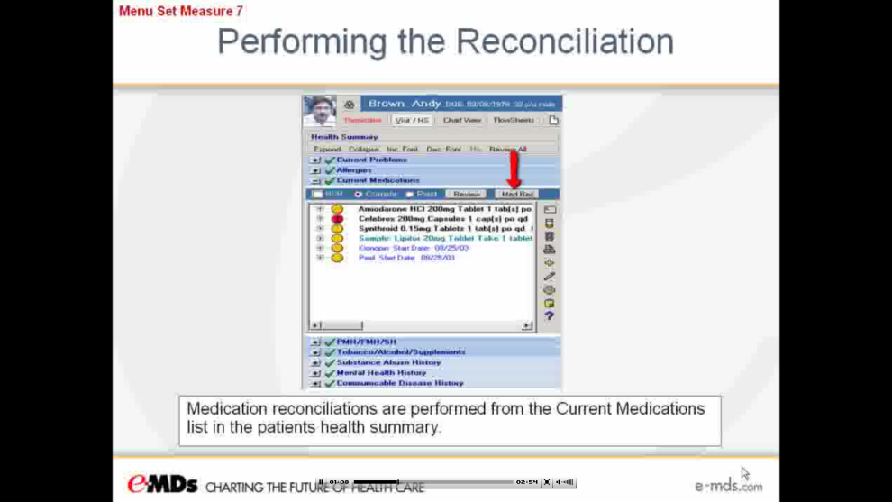

Menu Set # 8

* **The EP who transitions their patient to another setting of care or provider of care or refers their patient to another provider of care should provide “summary care record” for each transition of care or referral.**
* This must occur in more than 50% of all transitions of care or referrals.
* Custom ADMIT & REF CPT codes have been created and added as extended attributes to template items in all Plan templates.
* 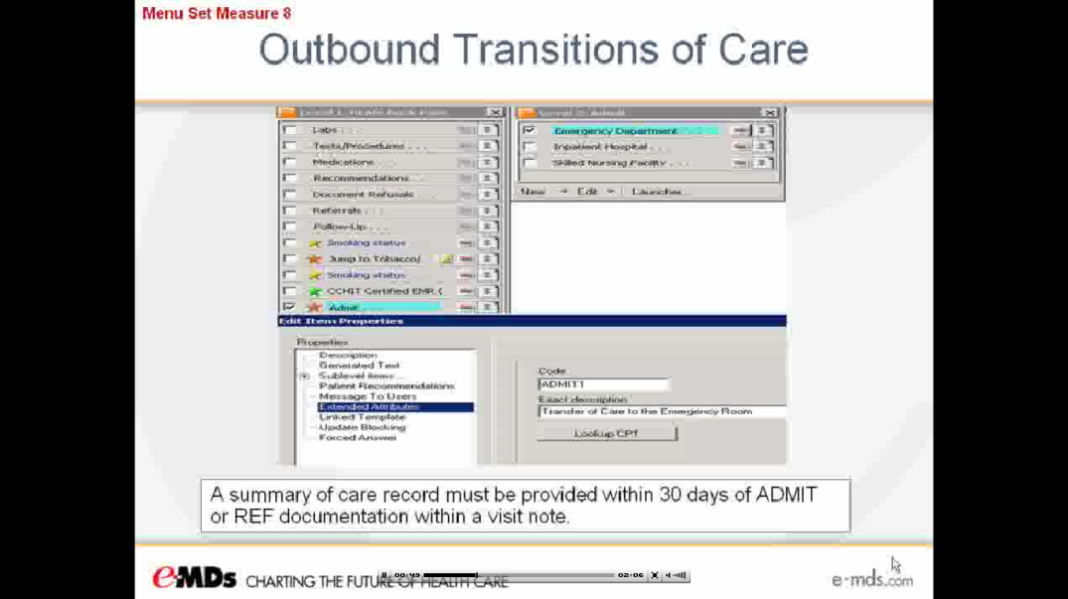
* A summary of care record must be provided within 30 days of ADMIT or REF documentation within a visit note.
* A Chart Summary is used to satisfy the summary of care requirement.
* This can be done by using the Continuity of Care Document (CCD)
* 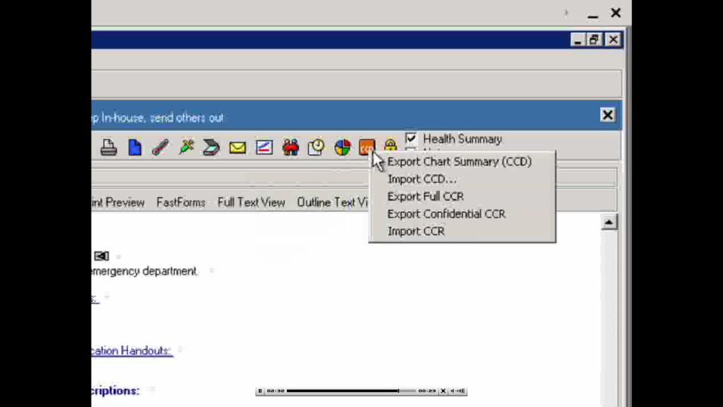

Menu Set #9 & #10

* **Capability to submit electronic data to immunization registries or immunization information systems and actural submission according to applicable law and practice.**
* **Capability to submit electronic syndromic surveillance data to public health agencies and actual submission according to applicable law and practice.**
* Must perform at least one test of the EHR technologies capacity to submit electronic data to immunization registry or provide electronic syndromic surveillance and follow up submission if the test is successful.
* If this immunization registry or public surveillance entity does not have the capability to accept this electronic information, storing the information in a file on the workstation will satisfy this requirement.
* The e-MDs interface engine will be utilized to submit this information.
* 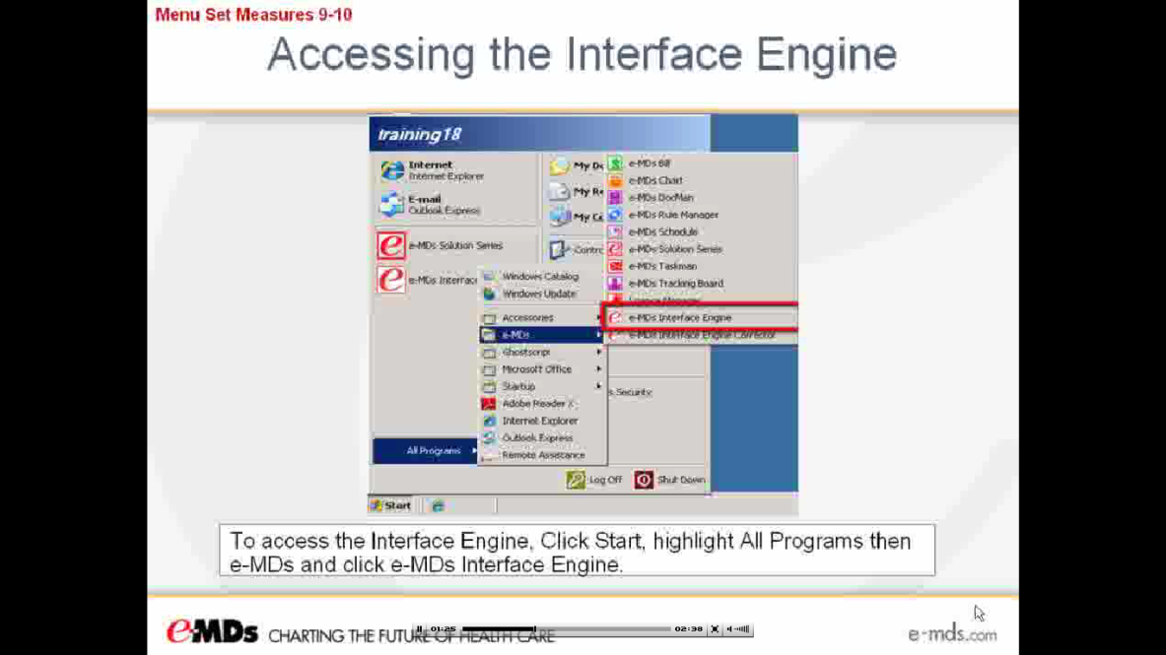
* See e-MDs Meaningful Use – Menu Set #9 & 10 video libraries to view how to run this e-MDs interface engine.

Christine Hunter PA-C

Southwest Family Physicians

8258 Hascall St.

Omaha, NE 68124

[pachunter@hotmail.com](mailto:pachunter@hotmail.com)