1. **Setup Django Project (Python Mandatory)**
2. create a folder like: django-react
3. paste code here
4. remove env folder
5. cd django-react > python3 -m venv env #create a python environment
6. then if you are using linux put this commands
7. cd django-react > source env/bin/activate
8. then run this command: pip install - r requirements.txt
9. I used database postgresql . Go to todo/settings.py file

change here database name and username, password.

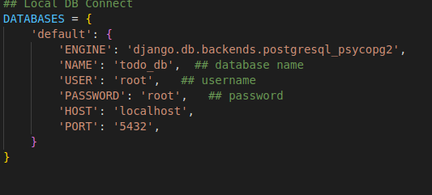

7. python3 manage.py makemigrations

8. python3 manage.py migrate

9. python3 manage.py runserver

http://127.0.0.1:8000/

10. http://127.0.0.1:8000/api/todos/

**2. React Project Setup**

* 1. please check in your system NPM and Node js (nodejs and npm install)
* 2. go to react_web/frontend folder

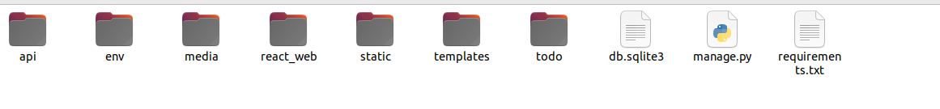

* 3. cd frontend> npm start

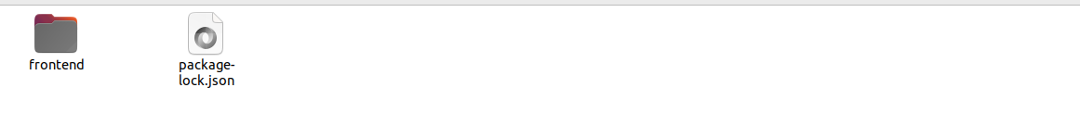

* 4. http://localhost:3000/