**Peer-graded Assignment: Final Assignment: Part 3 - Submission and Grading**

i

It looks like this is your first peer-graded assignment. [Learn more](https://learner.coursera.help/hc/articles/208279926-Submit-peer-reviewed-assignments" \t "_blank)

**Review fellow learners**

Congrats on submitting your assignment! You have reviewed enough peers, but you can continue to review peers and provide constructive feedback.

Review assignments

InstructionsMy submissionDiscussions

Data Visualization and Dashboard Development for Automobile Sales Analysis

Submitted on December 4, 2024

[Shareable Link](https://www.coursera.org/learn/python-for-data-visualization/peer/tuA5r/final-assignment-part-3-submission-and-grading/review/g5wzG7JZEe-O5wr_64IUOQ)

**Prompt**

**Task 1.1 - Develop a Line plot using the functionality of pandas to show how automobile sales fluctuate from year to year.**

Submit the image ***Line\_plot\_1.png***

Automobile sales over time

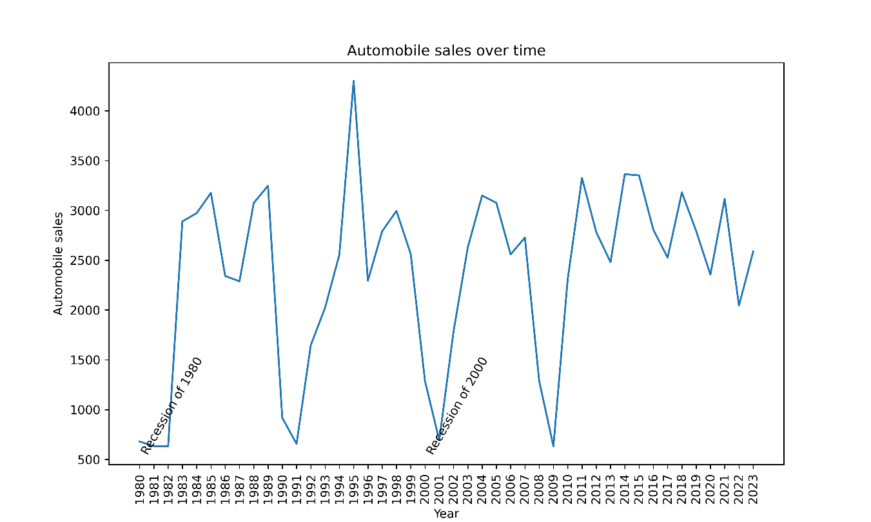

Fluctuations over the years 1980 to 2023 of the automobile sales, including two periods of recession.

**Prompt**

**Task 1.2 - Plot different lines for categories of vehicle type and analyse the trend to answer the question "Is there a noticeable difference in sales trends between different vehicle types during recession periods?"**

Submit the image ***Line\_plot\_2.png***

Automobile sales over time per vehicle type during recession

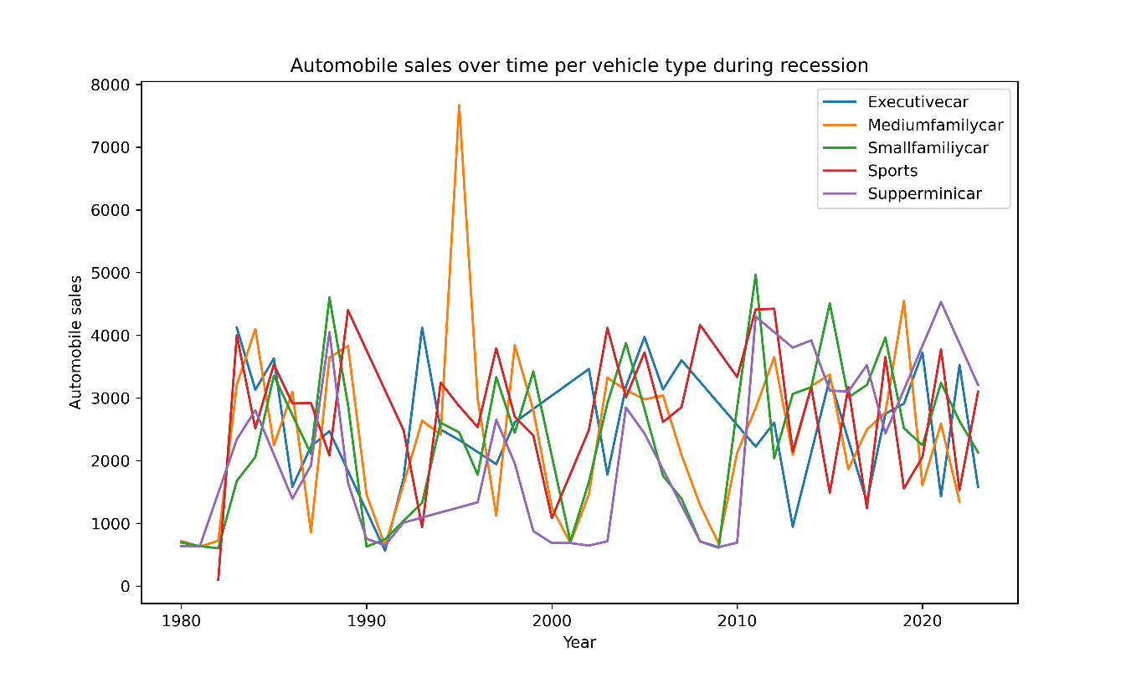

Fluctuations over the years 1980 to 2023 of the automobile sales, grouping by vehicle type. Different colours represent the five typyes of vehicles.

**Prompt**

**Task 1.3 - Use the functionality of Seaborn Library to create a visualization to compare the sales trend per vehicle type for a recession period with a non-recession period.**

Submit the image ***Bar\_Chart.png***

Mean car sales per vehicle type during recession and non-recession period

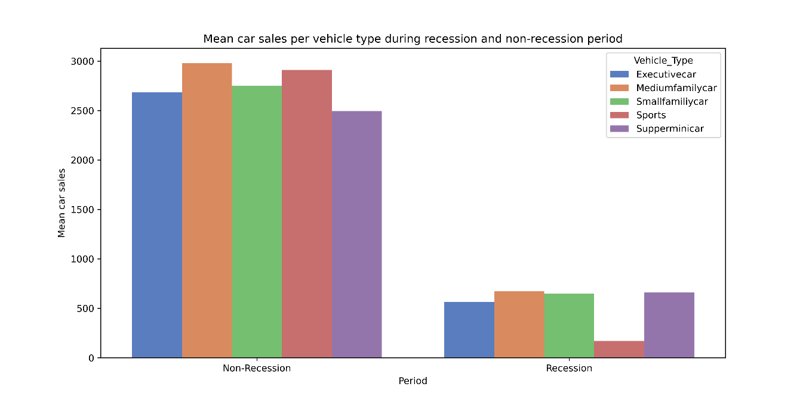

Five vehicle types analyzed are grouped by periods of recession and non-recession. It can be showed a clear differences between recession and non-recession periods, as the mean car sales have a difference of almost five times.

**Prompt**

**Task 1.4 - Use sub plotting to compare the variations in GDP during recession and non-recession period by developing line plots for each period.**

Submit the image***Subplot.png***

GDP vs time during periods of recession and non-recession

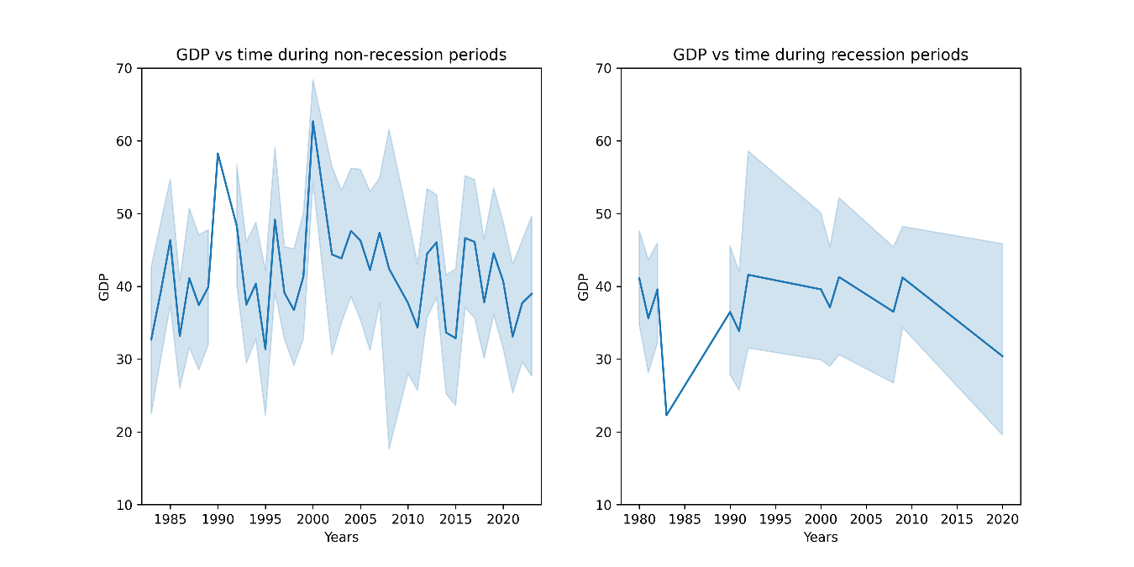

Left subplot shows the GDP vs time for non-recession periods, while the figure in the right shows the GDP vs time for period of recession. From this figure, it is evident that during recession periods (right plot), the GDP of the country tends to stay within a lower range compared to non-recession periods (left plot). The fluctuations in GDP are also less pronounced during recessions, indicating reduced economic activity. This likely impacted the overall sales of the company, as lower GDP often correlates with decreased consumer spending and demand in the automobile sector.

**Prompt**

**Task 1.5 - Develop a Bubble plot for displaying the impact of seasonality on Automobile Sales.**

Submit the image ***Bubble.png***

Seasonality impact on automobile sales

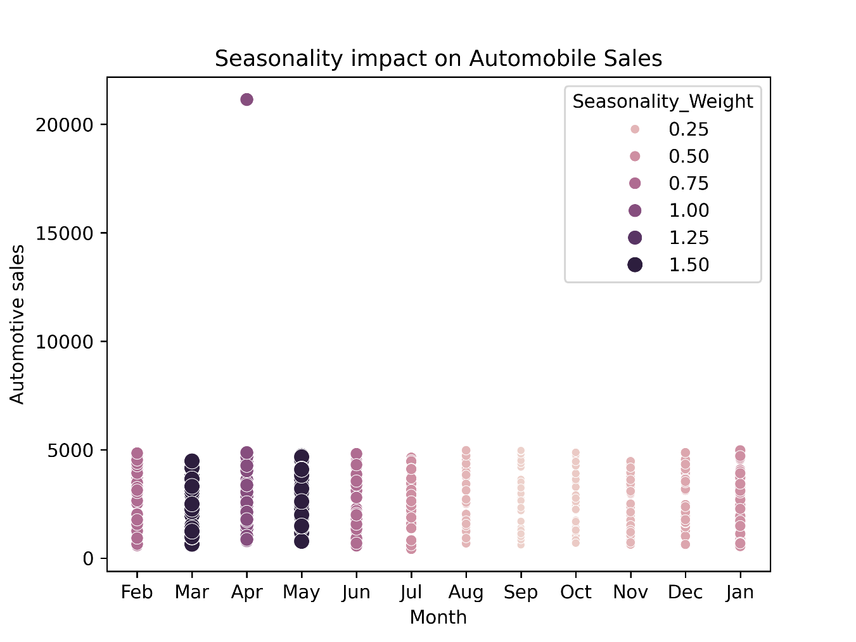

From this plot, it is evident that seasonality does have an impact on automobile sales. While sales remain relatively consistent across most months, there is a noticeable spike in sales in the month of May, indicated by the larger bubble size. This suggests that specific seasonal factors may significantly boost automobile sales during this period, whereas other months show a steadier trend.

**Prompt**

**Task 1.6 - Use the functionality of Matplotlib to develop a scatter plot to identify the correlation between average vehicle price relate to the sales volume during recessions.**

Submit the image ***Scatter.png***

Consumer confidence and automobile sales during recessions

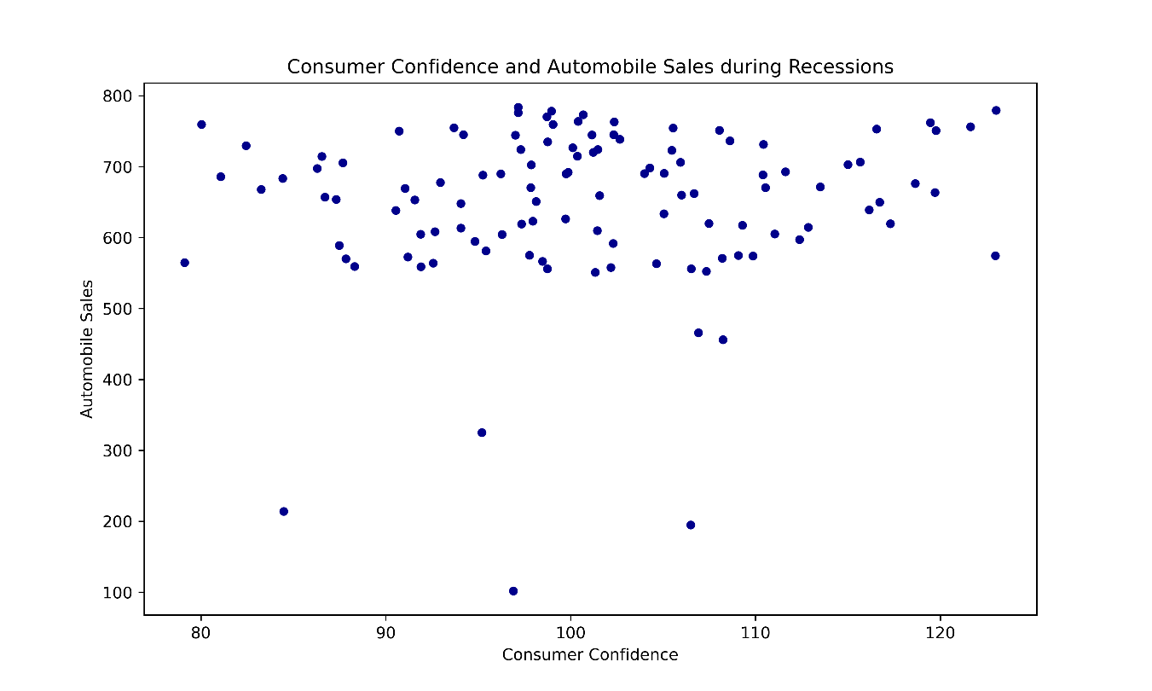

From this plot, it appears that there is no strong or clear relationship between consumer confidence and automobile sales during recessions. While consumer confidence values vary widely, the automobile sales remain relatively scattered without forming any discernible trend. This indicates that other factors may have a more significant impact on automobile sales during recession periods.

**Prompt**

**Task 1.7 - Create a pie chart to display the portion of advertising expenditure of XYZAutomotives during recession and non-recession periods.**

Submit the image ***Pie\_1.png***

Advertising Expenditure during Recession and Non-Recession Periods

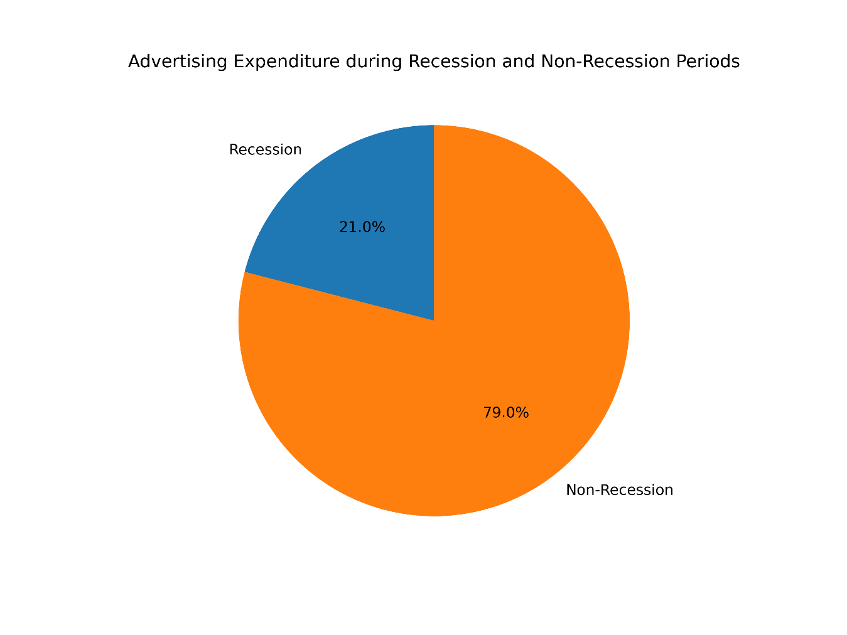

From the above plot, it is evident that ABCAutomotives has been allocating a significantly higher portion of its advertisement expenditure during non-recession periods (79%) compared to recession periods (21%). This strategy aligns with the idea of maximizing consumer outreach when economic conditions are favorable, while potentially reducing costs during challenging economic times.

**Prompt**

**Task 1.8 - Develop a pie chart to display the total Advertisement expenditure for each vehicle type during recession period.**

Submit the image ***Pie\_2.png***

Total advertisement expenditure per vehicle type

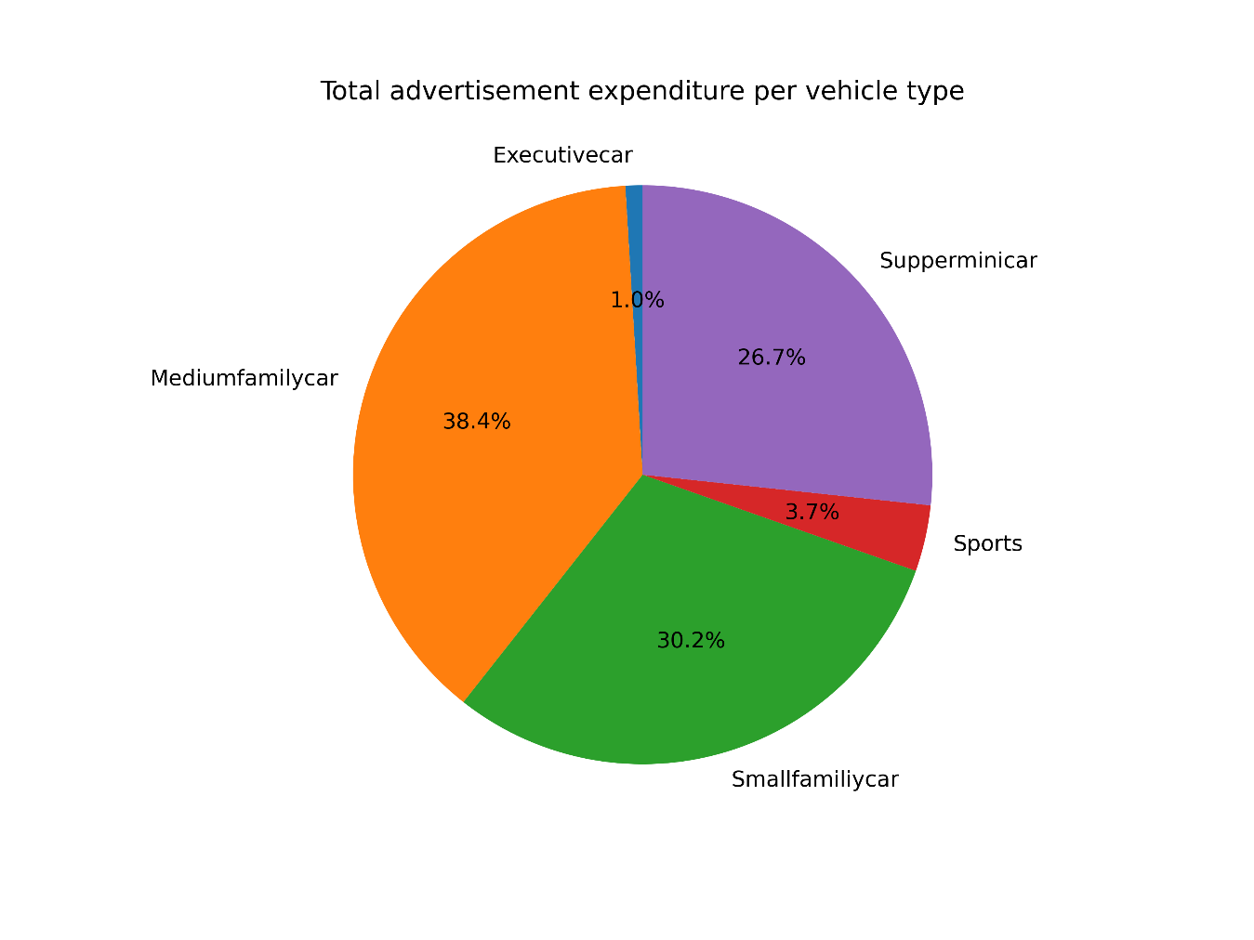

During the recession, the advertisements were primarily focused on medium family cars (38.4%) and small family cars (30.2%), which are likely more affordable and practical for consumers during economic downturns. This strategic focus on lower price range vehicles reflects a wise decision to target segments of the market that are more resilient to financial constraints.

**Prompt**

**Task 1.9 - Develop a line plot to analyse the effect of the unemployment rate on vehicle type and sales during the Recession Period.**

Submit the image ***Line\_plot\_3.png***

Effect of Unemployment Rate on Vehicle Type and Sales

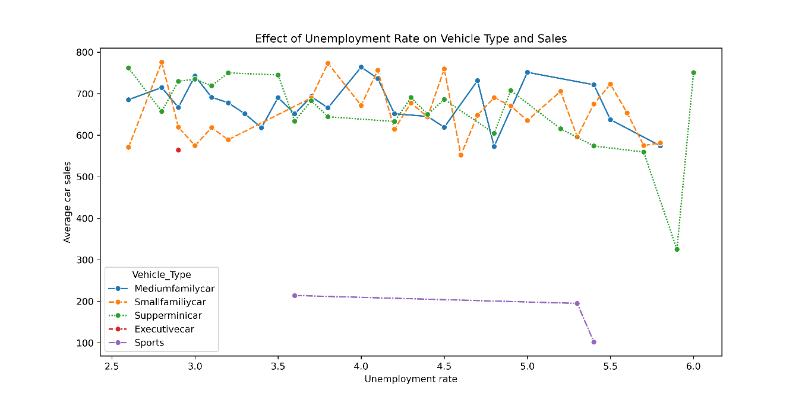

From this figure, it can be observed that during periods of higher unemployment rates (often associated with recessions), the buying pattern shifts towards lower-priced vehicles such as superminicars, small family cars, and medium family cars. These categories maintain relatively stable or higher sales compared to other vehicle types, highlighting consumer preference for more affordable and practical options during challenging economic conditions.

**Prompt**

**Task 2.1 - Create a Dash application and give it a meaningful title.**

Submit the image **Title.png**

Adding a Title to the Dashboard

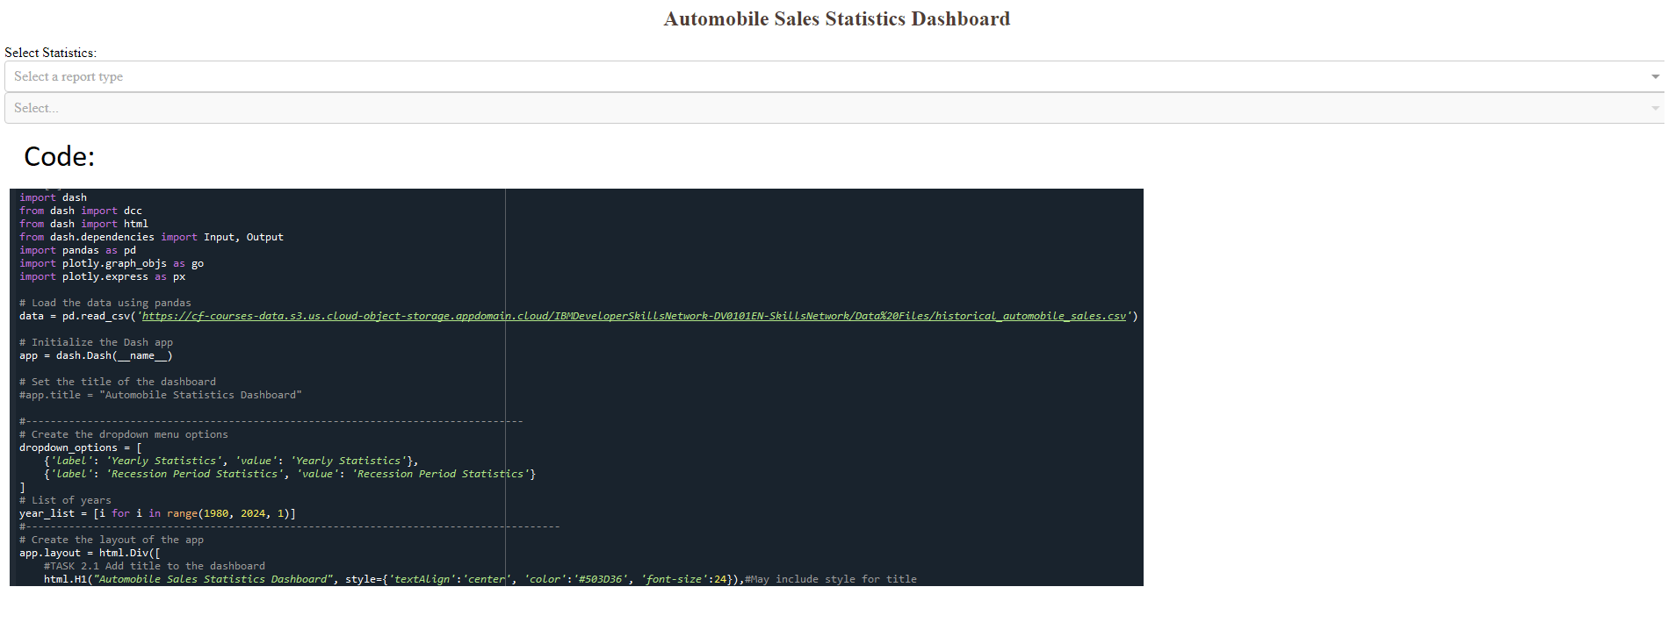

The dashboard now includes a meaningful title, "Automobile Sales Statistics Dashboard," displayed prominently at the top. This addition enhances the clarity and user experience by immediately communicating the purpose of the dashboard.

**Prompt**

**Task 2.2 - Add drop-downs to your dashboard with appropriate titles and options.**

Submit the image **Dropdown.png**

Adding Drop-Down Menus to the Dashboard

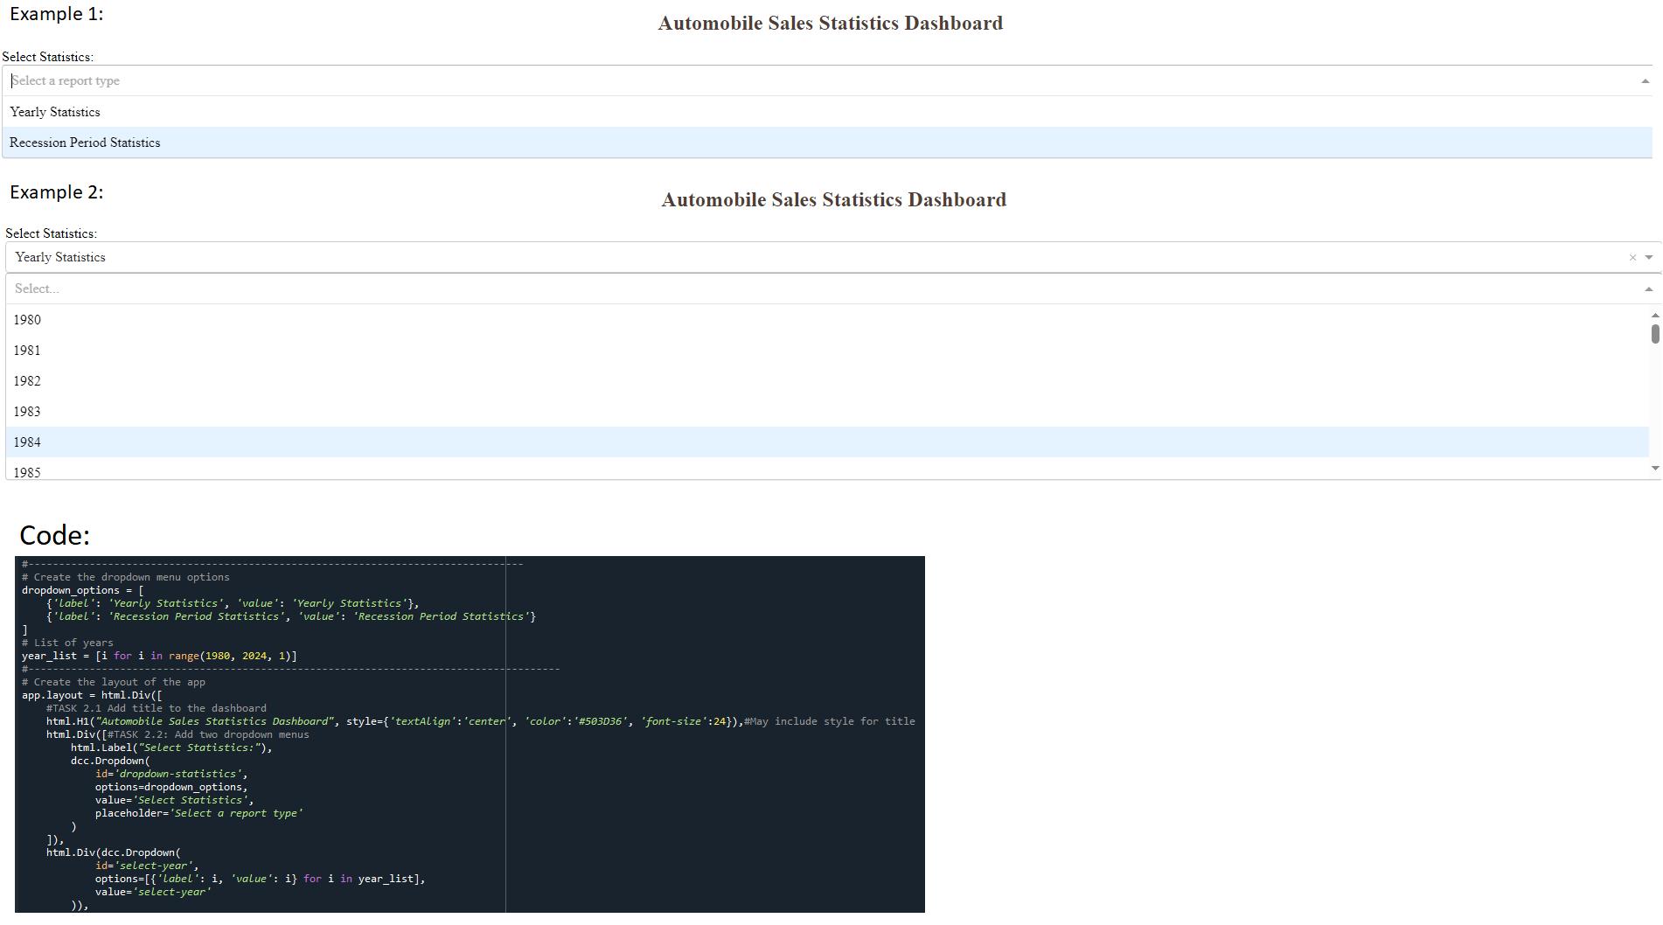

Two drop-down menus have been added to the dashboard. The first drop-down allows users to select a report type, such as "Yearly Statistics" or "Recession Period Statistics." The second drop-down enables users to choose specific years within a defined range. These features enhance the interactivity of the dashboard, providing users with customizable options to explore relevant data.

**Prompt**

**Task 2.3 - Add a division for output display with appropriate ‘id’ and ‘classname’ properties.**

Submit the image **outputdiv.png**

Adding an Output Display Division to the Dashboard

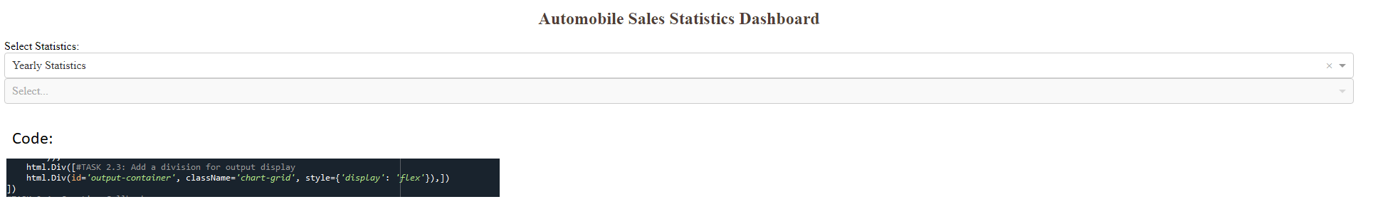

An output display division has been added to the dashboard, identified by the id="output-container" and styled with the classname="chart-grid". This division provides a flexible layout for dynamically displaying the selected statistics and visualizations based on user interaction with the drop-down menus.

**Prompt**

**Task 2.4 - Creating Callbacks; Define the callback function to update the input container based on the selected statistics and the output container.**

Submit the image **Callbacks.png**

Implementing Callbacks to Update Dashboard Components

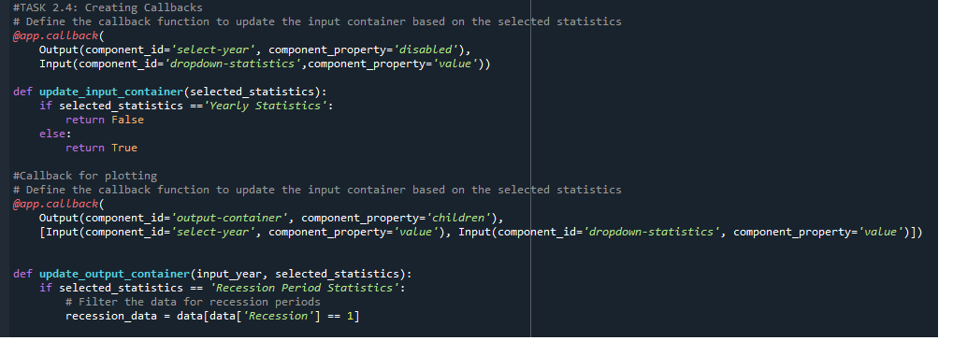

Callback functions have been implemented to dynamically update the dashboard components based on user selections. The first callback enables or disables the "Year" input field depending on the selected report type, while the second callback updates the output container to display the appropriate data visualization. These callbacks ensure a responsive and interactive user experience, adapting the dashboard content to the selected options.

**Prompt**

**Task 2.5 - Create and display graphs for Recession Report Statistics.**

Submit the image **RecessionReportgraphs.png**

Four graphs have been created to illustrate key recession report statistics:

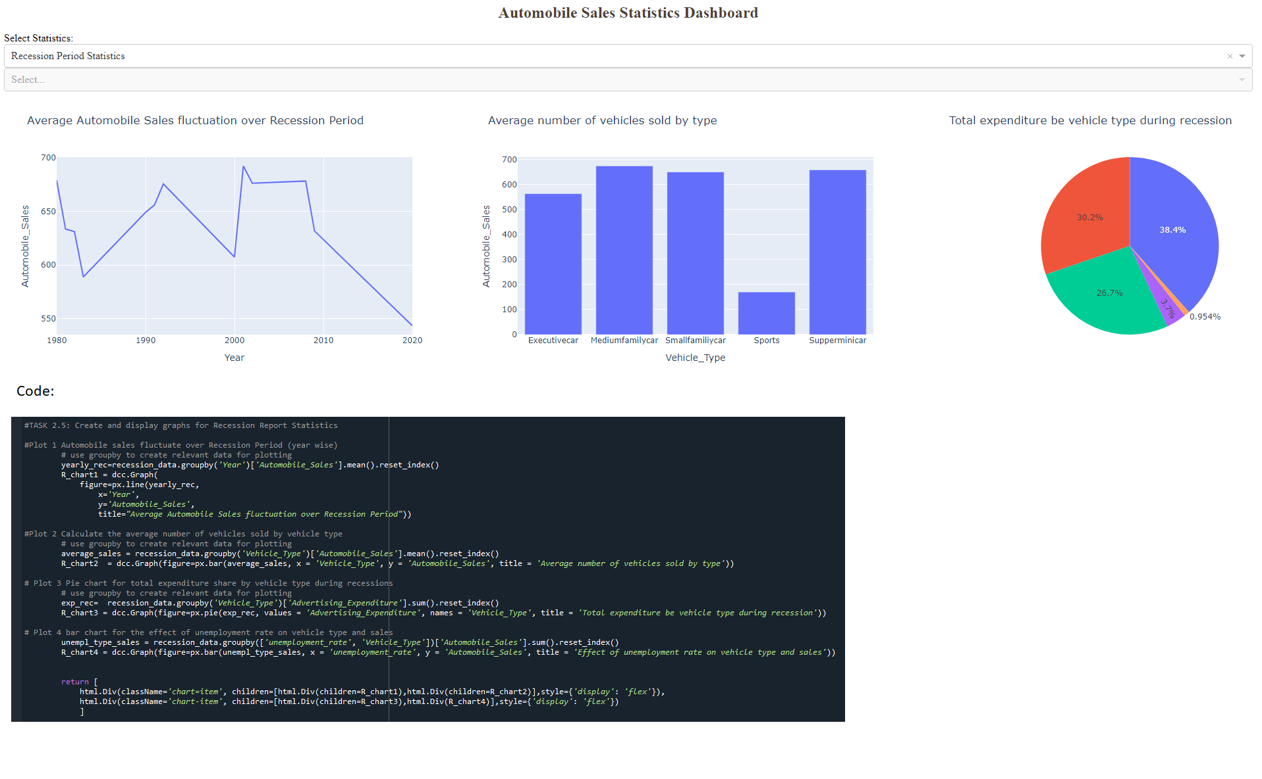

A line chart showing the fluctuation in average automobile sales over the recession period, highlighting a general downward trend. A bar chart depicting the average number of vehicles sold by type, with medium family cars and small family cars leading the sales during recessions. A pie chart displaying the total advertising expenditure per vehicle type during the recession, emphasizing the focus on family cars. A bar chart representing the effect of unemployment rate on vehicle type sales, showcasing how economic conditions influenced consumer choices.

**Prompt**

**Task 2.6 - Create and display graphs for Yearly Report Statistics.**

Submit the image **YearlyReportgraphs.png** for the report types

Graphical Representation of Yearly Report Statistics

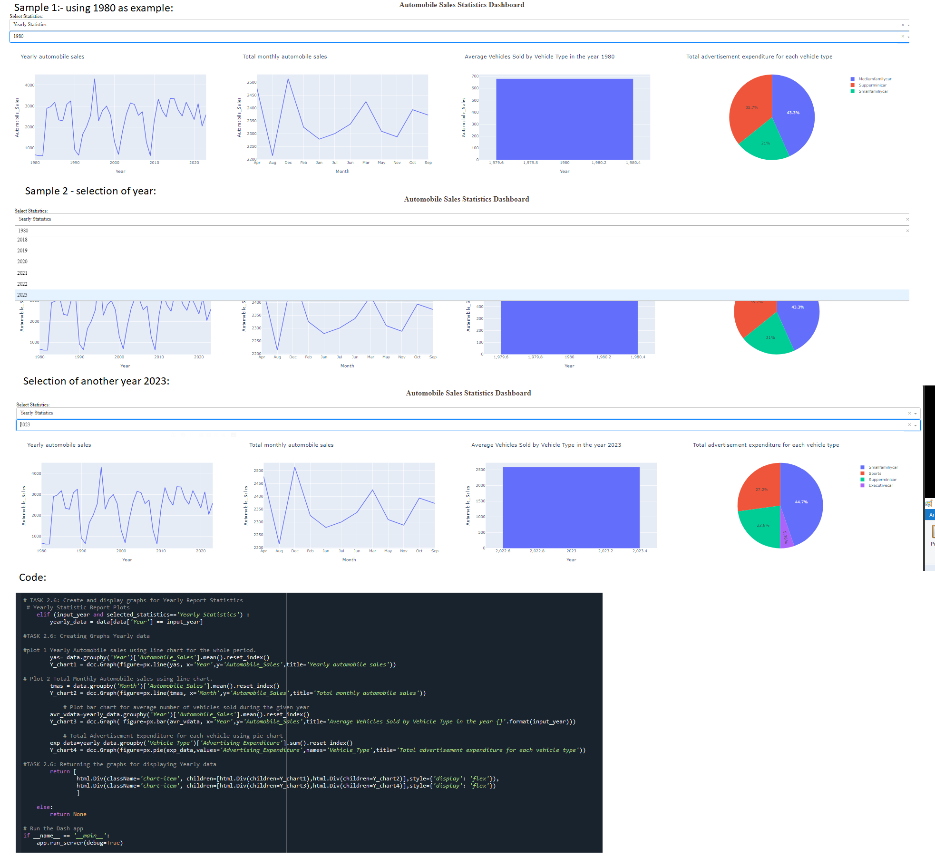

The dashboard displays yearly report statistics with the following visualizations: 1. Yearly Automobile Sales: A line chart depicting trends in automobile sales over the selected year. 2. Total Monthly Automobile Sales: A line chart showing monthly sales distributions within the selected year. 3. Average Vehicles Sold by Vehicle Type: A bar chart highlighting the average number of vehicles sold by type during the selected year. 4. Total Advertisement Expenditure for Each Vehicle Type: A pie chart representing the proportion of advertisement spending on various vehicle types in the selected year.