Untitled

Pablo Maldonado

16/01/2020

## R Markdown

This is an R Markdown document. Markdown is a simple formatting syntax for authoring HTML, PDF, and MS Word documents. For more details on using R Markdown see <http://rmarkdown.rstudio.com>.

When you click the **Knit** button a document will be generated that includes both content as well as the output of any embedded R code chunks within the document. You can embed an R code chunk like this:

library(tidyverse)

## -- Attaching packages --------------------------------- tidyverse 1.3.0 --

## v ggplot2 3.2.1 v purrr 0.3.3  
## v tibble 2.1.3 v dplyr 0.8.3  
## v tidyr 1.0.0 v stringr 1.4.0  
## v readr 1.3.1 v forcats 0.4.0

## -- Conflicts ------------------------------------ tidyverse_conflicts() --  
## x dplyr::filter() masks stats::filter()  
## x dplyr::lag() masks stats::lag()

df <- read_csv("./data/OnlineNewsPopularity.csv")

## Parsed with column specification:  
## cols(  
## .default = col_double(),  
## url = col_character()  
## )

## See spec(...) for full column specifications.

## Including Plots

You can also embed plots, for example:

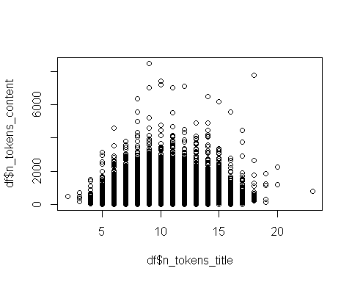

Note that the echo = FALSE parameter was added to the code chunk to prevent printing of the R code that generated the plot.