
Roles:
- Candidate
- Employer
- Admin

Modules:
- Candidate
- Employer
- Admin

Home / Launch Page:
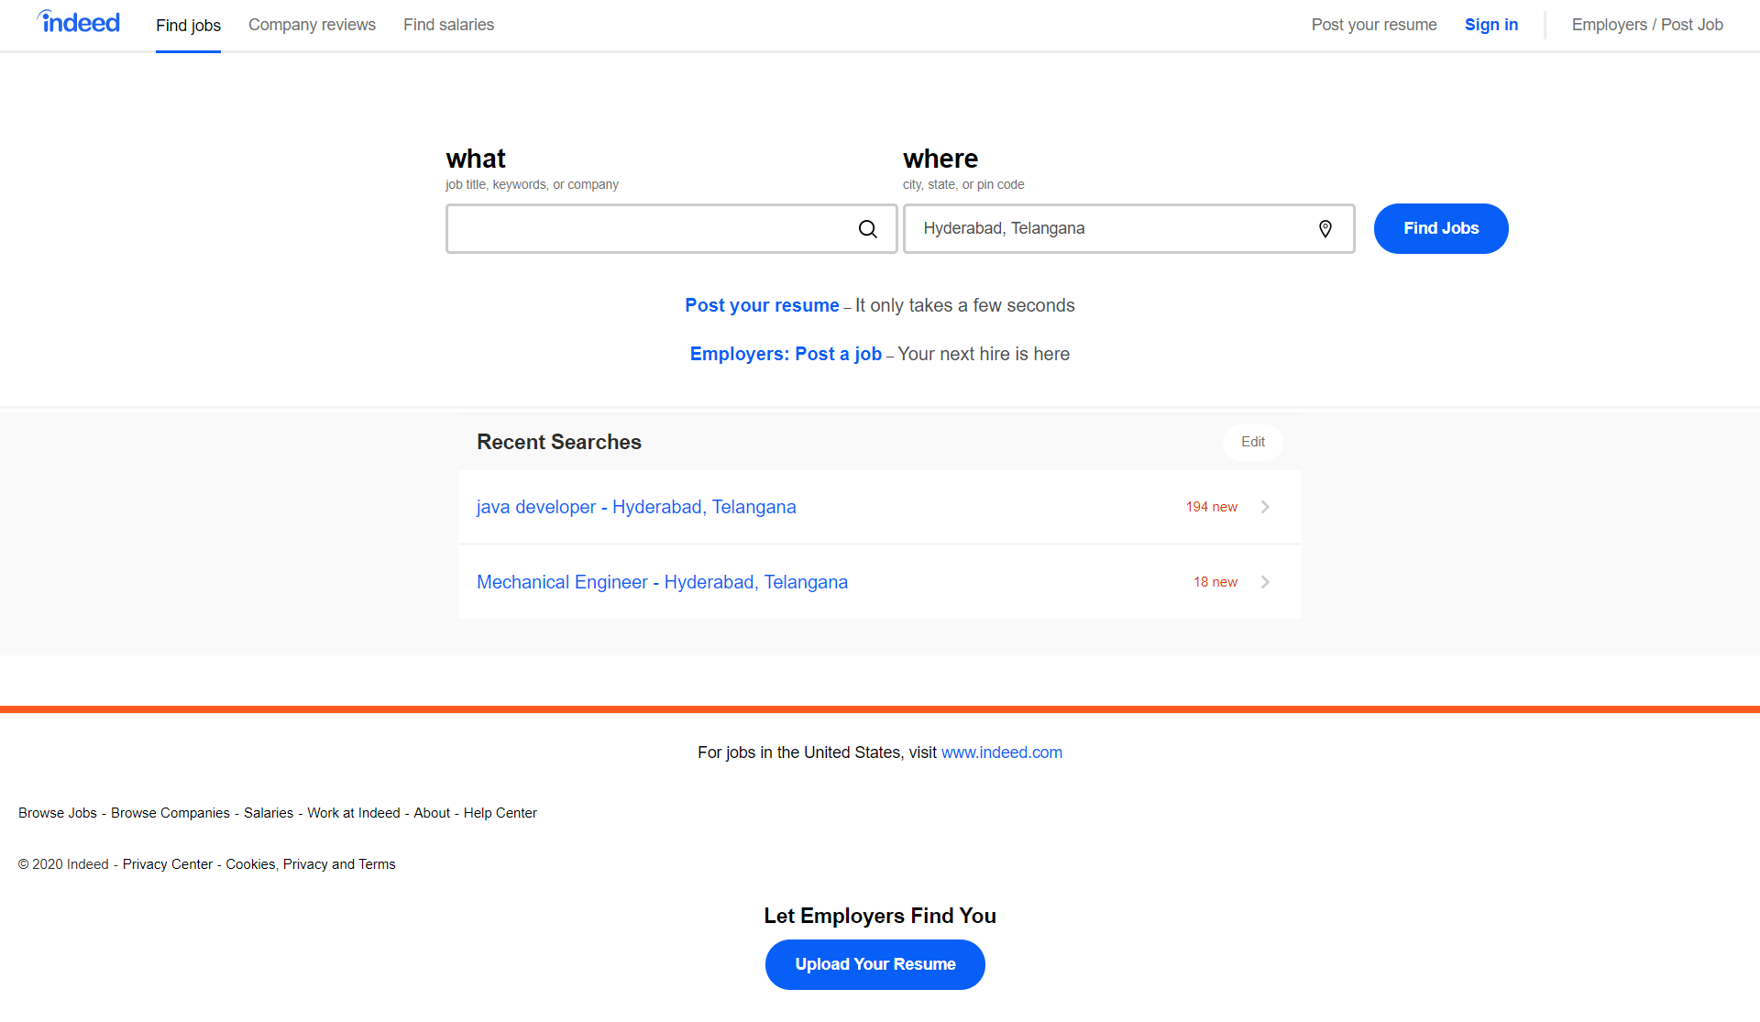

Post your Resume:
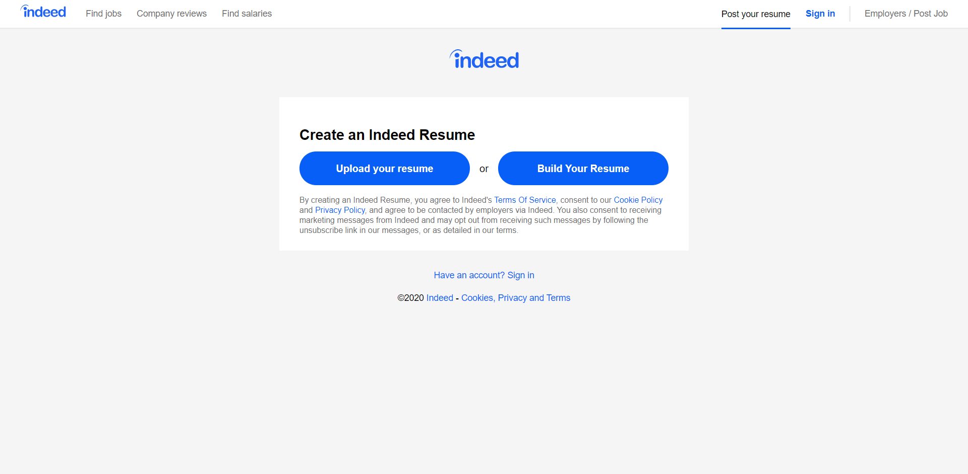

Sign In:
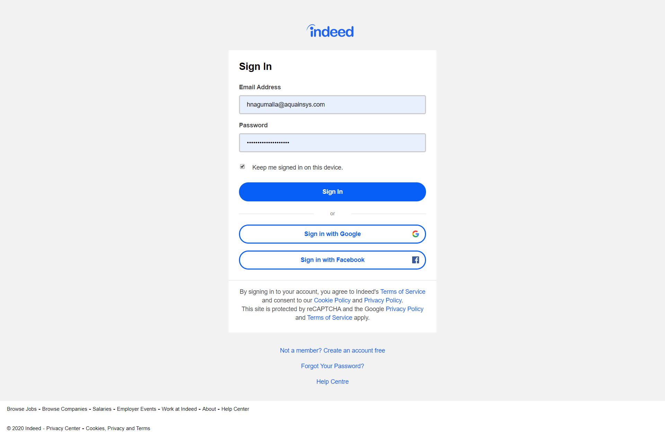

Preferences:
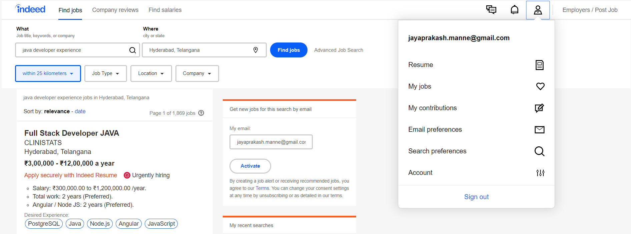

Find Jobs:
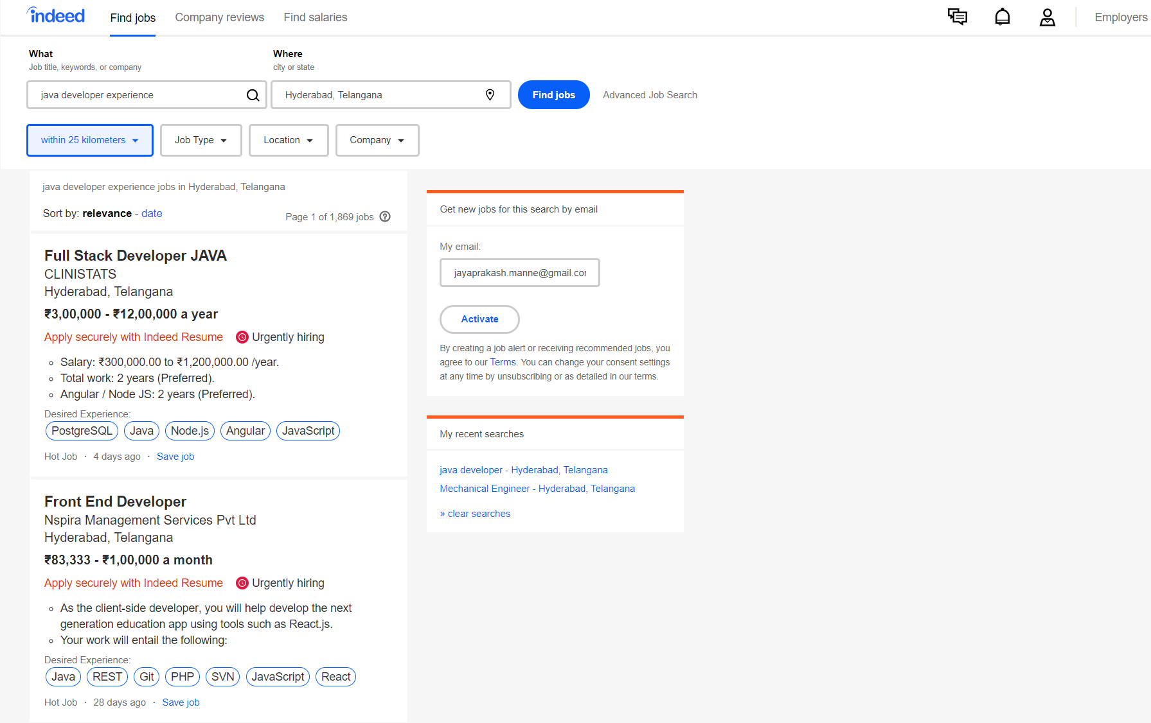

My Jobs:
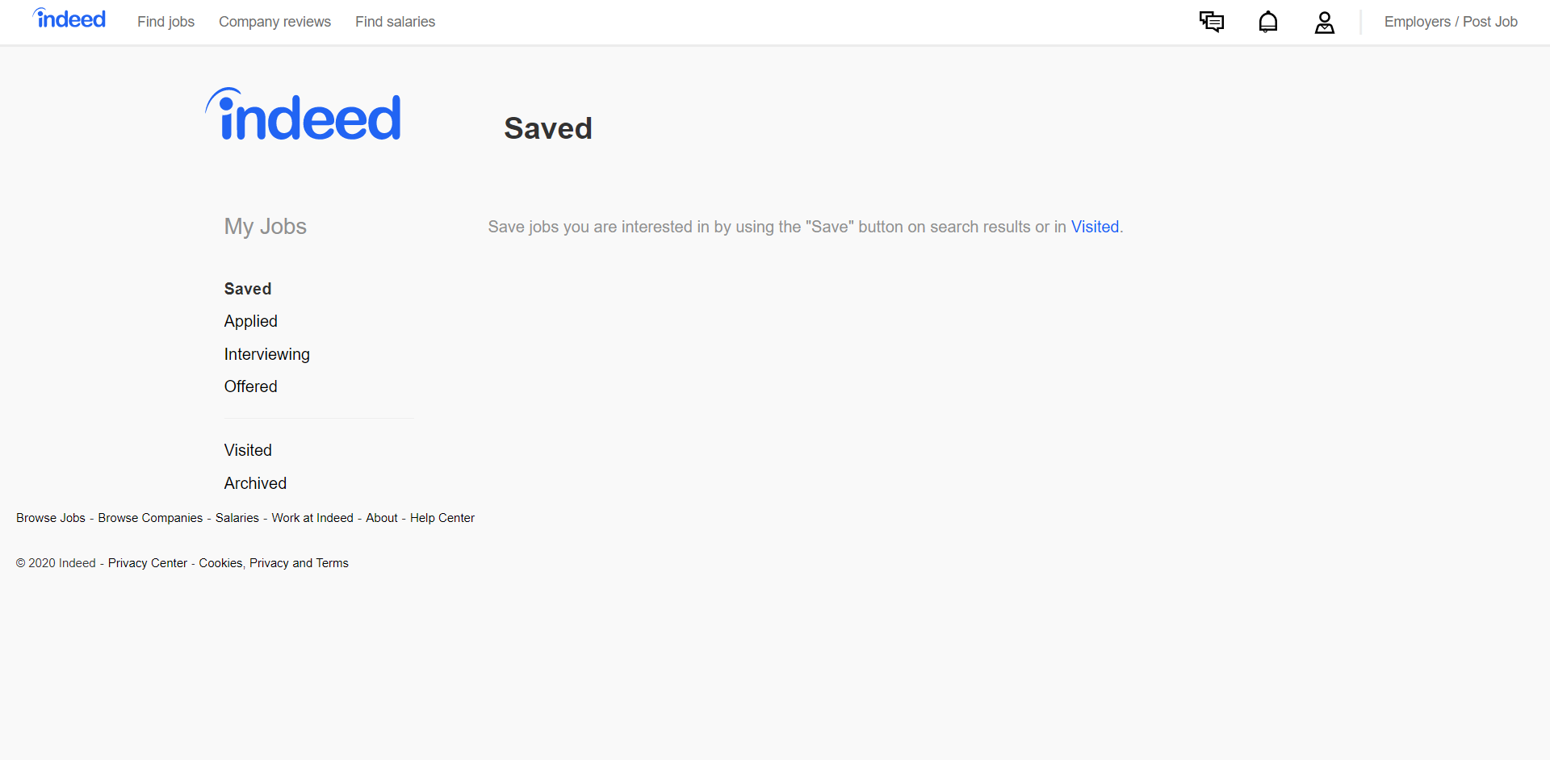

Email Preferences:
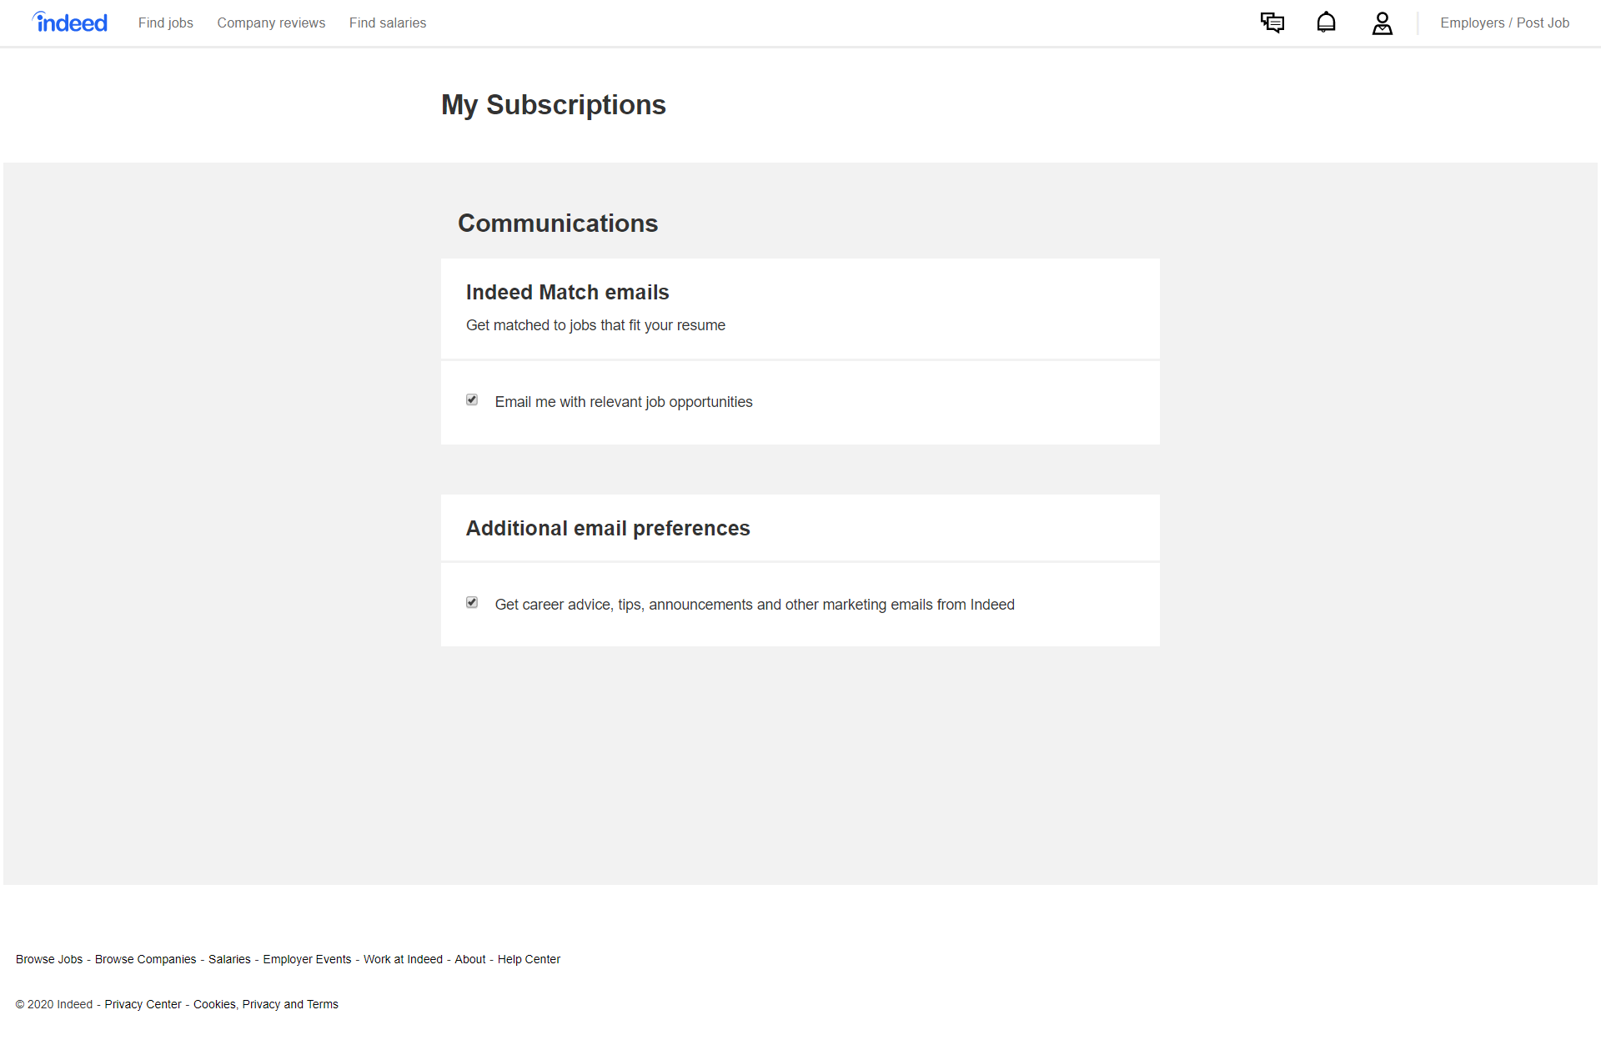
Messages:
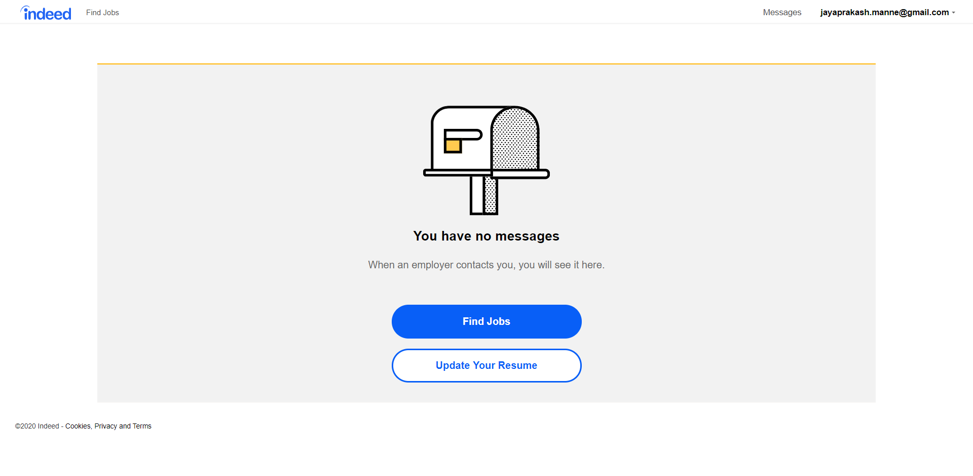

Employer:
1. As an Employer, I shall be able to change the Account Settings like, Email, Password and Phone Number.
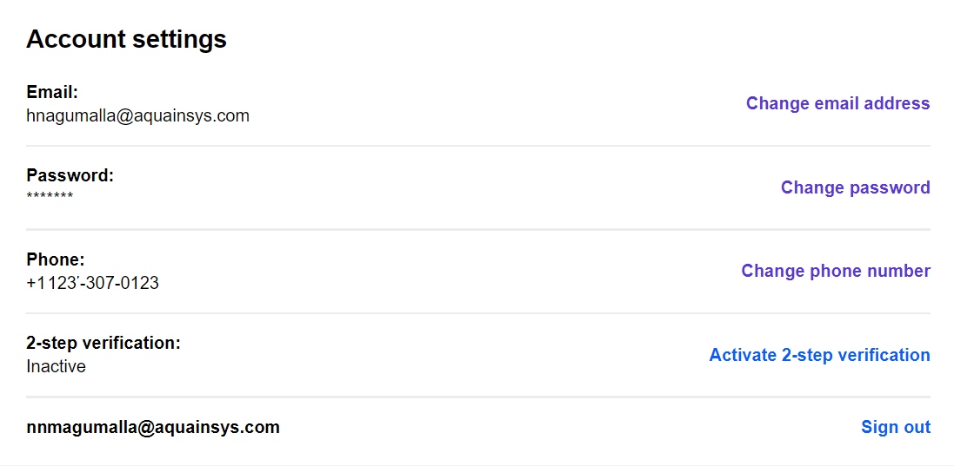

API:
1. Get Account Settings
2. Change email address
3. Change Password
4. Change Phone Number

2. As an Employer, I shall be able to Post Job
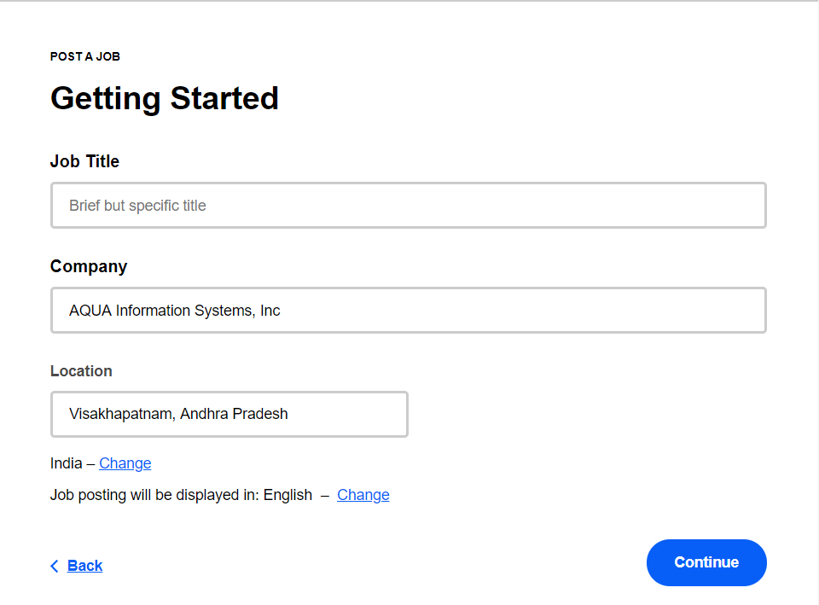
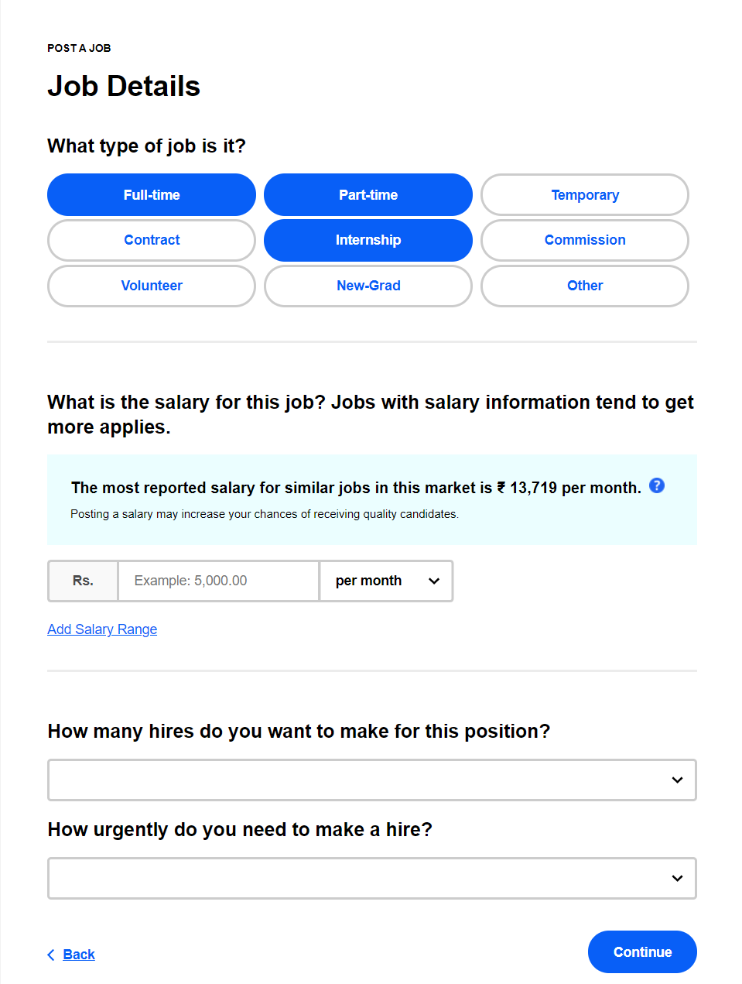

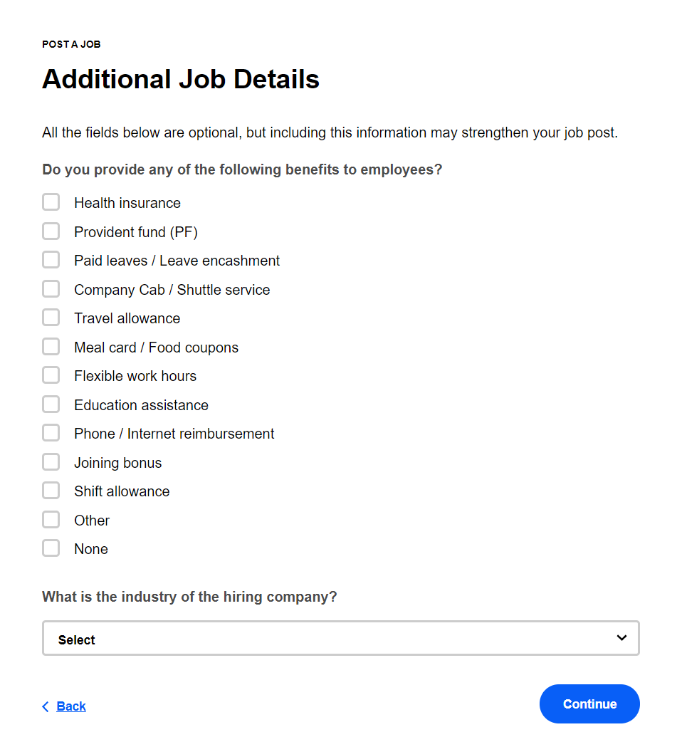

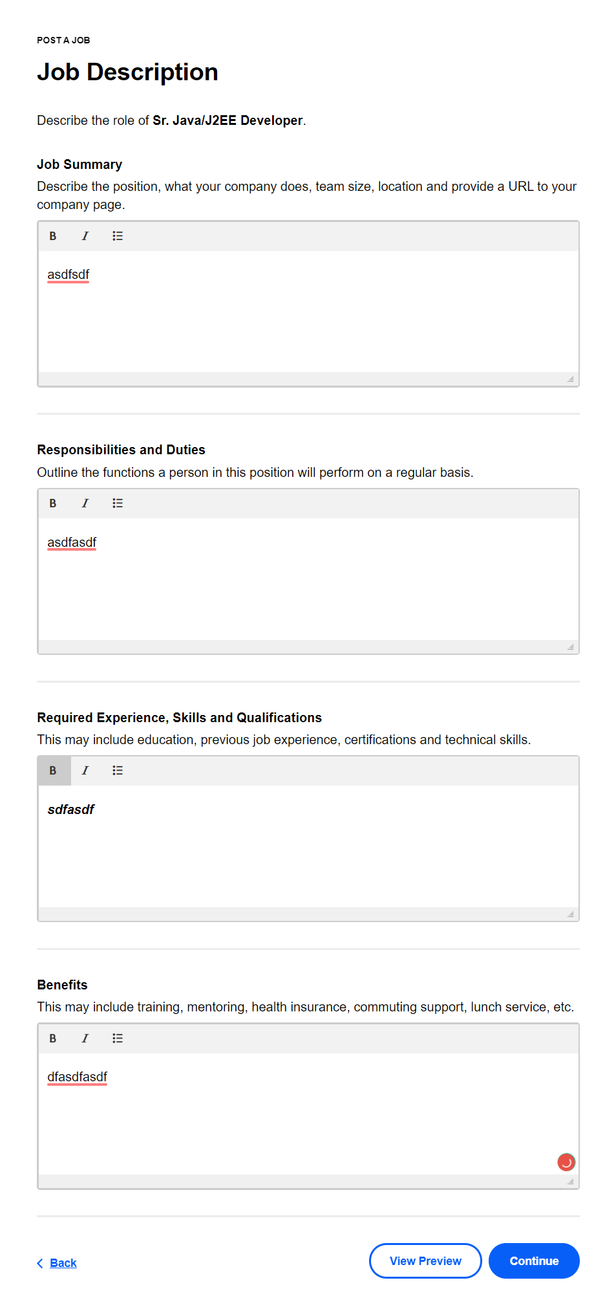
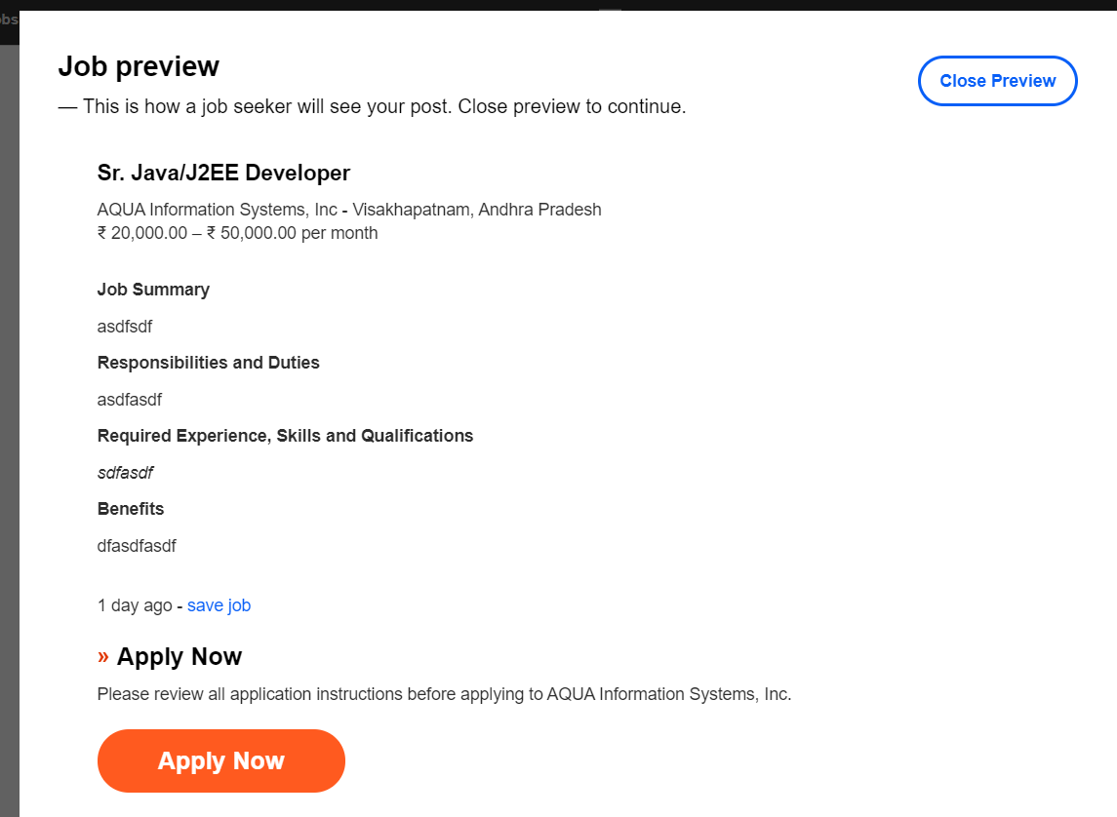

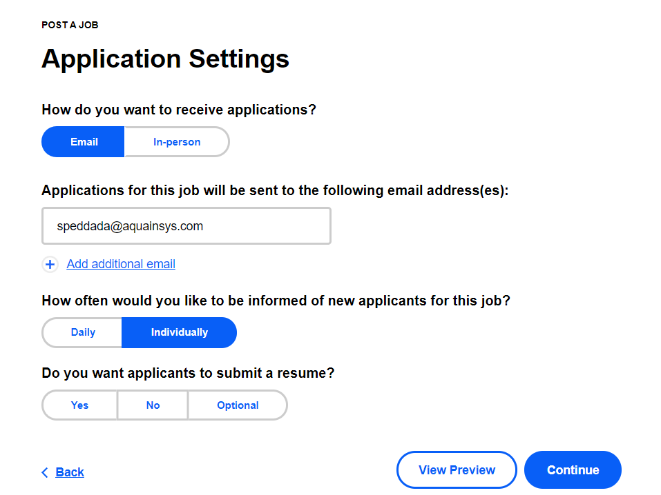

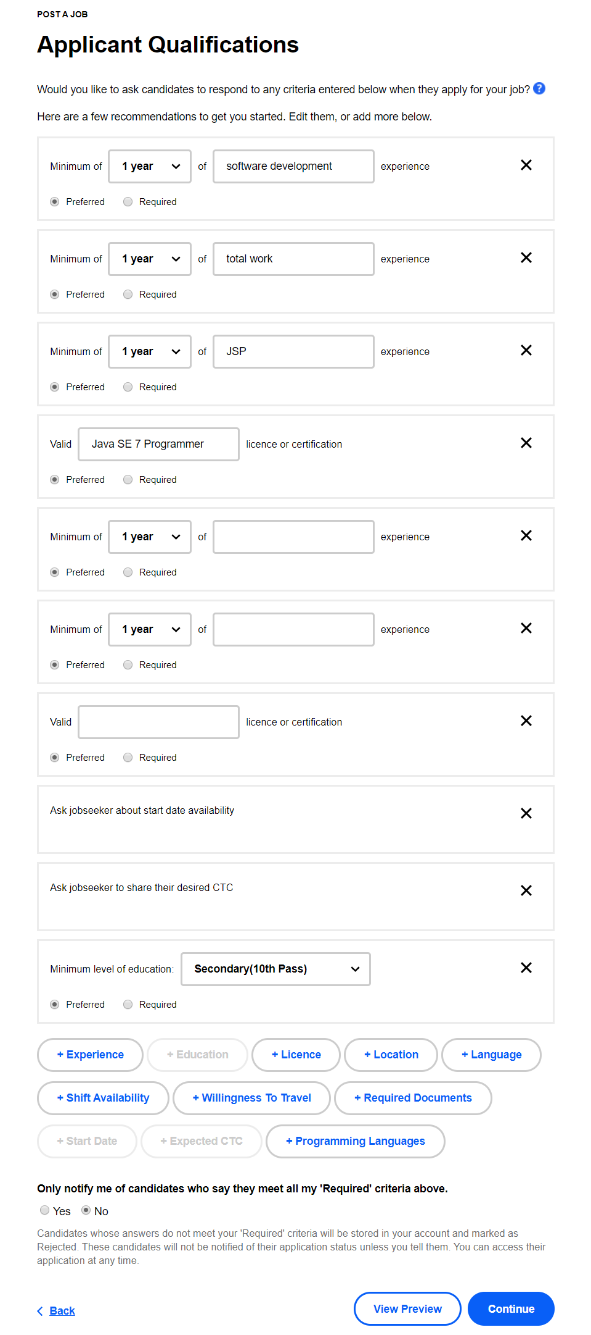
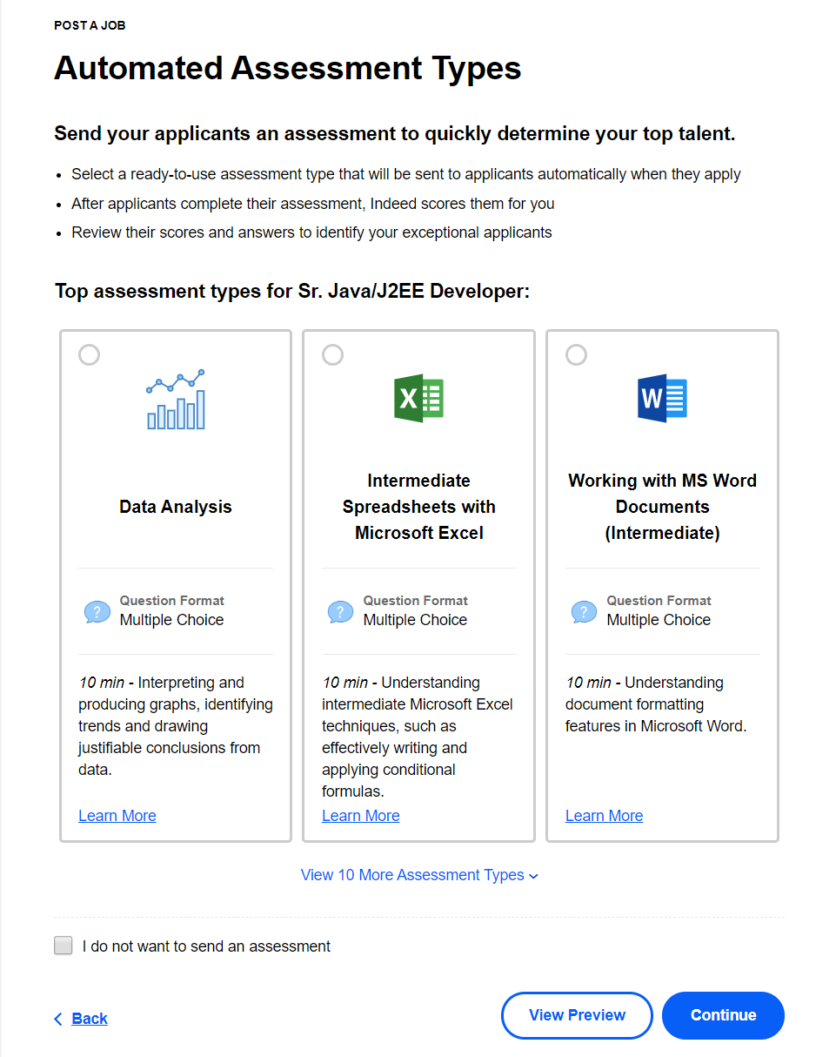

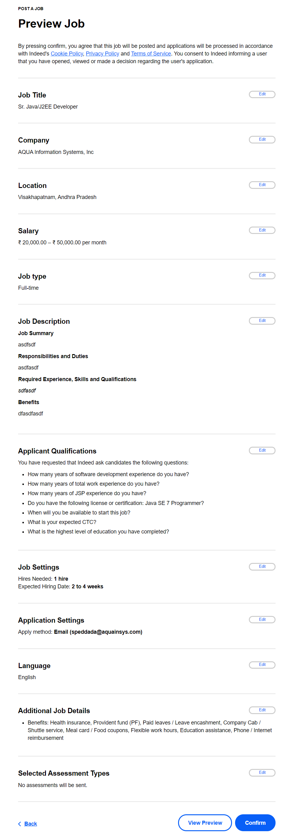
3. As an Employer, I shall be able to view the posted jobs

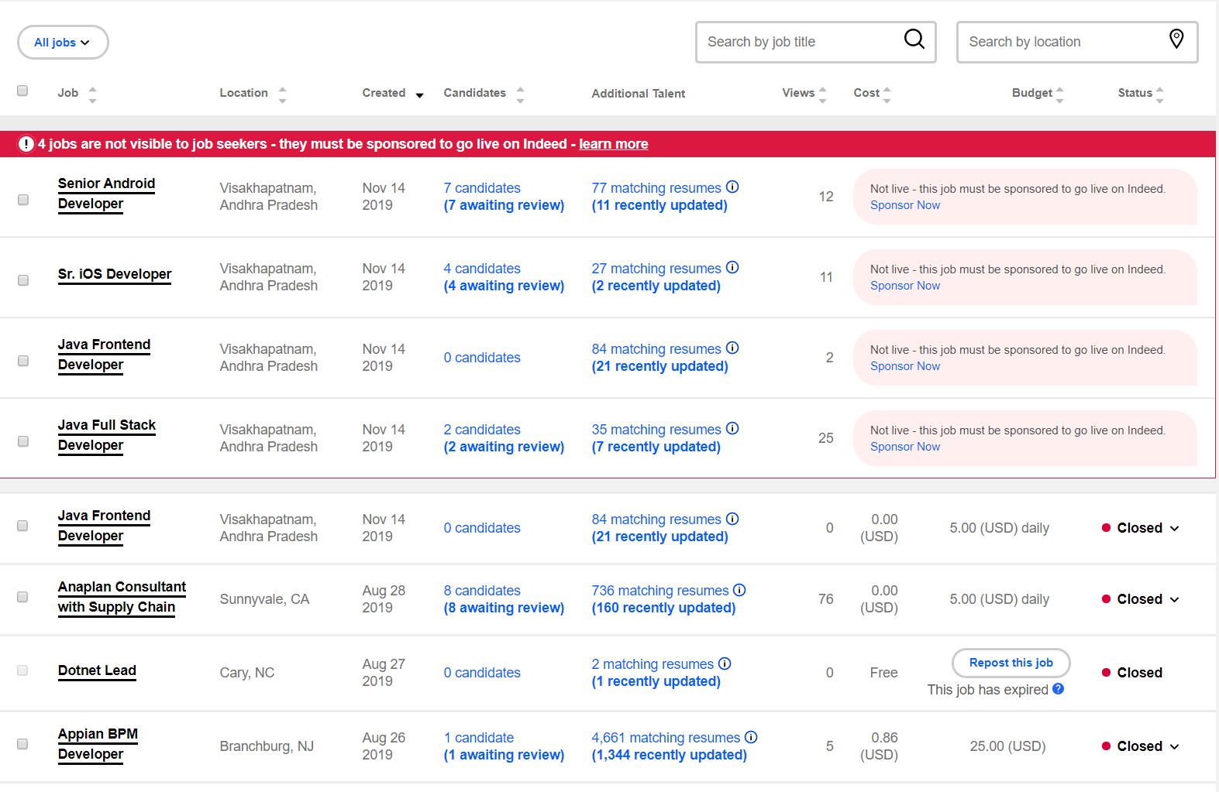

1. Job Dashboard:
Contains the list of Jobs posted in the application. User can search the Jobs by multiple Keywords, Location. (Contract, Freelance, Full Time, Internship, Part Time, Remote, Temporary). Any user can search Jobs using the Job Dashboard page. To apply or post a Job the user need to login to the application.

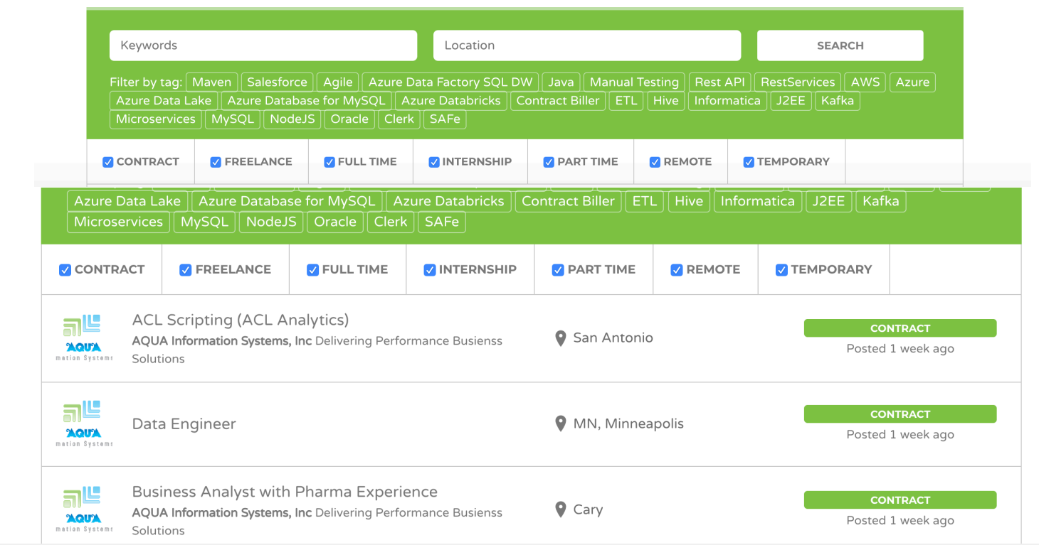

Questions:
Does the user needs to login to the application to view this screen? Not required
How does the location value is provided in the Location Text Box? Is it auto populated or how?
Does the displayed tags are pre-populated? Or Admin will save them in Database?

2. Post Job:
Employer can post a Job.

Questions:
What are the fields of the Post Job functionality?

3. View Jobs:
Employer can view the jobs posted by him and can edit, activate or deactivate the job. Only active Jobs will be displayed in the Job Dashboard. Job will be automatically deactivated after 90 days.

4. Company Profile:
Employer save, update the company profile.

5. Manage Subscriptions:
Employer can manage subscriptions

6. Candidate Dashboard:
Candidate can view his/her own dashboard. It contains the Candidate Profile. He can manage the resumes he uploaded. He can edit his own resume.

