**ICONS**

**Opened Mail**

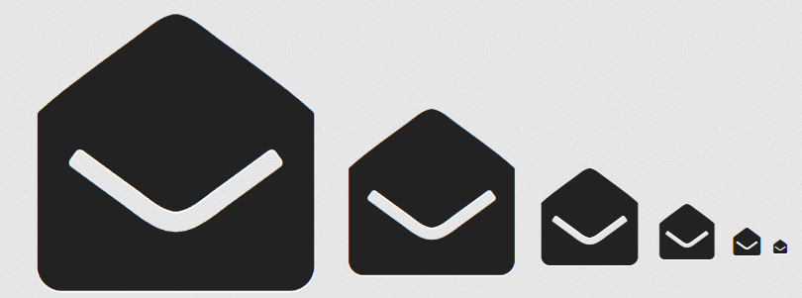

<i class="fa fa-envelope-open" aria-hidden="true"></i>

**User**

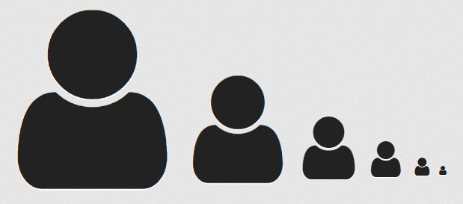

<i class="fa fa-user" aria-hidden="true"></i>

**Settings**

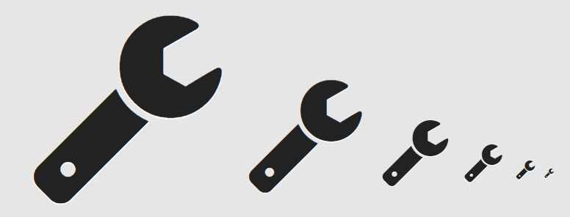

<i class="fa fa-wrench" aria-hidden="true"></i>

**Cancel or Delete**

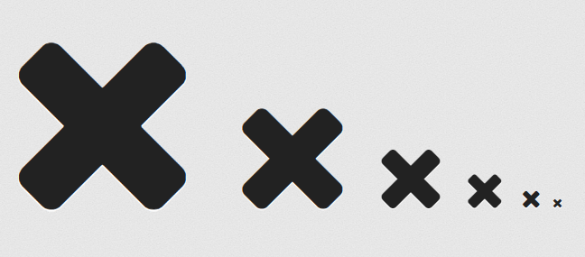

<i class="fa fa-times" aria-hidden="true"></i>

**Search**

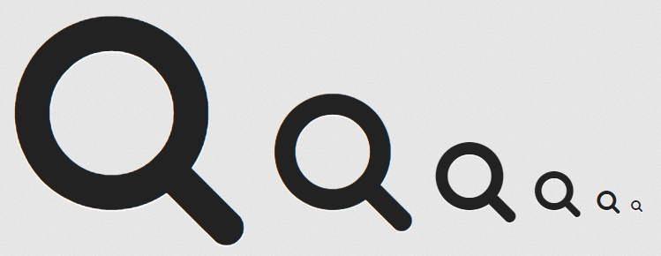

<i class="fa fa-search" aria-hidden="true"></i>

**Picture**

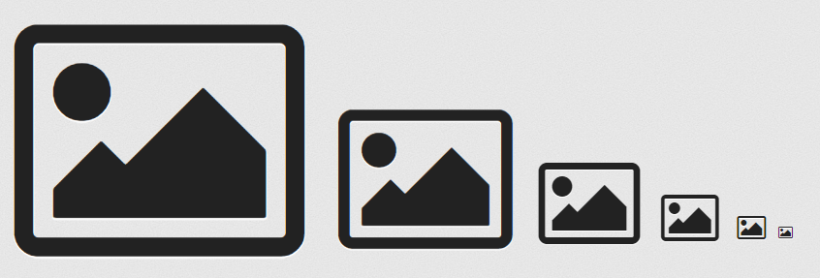

<i class="fa fa-picture-o" aria-hidden="true"></i>

**Dashbord**

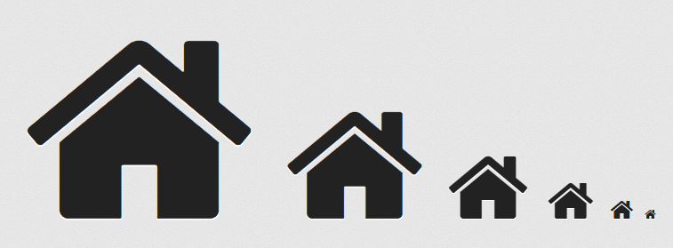

<i class="fa fa-home" aria-hidden="true"></i>

**Badges**



<i class="fa fa-graduation-cap" aria-hidden="true"></i>

**Mail**

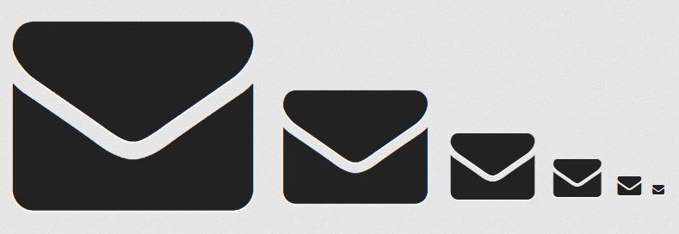

<i class="fa fa-envelope" aria-hidden="true"></i>

**Badges 2**

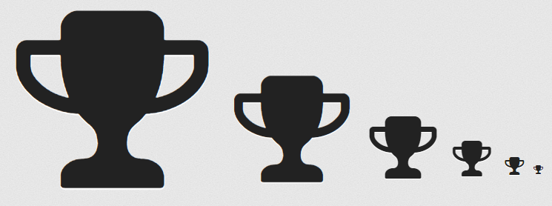

<i class="fa fa-trophy" aria-hidden="true"></i>

**Calendar**



<i class="fa fa-calendar" aria-hidden="true"></i>

**Group**

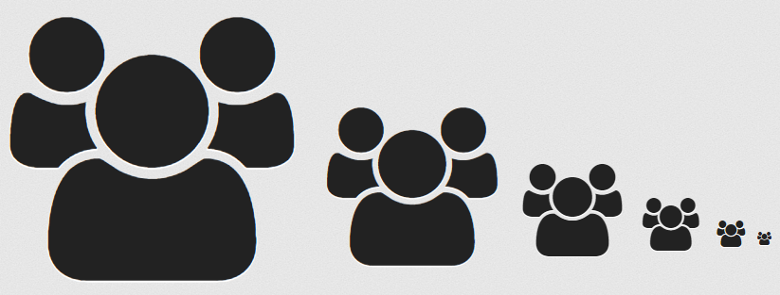

<i class="fa fa-users" aria-hidden="true"></i>

**Dollar**

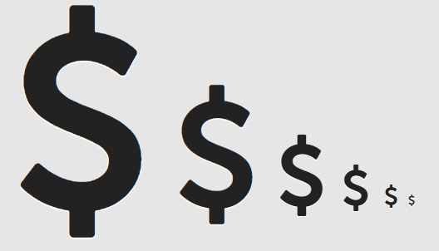

<i class="fa fa-usd" aria-hidden="true"></i>

**Hours**

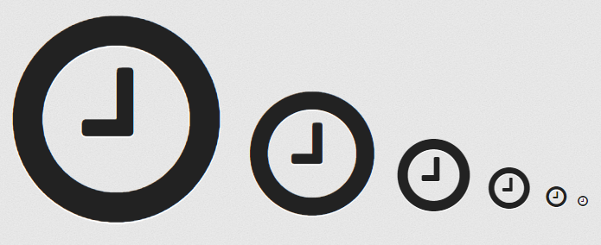

<i class="fa fa-clock-o" aria-hidden="true"></i>

**Notification**

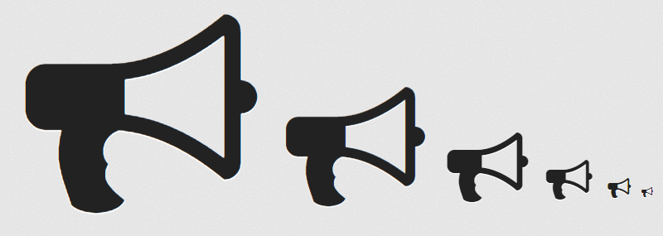

<i class="fa fa-bullhorn" aria-hidden="true"></i>

Report

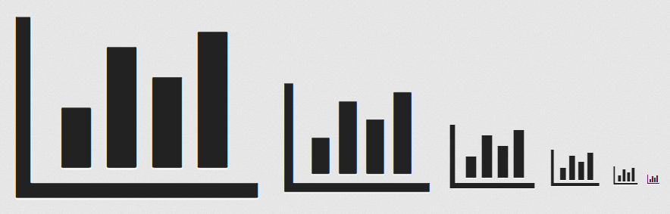

<i class="fa fa-bar-chart" aria-hidden="true"></i>

**Company**

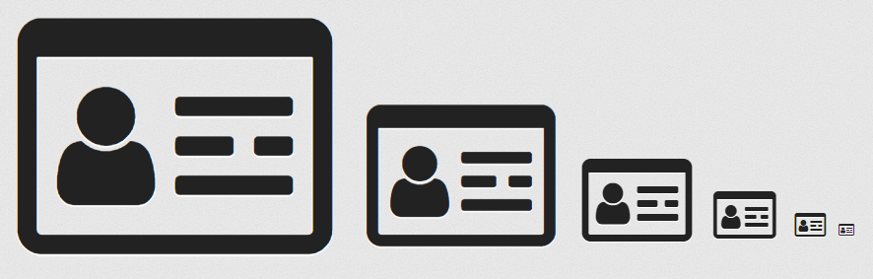

<i class="fa fa-id-card-o" aria-hidden="true"></i>

**Data**

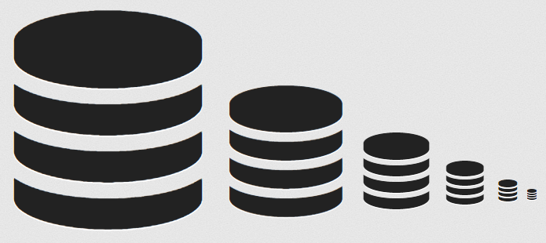

<i class="fa fa-database" aria-hidden="true"></i>

**Extra Icons**

**Flag**

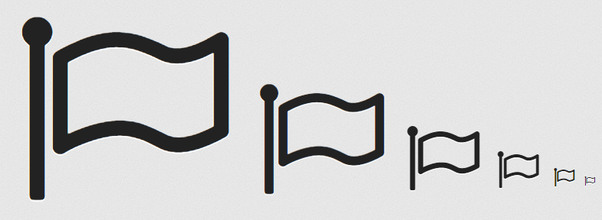

<i class="fa fa-flag-o" aria-hidden="true"></i>

**Check**

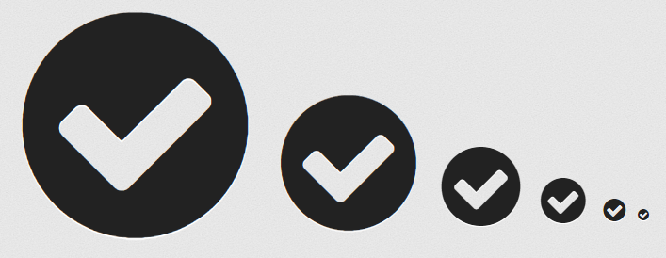

<i class="fa fa-check-circle" aria-hidden="true"></i>

**Un-check**

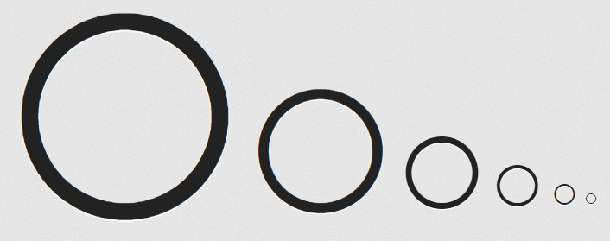

<i class="fa fa-circle-thin" aria-hidden="true"></i>

**Block**

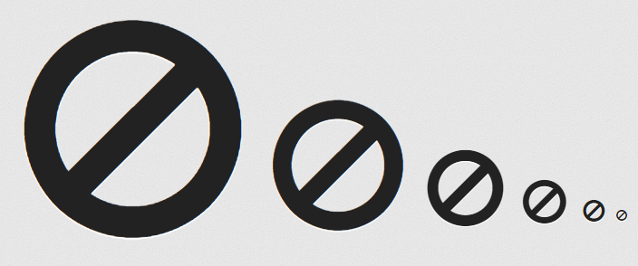

<i class="fa fa-ban" aria-hidden="true"></i>

**Edit**

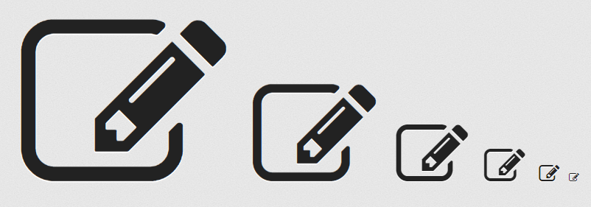

<i class="fa fa-pencil-square-o" aria-hidden="true"></i>

**Adding**

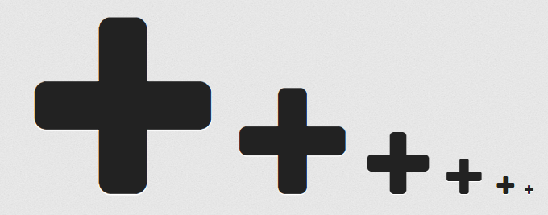

<i class="fa fa-plus" aria-hidden="true"></i>

**Prove or Check**

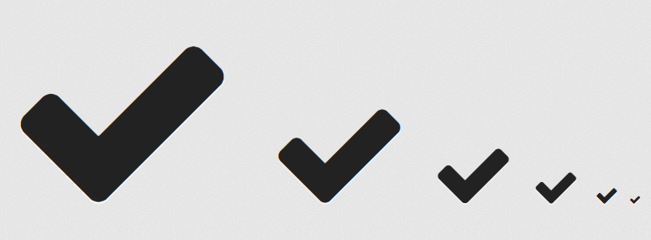

<i class="fa fa-check" aria-hidden="true"></i>

**Like**



<i class="fa fa-thumbs-o-up" aria-hidden="true"></i>

**Question**

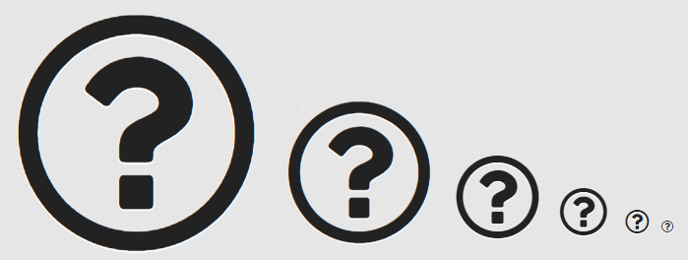

<i class="fa fa-question-circle-o" aria-hidden="true"></i>