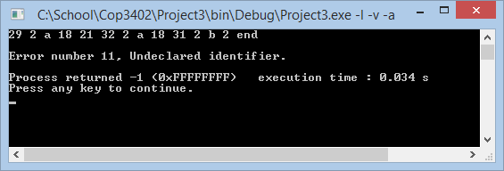**Error 11**

**var a;**

**begin**

**read a;**

**write b**

**end**

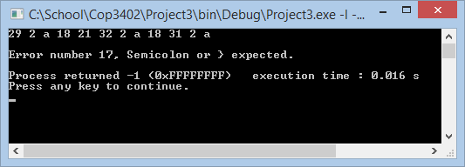

**Error 17**

**var a;**

**begin**

**read a;**

**write a**

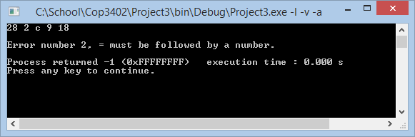

**Error 2**

**const c = ;**

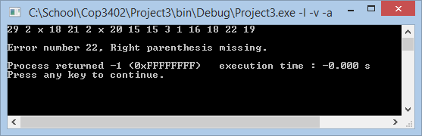

**Error 22**

**var x;**

**begin**

**x := ((1);**

**end.**

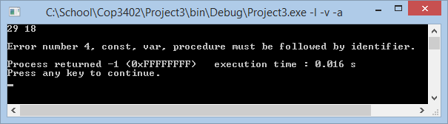**Error 4**

**var ;**

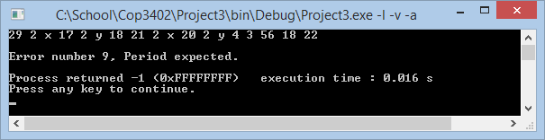

**Error 9**

**var x, y;  
begin  
 x := y + 56;  
end**

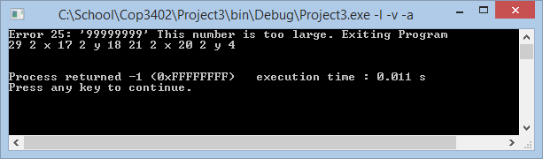

**Error 25**

**var x, y;  
begin  
 x := y + 99999999;  
end.**

**Error 16**

**const small = 0, large = 1;**

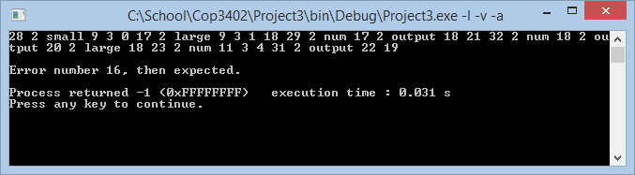**var num, output;**

**begin**

**read num;**

**output := large;**

**if num < 4**

**write output**

**end.**

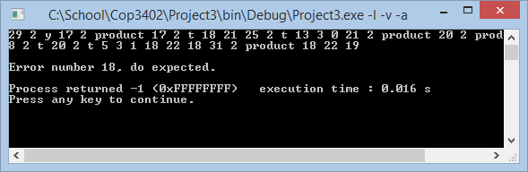**Error 18**

**var y, prdct, t;  
begin  
 while t > 0 begin  
 prdct := prdct + t;  
 t := t - 1;  
 end;  
 write product;  
end.**

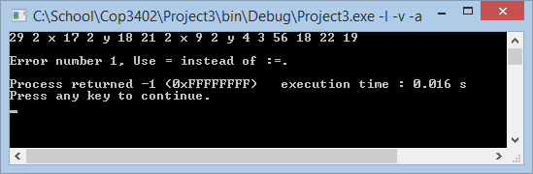

**Error 1**

**var x, y;  
begin  
 x = y + 56;  
end.**