

Project Design Specification

|  |  |  |
| --- | --- | --- |
| **Project Team** | | |
| **Student No** | **Firstname** | **Surname** |
| X12527037 | Giovanni | Antipala |
| X12374571 | Joanna | Bautista |
|  |  |  |

Caffeine Addict.com

Date: 26/03/13

Author: Joanna Bautista

**CONFIDENTIAL**

# Document History

## Revision History

|  |  |  |  |
| --- | --- | --- | --- |
| **Revision date** | **Previous revision date** | **Summary of Changes** | **Changes marked** |
|  |  | First issue |  |

## Approvals

This document requires the following approvals:

|  |  |  |  |
| --- | --- | --- | --- |
| **Name** | **Title** | **Date of Issue** | **Version** |
|  | Team Member 1 |  |  |
|  | Team Member 1 |  |  |
|  | Team Member 1 |  |  |

TABLE OF CONTENTS

1. Document History 2

1.1. Revision History 2

1.2. Approvals 2

2. Overview 4

2.1. Purpose of the document 4

2.2. Requirements Section 4

2.3. Business Rules 4

3. process deFINITION 5

3.1. Process Flow/Wireframe 5

4. Functional Decomposition 6

4.1. Function Description 6

4.2. Non- Function Description 6

5. User Interface Design 7

5.1. UI Description 7

6. Test Design 8

6.1. Test Plans 8

7. User manual 9

7.1. Special Instructions 9

7.2. User Instructions (games only) 9

# Overview

## Purpose of the document

The purpose of this document is to define and describe the functional design of the Multimedia project. It will be submitted in full support of the project demonstrated.

## Requirements Section

### Source

*Whose requirement is this? What research has being carried out?*

### Requirement Description

*This should be a detailed account of all requirements, with each detailed functional requirement numbered so it can be linked to the functional design and test plan*

|  |  |  |  |
| --- | --- | --- | --- |
| Req No | Description | Section | Recorded by |
| R1 |  |  |  |
| R2 |  |  |  |
|  |  |  |  |
|  |  |  |  |

## Business Rules

### Details

*Please list the Business rules that surround and govern this project.*

# process deFINITION

## Process Flow/Wireframe

Give a high level description of what the project consists of, please use as many flow diagrams or wireframes as required.

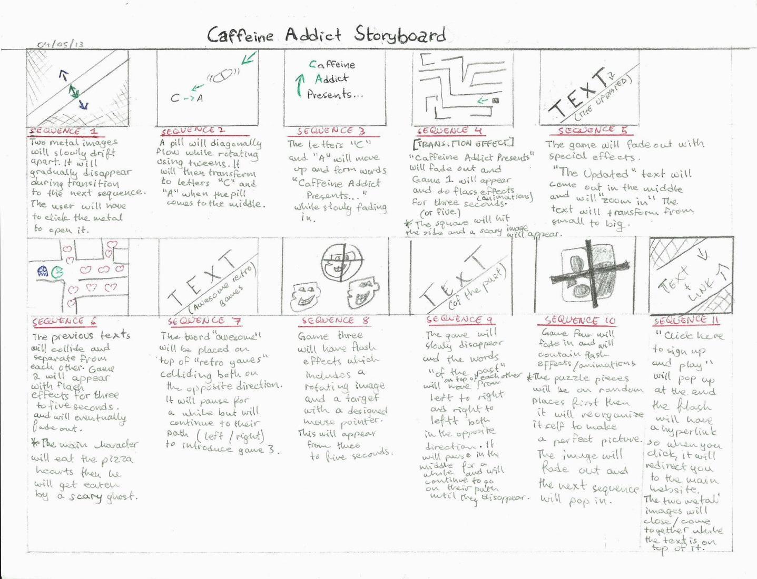

# Functional Decomposition

## Function Description

*All functions should be documented in detail in this section and they should all be linked to a specific requirement*

|  |  |  |  |
| --- | --- | --- | --- |
| Function No | Description | Req No | Developed By |
| F1 |  |  |  |
| F2 |  |  |  |
|  |  |  |  |
|  |  |  |  |

## Non- Function Description

*Functionality that is required for your system, but not directly related to the user requirements. (Functionality you create to enhance usability, accessibility etc.)*

|  |  |  |  |
| --- | --- | --- | --- |
| Function No | Description | Reason Required | Developed By |
| F1 |  |  |  |
| F2 |  |  |  |
|  |  |  |  |
|  |  |  |  |

# User Interface Design

## UI Description

This section should exist for each UI (e.g. screen/web page) and should give a description and diagram of the UI, and the details of its use. This should include

* *Display/Entry field description & validation,*
* *Option field description,*
* *Data inputs/outputs,*
* *User Roles,*
* *Error Handling,*

# Test Design

## Test Plans

This section should list out the tests that will be carried out on the project and record the results. This should include

* *All functionality to be tested*
* *Data or instructions to be used in the test*
* *Expected Results*
* *Actual results,*
* *Comments*
* *How the error was fixed and retested*

# User manual

## Special Instructions

This section should list out the any specific system requirements prior to running or installing.

## User Instructions (games only)

This section should list out the the full instructions as to how to play this game.