

Project Design Specification

|  |  |  |
| --- | --- | --- |
| **Project Team** | | |
| **Student No** | **First name** | **Surname** |
| X12527037 | Giovanni | Antipala |
| X12374571 | Joanna | Bautista |

CaffeineAddicts.com

Date: 26/03/13

Author: Joanna Bautista

**CONFIDENTIAL**

# Document History

## Revision History

|  |  |  |  |
| --- | --- | --- | --- |
| **Revision date** | **Previous revision date** | **Summary of Changes** | **Changes marked** |
|  |  |  |  |

## Approvals

This document requires the following approvals:

|  |  |  |  |
| --- | --- | --- | --- |
| **Name** | **Title** | **Date of Issue** | **Version** |
| Giovanni Antipala | Team Member 1 | 9th April 2013 | 1 |
| Joanna Bautista | Team Member 1 | 9th April 2013 | 1 |

TABLE OF CONTENTS

1. Document History 2

1.1. Revision History 2

1.2. Approvals 2

2. Overview 4

2.1. Purpose of the document 4

2.2. Requirements Section 4

2.3. Business Rules 4

3. process deFINITION 5

3.1. Process Flow/Wireframe 5

4. Functional Decomposition 6

4.1. Function Description 6

4.2. Non- Function Description 6

5. User Interface Design 7

5.1. UI Description 7

6. Test Design 8

6.1. Test Plans 8

7. User manual 9

7.1. Special Instructions 9

7.2. User Instructions (games only) 9

# Overview

## Purpose of the document

The purpose of this document is to define and describe the functional design of the Multimedia project. It will be submitted in full support of the project demonstrated.

## Requirements Section

### Source

CaffeineAddicts.com is an independent company that consists of ten employees. It is founded on the 20th of January 2013. There were no investments received from a known investor. It is a partnership business run and owned by Giovanni Antipala and Joanna Bautista who both holds a Bachelor of Science Degree in Computing at the National College of Ireland. They have an experience working as a Manager Assistant in Dell and Microsoft Company. CaffeineAddicts.com offers a variety of games in which made Giovanni and Joanna become interested on investing to a Software company that would provide them a great medium to use for editing graphics and animations.

CaffeineAddicts.com contemplates on running an e-commerce partnership business in Dublin Ireland. The company will be retailing high definition games on which the consumers could choose among downloading it online or have the CD delivered.

Our company offers high quality games that feature a great definition of graphics for a better view on the screen. CaffeineAddicts.com focuses to become a low-cost leader which could help to increase marketing sales; as well as that it will also benefit the customers with satisfaction.

Our Strategy will consist of creating free online games as a sample for the consumers to see if the game will become popular. We will also set up a Facebook account to promote sales and encourage people to go on our website.

**Research**

Our company creates brilliant games made by our excellent graphic designers and developers. The products are mainly based on the last generation's retro games. We are going to revamp as much games as possible to provide much more enhanced entertainment.

Caffeine Addicts’ games are mostly inspired by Miniclips.com which includes a wide range of unique and modern games. Our plan is to recreate sophisticated retro games which will have new implementations by us.

The first best thing that we offer that only a few gaming websites could have is our special made advertisements. What comes in our advertisements will be our games with a few exciting demonstrations being portrayed. We will be displaying videos, promotions and sales on Facebook, Twitter and Youtube.

The design and graphics of our website are unique and the functionality is excellent. The overall design of CaffeineAddicts.com has achieved its minimalistic appearance, which other gaming sites fail to do so.

The strategic games that our website proposes are not as complicated and boring like other website tend to have. We will have free demonstration games to provide the users a bit of experience and to help them decide whether our products are good enough and to know what more we could improve on.

We will be implementing new things on the old retro games to make it much more fun and appeasing for the users. A research has been done and only a few has the implementations of “meme” faces on their games. The “meme” faces went viral just recently, therefore we have the ability to produce a much more enhanced games.

### Requirement Description

*This should be a detailed account of all requirements, with each detailed functional requirement numbered so it can be linked to the functional design and test plan*

|  |  |  |  |
| --- | --- | --- | --- |
| Req No | Description | Section | Recorded by |
| R1 | Company Overview | Giovanni Antipala  Joanna Bautista | Joanna Bautista |
| R2 | Create and edit graphics for the website | Giovanni Antipala | Joanna Bautista |
| R3 | Build a Website | Giovanni Antipala | Joanna Bautista |
| R4 | Create and edit images in fireworks for the advertisement | Joanna Bautista | Joanna Bautista |
| R5 | Combines all the images to create the Advertisement in flash | Joanna Bautista | Joanna Bautista |
| R6 | Embed the flash advertisement on the website | Giovanni Antipala  Joanna Bautista | Joanna Bautista |

## Business Rules

### Details

1. Campaign shouldn’t be long as five minutes.
2. The website should have a user friendly interface.
3. Facebook and twitter should only post sales and promotion.
4. The Youtube website must only contain promotions and advertisements with a few previews of our games.

# process deFINITION

## Process Flow/Wireframe

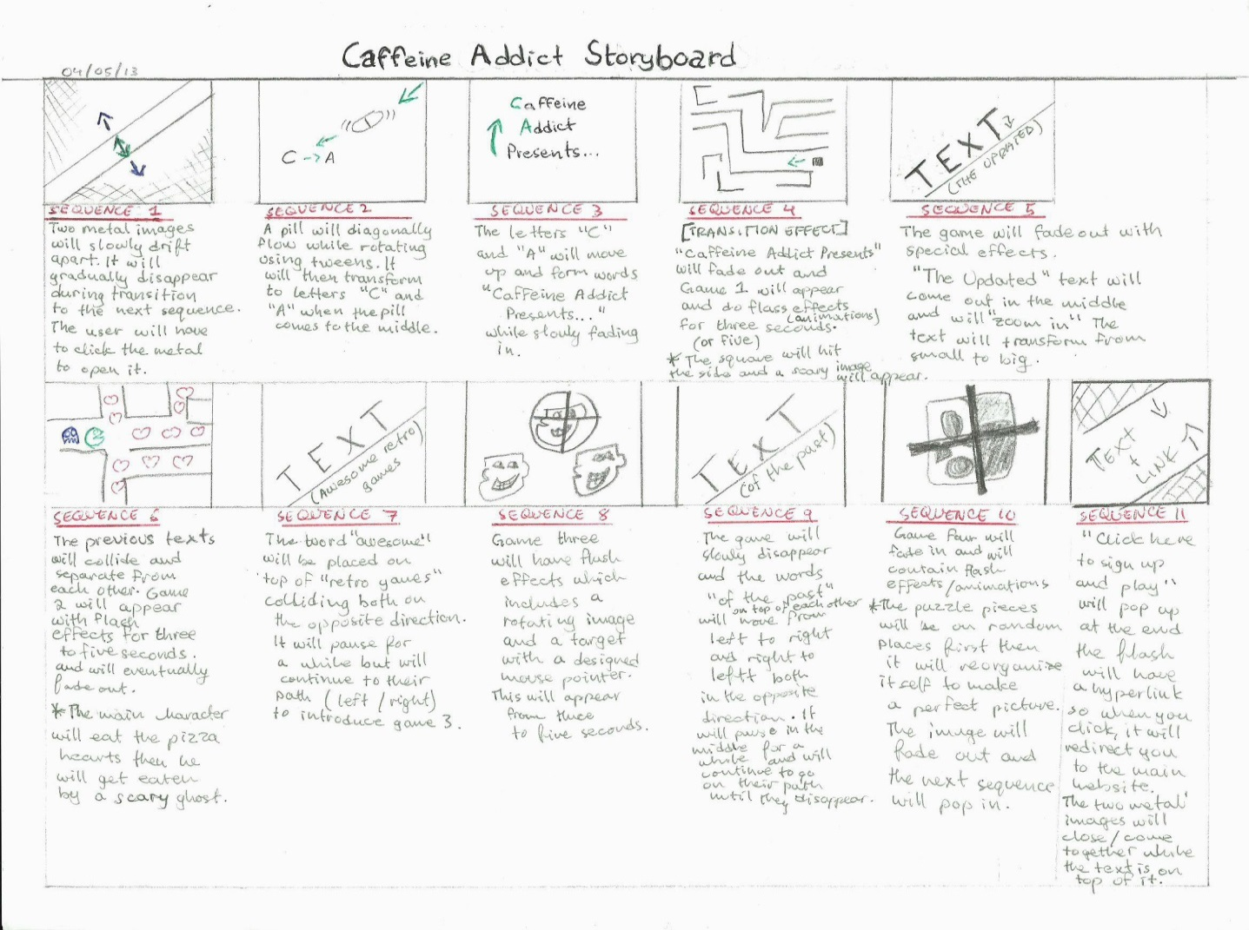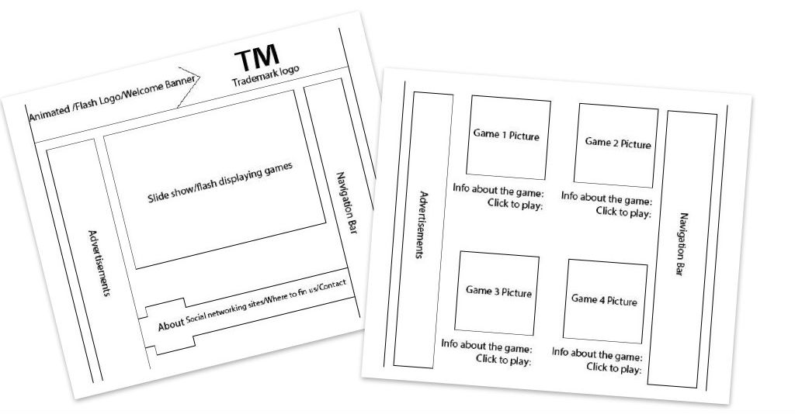

Website Wireframe

# Functional Decomposition

## Function Description

*All functions should be documented in detail in this section and they should all be linked to a specific requirement*

|  |  |  |  |
| --- | --- | --- | --- |
| Function No | Description | Req No | Developed By |
| F1 | Create graphics for the website | R2 | Giovanni Antipala |
| F2 | Build the website | R3 | Giovanni Antipala |
| F3 | Create and edit graphics in Fireworks for the advertisement | R4 | Joanna Bautista |
|  |  |  |  |

## Non- Function Description

*Functionality that is required for your system, but not directly related to the user requirements. (Functionality you create to enhance usability, accessibility etc.)*

|  |  |  |  |
| --- | --- | --- | --- |
| Function No | Description | Reason Required | Developed By |
| F1 | Use Adobe Fireworks, Blender and Adobe Flash | To create games and graphics. | Joanna Bautista |
| F2 | Embed the flash advertisement on the website | To display the advertisement of the games on the main website. | Giovanni Antipala |
|  |  |  |  |
|  |  |  |  |

# User Interface Design

## UI Description

This section should exist for each UI (e.g. screen/web page) and should give a description and diagram of the UI, and the details of its use. This should include

* *Display/Entry field description & validation,*
* *Option field description,*
* *Data inputs/outputs,*
* *User Roles,*
* *Error Handling,*

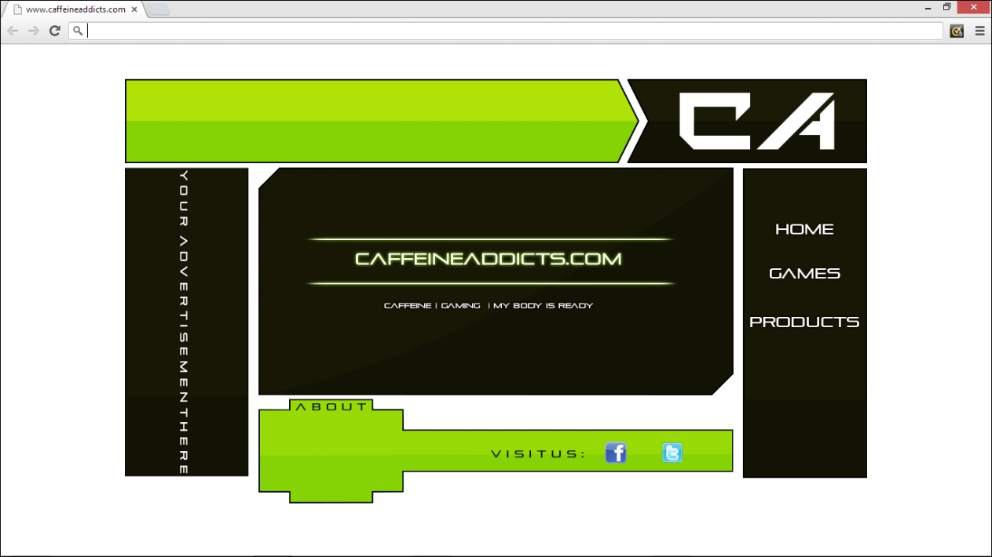

CaffeineAddicts.com is a gaming website that accommodates premium Retro

Games to all the game lovers on the internet. It has a validated code, meaning it

can be viewable on different internet browsers without having any errors.

# Test Design

## Test Plans

This section should list out the tests that will be carried out on the project and record the results. This should include

* *All functionality to be tested*
* *Data or instructions to be used in the test*
* *Expected Results*
* *Actual results,*
* *Comments*
* *How the error was fixed and retested*

Our website contains three pages overall. The right-hand side of our site has the navigation control and is always visible when you navigate to a different page of our website. It will have the “Home”, “Games” and “Products” buttons. The “Home” button will redirect you to the main page. The “Games” button will redirect you to our advertisement and game images. The “Products” button will link you to the games that we sell.

The advertisement could be embed in the “Games” page by converting the flash file into a different format of video, and then upload it in Youtube, or we could try to convert it in gif format and have it automatically playing on our website. The users will need flash to be able to play the clip.

# User manual

## Special Instructions

This section should list out the any specific system requirements prior to running or installing.

## User Instructions (games only)

This section should list out the the full instructions as to how to play this game.