**Multimedia Project Proposal**

**Giovanni Antipala -** x12527037

**Joanna Bautista** – x12374571

**Project Background**

Our project is about a gaming website that provides basic, fun and addictive games for anyone who is an absolute game lover. We chose the title “CaffeineAddict.ie” for our website as it represents the content of an energy drink that makes a person become more enthusiastic. The four games will consist of two different types of maze, a shooter and a puzzle. Each will be constructed using the programs Adobe Fireworks and Adobe Flash.

**Website - Wireframe**

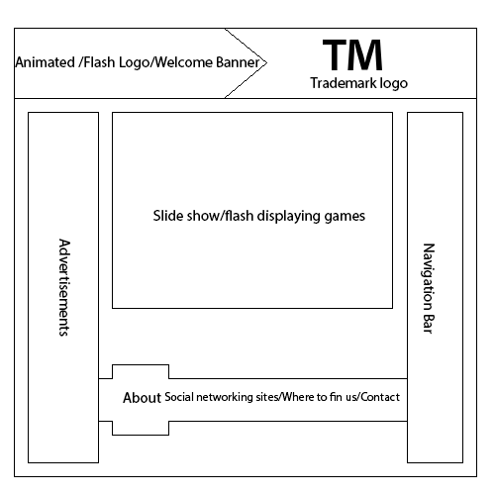

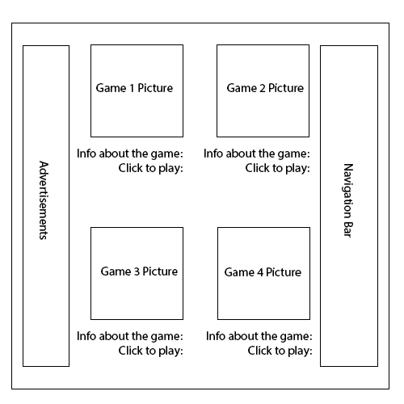

**Proposed Games**

**Game 1**

*Maze 1*

This game will require high concentration from the users. They have to prevent themselves from touching the edge or getting lost in the maze in order to be successful. Losing the game will have a consequence. A terrifying surprise will wait at the very end. Arrow keys will be used to move around.



**Game 2**

*Maze 2*

Modern version of the retro game “Pacman” will be the concept of this game. The player needs to collect all the dots and pizzas. The enemies will follow around and will try to capture the player. They have to do it really quick or else they will lose the game. The keyboard arrow keys will be used to make the character move.

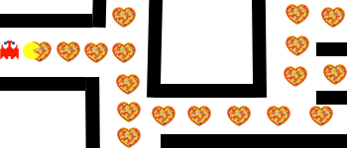

**Game 3**

*Shooter*

The Shooter player will be using an arrow and a bow to aim for the moving target which is a troll face. Only three shots will be given to the player. If they failed to hit the target, then that means they lose the game. The mouse will be used to control the bow.

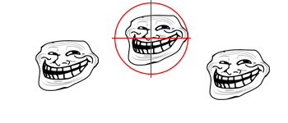

(These are moving targets)

**Game 4**

*Puzzle*

This game involves a brain exercise. The player will have to memorize the whole picture. It will then be broken into small pieces. We need to put it all back together to win the game.

The puzzle pieces can be dragged using the mouse.



**Marketing Campaign**

*How are we going to be popularized?*

Our goal is to be known well by all the game lovers in the world.

* First we will look at various websites to see if they have our ideas and also to discover an inspiration.
* We will be creating a Facebook page for our friends or other people to like it and make it popular.
* We are going to give trials for a few people and ask for a feedback
* If our ideas clicked with everyone, then we will create and post videos to advertise in Youtube as well as Facebook.