**Julio Pochet Edmead**

**02/01/2025**

**Module 4.2 Assignment: MySQL Install**

**Initial Database Connection:**

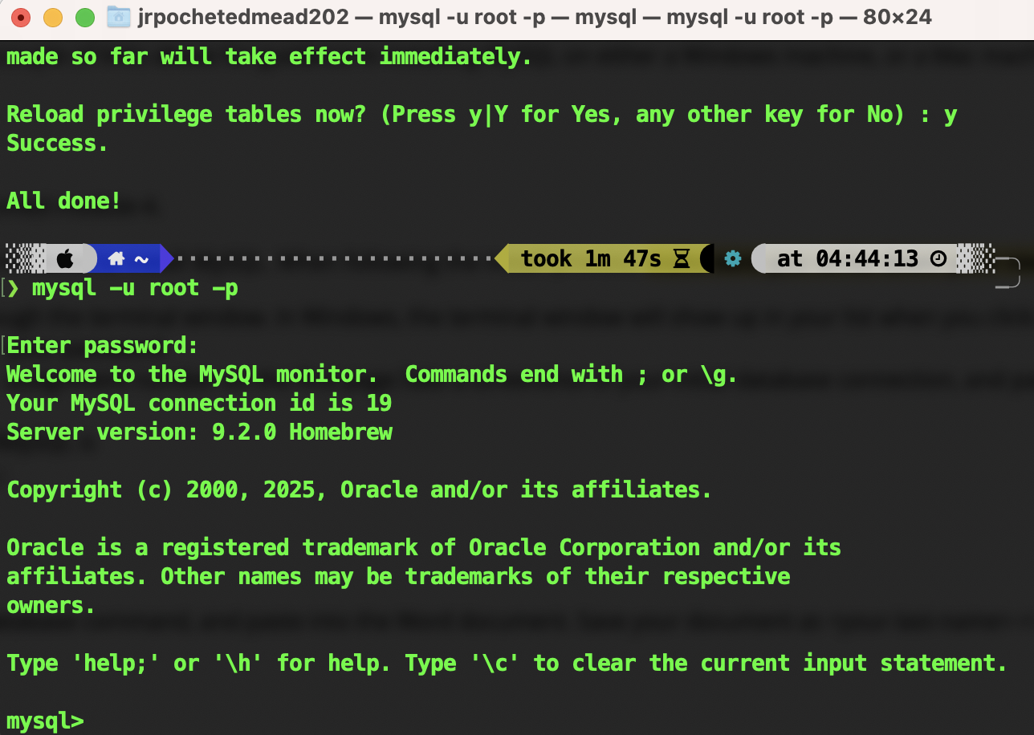

**Show Databases:**

