**Julio Pochet Edmead**

**02/01/2025**

**Module 5.2 Assignment: MySQL Functions**

**1. NOW() – Retrieve Current Date and Time**

**📌 Purpose:**

* Retrieves the **current date and time** in the format YYYY-MM-DD HH:MM:SS.
* Used to **log timestamps** for record creation and updates.

**📝 SQL Query with Alias:**

SELECT NOW() AS 'Current Timestamp';

**📷 Screenshot:**

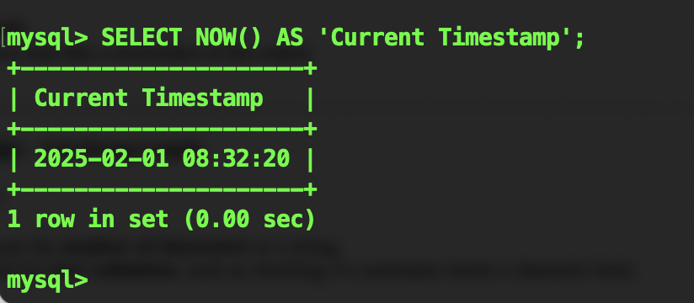

**2. LENGTH() – Get String Length**

**📌 Purpose:**

* Returns the **number of characters** in a string.
* Useful for **text validation**, such as checking if a username meets a character limit.

**📝 SQL Query with Alias:**

SELECT LENGTH('Pochet') AS 'Name Length';

**📷 Screenshot:**

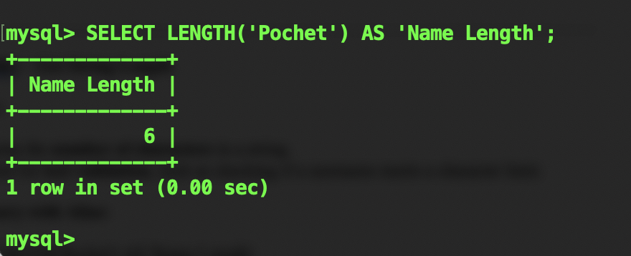

**3. ROUND() – Round Numbers**

**📌 Purpose:**

* Rounds a **floating-point number** to a specified number of decimal places.
* Useful for **financial calculations** where precision matters.

**📝 SQL Query with Alias:**

SELECT ROUND(123.4567, 2) AS 'Rounded Value';

**📷 Screenshot:**

