**Julio Pochet Edmead**

**02/08/2025**

**Module 6.2 Assignment:**

**Movies: Setup**

[**https://github.com/jpochetedmead/csd-310/tree/main/module-6**](https://github.com/jpochetedmead/csd-310/tree/main/module-6)

**First Screenshot: (Run the SQL script)**

**Screenshot (SHOW TABLES;) :**

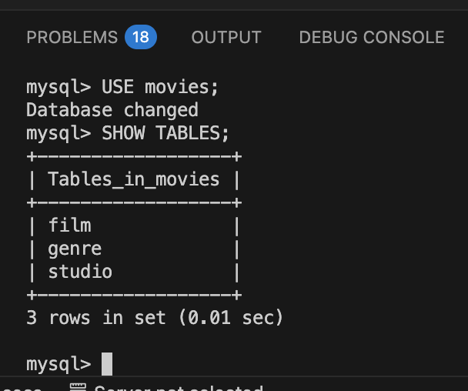

**MySQL: mysql_test.py.:**

