**Julio Pochet Edmead**

**Module 10.2 Assignment: GUI ToDo**

**Screenshot of the GUI Example:**

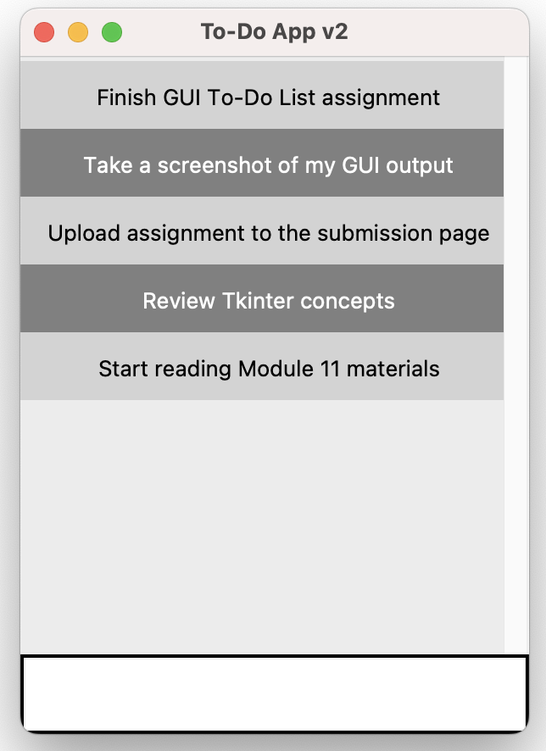

**Screenshot of the improved GUI after adding tasks:**

**Screenshot after deletion of a task:**

