Julio Pochet Edmead

**Module 2.2 Assignment: Documented Debugging + Flowchart(s)**

**Start the debugging process:**

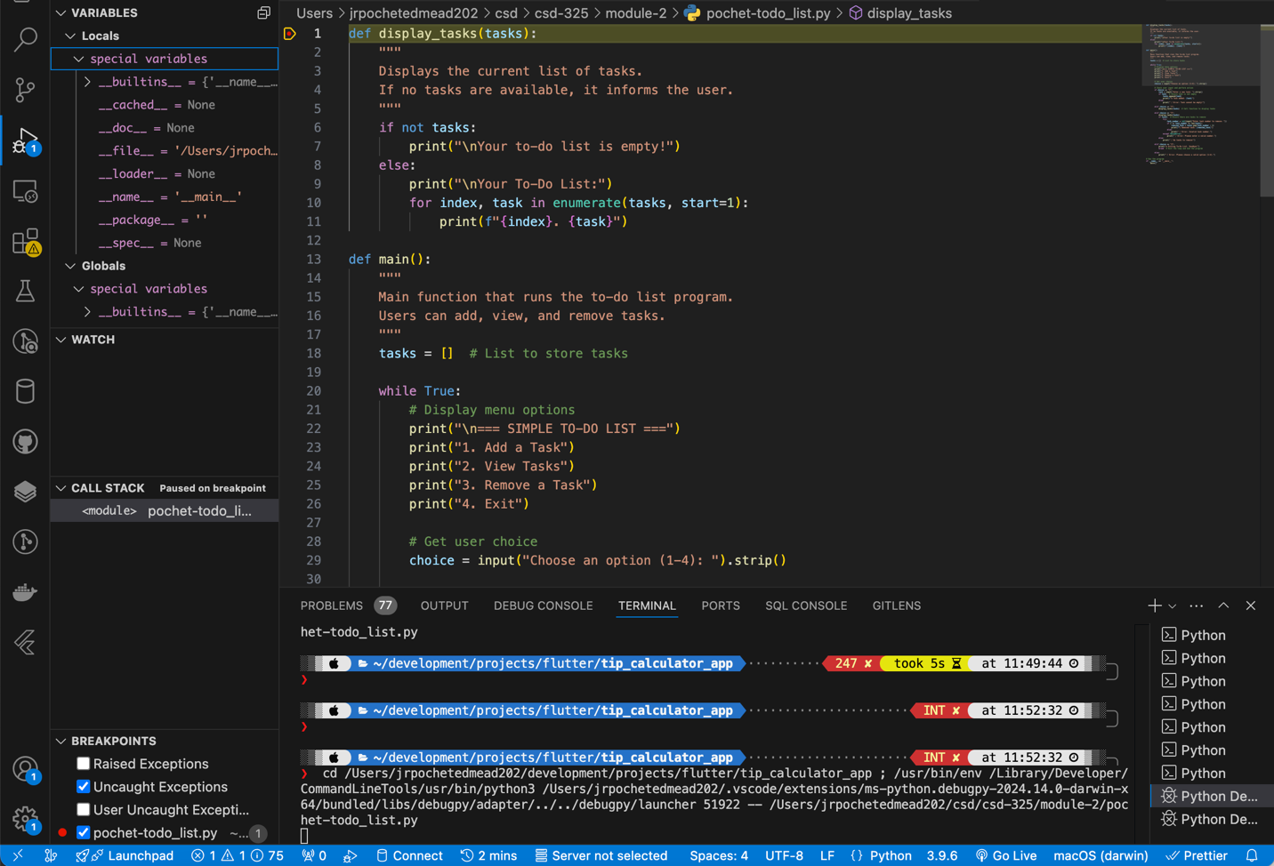

**Step Into the Function:**

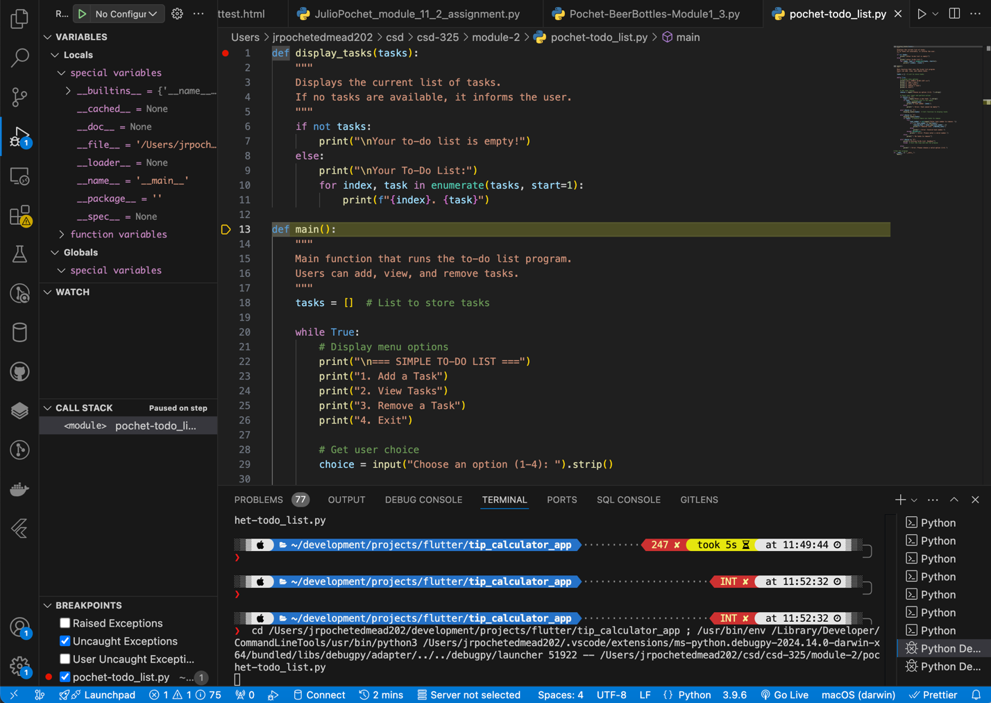

**Moving through the program:**

