**Julio Pochet Edmead**

**02/23/2025**

**Module 9.2 Assignment: APIs**

Testing the connection:

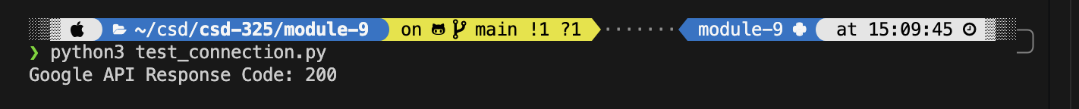

Retrieving current astronauts and formatting output:

Pokémon Type Strengths & Weaknesses Program Using PokéAPI :

