**Julio Pochet Edmead**

**03/22/2025**

**Module 1.3 Assignment: Building a Web Page Exercise, Part 1**

**GitHub Link:** [**https://github.com/jpochetedmead/csd-340/tree/main/module-1**](https://github.com/jpochetedmead/csd-340/tree/main/module-1)

**First Screenshot:**

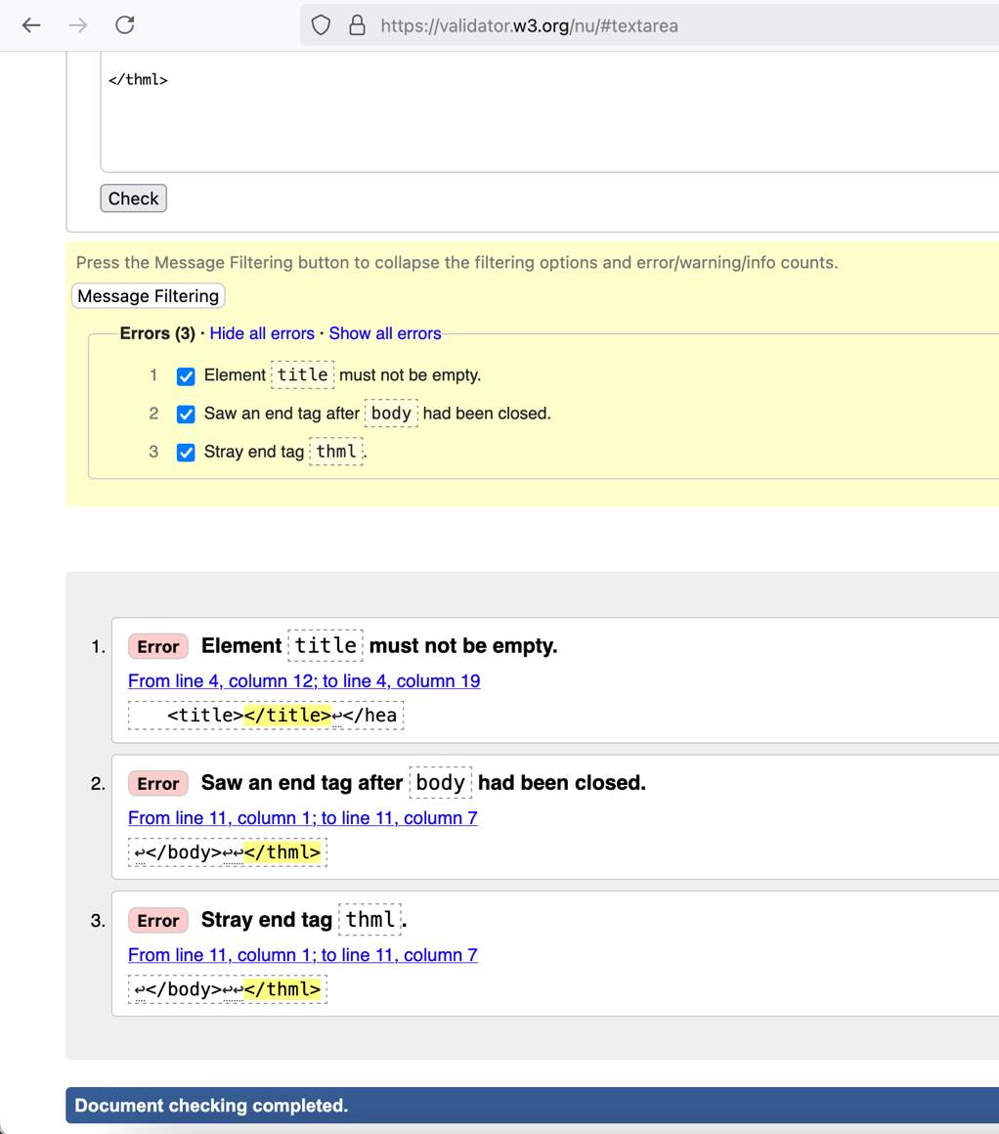

**Second Screenshot:**

**Third Screenshot:**

**Final Screenshot:**

