bioSite Project – Yismerlin Peña

Name: Julio Pochet Edmead

Course: CSD-340

Module 5.2 – Ideas, Sketches, and Inspiration

Date: 03/30/2025

# Project Summary

This bioSite project focuses on telling the story of Yismerlin, a dedicated mother and creative individual passionate about personal growth and family. The website will showcase her background, hobbies, goals, and accomplishments through thoughtful content, visual storytelling, and a consistent design approach. The final website will feature three main pages: Landing, About, and Hobbies.

# Interview with Yismerlin

• Q: Can you tell me a little about where you grew up and what your childhood was like?

A: I grew up in a rural area in the Dominican Republic with my aunt and her husband. My childhood was peaceful, surrounded by family and friends.

• Q: What’s a typical day like for you now?

A: I spend most of my time caring for my newborn daughter.

• Q: What are some things you love doing in your free time?

A: Going to the beach, visiting resorts, and watching movies.

• Q: Why do you enjoy going to the beach? Is it something you do often?

A: Yes, I go often. I love it because it helps me clear my mind and forget about problems.

• Q: What kind of books do you like to read? Do you have a favorite author or topic?

A: I enjoy reading poetry. I'm currently reading 'Carrusel de Mesedora' by Sabrina Román.

• Q: What type of movies do you enjoy the most? Do you prefer watching at home or in the theater?

A: I prefer watching horror movies at home.

• Q: What is a personal goal you’re currently working on?

A: I'm currently working on learning a new language – English.

• Q: How do you balance your goals with family responsibilities?

A: I organize my tasks in order of priority.

• Q: What is something you’re really proud of achieving so far?

A: I’m proud of having a stable and loving family.

• Q: What do you hope people feel or understand about you when they visit a site about your life? A: That I am a great mother. Haha.

# Biography of Yismerlin

Yismerlin is a dedicated mother, a lifelong learner, and a woman driven by creativity and love for her family. She was born and raised in a small town in the Dominican Republic, where she lived with her aunt and uncle. Her childhood was peaceful, surrounded by close-knit family and friends who helped shape her thoughtful and empathetic nature.  
  
Today, Yismerlin’s life centers around raising her newborn daughter, a role she embraces with responsibility and joy. She currently works as a Customer Service Assistant at Hospital Traumatológico Ney Arias Lora in Santo Domingo, Dominican Republic. Although motherhood and her job are full-time commitments, she continues to pursue personal growth. One of her biggest goals is to learn English as a second language, a challenge she has taken on with determination and optimism.  
  
In her free time, Yismerlin finds happiness in simple pleasures. She enjoys going to the beach, a relaxing spot to clear her mind. She also loves visiting resorts, catching up on movies — especially horror films — and diving into poetry. One of her current favorite reads is *Carrusel de Mesedora* by Dominican author Sabrina Román.  
  
Despite her daily responsibilities, Yismerlin keeps her goals focused by staying organized and prioritizing tasks. She believes strongly in balance and perseverance and is proud of the stable, loving family she and her partner have built together.  
  
Through her story, we see a portrait of resilience, creativity, and warmth. This bioSite is a tribute to her journey — from her peaceful roots to her ambitions for the future — and a celebration of the quiet strength she brings into everything she does.

# Image Placeholders and Write-ups

* Portrait of Yismerlin:

A current portrait photo of Yismerlin smiling in a natural environment. This will be placed on the About page above her biography.

* Hobby – At the Beach:

A picture of her relaxing at the beach represents one of her favorite peaceful activities. It will be used on the Hobbies page.

* Hobby – Reading Poetry:

An image of her reading a book like 'Carrusel de Mesedora', showing her reflective and creative side. Placed on the Hobbies page.

* Hobby – Movie Night:

A cozy photo of her watching a horror movie at home. Represents her love for film. Used on the Hobbies page.

* Goal – Studying English:

A photo of her with study materials or headphones, learning English as a second language. It will be featured on the Landing page.

* Goal – Raising Her Daughter:

The heartwarming image of Yismerlin and her baby daughter. Represents her biggest personal accomplishment and will go on the Landing page.

* Goal – Preparing for a New Job:

A professional-style image of Yismerlin on a laptop or organizing documents. Highlights her career ambition. Placed on the Landing page.

# Front-End Style Guide

## Selected Color Palette

• Soft Sand (#F5E9D4): Primary background color

• Light Coral (#F8B6A0): Used for buttons and call-to-action areas

• Aqua Blue (#A2D5D0): Accent for headings and icons

• Light Gray (#E5E5E5): Borders and secondary backgrounds

• Soft Brown (#8B6F47): Primary body text color

**Color Palette Visual:**

## Typography and Components

• Headings: Montserrat, bold, 24–36px, using Aqua Blue or Soft Brown

• Body text: Lora or Open Sans, 16–18px, in Soft Brown or black

• Blockquotes: Italicized or styled with a subtle left border

• Buttons: Rounded corners, Light Coral background, white text

• Cards: White or Soft Sand background, Light Gray borders, subtle shadow

• Navigation bar: Horizontal layout, Soft Sand or white background with Soft Brown text

• Links: Coral by default, Aqua Blue on hover

# Visual Mockup: Typography & Components

The following visual preview demonstrates how the selected typography and UI components will look on the actual bioSite. The theme uses soft tones, warm typography, and gentle UI elements to reflect Yismerlin's story and personality.

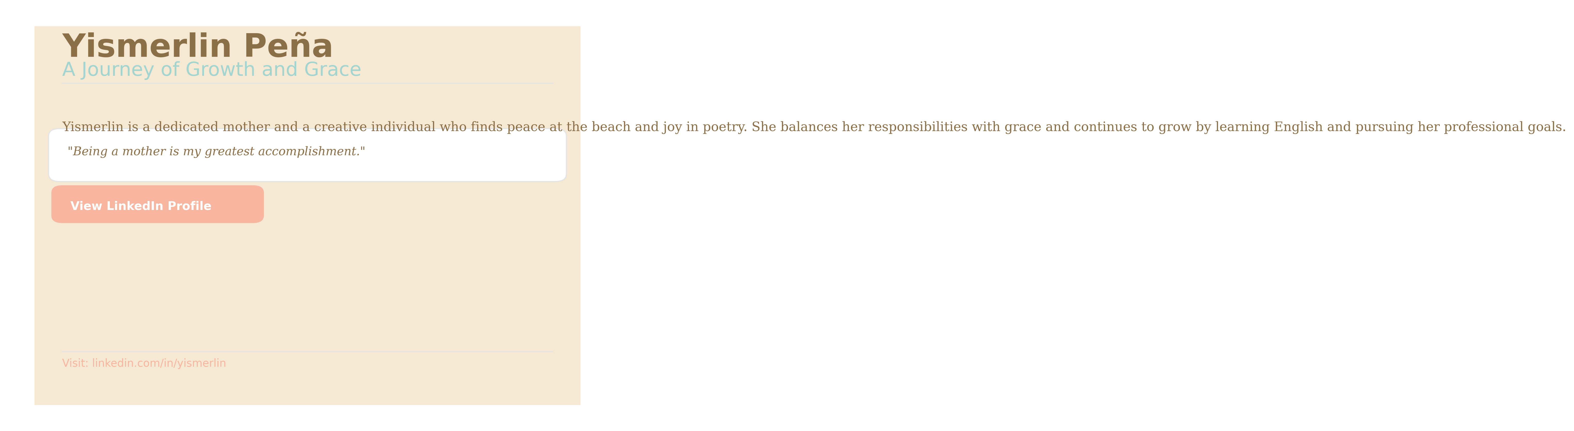

# Wireframe Layout Descriptions

## Landing Page

• Hero image and a welcoming headline introducing Yismerlin.

• Short paragraph summarizing her journey and achievements.

• Three highlight sections featuring images and captions about her goals/accomplishments.

• A link to her LinkedIn profile.

• Footer with navigation links.

## About Page

• Portrait photo at the top center.

• Main section with 250+ word biography.

• A decorative blockquote pulled from the interview.

• Consistent styling with background and font colors.

## Hobbies Page

• Three image cards for hobbies (beach, reading, movies).

• Each card includes a short paragraph below the image.

• Responsive layout using a grid structure.

• Navigation back to home and about pages.

**Wireframe Visual Overview:**

