**Julio Pochet Edmead**

**Module 7 Discussion Board**

**#57 – People Are Inherently Lazy**

The reading explains that users tend to take the path of least resistance. Instead of hunting for the perfect solution, they “satisfice” — settling for the easiest one that meets their needs. This reinforces the importance of intuitive layouts and navigation in web design. A simple design with clear actions encourages users to stay and explore.

Embellishment: A study by Nielsen Norman Group supports this. It found that users decide whether to stay on a website within 10–20 seconds. They'll leave if the content isn’t clear, and navigation isn’t intuitive. This reinforces how important it is to make design “effortless.” [Source: https://www.nngroup.com/articles/how-long-do-users-stay-on-web-pages/]

**#60 – Forming a Habit Takes a Long Time and Requires Small Steps**

According to the reading, habit formation isn’t quick. The average is 66 days, but it can range from 18 to 254 days depending on complexity. That means for web experiences or apps, it’s better to create **small, repeatable actions** that users can consistently complete and track.

**Visual Example**: Below is a habit-tracking interface that encourages long-term engagement by combining small goals, visual feedback, and progress tracking. This design motivates users to return daily and reinforces the habit over time:

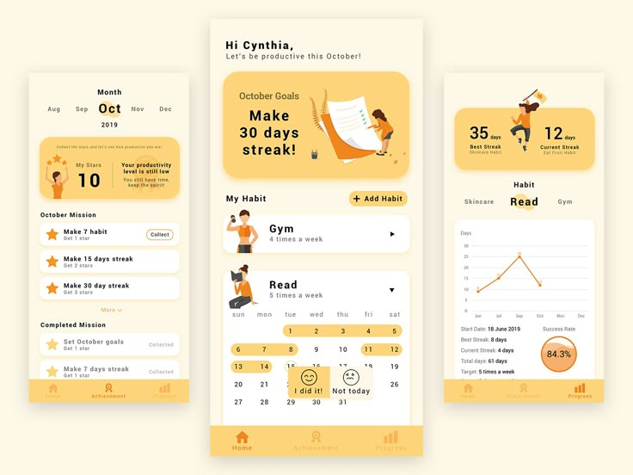

It includes daily check-ins, visual streaks, goal milestones, and success metrics—all of which align perfectly with what the reading describes. Simple and rewarding steps like these help users build commitment slowly but effectively.