**Julio Pochet**

**CSD370 – Module 6.2 Assignment: Code Signing**

**06/29/2025**

**🔹 Screenshot of Decrypted Digest:  
  
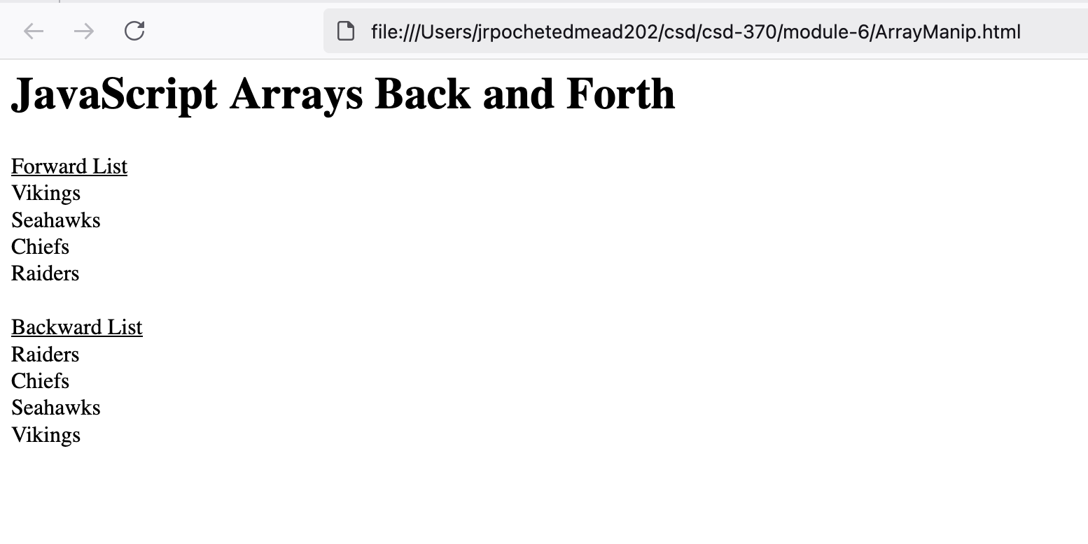**

**🔹 Screenshot of Generated Digest:  
  
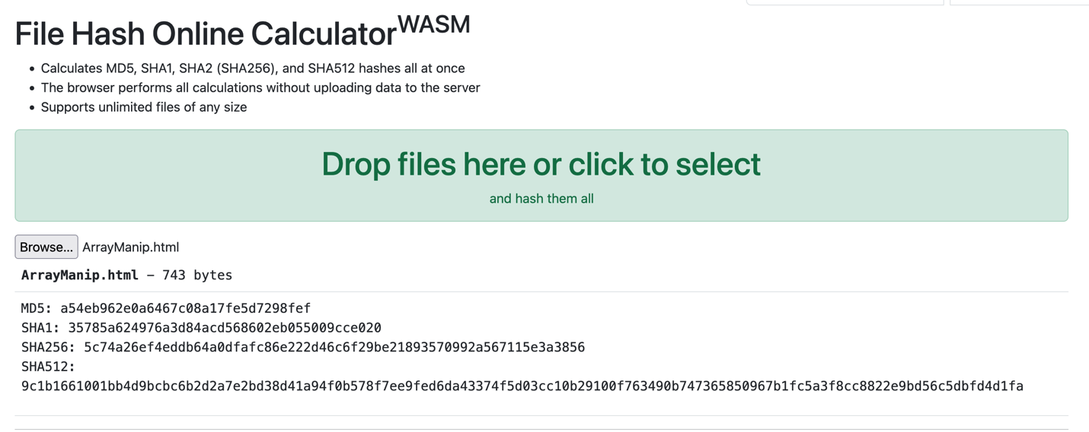**

**🔹 Digest Comparison:**

**Do the digests match?  
❌ No**

**Explanation:**The decrypted output shows the rendered contents of the ArrayManip.html page, not a raw MD5 hash string.