Project: Module 4.2 Assignment
Course: CSD380-O307 DevOps (2261-DD)
Description: Test plans based on business requirements
Date: 2025-02-09
To complete the test case plan, fill out the information for Project, Course, Description and Date in the header below.

TABLE OF CONTENTS
Test Case 01 2
Test Case 02 and 03 3
Test Case 04 and 05 4

For each test, the developer should: provide a test description, a test objective, the developer name and date tested. For each step, fill out the actions to be taken and describe the expected results, and indicate yes or no for each step depending upon the result. The peer tester should provide their name, date tested, indicate yes or no for each step depending upon the result, and a screenshot (thumbnail) of the result.

Test 1 | User Adding a Task
 | Test Objective: Adding a task | Developer:  Date tested: 2025-02-09 | Peer tester: Julio Pochet Edmead  Date tested: 2025/09/07
Step | Action | Expected results: | Developer pass/fail | Tester pass/fail  + Screenshot
1 | Open the website | Website loads correctly | yes | yes
2 | Locate the text input field | “New task” field is found and loaded | yes | yes
3 | Enter a task name in “New Task” | Text in the “New Task” is displayed correctly | yes | yes
4 | Click the “Add Task” button | “Add” button is clickable and functional | yes | yes
5 | Verify the new task appears in the list | New task appears in the list with correct name | yes | yes
Comments | 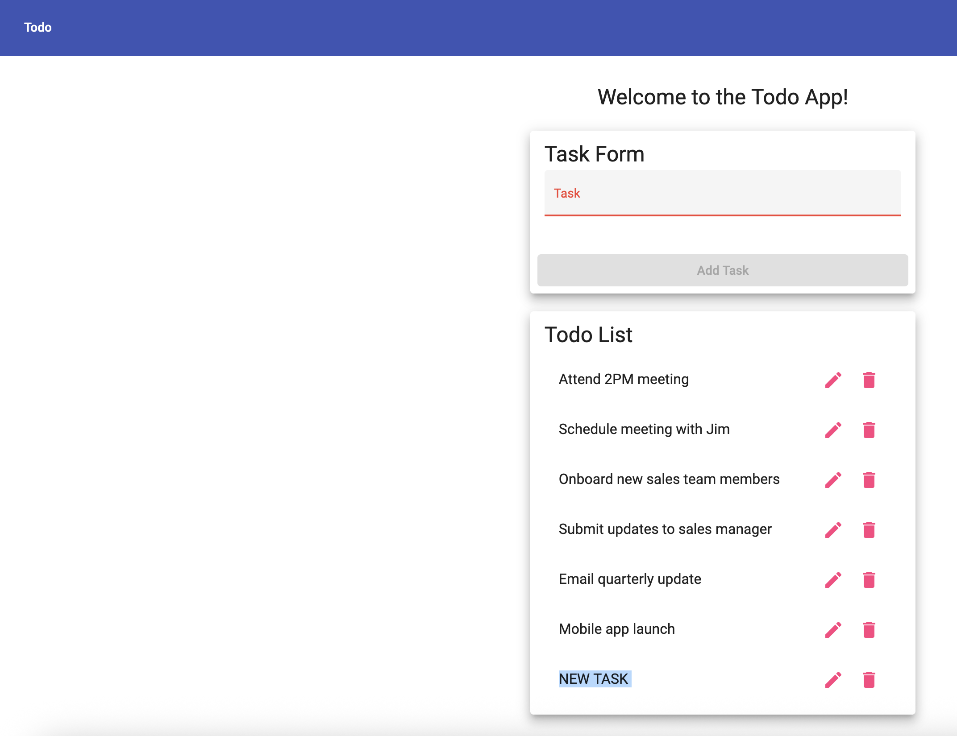

Test 2 | User Deleting a Task
 | Test Objective: Task deletion | Developer:  Date tested: 2025-02-09 | Peer tester: Julio Pochet Edmead  Date tested: 2025/09/07
Step | Action | Expected results: | Developer pass/fail | Tester pass/fail
1 | Open the website | Website loads correctly | yes | yes
2 | Find a task in the list | Task is located in the list | yes | yes
3 | Click the “Delete” button | Delete button is clickable | yes | yes
4 | Confirm deletion | Deletion is confirmed | yes | yes
5 | Verify that the task is removed from the list | Task is removed from the list | yes | yes
Comments | 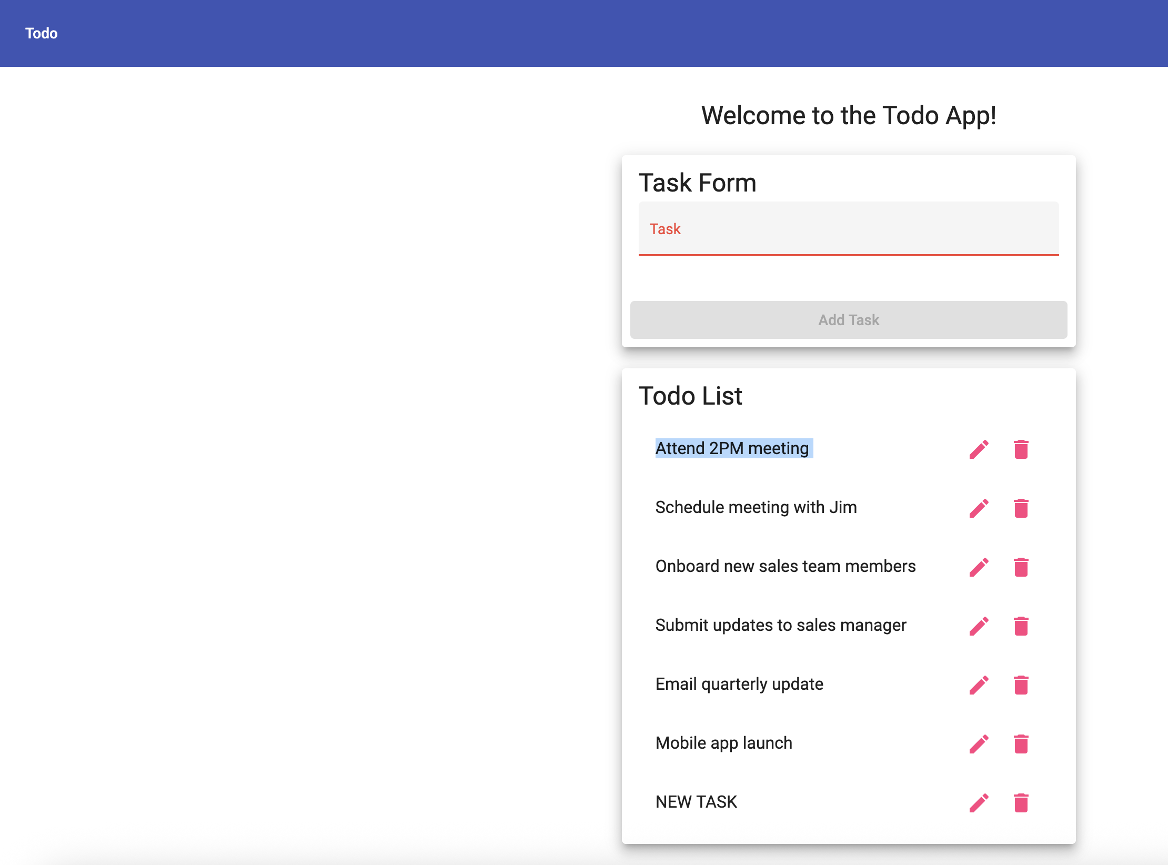  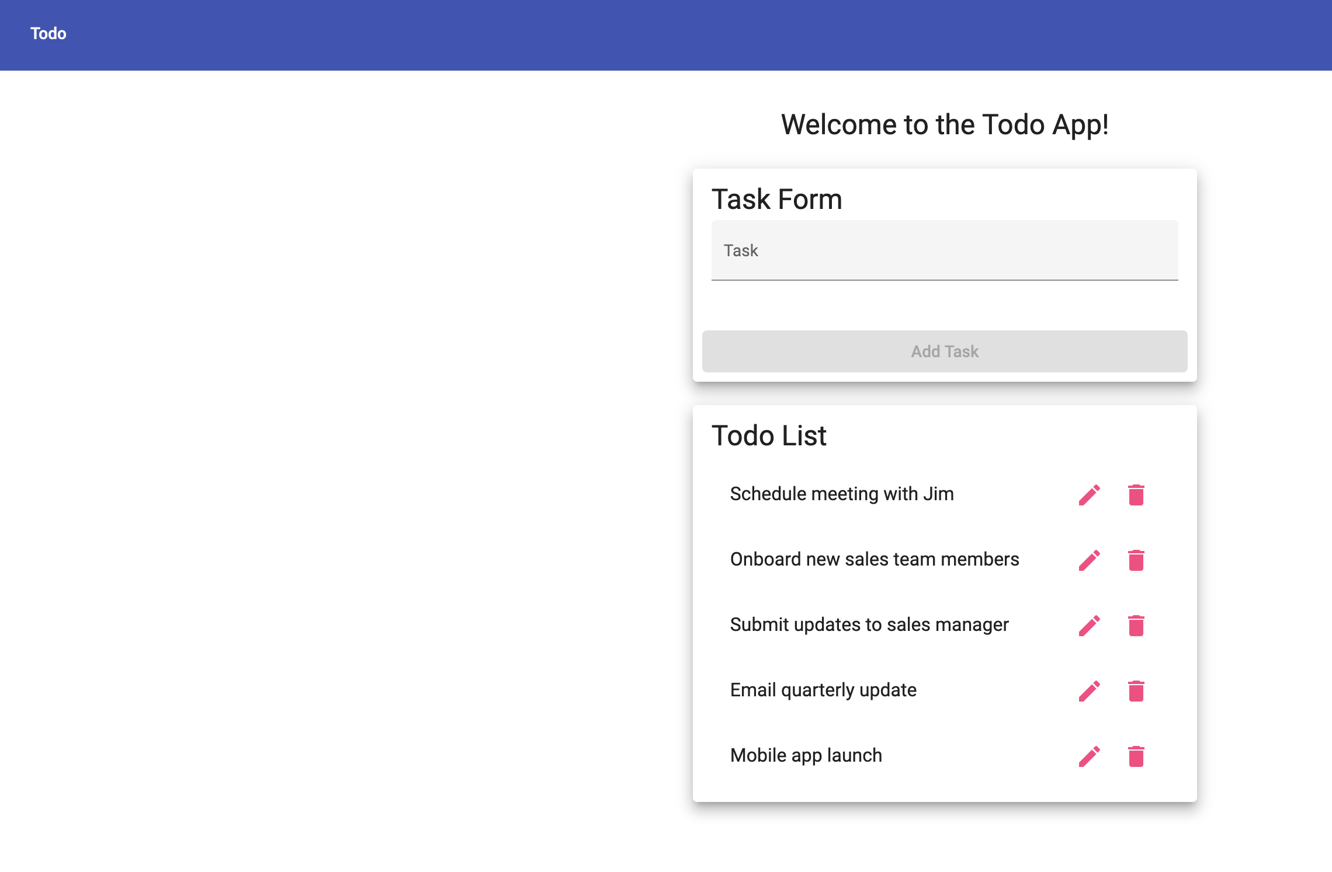

Test 3 | User Editing a Task
 | Test Objective: Task editing | Developer:  Date tested: 2025-02-09 | Peer tester: Julio Pochet Edmead  Date tested: 2025/09/07
Step | Action | Expected results: | Developer pass/fail | Tester pass/fail
1 | Open the website | Website loads correctly | yes | yes
2 | Find a task in the list | Task is located | yes | yes
3 | Click the “Edit” button | Edit button is clickable | yes | yes
4 | Modify the task and changes | Task is modified and saved | yes | yes
5 | Verify the task changes updated | Task name is updated | yes | yes
Comments | 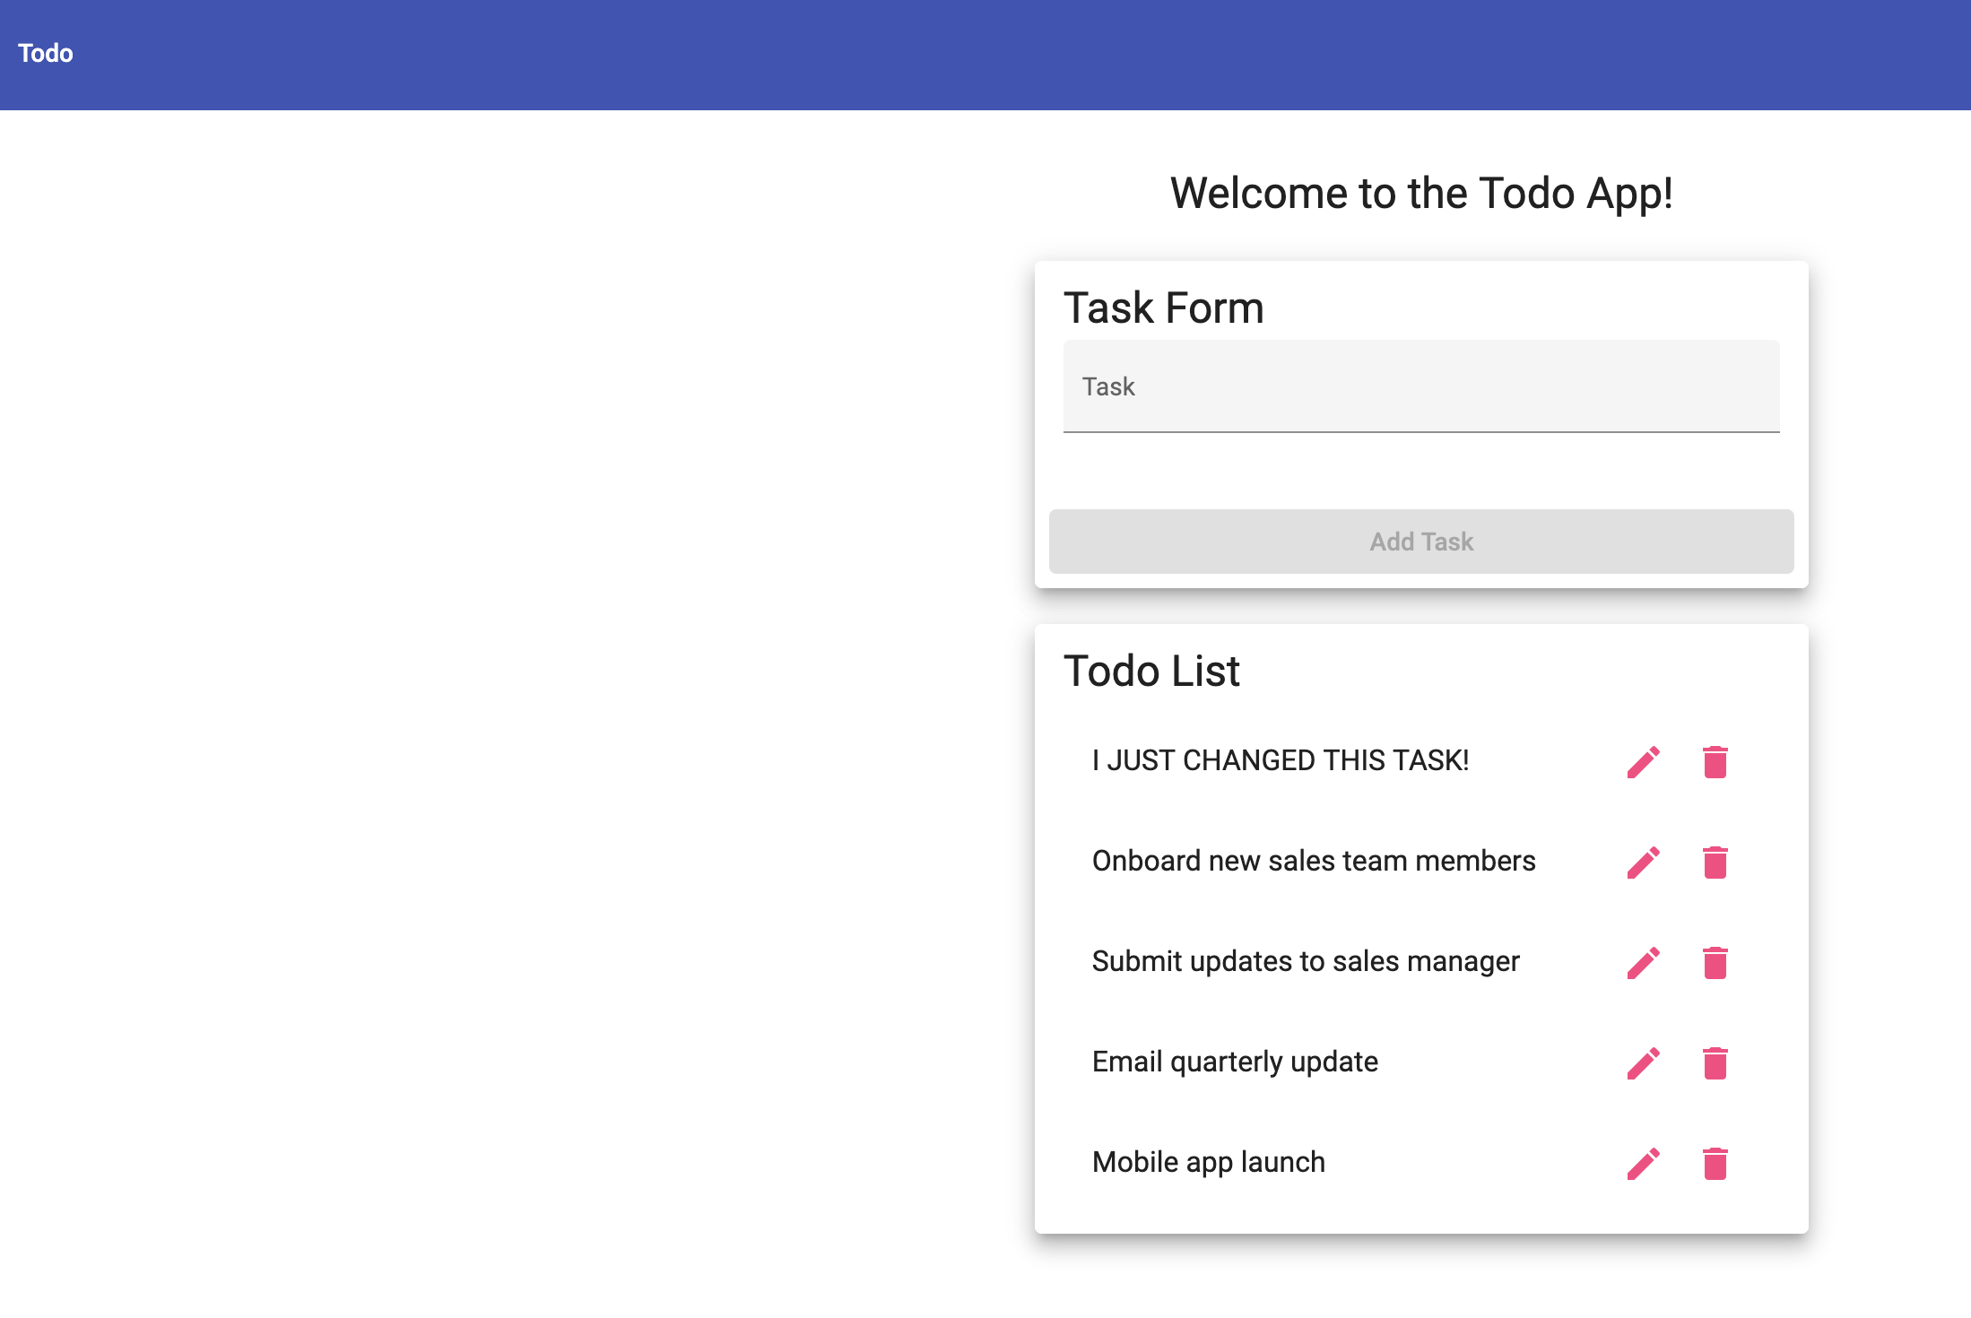

Test 4 | User Entering Invalid URL (404 Page)
 | Test Objective: 404 Page | Developer:  Date tested: 2025-02-09 | Peer tester: Julio Pochet Edmead  Date tested: 2025/09/07
Step | Action | Expected results: | Developer pass/fail | Tester pass/fail
1 | Enter/edit an invalid URL | Invalid URL is entered | yes | yes
2 | Navigate to the URL | Navigation occurs | yes | yes
3 | Verify a 404 page is displayed | Custom 404 page comes up | yes | yes
4 | Verify 404 includes helpful information | Helpful information is on the 404 page | yes | yes
5 | Test with different invalid URL’s | Consistent 404 pages come up | yes | yes
Comments | 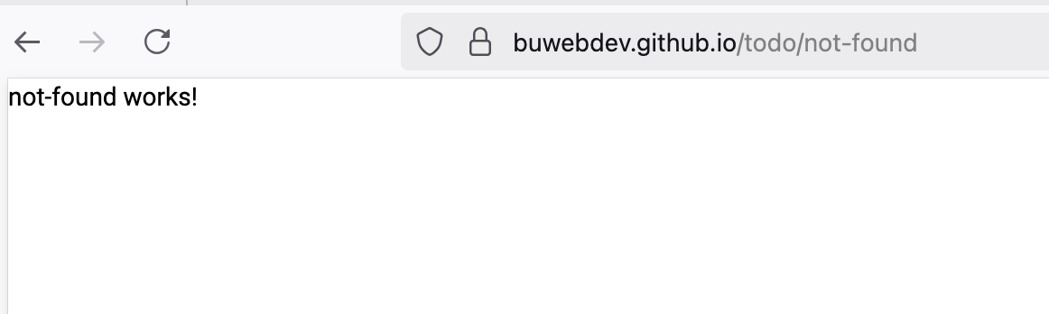

Test 5 | User Accessing Through Mobile Device
 | Test Objective: Mobile Device | Developer:  Date tested: 2025-02-09 | Peer tester: Julio Pochet Edmead  Date tested: 2025/09/07
Step | Action | Expected results: | Developer pass/fail | Tester pass/fail
1 | Open the website | Website loads correctly | yes | yes
2 | Verify website layout | Layout adapts | yes | yes
3 | Check all elements | All elements are functioning | yes | yes
4 | Test navigation on menus via mobile | Navigation works with mobile device | yes | yes
5 | Test on multiple mobile devices (if possible, android and apple) | Consistent mobile layout view | yes | yes
Comments | 