Project: Test Plan
Course: CSD-380
Description: Test cases for ToDo App
Date: 09/04/2025
Name: Dan Zhu
To complete the test case plan, fill out the information for Project, Course, Description and Date in the header below.
.
TABLE OF CONTENTS
Create a new Todo task item 2
Edit a new Todo task item 2
Delete a new Todo task item 3
View a list of Todo task items 3
Prevent users from submitting a task form without entering a Todo item 4

For each test, the developer should: provide a test description, a test objective, the developer name and date tested. For each step, fill out the actions to be taken and describe the expected results, and indicate yes or no for each step depending upon the result. The peer tester should provide their name, date tested, indicate yes or no for each step depending upon the result, and a screenshot (thumbnail) of the result.

Test 1 | Create a new Todo task item
 | Test Objective: | Developer:  Date tested: <yyyy/mm/dd> | Peer tester: Julio Pochet Edmead  Date tested: 2025/09/07
Step | Action | Expected results: | Developer pass/fail | Tester pass/fail  + Screenshot
1 | Visit https://buwebdev.github.io/todo/ | Load Todo application home page | <yes/no> | yes
2 | Click on task input filed | Stay focus on the input field | <yes/no> | yes
3 | Enter a Todo item | Task showing in the input filed and add task button enabled | <yes/no> | yes
4 | Click “Add Task” button | Task added to the list | <yes/no> | yes
5 | Check the added task | Task is showing at the end of the list | <yes/no> | yes
Comments | Comments should be substantive; this means there should be at least 2-3 well-structured sentences with constructive feedback.
TEST 1 | 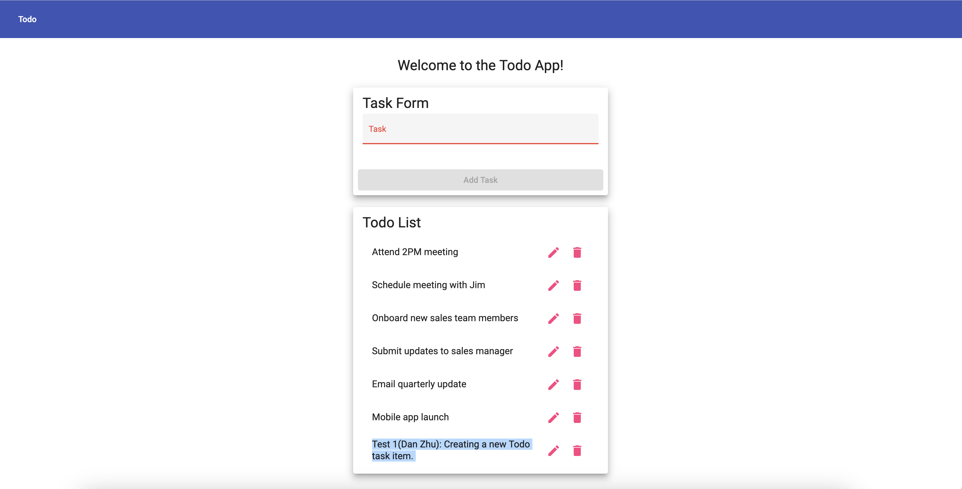

Test 2 | Edit a new Todo task item
 | Test Objective: | Developer:  Date tested: <yyyy/mm/dd> | Peer tester: Julio Pochet Edmead  Date tested: 2025/09/07
Step | Action | Expected results: | Developer pass/fail | Tester pass/fail
1 | Visit https://buwebdev.github.io/todo/ | Load Todo application home page | <yes/no> | yes
2 | Click “edit” button next to selected item | Edit form show up | <yes/no> | yes
3 | Update the Todo item | Updated Todo item in the input field | <yes/no> | yes
4 | Click “save” | Modal closed and item updated | <yes/no> | yes
Comments | TEST 2  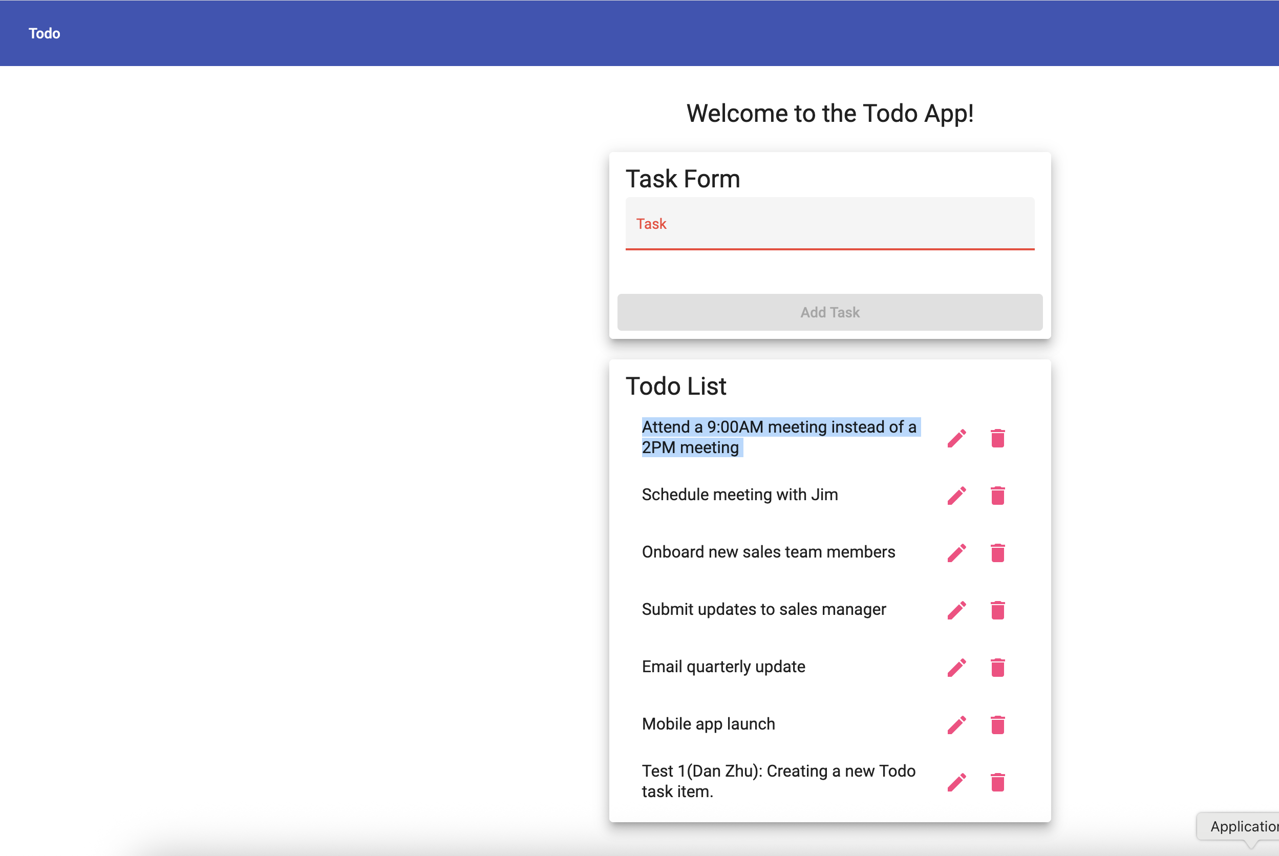

Test 3 | Delete a new Todo task item
 | Test Objective: | Developer:  Date tested: <yyyy/mm/dd> | Peer tester: Julio Pochet Edmead  Date tested: 2025/09/07
Step | Action | Expected results: | Developer pass/fail | Tester pass/fail
1 | Visit https://buwebdev.github.io/todo/ | Load Todo application home page | <yes/no> | yes
2 | Click delete button | Todo item removes from Todo list | <yes/no> | yes
Comments | 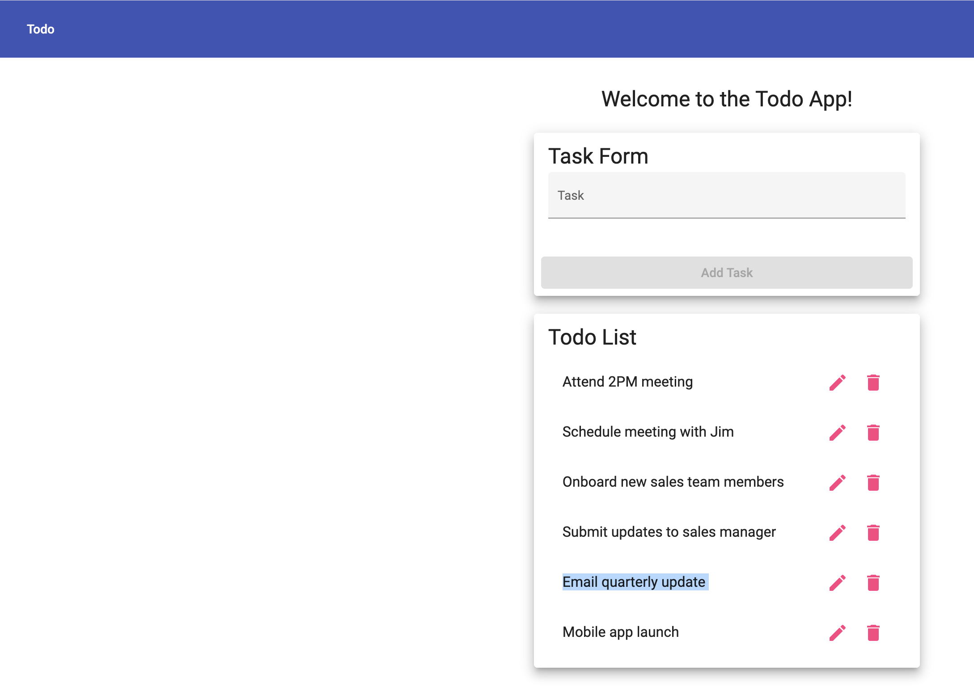  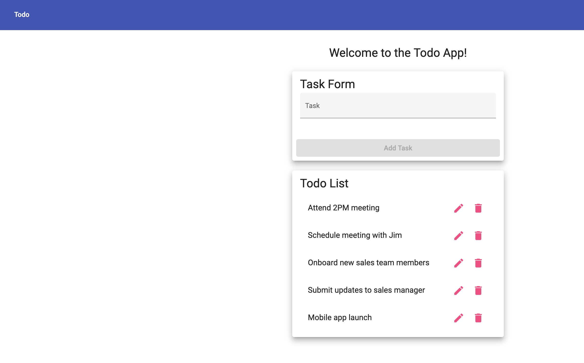

Test 4 | View a list of Todo task items
 | Test Objective: | Developer:  Date tested: <yyyy/mm/dd> | Peer tester: Julio Pochet Edmead  Date tested: 2025/09/07
Step | Action | Expected results: | Developer pass/fail | Tester pass/fail
1 | Visit https://buwebdev.github.io/todo/ | Load Todo application home page | <yes/no> | yes
2 | A list of Todo items showing under the task form | See a list of Todo items | <yes/no> | yes
Comments | 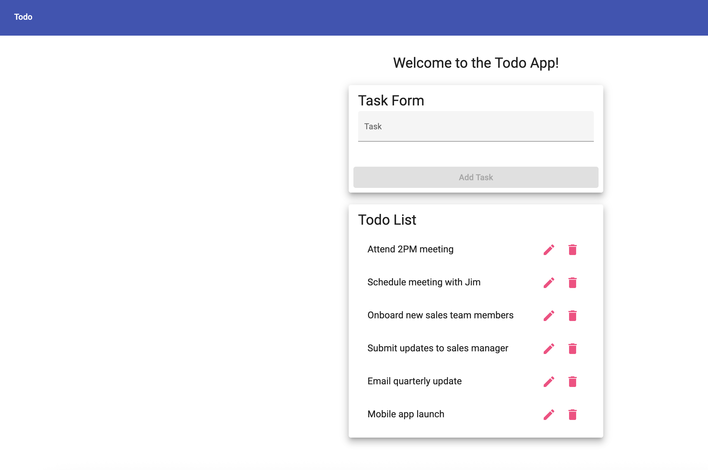

Test 5 | Prevent users from submitting a task form without entering a Todo item
 | Test Objective: | Developer:  Date tested: <yyyy/mm/dd> | Peer tester: Julio Pochet Edmead  Date tested: 2025/09/07
Step | Action | Expected results: | Developer pass/fail | Tester pass/fail
1 | Visit https://buwebdev.github.io/todo/ | Load Todo application home page | <yes/no> | yes
2 | Click “Add Task” button | Input field turn red | <yes/no> | yes
Comments | 