Module 5.2 – Value Stream Mapping Assignment
Name: Julio Pochet
Course: CSD-380
Assignment: Module 5.2 Value Stream Mapping (VSM)

Introduction
Value Stream Mapping (VSM) is a simple but powerful way to look at how work gets done. It’s usually used in software to spot delays and remove waste, but it also fits well into everyday life (Knight, 2020). For this assignment, I mapped my payday financial routine. Every time I get paid, there’s a flow of money through pretax deductions, savings, bills, and budgeting. By breaking it down step by step, I was able to see where I spend the most time and where small improvements could make the whole process smoother.

Value Stream Map
The map below shows my payday process, starting from my paycheck hitting the bank, through pretax allocations, post‑tax savings/investments, paying bills, and finally budget tracking. Percentages are labeled to show exactly how money is split.

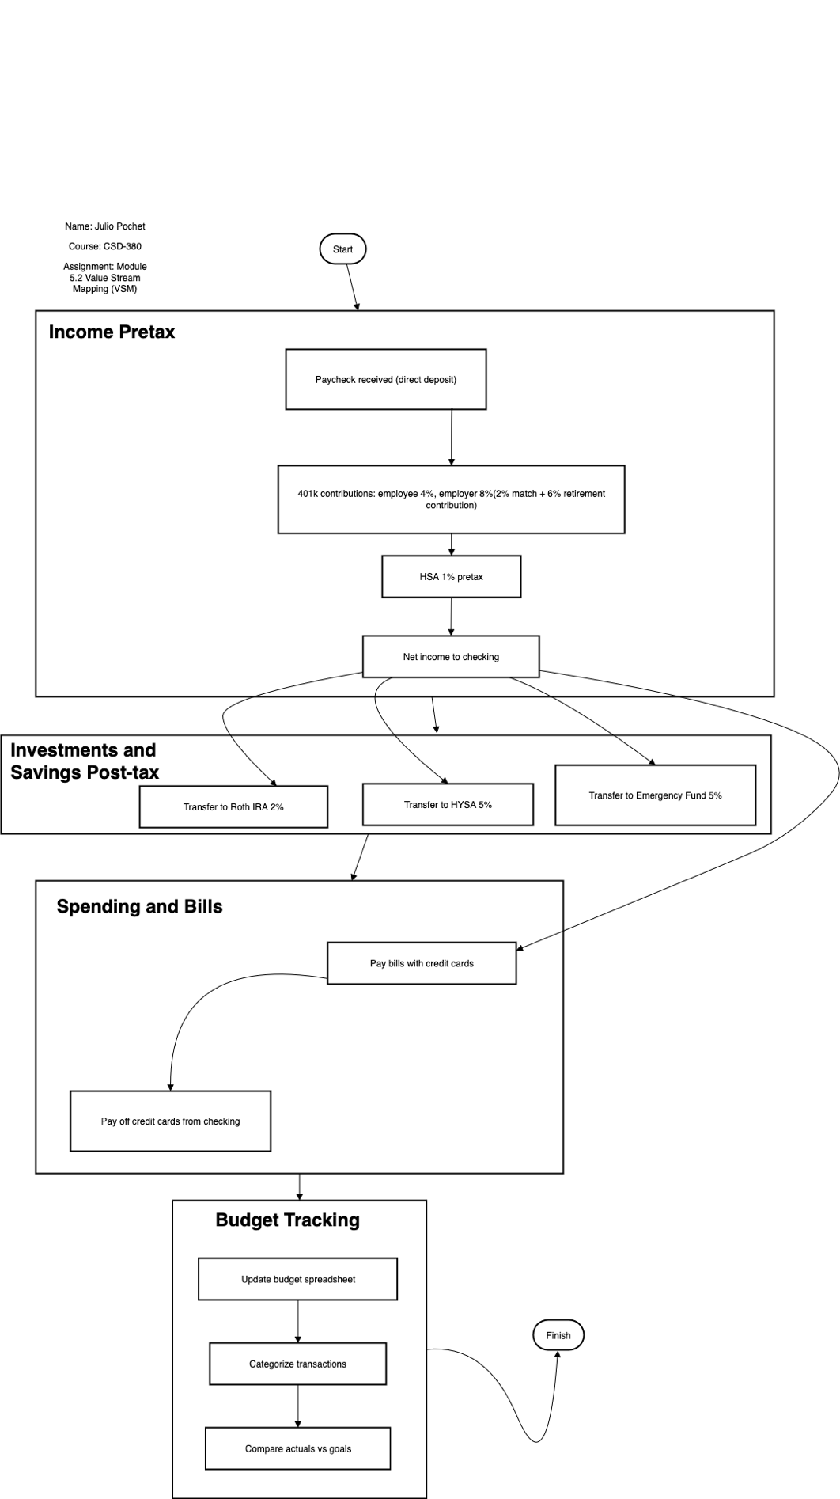

Lean Metrics
Here’s what the timing looks like for each stage:
• Income (Pretax): 15 minutes — check the deposit and deductions (401k 4%, HSA 1%)
• Investments & Savings (Post‑tax): 25 minutes — transfers to Roth IRA (2%), HYSA (5%), Emergency Fund (5%)
• Spending & Bills: 45 minutes — pay bills with credit cards and then pay off cards from checking
• Budget Tracking: 30 minutes — update my spreadsheet, categorize transactions, compare vs. goals
Estimated cycle time: ~115 minutes total. The longest stage is Spending & Bills, since I review due dates and double‑check balances before paying off cards in full.

Process Optimization
Looking at the map gave me a few clear wins:
• Cut waste: Automate recurring bill payments and savings/investment transfers to save ~20–30 minutes.
• Improve flow: Do all payments and transfers in one focused session instead of bouncing between apps on different days.
• Governance: Stick to set percentages — 401k 4% (with 8% from my employer into the 401k), HSA 1%, Roth IRA 2%, HYSA 5%, Emergency 5%. Pre‑scheduled calendar reminders help me follow this every payday.

Conclusion
This exercise showed me that even a routine like payday can be optimized. By visualizing the steps, I found ways to cut time, reduce stress, and stay consistent with my financial goals. The same idea applies in DevOps: when you map, measure, and optimize, you get a smoother pipeline. For me, that means more time freed up and more confidence that my money is going to the right places.

Reference
Knight, L. (2020, October 29). 3 easy steps for using VSM in everyday life. ConnectALL. https://www.connectall.com/3-easy-steps-for-using-vsm-in-everyday-life/

