**CSD-420 – Module 1 Assignment**

**GitHub Repository Setup**

**Student:** Julio Pochet  
**Date:** 05/30/2025

**1. GitHub Repository Link**

📎 **Repository URL:**  
<https://github.com/jpochetedmead/csd-420>

📝 *This repository was created to host my assignments for CSD-420. It is set to public and includes a README.md file and a Python .gitignore file.*

**2. GitHub Repository Screenshot**

📸

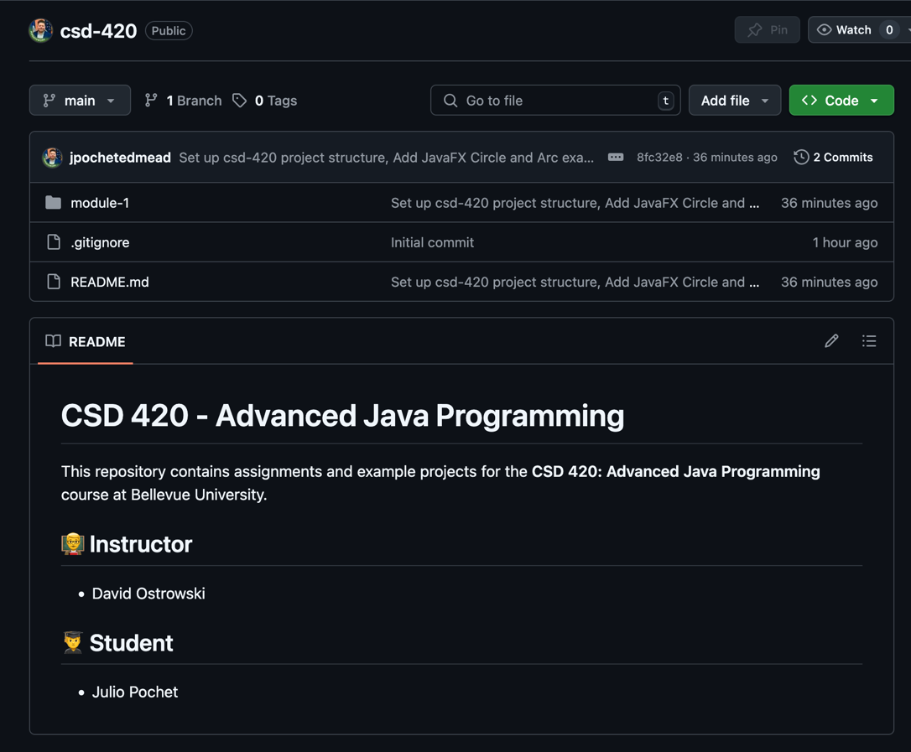

**3. Local Directory Screenshot**

📸

