**Julio Pochet Edmead**

**CSD-430**

**Modules 7 Assignment - Project Part 2 (Screenshots)**

**Screenshot #1:**

**Screenshot #2:**

**Screenshot #3:**

**Screenshot #4:**

**Screenshot #5:**

**Screenshot #6:**

**Screenshot #7:**

**Screenshot #8:  
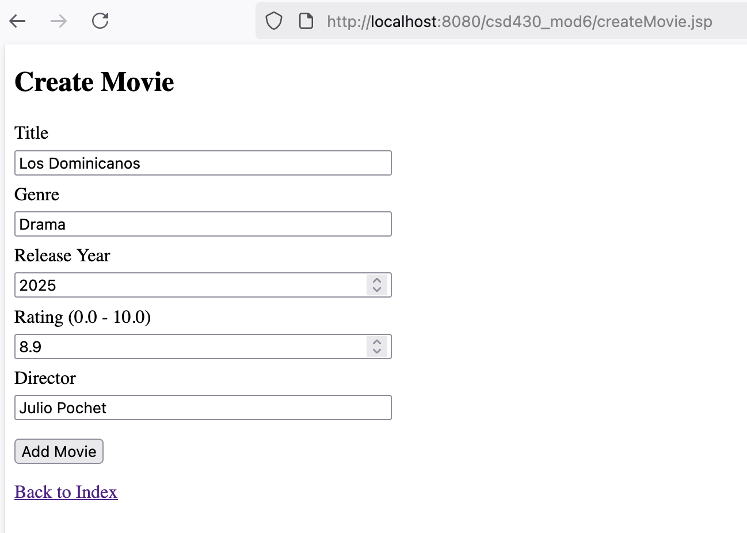**

**Screenshot #9:**

