project instruction:

Import Select DeviceSDK folder, import two projects after the import results are as follows
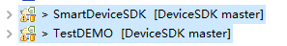

Import Eclipse：File->Import->Android->Existing Android Code Into Workspace->Chose ‘DeviceSDK’->Finish
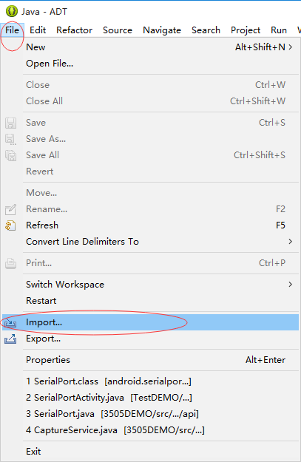

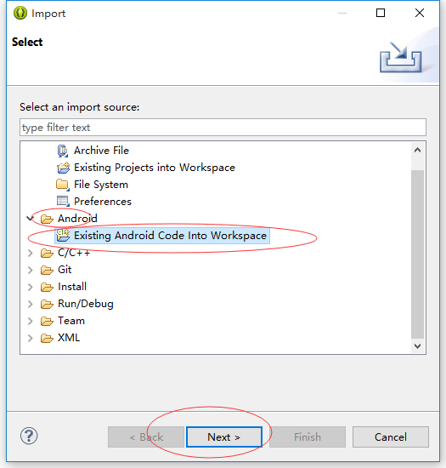
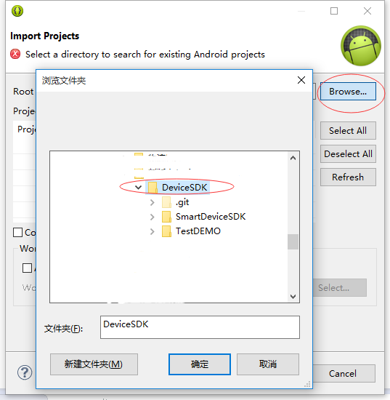

SDK package：

android.serialport.api
Serial user interface, the main use SerialPort class

SerialPortDescription：

Function | Description | Parameter | Remarks
SerialPort(String, int) | Instantiated, and automatically open the serial port, automatically receive data back thread | String  Serial devices, such as / dev / ttyS1  int  Serial port baud rate, such as 115200
SerialPort() | Instantiation |  | Call open (String, int) to open the serial port, and to receive data back using FileInputStream
setOnserialportDataReceived(SerialPortDataReceived) | Sign return data receive event |  | If you register this function, you need to use SerialPort (String, int) method to instantiate
open(String, int) | Open the serial port | String  Serial devices, such as / dev / ttyS1  int  Serial port baud rate, such as 115200
open() | Open the serial port
closePort() | 关闭串口，释放资源
Write(byte[]) | Close the window, the release of resources | Hexadecimal data
Write(String) | Send serial data | Character data in UTF-8 encoding to send
setOnserialportDataReceived(SerialPortDataReceived) | Sign return data monitor events

com.smartdevicesdk.adapter
UI adapter management
com.smartdevicesdk.camerascanner
Camera Scan Interface

Instructions:
//Registration required permissions
<uses-feature android:name="android.hardware.camera" />

//Open the scan window
Intent intent = new Intent(this, ZBarScannerActivity.class);
startActivityForResult(intent, ZBAR_SCANNER_REQUEST);

//Receives the scan data is returned
@Override
protected void onActivityResult(int requestCode, int resultCode, Intent data) {
if (resultCode == RESULT_OK) {
// Scan result is available by making a call to
// data.getStringExtra(ZBarConstants.SCAN_RESULT)
// Type of the scan result is available by making a call to
// data.getStringExtra(ZBarConstants.SCAN_RESULT_TYPE)
String str = "Scan Result:\r\n"
+ data.getStringExtra(ZBarConstants.SCAN_RESULT);
str += "\r\nScan Result Type:\r\n"
+ data.getIntExtra(ZBarConstants.SCAN_RESULT_TYPE, 0);
// The value of type indicates one of the symbols listed in Advanced
// Options below.

textView.setText(str);

} else if (resultCode == RESULT_CANCELED) {
textView.setText("Camera unavailable");
}
}
com.smartdevicesdk.database
SQLite Database Interface

com.smartdevicesdk.device
Different Android device management, function selection, primarily for equipment default serial port selection, understanding the correspondence between the serial device, the need to call this interface

com.smartdevicesdk.fingerprint
Fingerprint module interface, call the method, see TestDEMO in Finger Activity class

com.smartdevicesdk.idcard
Second-generation ID card Interface

Instructions:
Initialization Interface ID Card Helper (String, int), after the name of the incoming serial port baud rate, call getIDCard () to get the second generation ID card information

com.smartdevicesdk.media
Multimedia Sound playback Interface

com.smartdevicesdk.printer
Printer interface (serial)

Instructions:
Mainly used Printer Class SerialPort class
Function | Description | Parameter | Remarks
PrinterClassSerialPort(Context, Handler) | initialization | Context  Context instances  Handler  The printer returns data handle
open() | Open Device
close() | Turn off your device
printText(String) | Send text data to print, the default GBK coding
printImage(Bitmap) | Send picture data printing
printUnicode(String) | Send Unicode print data
write(byte[]) | Send hexadecimal data |  | Print instruction data, you can use this function
device : String | Serial device names
baudrate : int | Baud rate

com.smartdevicesdk.psam
Contact PSAM card interface

Function | Description | Parameter | Remarks
OpenCard(int[], int) | Open Device | Parameters: [in] int slotid, slot number, if you pass 0, automatically adapts to the first open card slot [out] unsigned long * fd outgoing device handle
CloseCard(long) | Turn off your device | Parameters: [in] unsigned long fd incoming To turn off the device handle Return value: the right to 0, the error is non-zero
ResetCard(long, byte[], int[]) | Equipment reset | Parameters: [in] unsigned long fd incoming To turn off the device handle [out] unsigned char * atr outgoing device reset information [in / out] int * atrLen device reset outgoing message length Returns: the right to 0, with error non-0
CardApdu(long, byte[], int, byte[], int[]) | Send command | Parameters: [in] unsigned long fd incoming device handle [in] unsigned char * apdu instruction [in] apdu to send int apdu apduLength Send your instruction length [out] unsigned char * response returns the data content [in / out] int * respLength return data length return value: the right to 0, the error is non-zero
CheckCard(long) | Check the card in place state | Parameters: [in] unsigned long fd incoming detection device handle Return value: the right to 0, the error is non-zero | Feature is not enabled

com.smartdevicesdk.scanner
One-dimensional two-dimensional scanning module interface

Function | Description | Parameter | Remarks
ScannerHelper(Context, String, int, Handler) | Instantiation | Context  Context instances  String  Serial device names  int  Baud rate  Handler  Receives the scan data handle
Close() | Close Module
scan() | Start scanning

com.smartdevicesdk.stripcard
Magnetic stripe card interface (I2C communication)
Call Stripcardhelper.ReadCard () to get the data card after detailed see TestDEMO in MagneticCardActivity

com.smartdevicesdk.ui
UI control interface

com.smartdevicesdk.utils
String Functions Process Interface

