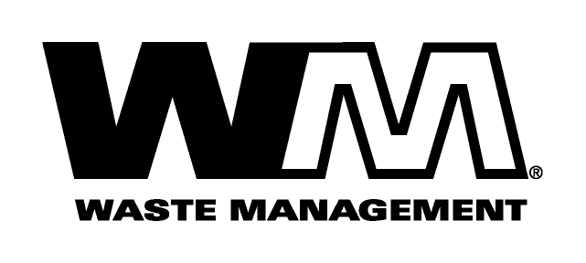

Waste Management of Four Corners
800/274-6284
101 Spruce 258 Stewart 1041 CR 500 PO Box 937

Farmington, NM 87401 Durango, CO 81301 Pagosa Springs,CO 81147 Cortez, CO 81321
505/327-6284 970/247-1821 970/264-5622 970/565-1133
Fax: Fax: Fax: 800/537-6731

505/325-8572 970/247-1867 970/264-5640 Fax: 970/565-6470

Your help is needed!!

We very much appreciate the opportunity to collect recycle materials from your facility. However, at some properties, we have experienced contamination in the recycle containers (trash, construction debris, food waste, tree limbs, etc.). We must all work together to ensure the continuation of the Recycle Route.

Please reiterate to your team that only acceptable items can be placed into the recycle container. If further contamination occurs, we will unfortunately, have no other choice but to convert the service to be collected as trash. This is certainly not our avenue of choice… we want very much to divert as much material to recycle as possible.

With your help, we have confidence we will see improvement.

If you have any questions, please call Customer Service at 800.274.6284.

THANK YOU FOR YOUR PROMPT ASSISTANCE WITH THIS CONCERN.

