**Automated cropland classification algorithm (ACCA)**

**Readme for the .gmd ACCA algorithm**

**Pardhasaradhi Teluguntla1,2(pteluguntla@usgs.gov)and Prasad S. Thenkabail1 (pthenkabail@usgs.gov)**

1 = U.S. Geological Survey, 2 = Bay Area Environmental Research Institute

1. **Overview:** This automated cropland classification algorithm (ACCA) is illustrated here for the country of Australia. A Mega-file data cube (MFDC) (see section 2.0) was created using MODIS 16-day NDVI time-series data for the Year 2014 and used to generate the reference cropland layer for Australia. An accurate reference cropland product (RCP) was produced using MODIS 250m NDVI time-series data of Australia for the year 2014 through extensive ground information collected by field visits and using Qualitative Spectral Matching Techniques(QSMTs). The RCP2014 accuracies were tested using two independent data sources with: (a) for six cropland classes involving irrigated-, rainfed-, and pasture croplands with an overall accuracy of 83.1% and kappa coefficients of 0.75. (b) two classes involving croplands versus non croplands with balanced sampling with an overall accuracy of 98.2% and kappa coefficient of 0.91. RCP2014 was then used as knowledge base to develop an automated cropland classification algorithm (ACCA). Finally, ACCA was applied on MODIS 250 m time-series data for each of the years from 2000 through 2015. A pixel by pixel comparison between the ACCA derived cropland product (ACP) of the year 2014 versus RCP2014 provided an overall accuracy of 89.4% (kappa = 0.814). ACPs for individual years 2000 through 2015 (ACP2000 through ACP2013) were computed automatically. RCP 2014 (6classes,) shown in Figure 1 and subsequently we have used ACCA (Figure 2) and generated ACP2014(6 classes) shown in Figure3 and Figure 4.

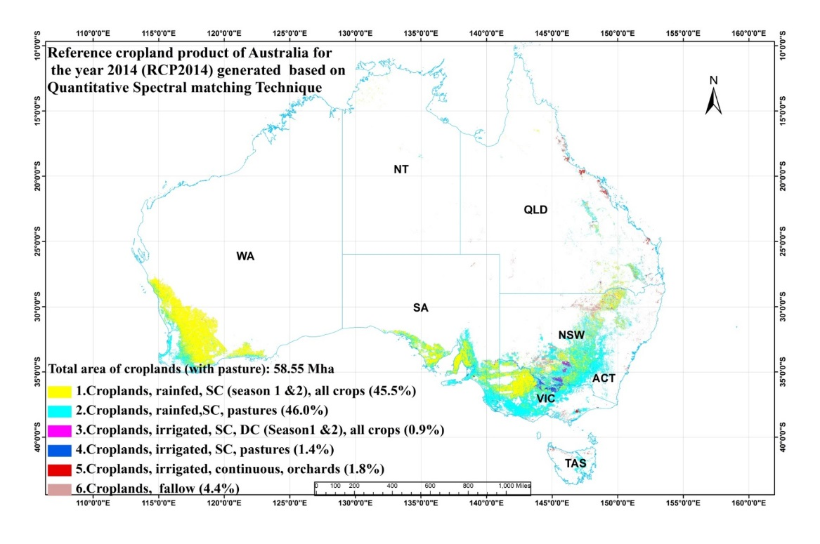

**Figure 1.** Reference cropland product of the year 2014 (RCP2014) for Australia at 250m generated using MODIS NDVI-16 day time-series data, field knowledge and QSMTs.

**2.0 ACCA Algorithm:** The ACCA is written in ERDAS Modeler, and hence the **algorithm file is available in .gmd format**. Datasets used in the ACCA algorithm include MODIS 250 m -16 day NDVI time series-23 layers. The data set is composed into a single file. T**hese datasets are made available on the U.S. Geological Survey’s Powell Center Working Group web site in order to enable users to run the algorithm and reproduce the results found here.**

**3.0 The simple concept of ACCA is**

**First**, generate a reference cropland product (RCP) from MODIS 250m time-series data for a normal climate year of 2014 (RCP2014) based on extensive ground information collected by field visits and using QSMTs.

**Second**, produce the ACCA algorithm that replicated the RCP. We do this first using the same datasets used to produce the RCP. Then used Knowledge base from RCP2014 to develop ACCA algorithm to replicate RCP2014. Then we use independent year dataset to run the ACCA algorithm and produce ACP for independent years (2000-105).

**4.0 Conceptual framework of the ACCA algorithm:**

1. **Mask layer**: We have generated 3 masks, which includes rainfed croplands, rainfed pastures and irrigated croplands. These are definitive 100% non-croplands.
2. **Algorithm 1**: Use MODIS 16-day NDVI time series to separate season 1, season 2 crops, pastures and current fallows from cropland mask.
3. **Algorithm 2:** Use MODIS 16-day NDVI time series to separate season 1, season 2 crops, pastures and current fallows from pasture mask.
4. **Algorithm 3:** Use MODIS 16-day NDVI time series to separate season 1, season 2 crops, double crops, continuous crops, pastures and current fallows from irrigated mask.
5. Finally recode all 14 classes from Algorithm 1, Algorithm 2, Algorithm 3 and recode to final 6 summarized classes.



**Figure 2.** ACCA algorithm for 3 masks of Australia

**5.0 Now run the above ACCA algorithm on Reference Year 2014 NDVI -16day time series datasets.** This resulted in producing 6 class cropland product of Australia for the reference year 2014.

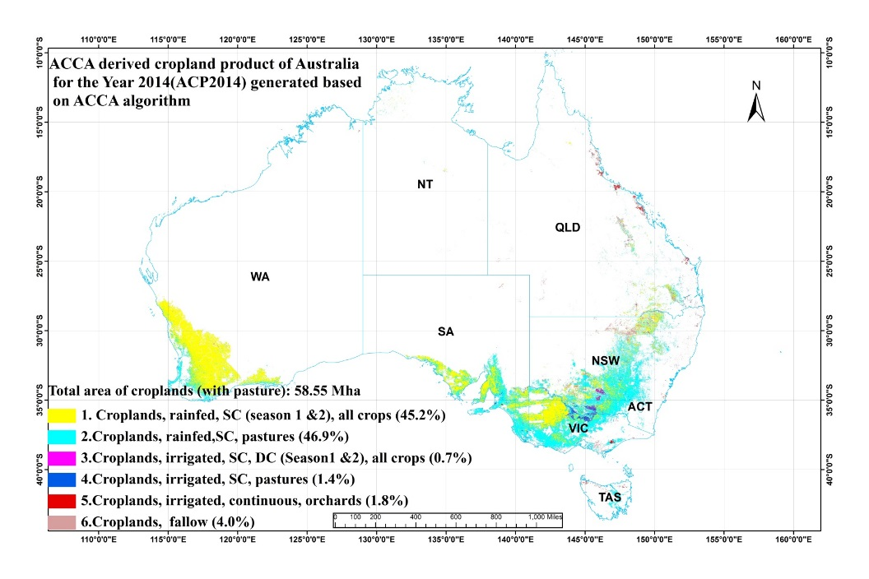

**Figure 3**. ACCA algorithm derived cropland product for the year 2014 (ACP2014) for Australia generated using MODIS 250m- 16 day NDVI time series data.

**6.0 Now run the above ACCA algorithm on the independent years NDVI -16day time series dataset.** This resulted in producing 6 class cropland product for Australia from 2000-to 2015

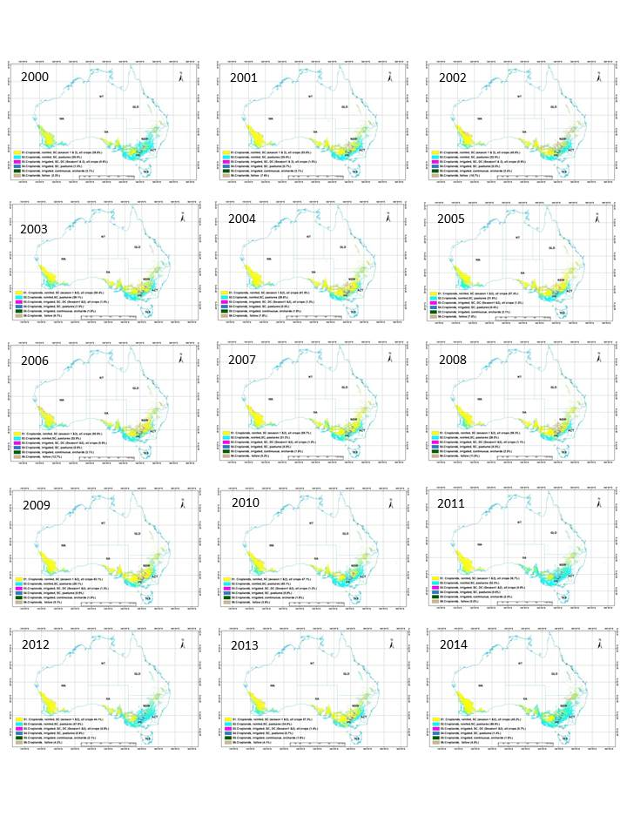

**Figure 4.** ACP of Australia generated using ACCA algorithm.

**Note**: The algorithm is built in ERDAS IMAGINE 2014, and the data directory linked to the algorithm is located at the E drive folder “E:\Australia_ACCA_Model\data-input\MODIS-data”. After downloading the algorithm, please either make the downloaded data folder in your E:\Australia_ACCA_Model\data-input\MODIS-data or redirect the link to your saved local drive.

**7.0 References**

Teluguntla, P., Thenkabail, P.S., Xiong, J., Gumma, M.K., Giri, C., Milesi, C., Ozdogan, M., Congalton, R., Tilton, J., Sankey, T.R., Massey, R., Phalke, A., and Yadav, K. (2015b). Global Food Security Support Analysis Data at Nominal 1 km (GFSAD1km) Derived from Remote Sensing in Support of Food Security in the Twenty-First Century: Current Achievements and Future Possibilities. Chapter 6, In Thenkabail, P.S., (Editor-in-Chief), 2015. “Remote Sensing Handbook” Volume II: Land Resources: Monitoring, Modeling, and Mapping:, Taylor and Francis Inc.\CRC Press, Boca Raton, London, New York. Pp. 131-159.

Thenkabail, P.S., Hanjra, M.A., Dheeravath, V., Gumma, M. 2011. Book Chapter # 16: Global Croplands and Their Water Use Remote Sensing and Non-Remote Sensing Perspectives. In the Book entitled: “Advances in Environmental Remote Sensing: Sensors, Algorithms, and Applications”. Taylor and Francis Edited by Dr. Qihao Weng. Pp. 383-419.

Thenkabail. P., Lyon, G.J., Turral, H., and Biradar, C.M. 2009a. Book entitled: “Remote Sensing of Global Croplands for Food Security” (CRC Press- Taylor and Francis group, Boca Raton, London, New York. Pp. 556 (48 pages in color). Published in June, 2009.

Thenkabail, P.S., Biradar C.M., Noojipady, P., Dheeravath, V., Li, Y.J., Velpuri, M., Gumma, M., Reddy, G.P.O., Turral, H., Cai, X. L., Vithanage, J., Schull, M., and Dutta, R. 2009b. Global irrigated area map (GIAM), derived from remote sensing, for the end of the last millennium. International Journal of Remote Sensing. 30(14): 3679-3733. July, 20, 2009.

Thenkabail, P.S., & Wu, Z. (2012). An automated cropland classification algorithm (ACCA) for Tajikistan by combining Landsat, MODIS, and secondary data. Remote Sensing, 4, 2890-2918