**Computer Graphics ClassAssignment1 Report**

**Prepared By: Wan (2019007901)**

Implemented Requirements

1. Upon program execution, the camera will **be looking at the global origin (0,0,0)** and it will be **launched in perspective viewing mode.**
2. **Camera orbit control** is implemented by holding and dragging left mouse button. Camera will rotate around the target point. Dragging mouse horizontally will rotate the camera in x direction and dragging mouse vertically will rotate the camera in y direction.
3. **Camera pan control** is implemented by holding and dragging right mouse button. Camera will move the target point according to the direction of the mouse movement.
4. **Camera zoom control** is implemented by scrolling the mouse wheel. Zoom in by scrolling up and zoom out by scrolling down.
5. The projection of the program can be **toggled between perspective and orthogonal** by pressing ‘v’ key.
6. A 18x18 rectangular **grid lines on xz plane** is drawn as a reference ground.

Program Screenshots

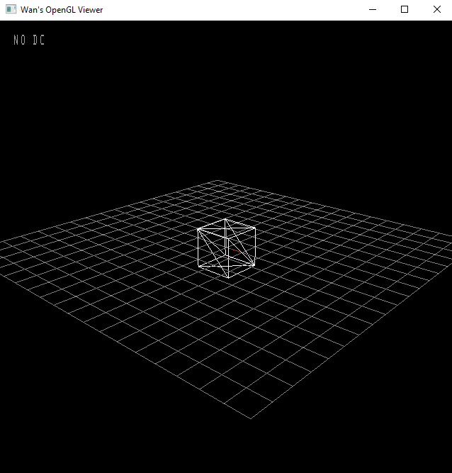 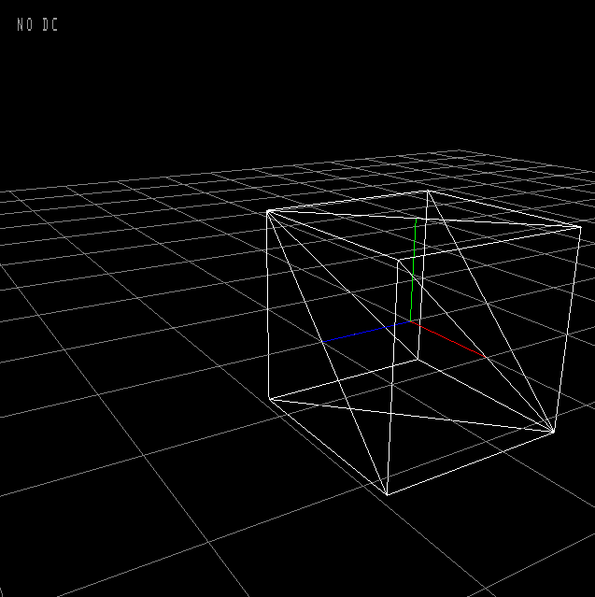

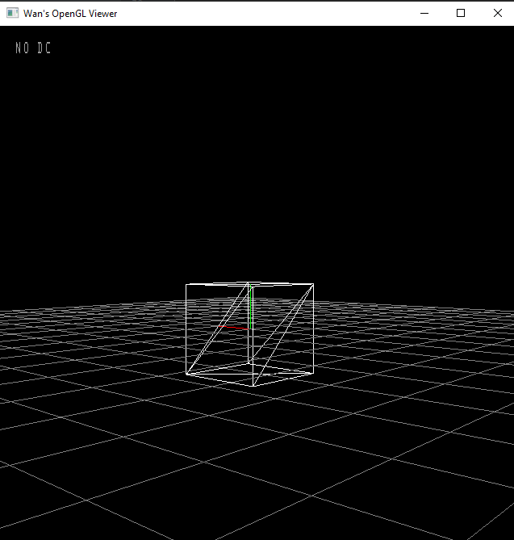 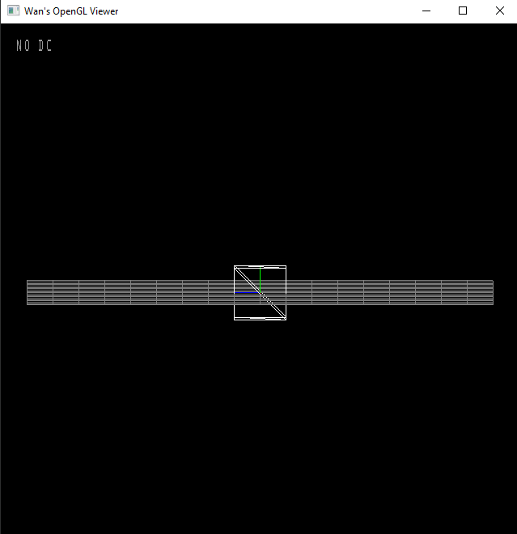

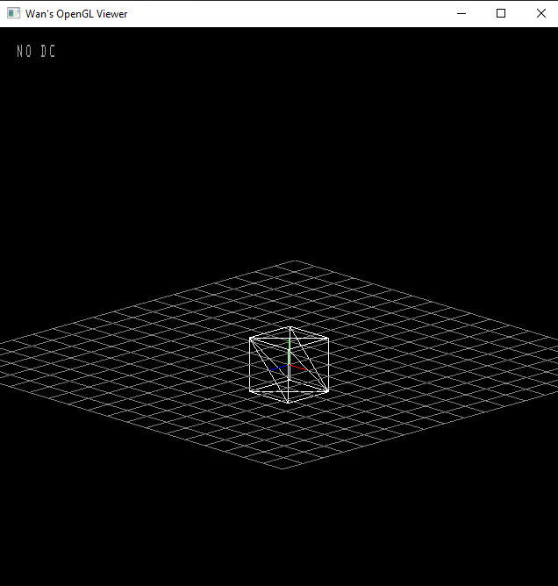 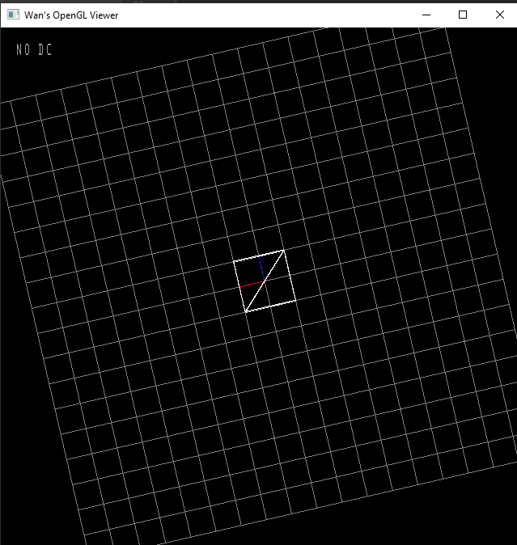v