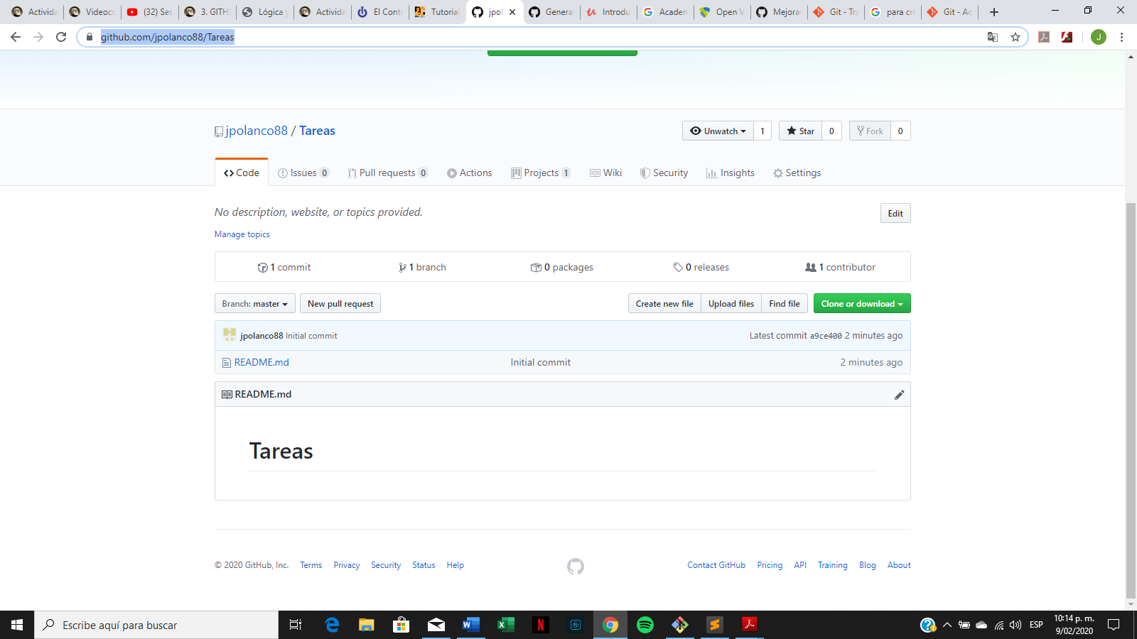

Link repositorio <https://github.com/jpolanco88/Tareas>