Ouragan Matthew réponse, Département de la Grand’ Anse, Haiti

Rapport sur le renforcement de la surveillance épidémiologique et gestion des données

**Jonathan Polonsky** Epidemiologist, WHO Emergencies Programme

## Background

On 4 October, Hurricane Matthew violently struck Haiti and resulted in the country’s largest humanitarian emergency since the 2010 earthquake. It caused extensive flooding and mudslides, damage to road infrastructure and buildings, as well as electricity and water shortages. The latest figures from the governmental Directorate of Civil Protection (DPC) of Haiti have so far confirmed 546 deaths and 438 injured as a result of the hurricane.

Humanitarian needs are said to include access to a sufficient supply of quality water, education, shelter, child protection, health, and nutrition. Of the 1.4 million people who need humanitarian assistance, more than 40 per cent are children who are mainly in the Grand’Anse and Sud Departments

In this context, I was deployed as a field epidemiologist to Jeremie, the departmental capital of Grand’Anse, to analyse the situation and provide support to the PAHO country office in assisting the Ministère de la Santé Publique et de la Population (MSPP) in re-establishing/strengthening epidemic-prone disease surveillance in the affected areas.

## Data collection, management & reporting

### Description of the process

An immediate assessment of the ongoing data collection and

## Epidemiological context

* need to rebuild surveillance
* community based
* line list to capture essential variables for analysis
* ewars-like system to improve data flow
* describe weaknesses
  + 2-level sensitivity analysis
  + from community to CTC
  + from CTC to central level
  + develop methodology for this
* describe the process of calling for aggregated updates
* regular field visits for:
* investigations (alerts, community deaths, clusters of cases/deaths, etc)
* multidisciplinary visits for rationalising resources - prevents repeated trips to same locations and added burden to staff at CTCs
* collecting and comparing

## Analysis of key indicators

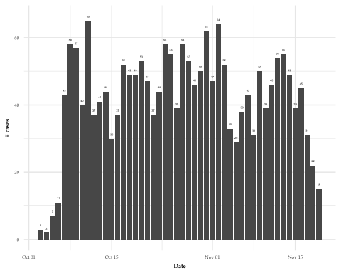

Tendance des cas de diarrhées aigues, 03 Oct 2016 - 19 Nov 2016 Grand’Anse (données partielles).

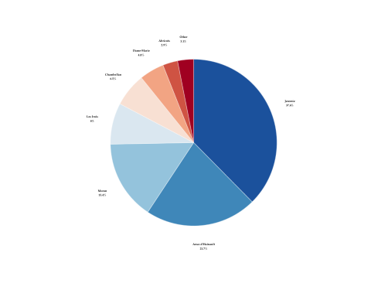

Répartition des cas de diarrhées aigues par commune, 03 Oct 2016 - 19 Nov 2016 Grand’Anse (données partielles).

|  |  |  |  |  |  |
| --- | --- | --- | --- | --- | --- |
| Commune | UTC/CTC | Cas (%) | Décès inst. (%) | Décès comm. (%) | Total décès |
| Abricots | Anse-du Clerc | 0 (0) | 0 (0) | 0 (0) | 0 |
| Abricots | Bontemps | 5 (0.2) | 0 (0) | 0 (0) | 0 |
| Abricots | SSPE des Abrcots | 54 (2.7) | 1 (2.4) | 0 (0) | 1 |
| Anse-d'Hainault | HCR Anse d'Hainault | 434 (21.6) | 8 (19.5) | 1 (11.1) | 9 |
| Anse-d'Hainault | UTC Sicard | 1 (0) | 0 (0) | 0 (0) | 0 |
| Beaumont | Citymed | 11 (0.5) | 0 (0) | 0 (0) | 0 |
| Beaumont | Mouline | 0 (0) | 0 (0) | 0 (0) | 0 |
| Bonbon | Bonbon | 9 (0.4) | 0 (0) | 2 (22.2) | 2 |
| Chambellan | Bourdon | 0 (0) | 0 (0) | 0 (0) | 0 |
| Chambellan | Centre de santé de Chambellan | 131 (6.5) | 2 (4.9) | 1 (11.1) | 3 |
| Chambellan | UTC Boucan | 0 (0) | 0 (0) | 0 (0) | 0 |
| Corail | Centre de Santé de Corail | 0 (0) | 0 (0) | 0 (0) | 0 |
| Corail | Chardonnette | 0 (0) | 0 (0) | 0 (0) | 0 |
| Dame-Marie | UTC Dame-Marie | 97 (4.8) | 5 (12.2) | 0 (0) | 5 |
| Jeremie | Carrefour sanon | 0 (0) | 0 (0) | 0 (0) | 0 |
| Jeremie | Castillon | 0 (0) | 0 (0) | 0 (0) | 0 |
| Jeremie | Dispensaire Siloé | 0 (0) | 0 (0) | 0 (0) | 0 |
| Jeremie | Ferme Latiboliere | 0 (0) | 0 (0) | 0 (0) | 0 |
| Jeremie | Ferme Numero deux | 0 (0) | 0 (0) | 0 (0) | 0 |
| Jeremie | Gond Ayer | 41 (2) | 4 (9.8) | 0 (0) | 4 |
| Jeremie | Hôpital St-Antoine | 247 (12.3) | 1 (2.4) | 0 (0) | 1 |
| Jeremie | Lory | 114 (5.7) | 4 (9.8) | 0 (0) | 4 |
| Jeremie | Marfranc | 134 (6.7) | 0 (0) | 0 (0) | 0 |
| Jeremie | Painket | 0 (0) | 0 (0) | 0 (0) | 0 |
| Jeremie | Previle | 219 (10.9) | 6 (14.6) | 0 (0) | 6 |
| Les Irois | Carcasse | 0 (0) | 0 (0) | 0 (0) | 0 |
| Les Irois | UTC Les Irois | 160 (8) | 1 (2.4) | 1 (11.1) | 2 |
| Moron | UTC Chameau | 0 (0) | 0 (0) | 0 (0) | 0 |
| Moron | UTC Moron | 310 (15.4) | 7 (17.1) | 0 (0) | 7 |
| Moron | UTC Tiparis | 0 (0) | 0 (0) | 0 (0) | 0 |
| Pestel | Ferme Anse-a Macon | 0 (0) | 0 (0) | 0 (0) | 0 |
| Pestel | Ferme Duchity | 0 (0) | 0 (0) | 0 (0) | 0 |
| Pestel | Tozia | 0 (0) | 0 (0) | 0 (0) | 0 |
| Pestel | UTC Pestel | 25 (1.2) | 1 (2.4) | 4 (44.4) | 5 |
| Roseaux | Annette | 0 (0) | 0 (0) | 0 (0) | 0 |
| Roseaux | Carrefour Charles | 17 (0.8) | 0 (0) | 0 (0) | 0 |
| Roseaux | Grand Vincent | 0 (0) | 1 (2.4) | 0 (0) | 1 |
| Roseaux | Lopino | 0 (0) | 0 (0) | 0 (0) | 0 |
| Roseaux | Pousline | 0 (0) | 0 (0) | 0 (0) | 0 |
| Roseaux | UTC Roseaux | 0 (0) | 0 (0) | 0 (0) | 0 |
| Total | - | 2009 (100) | 41 (100) | 9 (100) | 50 |

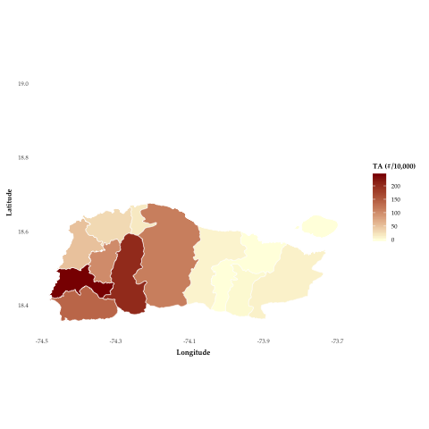

Répresentation du taux d'attaque des cas de diarrhées aigues par 10,000 personnes, 03 Oct 2016 - 19 Nov 2016 par commune, Grand’Anse (données partielles).

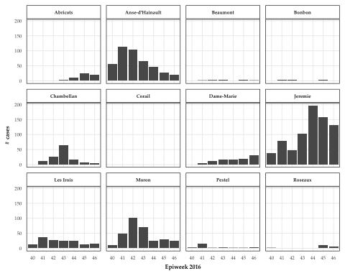

Tendance des cas de diarrhées aigues, 03 Oct 2016 - 19 Nov 2016 par commune, Grand’Anse (données partielles).

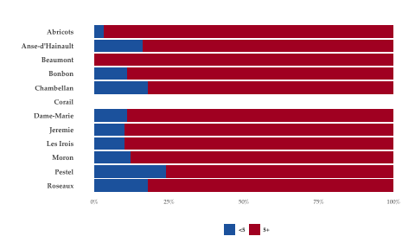

Répartition des cas de diarrhées aigues par tranche d'age, 03 Oct 2016 - 19 Nov 2016 par commune, Grand’Anse (données partielles).

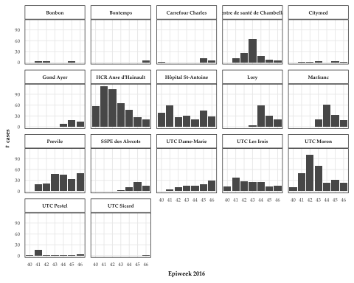

Tendance des cas de diarrhées aigues, 03 Oct 2016 - 19 Nov 2016 par CTC, Grand’Anse (données partielles).

## Recommendations

* IM and DM/Epi should have closer collaboration
* Field epis + logs to support surveillance
* Stronger coordination required - overall surveillance, lab, epi
* Better system - exists in Angola - forms entered by WHO in morning, then DB passed to lab who enter results, which is then shared back with WHO
* Eventual plan should be for proper decentralised and disaggregated surveillance system (e.g EWARS), with single, centralised database (one source of truth from which everyone works, incl. MoH, WCO, RO and HQ)
  + plan for decentralisation only to provincial level
  + current IDSR is aggregated only
* training for staff
* reinforce surveillance on road to, and within, Kikwit
* Evaluate the sensitivity of the surveillance system (e.g. Rapid capture-recapture study)
* Somebody should bring epiinfo DB master to CC meeting and work done directly on that DB
  + or code written to compare last version of lab with what was just sent to identify those with changes

## Annexes

* Weekly epidemiological bulletin