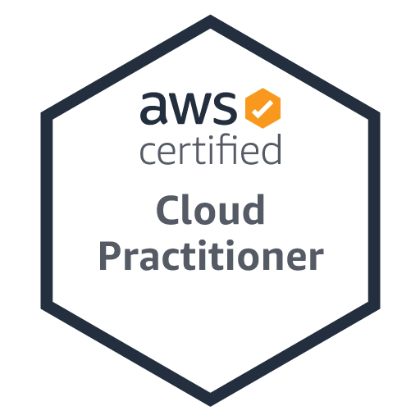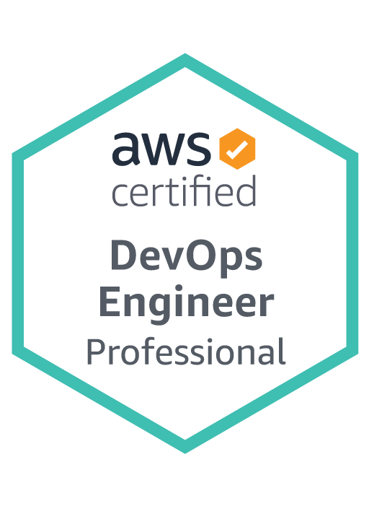

**SUMMARY**

* 9+ Years of experience in IT industry in various roles as DevOps, **Site Reliability Engineer**, Cloud Engineer and Build &Release Engineer with excellent experience in Software Integration, Configuration, Packaging, Building, Automating, managing and releasing code from one environment to other environment and deploy to servers, support and maintenance under Unix/Linux/VM’s Platforms.
* Well experienced in Installation, administration, patches, upgradation, configuration, security issues, performance tuning and **troubleshooting of RedHat Linux 5/6/7, Sun Solaris 8/9/10/11**
* Experience in implementing CI/CD flows using **Jenkins**.
* Experience on **Pivotal Tracker, Github, Docker** and **Kubernetes** Orchestration tools.
* Experience in Pivotal cloud foundry (PCF) Architecture (Diego Architecture), PCF components and their functionalities. Experienced in using Pivotal Cloud Foundry (PCF) CLI for deploying applications and other CF management activities.
* Proficient in automation and configuration management frameworks such as **Puppe**t, **Ansible** and **Chef.**
* Ability to grasp latest technologies and to properly apply new tools like **Docker** to **build applications.**
* Experience in installation, configuration, management and troubleshooting of **Tomcat** container.
* Implemented a **CD pipeline involving Jenkins, Chef** to complete the Automation from commit to Deployment.
* Experience with AWS tools and services to build next generation automated CICD tools and pipelines.
* Experience with CICD tool implementation based on Configuration-as-Code and Pipeline-as-Code strategies.
* Responsible for integrating and maintaining Code Analysis and Code Security tools across multi-stage CICD platform.
* Automation of AWS implementations for new cloud computing systems or existing systems migrating to cloud architectures.
* Experience with node js, react js and javascript
* Experience in **Red Hat OpenShift**, **Docker, Kubernetes**, systems automation, security, and migrating workloads to container-based deployments.
* Extensive experience in writing builds using **MAVEN, ANT, MS-build** as build tools for the building of deployable artifacts from source code.
* Experience in setting up ELK Stack for Log reporting and debugging issues.
* Have strong skills in installing, administering, maintaining and troubleshooting **NFS, DNS, DHCP, NIS, LDAP, Mail Server and Samba Server** in heterogeneous environment.
* Expertise to handle tasks in RedHat Linux includes upgrading **RPMS** using **YUM, kernel, HBA** driver; configure **SAN** Disks, Multipathing and **LVM** file system.
* Performed Scripting for automation, Expertise in utility and monitoring using Shell & Perl scripts.
* Experience with backup technologies like Tivoli Storage Manager 5.x, 6.x and Veritas Netbackup 4.x, 6.x, 7.x.
* Configured and Administered **Nexus Repository Manager** for **GIT** repositories and builds.
* Experience managing NetApp filers by creating volumes on raid groups and aggregates and sharing to Windows and UNIX servers using CIFS & NFS
* Coordinated with **SAN** Team for storage allocation and **Disk Dynamic Multi pathing** (DMP).
* Experience in Preboot Execution Environment (PXE) and Fully Automated Installation (FAI).
* Experience working with Snap mirror & Snap vaults for backup and replication purposes on NetApp devices.
* Expereince on cloud native CICD tools such as **Gitlabs CI, AWS Bamboo,** and **AWS CodeCommit, CodeBuild, CodeDeploy, CodePipeline.**
* Experience in creating **modules, classes, manifests, configuring hiera, Puppet dashboards, custom facts, reporting** and Orchestration.
* Experienced in **AWS, Azure and Google Cloud** based Puppet installation and configuration.
* Planned, documented and supported high availability, data replication, business persistent, fail-over, fall-back Solutions using Sun Cluster 3.1, Veritas Cluster Server 4.0 and Redhat cluster in SAN environment.
* Strong experience and understanding of Auto mounts, TCP/IP, SMTP and Printer configurations.
* In Depth knowledge and experience with LDOMs, Server Domains and Zones/Containers.
* Backup jobs, housekeeping, database, proprietary jobs using **CRON, EMC** legato Networker and BMC Control-M troubleshooting daily job problems.
* Experience in **Jenkins, GitHub, CFT and Terraform.**
* Experience on application deployment strategies like Blue-green, canary and rolling.
* Experience on application monitoring/logging tools New Relic/ELK.
* Experience on CICD Security tools such as Rapid7, Vericode.
* Experience on Identity Management tools Okta or Auth0.
* Good presentation, customer support and trouble shooting skills & experience in providing 24x7 supports.
* **Self-driven** and **Self-motivated** to learn new things.
* Excellent interpersonal skills, independent problem-solving skills, the ability to work effectively in critical situations and hard working

**TECHNICAL SKILLS:**

|  |  |
| --- | --- |
| **Operating Systems**: | LINUX - Red hat 3, 4,5,6,7  UNIX - Sun Solaris 7, 8, 9 &10 11.x  Windows - 2003, 2007, 2008 R2, 2012 R2, 2016 |
| **Hardware:** | HP Proliant, IBM x236 IBM x232, IBM 3650, IBM HS22, HS12, LS22 Blade Center,  SunT2000,T5240,T5120, V880/890,E6500,E4500/E3500,E450/420/250,E220,  Netra1405/X1,T1000/2000,T5120/5220, M4000, B6000, Cisco UCS |
| **Tools**: | WebLogic 10.x/9.x/8.x, WebSphere, Nagios, Apache HTTP/Tomcat/JBoss, VERITAS Volume Manager, Jenkins, GitHub, CFT, Terraform.  Netscape/iPlanet Server, Pivotal Tracker, Chef, Puppet VERITAS Net backup5.1, TSM 5.5, Cluster server 3.5 & 4.1, AWS, Redhat Cluster Server. |
| **Languages**: | Scripting Shell, Bash, Perl, Python, SQL, HTML, C#, |
| **RDBMS**: | Oracle 7.x/8.0/9i/10g, Cassandra, SQL Server, DB2, MYSQL, PL/SQL, T-SQL Sybase. |
| **Network** **Protocols**: | TCP/IP, NIS, NFS, DNS, DHCP, LAN, FTP/TFTP, SSH, SFTP, SNTP, SMTP, ARP,  RARP, PPP, POP3 and Firewalls |
| **DevOps/Cloud/Virtualization** | AWS, AZURE, Puppet, Ansible, Jenkins, Continuous Integration, Continuous Delivery, Docker, Red Hat OpenShift Kubernetes, Nagios, Zabbix, ELK and VMware. |

**PROFESSIONAL EXPERIENCE**

**Neilsen Dec ’17-Present**

**Tampa, FL**

**DevOps Engineer/ SRE**

**Responsibilities:**

* Working as a **Site Reliability Engineer (SRE)**. Worked on latency performance efficiency and change management.
* Installation, configuration and administration of **Linux/Unix** operating systems.
* Worked on **Docker** open source project by automating the deployment of applications inside software containers.
* Experience with Pivotal Tracker.
* Experience on Azure cloud platform tools mainly AKS -Kubernetes engines, COSMOS DB , containers like PCF.
* Installed Pivotal Cloud Foundry ( PCF) on instances to manage the containers created by PCF.
* Used Docker to virtualize deployment containers and push the code to instances cloud using PCF.
* Used Jenkins as Continuous Integration tools to deploy the Spring Boot Microservices to Pivotal Cloud Foundry ( PCF) using build pack.
* Ensured, successful architecture and deployment of enterprise grade PaaS solutions using Private Cloud Foundry (PCF) as well as proper operation during initial Application migration and net new development.
* Creating Automated build process by using **Jenkins** CI tool and use of custom tools for configuration.
* Working on **VMware** guest host operating system installation, Virtual Machine server provisioning, post configuration of Virtual Machine.
* Implemented Jenkins for user management with active directory.
* Worked on tools such as **Ansible** and **Puppet** as a part of configuration management.
* Configured the Kubernetes clusters and deployed the package using Helm package management tool.
* Configured Envoy and Istio in micro services.
* Creating **Ansible Playbooks**, to Deploy VM and install the Components as per requirements.
* Managing the system life cycle with **Puppet** and **Manifests.**
* Automated setting up server infrastructure for the DevOps services, using **Puppet/Ansible**, shell and python scripts.
* Experience with node js, react js and javascript.
* Deployed built artifacts to WebSphere application server using python scripts
* Working on **Puppet** and able to create manifests and modules for automation.
* Worked on **Jenkins** to build the automation of auto deployments to DEV environment into the **AWS** cloud (S3, Lambda, Containers).
* Created **Jenkins** Jobs for push button deployments in QA, Integration, Staging and Production servers.
* Responsible for orchestrating **CI/CD** processes by responding to Git triggers, human input, and dependency chains and environment setup.
* Integrated Puppet Modules with **Jenkins** for Push button deployments.
* Key team member architecting and deploying **Kubernetes** into production on **Azure and AWS** (S3, Lambda, Containers) cloud environment.
* Developed and maintained **Puppet** modules to manage configuration and software.
* Created the build scripts using **Maven** for Java projects. Automating the build process by configuring Subversion for projects. Build tracking so that whenever defect is detected, developers will be able to track the source code. Handling Environment issue in **Linux boxes**.
* Built centralized logging to enable better debugging using **ElasticSearch, Logstash (ELK) and Kibana**.
* Built and managed different monitoring dashboards using Kibana 4 that helped Site Reliability Engineering to monitor the uptime of services.
* Implemented **Nagios** Monitoring and alerting for the applications.
* Troubleshooting **JAVA** application running on nix environments.
* Automating day-to-day tasks using **Shell** and **Python** scripts.
* Building Clusters in Azure and configured load balancers top support the clusters.
* Followed RPC call chains across arbitrary network steps.
* Build and configured a virtual data center in the **AWS, Google Cloud & Azure** **cloud** to support Enterprise Data Warehouse (EDW) hosting including Virtual Private Cloud (VPC), Public and Private Subnets, Security Groups, Route Tables, Elastic Load Balancer (ELB).
* Worked on Jenkins, GitHub, CFT and Terraform.
* Hands on experience in using **Azure and AWS** Cloud (S3, Lambda, Containers) in various AWS services such as Redshift Cluster, Route 53 domain configuration.
* Setup and build AWS infrastructure various resources **VPC, EC2, S3, IAM, EBS**, **Security Group, Auto Scaling, and RDS** in Cloud Formation JSON templates.
* Maintained the user accounts **(IAM), RDS, Route 53, VPC, RDB, Dynamo DB, SES, SQS and** SNS services in AWS cloud.

**Environment:** Devops, AWS , Pivotal Cloud Foundry ( PCF), Lambda,Puppet, Python, Jenkins, Red Hat OpenShift,VPC, EC2, S3, IAM, EBS Site Reliability Engineer (SRE),Ansible, Chef ,Puppet,Docker,Git, Kubernetes, RedHat, Maven,CentOS, Elasticsearch, Logstash, Kibana, JIRA.

**MASONITE Jan’15-Nov’17**

**Tampa, FL**

**DevOps Engineer**

**Responsibilities:**

* Installation, Maintenance, Administration and troubleshooting of **Linux** and **Solaris** servers.
* Responsible for managing infrastructure provisioning **(EC2, ELB, S3, Route 53, IAM, security groups - CIDR's, NAT)**, application deployment and monitoring.
* Implemented and maintained the monitoring and alerting of production and corporate servers/storage using **AWS Cloud watch and**  **AWS (S3, Lambda, Containers).**
* Setting up private networks and sub-networks using virtual private cloud (**VPC**) and creating security groups to associate with the networks and Setting up scalability for application servers using command line interface.
* Setting up and administering DNS system in **AWS** using **Route53**.
* Generated python scripts to manage the Automatic backup of the EC2 - ELB volumes and Cron the job to create the snapshots of the volumes with the **AWS API for EC2** Instances storage.
* Container management using **Docker by writing Docker files** and set up the automated build on Docker HUB and installed and configured Kubernetes.
* Designed, Installed and Implemented Ansible configuration management system.
* **Used Ansible** to manage Web applications, Environments configuration Files, Users, Mount points and Packages.
* Experience on Azure cloud platform tools mainly AKS -Kubernetes engines, COSMOS DB , containers like PCF.
* Installed Pivotal Cloud Foundry ( PCF) on instances to manage the containers created by PCF.
* Used Docker to virtualize deployment containers and push the code to instances cloud using PCF.
* Used Jenkins as Continuous Integration tools to deploy the Spring Boot Microservices to Pivotal Cloud Foundry ( PCF) using build pack.
* Ensured, successful architecture and deployment of enterprise grade PaaS solutions using Private Cloud Foundry (PCF) as well as proper operation during initial Application migration and net new development.
* Experience with node js, react js and javascript.
* Worked on **Red Hat OpenShift** for Container based software deployment and management.
* Performed integration of Code Quality Analysis techniques - Checkstyle, Findbugs with CI tools like **Bamboo.**
* Create and setup automated nightly build environment for java projects using **Maven**.
* Build scripts using **ANT and MAVEN** build tools in Jenkins to move from one environment to other environments.
* Managed **Sonatype Nexus repositories** to download the artifacts (jar, war & ear) during the build.
* Monitored the servers using **Zabbix**.
* Built virtualized Linux servers on **ESX** and blade servers to host multiple applications on same chassis across different server hosts
* Managing users and groups using the amazon identity and access management (IAM).
* Implementing a Continuous Delivery framework using Jenkins, Chef, Maven & Nexus in Linux environment
* Created alarms in **Cloudwatch** service for monitoring the server’s performance, CPU Utilization, disk usage etc.
* Coordinate/assist developers with establishing and applying appropriate branching, labeling/naming conventions using **Git** Version Control.
* Created Automated Deployment using Jenkins.
* Experience with web deployment technology specifically Linux/Nginx/Apache/Tomcat/Java.
* Scripted Linux repository database comparisons using **Python**.
* Responsible for Development, Integration, Staging and Production deployments.
* Analyzed and resolved conflicts related to merging of source code for **GIT**.
* Managed Dependency Management within the teams by installing and configuring Nexus Repository Manager.
* Deployed **Puppet**, **Puppet** dashboard for configuration management to existing infrastructure
* Good experience writing Manifests, Modules using Industry Best Practices for both Deployment Automation and Infra Configuration Management.
* Practical understanding and experience in scaling puppet with 100's of agents and few puppet servers.
* Used Puppet to manage Web Applications, Config Files, Data Base, Commands, Users, Mount Points, Packages.
* Built and maintained **Elasticsearch, Logstash, Kibana** stack to centrally collect logs that are used to monitor applications.
* Use of **Docker containers** to run various applications and Deployment.

**Environment**: AWS, , EC2, S3, Pivotal Cloud Foundry ( PCF) ,IAM ,Devops, Lambda, Git, Jenkins, Cheff,Puppet, ELK, MAVEN, Shell Script, Ansible ,RedHat Linux, CentOS, JIRA.

**CEXO Nov’11 -July’14**

**Hyderabad, India**

**Linux/Windows & VMware Engineer**

**Responsibilities:**

* Assisted in planning and implementation of virtual environment. Creating a procedure for the P2V migration.
* Analyzing the servers to be virtualized or migrated.
* Managed a decent cloud storage environment with Vrealize cloud environment, performed backups and Audit reports based on user log information from Vrealize.
* Used VMware vCenter, created DataCenter Environment by creating VMware clusters, adding ESX hosts in the clusters, and implemented HA and DRS.
* Performed physical to virtual (P2V) migrations for approximately 500 physical servers utilizing VMware Converter.
* Daily provisioning and optimization of storage environment with NetApp FAS3050, FAS3160, FAS270 .
* Worked on deploying Linux SuSE 10, 11 and 12 versions.
* Upgraded from Linux SuSE version 10 to 11 and from 11 to 12.
* Worked over RDSH in updating operating systems from windows 2008 to 2012.
* Installed and upgraded Horizon Client suite environment to VMware horizon 6 version.
* Involved in installing/configuring and troubleshooting VMware Lab Manager and administrating multiple labs in Lab Manager and dealing with Lab Manager Issues.
* Involved in built and deploy the windows XP and windows 7 golden image for the VDI environment.
* Performed Audit report generation using Power Shell scripting.
* Used HP C7000 blade enclosures with installing multiple layers of HP blade servers.
* Upgraded from HP C7000 server to HP C7000 platinum server, which improve transmission speeds at exponentially high level.
* Managed EPIC infrastructure, regarding Health care management.
* Designed work flow and data base architecture using EPIC
* Reduced CPU load on NetApp filers from 90% to 55% by optimizing volume configuration.
* Planned and performed a head swap from a NetApp FAS3050 to a NetApp FAS3160.
* Installing, configuring and troubleshooting VMware View.
* Performed tons of V2V Migration.
* Experienced in maintenance of source code repositories management systems, such as GIT, SVN, Bitbucket, and IBM ClearCase applications
* Performed operation on Team city on tool building at the application level.
* Worked on SCSI internet protocol commands and perform data transfer via serial communication, worked on SCSI versions such SCSI-FCP and SCSI-UAS.
* Discussing with the user and team and scheduling migration and monitoring migration.
* Creating a workflow for Pre/Post Migration.
* Perform operational turnover on all system implementations.
* Migrating machines either P2V or from Microsoft Hyper V environment to VMware environment
* Worked with Servers like Windows 2000, 2003, 2003R2, 2008, 2008R2.

Environment: VMware ESX 4.0/3.5, VSphere 4.0, Windows Server 2008/2003, Windows xp/vista, Active Directory 2003, SQL Server 2008/2005, HP Proliant Servers, HA/DRS, SCCM, Linux SuSE

**Education:**

* Master’s in Information systems