Installing sBitx software on Raspberry OS (64-bit) with Cinnamon Desktop

- Installation is mostly automated by a bash script.
- Optionally install sdrplay driver software and any or all of the following SDR software: CubicSDR, SDR++, SDRangel and SDRconnect (only works with sdrplay hardware). They are built from source. The sdrplay driver, v3.12, is installed from the sdrplay.com site.

The Raspberry OS 64-bit seems to work on my sBitx V3 board using a Raspberry Pi 4B 4GB and a 9-inch HDMI monitor. A second HDMI monitor can also be used. In fact, I sure you could build your sBitx V3 in a case without a 7-inch DSI display - just attach a HDMI desktop monitor to the Pi’s HDMI connector. The total storage used on the storage device is about 7GB or 12GB with the optional SDR software. I recommend using a USB flash drive which is much faster than a SD card. I used a 128GB USB 3.1 Lexar flash drive for storage.

This setup has not been tested with any other hardware then the Pi 4B 4-Gigabyte single board computer (SBC), 9 inch (800 x 480 resolution) HDMI touchscreen display (buydisplay.com) , and the sBitx V3 board. There is a setting in the boot/config.txt file that forces output to be 800 x 480 resolution on HDMI-0 for the 9-inch display. Comment it out if it interfers with with your monitor. It shouldn’t affect the 7-inch Raspberry DSI display since it’s not connected through HDMI. The capacitive touch screen feature is not being used at this time. I may try it in the future but a wireless wheel mouse and keyboard will be all that’s needed besides a fast Internet connection.

The reason I came up with this setup is because I wanted to use my Pi 4 with my sdrplay RSPdx sdr using SDRconnect, SDR++, SDRangel or CubicSDR which only run on 64-bit OSes. The sBitx software as shipped, unfortunately for me, came with Bullseye 32-bit Raspberry OS by default.

Software Fixes
In order to use the sBitx software on Raspberry OS (64-bit), there were two changes made. The sbitx/ft8_lib software was recompiled with a small change to the Makefile. On the other hand, the WiringPi software was totally broken using the v6.1 kernel. The original WiringPi software would check to see what hardware revision was being used by parsing the HARDWARE line output from /proc/cpuinfo and refused to run if not found. The Raspberry Pi Organization states not to rely on the revision info because the revision can change if different manufacturers are used. With version 6.1 of the Linux kernel, the output from proc/cpuinfo no longer has the HARDWARE info section and consequently the software no longer worked. My workaround was to take the output from /proc/cpuinfo from the 32-bit OS which has the HARDWARE section, place it in a file called cpuinfo.txt and modify the software to parse that file instead of /proc/cpuinfo on the 64-bit OS. Voila!

What you'll need.
SBitx 3 board with Raspberry Pi 4B 4GB SBC, 7-inch offical Raspberry Pi display, or as in my case, I used a 9-inch HDMI display which has the same 800 x 480 resolution as the Pi display.

I used a Lexar JumpDrive S47128GB USB 3.1 Flash Drive (LJDS47-128ABBKNA) for storage. It's small, works with USB 3, and much faster than SD. There are also 32GB, and 64GB versions. Priced from about $9 - $25 plus shipping on Amazon.
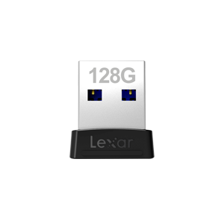

After the OS is setup you’ll need to copy of your sBitx/data files from your SD card to the pi/sbitx directory. You can transfer it as a zip file, scp it to the Pi with Putty or another Linux system or put the SD card in a card reader and plug it into the Pi 4 and copy/paste them. I haven’t used Windows at home for over 20 years, so if some of this does not apply, I probably can’t help you.

Installation Steps

Get the Raspberry Pi OS Imager from https://www.raspberrypi.com/software/ to write the os to you storage. Use it to download the OS image, preconfigure the WiFi network SSID/password , your timezone, keyboard layout, pi user/password, and hostname.

Runit and then select your device, select the lite 64-bit OS (under Raspberry Pi OS (other)) and your storage device (which hopefully you’ve plugged into our computer).

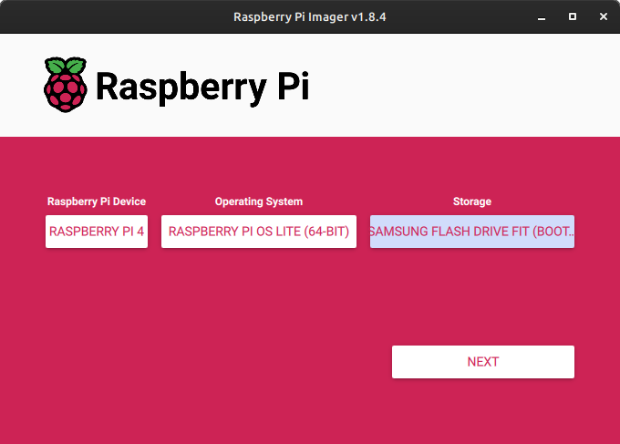
Click on ‘Next’ and edit the OS customization settings. The settings will be retained when saved.

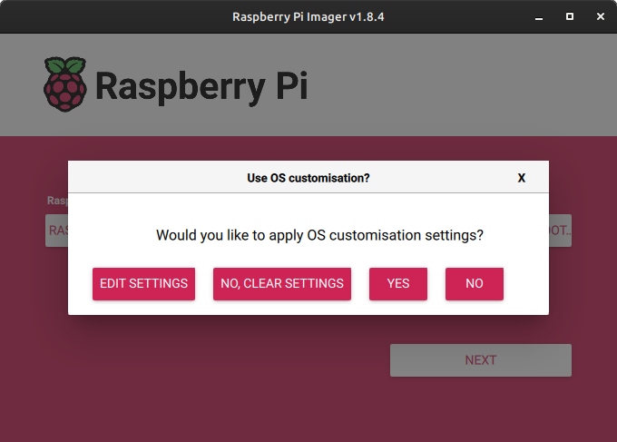

Click on ‘EDIT SETTINGS’. There are three section tabs to fill out. The user name needs to be ‘pi’ the password can be whatever you want but I used the traditional password of ‘raspberry’. You’ll see a warning on the console login about changing the password if you use ‘raspberry’. I don’t know if this warning is generic on first run. You can always change the pi user password after login with the command, ‘passwd’.

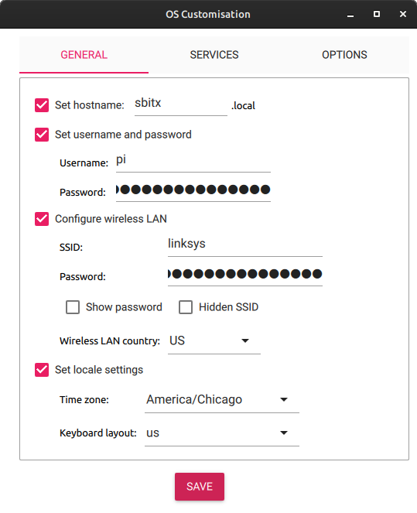
Fill out the fields and then click on ‘SERVICES’.

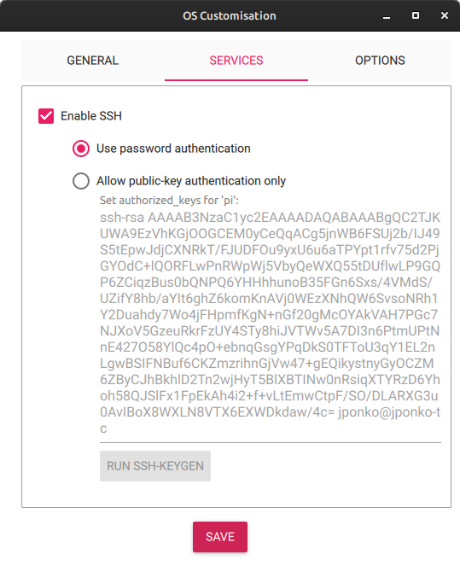

Enable SSH and set ‘Use password authentication’. Click on ‘OPTIONS’.

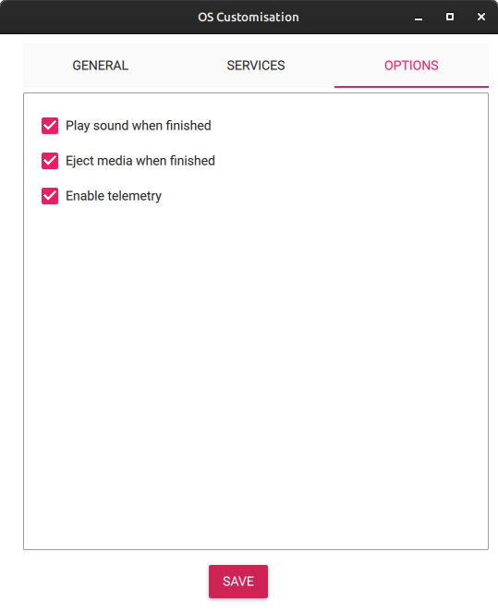

Select all three and then click on ‘SAVE’. You’ll be back at the main menu and just click on ‘NEXT’

The telemetry option just sends info about which images are being written with imager and can be viewed at https://rpi-imager-stats.raspberrypi.com/ . If your scared, unmark it.

This time click on ‘YES” to use the custom settings.
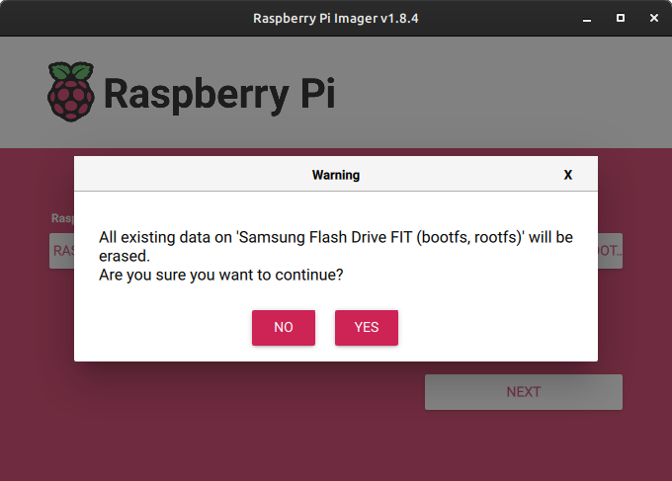
Click on “YES’ and you will be prompted for your SUDO password to write the image. Yes all the data on the device will be erased. After you click on ‘YES’ to continue, it’s pointless to click on ‘CANCEL WRITE’ :(
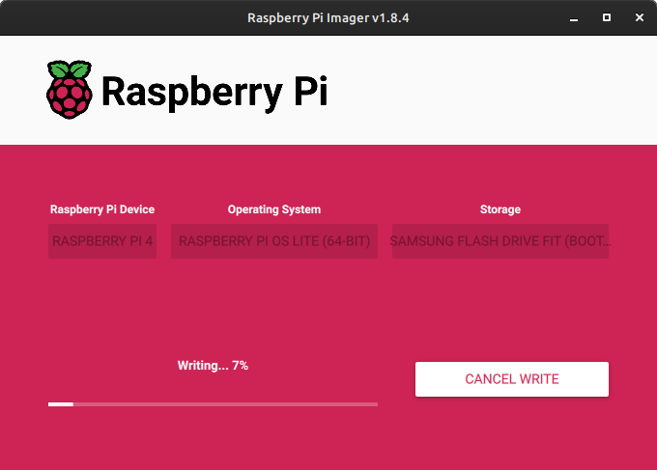
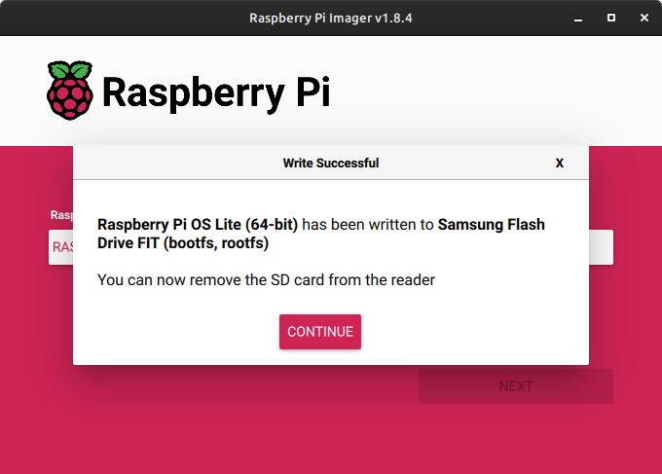

Done! Remove the storage media, place it in the Raspberry Pi and power on.

The Pi will boot to a screen where it will generate and store the system SSH keys and reboot. The Pi will then boot to the console screen a second time where it looks like it’s ready for the pi user to login. It’s not. The OS will reboot again after it expands the file system to the maximum.

Login as pi with whatever password you used in imager. You can ssh into the Pi to do the following commands with cut and paste the text between the quotes on the consoleif you wish:

1.) ‘sudo apt install git ‘.
2.) ‘git clone https://github.com/jponko/sbitx-on-64-bit ‘ and when completed
3.) ‘cd sbitx-on-64-bit’
4.) ‘chmod +x install.sh’
5.) ‘./install.sh’

And it will take about 45 minutes to install everything and will reboot afterwards. There will be a sBitx icon on the desktop with my desktop preferences – background, dark theme, cpu monitor and diskspace desklets and cpu temperature and shutdown applets on the panel (aka taskbar?). Feel free to customize to your liking. Most everything can be changed under the Menu > Preferences > System Settings. WSJTX and fldigi are under the ‘Hamradio’ category. You can add them to the desktop or panel by right clicking on the icon in the menu. The menu by the way, is the left icon on the panel which looks like a snow topped mountain range in a circle. If you hover over a icon a popup baloon with its name will appear.

For those who wish to install CubicSDR, SDR++ or SDRangel, there’s a sdr.zip file which contains scripts to build and install these three. SDRplay’s SDRconnect is in beta and can be gotten from sdrplay.com. Unlike the other three SDR programs, SDRconnect only works with sdrplays hardware.

JP 01/13/24

