**BLIND – THE ECHOLOCATION GAME WALKTHROUGH**

1. The game first presents itself to the player, shows the title of the game as well as the one who created the game. The game asks the player to press any button on the keyboard in order to proceed with the program.



1. The game will now give the game objective, which also works as a “primer” in order to let the player know of the game they are about to play.



1. The game will now present its in-game screen and the “room” to where the blind man can navigate around with. Also on the right of the screen is a real-time coordinate tracker, as well as the game directions and things to keep in mind. This part of the program will also randomly scatter 10 obstacles to avoid, as well as randomly assign where the goal area is. Those cannot be seen here because the player is moving a blind character, and the player will be needing to use the ability of echolocation in order to find them.

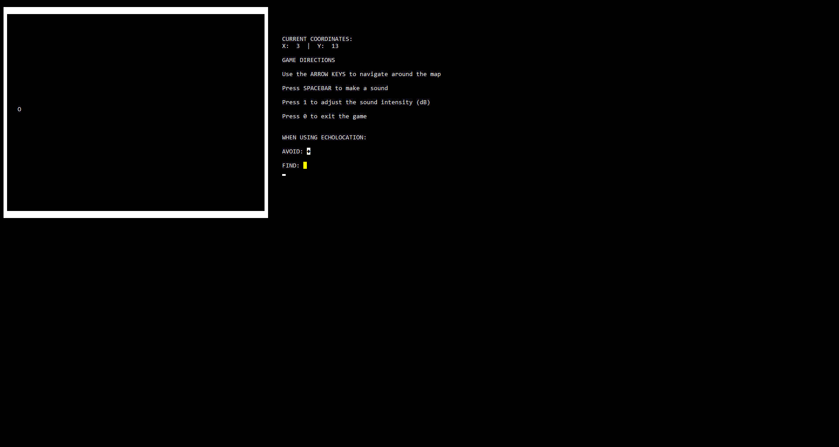

1. Use the arrow keys to move around the room.

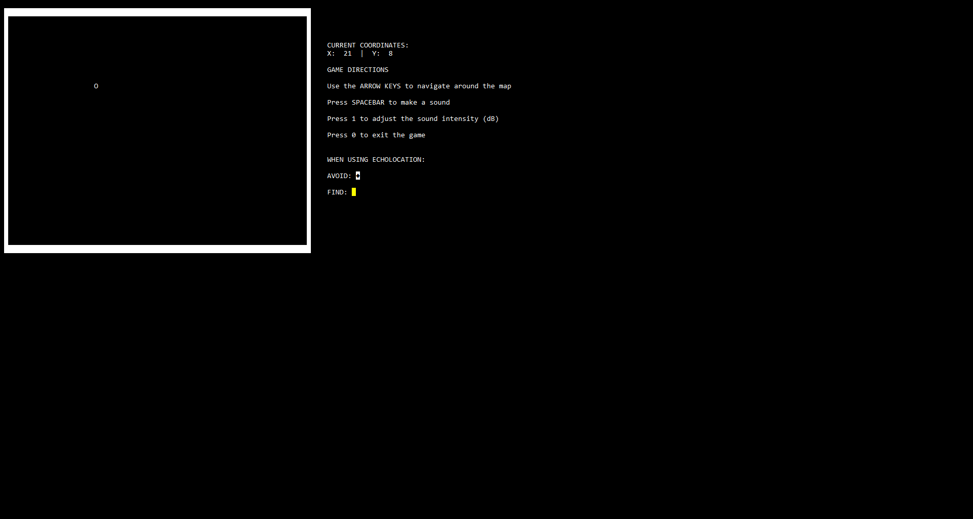

1. Press the “1” key to adjust the sound intensity level (dB) of the sound that the character will make. A greater value here will visually represent a larger sound wave and cover more of the room, but it will take the user longer to make another sound-scan of the room.

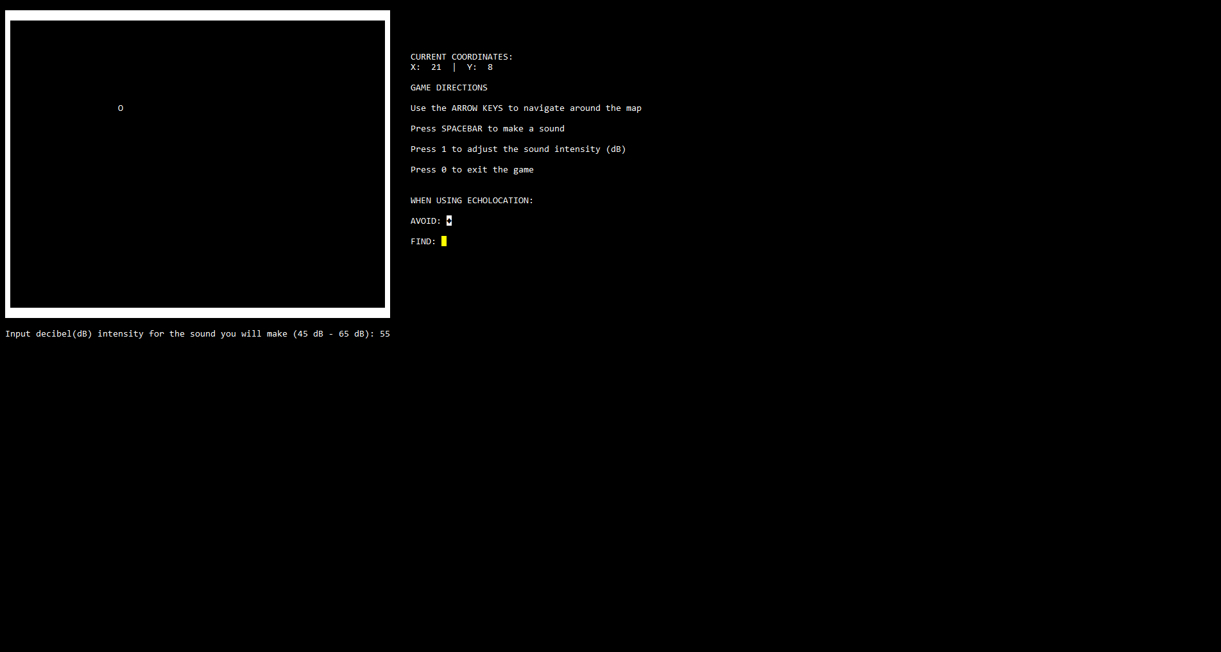

1. A sound too quiet / too loud will prompt the user to enter another value.

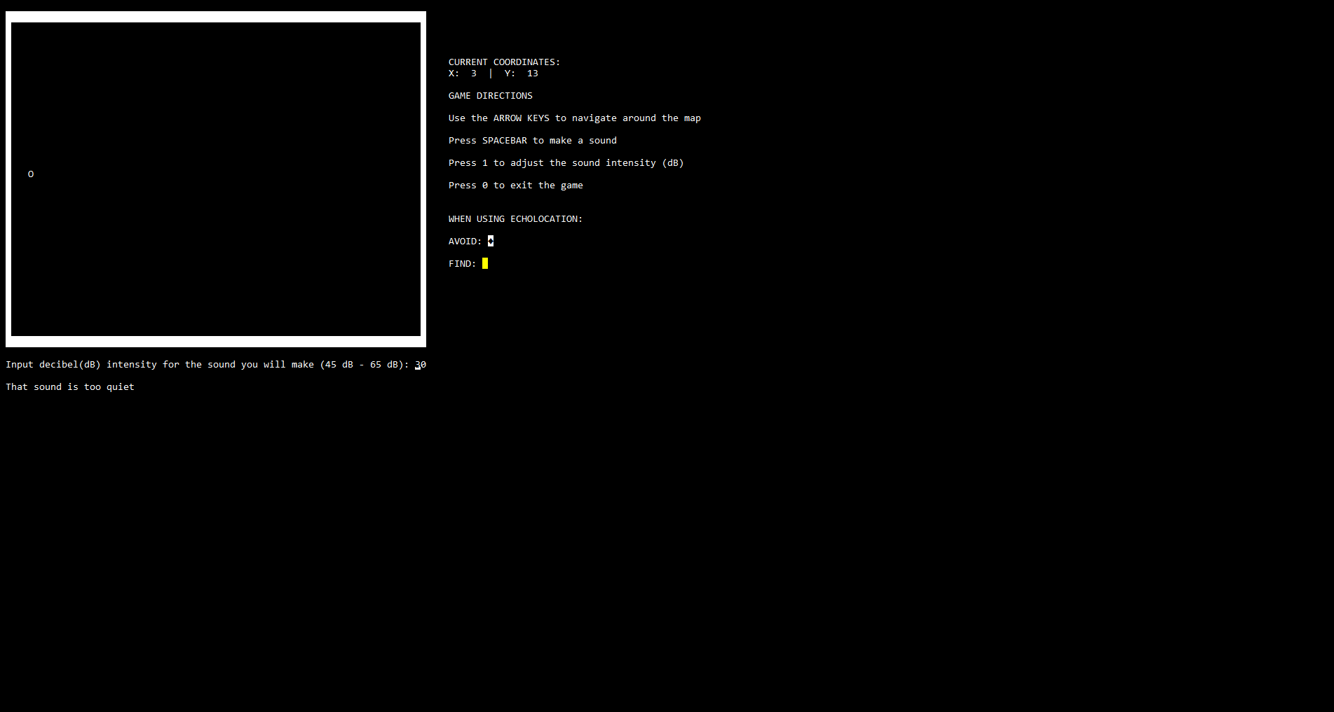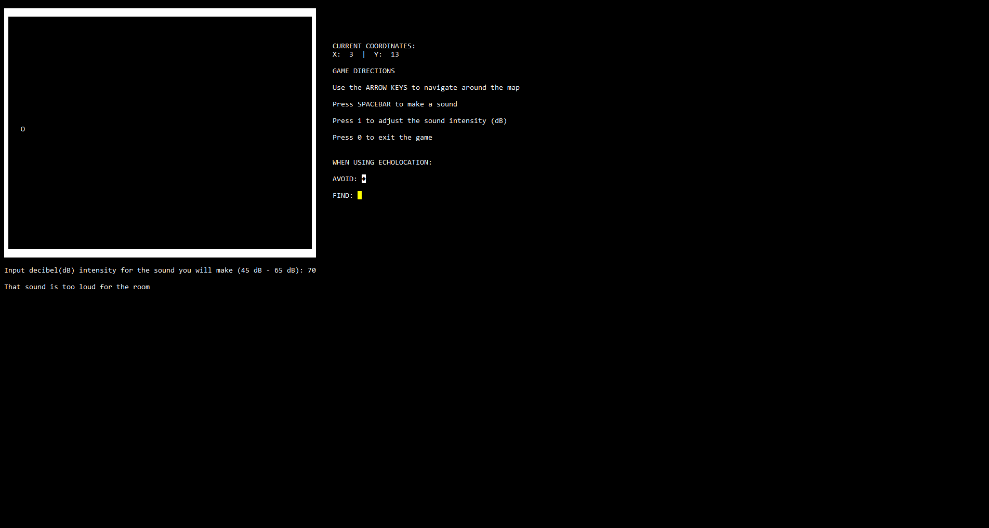

1. Press the spacebar key to visually present the sound waves on-screen.

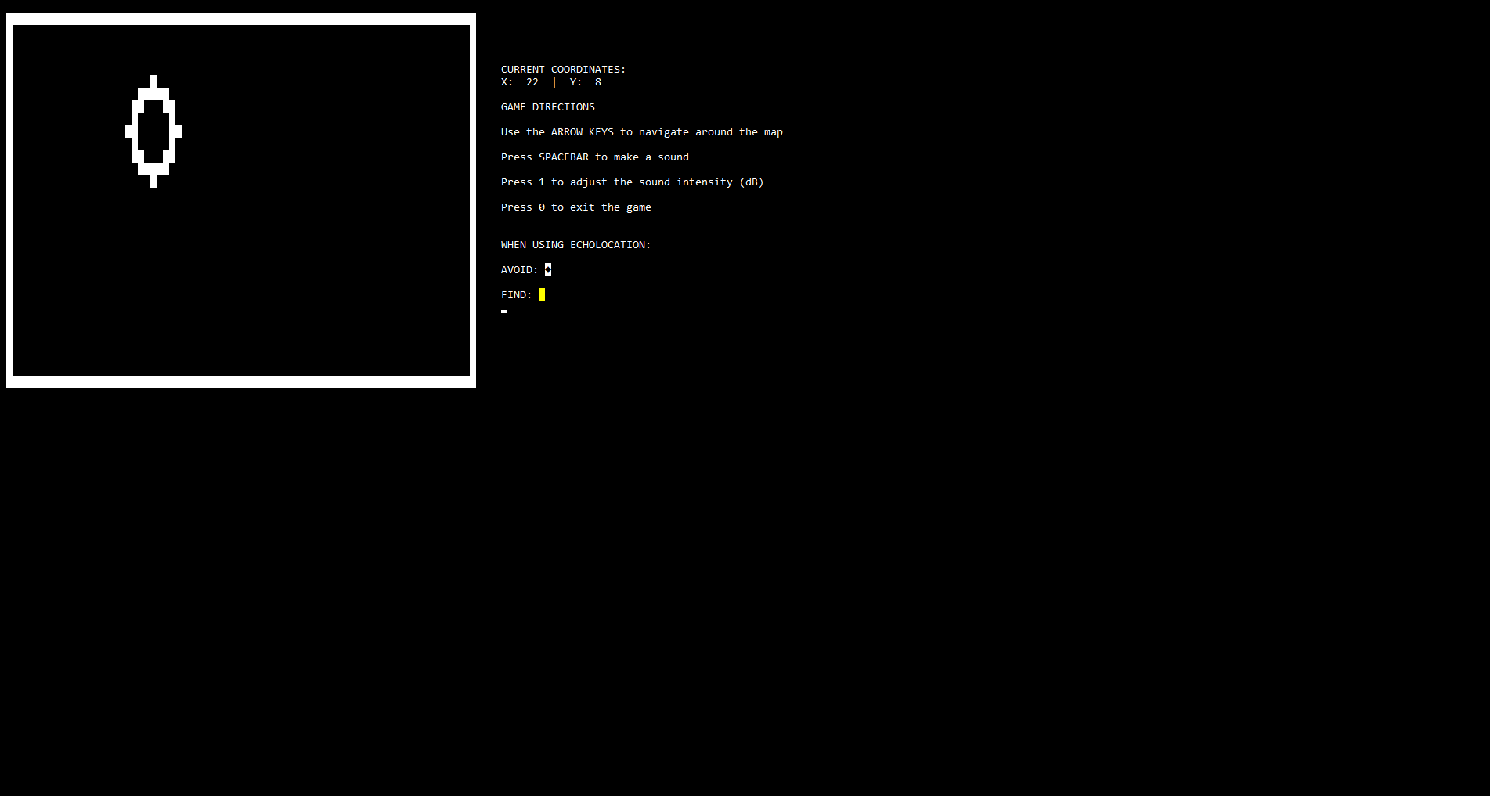

1. When detected, avoid the “black diamond shapes”, for those the obstacles to avoid.

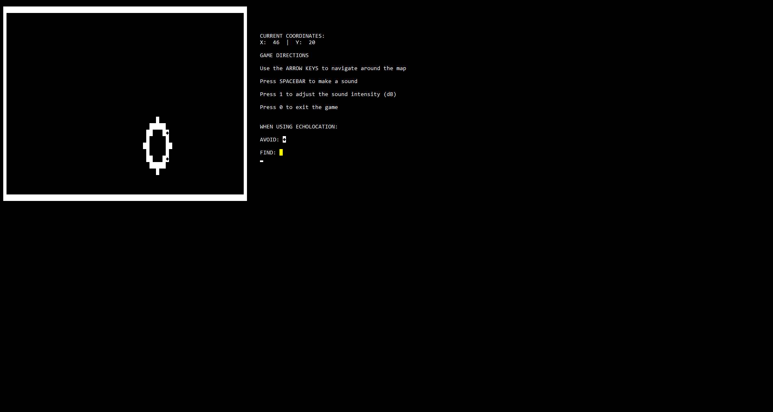

1. Making contact of the obstacles will yield the player to lose the game. Shown in this screen are how many moves the player made before losing

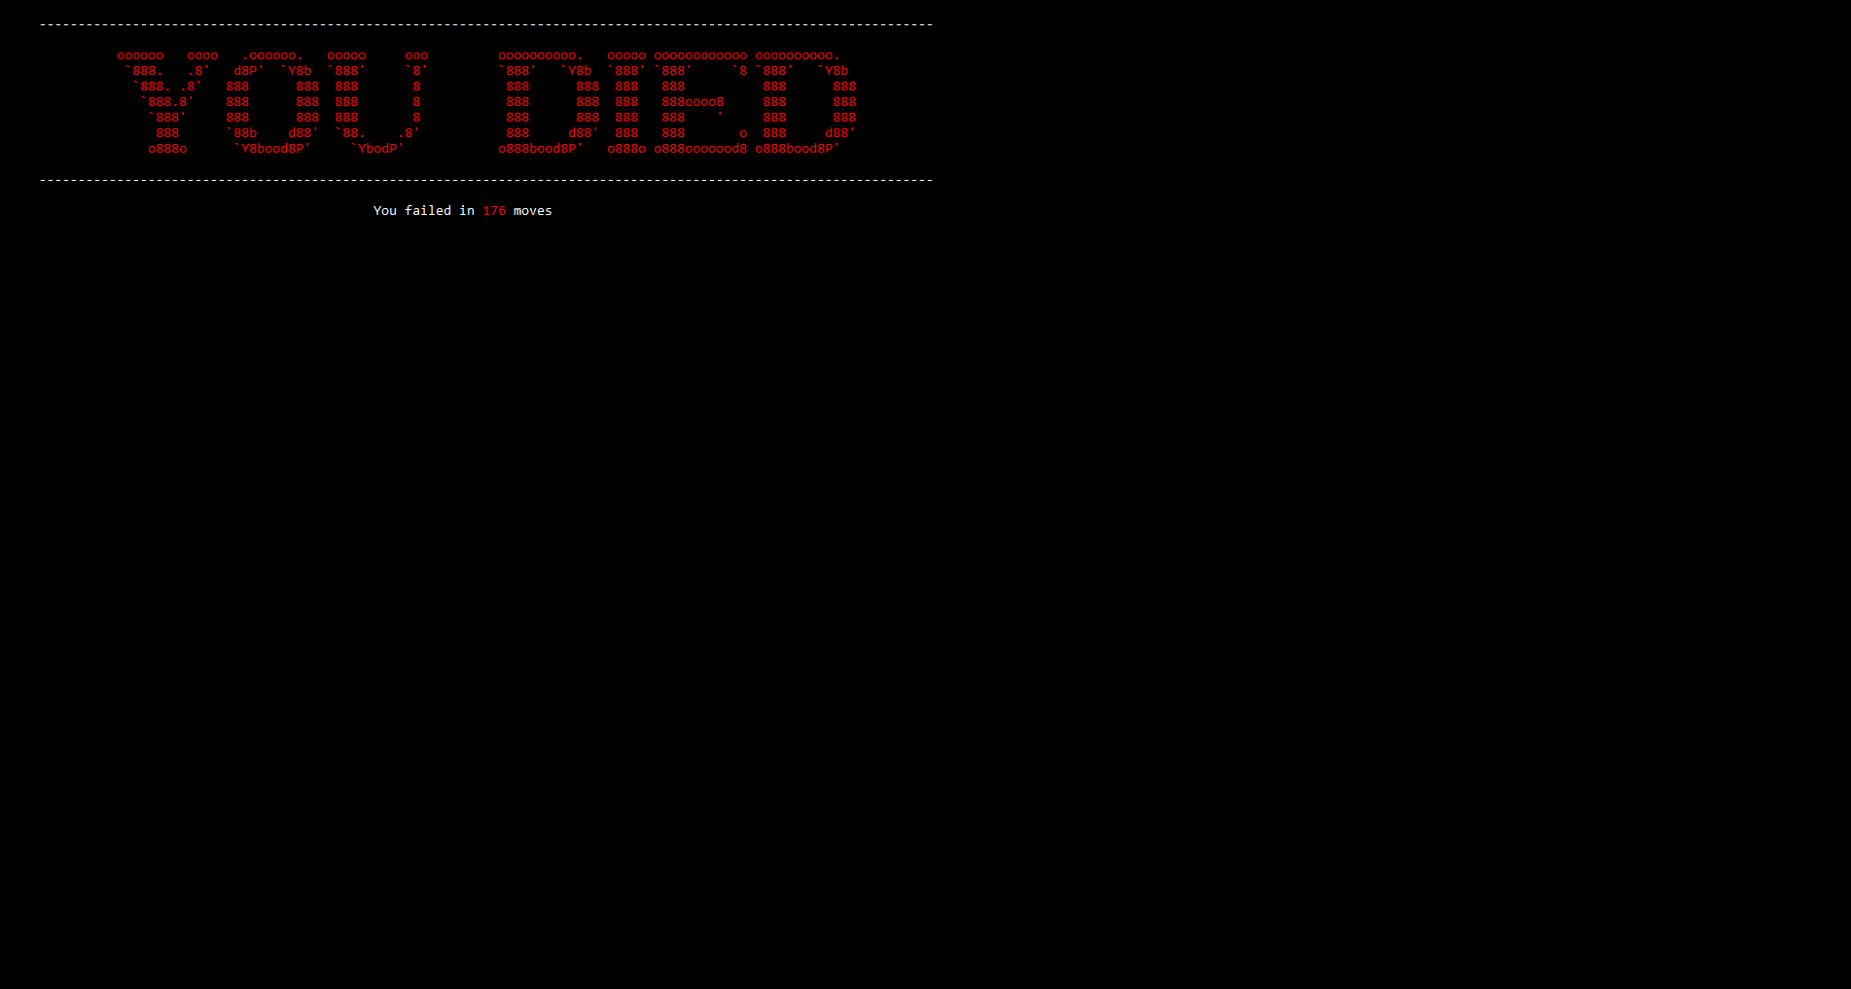

1. The goal of the player is to find the “light at the end of the room”, represented visually by a yellow cell when detected by sound.

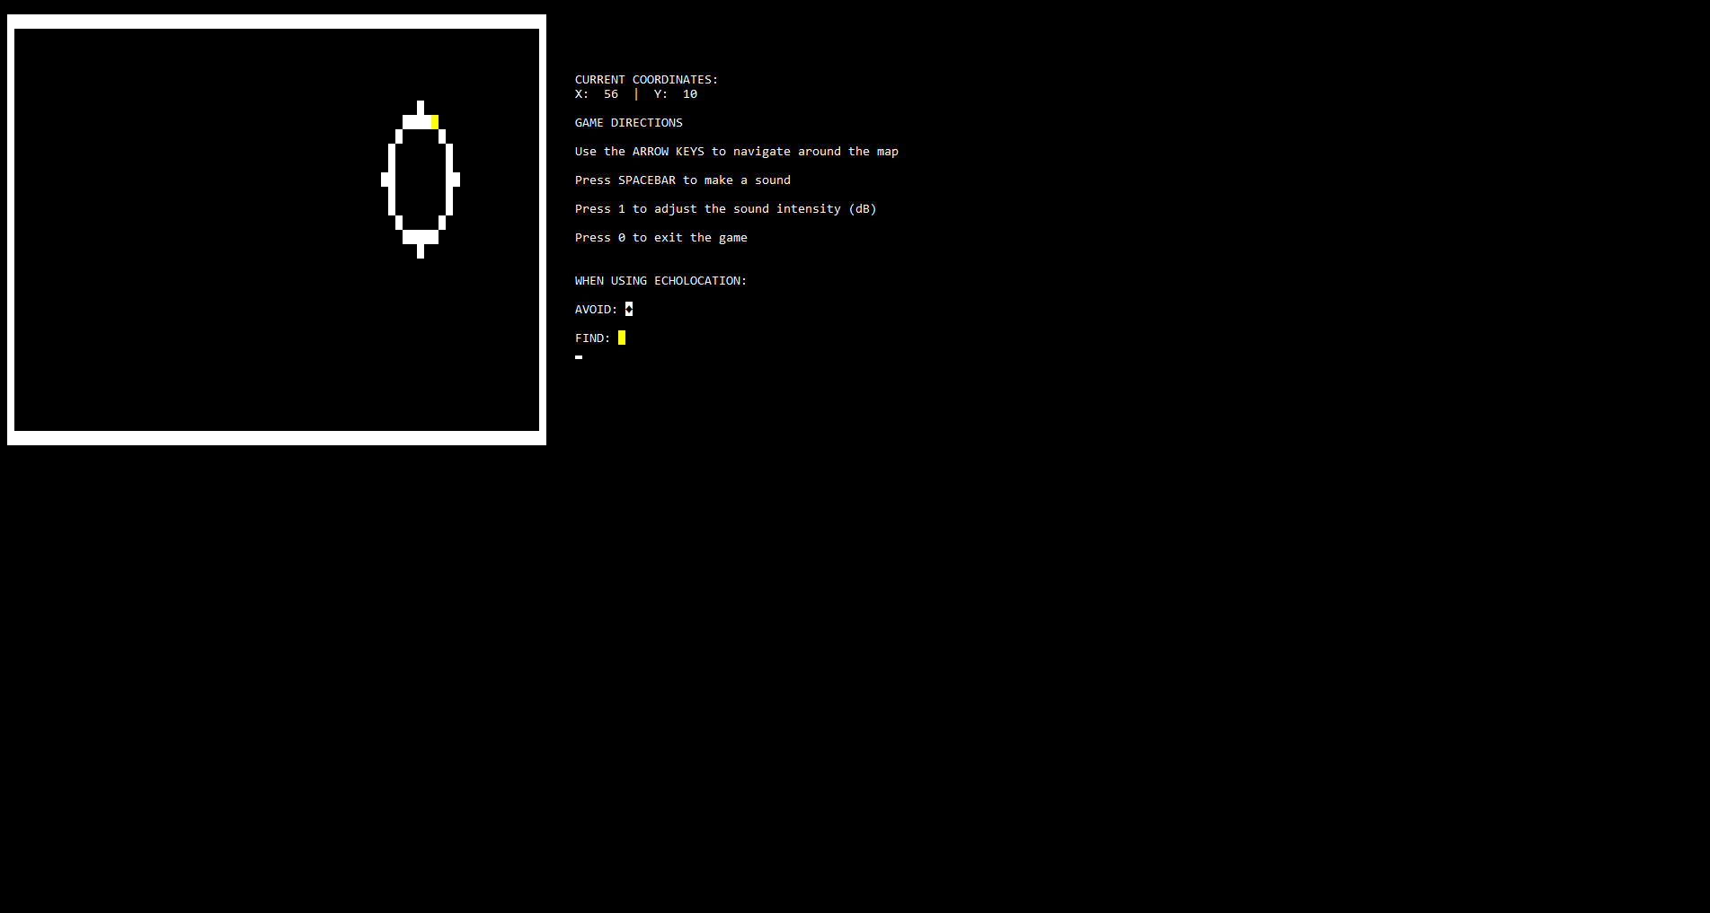

1. When the player makes contact of the goal area they will receive a message that they have won the game, and “made it out alive”. Shown here as well is how many total arrow key-based moves the player made, and how many times the player made a sound.

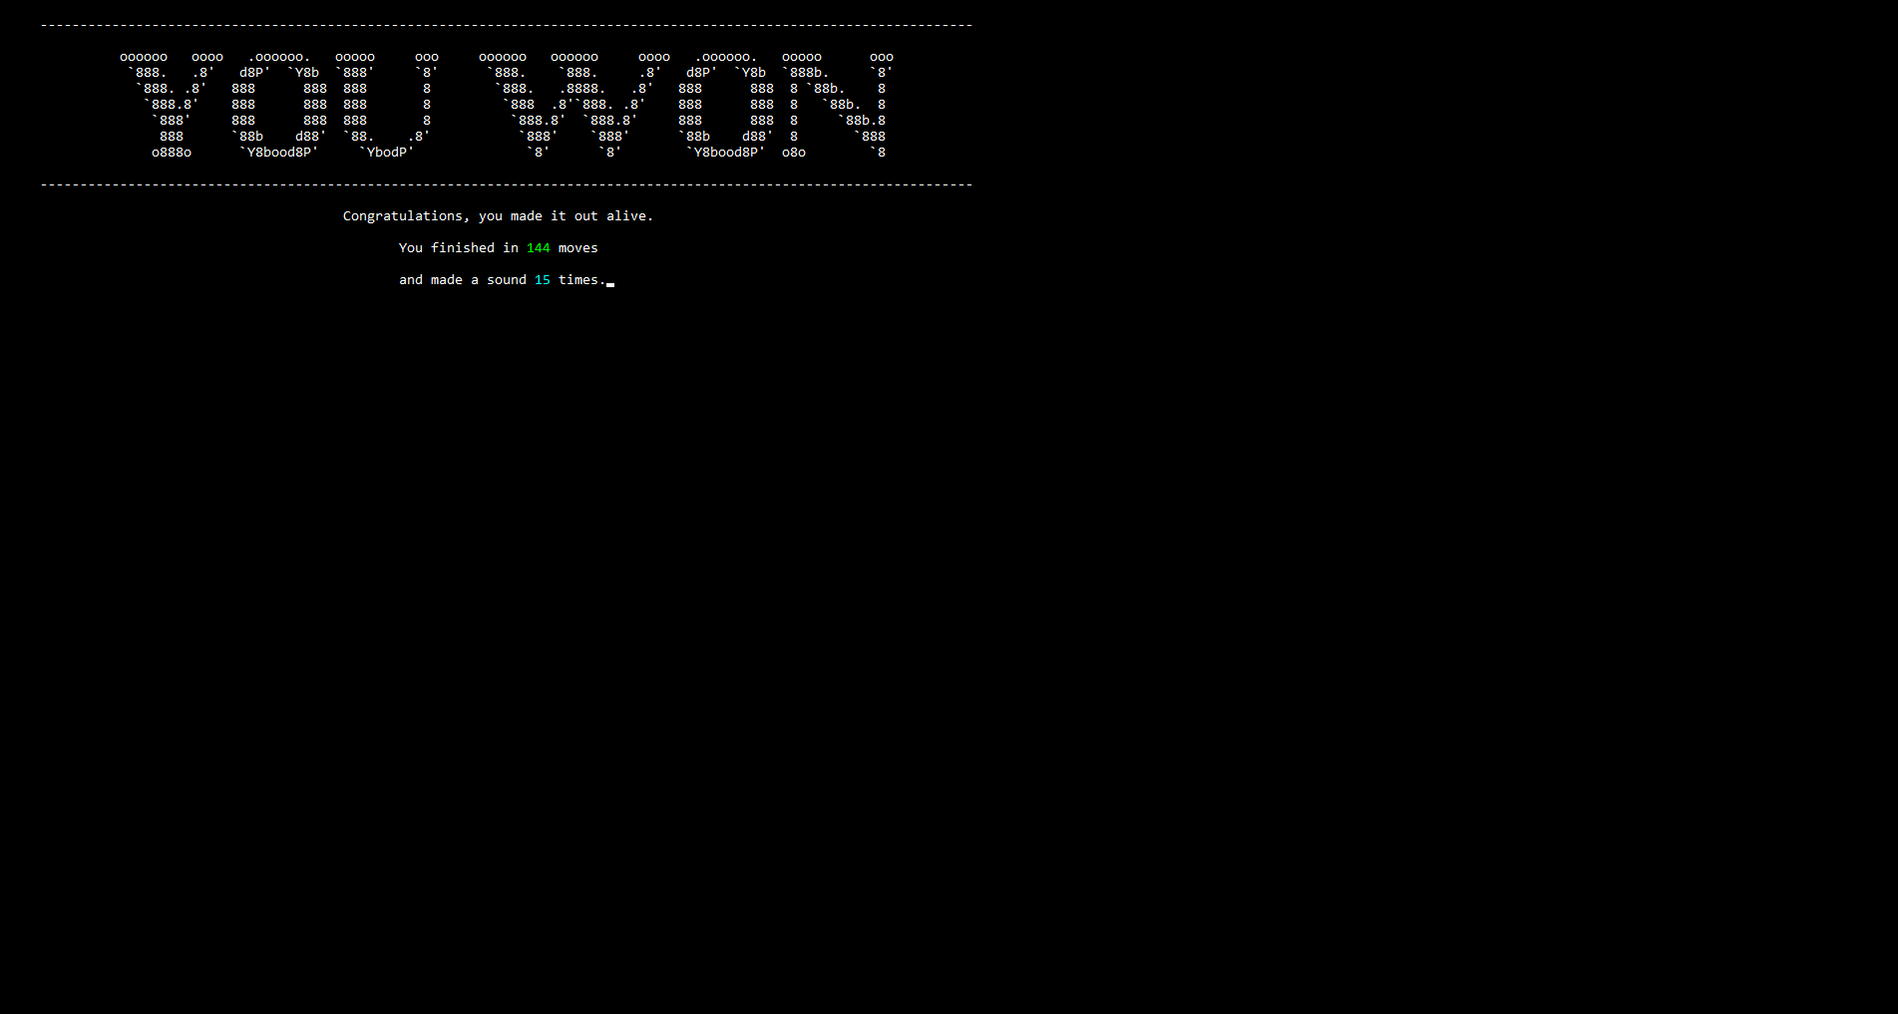

1. When in-game, the player can quit anytime by pressing the “0” key, and they will be given this message:

