Jamie Pordoy

Stdent example assignment:
Systems Analysis And Design

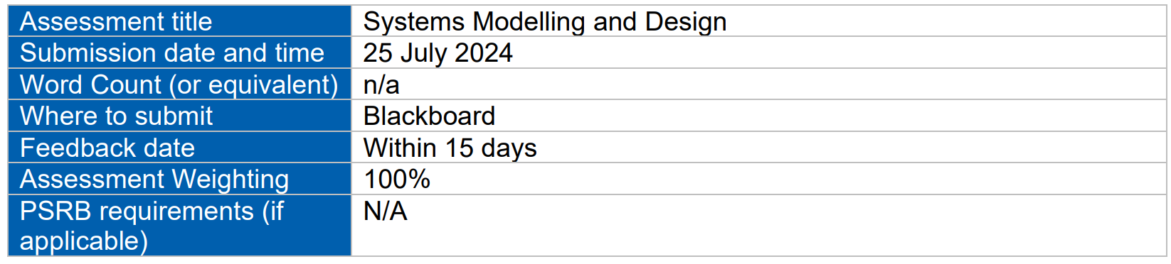

Contents
Client Survey Form Example 4
Client Survey Form Example 5
Requirement Gathering Questionnaire 5
Question 1: Primary Functions 5

Client Survey Form Example
- Patient Appointments Management
  - Questionnaire How do you currently manage patient appointments?
  - What improvements would you like to see in the appointment scheduling process?
- Medical Records Management
  - How easy is it to access and update patient medical records?
  - What challenges do you face with the current medical records system?
- Notification System
  - How effective is the current notification system for patients and practitioners?
  - What additional notification features would be beneficial?
- Prescription Management
  - How do you handle prescriptions and repeat prescriptions?
  - What changes would improve the prescription management process?
- Payment and Billing
  - How do you currently process payments and handle billing issues?
  - What improvements would you suggest for the billing system?
- System Security
  - Are you confident in the security of patient data in the current system? (Yes/No)
  - What security features are most important to you?
- System Integration
  - How well does the current system integrate with other systems you use?
  - What integration capabilities are most critical for your workflow?
- System Performance
  - How would you rate the performance of the current system? (Excellent/Good/Fair/Poor)
  - What performance issues have you encountered?
- Overall Satisfaction
  - How satisfied are you with the current practice management system? (Very Satisfied/Satisfied/Neutral/Dissatisfied/Very Dissatisfied)
  - What overall improvements would you like to see in the new system?

Requirement Gathering Questionnaire

Question 1: Primary Functions
Q) Can you describe the primary functions you need from the new practice management system?
A) We need the system to help manage appointments, keep track of patient records, and handle payments.

Question 2: Key Data Types
Q) What are the key types of data that need to be managed and stored in the system?
A) Information about patients, their medical history, their treatments, and their bills.

Question 3: Appointment Handling
Q) How do you currently handle patient appointments and how would you like this process to improve?
A) Right now, appointments are booked manually. We want a simpler way to book and manage them, ideally something that works online.

Question 4: Medical Records Management
Q) What specific features do you need for managing patient medical records and history?
A) We need a place to store all patient information that’s easy to access and update when needed.

Question 5: Notification System
Q) How do you envision the notification system working for both patients and practitioners?
A) Patients and doctors should get reminders about appointments and updates about treatments. Text messages and emails would be great.

Question 6: Prescription Management
Q) What are your requirements for prescription management, including repeat prescriptions?
A) It would be helpful if the system could automatically handle repeat prescriptions and let doctors adjust them when necessary.

Question 7: Payments and Billing
Q) How should the system handle payments and billing, including dealing with insurance providers?
A) We want to make it easy for patients to pay their bills and for the system to keep track of who owes what. It should also work with insurance companies.

Question 8: Security and Privacy
Q) What are your expectations regarding system security and data privacy?
A) Patient information needs to be kept private and secure. We need to follow all the rules about patient data protection.

Question 9: Integration with Legacy Systems
Q) How important is it for the system to integrate with your existing legacy systems?
A) The new system should work well with the current systems we use without causing too many issues.

Question 10: Scalability and Performance
Q) What are your scalability and performance expectations for the system as your hospital expands?
A) As we grow, the system should continue to work well and not slow down, even if many people are using it at the same time

Functional and Non-Functional Requirements
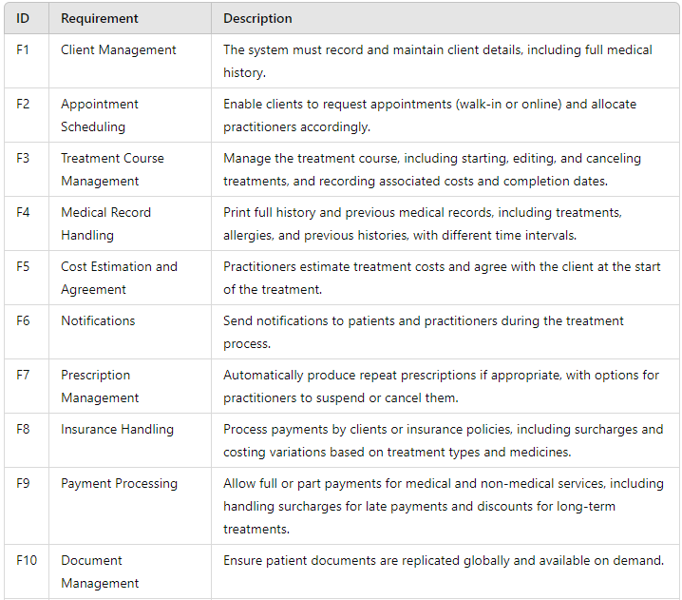

Non-Functional
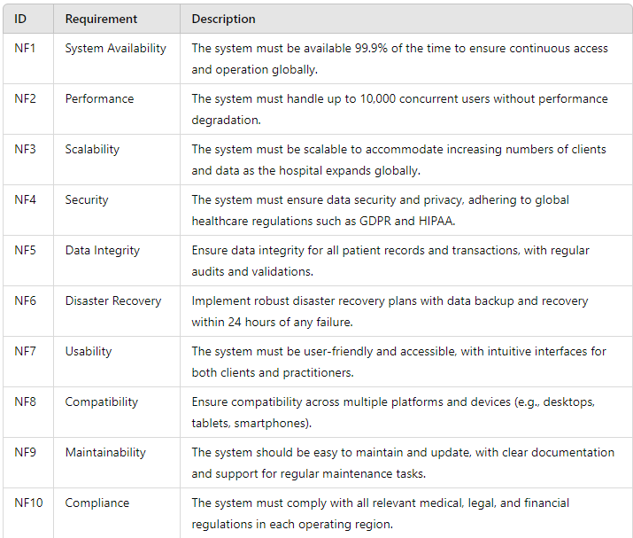

Use Case Example
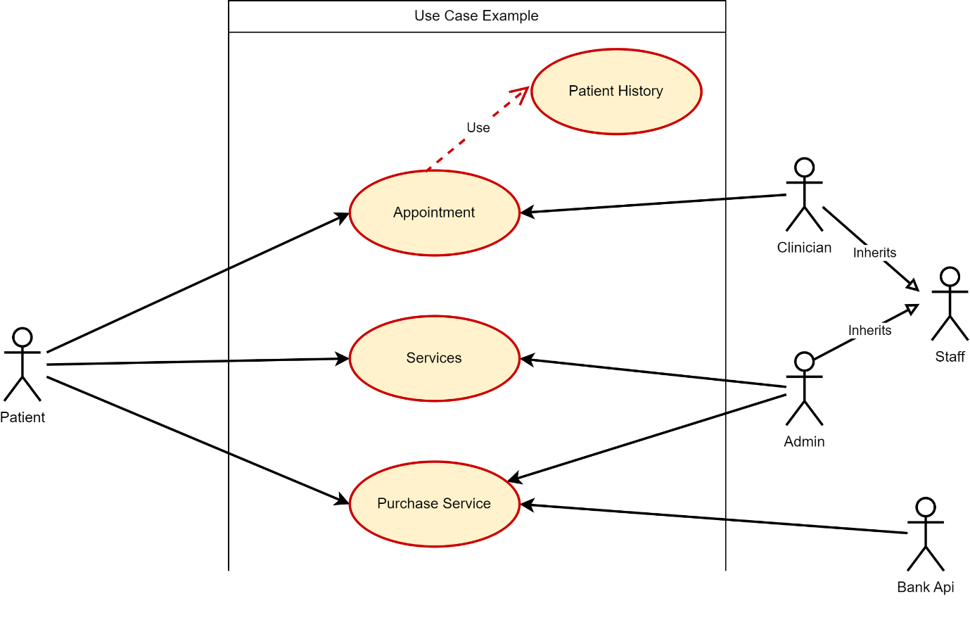
Figure 1: Use case example demonstrating the LLM structure for how a patient interacts with admin, clinicians and banking services

