PENTAHO DATA CATALOG 10.2.11 · TECHNICAL DEEP-DIVE
Data Identification
How Dictionaries and Data Patterns turn profiling results into governance — the engine behind PII detection, sensitivity, and the Galaxy View.
Audience | Runs on | Pairs with | Next
Data Steward / Developer / Admin | Profiled data | BA Workshop 5 — Protect Sensitive Data | Module 02 — Build Your Own (hands-on)

Why this matters
Profiling tells you what your data looks like. Data Identification is the step that turns those profiling results into governance: it scans the profiled values, recognises what they are, and applies Tags and Business Terms automatically. It is how a raw column called email becomes a column the catalog knows is PII, Sensitive, and linked to the Email Address business term — without anyone tagging it by hand. Those tags are also what later business rules act on.
Remember
Data Identification runs on profiled data, so profiling must come first — a method can only match values it can see. And the Trust Score is computed last, after tags exist.

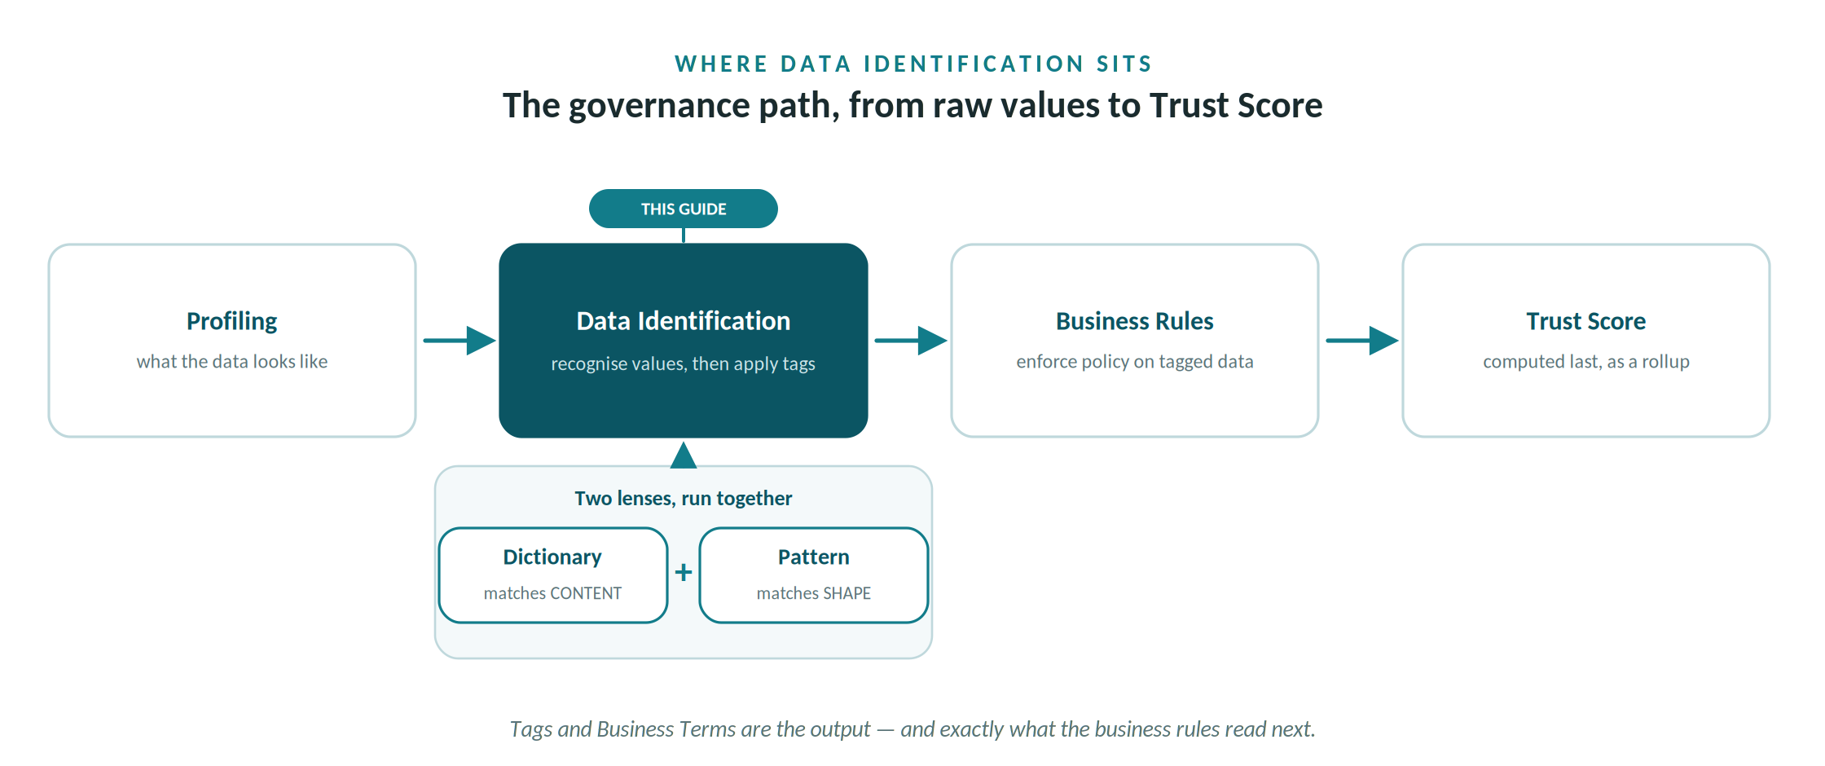
Profiling feeds Data Identification, whose tags feed the business rules and, last, the Trust Score.

Two methods, one goal
Data Identification classifies each profiled column two complementary ways, then tags it. The two lenses catch different things, which is why you usually run both together.
Method | Matches on | Good for
Data Dictionary | the column's actual values, against predefined lists of known terms | country/state codes, SKUs, department codes, custom vocabulary, classifications
Data Pattern | the shape of the values, as a character-position signature | emails, SSNs, passport and account codes, dates — anything with a recognisable format
The core equation: Data Dictionary + Pattern Analysis = a Data Identification Policy. You select the methods that fit your data, run them as one job, and on every match the policy applies tags.

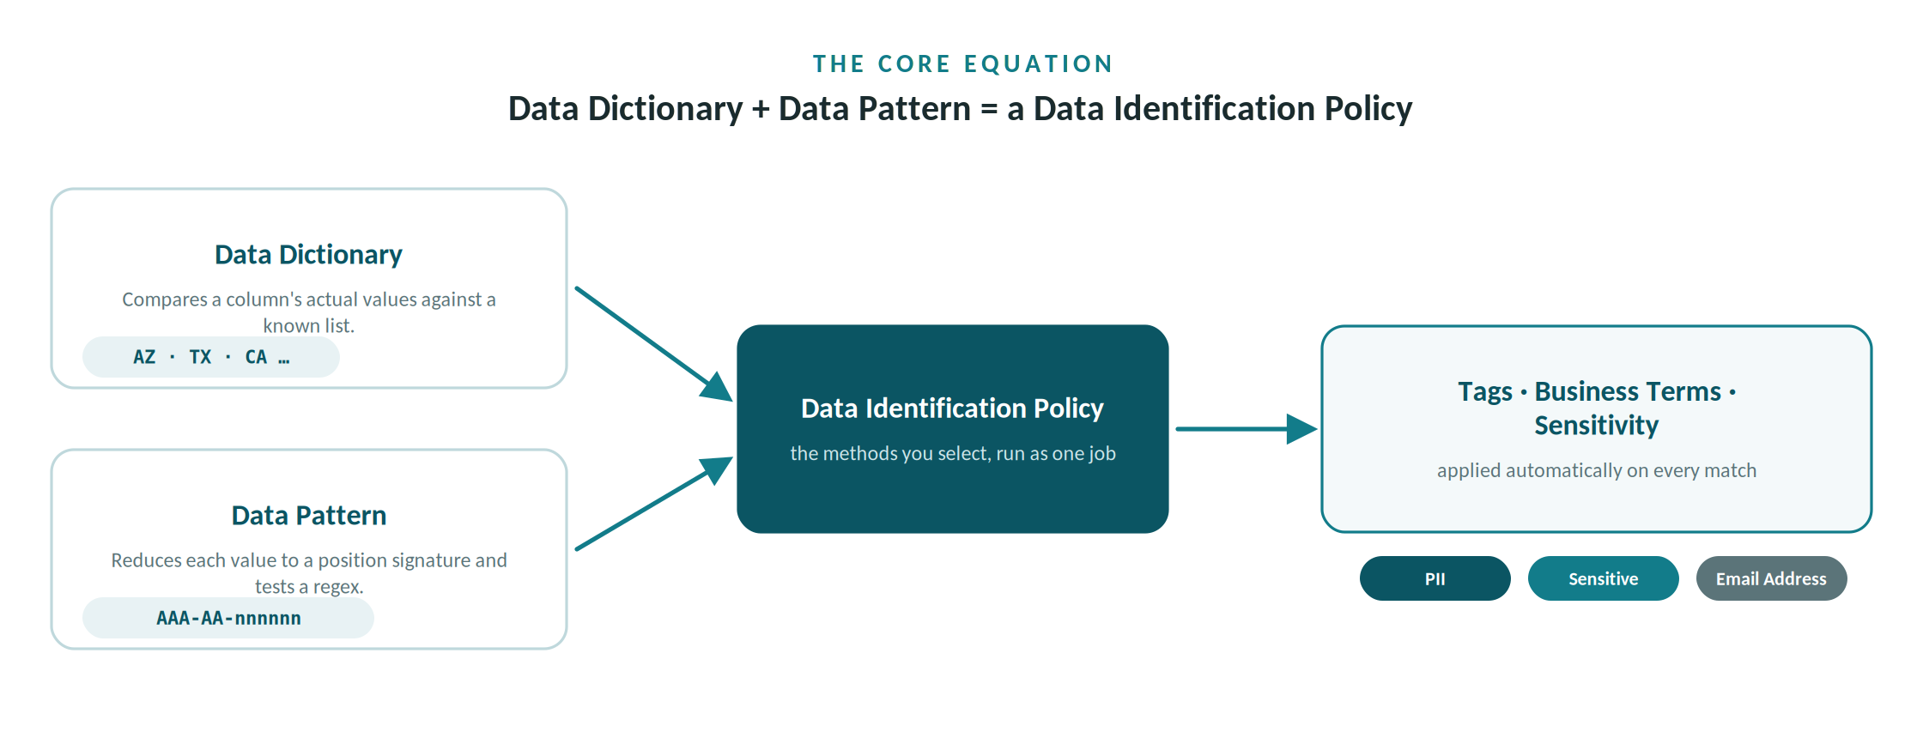
Dictionary and Pattern are selected together as one policy; every match applies tags and business terms.

Method 1 — Data Dictionaries
A data dictionary is a collection of predefined terms and values. Unlike a glossary, it actively scans the actual column values and classifies the column by what it contains, not just its name — so it can identify data that names alone never reveal, such as a column of two-letter country codes.
- System-defined. PDC ships with 95 built-in dictionaries — ISO country codes, currency symbols, standard classifications — ready to use.
- User-defined. Built for your business context. (Authoring these — for AWC's account, asset and contaminant vocabularies — is the work of Module 02.)

The matching rule and confidence score
Every dictionary carries a JSON rule. It computes a weighted confidence score, tests it against conditions, and — if they pass — applies tags. Condensed, the built-in Marital_Status dictionary reads:
In plain language
Confidence = similarity × 0.9 + metadata-hint × 0.1 (value similarity, nudged by a column-name hint). Fires when confidence ≥ 0.7 AND cardinality ≥ 3 (the cardinality test stops it firing on a near-empty column). On a match it tags the column PII and Sensitive: Marital Status.

Method 2 — Data Patterns
Pattern analysis reduces each value to a signature — a character-by-character substitution that records where letters, digits, symbols and whitespace fall. It is dimensional reduction for text, and it is what lets PDC recognise a format rather than a value.
Symbol | Means | Symbol | Means
a | lower-case letter | w | whitespace (space, tab)
A | upper-case letter | s | symbol - / | ! $ % ^ & *
n | digit 0–9 | - | other / control character
Worked example. An AWC account number AWC-CG-001001 reduces to AAA-AA-nnnnnn — three letters, a dash, the two-letter community code, a dash, six digits. Significant symbols (a dash or underscore) can be kept verbatim, and case can optionally be tracked.
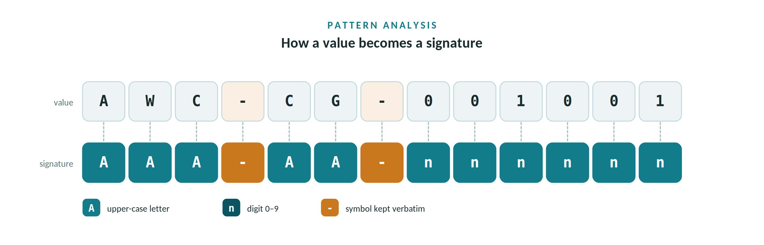
Each character maps to a class symbol — letters, digits, and kept symbols — to form the signature.

Position analysis, and from pattern to tag
As values stream in, PDC tallies each recurring pattern and tracks the largest and smallest character seen at every position — revealing fixed prefixes (here, the AWC- prefix) and how variable each position is, so it can propose tighter RegEx. The top ~20 patterns are kept and fed to three jobs at once.
- RegEx generation — an auto-built regular expression for the format.
- Data identification — a profiled column's profilePattern is compared, with a confidence score, to a predefined pattern; on a match it applies tags, exactly as a dictionary does.
- Data-quality checks — values that fall outside the accepted pattern surface as outliers, the candidate errors a DQ rule flags.

Policies — combining the two
Together, dictionaries and data patterns are called data identification policies. PDC ships many, spanning whole sectors — Finance, Education, Aviation, Law Enforcement, PCI-DSS, and Data Privacy. You select the methods relevant to your data and run them as one job. After a run, open the Galaxy View to visualise the tagging, follow the data flow, and locate sensitive data with its security and sensitivity at a glance.

Running Data Identification
- Open the Data Identification tile. On a profiled table, choose Actions → Process, then the Data Identification card.
- Select Methods. Pick the dictionaries and data patterns that fit your data — together they form the policy.
- Start, and track in Workers. The job runs asynchronously; watch its progress on the Workers page.
- Read the results in Data Canvas. Matching columns are now tagged — for example PII and Sensitive — ready for search and governance.

Data Identification in action — a simple AWC policy
You don't have to build anything to see this work. PDC's built-in Data Privacy policy already covers email and US ZIP. Run it on the Arizona Water Company customers table and read what it applies.
Column | How it matches | Tags applied | Sens.
customers.email | Email data pattern (regex value match) + name hint “email” | PII · Sensitive · term Email Address | HIGH
customers.service_zip | US ZIP pattern nnnnn / nnnnn-nnnn + name hint “zip” | PII · Location | MEDIUM
Plus a table tag Contains_Personal_Data on customers. Each rule fires when confidence clears its threshold and cardinality is high enough, and the table's Sensitivity reflects the highest matched column. That is the whole loop: profiled values in, governed tags out — and those tags are exactly what a business rule reads next.

From tags to business rules
Identification is where governance starts, not where it ends. Once a column is recognised, a business rule can act on it. AWC's flagship example lives right in the customers table.
AWC-Marketing-OptOut-Compliance
The schema carries a consent flag, opted_out_marketing — TRUE means the customer has opted out of marketing and must not be contacted. Identification has already tagged customers.email as PII. The business rule joins the two: no marketing email may be sent to any customer whose opt-out flag is TRUE. And the data is seeded to test it — several opted-out customers still hold a valid email address, which is precisely the violation the rule must catch.
So the path runs profiling → identification (the tags) → business rules (the policy that enforces them) → Trust Score (which only becomes meaningful once all of that has run). This deep-dive covers the first two steps; the opt-out rule itself is the BA Workshop's flagship scenario.

Key takeaways
- Dictionaries match content — known values, via a weighted confidence score and a cardinality test.
- Patterns match shape — a per-position signature that also generates RegEx and finds data-quality outliers.
- Policies combine both — selected methods, run as one job, on already-profiled data.
- Output is governance — Tags and Business Terms that feed Sensitivity, search, the Galaxy View, and the business rules that act on them.
Next: Module 02 — Build Your Own AWC Dictionary & Pattern authors the methods behind this engine for AWC's own account numbers, assets, and regulated-contaminant vocabulary.Arizona Water Company Edition · Technical Deep-Dive · Data Identification

