PENTAHO DATA CATALOG 10.2.11 · TECHNICAL LAB
Build Your Own AWC Dictionary & Pattern
Author and import the Arizona Water Company method library — every dictionary and pattern in the dataset — then run them as escalating Data Identification policies across the operations database and the document store.
Primary role | Estimated time | Dataset | Companion to
Data Steward or Data Storage Administrator | 60 minutes | awc_operations + awc-documents | Module 01 (concept) · Workshop 5 (Glossary Generator app)

From concept to authoring
Module 01 covered the engine: how Dictionaries match content, Data Patterns match shape, and a policy applies Tags and Business Terms to profiled data. This lab does not re-teach that. Here you author the methods AWC actually needs, import the full library, and run it — first on the operations database, then on the document store. PDC ships 95 dictionaries and a library of patterns, but none of them know AWC's account numbers, water-system names, asset tags, or regulated-contaminant vocabulary. You will build those.
Remember
Data Identification runs on profiled data (structured) or discovered data (documents). A method can only match values it can see — and the Trust Score is computed last, after tags exist.

What you'll build — the AWC method library
Twenty-three methods, each tied to a real column or document in the AWC dataset: eighteen dictionaries (match by content) and five patterns (match by shape). You author one of each by hand to learn the screens, then import the rest from the supplied files. There are three import routes:
- Upload Dictionary — a one-column CSV of values, loaded straight into a new dictionary (the simplest route).
- Import Dictionaries — a ZIP of CSV value-lists and JSON rules; loads the whole dictionary library at once.
- Import Patterns — a JSON file (or a ZIP of JSON); loads a pattern, or all of them together.

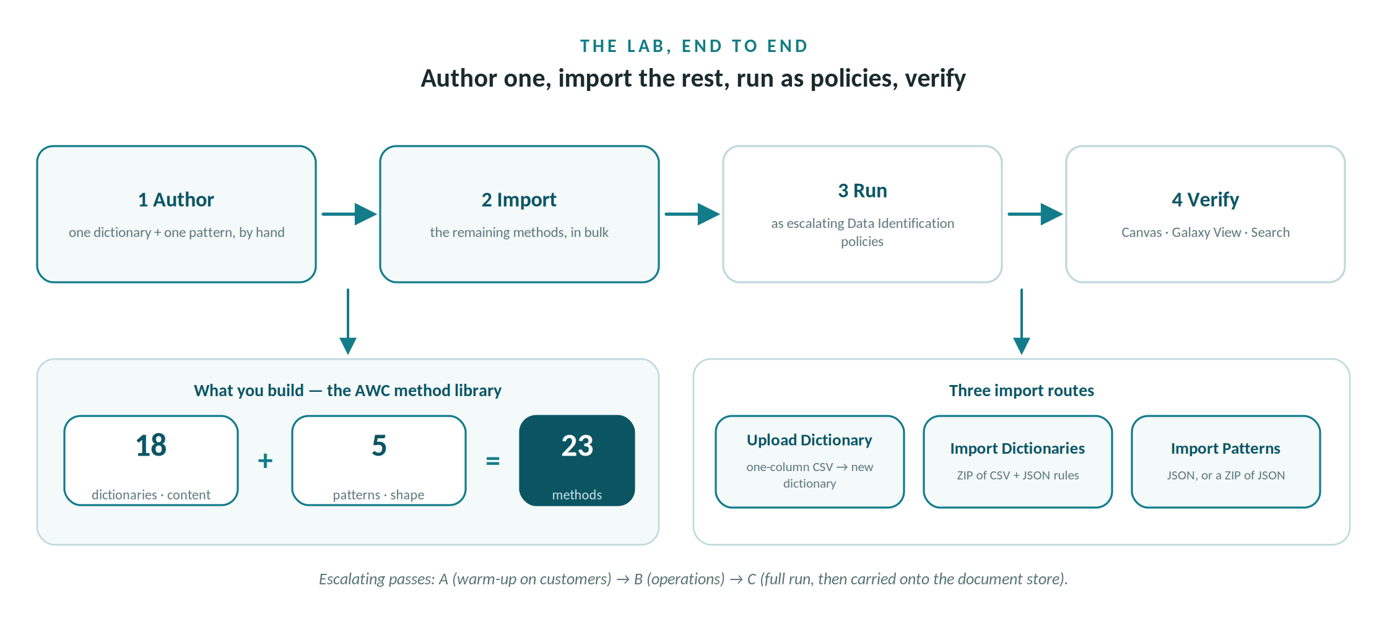
The lab in four moves: author one of each method, import the rest, run as escalating policies, verify.
The library groups into five categories. The full method-by-method index is in the appendix.
Category | What it covers | Methods
AWC_Status | Account, payment and workflow state vocabularies | Dictionaries
AWC_Reference | Customer/asset/system reference lists and every ID format | Dictionaries + Patterns
AWC_Location | Arizona counties and service geography | Dictionaries
AWC_Operations | Alerts, severity, criticality, pipe and asset condition | Dictionaries
AWC_Compliance | Compliance status, quality, and regulated contaminants | Dictionaries

Before you begin
- Profile the structured tables. The awc_operations tables you want to tag — customers, water_systems, monthly_usage, water_quality_reports, account_alerts — must already be profiled, and the two file assets (asset_inventory, pipe_network_segments) discovered.
- Discover the documents. For the awc-documents store (the EPA compliance PDFs and field-inspection reports), run Metadata Ingest and Data Discovery first — documents are not column-profiled.
- Check your role. Creating and importing methods requires the Data Steward or Data Storage Administrator role. No Data Operations → Data Identification Methods card means a permissions issue, not a missing feature.
- Have the library files. The value CSVs, rule JSONs, AWC-Dictionaries.zip, AWC-Patterns.zip, and INDEX.csv from the method-library package.

Part A — Build a dictionary, then import the rest
A dictionary matches by content: it compares a column's actual values against a known list. You'll author one — AWC Asset Type — to learn every field, then import the other seventeen in one step.

Author AWC Asset Type (Upload Dictionary route)
- Open the page. Left nav → Data Operations → on the Data Identification Methods card, click Dictionaries → Add Dictionary.
- Name & category. Name it AWC Asset Type; in Category type AWC_Reference and click Add New. Leave Dictionary Status enabled.
- Apply Values. Choose Upload Dictionary, upload awc_asset_type.csv (11 values: Booster Station, Pump Station, Groundwater Well, Storage Tank …), and set a confidence score of 0.8.
- Column-Name Regex. Add the hint (?i)asset_?type at 0.9, and set the pane weight to 0.2. (Similarity 0.8 + metadata 0.2 = 1.0.)
- Condition. Confidence Score ≥ 0.6 OR Metadata Score ≥ 0.7, AND Column Cardinality ≥ 3.
- Actions. Assign Tag Asset Type.
- Create. Click Create Dictionary. asset_inventory.asset_type is now recognised by what it contains, not its name.

Import the other seventeen
Rather than re-key each one, load them together: Dictionaries → Import → upload AWC-Dictionaries.zip → Continue. Track it on the Workers page. Each dictionary arrives with its value-list and rule already configured.
Increasing complexity — the four kinds of dictionary you just loaded
Simplest — a closed value list (Account Status, Payment Status, Severity): no name hint needed. With hints + a term — Water System Names adds a column-name hint and assigns the Water System business term. Compliance-driving — Compliance Status can be built by the Select Column route (extract values from a profiled compliance_status column) and exported as a ZIP for reuse. Beyond a value list — Drinking Water Contaminants (46 terms) is the case you can't express as a shape, and it's the one that also fires on the document store in Part D.
Note
A dictionary created by the Select Column route works on structured data only. To match values inside documents, the dictionary must be CSV/uploaded — which is why the library ships every dictionary as a CSV.

Part B — Build a pattern, then import the rest
A pattern matches by shape: it reduces each value to a position signature and tests a regular expression. You'll author AWC Account Number, then import the other four.

Author AWC Account Number
- Open the page. Data Operations → Data Identification Methods → Data Patterns → Add Pattern.
- Name & category. Name it AWC Account Number; Category AWC_Reference; status enabled.
- Column-Name Regex. Add (?i)(account|acct)_?(no|num|number|id)?; weight this pane 0.3.
- Content Patterns. Add the position signatures AAA-AA-nnnnnn, AAA-AAA-nnnnnn, AAA-AAAA-nnnnnn (the community code is 2–4 letters); weight this pane 0.4.
- Content Regex. Add ^AWC-[A-Z]{2,4}-\d{6}$; weight this pane 0.3.
- Check the weights. The three pane weights must sum to 1.0 (0.3 + 0.4 + 0.3).
- Condition & Actions. Confidence Score ≥ 0.7. Assign Tags Account Number and Sensitive; Assign Table Tag Contains_Customer_Identifiers; Assign Business Term Customer Account.
- Create. Click Create Pattern. A real value is AWC-CG-001001 — AWC, the Casa Grande community code, then six digits.

Import the other four
Data Patterns → Import → upload AWC-Patterns.zip (or an individual pattern JSON) → Continue. The five ID formats across the AWC estate:
Pattern |  | Column / source | Format | Example
Account Number |  | customers.account_number | ^AWC-[A-Z]{2,4}-\d{6}$ | AWC-CG-001001
Meter ID |  | monthly_usage.meter_id | ^MTR-\d{6}$ | MTR-001001
Asset ID |  | asset_inventory.asset_id | ^AST-\d{4}$ | AST-0001
Pipe Segment ID |  | pipe_network_segments.segment_id | ^SEG-\d{5}$ | SEG-00001
Equipment Tag |  | inspection documents | ^(PS|BS|T|TK|PRV|LS)-\d{2,3}$ | PS-012, T-03
Qualify and disqualify
Account numbers and meter IDs both end in six digits, so a loose pattern would collide. The anchored content regex keeps them exclusive — ^MTR-\d{6}$ qualifies a meter and disqualifies an account. Equipment Tags rarely appear as a column; they surface inside the inspection reports, which is why that pattern earns its keep in Part D.

Part C — Combine into escalating policies and run
A set of selected methods is a Data Identification policy. Run them in three escalating passes rather than all at once — it keeps results legible and mirrors how a steward rolls coverage out.
Policy | Run on | Methods selected
A — warm-up | customers | Account Status (dict) + Account Number (pattern) + built-in Email, US ZIP, US Phone
B — operations | water_systems, monthly_usage, water_quality_reports, account_alerts, asset_inventory, pipe_network_segments | System Names, System Type, Water Source, Meter ID, Payment Status, Compliance Status, Quality Rating, Contaminant Level, Drinking Water Contaminants, Alert Type, Severity, Workflow Status, Asset Type, Asset ID, Criticality, Pipe Material, Pipe Status, Segment ID
C — full | all awc_operations | every custom method + built-ins, run as one job; then carried onto awc-documents in Part D

Run a policy
- In Data Canvas, open a profiled table, then Actions → Process → the Data Identification card.
- Click Select Methods, tick the methods for that policy, click Apply, then Start.
- Watch the job on the Workers page — it runs asynchronously.
- Back in Data Canvas, matching columns now carry their tags, business terms and sensitivity.

What you should see
Column | Method → result
customers.account_number | Account Number pattern → Account Number, Sensitive + term Customer Account
customers.account_status | Account Status dictionary → Account Status
monthly_usage.meter_id | Meter ID pattern → Meter ID + term Meter ID
water_quality_reports.compliance_status | Compliance Status dictionary → Compliance
asset_inventory.asset_id | Asset ID pattern → Asset ID
pipe_network_segments.material | Pipe Material dictionary → Pipe Material

Part D — Run the methods on unstructured data
The same methods carry onto the awc-documents store, with one change in mechanism. Documents are not column-profiled — you run Data Discovery, and on its Document Processing tab you reach identification three ways.
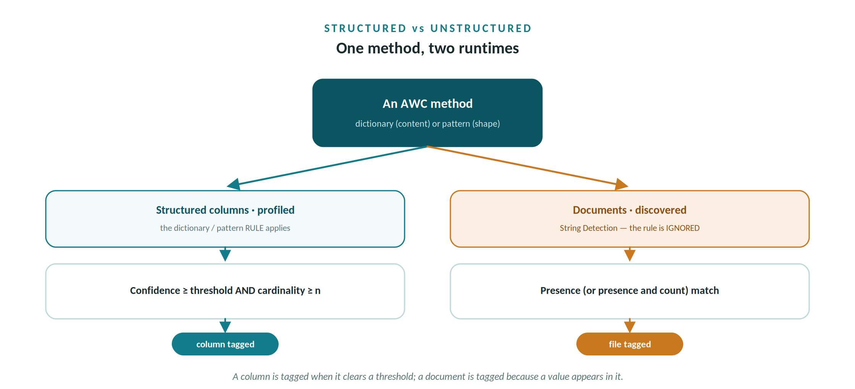
The same method behaves differently by target — a rule-driven match on columns, a presence match on documents.

Set up Document Processing
- In Data Canvas, select the awc-documents folder → Process → run Metadata Ingest, then open Data Discovery.
- String Detection. Add dictionaries (AWC Drinking Water Contaminants, AWC Water System Names) and patterns (AWC Account Number, AWC Equipment Tag). Choose Detect presence, or presence and count.
- Address Detection. Enable it and choose a business term (e.g. Service Address) — files containing US postal addresses get tagged.
- Data Classification. Supply the business terms that name your document classes — Water Quality Compliance Report, Field Inspection Report — and PDC assigns them by semantic content, no exact string required.
- Click Start Discovering and track it on Workers.
The mechanism change that matters
On documents, String Detection ignores the dictionary's rule — the confidence score and conditions that govern columns don't apply. It is a pure presence (or presence-and-count) match, after which the method's actions are applied to the file. So the same artifacts transfer, but a document is tagged because a value appears in it, not because a column crossed a confidence threshold.

What you should see on the sample documents
Document | Identified as
epa_compliance_*.pdf | Contaminants present (Turbidity, Lead, Copper, TDS…) + System Name present (Apache Junction, Bisbee, Pinal Valley, Sedona) → classified Water Quality Compliance Report; Compliance / Confidential
inspection_*.docx | Equipment Tag present (PS-012, T-03) + System Name present → classified Field Inspection Report
any document quoting an account | Account Number pattern via String Detection → presence (and count) of customer identifiers

Verify the results
- Data Canvas. Open tagged columns and document assets; confirm tags, business terms and Sensitivity are present.
- Galaxy View. See the tagging visually and locate sensitive and regulated data across the catalog at a glance.
- Search. Filter by the Account Number, Asset ID or Regulated Analyte tag to prove assets are discoverable by what they are, not just by name.

Gotchas & good practice
- Profile (structured) or discover (documents) first. A method only matches data it can see.
- Re-running identification re-applies method tags. If you hand-tune tags — or the Glossary Generator app writes overrides over the API — re-running the policy re-asserts the dictionary/pattern tags. Identify once, then curate; don't loop.
- Tags are an array. Over the API a PATCH replaces the whole tag set, so any tool that edits tags must read-merge-write. Sensitivity is a scalar and overwrites cleanly.
- Pattern pane weights must sum to 1.0. Column-Name + Content Patterns + Content Regex.
- String detection ignores dictionary rules. On documents it's presence/count only, and a column-derived dictionary can't be used there — use CSV-based dictionaries for the doc store.
- Template the import envelope from an Export. Author one method in the UI, click Export, and mirror that exact ZIP/JSON for bulk authoring. It's validated on load.
- Trust Score is last. It rolls up quality, lineage, ratings, classification and term assignment, so it only becomes meaningful after identification has run.

How this connects
Module 01 taught the engine; here you authored its inputs for AWC. The tags this identification produces are what the Glossary Generator app rides on — reading them over the API and letting a steward refine the resulting glossary. Author the methods here; let the app curate the output there. Next module: 03 — Glossary Generator App.

Appendix — AWC method library index

Dictionaries (match by content)
Dictionary | Matches (column / source) | Size | Tags / term
Account Status | customers.account_status | 4 values | Account Status
Payment Status | monthly_usage.payment_status | 4 values | Payment Status
Customer Type | customers.customer_type | 5 values | Customer Type
Arizona Counties | customers.service_county / water_systems.county | 15 values | Location, Arizona County + term County
Water System Names | water_systems.system_name / customers.service_area_system | 16 values | Water System + term Water System
System Type | water_systems.system_type | 3 values | System Type
Water Source | water_systems.source_type / primary_source | 8 values | Water Source
Compliance Status | water_quality_reports.compliance_status | 3 values | Compliance, Compliance Status + term Compliance Status
Quality Rating | water_quality_reports.quality_rating | 4 values | Quality Rating
Contaminant Level | water_quality_reports.contaminant_level | 4 values | Contaminant Level
Alert Type | account_alerts.alert_type | 7 values | Alert Type
Severity | account_alerts.severity | 4 values | Severity
Workflow Status | account_alerts.status | 3 values | Workflow Status
Asset Type | asset_inventory.asset_type | 11 values | Asset Type
Asset Criticality | asset_inventory.criticality | 4 values | Criticality
Pipe Material | pipe_network_segments.material | 9 values | Pipe Material
Pipe Status | pipe_network_segments.status | 4 values | Asset Status
Drinking Water Contaminants | water_quality_reports.* / awc-documents | 46 values | Regulated Analyte, Compliance + term Drinking Water Contaminant

Patterns (match by shape)
Pattern | Matches (column / source) | Format | Tags / term
Account Number | customers.account_number | ^AWC-[A-Z]{2,4}-\d{6}$ | Account Number, Sensitive + term Customer Account
Meter ID | monthly_usage.meter_id | ^MTR-\d{6}$ | Meter ID + term Meter ID
Asset ID | asset_inventory.asset_id | ^AST-\d{4}$ | Asset ID
Pipe Segment ID | pipe_network_segments.segment_id | ^SEG-\d{5}$ | Segment ID
Equipment Tag | inspection documents (PS-012, T-03, BS-04) | ^(PS|BS|WL|PRV|LS|TK|T)-\d{2,3}$ | Equipment Tag
Arizona Water Company Edition · Technical Lab · Data Identification authoring

