PENTAHO DATA CATALOG 11.0.0 · TECHNICAL TRACK
PDC PROCESS · DATA IDENTIFICATION
MODULE 02
Data Identification: the Engine
How dictionaries and patterns combine into policies that tag CSCU's data — and where the steward takes over.

Primary role: Data Steward / Data Developer / Admin
Estimated time: 45 minutes
Dataset: Copper State Credit Union (cscu_core + cscu-documents)

1. What identification is
Data Identification stamps tags and business terms (and drives sensitivity) onto profiled columns and discovered documents. Two method types:
- Dictionaries — match by content. A value list; a column whose profiled values sit inside the list scores high similarity. Right tool for enums: txn_type_cd, acct_type_cd, risk_rating_cd.
- Data Patterns — match by shape. Weighted signals: column-name regex, position analysis (AAAA-nnnnnn), content regex. Right tool for identifiers: CSCU-100501, ACC-00070001, nine-digit routing numbers, card PANs.
📷 SCREENSHOT — Data Operations → Data Identification Methods

2. Anatomy of a rule
Walk cscu_transaction_types_rule.json (Module 03): confidence formula (0.8 × similarity + 0.2 × metadata), column-name regex with a score, fire condition (confidence ≥ 0.6 OR metadata ≥ 0.7), actions (apply tags, assign business term). Then cscu_member_number.json: three weighted signals (name 0.3, shape 0.4, regex 0.3) against a 0.7 threshold.
📷 SCREENSHOT — method rule editor

3. Policies and the run
Methods are grouped into a policy; the policy runs as a job over selected sources. On CSCU: system methods (SSN, email, phone, credit card) find members.ssn, members.email, cards.card_no; the custom methods from Module 03 pick up the enums and CSCU identifiers.
📷 SCREENSHOT — policy run + results on members

4. The rules that matter in operation
- Profile first — identification reads profiled values; an unprofiled table gives the engine nothing to match.
- Identify once — re-running after steward overrides (the Glossary Generator's Apply) clobbers their work. Baseline once, then curate.
- Tags merge, sensitivity overwrites — remember this when the app writes back.
- Trust Score last — it rolls up quality + ratings + lineage + classification + term links.
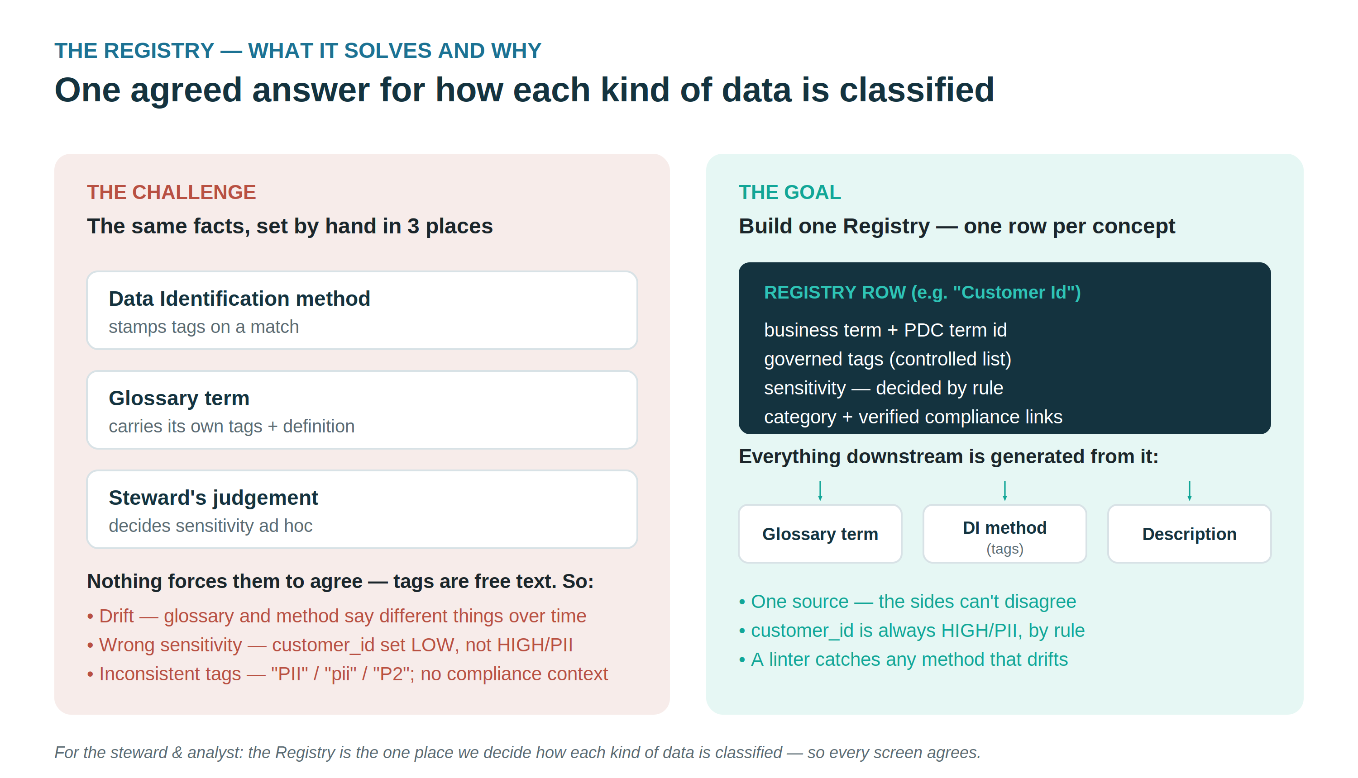

5. Where the steward fits
Identification is the baseline, not the verdict. The CSCU story: cards.cvv_cd — a 3-digit column generic methods may miss — is caught by the failing PCI business rule (Workshop 4), the PCI attestation document, and the steward's review in the Glossary Generator. Module 01 applies that curation over the PDC API.
All Copper State Credit Union data is fictional and generated for training.

