PENTAHO DATA CATALOG 11.0.0 · BUSINESS ANALYST
PDC PROCESS · BUSINESS GLOSSARY
WORKSHOP 3
Build the Business Glossary
Give CSCU one governed vocabulary: import, review, link and steward the draft terms.

Primary role: Business Steward / Business Analyst
Estimated time: 45 minutes
Dataset: Copper State Credit Union (cscu_core + cscu-documents)
You stand up CSCU's business glossary: eight categories (Member, Accounts & Deposits, Cards & Payments, Transactions, Lending, Compliance & Risk, Finance & Ledger, Branch Operations), one term per business-meaningful column, each with sensitivity, CDE flag and governed tags — then link terms to columns and assign stewards.
Two paths. This workshop imports the prepared glossary (CSCU-Business-Glossary.jsonl) and reviews it — the manual path. The Technical Track builds the same glossary interactively with the Glossary Generator app (scan → review → govern → generate). Use one path per environment, not both.

Why this workshop matters
Tables answer where data lives; the glossary answers what it means — in the language the business actually speaks. Terms carry the definitions, sensitivity and criticality that examiners ask about, and they are the anchor that later links columns, documents and policies into one governed vocabulary.
The business problem. Ask three CSCU departments what "member number" means and you may get three answers (the ID, the account, the card). A governed glossary makes one answer authoritative, assigns it a steward by name, and connects it to the exact columns that hold it.

What you will learn
- How a category tree and draft terms are imported in one pass — and why the import replaces the whole glossary.
- What a well-formed term carries: definition, sensitivity, CDE flag, governed tags, steward.
- How term-to-column links turn definitions into navigation.
- How stewardship maps CSCU's four business domains onto named Business Stewards.
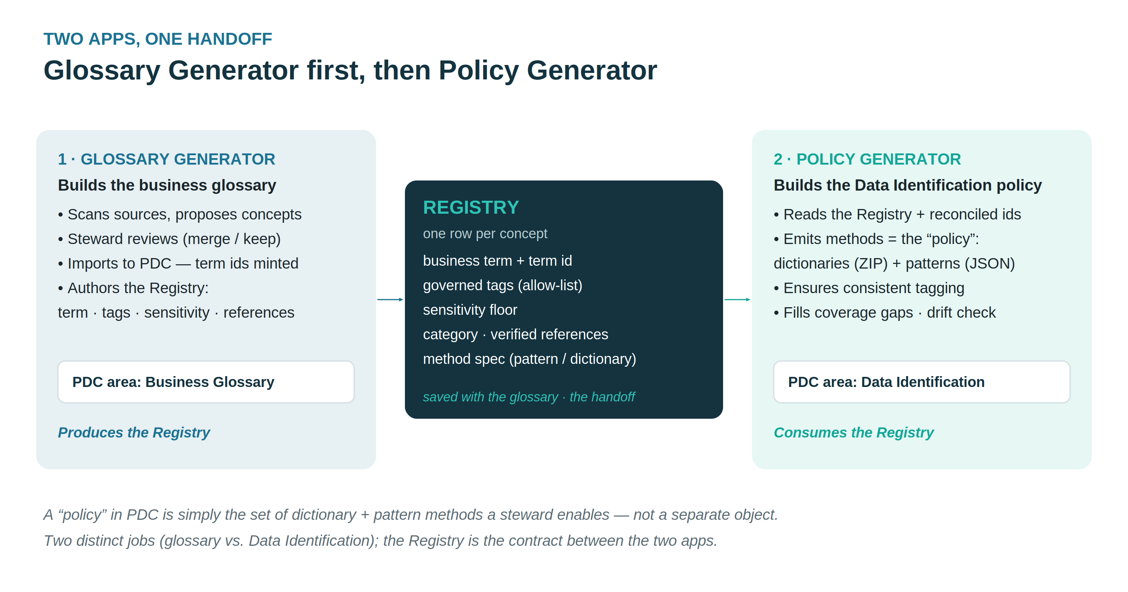

Part A — import the glossary
- As nadia.flores (or any Business Steward): Business Glossary → Actions → Import → choose assets/CSCU-Business-Glossary.jsonl.
- The import replaces the whole glossary — on a fresh instance that's fine; to update later, re-import a complete set with the same term ids.
- Verify the eight categories and ~114 draft terms.
📷 SCREENSHOT — Business Glossary — category tree after import

Part B — review the terms a steward owns
- Open Compliance & Risk (Nadia's domain): Risk Rating Code, Suspicious Activity Report, KYC Review Record … — all HIGH/CDE.
- Check the definitions came from the column comments (High confidence) and the tags stay inside the governed set (compliance, aml).
- Open Cards & Payments and find CVV Code: its definition carries the PCI warning. Confirm sensitivity is HIGH; this term documents a defect, not an approved data element.
📷 SCREENSHOT — CVV Code term detail

Part C — link terms to columns
As elena.ramirez (her Data Steward side carries the data-source write rights a Business Steward lacks), use assets/CSCU-Term-Linking-Map.csv (schema,table,column → business_term) to attach terms to the profiled columns — e.g. members.mbr_no → Member Number, ach_payments.ach_rte_no → ACH Routing Number. In the UI: open the column → Business Terms → Add. (The Technical Track automates exactly this via the app's Resolve → Apply.)
📷 SCREENSHOT — members.mbr_no with linked term

Part D — stewardship
Assign each category's steward per assets/users.csv / the user-map CSV — the expertise-driven map covers all nine categories: Elena → Member, Accounts & Deposits, Transactions, Branch Operations; Marcus → Lending, Finance & Ledger; Nadia → Compliance & Risk, Records & Documents; Tom → Cards & Payments.

Checkpoint
- ☐ Glossary imported: 8 categories, ~114 terms, status Draft
- ☐ CVV Code reviewed and HIGH
- ☐ At least five terms linked to columns
- ☐ Stewards assigned per domain
All Copper State Credit Union data is fictional and generated for training.

