PENTAHO DATA CATALOG 11.0.0 · TECHNICAL TRACK
PDC PROCESS · GLOSSARY GENERATOR
APP WORKSHOP
Build the Glossary with the Glossary Generator
Scan, review, govern and apply CSCU's governed glossary — and author the Registry — with the app.

Primary role: Data Steward / Solution Architect
Estimated time: 60–90 minutes
Dataset: Copper State Credit Union (cscu_core + cscu-documents)
Prerequisites: the shared lab running with CSCU loaded (data_sources/lab → make up && make load SCENARIO=CSCU), PDC reachable over HTTPS, the CSCU domain pack installed (data_sources/CSCU/cscu-domain-pack.zip → unzip into glossary_generator/).

1. The scenario
Copper State Credit Union is a fictional Arizona credit union with six branches (Phoenix, Tempe, Tucson, Casa Grande, Globe, Prescott), ~13 pilot members, and a core banking schema (cscu_core, 11 tables) plus a document store (cscu-documents bucket, 18 files). Its data estate has exactly the governance problems the Registry approach fixes:
- PII everywhere — SSNs, DOBs, card PANs, account and routing numbers spread across members, cards, accounts, ach_payments.
- A planted PCI violation — cards.cvv_cd stores card verification values, which PCI DSS forbids after authorization. Your steward review must catch it.
- Cryptic core-banking names — mbr_no, prin_bal_amt, apr_rt, ach_rte_no. The generator's abbreviation expansion (plus the CSCU pack) turns them into readable terms: Member Number, Principal Balance Amount, APR, ACH Routing Number.
- A compliance story that spans sources — SAR 97001 (structuring: two $9,450 transfers just under the $10,000 threshold) exists as database rows (suspicious_activity, ach_payments, transactions) and as documents (the Q2 SAR summary PDF, the ACH batch JSON). One glossary must cover both.
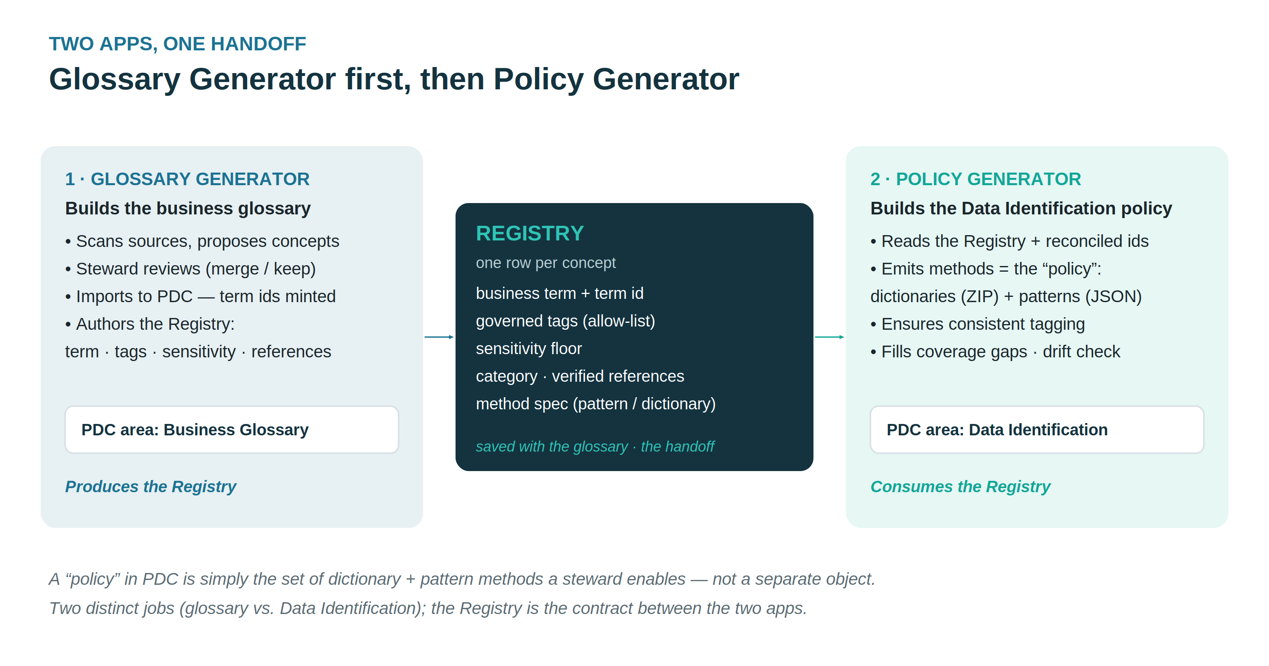

2. What you will build
An import-ready business glossary for PDC — one reviewed term per business-meaningful column and document folder, each with governed tags (pci, aml, lending, …), rule-based sensitivity, CDE flags, and steward assignments — plus the Registry the Policy Generator will later read to emit Data Identification methods.

3. Lab flow

Step 1 — Stand up the sources
cd data_sources/lab
cp .env.example .env
make up # shared postgres + minio (all scenarios)
make load SCENARIO=CSCU # cscu_core db + cscu-documents bucket, verified
make console reprints the PDC connection values (database CopperState_Core_Banking, object store CopperState_Documents).

Step 2 — Register the sources in PDC
Use the app's bulk loader (Connections → Bulk-load data sources) with data_sources/CSCU/cscu-datasources.csv, or create the two sources by hand. Then run Metadata Ingest → Profile → Data Identification in PDC, and click Scan Files on the document store. (Identify once — the steward's overrides come later and must not be clobbered.)

Step 3 — Install the scenario and start the app
Unzip cscu-domain-pack.zip into glossary_generator/ (this drops domain_pack.json and the people.json steward roster), delete any previous tag_dictionary.json, then ./run.sh. Confirm on /config that GLOSSARY_COMPANY=Copper State Credit Union.

Step 4 — Scan & review
Connect to cscu_core (schema cscu_core, read-only pdc_user), Scan, then Add to glossary from the MinIO bucket so one glossary spans both sources. On the review grid:
- Check the expansions: mbr_since_dt → Member Since Date, apr_rt → APR Rate. Edit anything weak.
- Confirm sensitivity: ssn, card_no, acct_no must be HIGH. The profiler and the pack's sensitivity floors should already say so — verify, don't trust.
- Find the planted violation: cvv_cd on cards. Its column comment and the PCI attestation PDF both flag it. Keep the term, set sensitivity HIGH, tag pci, and note the remediation in the definition — the glossary is where the finding becomes visible to everyone.
- Check the tags the CSCU pack derived: ach_rte_no → payments · ach, risk_rating_cd → compliance · aml, statements folder → statement · records. A bare document tag means a vocabulary gap — extend the pack, don't hand-edit.

Step 5 — Govern
The roster is pre-seeded with the CSCU team, each steward carrying the expertise keywords the matcher uses. Auto-assign all slots and verify the result: Elena Ramirez stewards Member, Accounts & Deposits, Transactions, Branch Operations; Marcus Webb Lending, Finance & Ledger; Nadia Flores Compliance & Risk, Records & Documents; Tom Callahan Cards & Payments. Elena's Data Steward role fills the owner slots, and Omar Haddad (Data Storage Administrator) fills every custodian slot — every pick shows its confidence and matched terms. Set ratings (Auto/DQ), review date, and status.

Step 6 — Generate, import, resolve, apply
Generate JSONL (writes the Registry alongside), import it in PDC (Business Glossary → Actions → Import), Resolve term ids, then Apply to PDC — dry-run first, always. Finish with the Trust Score rollup.

4. Checkpoints
# | Check | Evidence
1 | 11 tables + 18 documents scanned | Sources chip on the Glossary page
2 | cvv_cd flagged HIGH / pci | The review grid row + your note
3 | SAR terms marked CDE, HIGH | suspicious_activity terms
4 | Tags all governed (no drift) | Dictionary page: 0 off-vocabulary
5 | Stewards assigned per domain | Govern page slots
6 | Registry written at export | registries/registry.<glossary>.json

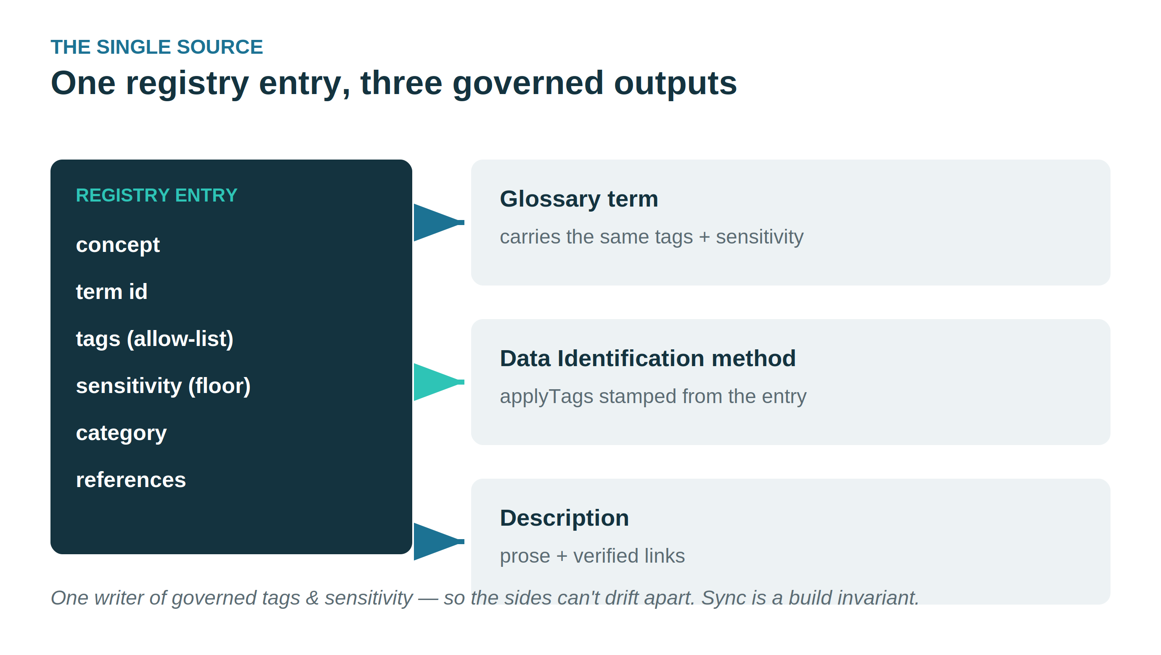

5. Where the story continues
The Registry you just produced is the input contract for the Policy Generator, which emits the Data Identification dictionaries and patterns (card PAN, routing number, SSN) bound to these term ids — and then drift-checks them. That is a separate session.
All Copper State Credit Union data — members, accounts, transactions, SARs and documents — is fictional and generated for training.

